RAID CONFIGURATION

RAID:

RAID (Redundant Array of Independent Disks) is a technology for
managing how data is stored on the physical disks that reside in your system or
are attached to it.

Types Of RAIDS:

1.Hardware RAID

2.Software RAID

RAID LEVELS:

Based on the functionatly RAID having 7 levels (0-6).

1.RAID 0

2.RAID 1

3.RAID 2

4.RAID 3

5.RAID 4

6.RAID 5

7.RAID 6

RAID 0: Disk Striping

1.Groups n disks as one large virtual disk with a capacity of
(smallest disk size)*n disks.

2.Data is stored to the disks alternately.

3.No redundancy data is kept. When a disk fails, the large virtual disk fails
with no means of rebuilding the data.

4. Minimum “two” hard disk needed.

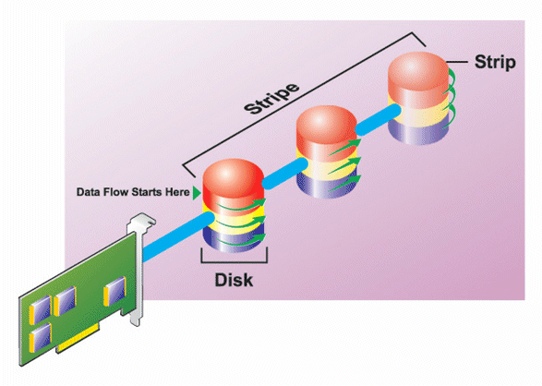

RAID 1: Disk Mirroring

1. Data is replicated on the two disks.
2. When a disk fails, the virtual disk still works. The data will be read from
disk's mirror.

3.Redundancy for protection of data.

4. Minimum “two” hard disk needed.

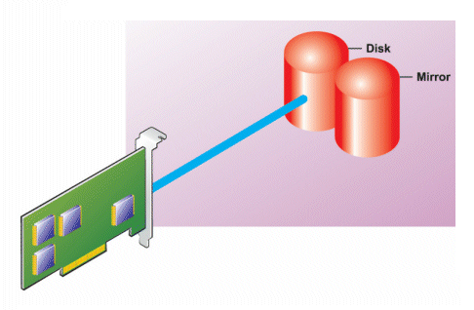

RAID 5: Striping with distributed parity

1.Redundant information (parity) is alternately stored on all disks.

2.When a disk fails, the virtual disk still works, but it is operating in a
degraded state.

3.Redundancy for protection of data.

4.Minimum “three” Hard disk needed.

5.When one hard disk fail, we can retrive the data from those two hard disk.

6.when two hard disk fail, we cannot retrive the data.

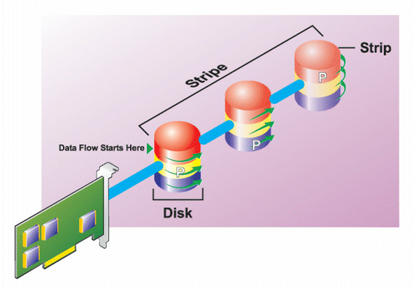

RAID Configuration in linux:

The command “mdadm” is used to create the software raid in linux.

Before that we create the partition in linux by using “fdisk” command.

Hard disk:

1.IDE

2.SATA

IDE :

fdisk /dev/hda ----> Master Drive

fdisk /dev/hdb ----> Slave Drive

SATA:

fdisk /dev/sda -----> Master Drive

fdisk /dev/sdb -----> Slave Drive

Partition Creation in Linux:

#fdisk /dev/hda

Here we have some option for disk management. By using those options
we can create the disk and format it.

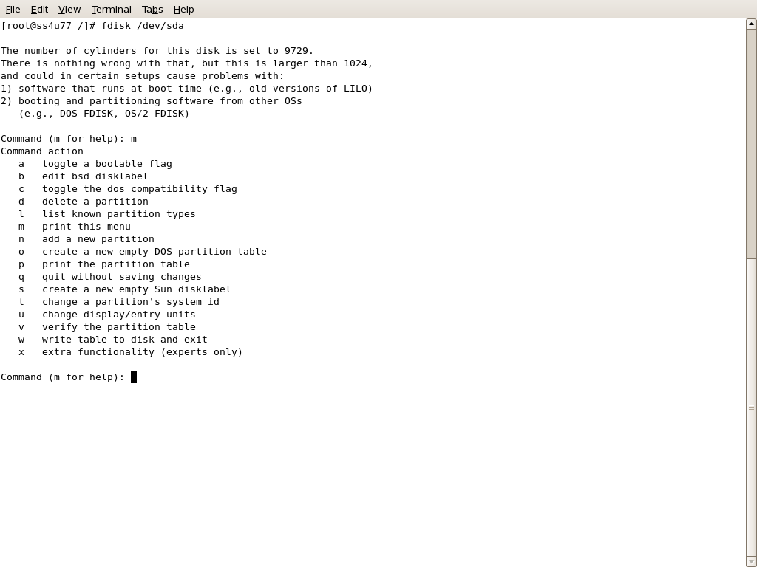

After creating the disk you can format as “ext3” format. By using the following
command.

#mkfs -t ext3 /dev/sda2

The number 2 is partition number given at “during the partition creation”.

RAID Creation:

#mdadm -C /dev/md0 -l 5 -n 3 -x 1 /dev/sda2 /dev/sda3 /dev/sda4 /dev/sda5

In the above command,

-C -----> Create

-l -----> Level

-n ------> Number of Partition for Creation of RAID

-x -------> Spare Partition used in future.

/dev/md0 ----> RAID Device

After creation of RAID Device you must format that by file system type.

#mkfs -t ext3 /dev/md0

The above command used to format the RAID Device as “ext3” file system.

Mount the RAID Partition:

#mkdir /raid

First you create the directory by using the above command.

Here we create the directory named as “raid”.

#mount /dev/md0 /raid

This command is used to mount the partition at the moment only. After the
reboot, it is automatically unmounted from the file system.

For Permanent Mount:

Go to the “/etc/fstab” file and make the following changes.

#vim /etc/fstab

at last you put the entry like this

/dev/md0 /raid ext3 defaults 0 0

It will mounted permanently on the file system.

You want to know the details of your RAID Device by using the following
command

#mdadm - - detail /dev/md0

It will show the detail of your RAID Device.

Manage the RAID Device by using the following commands.

#mdadm - - manage /dev/md0 -f /dev/sda2

Set the fault device for failure devices.

# mdadm - - manage /dev/md0 -r /dev/sda2

Remove the partition from RAID Device.

# mdadm - -manage /dev/md0 -a /dev/sda7

Add the Partition to RAID Device.

