
Soft_Solutions4U
Quality System Procedure

Training Manual Template Effective from january 20.01.2011
January 20.01.2011



<< Skype Voice Chat in Ubuntu OS >>

Prepared By (SS4U) | Signature | R.MARIKKANNAN
Prepared By (SS4U) | Name | R.MARIKKANNAN
Reviewers | Signature
Reviewers | Name
Approves | Signature
Approves | Names

Soft_Solutions4U
Quality System Procedure

Training Manual Template Effective from January 20.01.2011
January 20.01.2011

Documentation Of Skype Voice Chat in Ubuntu OS

Step: 1

Installation of Skype in Ubuntu OS

Using “Synaptic Package Manager” you install the skype software in ubuntu OS.By using the
following path you choose the “Synaptic Package Manager”.

“System -------> Administration -------->Synaptic Package Manager”

In Synaptic Package Manager search box you must type “Skype”, it will show the related
packages.

In that Packages, you make “Mark for Installation” that will automatically download the packages
from internet and made installation also.

Step: 2

Access the Skype Software

you access the skype software by using the following path

“ Applications -------->Internet------->Skype ”

Soft_Solutions4U
Quality System Procedure

Training Manual Template Effective from January 20.01.2011
January 20.01.2011

Step: 3
Configuration of Sound Setting for Skype Voice Chat

Test the hardware (both speaker and mike ) and make the following settings in the sound
recorder software.

Go to sound recorder software by using the following path

“Applications----->Sound & Video -----> Sound Recorder”

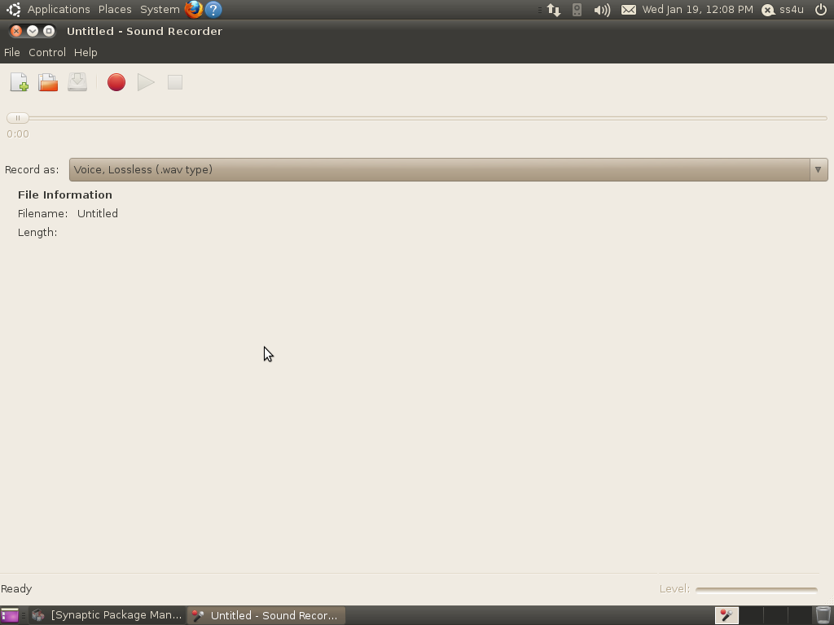

Soft_Solutions4U
Quality System Procedure

Training Manual Template Effective from January 20.01.2011
January 20.01.2011

In sound recorder you must make the changes in "Open Volume Control" ,you choose the Open
Volume Control by using the following path

“File----->Open Volume Control”

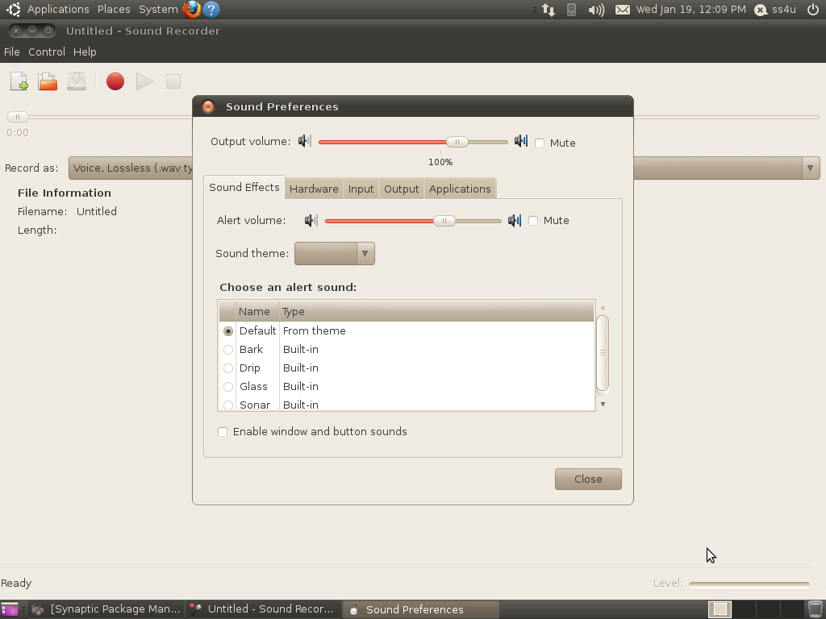

This is the default “sound Effects”,here you can make the sound effects as per your wish.

Soft_Solutions4U
Quality System Procedure

Training Manual Template Effective from January 20.01.2011
January 20.01.2011

In Hardware Selection part, you must set the hardware type as “Analog Stereo Duplex”. This
hardware selection is made by using “profile” option field.

In profile option field what ever you choose, that one is set as “HardWare” type.

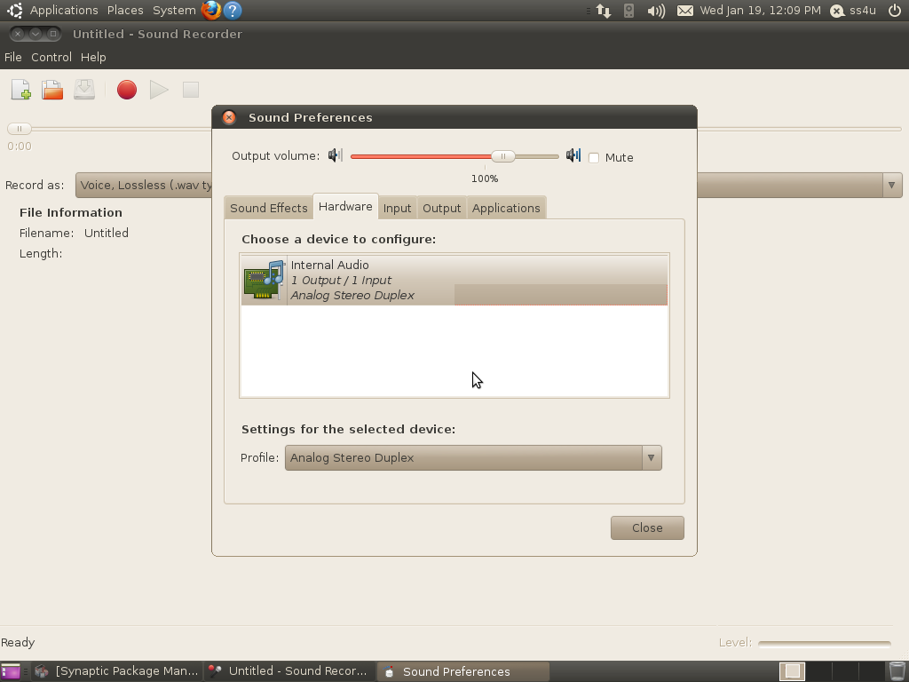

Soft_Solutions4U
Quality System Procedure

Training Manual Template Effective from January 20.01.2011
January 20.01.2011

In input selection part, you must set the “input volume and connector”.

During the "connector" selection you must test the device that must amplified with voice or not,
and also verified which panel you should choose.

microphone1-----> Backend Panel

microphone2-----> Frontend Panel

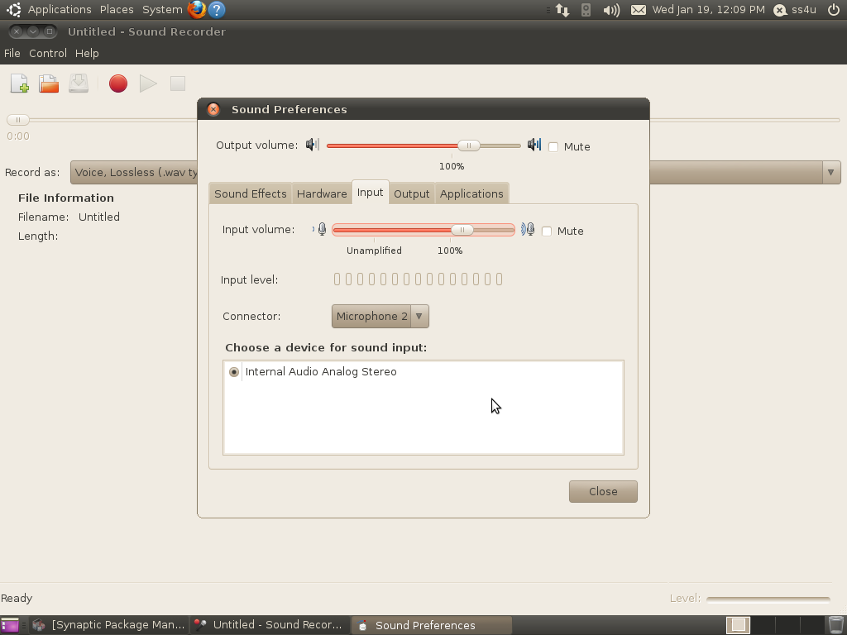

Soft_Solutions4U
Quality System Procedure

Training Manual Template Effective from January 20.01.2011
January 20.01.2011

In output Selection part, you must set the connector as “Analog Output”.

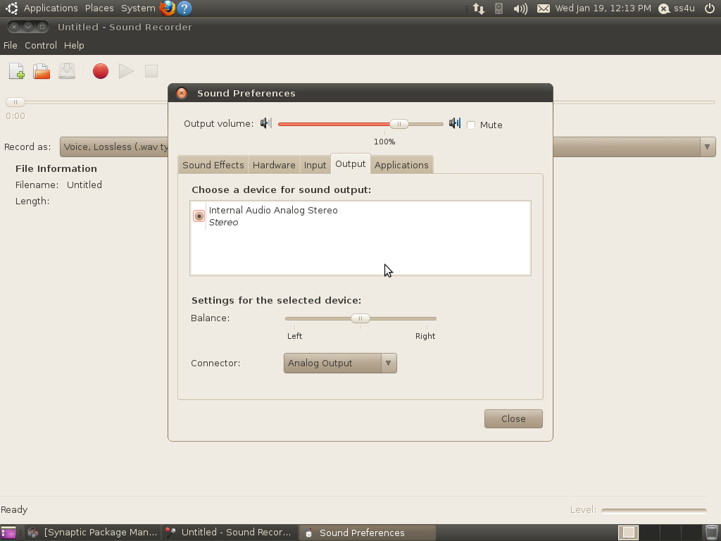

Now you test both the “voice recording” and “voice Playing” locally through sound recording
software .It is working fine means that must support for “Skype Voice Chat”.

