OCS INVENTORY INSTALLATION and CONFIGURATION

my OCS Version & system Information

Server : Ocsinventory_Unix_Server-2.1.2 For CentOS

Agent : Ocsinventory-Unix-Agent-2.1.1 For Ubuntu

OCS inventory Server Installation and Configuration

step :1 I have setup before Installation of pre-request packages likes :

1->Mysql
2->php
3->apache
4->perl

step :2 Install OCS Inventory pre-request packages

Under the Communication server

yum install php-gd
yum install php-mysql
yum install php-mbstring

Under the Administration server

yum install perl-XML-Simple
yum install perl-Compress-Zlib
yum install perl-DBI
yum install perl-DBD-MySQL
yum install perl-Apache-DBI
yum install perl-Net-IP
yum install perl-SOAP-Lite

step :3 Download ocs inventory server

I had to download OCS server package for 2.x for website

OCSNG_LINUX_SERVER_2.1.2.tar.gz
Extract the package

tar –xvzf OCSNG_LINUX_SERVER_2.1.2.tar.gz

step :4 Install ocs inventory server

I had to enter the location of ocs server
Run the setup.sh while installation it’s ask number of installation questions

finally,I have successfully installed the server

step:5 Configuration of OCS server

I have open the Browser and run the URL http://192.168.1.101/ocsinventory to connect the webpage of my server pages

And I have follow the documentation for OCS inventory websites documentation

my working Screenshorts are following :

steps:All computer page show like :

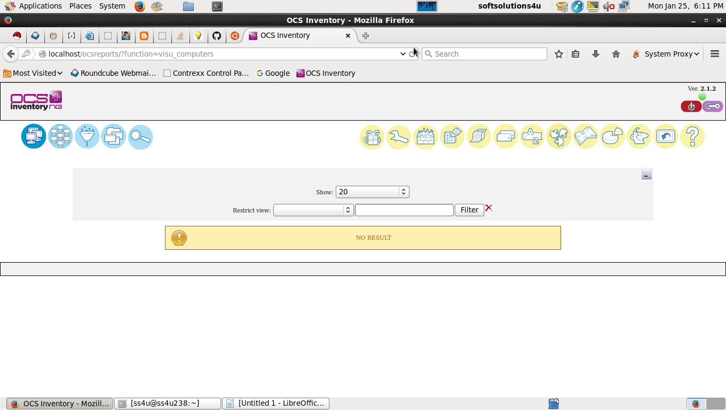

Inventory page

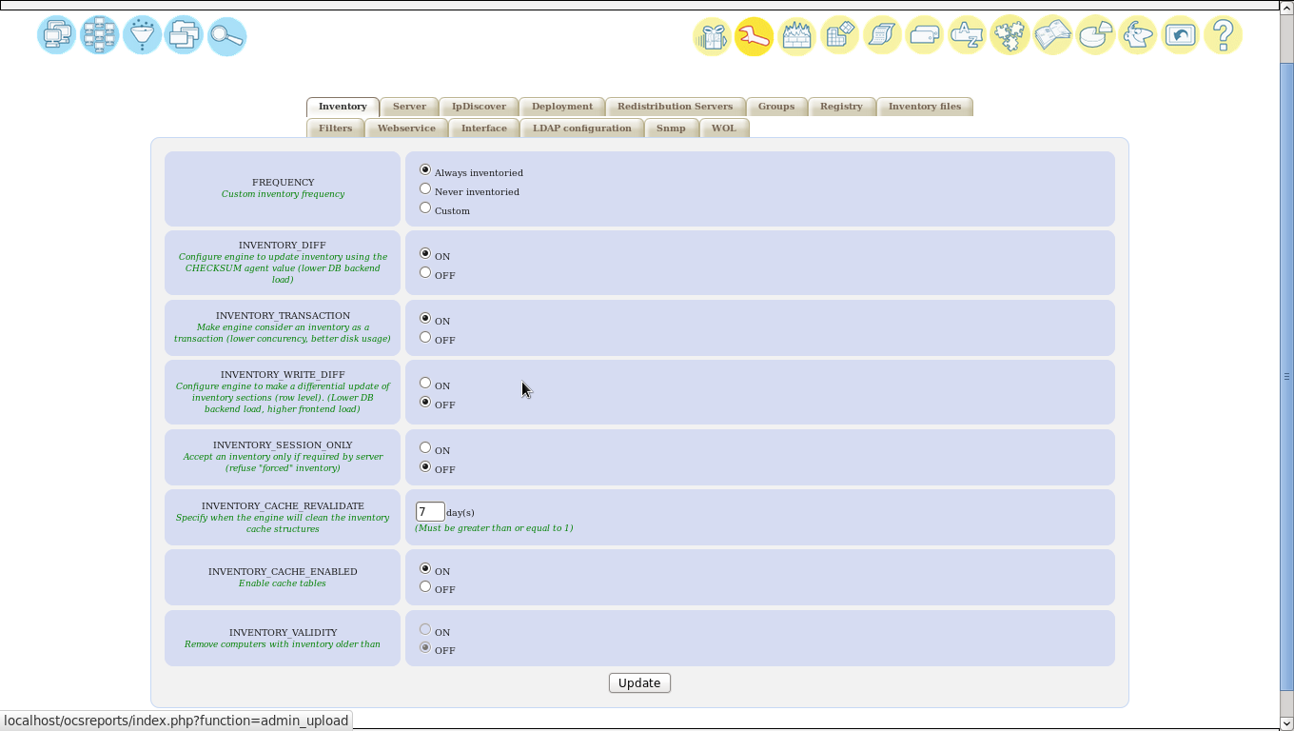
Server page :
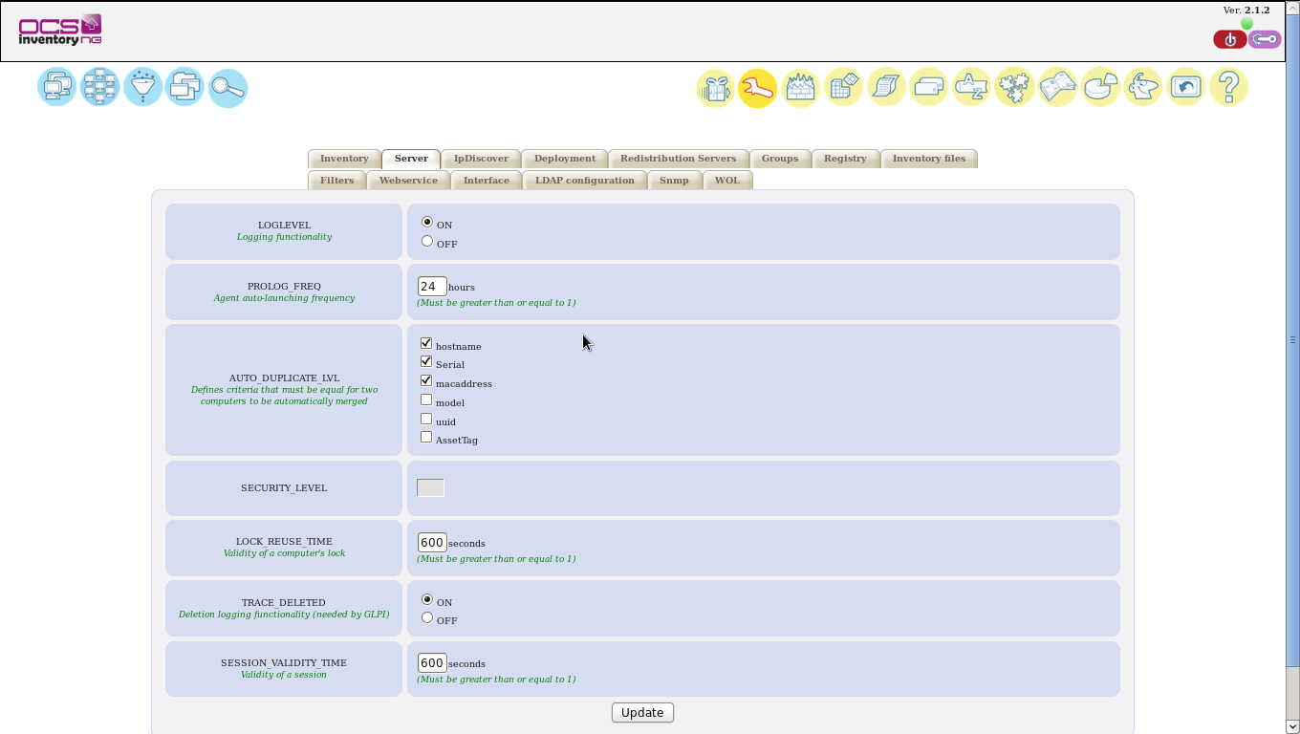

Ip_Discover Page :

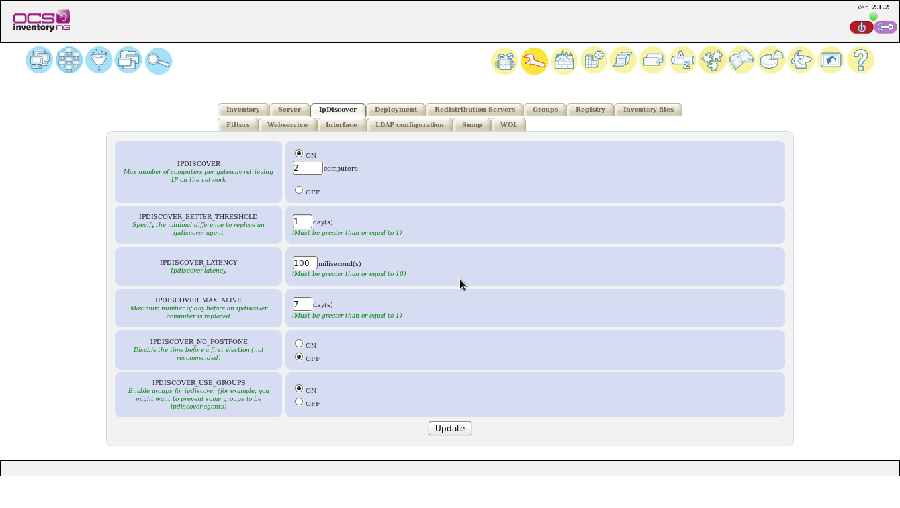
Deployement Page :

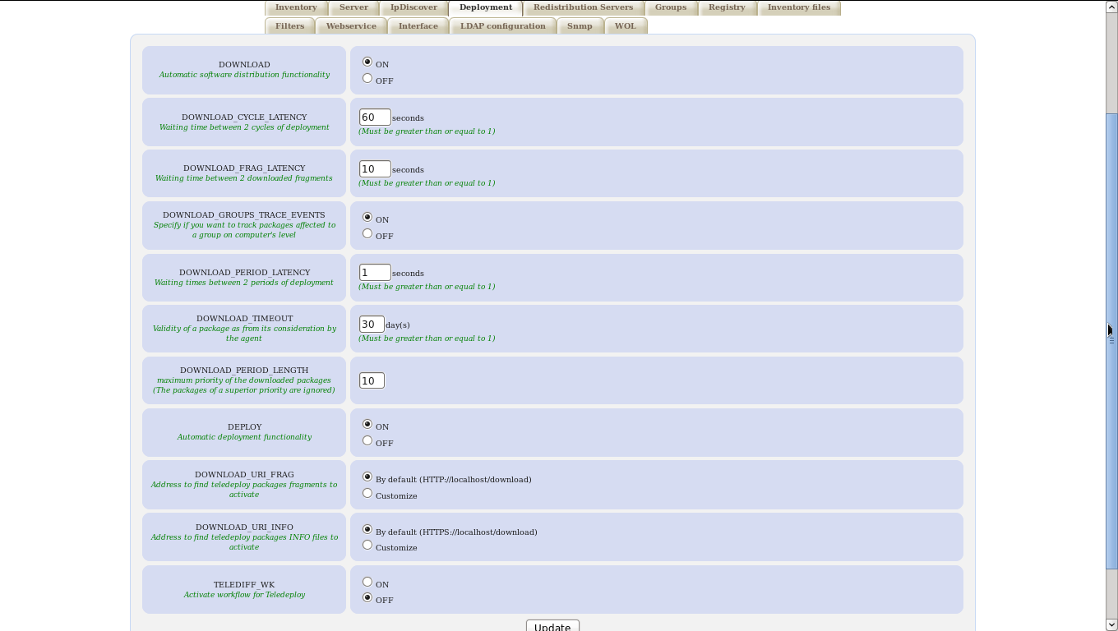

Redistribution_Server Page :

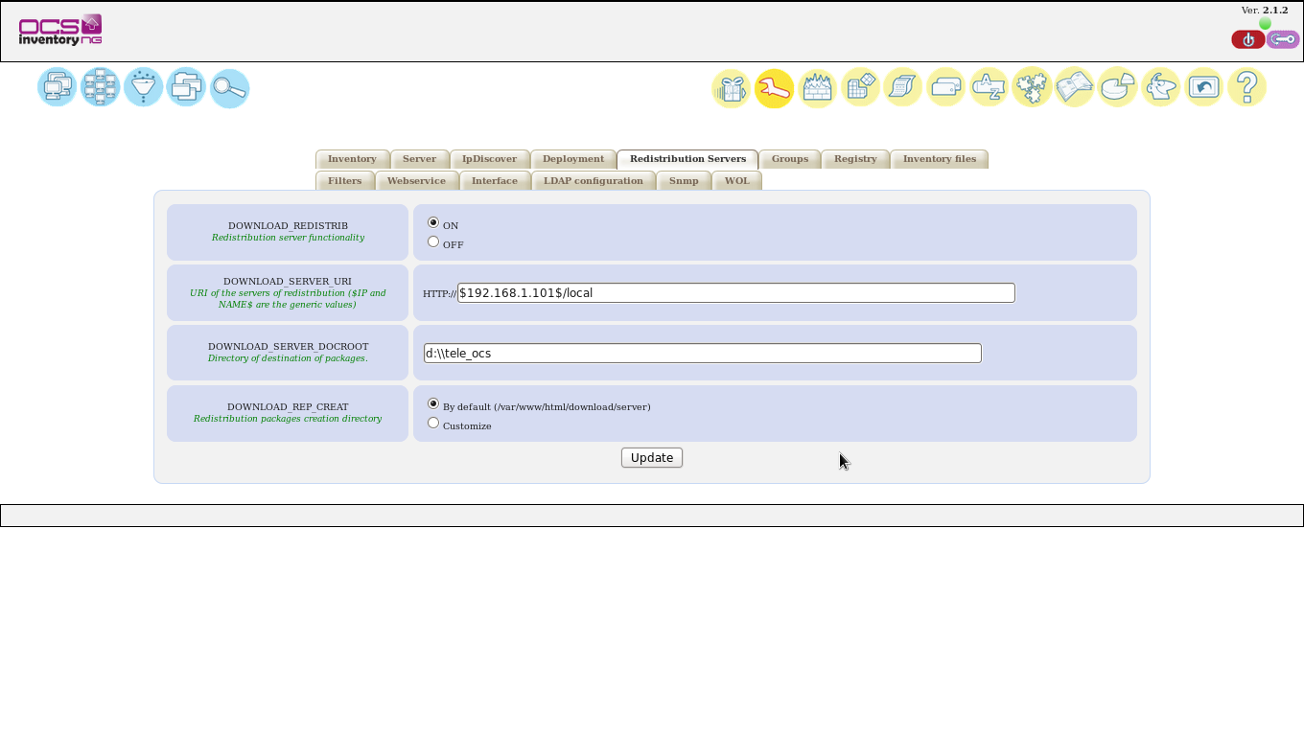
Inventory_file Page:

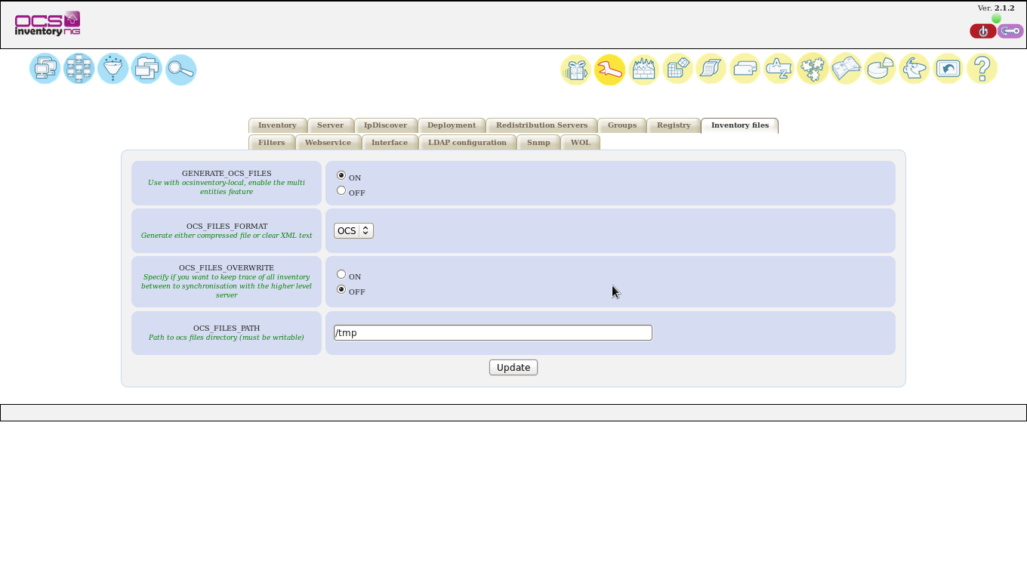

Interface Page:
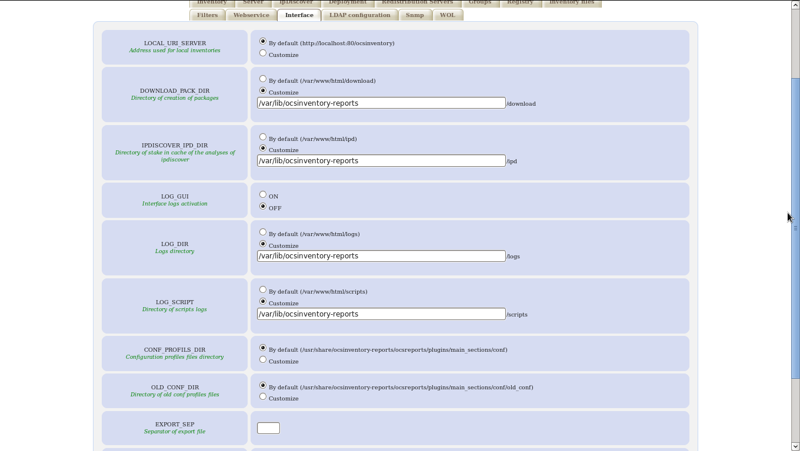
SNMP page:
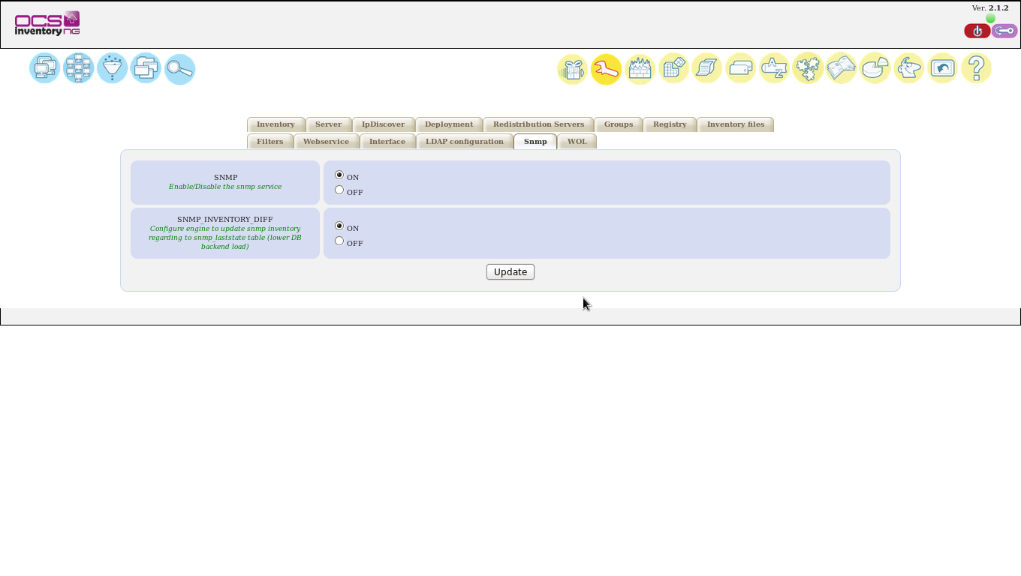

Sever Installation & configurarion over..!

OCSinventory Agent installaiton and Configuration

step :1 I have setup before Installation of pre-request packages likes :

1->Mysql

2->php

3->apache

4->perl

step :2 Install OCS Inventory pre-request packages

apt-get install libxml-simple-perl

apt-get install libcompress-zlib-perl

apt-get install libnet-ip-perl

apt-get install libwww-perl

apt-get install libdigest-md5-perl

apt-get install libnet-ssleay-perl

step :3 Download ocs inventory agent

I had to download OCS agent package for 2.x for website

OCSNG_LINUX_AGENT_2.1.1.tar.gz

Extract the package

tar –xvzf OCSNG_LINUX_AGENT_2.1.1.tar.gz

step :4 Install ocs inventory agent

I had to enter the location of ocs agent

Run the setup.sh while installation it’s ask number of installation questions

Those Screen shorts are following:
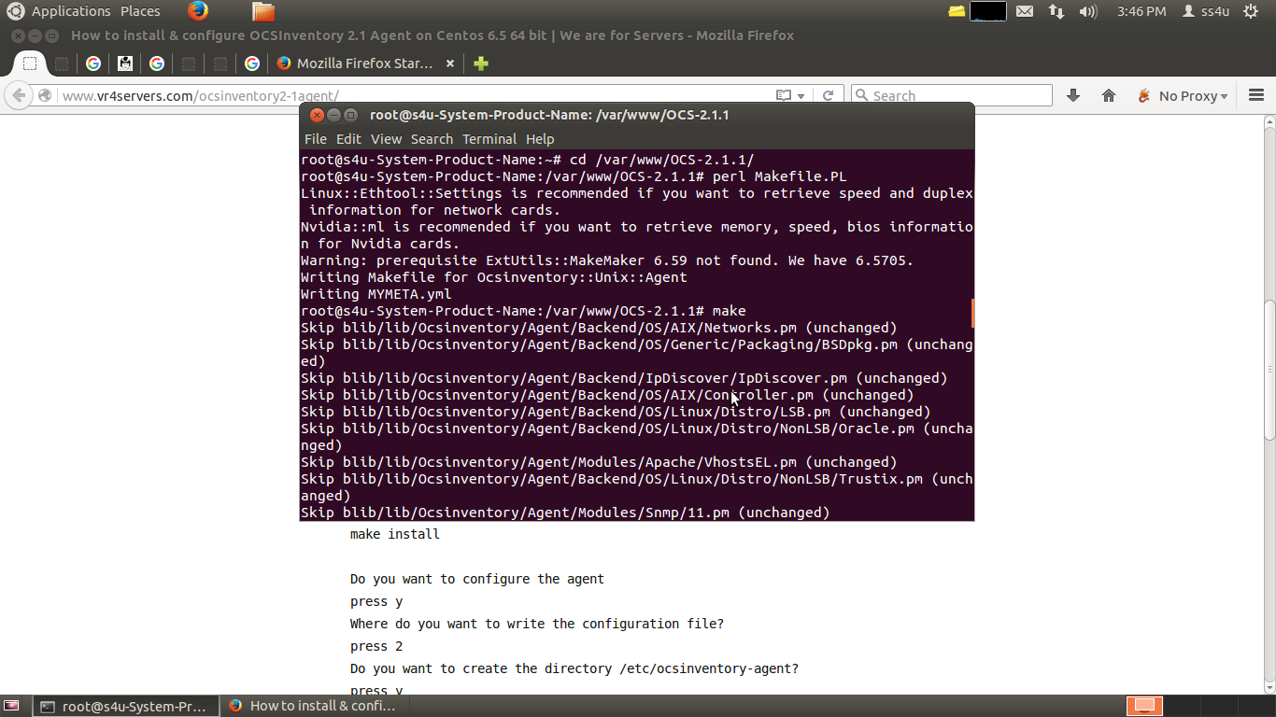

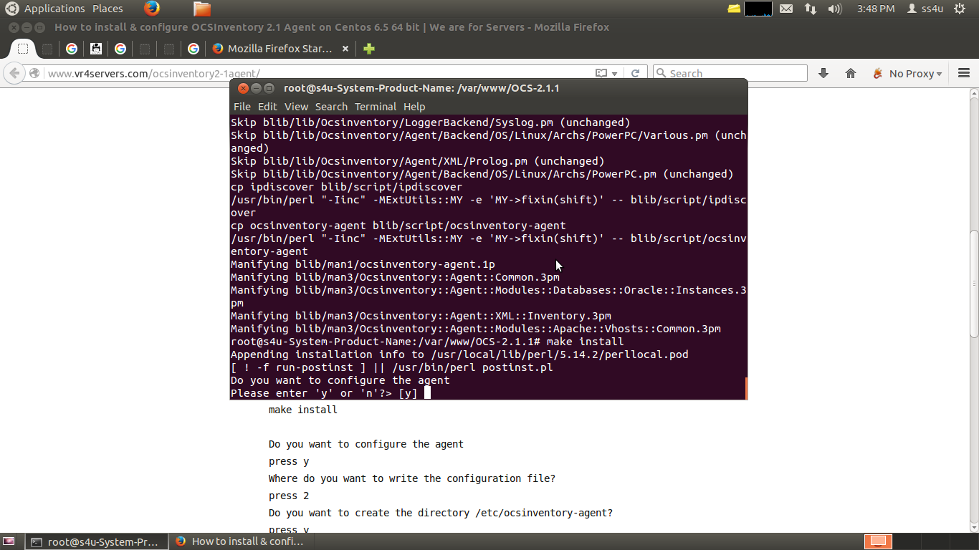

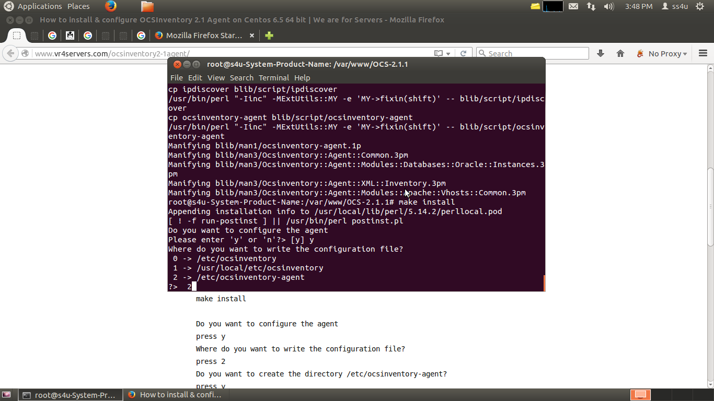

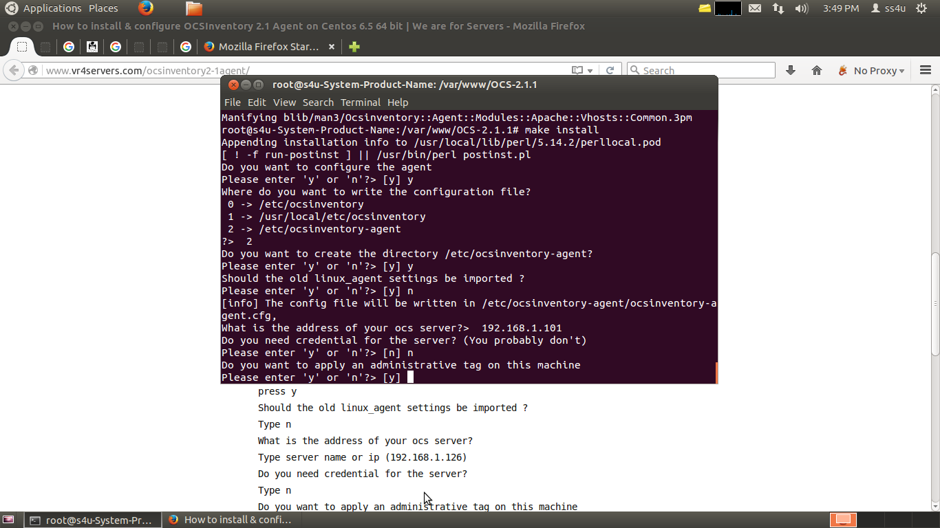

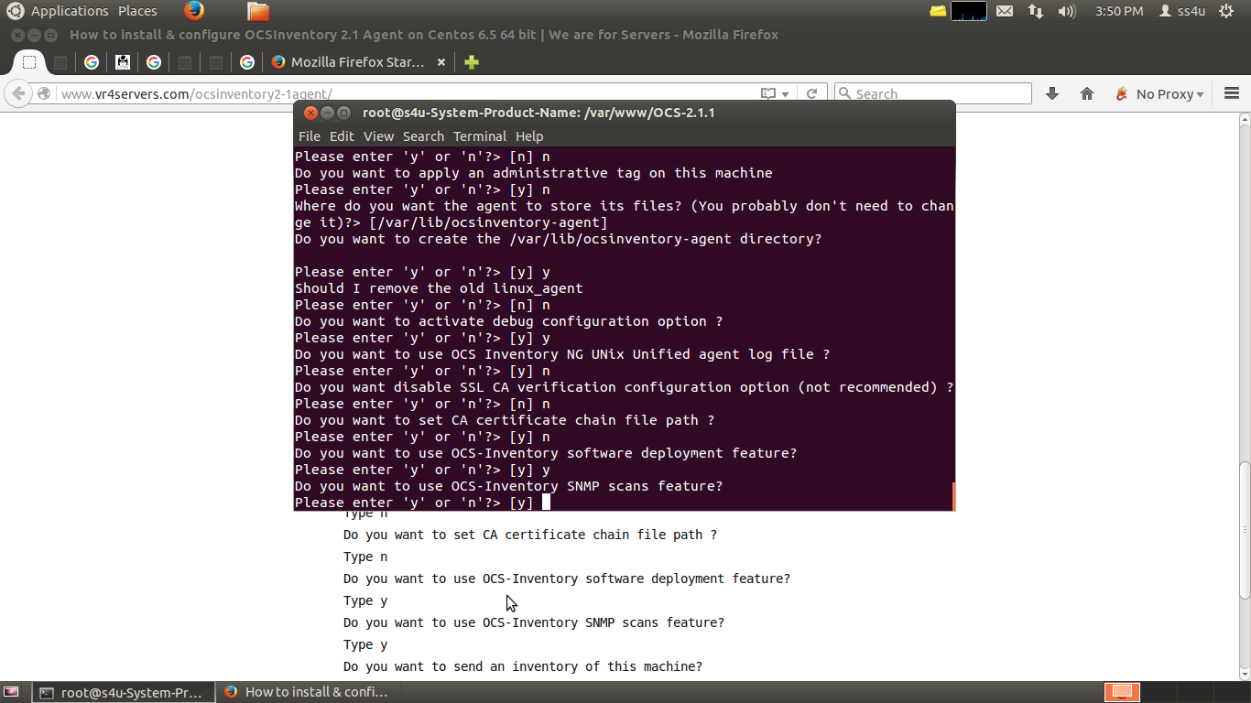

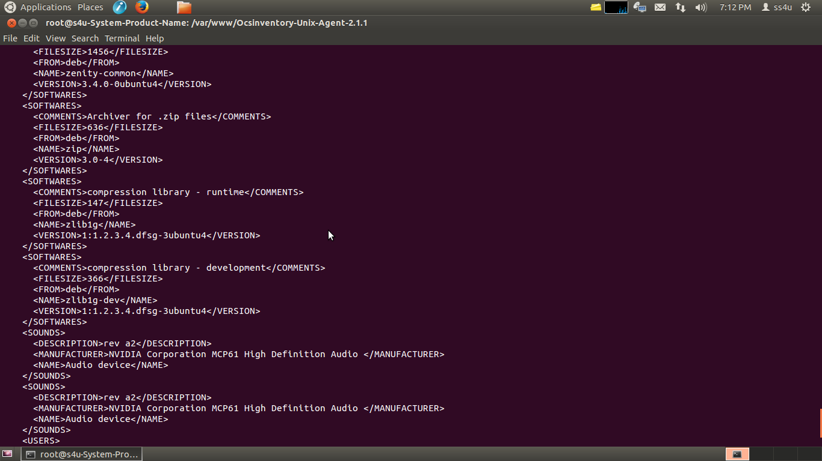

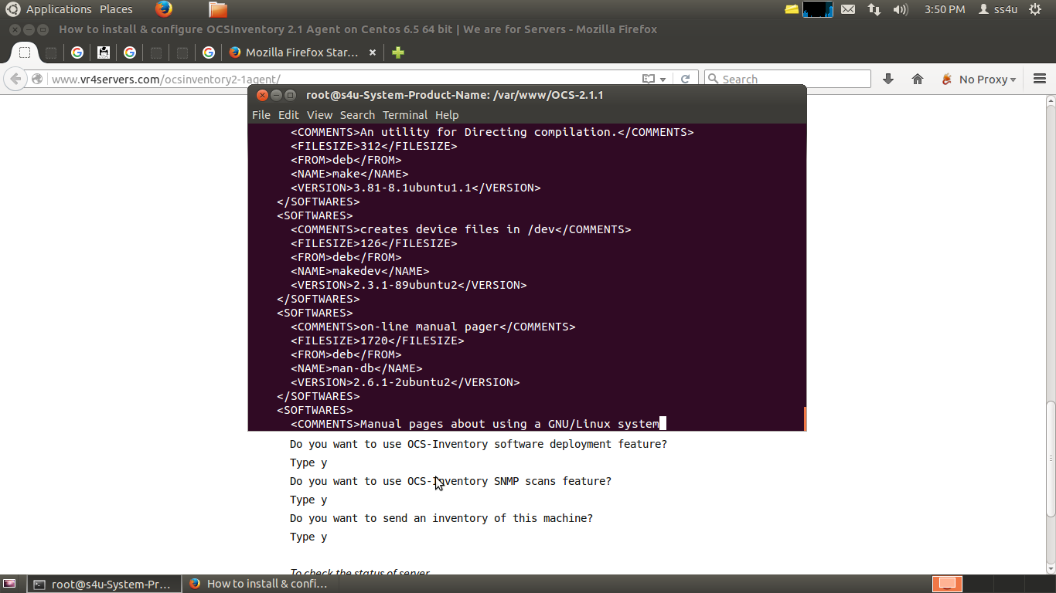

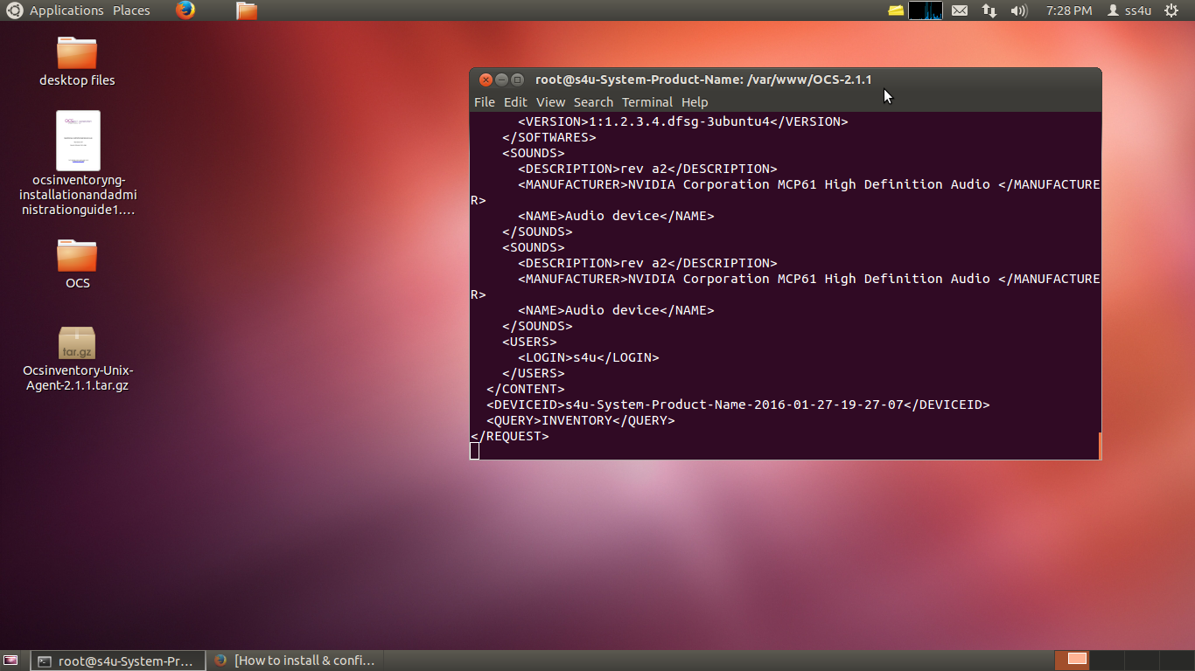

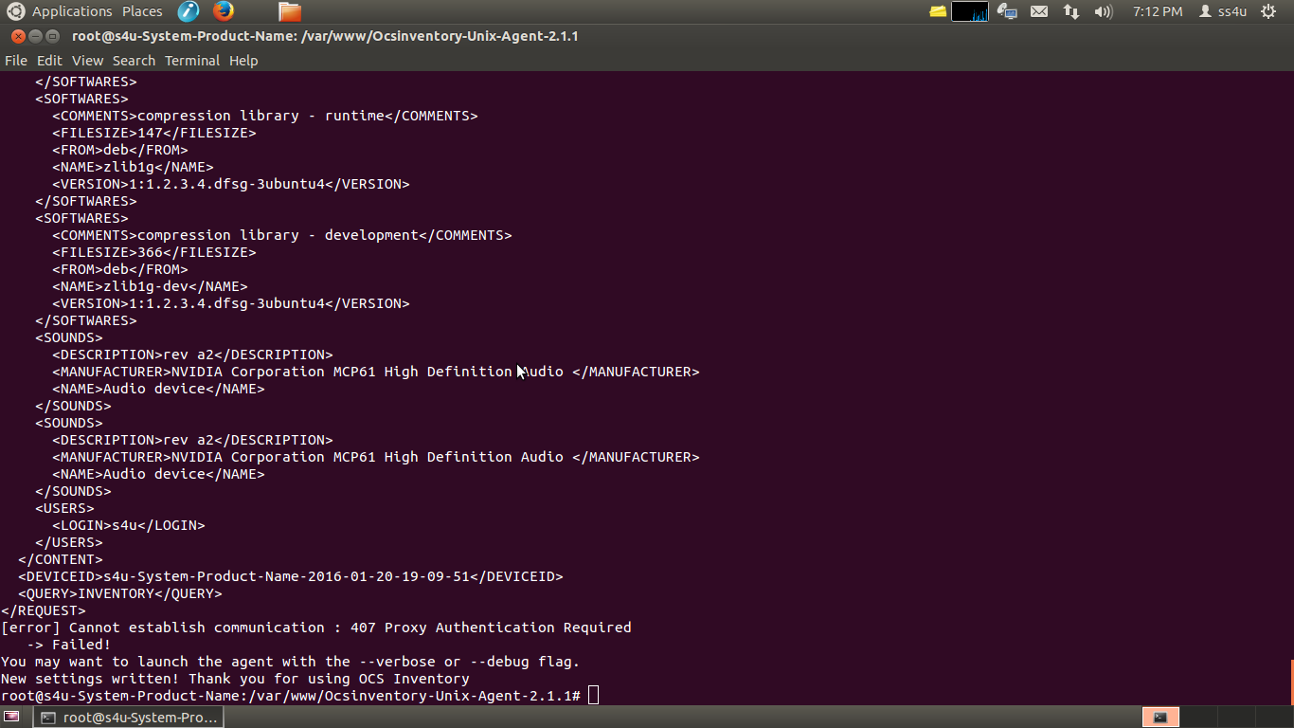

The above Screen shorts are my OCS Agent installation process but when the final screen shorts
showing error failed messsage.

I don’t know where is the problem please give me a suggestion

Ocsinventory deploy Tool Screenshorts like :
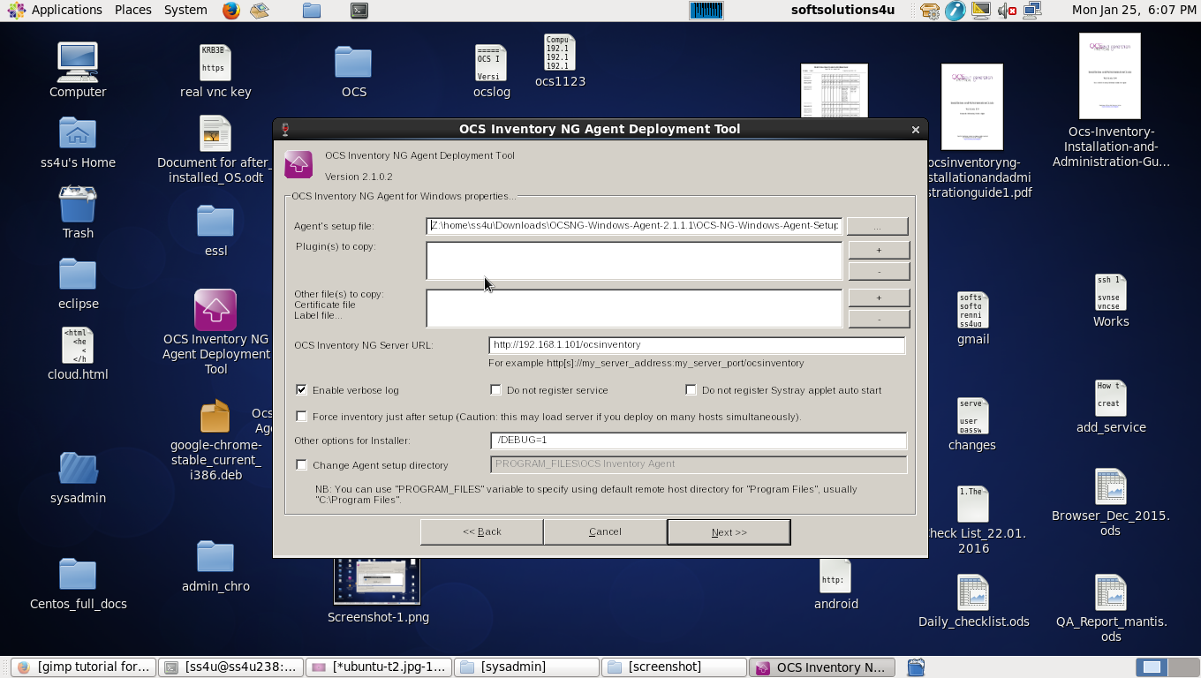

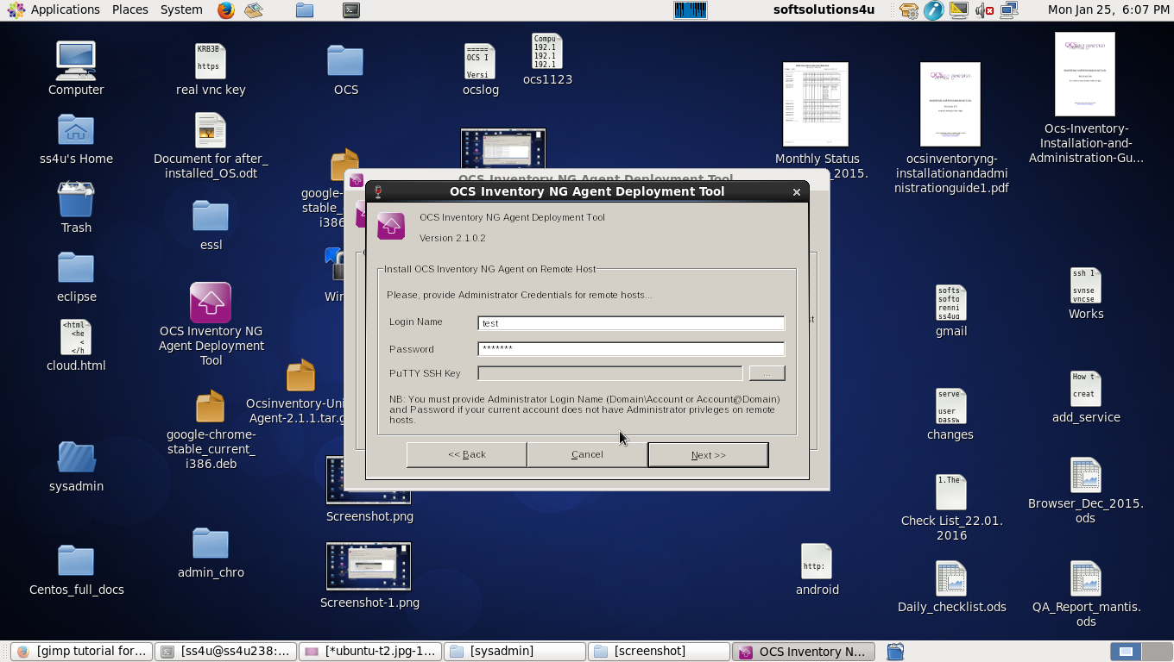

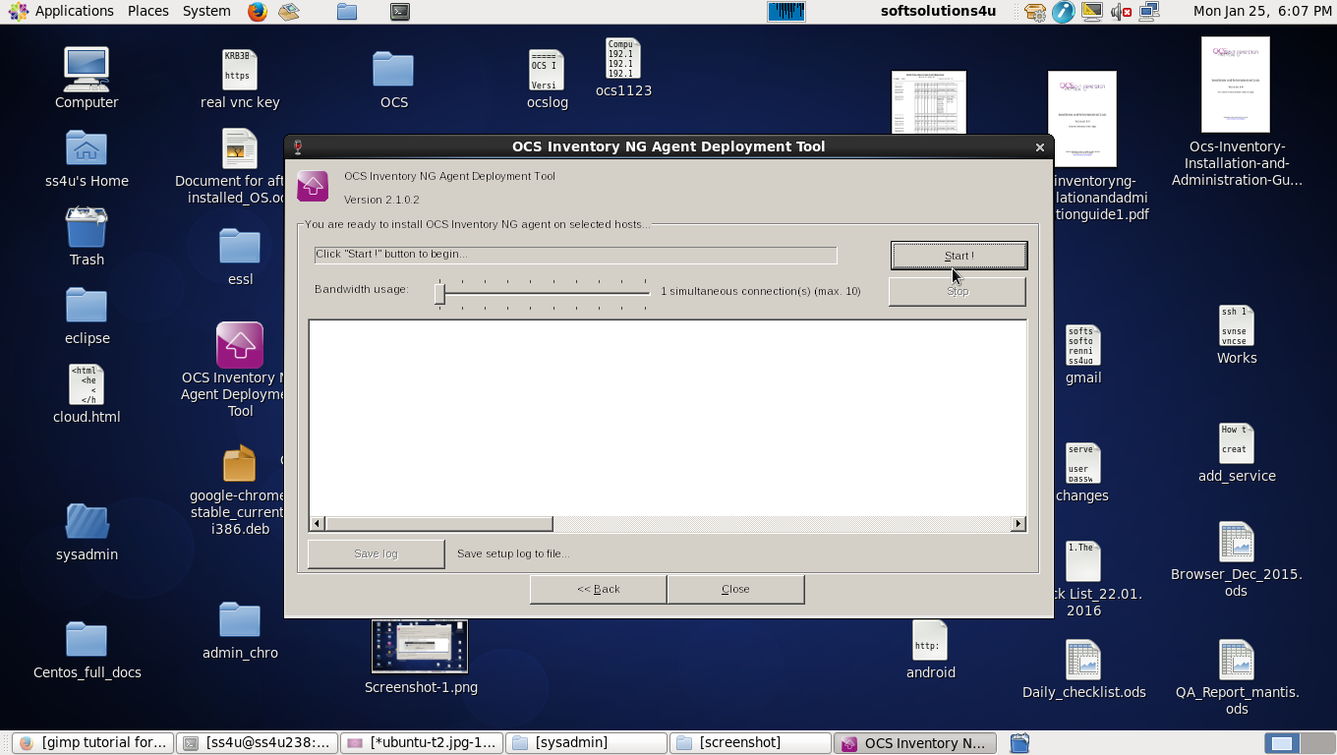

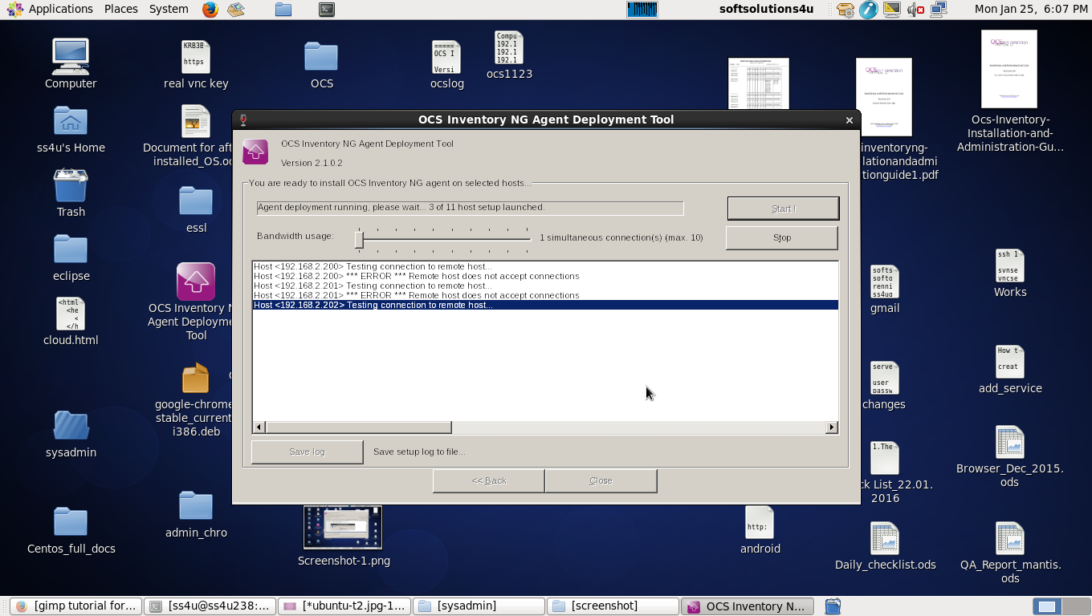

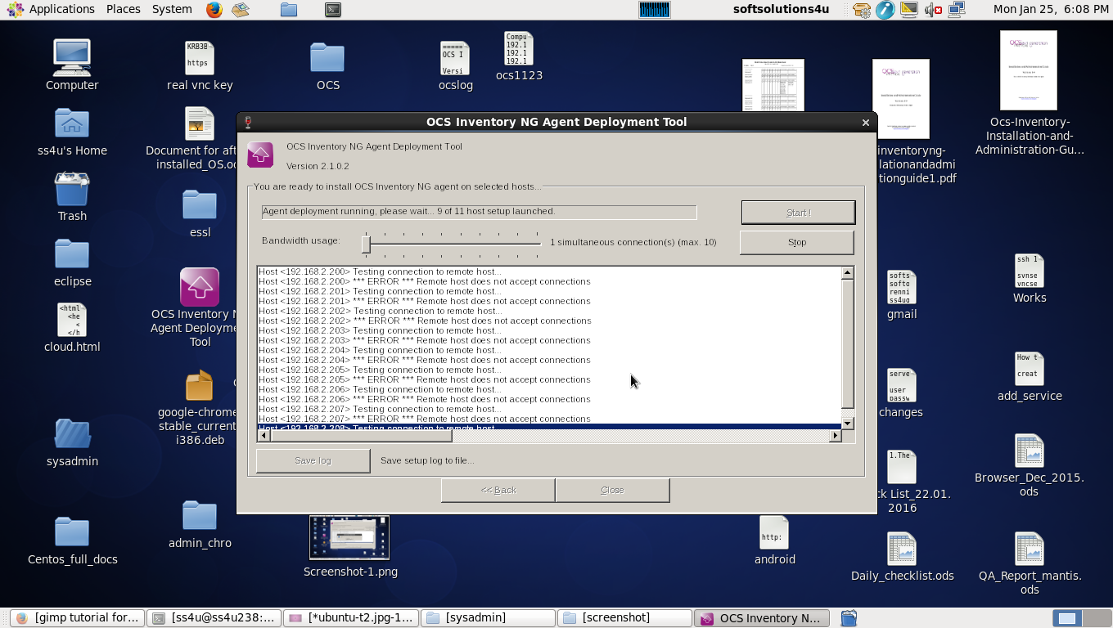

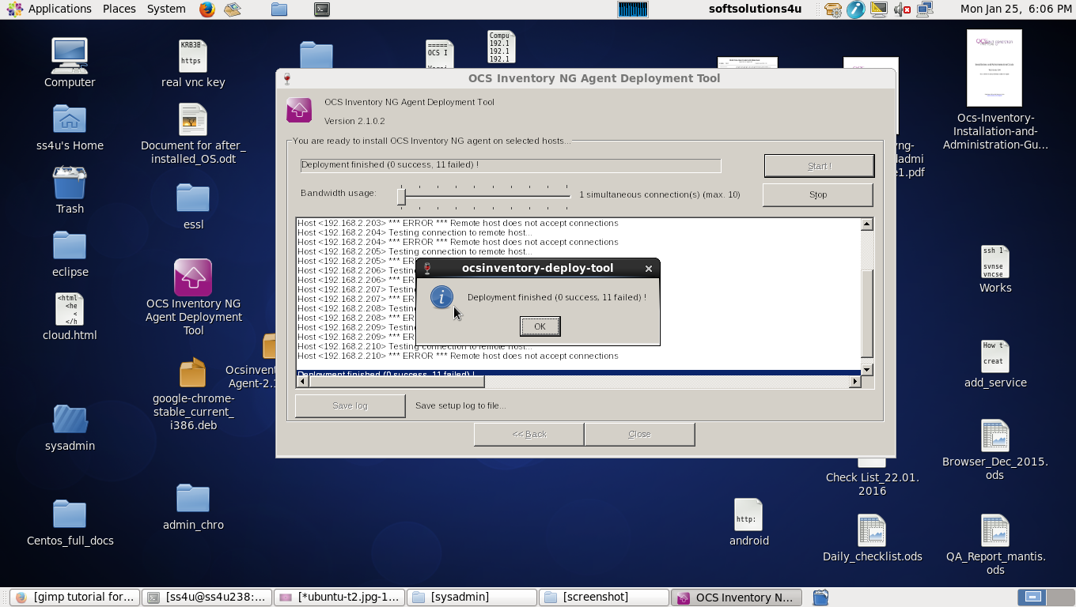

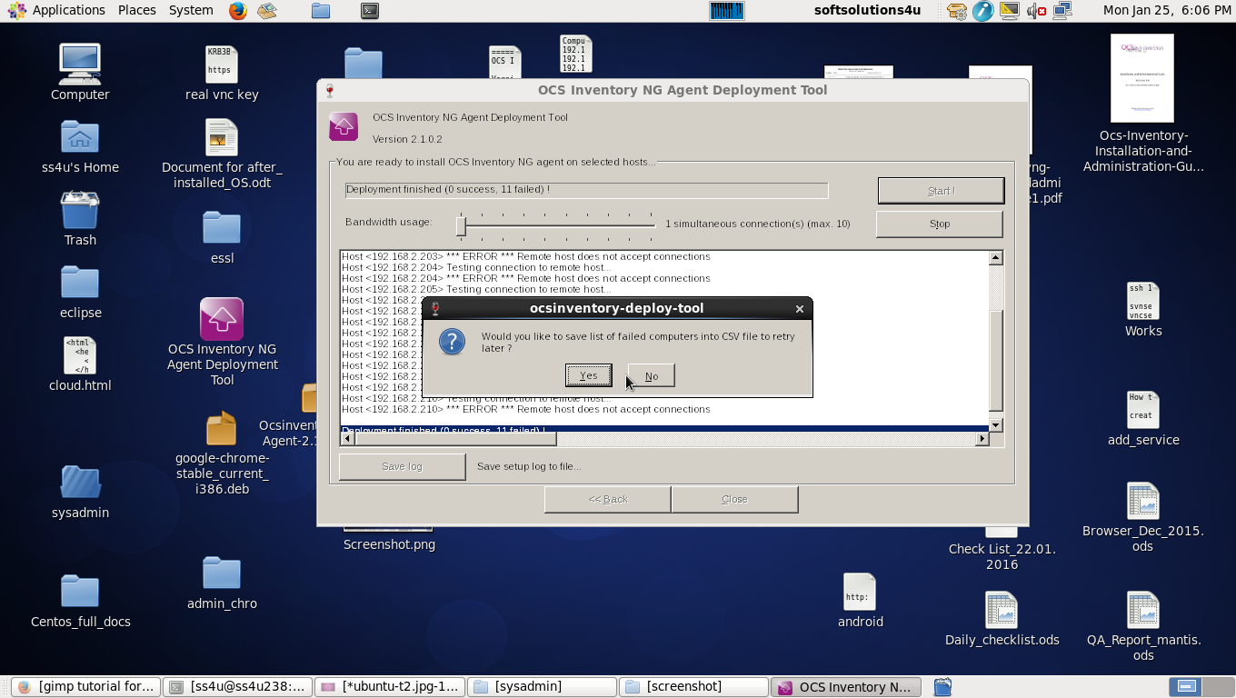

The Ocsinventory deployment tool processs are finished …!

In my system “NOT” connected proxy server but “before” Installation & configuration of OCS those two (Server & Agent ) system are Connected in proxy sever.

when I have start to the installation ,I will connect Direct Connection of other LAN Network to Server and Agent of two system Because of my LAN network configured “PROXY SERVER”

my LAN network information

IP Address : 192.168.2.1 to 192.168.2.254

Static ip Configuration and proxy server

Before Installation the Server & Agent system Information

ip address of “server” system :192.168.2.238 (using proxy 192.168.2.55 port: 3128)

ip address of “agent” system :192.168.2.235 (using proxy 192.168.2.55 port: 3128)

while Installation I will configured Server and Agent System to other Network .

ip address of “server” system :192.168.1.101 (“NOT” using proxy)

ip address of “agent” system :192.168.1.103 (“NOT” using proxy)

I think problem proxy server ,

so please give suggestion of “how to configure proxy using OCS Server and Agent Installation and Configuration”

