MANTIS

- You can download the file from www.mantisbt.org/download.php and www.phpmyadmin.net/home_page/index.php

- Extract and paste the mantis and phpmyadmin file to /var/www.

- Set full permission to /var/www
chmod -R 777 /var/www

- Go to web browser then type “localhost/mantis” to click on install/upgrade database option to install.

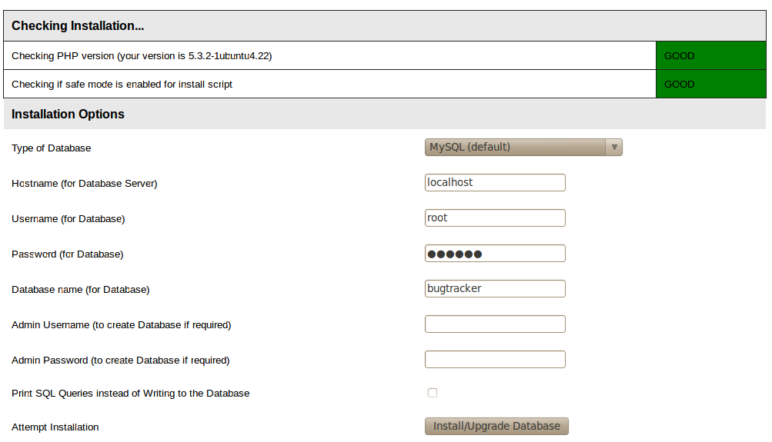

- If you use first time, you give user name as “administrator” and password as “root”.
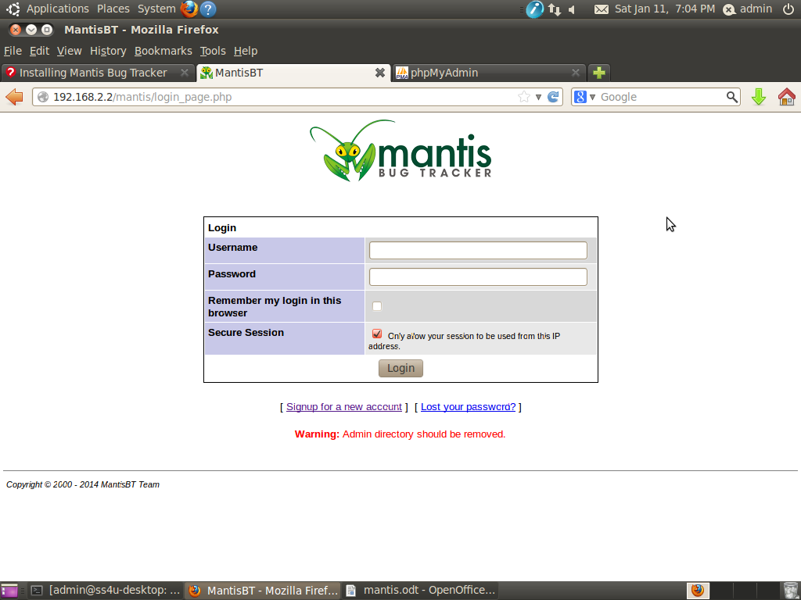

- Go to Manage -> Manage Users -> Create a new account to create a user with required access level.

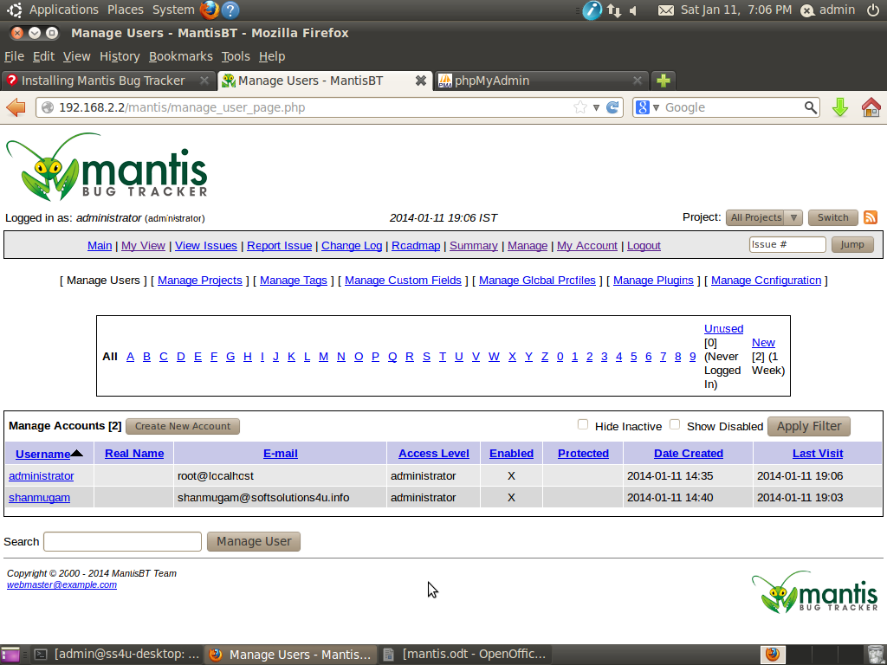

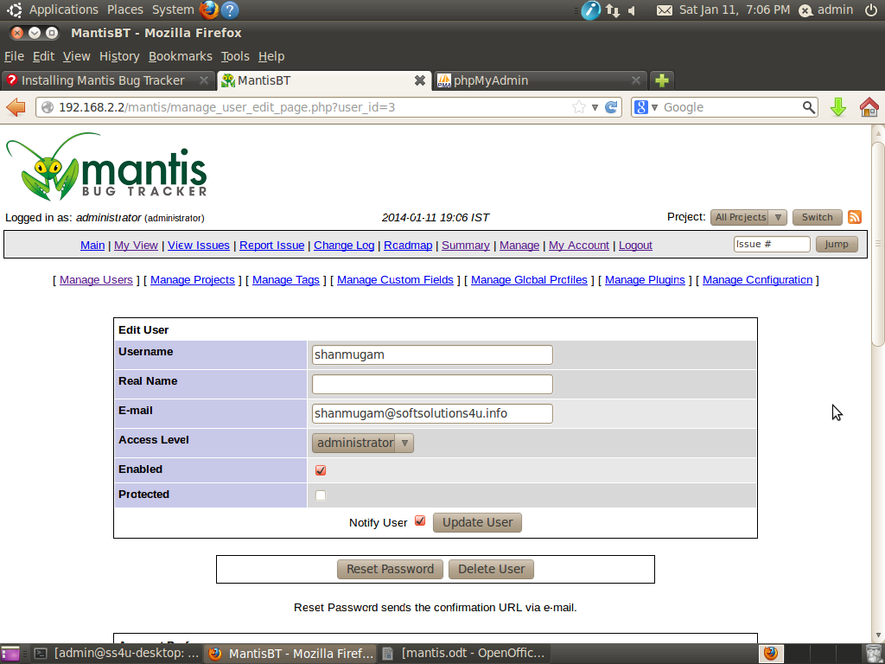
- To edit a existing user

- Go to web browser then type “localhost/phpmyadmin” to enter into login page

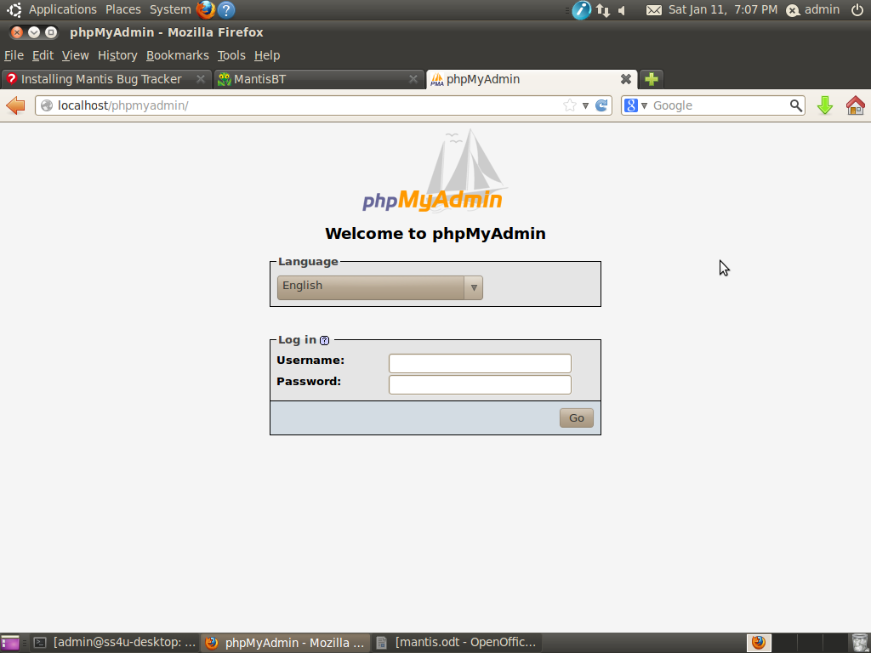

- If you set user details, then go to Databases -> bugtracker -> mantis_user_tables to set password, email etc.,

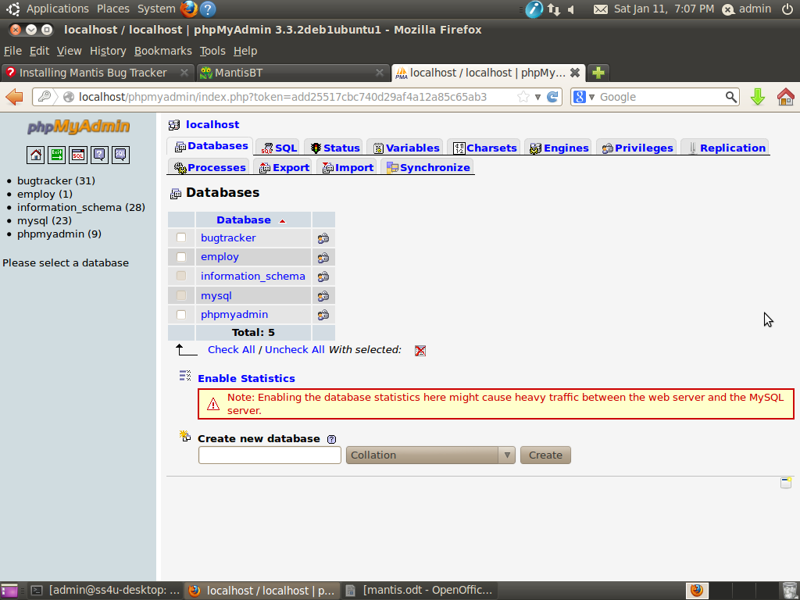

- Click mantis_user_table to view existing users details.

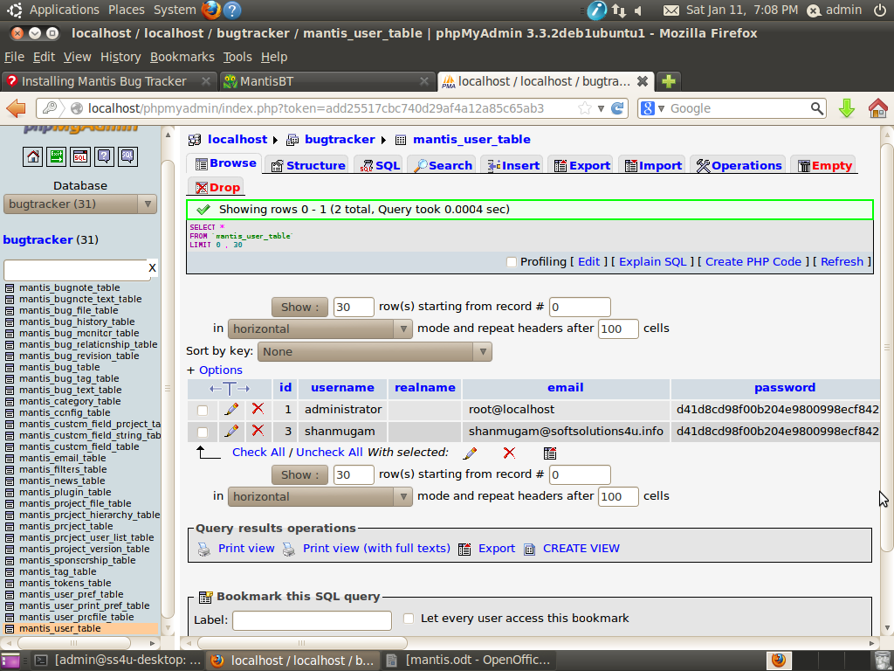

- To set user details like password, access level etc.,





