WORDPRESS INSTALLATION

Step 1: Extract the wordpress zip file to "/var/www" folder and set permission for /var/www/contrexx.

“chmod -R 777 /var/www/wordpress”

Step 2: Open the browser then type “localhost/wordpress” page.

Step 3: First create a configuration file.

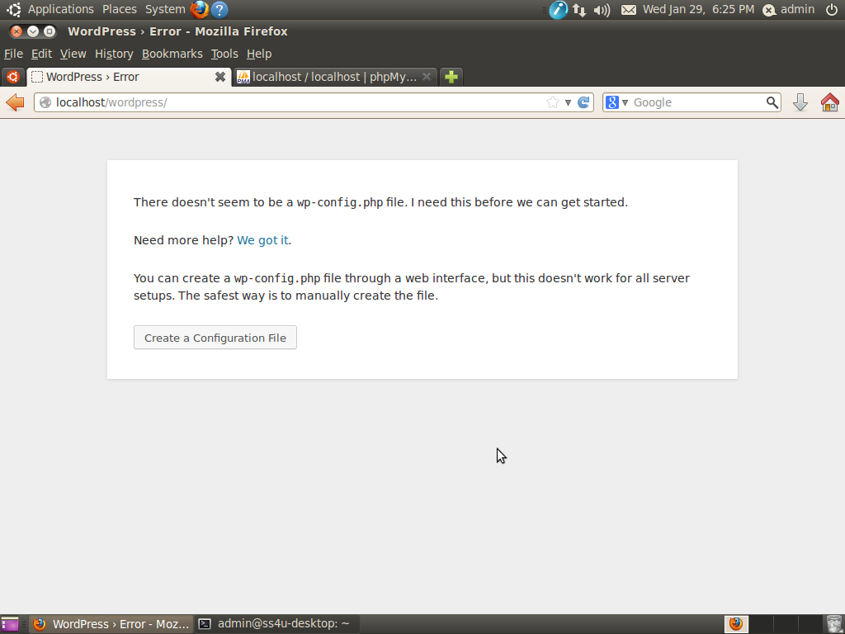

Step 4: To read the instructions

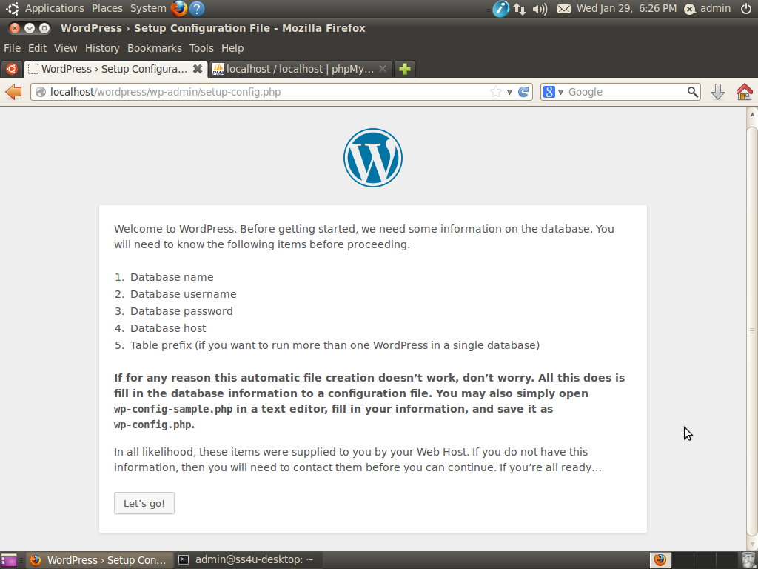

Step 5: Enter the database name, mysql username with password then submit.

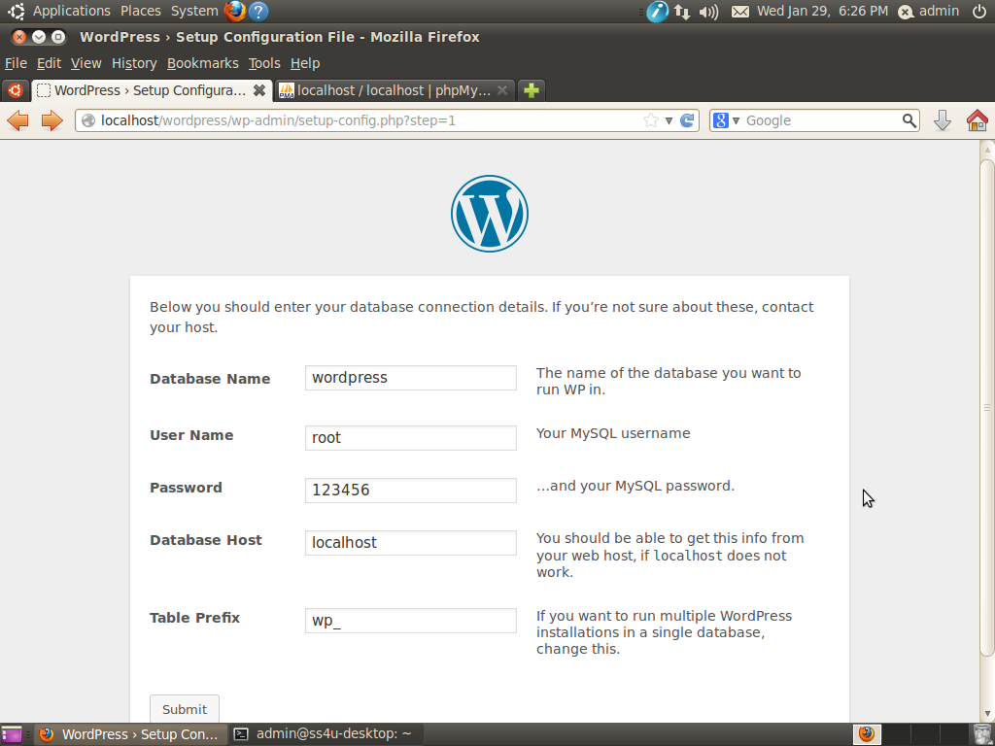

Step 6: Now you ready to install the wordpress.

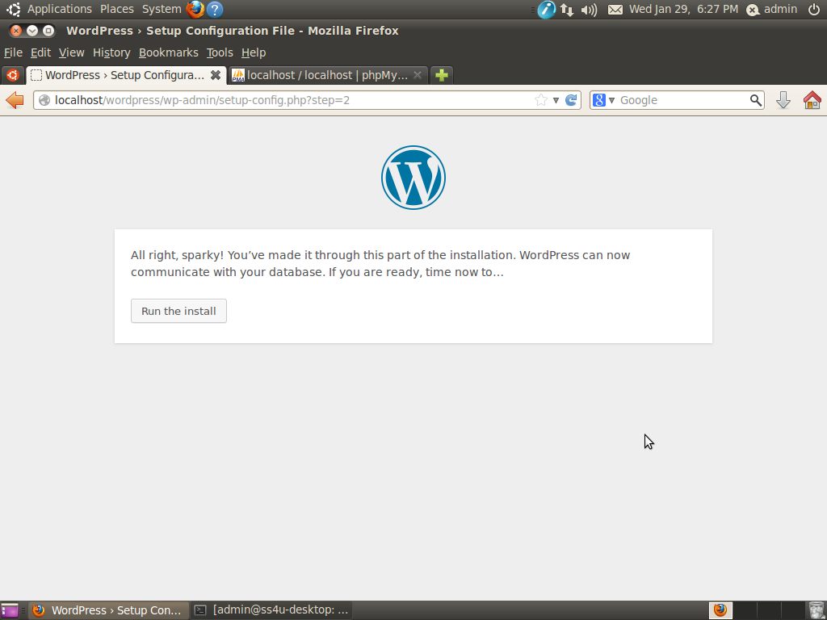

Step 7: Enter the site name, username with password and email id.

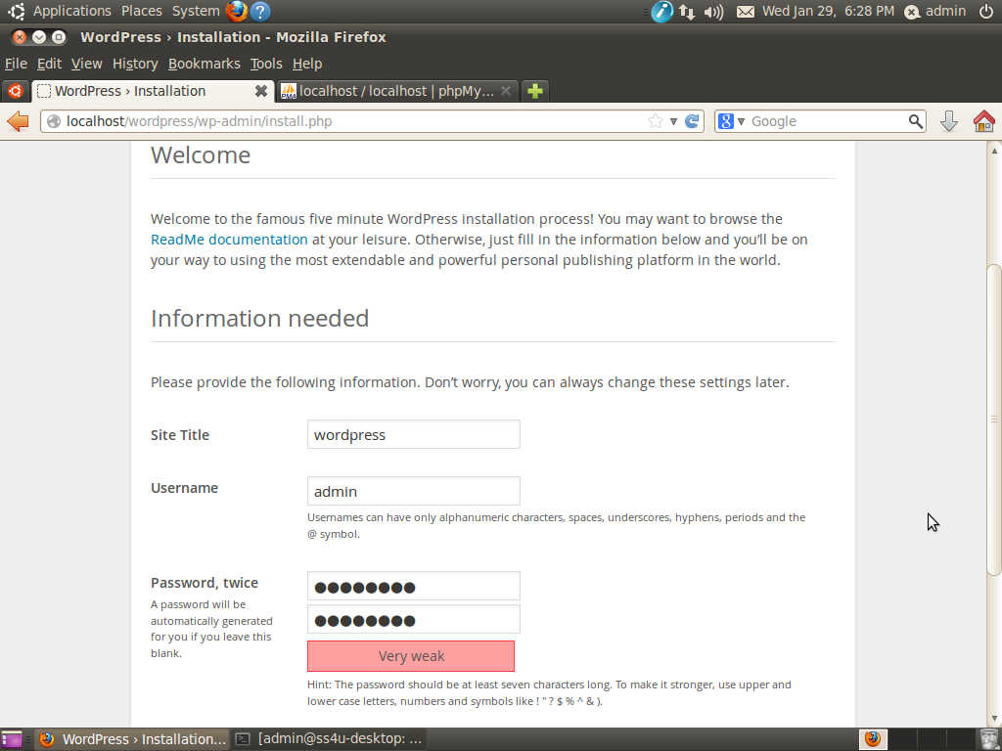

Step 8: Now wordpress installed, click login.

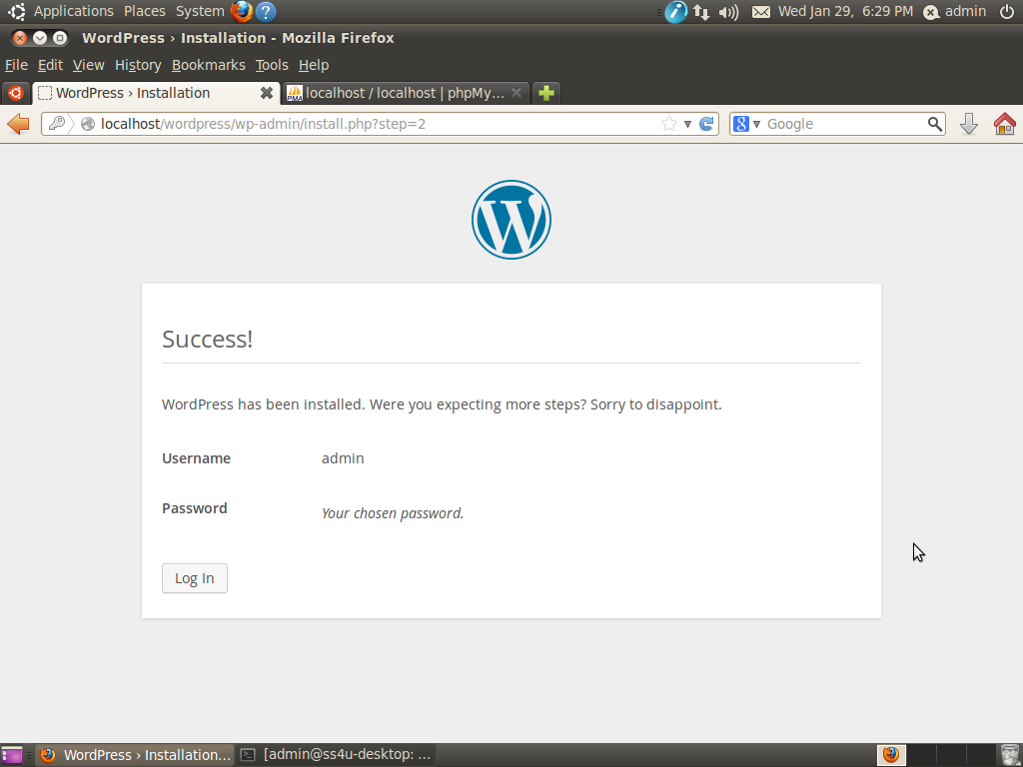

Step 9: Enter the username and password to login the site.

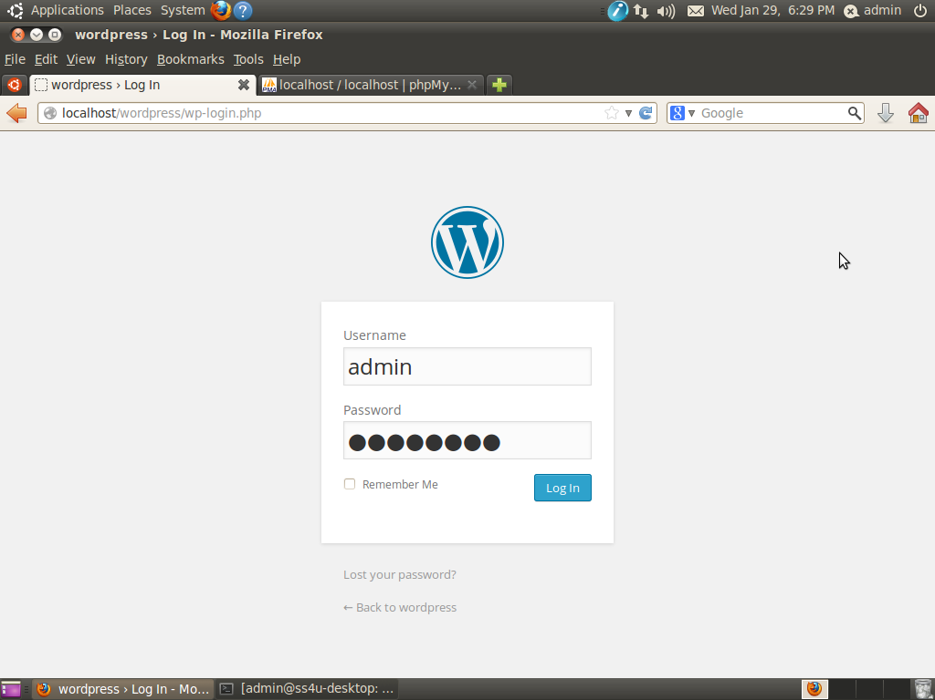

Step 10: Now you see the wordpress site.

