Install and configuration of sonarqube

step 1: Sonarqube system squirments

sonarqube version : 6.3
java version : 1.8
Database : 5.6
Driver : mysql connector java
Dependencies : Execstack

step 2: Download sonarqube

Go to the download page and download (https://www.sonarqube.org/downloads/) the latest version of sonarqube. When download is completed, go to your download directory extrat the sonarqube pakage and move to the installation directory

#cd /home/ss4u/Downloads/

#unzip sonarqube-5.x.x.zip

#mv sonarqube /opt/

#chmod -R 777 /opt/sonarqube

To give the permission of installatiuon direcory of sonarqube.

step 3: Database creation

To login mysql client using following commands

#mysql -u root -p

#mysql>enter the password

After login mysql create a database to sonarqube and grant the all permission to the database

#mysql>create database sonarqube;

#mysql>creare user ‘root’@’localhost’ identified by ‘root@localhost’;

#mysql>grant all privileges on sonarqube.* to root@localhost’ identified by ‘123456’;

#mysql>flush privileges;

#mysql>exit;

Or using phpmyadmin create a database for sonarqube.

Change the sonarqube configuration according to the creation of database

#gedit /opt/sonarqube/conf/sonar.properties

Remove the (#) comments and change the values of the following variables :

sonar.jdbc.username=root
sonar.jdbc.password=123456
sonar.jdbc.url=jdbc:mysql://localhost:3306/sonar?useUnicode=true&characterEncoding=utf8&rewriteBatchedStatements=true&useConfigs=maxPerformance

To save & exit the editor.

Step 4: Install sonarqube

After finishing the system requirments and database creation, to setting the sonarqube web configuration

Open the sonarqube configuration by using test editor

#gedit /opt/sonarqube/conf/sonar.properties

sonar.web.host=127.0.0.1
sonar.web.port=80
sonar.web.context=/sonar

save the configuration file and exit.

step 5: Sonarqube services

Open the terminal to access the sonarqube installtion directory

#cd /opt/sonarqube/

Start the sonarqube service

#/opt/sonarqube/bin/linux-x86-32/./sonar.sh start

Restart the soanrqube service

#/opt/sonarqube/bin/linux-x86-32/./sonar.sh restart

Stop the soanrqube service

#/opt/sonarqube/bin/linux-x86-32/./sonar.sh stop

Step 5: Access sonarqube

you can access the sonarqube through your best browser by using http://www.sonar.local/sonar, login page look like below :

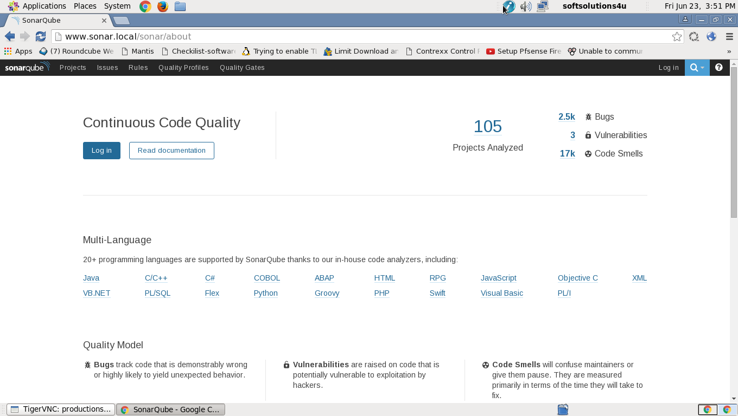

Finally login administrator you can manage the sonarqube server.

Step 6: Sonarqube Runner

First download the latest version of sonarqube runner followingdownload page https://www.sonarqube.org/downloads/

To your download directory extract the sonnarqube runner and move to the installation directory

#cd /home/ss4u/Downloads/

#unzip sonar-runner-dist-2.4.zip

#mv sonar-runner-2.4 /opt/

To give the permission of sonar-runner directory

#chmod -R 777 /opt/sonar-runner-2.4

Open the sonar-runner configuration file, uncomment and give the correct values of according to the sonarqube server properties

#gedit /opt/sonar-runner/conf/sonar-runner.properties

sonar.host.url=http://localhost:8080

sonar.jdbc.url=jdbc:mysql://localhost:3306/sonar?useUnicode=true&characterEncoding=utf8

sonar.jdbc.username=root

sonar.jdbc.password=123456

encoding sonar.sourceEncoding=UTF-8

#sonar.login=ss4u

#sonar.password=ss4u_123

finally we have installed both sonnarqube abd sonar-runner. Now we have analysis, compose and manage the projects.

