HOW TO INSTALL TYPO3

Step :1 Prerequisites

Before install typo3, we need to install lamp-server configuration of website server.

Apache2 : apache2.4

PHP : PHP-7.0.X

mysql : mysql-5.6

Step :2 Database creation

To login the mysql root user

#mysql -u root -p

After we give athendication of mysql root server. We need to create a dtabase..

#Create database typo3;

Create a database administrator user.

#create user root@localhost identified by ‘123456’;

Next, give a administrator permission for typo3 database.

#grant all privileges on typo3,* to root@loaclhost;
#flush privileges;
#exit

The database name is typo3. We need database name for future installation.

Step :3 PHP & Apache Configuration

We need to make a some configuration in php file.

Open the php configuration file with our text editor.

#gedit /etc/php5/apache2/php.ini

max_execution_time = 240

post_max_size = 10M

upload_max_size = 10M

save and close the php file.
Open the apache virtualhost configuration file

#gedit /etc/apache2/sites-available/default-ssl.conf

<VirtualHost *:443>
DocumentRoot /var/www/typo3
ServerName www.typo.local
SSLEngine on
SSLCertificateFile /etc/ssl/certs/ssl-cert-snakeoil.pem
SSLCertificateKeyFile /etc/ssl/private/ssl-cert-snakeoil.key
<Directory "/var/www/typo3">
AllowOverride All
Allow from all
</Directory>
</VirtualHost>

Save & close the apache configuration file.

Now restart the apache servoce

#service apache2 restart

Step :4 Download & Install typo3

Now we have download the latest version of typo3 by using following link : https://typo3.org/download/

To extract the typo3 pakage and move to the root directory of our web server

#cd /home/ss4u/Download/

#tar zxvf typo*

#mv typo3 /var/www/html/

To create a FIRST_INSTALL and typo3_src in the installation directory to start our web installation.

#cd /var/www/html/typo3/

#touch FIRST_INSTALL typo3_src

Next move to the files _.htaccess to .htaccess

#mv _.htaccess .htaccess

Now give the permission of our typo3 directory.

#chmod -R 777 /var/www/html/typo3

Step :5 Web Installation
In our browser to open the https://www.typo.local. We have see the initial configuration of typo3 page

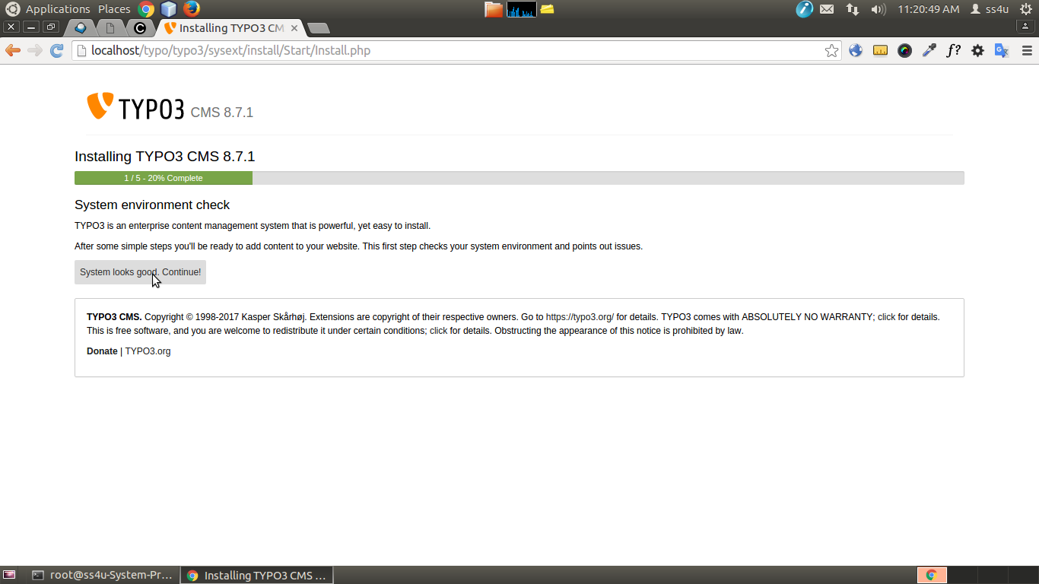
To click system looks good and contiune to the next page.

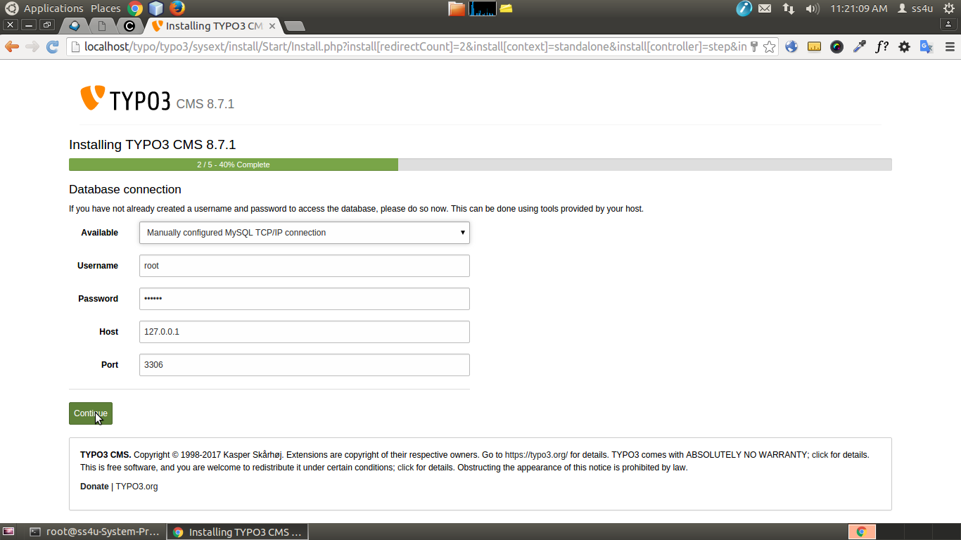
Here, give the database connection details for typo3 . Then clikck contiune to next page.

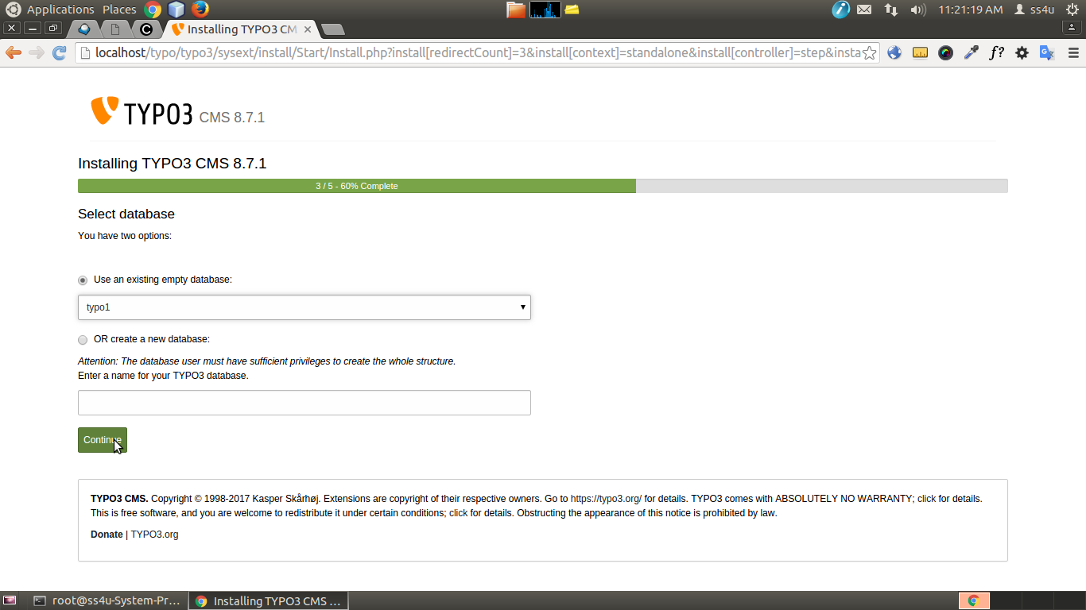
Now we have create a database or already created the database give it here. Then click to continue.

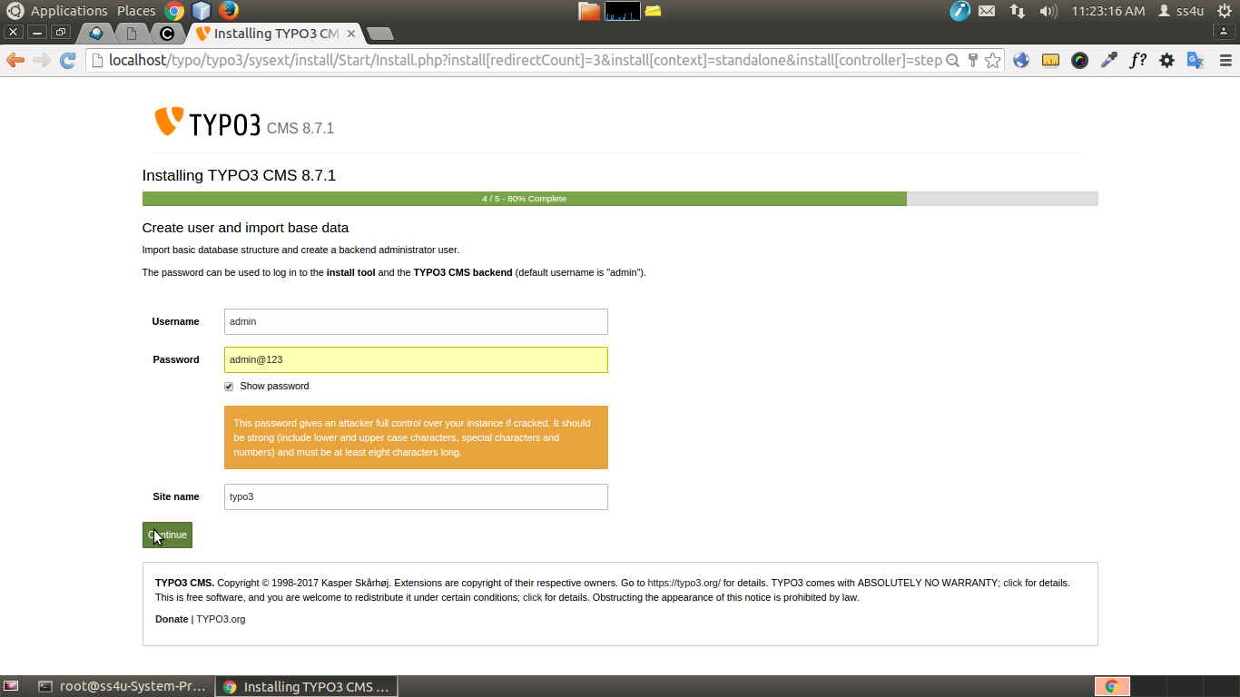

We have create a admin account and typo3 site name this page and click contiune to next page.

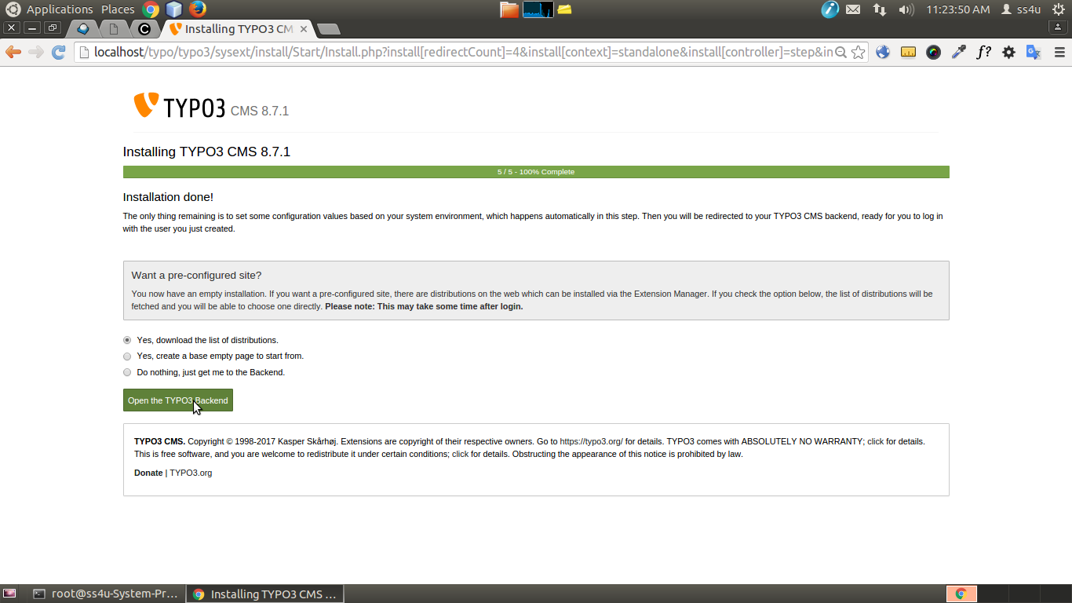
Now to click contiune typo3 installation completed.
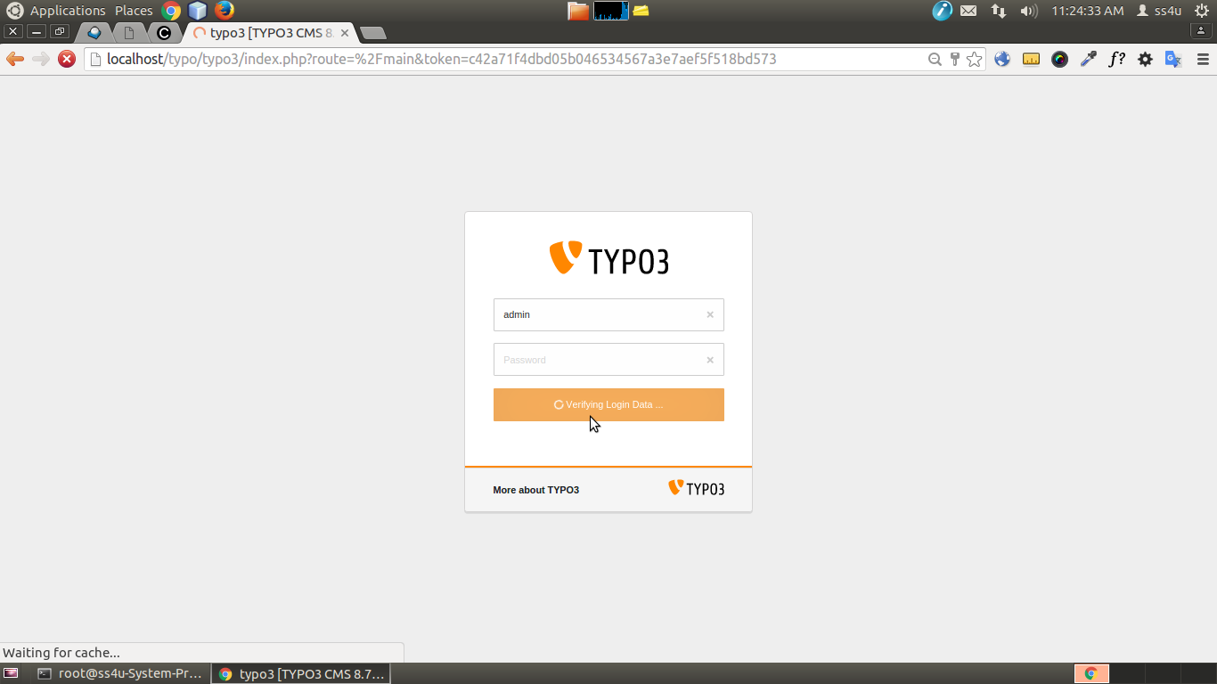

In above page is a typo3 backend login page. To give a admin login username & password typo3.

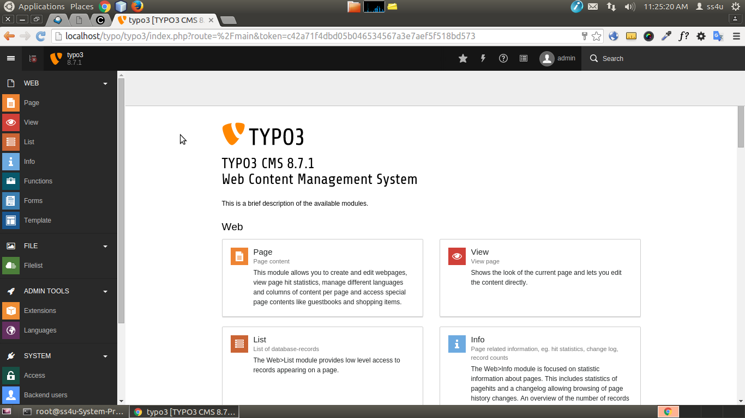
Now we have see the typo3 welcome home page.

We have successfully installed and configured typo3.

