CONTREXX INSTALLATION

Step 1: Extract the contrexx zip file to "/var/www" folder and set permission for /var/www/contrexx.
“chmod -R 777 /var/www/contrexx”
Step 2: Open the browser then type “localhost/contrexx” page.
Step 3: Select the Language. Click Next.

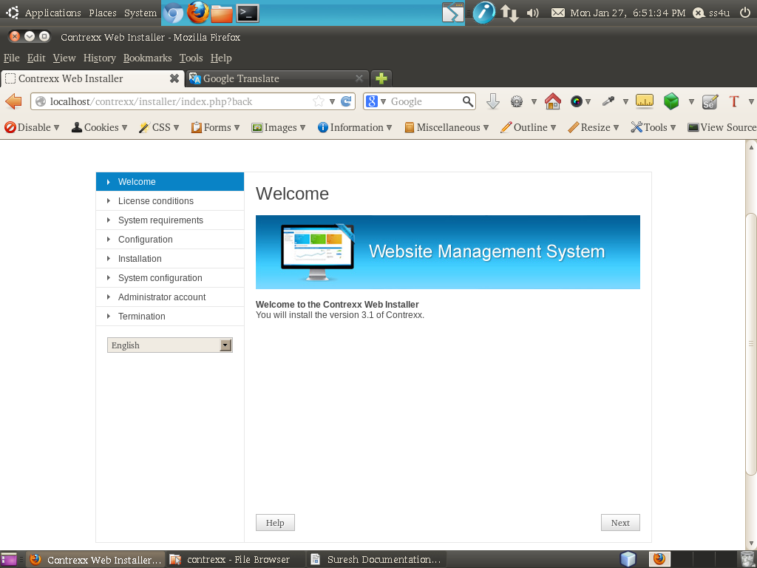

Step 4: You read the License conditions and accept the conditions, then click Next.
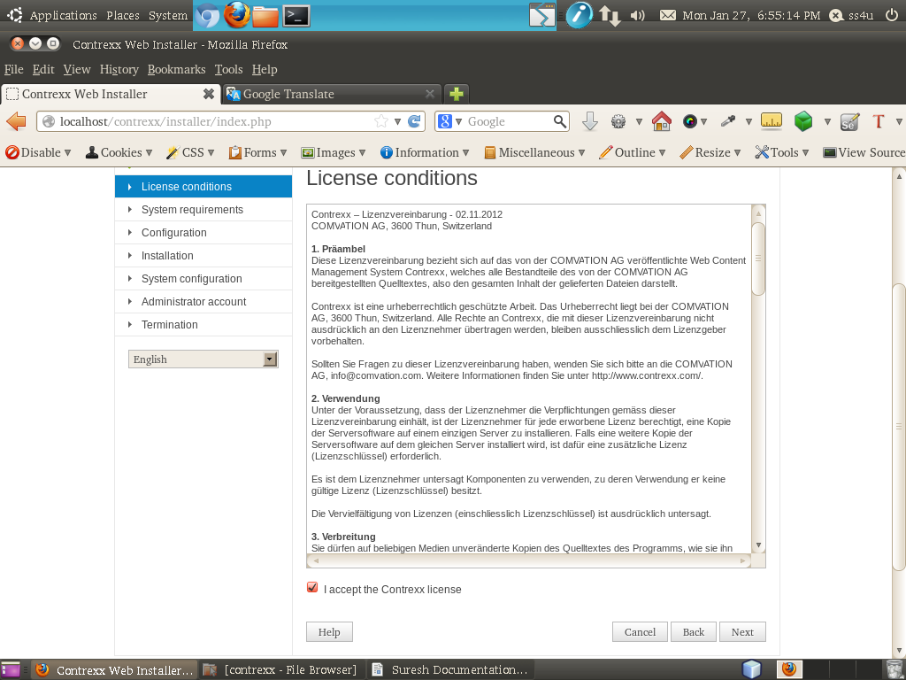

Step 5: You read the system requirements then click Next.
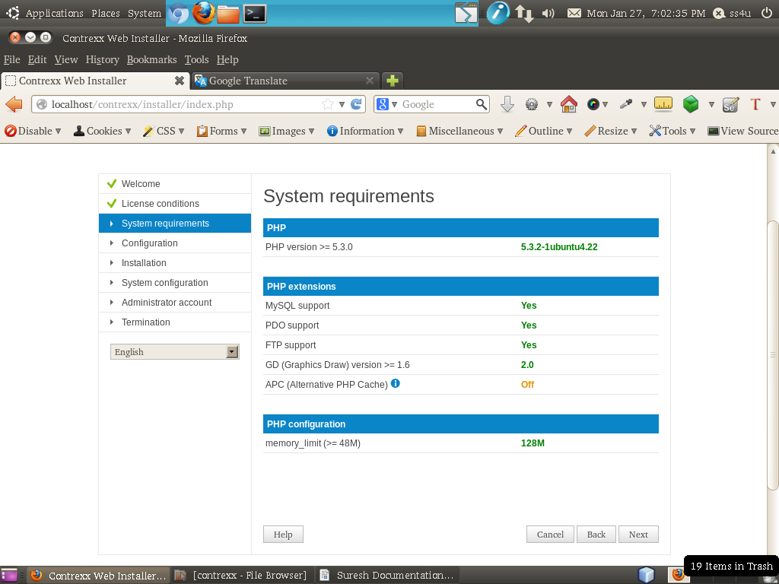

Step 6: You see the configuration page then select timezone as Europe/zurich.
Enter the database name and select “create database” option. Then type username with password and if you dont want FTP, unselect “Use FTP” option then click Next.
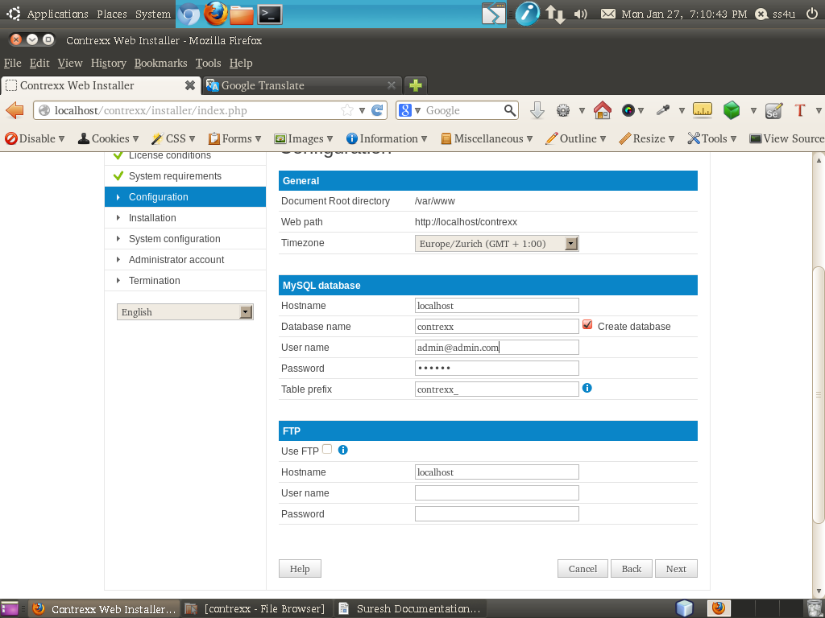

Step 7: You see the installation page and check permissions details, then click Next.
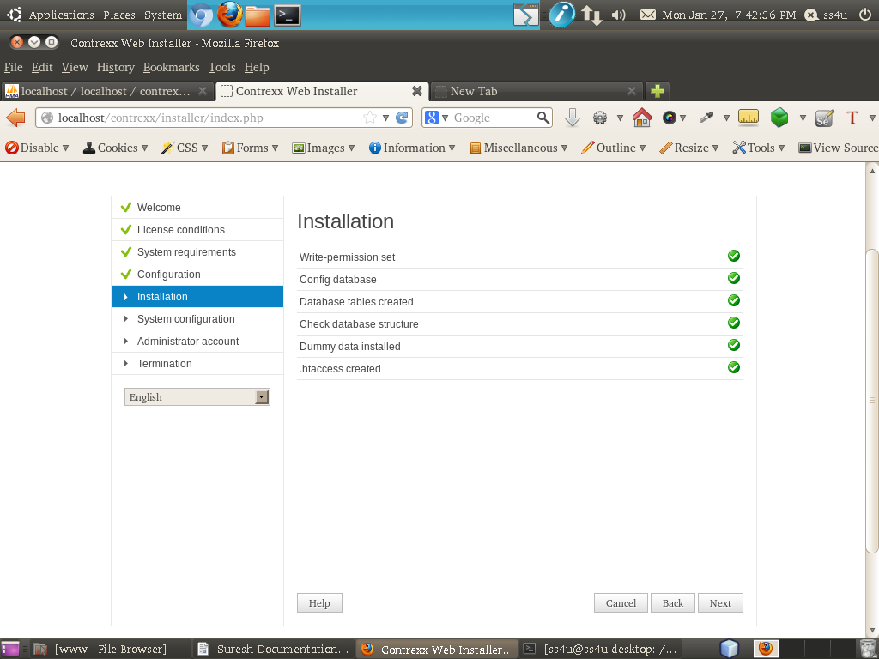

Step 8: You see the system configuration page, then type administrator e-mail address and name then click Next.
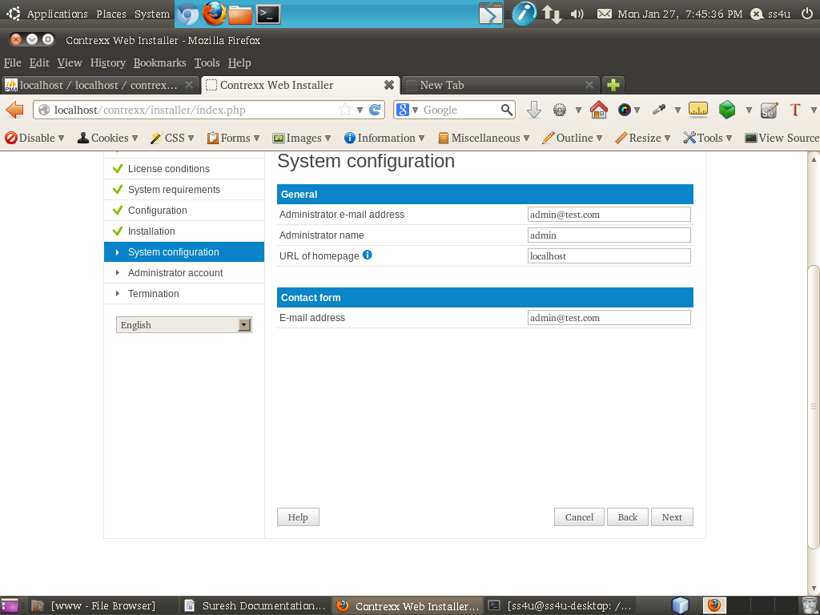

Step 9: You see administrator account page give email id with password, then click Next.
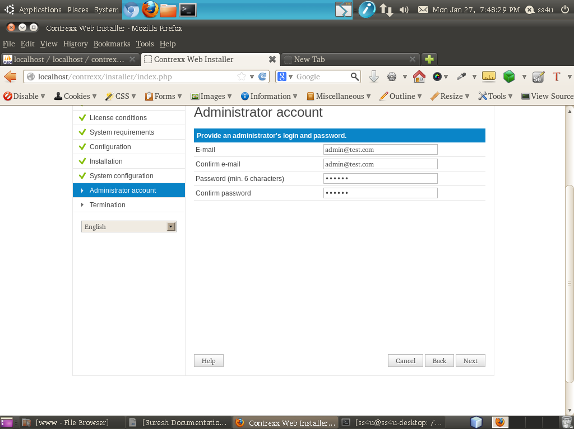

Step 10: You will see the last page of the installation.
