TEAM VIEWER

Step 1 : Download the Team viewer software from the internet.

Step 2 : After the installation, the team viewer will generate the unique ID to that machine.
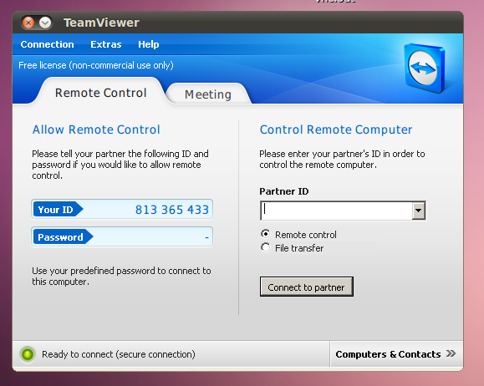
Step 3 : Go to Extras menu and select the General option to set the display name and choose accept option from LAN connections.
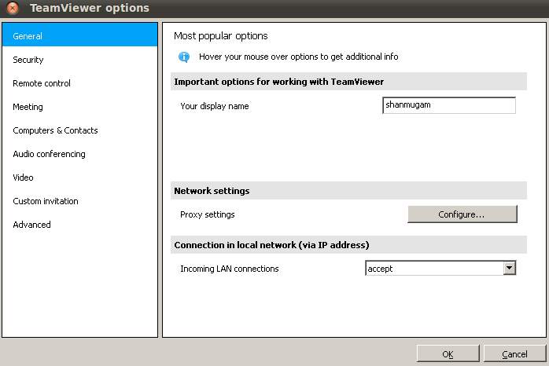
Step 4 : Set Proxy settings by using configure button
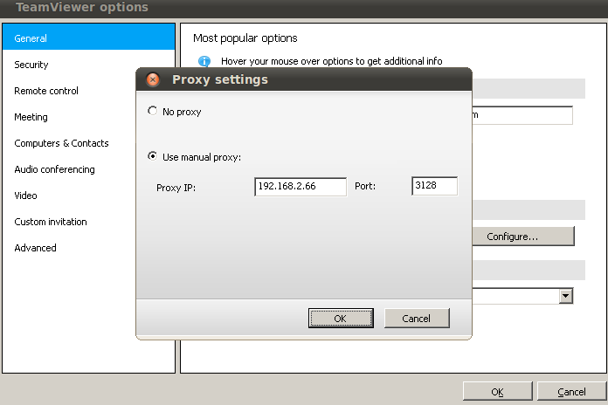
Step 5 : Go to the Extra menu and then select the security option to set password and choose Disabled (no session password) option.
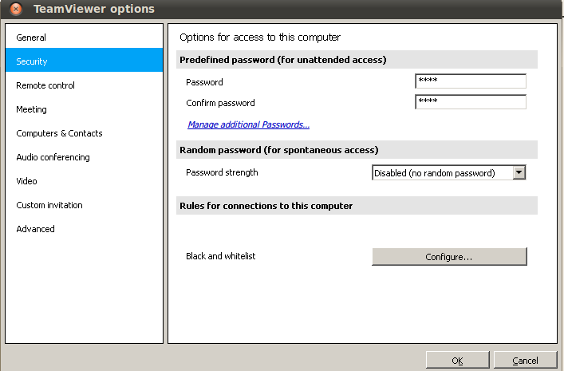
Step 6 : Connect to the remote host by using ip, then connect to partner.
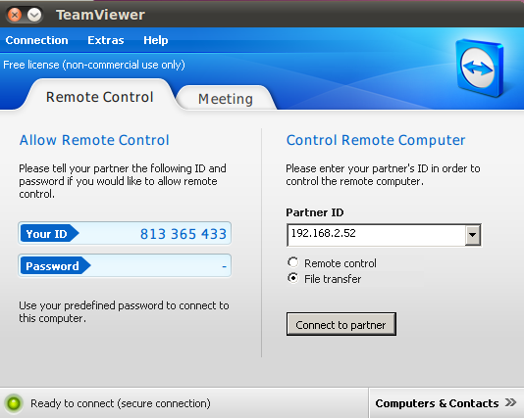
Step 7: Give teamviewer remote password to logon the remote system.
