Troubleshoot the sudo file

Problem:

Try to execute “sudo -i” in terminal, then receive the following error message:
“sudo: must be setuid root”
Solution:
- Restart the system, press shift until the GRUB menu appears. Select Ubuntu version...(recovery mode).
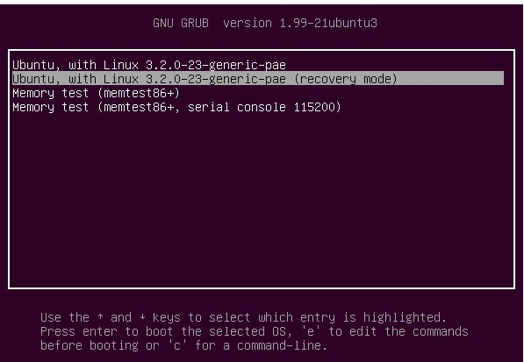

- Choose the root option from recovery menu.
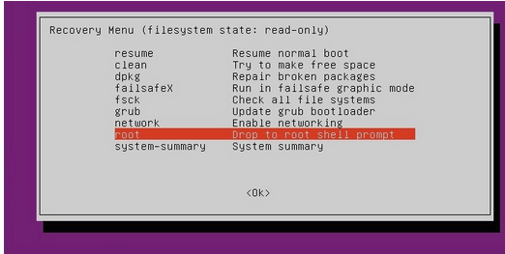

- Enter “chmod 4755 /usr/bin/sudo” in terminal.
- Restart and boot into normally.
- Now access “sudo -i” in terminal.

