How to setup the ip address

Step 1: Open Network Connections to set up network settings in Ubuntu. Go to System -> Preferences -> Network Connections.
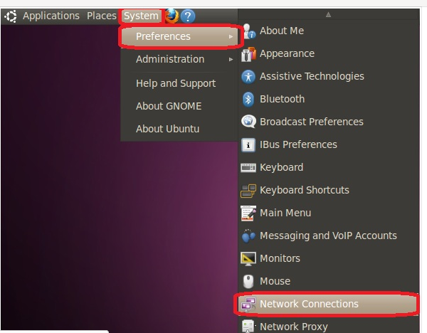

Step 2: Under the “Wired” tab, click on “Auto eth0” and select “Edit."

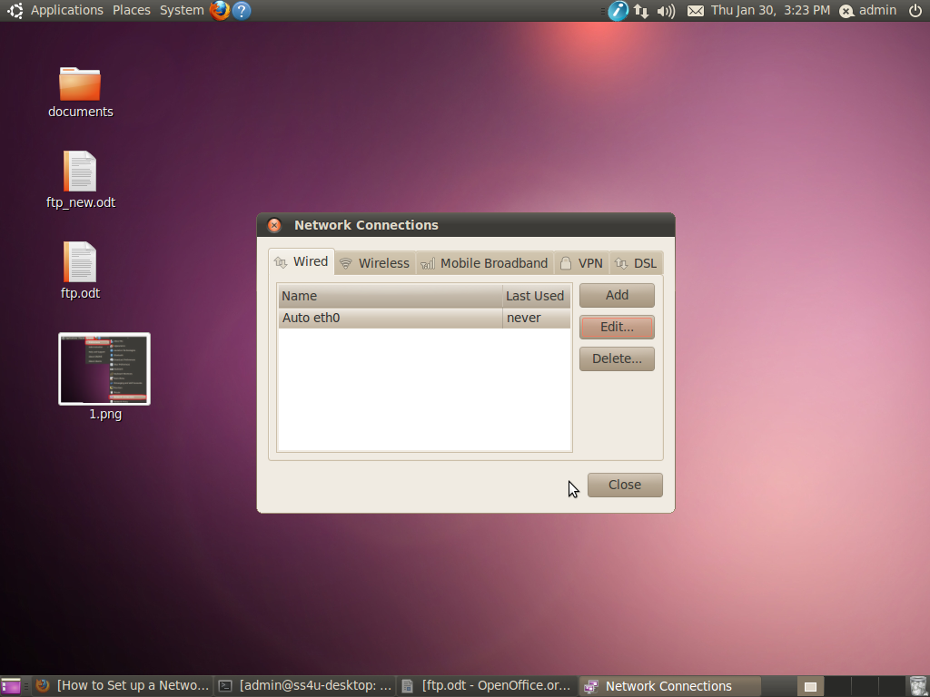

Step 3: Click on “IPV4 Settings” tab. Chose the “Manual” option from the drop-down list and assign the IP address, netmask and gateway manually.

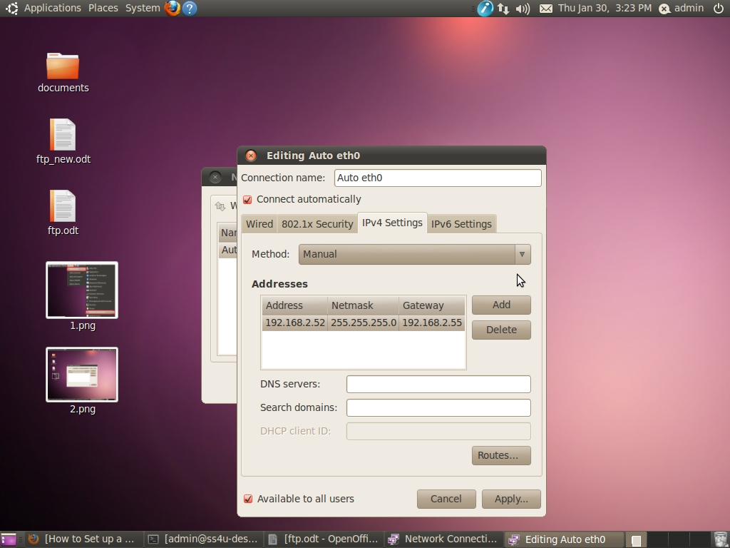

Step 4: Finally click apply to enter administrator password to set ip address.

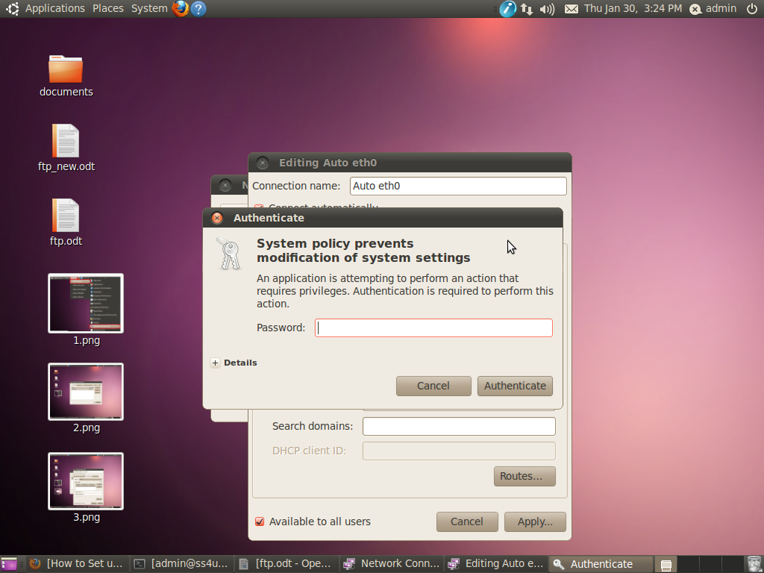

Step 5: Now you check the ip address using ifconfig command.
