SVN

- It is used to checkout, update, delete, export and import changes done on the modules in to the server.

Configuration of SVN Server :

- Install SVN Server

yum install subversion

- Create “SVN ADMIN”

mkdir -p /var/repo/source

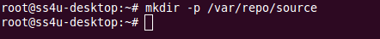

svnadmin create /var/repo/source

- Once svnadmin created, following directories and files are auto-generated.

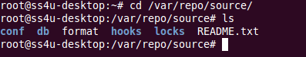

- Open svn configure file:

vim /var/repo/source/conf/svnserve.conf

“uncomment” and set the following lines.
anon-access = read
auth-access = write
password-db=passwd

- Create user:

vim /var/repo/source/conf/passwd.conf

Edit and add username and password

shanmugam = pass12345

- Start SVN Service:
svnserve -d -r /var/repo/source

--------

