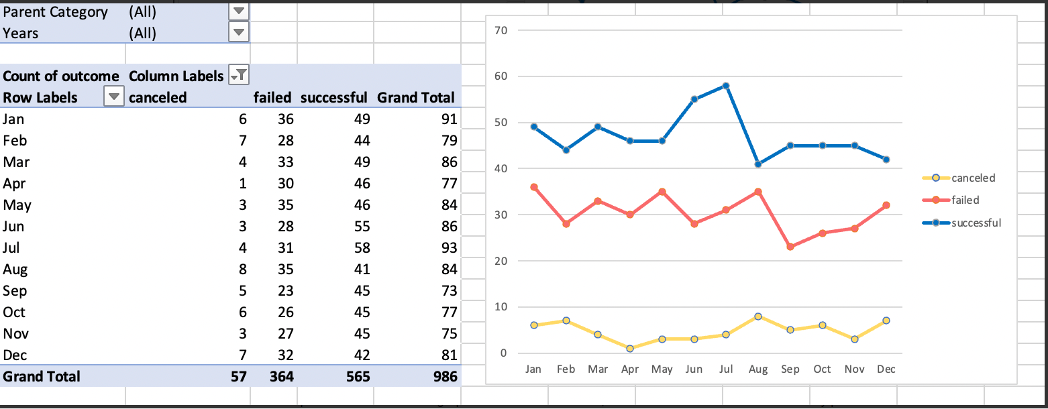

1.Given the provided data, what are three conclusions that we can draw about crowdfunding campaigns?

* The campaign is successful based on dataset (Successful 565 - Failure 365)
* First half of the year has more successful and peeking in July, second half very lower.
* Failure and success almost converge in August.
* Failure and success move equally till may then diverge in June/July and converge in august, flat for the rest of the year.

2.What are some limitations of this dataset?

* Different currency is used, so not able to determine the exact price.
* Exact date of the pledge, so not able to determine which day of the week is very effective.
* Reason of the failure

3.What are some other possible tables and/or graphs that we could create, and what additional value would they provide?

* Pie chart: Based on the countries, what is the Success and failure rates. We can target countries where the success rates are high.
* Reason of the failure

#### Statistical Analysis

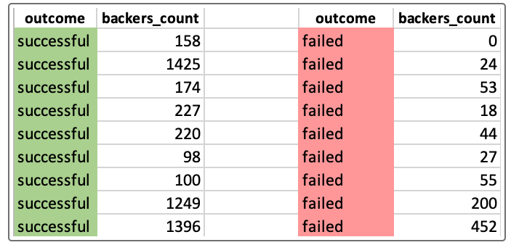

|  |  |  |  |  |
| --- | --- | --- | --- | --- |
| **Successful campaigns statistics** | |  | **Unsuccessful campaigns statistics** | |
| Mean (AVG) | 851.1469027 |  | Mean (AVG) | 585.6153846 |
| Median | 201 |  | Median | 114.5 |
| Minimum | 16 |  | Minimum | 0 |
| maximum | 7295 |  | maximum | 6080 |
| Variance | 1603373.732 |  | Variance | 921574.6817 |
| Standard Deviation | 1266.243947 |  | Standard Deviation | 959.9868133 |

**Use your data to determine whether the mean or the median better summarizes the data.**

Difference between mean and median, mean is very high so better we take mean and summarize the data.

**Use your data to determine if there is more variability with successful or unsuccessful campaigns. Does this make sense? Why or why not?**

Considering variance between success and failure, success has more variability than failure.