DISHES AND THEIR ALLERGEN CONTENT
(Note – Please state the name of the cereal(s) containing gluten** in that column AND/OR the name of the nut(s)* in that column)
DISHES | 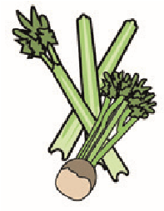 |  | 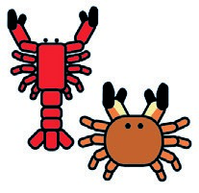 |  |  | 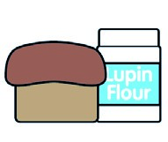 |  |  | 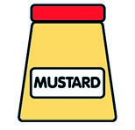 |  |  | 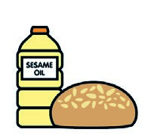 |  | 
 | Celery | Cereals containing gluten** | Crustaceans | Eggs | Fish | Lupin | Milk | Molluscs | Mustard | Nuts* | Peanuts | Sesame seeds | Soya | Sulphur dioxide
Review date: Reviewed by:You can find this template, including more information at www.food.gov.uk/allergy

