Results

Age Pyramid
4 of 22 input rows were excluded. All tables and bars use only the 18 retained observations; see Data Summary for disjoint exclusion reasons.
Fewer than 30 retained observations: the pyramid is a descriptive sample profile, not a stable population estimate.
Data Summary
Row Classification | Rows
Input rows | 22
Missing age or gender | 2
Unusable ages (negative or nonfinite) | 1
Unselected gender levels | 1
Outside age-break range | 0
Retained observations | 18

Population Data
Age Band | Female (n) | Male (n) | Total (n) | Female (%) | Male (%)
0-4 | 2 | 1 | 3 | 25.0 % | 10.0 %
5-9 | 1 | 2 | 3 | 12.5 % | 20.0 %
10-14 | 1 | 3 | 4 | 12.5 % | 30.0 %
15-19 | 1 | 0 | 1 | 12.5 % | 0.0 %
20-24 | 2 | 2 | 4 | 25.0 % | 20.0 %
65-69 | 0 | 1 | 1 | 0.0 % | 10.0 %
85+ | 1 | 1 | 2 | 12.5 % | 10.0 %
Total | 8 | 10 | 18 | 100.0 % | 100.0 %
Note. Only occupied bands are displayed, in increasing age order. An absent group has undefined within-group percentages. Empty bands are omitted from the plot; vertical spacing does not represent elapsed years.

Female level: Female; male level: Male. Percentages use each gender separately (each nonempty side sums to 100%). Ages are measured in years. Bands are left-closed; an exact boundary age starts the next band.
Age Pyramid
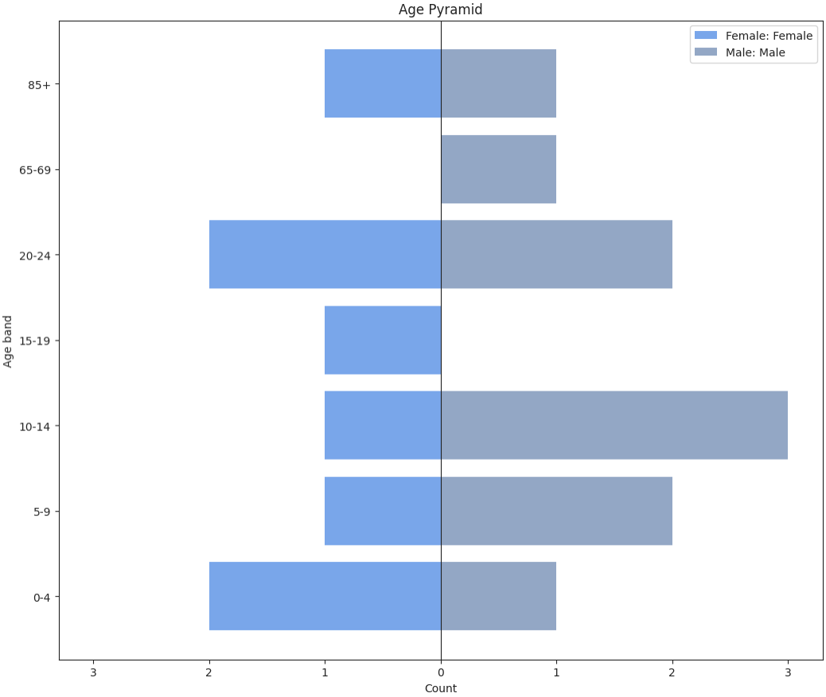

Age Pyramid via Pj
4 of 22 input rows were excluded. All tables and bars use only the 18 retained observations; see Data Summary for disjoint exclusion reasons.
Fewer than 30 retained observations: the pyramid is a descriptive sample profile, not a stable population estimate.
Data Summary
Row Classification | Rows
Input rows | 22
Missing age or gender | 2
Unusable ages (negative or nonfinite) | 1
Unselected gender levels | 1
Outside age-break range | 0
Retained observations | 18

Population Data
Age Band | Female (n) | Male (n) | Total (n) | Female (%) | Male (%)
0-4 | 2 | 1 | 3 | 25.0 % | 10.0 %
5-9 | 1 | 2 | 3 | 12.5 % | 20.0 %
10-14 | 1 | 3 | 4 | 12.5 % | 30.0 %
15-19 | 1 | 0 | 1 | 12.5 % | 0.0 %
20-24 | 2 | 2 | 4 | 25.0 % | 20.0 %
65-69 | 0 | 1 | 1 | 0.0 % | 10.0 %
85+ | 1 | 1 | 2 | 12.5 % | 10.0 %
Total | 8 | 10 | 18 | 100.0 % | 100.0 %
Note. Only occupied bands are displayed, in increasing age order. An absent group has undefined within-group percentages. Empty bands are omitted from the plot; vertical spacing does not represent elapsed years.

Female level: Female; male level: Male. Percentages use each gender separately (each nonempty side sums to 100%). Ages are measured in years. Bands are left-closed; an exact boundary age starts the next band.
Age Pyramid
This analysis uses the installed Pj public service with jamovi Python; no Pj editor opens. The existing Age Pyramid analysis uses ClinicoPathPj's own Python bridge. Both execute the same age-pyramid calculation and use the same native tables and static plot renderer. Matched inputs and options should give identical results. Backend elapsed time excludes plot rendering and is not an isolated launcher benchmark.

Backend Elapsed Time
Route: pj; backend elapsed: 1.485 s.
Includes selected-data encoding, startup/imports, calculations, HTML and native mapping.
Excludes native image rendering and browser drawing. Pj resource preparation is included.
Pj 1.5.0; runner: processx; checkpoint enabled; shared call timeout.

References
[1] R Core Team (2026). R: A Language and environment for statistical computing. (Version 4.6) [Computer software]. Retrieved from https://cran.r-project.org. (R packages retrieved from CRAN snapshot 2026-05-11).
[2] The jamovi project (2026). jamovi. (Version 28) [Computer Software]. Retrieved from https://www.jamovi.org.

