Git and GitHub Assignment

Sydney Ball

Data 413

URL: <https://github.com/sball32/git_clone_push_assignment.git>

**Git clone: clone the repository to my terminal**

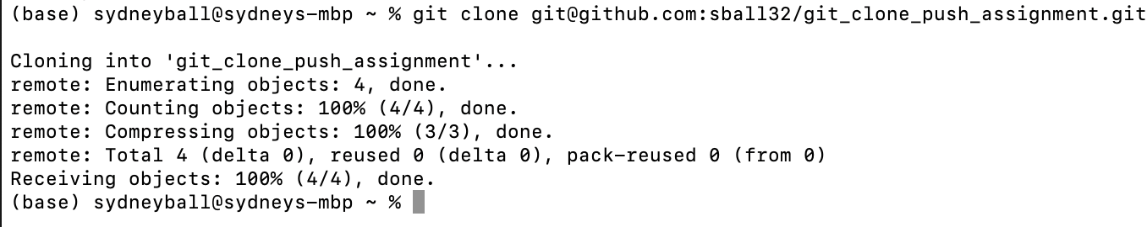

**Navigate into the repository and see what is inside**

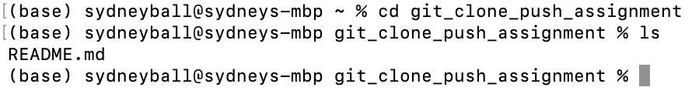

**Now I add something to the README.md file & the status is modified**

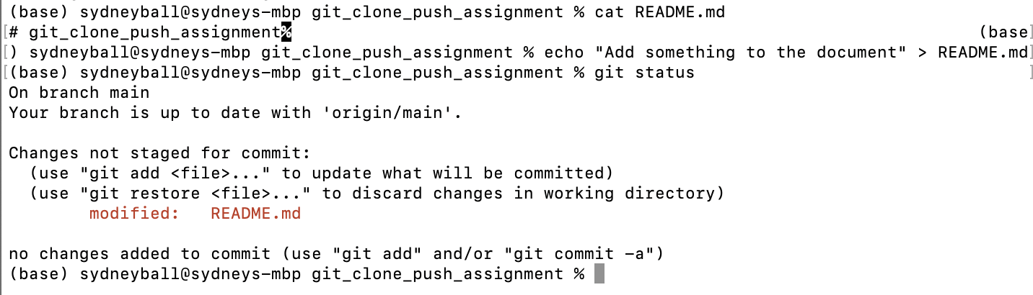

**Use git add to add modifications and ensure git status is green**

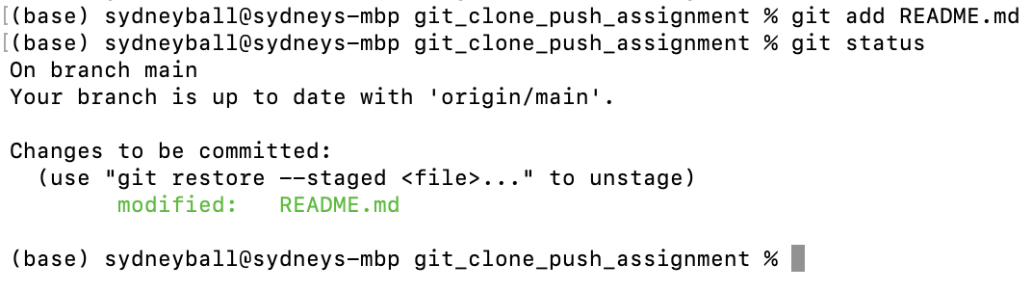

**Use git commit to begin moving the comment**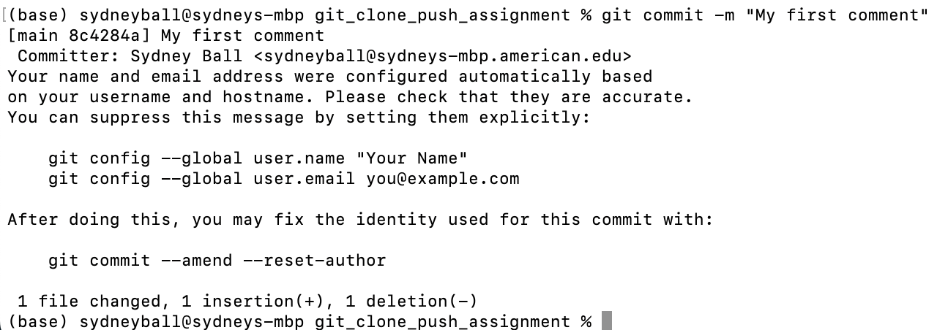

**Use git push to push the comment all the way through the repository**

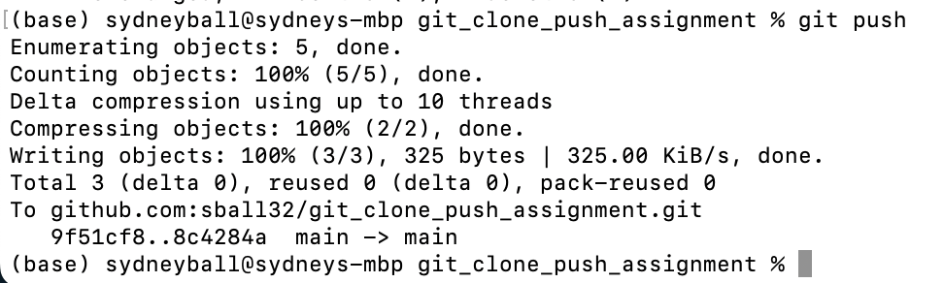

**Check that the comment is in the repository: we see that “My first comment” is in the repository**

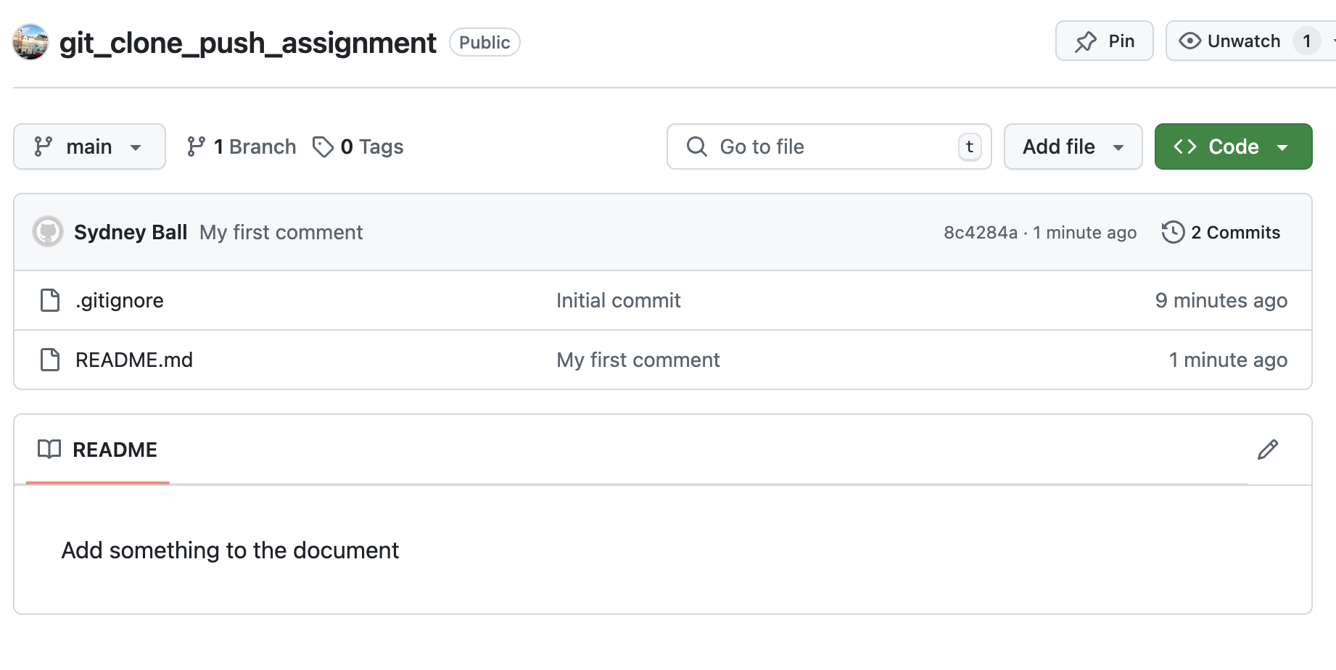

I ran the practice again using a new file which was not the README.md file to be sure that I followed directions. I started by creating the new file (touch newfile.txt), then I added to the file (cat “comment”), I then added that to the repo (cat newfile.txt). After adding, I check the status of the repo (git status). I had to do this twice because I at first used the wrong command. Then I committed the comment (git commit m- “new file, new comment”), then I pushed the new file and comment into the repo (git push).

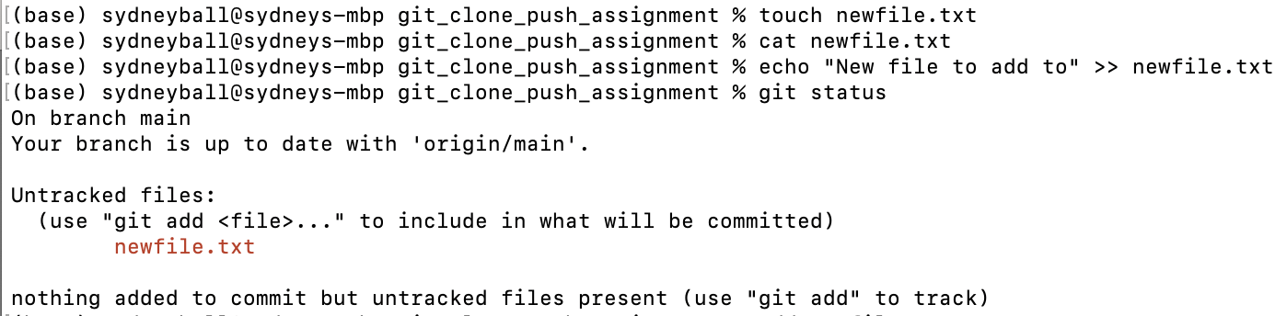

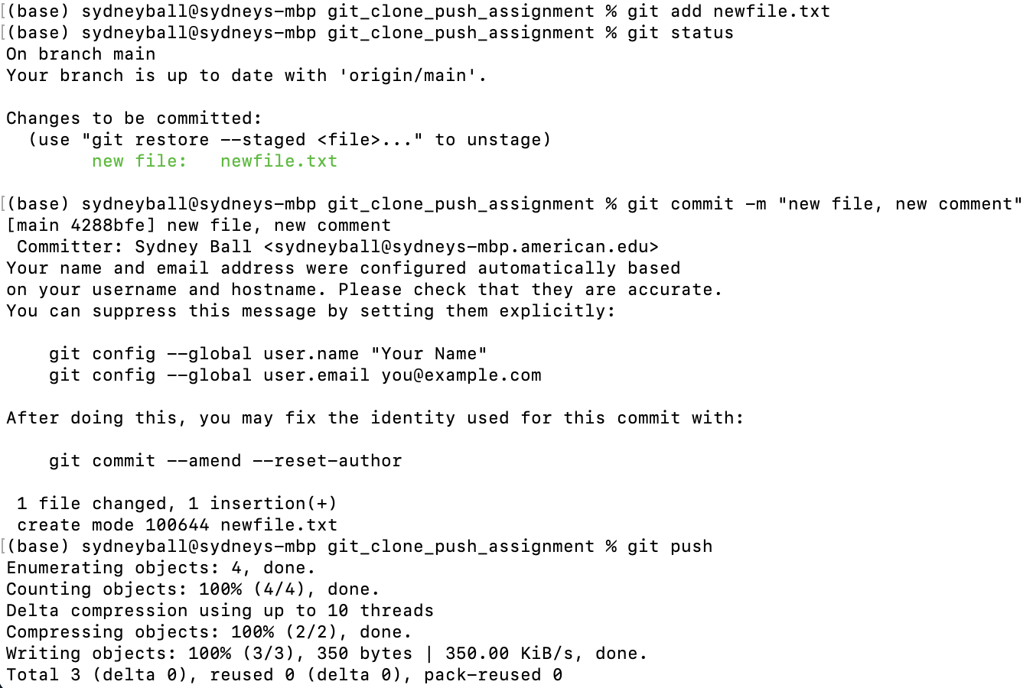

Then I needed to check this new change in GitHub to see that everything was done correctly. And we see the newfile.txt appear with the new comment. 