1) I will rework text, intro etc.

2) Equations 2 and Fig.2 should be explained much better. If you write
a rough draft to help me understand I will rework the text.

Equation 2 is a model for co-circulating influenza types (A, B) or subtypes (H3N2, H1N1) interacting only via a period of temporary full cross immunity (denoted by Q) and the absence of co-infections.
The number of states variable is greatly reduced as we neglect birth and death processes in front of antigenic drift.
We can send you the full model including birth and death processes if you want.

We denote the set of all possible subtypes noted 1,2,3... K (including the empty set (\varnothing in latex) here 0)
X_J are hosts currently immunized toward subtypes belonging to the subset J (included in K)
In the 2 subtypes case (represented figure 2) X_J are:
X_0 : hosts currently fully susceptible
X_1: hosts currently immunized to subtype 1
X_2: hosts currently immunized to subtype 2
X_12: hosts currently immunized to subtypes 1 and 2.

g_k represent antigenic drift rates. As the viral population evolves, hosts can loose immunity.
In the 2 subtypes case g_1 is antigenic drift rate of subtype 1 and g_2 the antigenic drift rate of subtype 2.
Viral evolution (antigenic drift) is represented by black arrows in figure 2.

I^k_J\k are hosts currently infectious by subtypes k resulting from infections from hosts who were immunized toward strain belonging to the subset J\k (subset J which does not contain k).
After recovery, infectious hosts I^k_J\k spend an average time 1/q in the classe Q^k_J\k where they are “invincible” due to the temporary period of full cross-protection and then pass to class X_J where they are susceptible to every subtypes not present in subset J.

Transition from states X_J\k to X_J are represented by red and blue arrows for subtypes 1 and 2 in figure 2.
During the transition hosts pass through states I^k_J\k and Q^k_J\k as denoted on the arrows.

If you are disturbed by the subset notation, the figure presents the full equation for the 2 subtypes cases when the parameters are equal for the 2 subtypes and N=1.

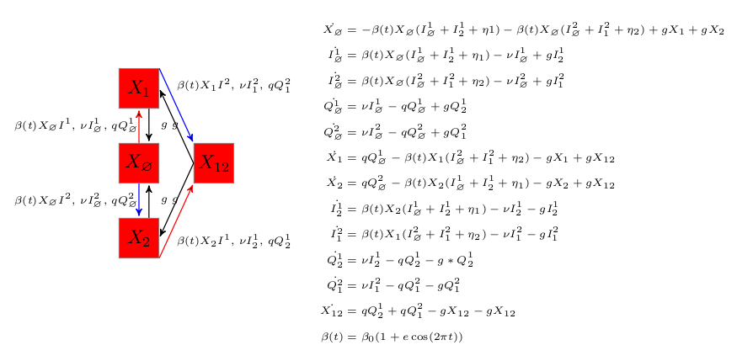
3) Please email me Lavenu paper

Lavenu phD thesis is attached to this mail. Parameters are taken from page 22. The referred paper (in english) is included starting from page 80 of the PDF. We also join a paper from Lessler where you can find a review of all R0 estimates (figure 4 page 760)

4) Page 8. "We have implemented a stochastic version." Excellent. I am confused though. Do you take N=100,000?

If so, you realize that there should be a lot of stochastic extinctions. And
if you don't have these extinctions then this is the reason external
immigration is so important!

This is a difficult point. The problem is that the data comes normalized for 100 000 hosts after a lot of adjustments to take into account the practician activities etc...
Rescaling the data from 1e5 to 1e7 hosts (a size relevant for Paris) can induce some problems as the few zeros of the data result in abrupt change from 0 to say 400.
This can lead to to inter peak parts of the cuve to be quite high. This is a cause a concern as the interpeak values of the epidemics are the major contribution to the likelihood.
This situation is problematic as persistence of influenza in temperate area is not expected in the absence of external reintroduction.
The data are Influenza like illness and not confirmed influenza cases and therefore interpeak activities are not necessarily influenza...

We have thus keep N to 1e5 (as finkenstadt et al. 2005) for the inference procedure only and have checked that UPCA remains valid in population of 1e7 hosts.

I think you definitely MUST deal with this model for large city sizes.
N=millions. Otherwise it wouldn't make sense. Will the UPCA hold up in
normal populations. This is very important.

We have started parameter inference for a population size of 1e7 and a rescaling of the incidence to incidence per 1e5 hosts in the observation process. This is probably the most rigorous way to proceed.
We send you the results as soon as the algorithm converge.
Maybe with fewer demographic stochasticity, the simper single strain SIRS model is not the good one to fit. Maybe we should allow for more realistic infectious distribution and overdispersion with allowing stochastic rate in the markov process.

An important point is that UPCA can be found in the meta population model (figure 8). In this model the population size of the 52 cities are the real value from 2005/10 UN data and the migration rate is given directly for transportation data from IATA.

5) Page 8, 3.1: What is the dephasing term? Let me know more details

If we measure the time t in weeks the seasonly varying transmission term is : (b0*(1.0+e*cos( 2.0*M_PI*t/(365.0/7.0) +d*2.0*M_PI) )) where d is the dephasing term constrained between 0 and 1 by a logit transform.

6) Fig.6. I don't get it. What is I, I1, I2 and I1+I2?

I is prevalence for the single subtype model. (I can replace prevalence by incidences time series if you prefer).
I1, I2 and Itot are prevalence for the 2 subtypes models. I1 can be H3N2 and I2 H1N1. I1+I2 are to total prevalence to contrast to the data where all type and subtypes are aggregated.

If I'm not mistaken, the 2nd time series is for the single strain model.
3'rd and 4 time-series is for two strain model.

That's it

What does one learn from comparing 3'rd time-series with 4'th?

The 4th time series shows trajectories with higher minima and less peak variability.

I doubt that you need all those attractor reconstructions

7) Is there a better 3-D view of the attractor? That would be good.

I send you the figure soon.

8) Figure 5. What is the colour code? The LE?

The color code is the main Lyapunov exponent as for figure 3.

Is this for one strain or two strain model?

This is for the fitted model which is the single subtype model.

Page 11. "WE have seen that UPCA critically depends on external
infections." Where do we see that actually? Fig.5 shows something like
this, but one sees that "too many" external infections induces periodicity.
How do you interpret this? Can you quantify what is "too many"? the point
of "too many" in the bif diagram is about: log eta =-6.8 . How many people
is that?

The migration term is given in
b(t)*S/N*(I+eta)

eta can be interpreted in different ways:
-the number of external infectious hosts present in the focal population at time t.
-the contribution to the force of infection of infectious hosts from outsides regions.
I prefer the second interpretation as for the stochastic models eta is not necessarily integer valued.

The bifurcation diagram for eta is for the deterministic model were S and I can be interpreted as proportion (N=1)
log eta =-6.8 is thus 10^-6.8 hosts so for a population size of 1e7 these are 1.58 infectious hosts from outsite regions present at any times.

My interpretation of the role of reintroduction is that UPCA dynamics occurs at the boundary between source and sink dynamics. Influenza in temperate areas is expected to be on such a boundary (Rambaut et al 2008, Russel et al. 2008 and also Martha I. Nelson works e.g. Phylogenetic Analysis Reveals the Global Migration of Seasonal Influenza A Viruses
PLoS Pathogens, 2007)

8) Page 9. "Our estimates also support low seasonal forcing." What does
that mean? Why? How?

It means that the intensity of seasonal forcing (e) is low (as supported by the likelihood profile of figure 4.)

The evidence of seasonality is difficult to find mechanistically for influenza so it was postulated I guess by Dushoff et al 2004 that this could be due to the fact that key parameters do not varies that much during a year dispite the strong epidemiological signature of seasonality.

