Document Management System (DMS)

Low-Level Design (LLD)

1. Introduction
This Low-Level Design (LLD) document provides the detailed logical and physical design for the DMS. It translates the functional requirements (FR-01 to FR-10) and system interfaces into technical specifications for developers.
+1

2. Database Design (Schema)
The system uses a Relational Database for metadata (Users, Permissions, Metadata) and Object Storage for physical files.

2.1 Entity Relationship Logic

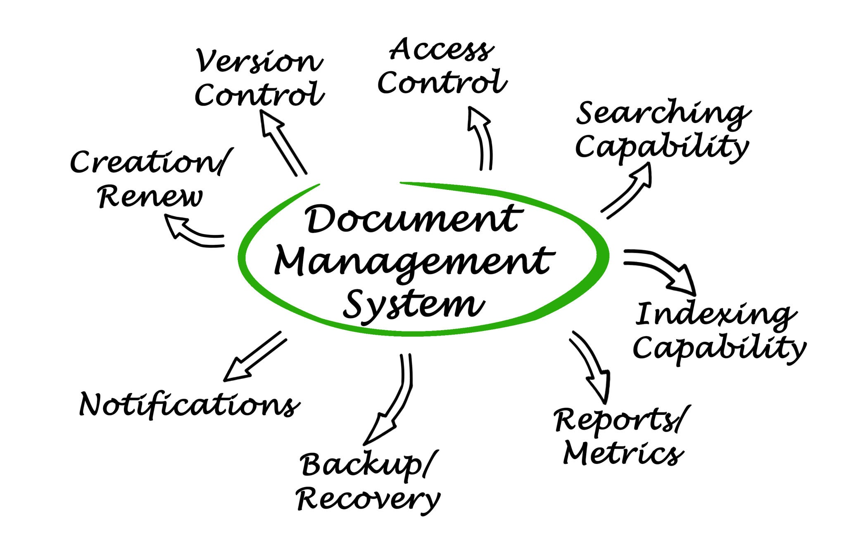

Getty Images

2.2 Table Definitions
Table: Users (Supports User Management Epic ) | Column | Type | Constraints | Description | | :--- | :--- | :--- | :--- | | user_id | UUID | PK | Unique User Identifier | | email | VARCHAR | UNIQUE, NOT NULL | SSO Email / Login ID | | role | ENUM | NOT NULL | 'Admin', 'Internal', 'Manager', 'External' | | status | VARCHAR | DEFAULT 'Active' | Supports Deactivate/Suspend (US-3) |
+2
Table: Documents (Supports Document Storage Epic ) | Column | Type | Constraints | Description | | :--- | :--- | :--- | :--- | | doc_id | UUID | PK | Unique Document Identifier | | folder_id | UUID | FK | Reference to Folders table (US-5) | | owner_id | UUID | FK | Uploader/Owner | | storage_path | VARCHAR | NOT NULL | Path/Key in Object Storage | | current_version| INT | DEFAULT 1 | Tracks latest version | | is_encrypted | BOOLEAN | DEFAULT TRUE | Security flag (FR-05) |
+2
Table: Versions (Supports Version Control Epic ) | Column | Type | Constraints | Description | | :--- | :--- | :--- | :--- | | version_id | UUID | PK | Unique Version Identifier | | doc_id | UUID | FK | Reference to parent Document | | version_num | INT | NOT NULL | Sequential version number (US-13) | | change_log | TEXT | NULL | Description of changes (US-15) | | storage_path | VARCHAR | NOT NULL | Path to this specific version blob |
+1
Table: Permissions (Supports Sharing Epic ) | Column | Type | Constraints | Description | | :--- | :--- | :--- | :--- | | perm_id | UUID | PK | Unique Permission Identifier | | doc_id | UUID | FK | Document being shared | | user_id | UUID | FK | User receiving access | | access_level | ENUM | NOT NULL | 'View', 'Edit', 'Download' (US-8) |
+1
Table: AuditLogs (Supports Reporting Epic ) | Column | Type | Constraints | Description | | :--- | :--- | :--- | :--- | | log_id | UUID | PK | Unique Log Identifier | | action | VARCHAR | NOT NULL | e.g., 'LOGIN', 'UPLOAD', 'DELETE' | | actor_id | UUID | FK | User who performed action (US-17) | | timestamp | DATETIME | DEFAULT NOW() | Time of event |
+1

3. API Specification (REST)
The system will expose RESTful services. Below are the key endpoints mapped to user stories.

3.1 Authentication & User Management
- POST /api/v1/auth/login - Authenticate via SSO/OAuth2.
- POST /api/v1/users - Create new user (Admin only) (US-1).
- PUT /api/v1/users/{id}/suspend - Deactivate a user (US-3).

3.2 Document Operations
- POST /api/v1/documents/upload - Multipart upload for files (US-4).
  - Input: File binary, metadata (tags, folder_id).
  - Process: Stream to Object Storage, Insert into Documents & Versions tables.
- GET /api/v1/documents/{id} - Download specific document.
  - Logic: Check Permissions table first. If valid, generate pre-signed URL for Object Store.
- PUT /api/v1/documents/{id}/tags - Update metadata/tags (US-6).

3.3 Search & Discovery
- GET /api/v1/search - Full-text search (US-10).
  - Query Params: q (keyword), tags (filter), date_range.
  - Response: List of document summaries with relevance scores.

3.4 Versioning
- GET /api/v1/documents/{id}/history - Get list of past versions (US-13).
- POST /api/v1/documents/{id}/restore/{version_id} - Rollback to previous version (US-14).

4. Component Design & Logic

4.1 Upload & Versioning Workflow
Logic Flow:
- Request: User initiates upload via Web UI.
- Validation: API Service checks file size constraints and user quota.
- Storage: File is streamed to Object Storage (encrypted).
- Database:
  - If New File: Create record in Documents, set version_num = 1.
  - If Existing File: Increment version_num, insert new row in Versions table (US-13).
- Indexing: Asynchronous event triggers Search Service to index file content/metadata.

4.2 Security & Permissions Logic
- Encryption:
  - At Rest: All files in Object Storage are encrypted using AES-256.
  - In Transit: TLS 1.2+ for all API communication.
- Access Control Middleware:
  - Every request to /documents/{id}/* passes through a permission interceptor.
  - Check: SELECT access_level FROM Permissions WHERE doc_id = ? AND user_id = ?
  - If no record found, check if user is Admin or Document Owner.
  - If unauthorized, return 403 Forbidden.

4.3 Search Implementation
- Technology: Elasticsearch or Solr.
- Indexing Strategy:
  - Metadata (Title, Tags, Author) is indexed immediately upon creation.
  - Full-text content is extracted (via OCR/Text extraction) in a background worker queue to avoid blocking the user response (Performance constraint <3s).

5. Deployment Specifications
- Containerization: Docker containers for API Services (Node.js/Python).
- Orchestration: Kubernetes for scaling and availability (99.9% uptime requirement).
- Load Balancing: Nginx/AWS ALB to distribute traffic.

