China – The Empire That Did Not Bark

presented at

Social Science History Association

Annual Conference

Vancouver, B.C.

November 1 - 4, 2012
Stephen C. Bannister
Department of Economics
University of Utah
Salt Lake City, Utah 84112
USA
steve.bannister@econ.utah.edu

Abstract
Recent scholarship demonstrates that while late imperial China and early modern Europe were very different places politically, culturally, and institutionally, they were broadly similar in terms of economic possibilities until the fundamental nineteenth century discontinuities.
These dichotomies raise, once again, the most interesting questions: Why did Western Europe’s economy diverge so dramatically from China’s, the difference becoming strikingly apparent in the nineteenth century? How could such different political structures lead, first, to similar pre- century economic outcomes and, second, to the great economic divergence after that?
In some senses this is a “Nature or Nurture” question – but a very important one which, as we try to disentangle the important drivers, can help answer fundamental economic development questions that remain today, and can contribute to the ongoing debate over the origins of the English Industrial Revolution.

1 Introduction and research questions
While there are sufficient unsettled questions for a career, here I focus on those key facts about China and its paradoxical failure to participate in the growth miracle emerging from the English Industrial Revolution.
Given that recent scholarship shows that century per capita incomes in England and parts of China were roughly comparable and had both grown somewhat since the century, why did English output then accelerate into the first continually sustained period of per capita growth ever experienced in history and Chinese output, at least relatively, stagnate?
China, a highly integrated society sharing world population dominance with India, by all the known rules explaining economic dynamics up to that time as summarized by the Reverend Thomas Malthus, should have dominated the world economy. And it did. From Angus Maddison’s data, China and India had roughly 50% of both world population and gross domestic product (GDP) at the beginning of the century, while England accounted for 1% of population and 1% of GDP. Yet England’s growth so dominated the and century that in 1900 England’s share of world GDP was 9% while her population was only 3% of the world total. China and India’s combined share of GDP in 1900 had fallen to 20% while their combined population was still 44% of the world total.
Most scholars search for and discern some combination of social, cultural, and/or institutional factors to explain the phenomenon of the Industrial Revolution. Yet the magnitude of the post century growth trajectory differences imply a level of English exceptionalism that strains credulity. Are we to believe that, over a very few generations, English “growth enabling” institutions somehow grew sufficiently superior to Chinese to account for the growth differences?
A further mystery is the “Needham question,” which arises from the fact, as Joseph Needham documented in the seven volumes of “Science and Civilisation in China,” that China had great scientific and technological discoveries but lost the “race” to both the Scientific and Industrial Revolutions. This fact further supports the idea of functionally sufficient Chinese institutions of the very kind needed to participate in the revolution.
Further, in the long sweep of history, England had a relatively brief period of per capita growth dominance. By no later than 1875, the growth revolution was quickly spreading to North Western Europe, North America, and Meiji Japan. If England’s lead in growth was uniquely determined by an institutional exceptionalism, is there evidence that those usually long-gestation changes in culture, institutions, and society itself were so quickly transmitted to other cultures?
And if transmitted institutional exceptionalism accounts for the rapid spread of growth, why was it transmitted relatively narrowly until the half of the century? Why didn’t China immediately converge? Is the relevant effect in fact that societies oppose fundamental economic changes that in turn cause societal changes until the economic forces becoming overwhelming? Was China “not barking” because there was nothing to bark at, because the dog saw nothing but the long familiar unthreatening agrarian empire? This explanation is certainly consistent with an English exceptionalism story. Or, is it rather a story that there were no economic forces that, at the individual level, would have driven Chinese entrepreneurs to English style energy innovation. The literature on English exceptionalism, from Weber through Landes to McCloskey is well known; I focus elsewhere.
In this paper I explore the counter question: what underlying economic reasons might account for this remarkable series of events and non-events? I argue elsewhere that what England discovered and transmitted, initially narrowly, to the world, was an energy revolution in economic activity. Why did China fail to follow that revolutionary path until the century? Does economics provide a more satisfactory explanation …within the simplifying context of Ockham’s Razor?
The question, then, is one of primary causality, not monocausality. Institutionalists would claim that superior institutions were the primary cause of the Industrial Revolution. I claim that superior economic conditions were the primary cause, while fully acknowledging as proximate the supporting and surrounding institutional and cultural fabric.

2 Main Hypothesis
Given that institutions in regions of China and in England had produced essentially the same standard of living by 1800, and that the market systems were roughly equivalent, I present a story of the energy revolution that China did not experience, and that England did. The differences, explained by different market forces, and geological and geographical luck, are not only sufficient to explain the divergence in their post-1800 economic paths, but, I argue in detail elsewhere, were the necessary conditions for the English Industrial Revolution to occur. China missed a microeconomic incentive that England enjoyed, and therefore also missed the network effects of a virtuous feedback cycle that became the Industrial Revolution.

3 Contribution
I use a comparative descriptive and empirical structure to argue that English economic factors and geographical luck created a (fossil) energy revolution that substituted (fossil) mineral energy for organic sources as the prime mover for the Industrial Revolution. This replaces arguments for English institutional exceptionalism as the prime mover. China, with a brief historical exception, did not experience fossil energy revolution because their economic fundamentals did not support it.

4 Comparative data and observations
For context, I begin by examining world population, gross domestic product, and the resultant GDP per capita through the current period, covering the crucial pre-industrial and Industrial Revolution periods, and showing the current levels for context. The initial data is from Angus Maddison. Maddison measures GDP in 1990 International Geary-Khamis Dollars, which measure purchasing power parity (PPP) adjusted output. Maddison’s data set, whatever its demerits, is where many comparative scholars start because it is widely accepted. I also start with it.

4.1 Comparative growth 1500 – current

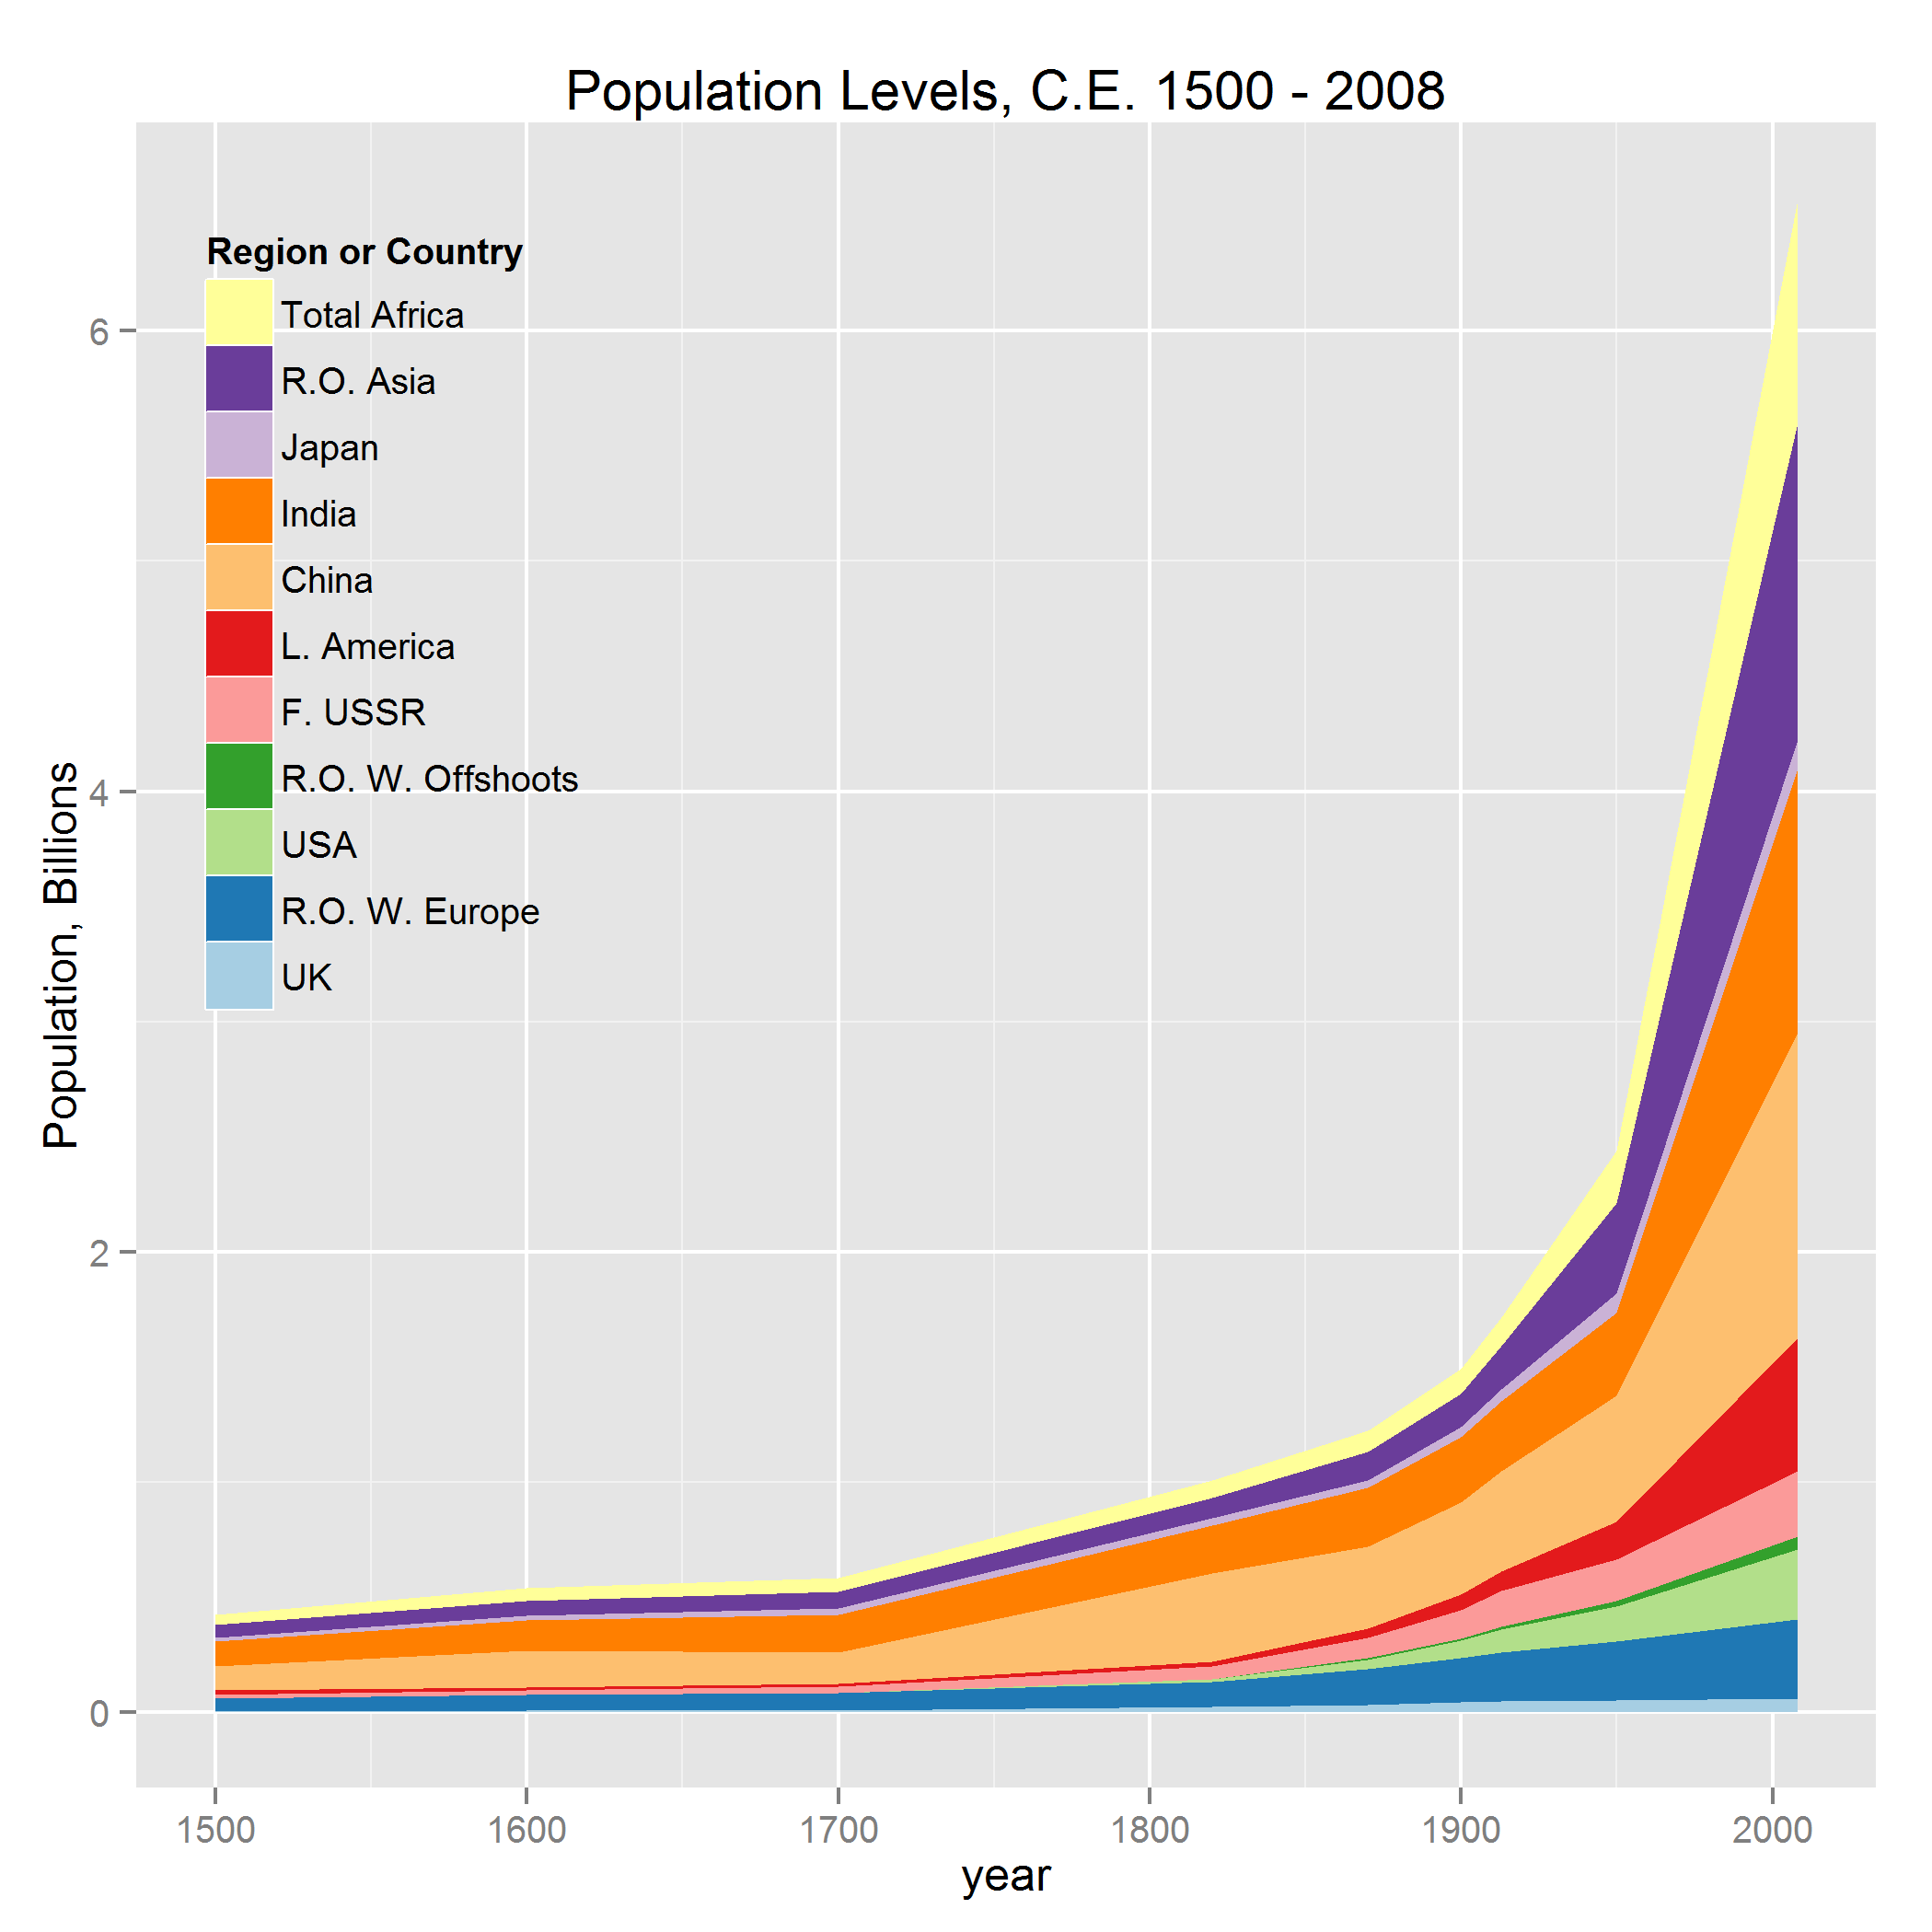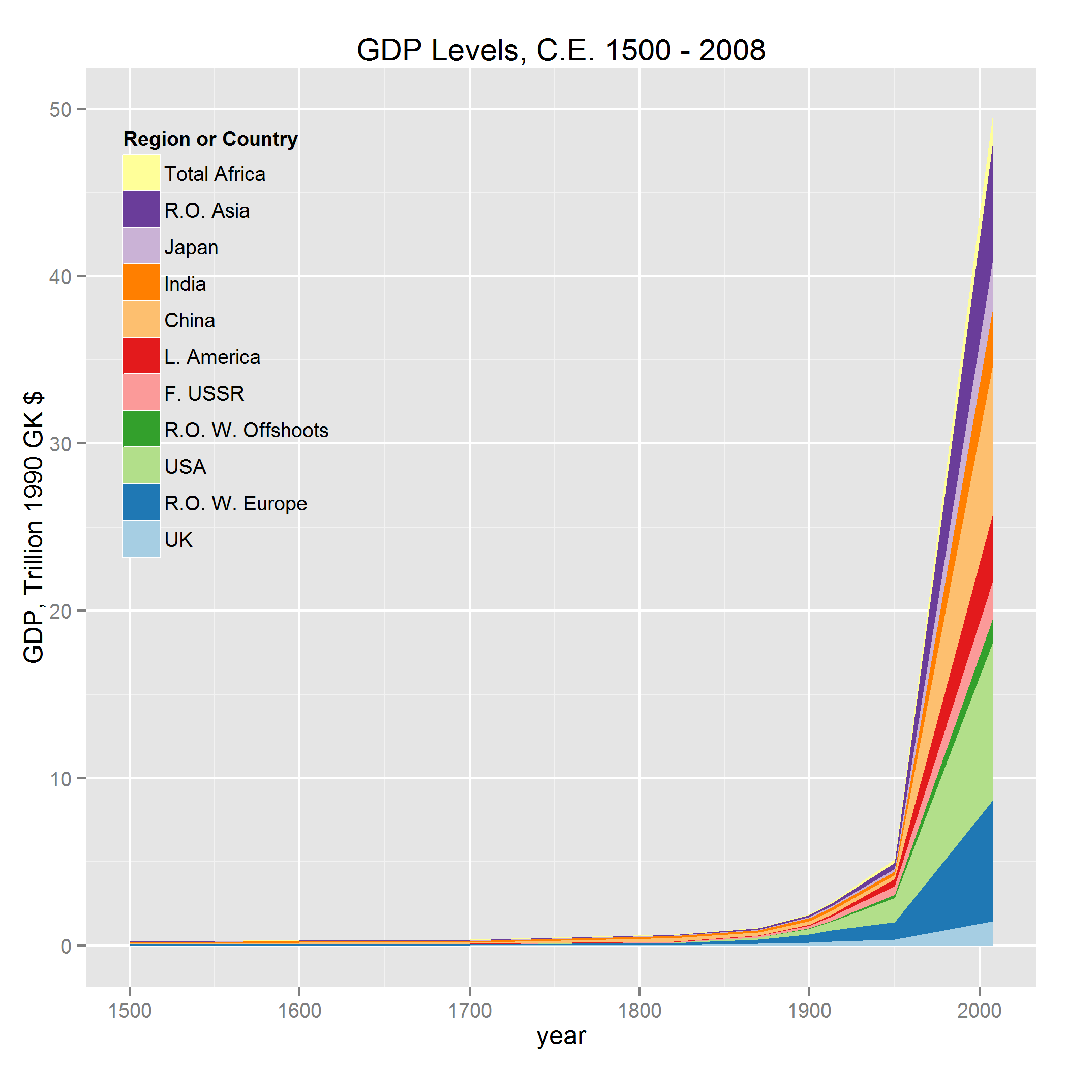
Figure 1: Angus Maddison: population and GDP levels 1500 through recent
Figure 1 shows the Maddison world population and GDP level data from CE 1500. The data are at the major region level with specific countries called out. Note the acceleration in total population toward the end of the little ice age (∼1700), and the acceleration in total GDP after 1900.
Next I focus in on the most important period.

4.2 Comparative growth 1500 – 1900

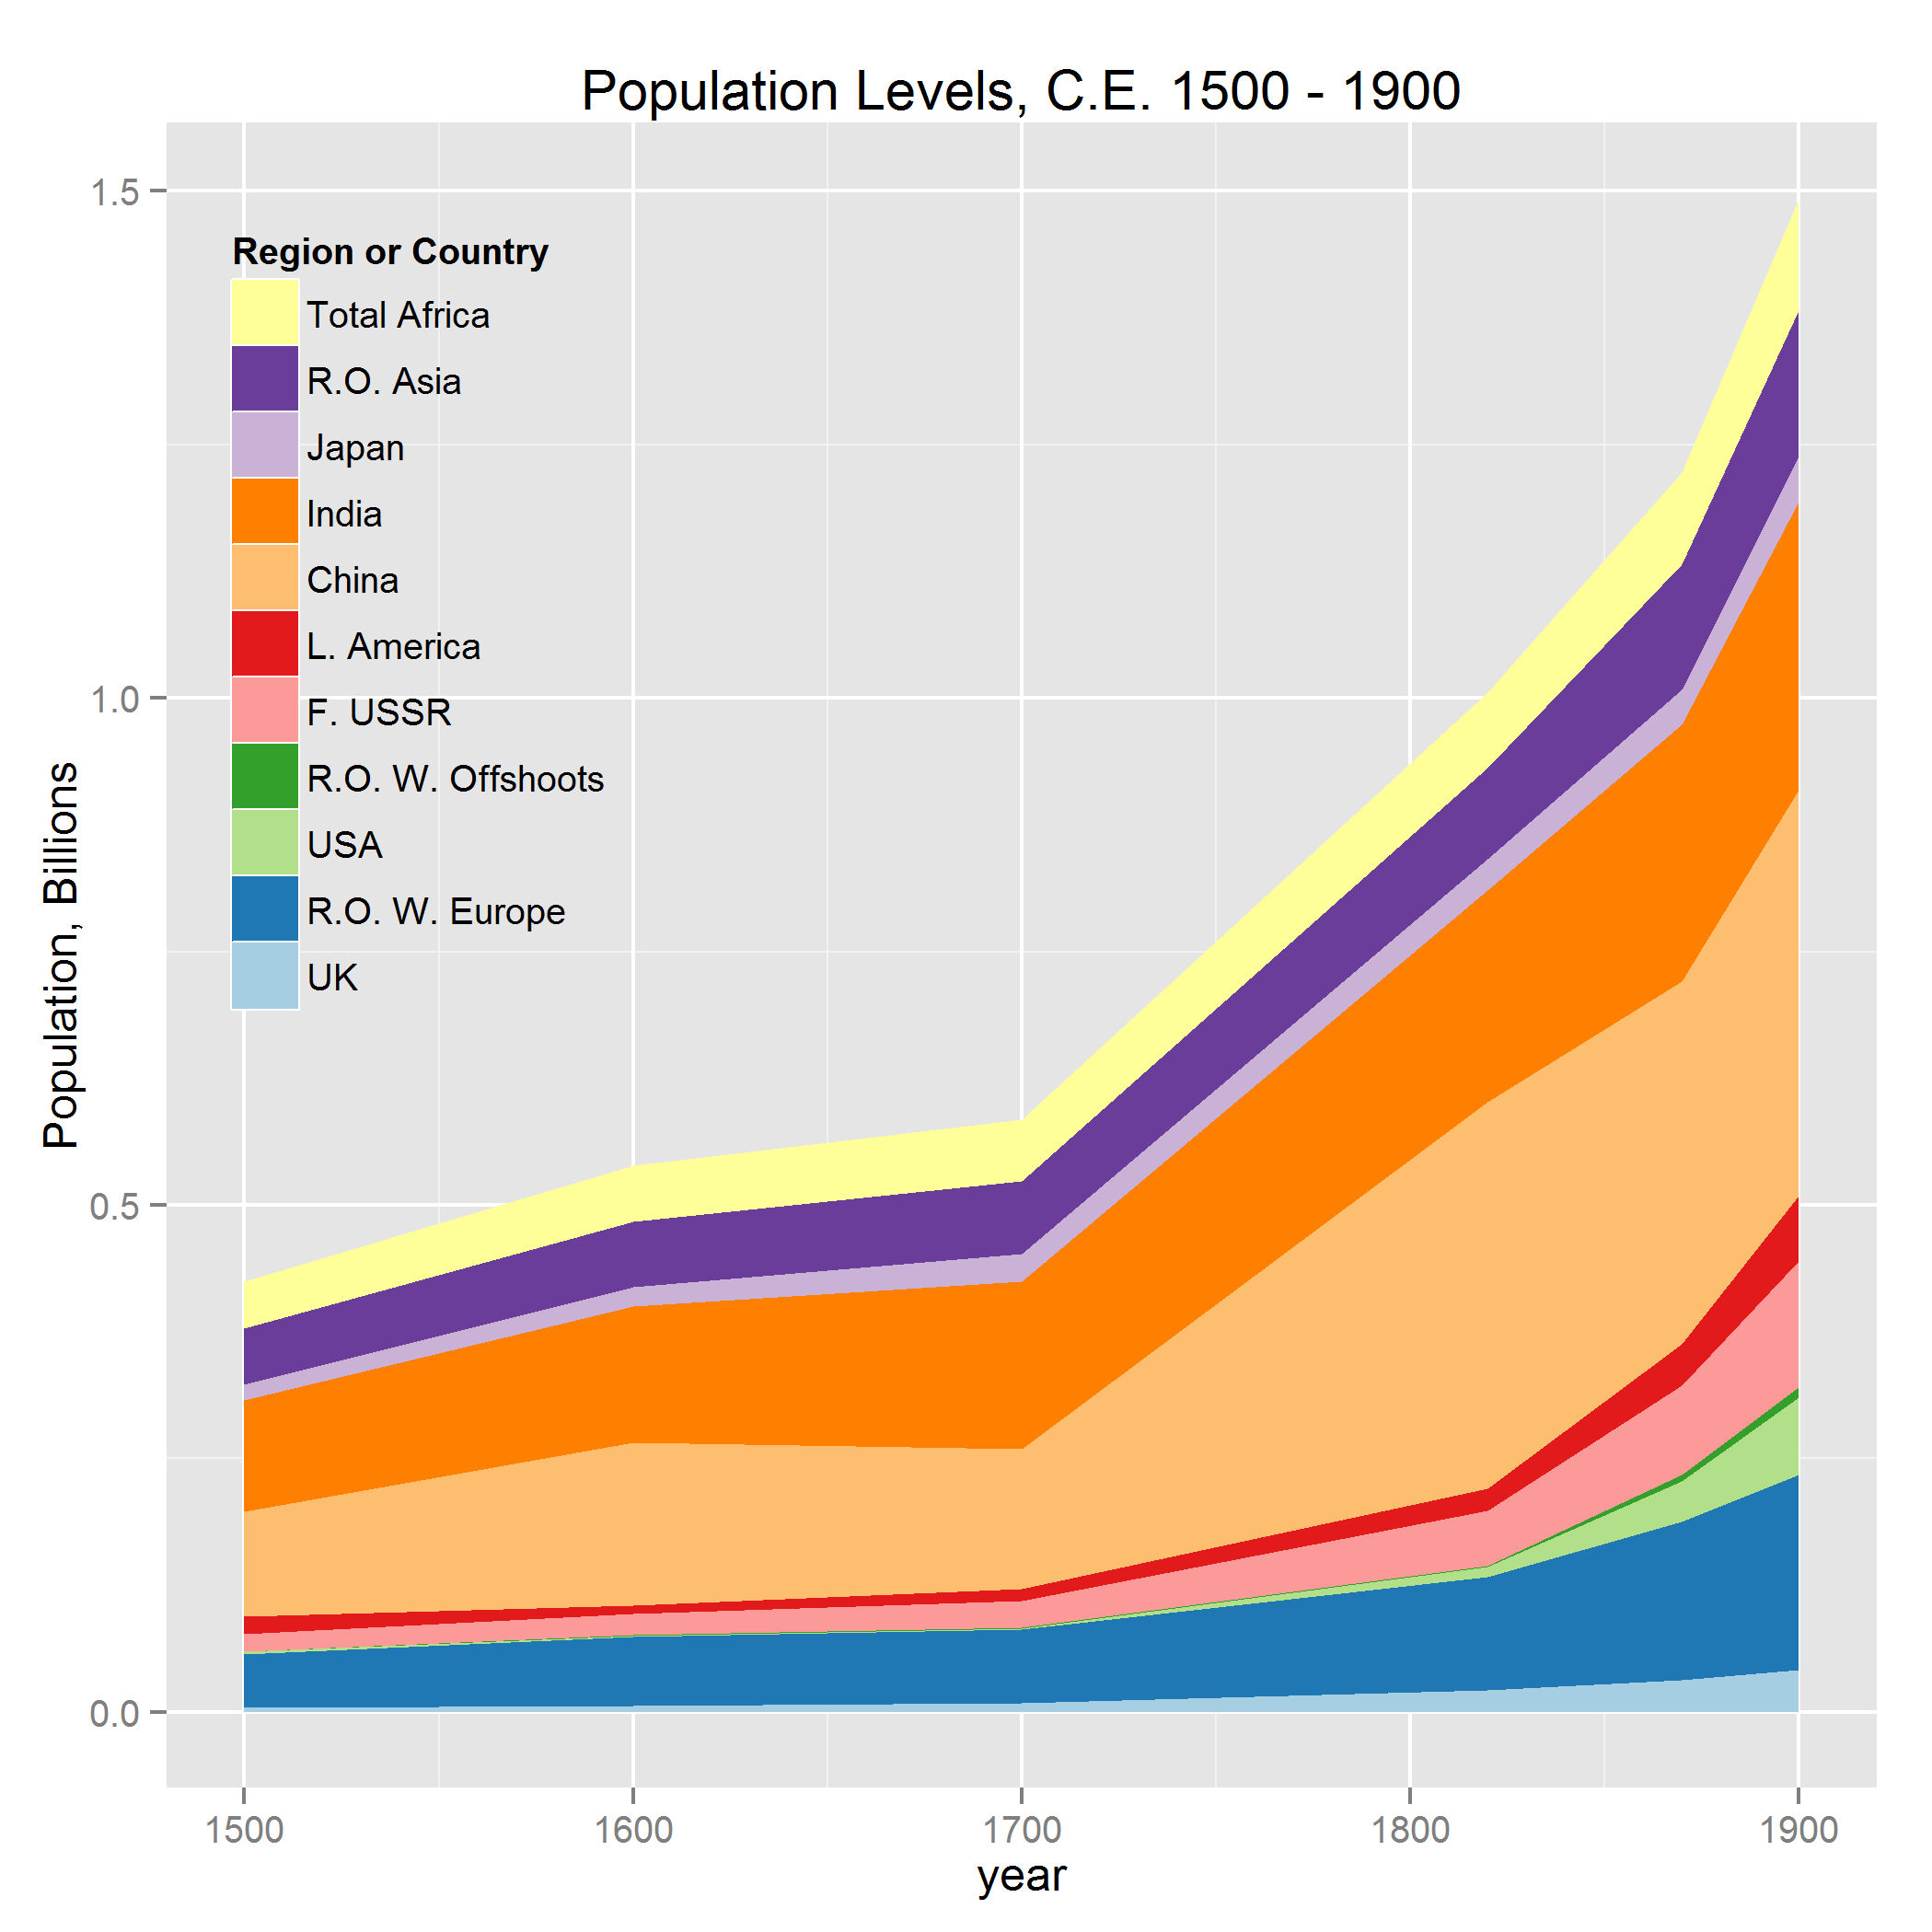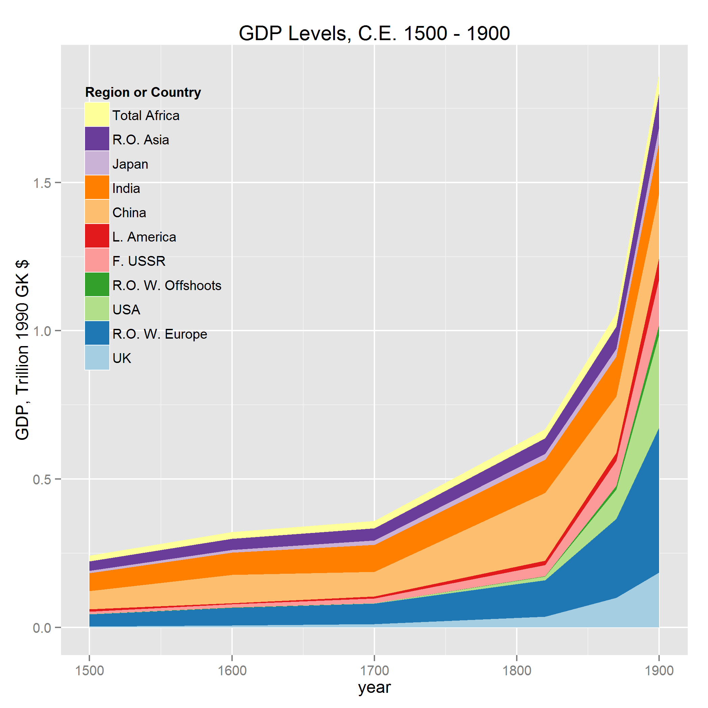
Figure 2: Angus Maddison: population and GDP levels 1500 – 1900
Figure 2 shows the Maddison world population and GDP level data for CE 1500 – 1900. Note that China and the rest of Asia dominate a growing world population after 1700; also note that after 1820 GDP growth in Western Europe and the offshoots begins to dominate accelerating world growth. An open demographic controversy is the pattern of a faster population growth rate in both Chinese and English proto-industrial periods, though on this chart the English growth is hard to see.

4.3 Population and GDP proportions

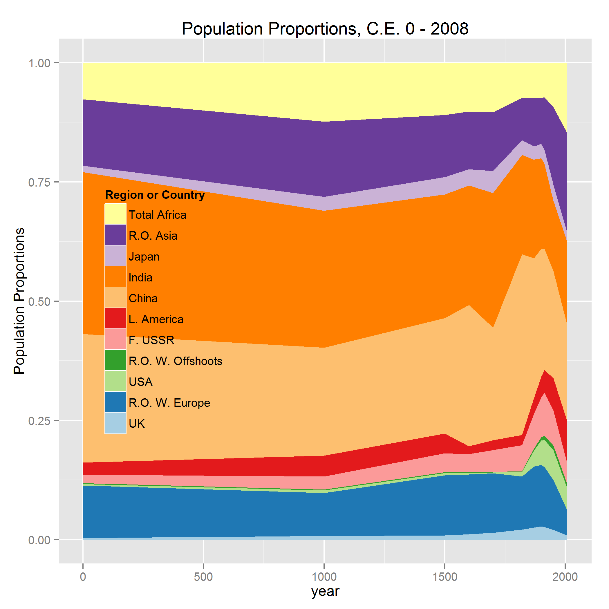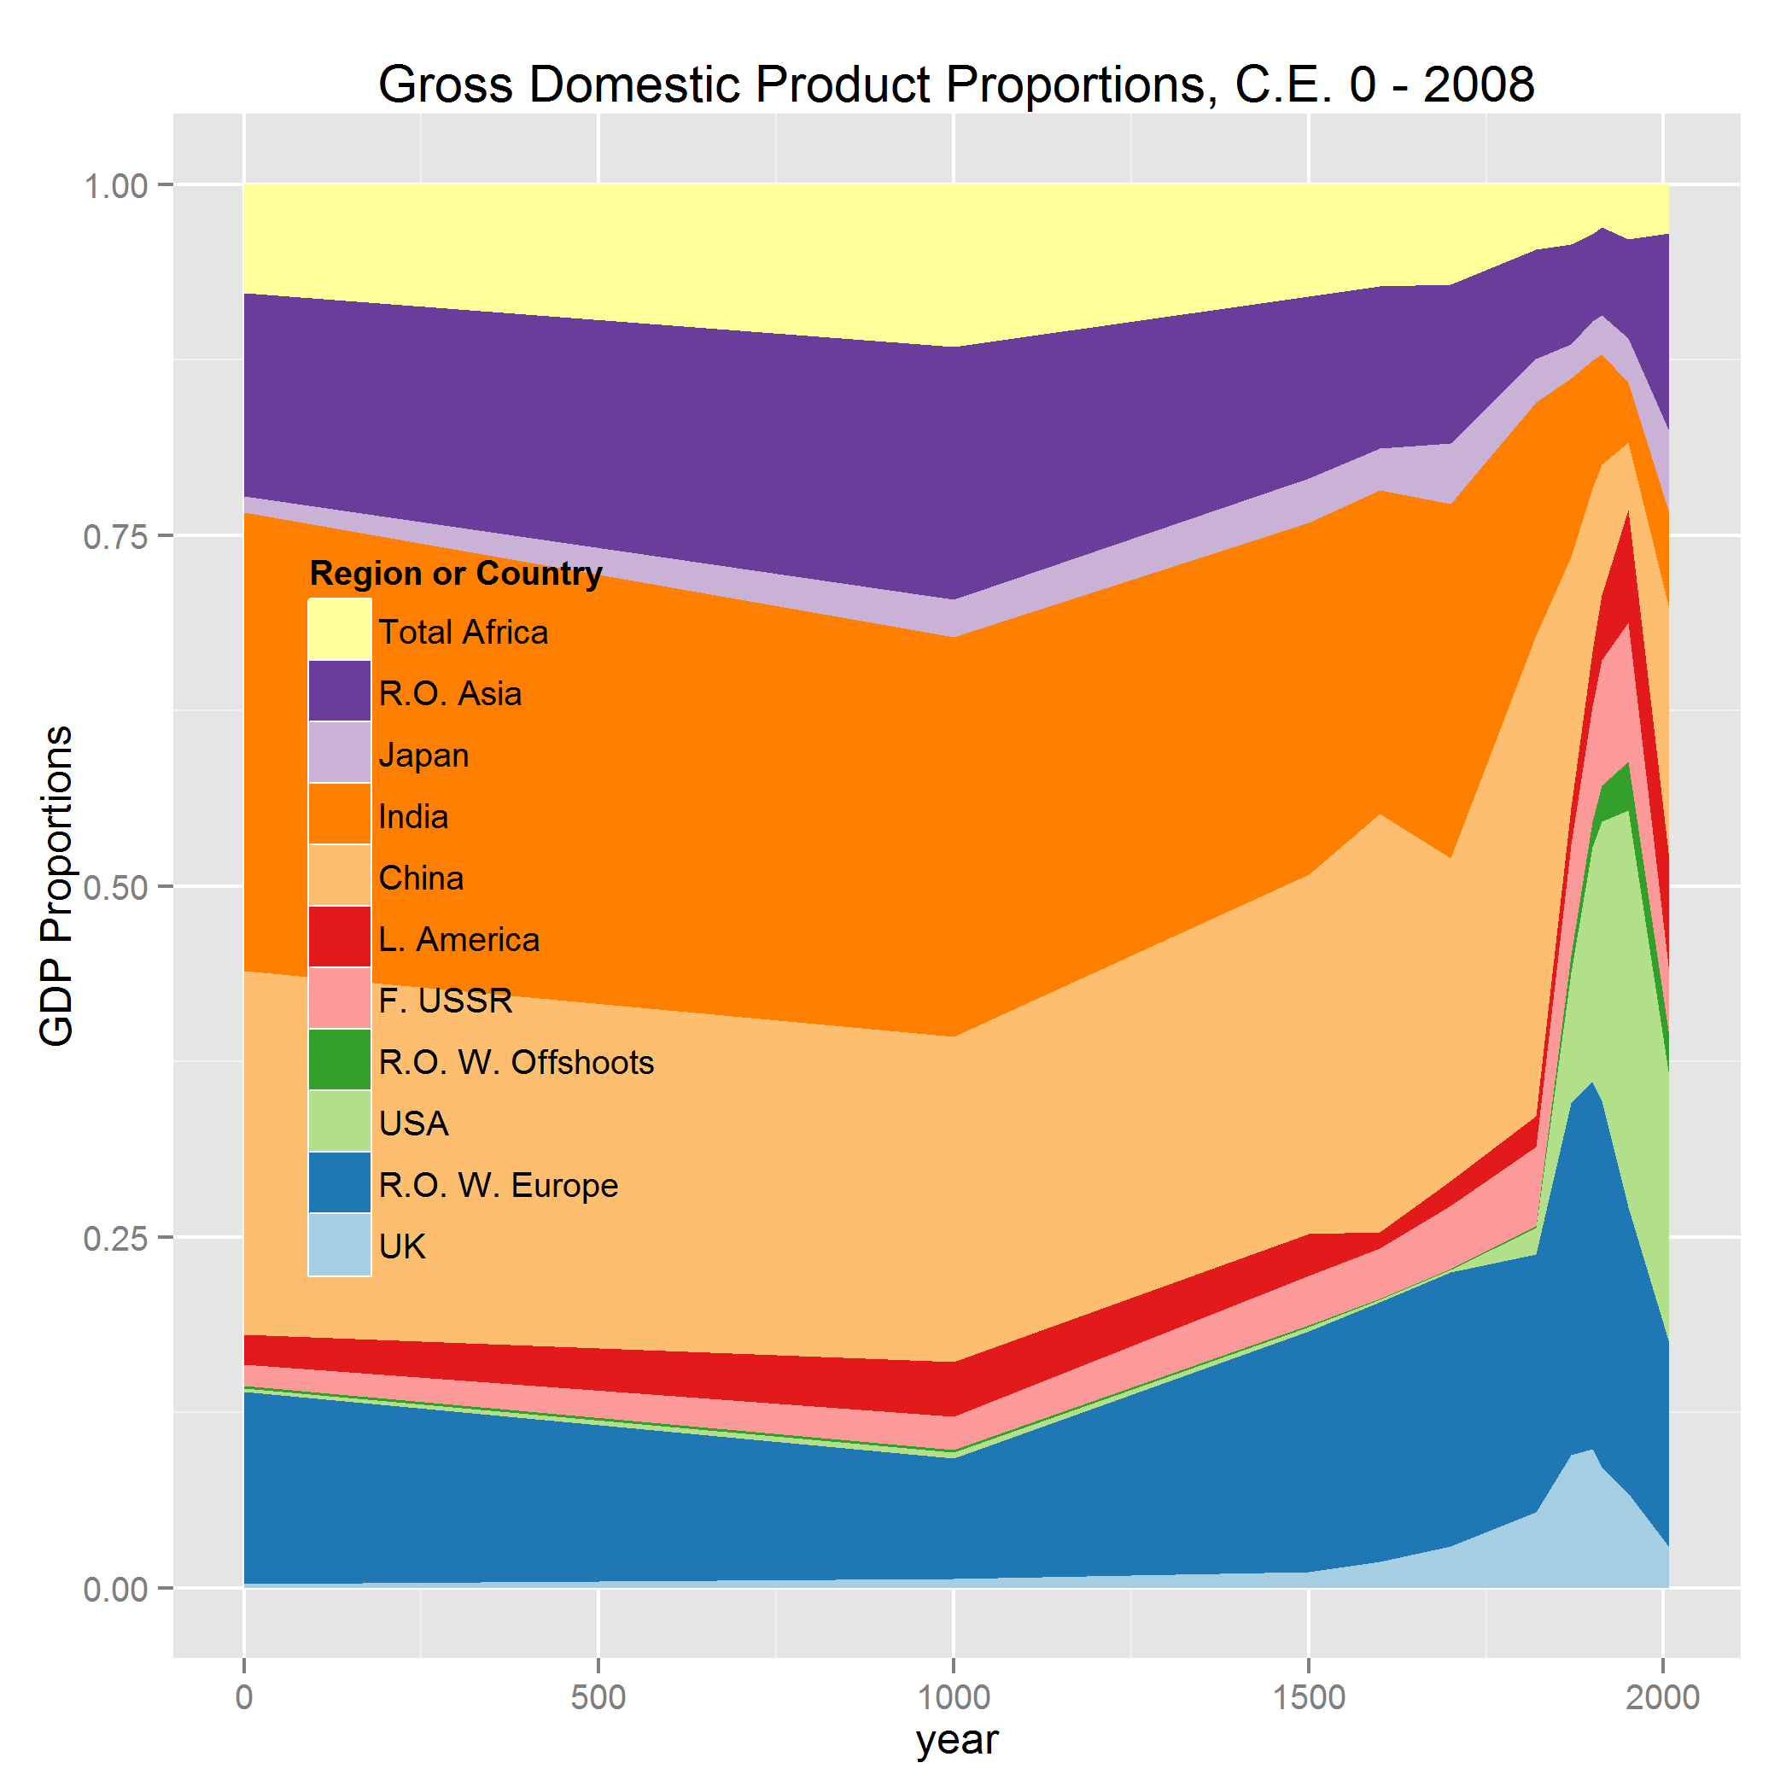
Figure 3: Angus Maddison: population and GDP proportions CE 1 – recent
Figure 3 emphasizes how China-led Asia dominates world population and GDP until the Industrial Revolution. Note that the China et al. GDP proportions decrease dramatically after 1820, and the population proportion also shows a decrease.

4.4 Comparative GDP per capita

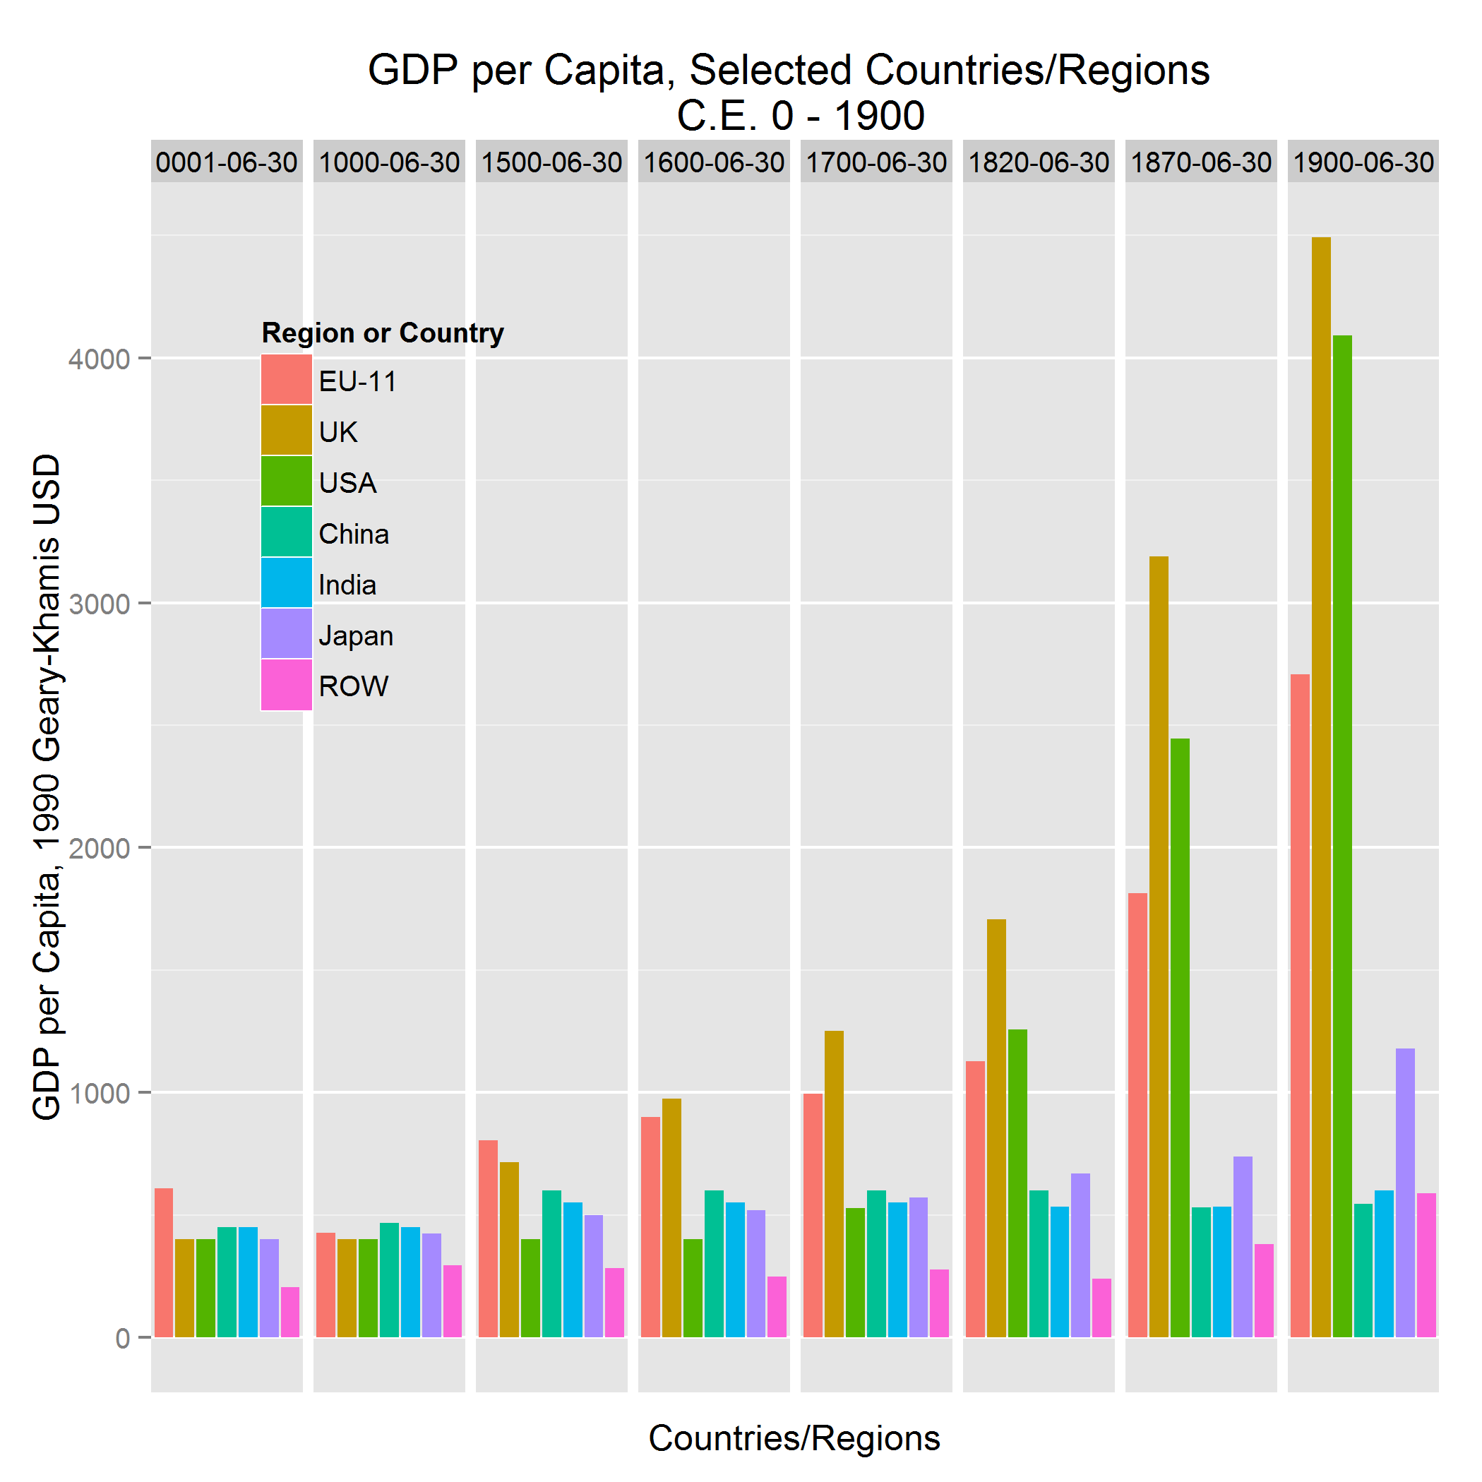
Figure 4: Comparative World Per Capita GDP
Figure 4 shows per capita GDP by regional and national groupings of interest from CE 1 through 1900, using the underlying Maddison data. Here, two facts stand out. First, China maintains a relatively constant level of per capita GDP throughout the period. Second, the grouping I called the EU-11, led by England, is increasing per capita GDP starting in 1500, with rapid increases after 1800. The Western Offshoots show a similar growth pattern of per capita GDP. The sustained standard of living increases resulting from the Industrial Revolution in Western Europe and Western Offshoots stand in stark contrast to China and the rest of the world.
The lack of a growth pattern in Chinese per capita GDP leads to a fascinating question: How much is our perception of this fact coloured by our century point-of-view? More formally, what would our expectations for the rate of growth of per capita GDP have been as an astute economic observer in century China? Or, for that matter, in England?
The evidence is that the classical economists had no expectations for any prolonged positive growth in GDP per capita because they had never observed that phenomenon. Thomas Malthus clearly represents the then widespread point-of-view that expectations were for subsistence GDP, essentially zero growth per capita levels forever. Thus our fascination with what actually happened, and our dramatically different modern expectations.
These charts represent highly aggregated numbers, and thus potentially mask important underlying structural and regional differences, especially in China. Kenneth Pomeranz, for example, asserts that the standard of living in China was equivalent to Western Europe in 1800 (somewhat different than the Maddison data), and that the standard of living wage levels in the Lower Yangzi region in China were at English levels in 1800. . Decomposing the standard of living into wages and cost-of-subsistence softens those differences except in the Lower Yangzi, but in any case we need to explain the post-1820 divergence.
The two main explanatory threads oppose each other: One thread appeals to institutional differences, the other to economic and geographic differences exploited by inventor/entrepreneurs. The essential factor to decode is the prime mover, recognizing that there are interaction effects over time which are surely important.
I question the institutional argument that the prime mover in the Industrial Revolution was English institutional exceptionalism, and set up the economic/geographical prime mover hypothesis; this suggests analyzing the growth divergence between China and England as an exercise in comparative micro- and macroeconomics. But first I examine the political economies to establish the essential institutional sufficiency for growth in each country.

4.5 Comparative Political Economies
The logic for rejecting institutional exceptionalism as prime is that whatever the institutional differences between China and England, there were sufficient similarities to yield similar economic results up until 1800 at least in the most comparable Chinese region, the Lower Yangzi. It is thus difficult to imagine sufficient institutional differences to cause such a dramatic divergence over the next century. This logic appeals to the work of R. Bin Wong and Kenneth Pomeranz.
First, comparative political economies in post-1500 late Imperial China and early modern Europe from R. Bin Wong:
“The Chinese state maintained an active interest in the agrarian economy, promoting is expansion over large stretches of territory and its stability through uneven harvest seasons…Despite considerable variation in techniques, there was basic agreement through the eighteenth century about the type of economy officials sought to stabilize and expand. They supported an agrarian economy in which commerce had an important role.”
“Mercantilism, the dominant philosophy of political economy in Europe between the late sixteenth and the early eighteenth century, posed a close relationship between power and wealth. For a state to become powerful, society had to become wealthier. This was achieved by expanding economic production in rich core areas and by extending trade across the country and especially beyond it…competition for wealth on a global scale became a component of European state making. European states promoted the production and commerce of their private entrepreneurs, whose successes contributed to the consolidation and prosperity of competing states.”
So Wong contrasts a Chinese imperial agrarian state interested in social stability with a group of European power elites competing over a zero-sum economic game with military Mercantilism. Yet, until the century divergence, roughly the same level of subsistence was the norm.
To Ken Pomeranz who evaluates Chinese and English, Asian and Western European, economic levels at more granular scales involving agriculture, transport, and livestock capital, longevity, health and nutrition, birthrates, accumulation, and technology.
“…as late as the mid-eighteenth century, western Europe was not uniquely productive or economically efficient…many other parts of the Old World were just as prosperous and “proto-industrial” or “proto-capitalist” as western Europe…What seems likely is that no part of the world was necessarily headed for such a [industrial] breakthrough.”
“…the production of food, fiber, fuel, and building supplies all competed for increasingly scarce land…western Europe…became a fortunate freak only when unexpected and significant discontinuities in the late eighteenth and especially nineteenth centuries enabled it to break through the fundamental constraints of energy use and resource availability that had previously limited everyone’s horizons…the new energy itself came largely from a surge in the extraction and use of English coal…”
So Pomeranz’s detailed comparative evaluation somewhat contradicts Maddison’s data, and highlights both institutional differences and similarities, but the differences are irrelevant in the end simply because England uniquely led the organic to mineral energy transition that was the revolutionary foundation for and the prime mover at the center of the Industrial Revolution.

4.6 The path: microeconomic incentives create emergent macro effects in a self-reinforcing positive feedback loop
What are the possible economic explanations for prime movers of the Industrial Revolution since the evidence for causal institutional exceptionalism appears insufficient?
There are at least two, one microeconomic and factor substitution driven and one macroeconomic.
Robert Allen proposes a relatively simple factor substitution argument that relies on differences in relative labour and energy prices between China and England, most dramatically between Newcastle and the rest of the world. Essential to his argument is that England, almost uniquely, was a high wage economy. This is illuminated in figure 5.

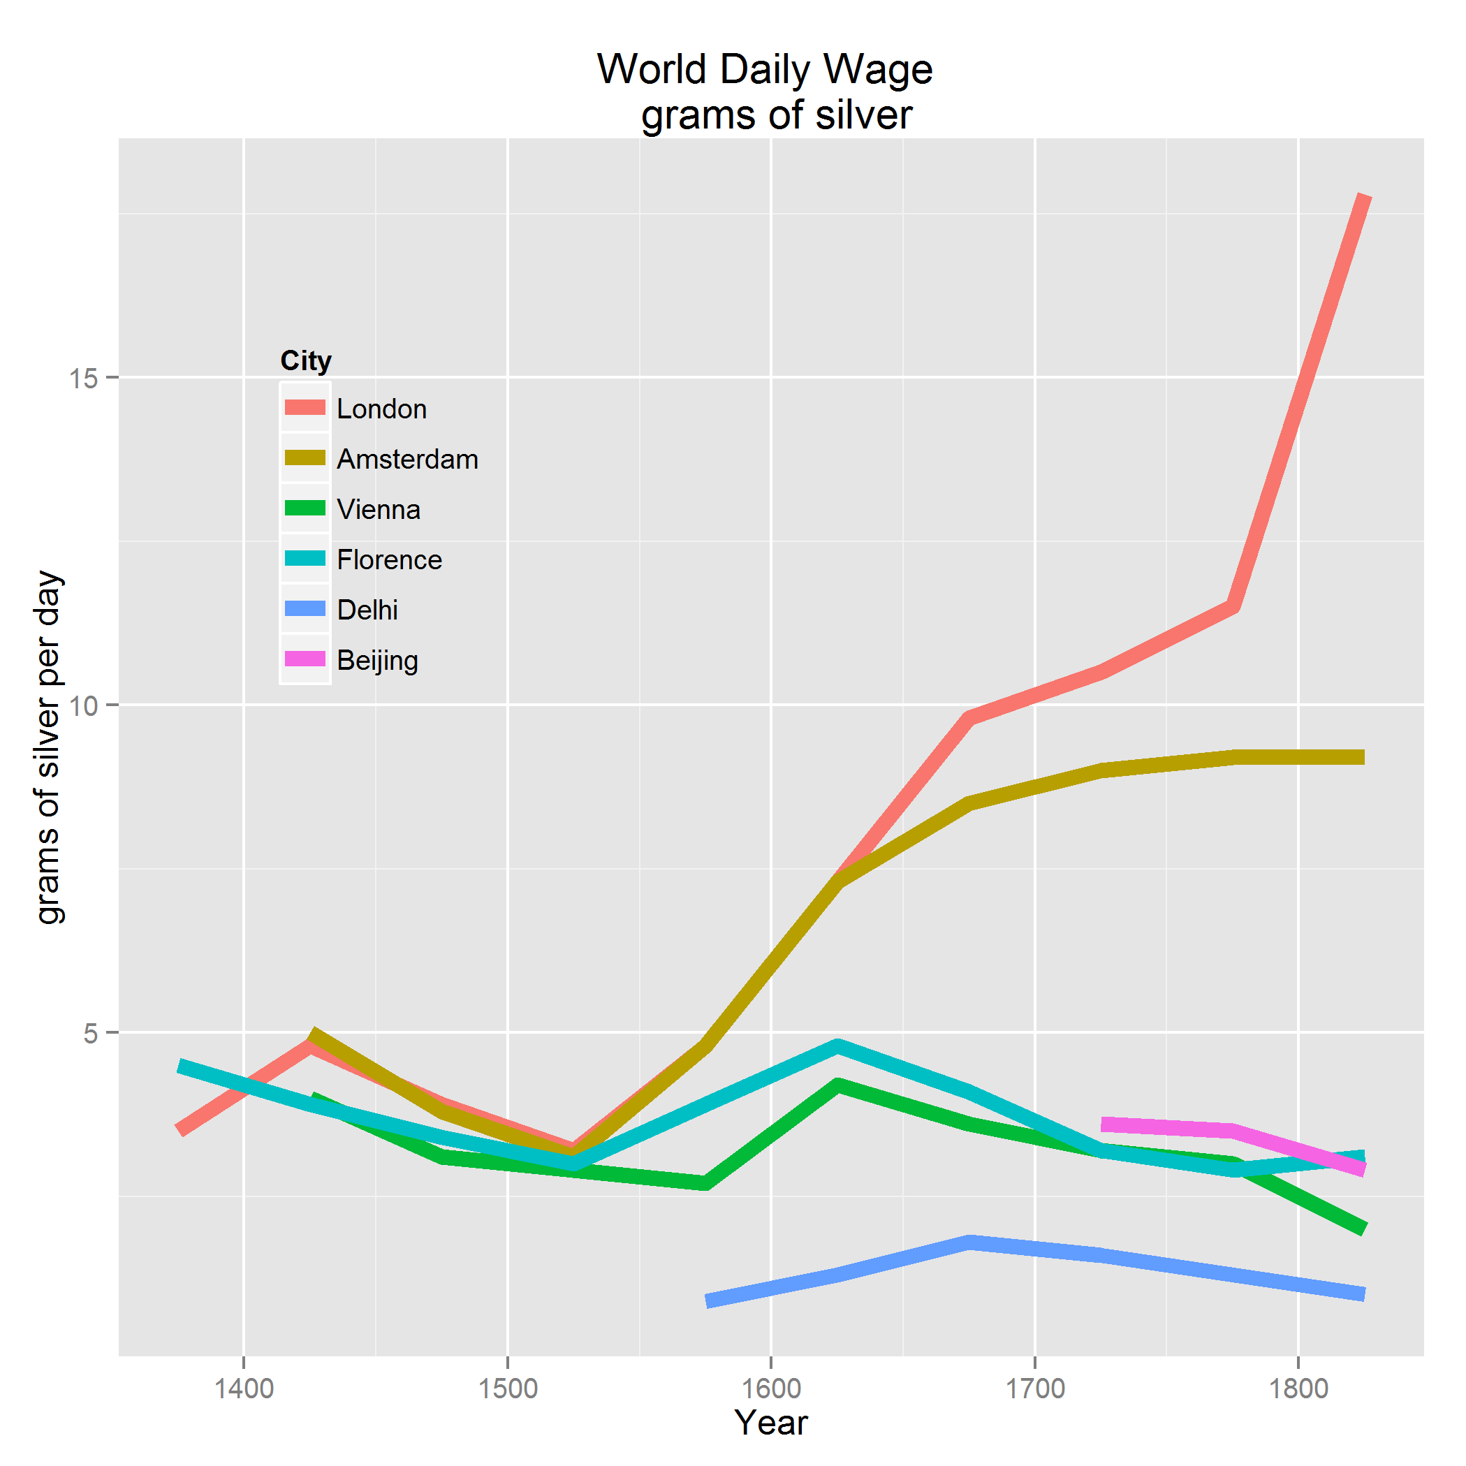
Figure 5: World wages, CE 1375 – 1825, source: Allen
He also examines world energy prices, which I do not reproduce here, though England had the lowest energy prices in the world. This led to a high English wages-to-energy prices ratio which fueled the energy transition, notably compared to China The basis for this argument can be seen in the next figure.

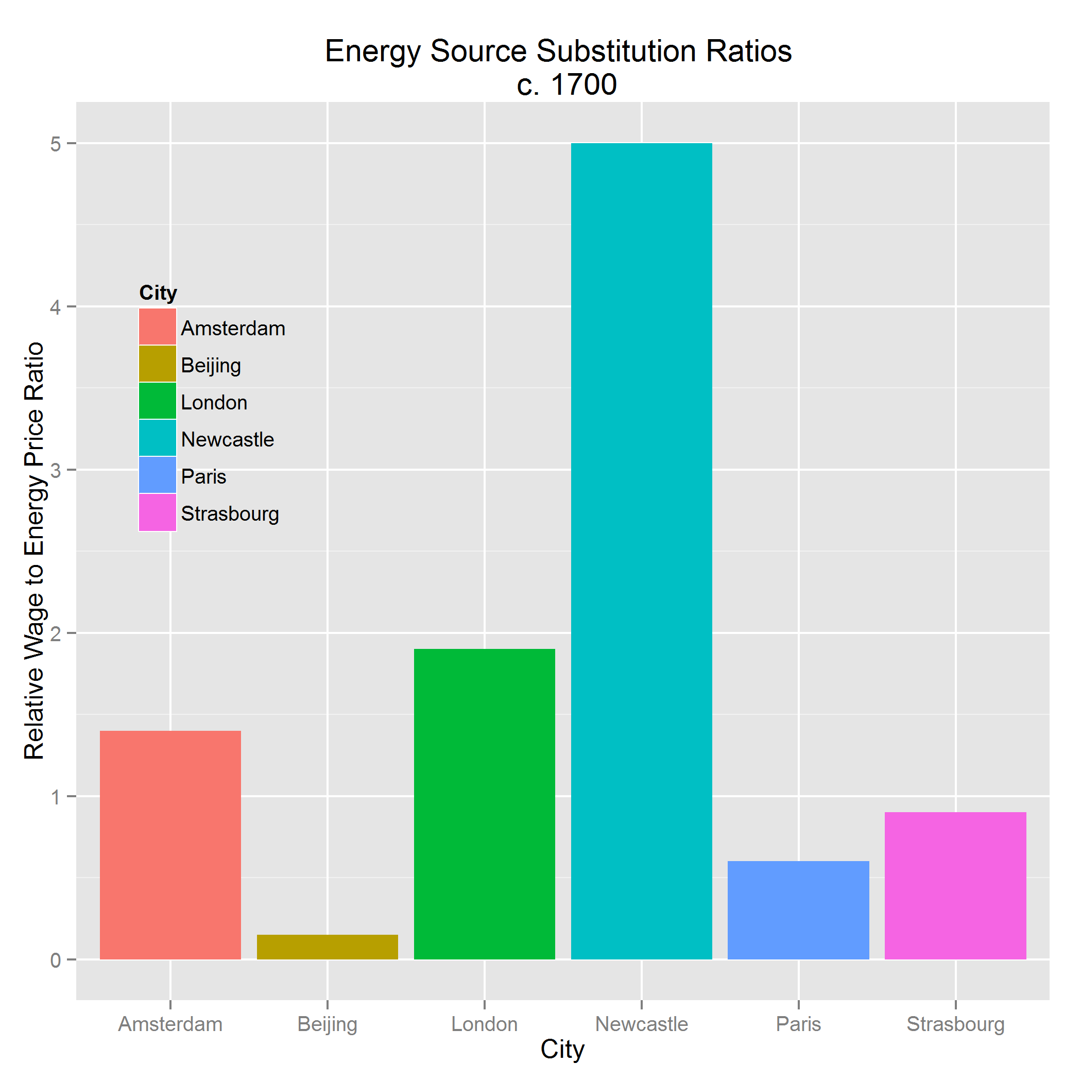
Figure 6: Wage/Energy ratios, 1700 CE, source: Allen
Figure 6 shows that the relative price ratio of wages to energy prices was highest in Newcastle and lowest in Beijing. Thus, there was a strong economic incentive to substitute coal energy for human energy in Newcastle and almost none in Beijing. This microeconomic effect is founded on London heating demand and with the spread of high wages, increasing demand for market-supplied consumer goods.
The effect of Allen’s graph can be explained using basic microeconomic theory. If an entrepreneur has two substitutable sources of energy inputs, say human and coal, her profit maximizing behaviour is described as in the following equation where the Marginal Revenue Product is the amount of revenue generated by the last joule that is input:
(1)
Assume that the production technology is neutral on the source of joules, i.e. an organicenergyjoule is equal in marginal revenue product to a mineralenergyjoule. Then if the price of mineral energy is much lower than the price of organic energy, as in the case of England, she will substitute coal for humans until the price of human energy equals the price of coal energy, which is probably never. That condition did not happen in China, so the micro-incentive never kicked in.
Allen further argues the following logic chain: Coal was plentiful and cheap in both Northwest and Northeast England. As London grew rapidly due to English success in international trade, London experienced high wages which spread throughout England, and faced increasing heating prices due to local deforestation. Thus, beginning in the century, the “coal-burning house” which was invented in London led English coal demand and production to increase. See figure 7.

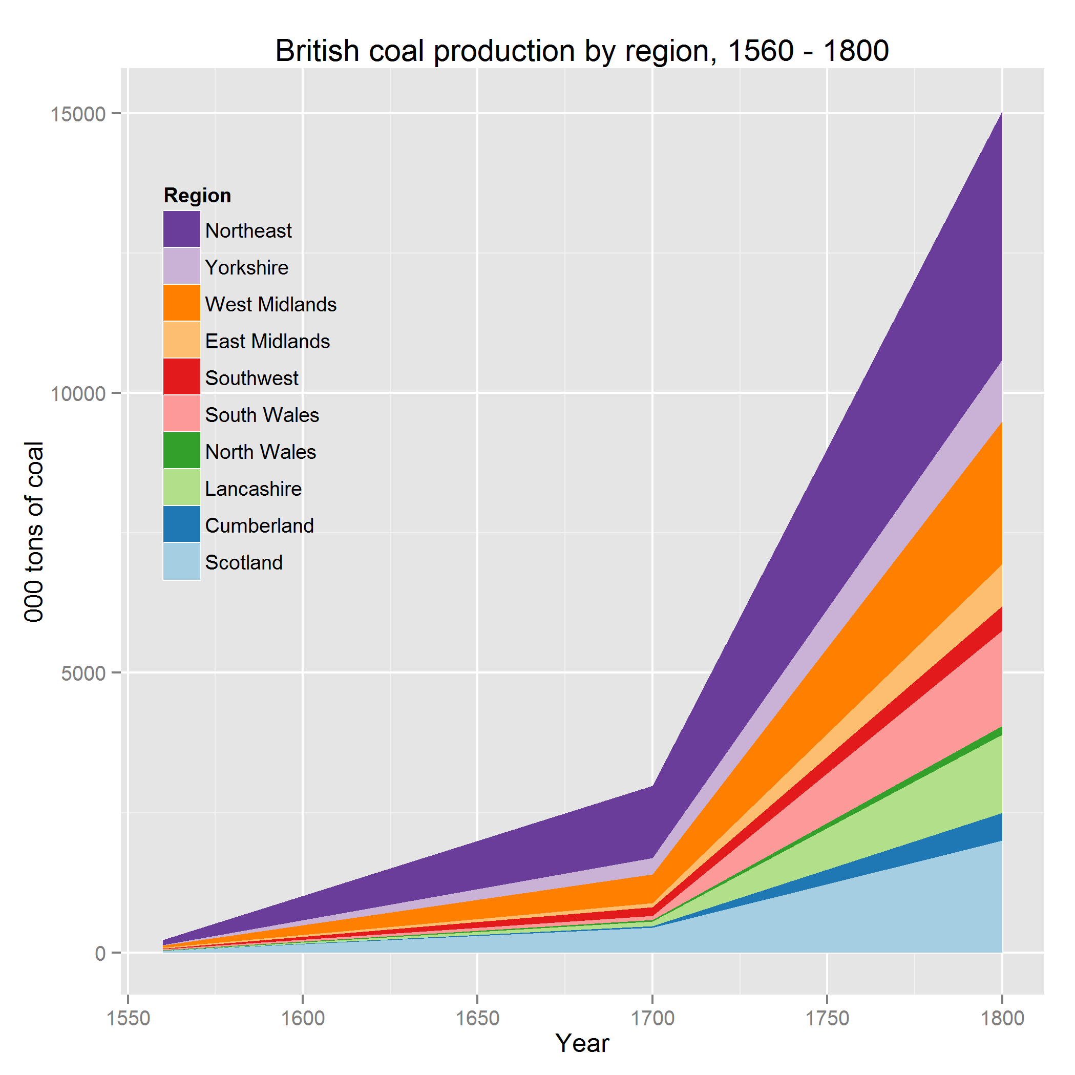
Figure 7: English coal production, CE 1560 – 1800. Source: Allen’s data, graph by author.
English coal mines had a problem with water infiltration; human or animal pumping became increasingly expensive and lacked scale as demand increased and the mines went deeper. The first real, practical use of the inefficiently crude Newcomen steam engines was to pump the water from the mines using otherwise surplus coal. As the inventions became more efficient, they became both the literal and figurative engines of the Industrial Revolution.
Ken Pomeranz tells a different story, an essentially macro story. Beyond his revisionist and contested view of century China and England being at essentially similar development levels, he contends that Western Europe was running out of land, was thus at the precipice of impending land scarcity. Pomeranz further contends the English escape was due to coal and colonies. To illustrate the dilemma I prepared the chart in figure 8.

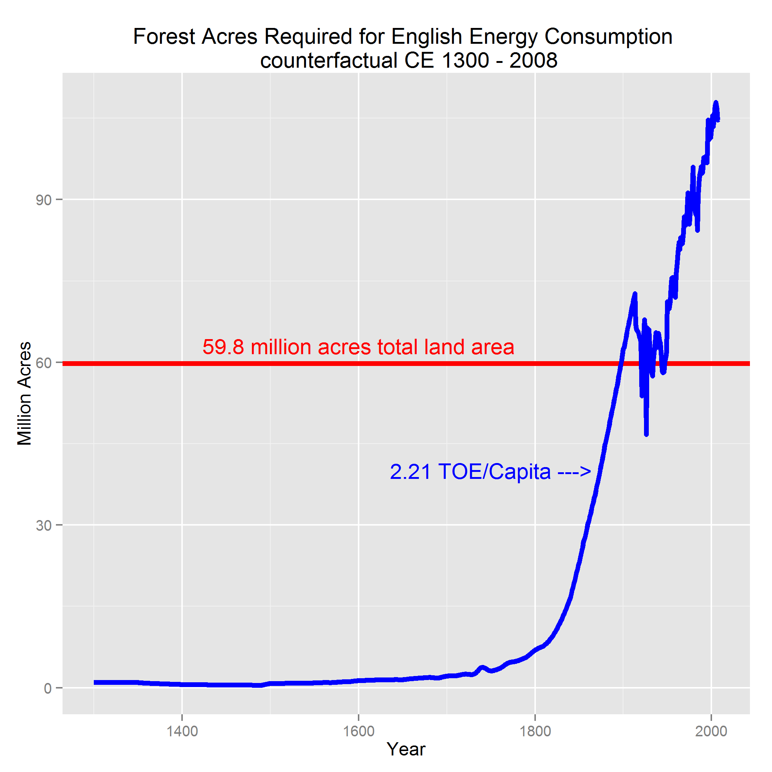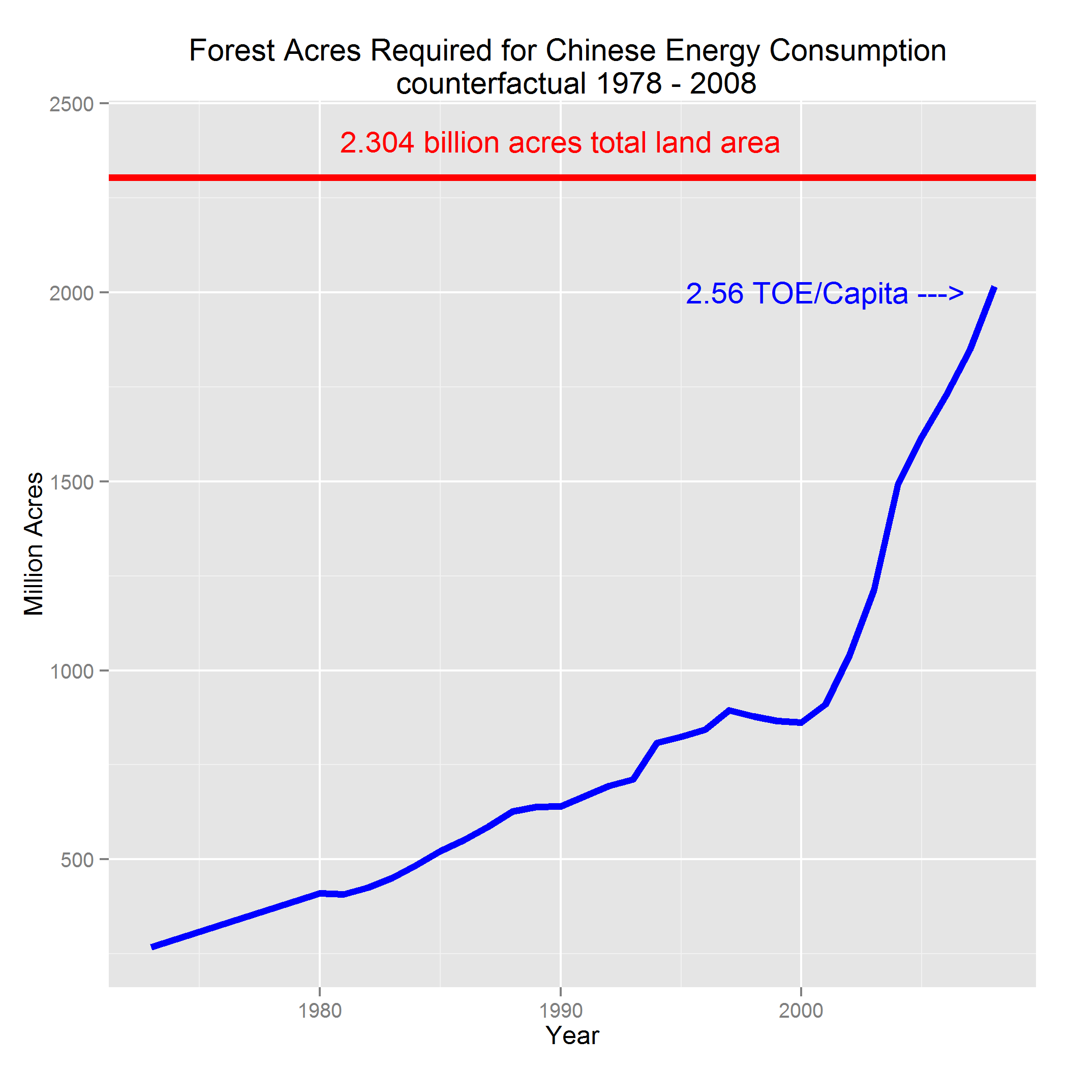
Figure 8: Projected English and Chinese wood fuel requirements. source: Roger Fouquet’s energy consumption data (England), U.S. DOE (China) and the author’s calculations.
Figure 8 is the result of a counterfactual exercise asking if it was feasible for England to meet its actual energy consumption demand during the Industrial Revolution without substituting coal for other sources – in this particular experiment wood. The graph shows that England would indeed have required all of its landmass to be forest in order to supply a sustainable fuel source to meet its energy requirements by the last quarter of the century. England “escaped” this bottleneck by learning how highly scalable mineral energy economies are. The graph for the Chinese counterfactual experiment, using recent energy consumption data, shows a similar pattern, and a remarkably similar outcome – China is now approaching the point at which the entire country would be forested if it had to provide its energy demand with wood.
To illustrate how powerful the virtuous feed-back cycle was from English entrepreneurs individually substituting coal for humans, figure 9 is a log of English energy consumption, showing the structural breaks and related change in slopes. The slope changes in this chart indicate a super-exponential growth in energy consumption, a signature of the English energy revolution.

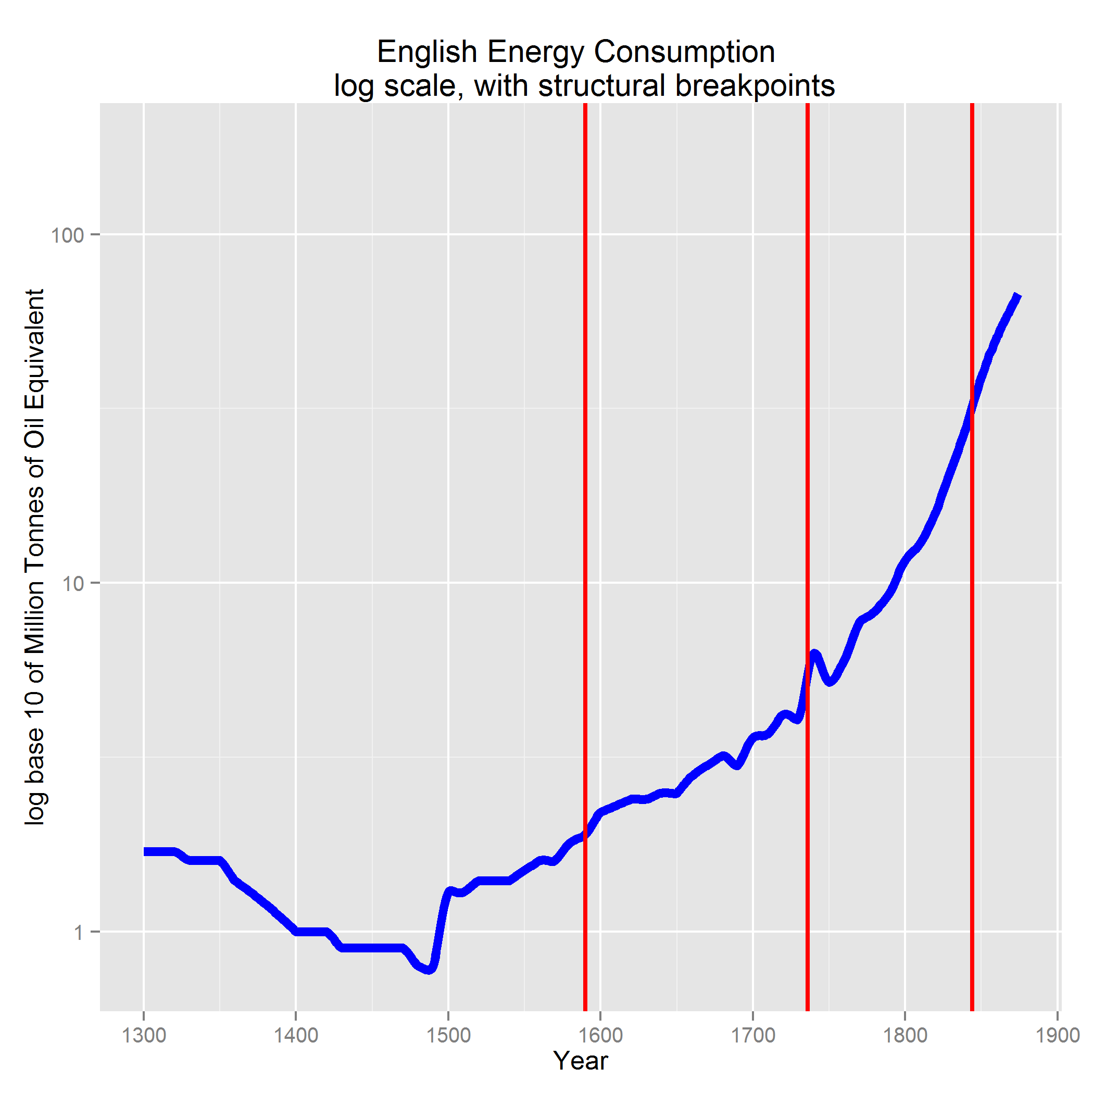
Figure 9: The English Energy Revolution, in logs source: Roger Fouquet’s energy consumption data and the author’s calculations.
Pomeranz further provides a macroeconomic story of the lack of a sustained mineral energy transition in China. What is stunning from his telling is that China did begin a coal-based energy transition in the century based on the large coal and iron deposits in North and Northwest China close to the then political, demographic, and economic center. Chinese iron production in 1080 likely exceeded non-Russian European production in 1700.
The region was then subjected to a series of “staggering catastrophes” including Mongol invasions and occupations, civil wars, enormous floods, and plague. The demographic and economic centers shifted south, incurring large transportation costs for raw materials. Coal-based industrialization never recovered until well into the century despite century attempts by the government to develop the mines to alleviate fuel shortages in the Lower Yangzi Delta.
Further, while this is an intriguing historical event, there is no evidence that the Chinese had any incentive to develop steam engines as the technical problem in the Chinese coalfields was (and is) ventilation to prevent spontaneous combustion, not the water pumping problem of English fields. And thus they did not develop industrial steam engines.

5 The empirical evidence
In other work related to my dissertation, I use English energy consumption time series dating to CE 1300 and establish a strong correlation over history between energy consumption and GDP.
Chinese historical energy data remains elusive, though my search continues. What follows is data from Angus Maddison and others, which is at least suggestive.
Maddison, in a 2003 paper, publishes a table titled “Primary Energy Consumption Per Capita, Major Countries, 1820 – 1998.” The units are metric tonnes of oil equivalent consumed per capita. This brief table, Table 1, summarizes the relevant data.

Year | England | China | Netherlands | India
1650 |  |  | 0.63
1820 | 0.61
1840 |  |  | 0.33
1870 | 2.21
1970 |  |  | 8.07 | 0.33
1973 |  | 0.48
1998 | 6.56 | 1.18
2008 | 5.99 | 2.56 | 9.86

Table 1: Per Capita Primary Energy Consumption, annual Tonnes of Oil Equivalent. Source: Angus Maddison, de Zeeuw, US DOE EIA
Energy consumption is the central theme in my theory of development, growth, and the Industrial Revolution. Chinese per capita energy consumption in 1973 was 79% of English consumption in 1820, and only 22% of English consumption in 1870.
Also, during those 50 years, the peak of the English Industrial Revolution, English per capita energy consumption increased by a factor of 3.6.
Vaclav Smil notes the following:
“By 1700 typical levels of energy use, and hence of material affluence, were still broadly similar in China and Western Europe. Then the Western advances gathered speed …By 1850 the two societies belonged to two different worlds. By 1900 they were separated by an enormous performance gap: Western European energy use was at least four times the Chinese mean.”
China, in the late century, finally started down what I hypothesize as the only path to development.

6 Conclusion
China failed make a permanent transition from organic energy to fossil mineral energy until 150 years after the English Industrial Revolution. The failure is not surprising given no other civilization had made the transition until the English and especially so considering the great luck in economics, geography, and geology the English enjoyed that supported their revolution. China did not enjoy that luck, except fleetingly. This was not an institutional failure.
England enjoyed success in international trade which caused a growing and high wage London population to deforest her environs. This created a demand for the cheap coal from the north to heat London and begin to substitute for high-wage labour.
Geographically, the northeast had tidewater coal, so was close to the cheapest bulk transport of the time, the sea. Also, the northwest had iron deposits, thus co-locating the ore and fuel to produce iron in an economically advantageous physical juxtaposition.
Geologically, the English coal fields were water infiltrated, leading to the invention, starting with Newcomen, of ever more efficient coal-fired steam engines capable of powering the Industrial Revolution. These replaced high wage English labour in English factories and thus created an Industrial scale far beyond anything human or animal power was capable of. The engines also became the foundation of the century railroad- and steamship-driven transportation revolution.
These three fortunate juxtaposed events caused the Industrial Revolution, the great transition in food, fuel, fiber, and building materials that determined the economic future of the world.
China, ironically, experienced an early coal-fired iron revolution that never had the opportunity to develop into a sustained energy transition due to the bad luck of two centuries of “staggering catastrophes.” The economic and demographic center shifted away from the advantaged region, and the industry did not recover. China did not experience the economic drivers of high wages and cheap energy.
Further, China’s mine geology did not have the paradoxically favorable water-infused conditions that led to English steam-power engine superiority.
Yet, China’s early century energy transition success suggests that geographical luck is prime in the Industrial Revolution, not institutional exceptionalism. The essentially the same institutions that existed then existed in the and centuries when China failed to make the transition with different geo-spatial economic conditions.
The empirical evidence on energy consumption, sparse though it currently is, strongly suggests a Chinese economy that failed to make the development-crucial energy transition until late in the century.

7 Bibliography
References
Allen2009allen\s\do6(b)ritish\s\do6(2)009 Allen, R. C. 2009, The British Industrial Revolution in Global Perspective, 1 edn, Cambridge University Press.
Crosby1972crosby\s\do6(c)olumbian\s\do6(1)972 Crosby, A. W. 1972, The Columbian exchange; biological and cultural consequences of 1492, Contributions in American studies, no. 2, Greenwood Pub. Co, Westport, Conn.
Fouquet2008fouquet\s\do6(h)eat\s\do6(2)008 Fouquet, R. 2008, Heat, power and light : revolutions in energy services, Edward Elgar, Cheltenham ; Northampton, MA.
Maddison2003maddison\s\do6(g)rowth\s\do6(2)003 Maddison, A. 2003, ‘Growth accounts, technological change, and the role of energy in western growth’, Economia e Energia Secc. XIII-XVIII .
Maddison2010maddison\s\do6(m)addison\s\do6(2)010 Maddison, A. 2010, ‘Maddison data’, http://www.ggdc.net/.
http://www.ggdc.net/
Needham Wang1954needham\s\do6(s)cience\s\do6(1)954 Needham, J. Wang, L. 1954, Science and Civilisation in China, University Press, Cambridge [Eng.].
Pomeranz2001pomeranz\s\do6(g)reat\s\do6(2)001 Pomeranz, K. 2001, The Great Divergence: China, Europe, and the Making of the Modern World Economy., revised edn, Princeton University Press.
Smil1994smil\s\do6(e)nergy\s\do6(1)994 Smil, V. 1994, Energy In World History, Westview Press.
Wong1997wong\s\do6(c)hina\s\do6(1)997 Wong, R. B. 1997, China transformed: historical change and the limits of European experience, Cornell Univ Pr.

7.1 image/script/data table

png image | script | data file
maddisonregpoplevels | maddison.gdp.R | maddison.reg.pop.csv
maddisonreggdplevles | maddison.gdp.R | maddison.reg.gdp.csv
maddisonregpoplevels1900 | maddison.gdp.R | maddison.reg.pop.csv
maddisonreggdplevels1900 | maddiosn.gdp.R | maddison.reg.gdp.csv
maddisonregpoppct | maddison.gdp.R | maddison.reg.pop.pct.csv
maddisonreggdppct | maddison.gdp.R | maddison.reg.gdp.pct.csv
ggdpcapitadodge | gdppop.R | gdp.ex.csv,pop.ex.csv
gworldwages | allen_energy.R | allen_wages1.csv
wage-energy | defense.R | df with ratio,city names
allen_coal | allen_coal.R | allen_coal.csv
wood | defense.R | gothenburg.Rdata
chinawood | defense.R | china.energy.csv
gbmtoelog | defense.R | dissert.RData

List of Figures

following the Sherlock Holmes story “Silver Blaze” by Sir Arthur Conan Doyle, Holmes was able to deduce that the killer of Colonel Ross’s racehorse was the owner of the stable dog, the dog that did not bark. What does not happen is often as important as what does.
Maddison (2010)
Needham & Wang (1954)
Maddison (2010)
Pomeranz (2001, p. 22)
One theory (Alfred Crosby and others) has it that the arrival in Europe and China of American crops like maize and potatoes increase agricultural productivity per land unit by 3 or 4 times, enabling a level rise in otherwise Malthusian subsistence population levels. Crosby (1972)
The EU-11 grouping includes Austria, Belgium, Denmark, Finland, France, Germany, Italy, the Netherlands, Norway, Sweden, and Switzerland.
The Western Offshoots are statistically dominated by the United States, but also include Canada, Australia, and New Zealand.
Pomeranz (2001, p. 107)
Wong (1997, pp. 115 – 116)
Wong (1997, p. 140)
Pomeranz (2001, pp. 206 – 207)
We can proceed either with a neo-classical factor substitution argument, or a more general classical view of normal prices of production. Either approach will react to the enormous productivity-enhancing energy supply shock that was the Industrial Revolution. The more classical story benefits from exploring how effective aggregate demand rises during the period. High English wages support this argument.
Allen (2009, p. 34)
Allen (2009, p. 140)
Allen (2009, p. 82)
Allen (2009, pp. 86 – 93)
Allen (2009, p. 264)
Fouquet (2008)
Pomeranz (2001, p. 62)
Pomeranz (2001, p. 62)
Maddison (2003, p. 10)
Smil (1994, p. 234)

