**Nama : Reihan Al Sya’Ban**

**NIM : 2109106051**

**SOURCE CODE**

#include<iostream>

#include<conio.h>

#include<stdlib.h>

#include<fstream>

#include<sstream>

#include<string>

using namespace std;

struct pahala{

int nomor;

string nama;

int sedekah;

};

int sizee;

pahala phl[100];

fstream file_phl;

//FUNGSI IMPORT DATA DARI FILE KE PROGRAM

void import(){

file_phl.open("posttest7_saban.txt", ios::in);

string nomor, sedekah;

while(!file_phl.eof()){

getline(file_phl, nomor, ',');

getline(file_phl, phl[sizee].nama, ',');

getline(file_phl, sedekah, '\n');

stringstream strnomor(nomor);

stringstream strsedekah(sedekah);

strnomor>>phl[sizee].nomor;

strsedekah>>phl[sizee].sedekah;

if(file_phl.eof()){

break;

}

sizee++;

}

file_phl.close();

}

//FUNGSI UNTUK MENGECEK FILE EKSTERNAL

void file_check(){

file_phl.open("posttest7_saban.txt", ios::in);

if (!file_phl.is_open()){

file_phl.open("posttest7_saban.txt", ios::out | ios::trunc);

file_phl.close();

}

file_phl.close();

}

//FUNGSI MENGUPDATE ISI FILE SETELAH DIUBAH

void update_file(){

file_phl.open("posttest7_saban.txt", ios::out);

for (int x=0; x<sizee; x++){

file_phl<<phl[x].nomor<<',';

file_phl<<phl[x].nama<<',';

file_phl<<phl[x].sedekah<<'\n';

}

file_phl.close();

}

//BUBBLE SORT

void bubble(pahala phl[], int size){

int tipe;

pahala swap;

cout<<"================== MENU SORT ==================\n"

<<"=============== TIPE PENGURUTAN ===============\n"

<<"\n"

<<"1. Ascending\n"

<<"2. Descending"

<<"\n"

<<"Pilih : ";

cin>>tipe;

system("cls");

switch(tipe){

case 1:

for (int x=0; x<size-1; x++){

for(int y=0; y<size-1; y++){

if(phl[y].nama > phl[y+1].nama){

swap = phl[y];

phl[y] = phl[y+1];

phl[y+1] = swap;

}

}

}

break;

case 2:

for(int x=0; x<size-1; x++){

for(int y=0; y<size-1; y++){

if(phl[y].nama < phl[y+1].nama){

swap = phl[y];

phl[y] = phl[y+1];

phl[y+1] = swap;

}

}

}

break;

break;

}

}

void swap(pahala *xp, pahala *yp){

pahala temp = *xp;

*xp = *yp;

*yp = temp;

}

//SELECTION SORT

void selection(pahala phl[], int size){

int min;

int tipe;

cout<<"================== MENU SORT ==================\n"

<<"=============== TIPE PENGURUTAN ===============\n"

<<"\n"

<<"1. Ascending\n"

<<"2. Descending"

<<"\n"

<<"Pilih : ";

cin>>tipe;

system("cls");

for (int x=0; x<size-1; x++){

min = x;

for (int y=x+1; y<size; y++){

switch (tipe){

case 1:

if (phl[y].sedekah < phl[min].sedekah){

min = y;

}

break;

case 2:

if (phl[y].sedekah > phl[min].sedekah){

min = y;

}

break;

}

}

swap(&phl[x], &phl[min]);

}

}

//QUICK SORT

int partition_ascen(pahala phl[], int low, int high){

int pivot = phl[high].nomor;

int x=(low - 1);

for (int y=low; y<=high- 1; y++){

if (phl[y].nomor <= pivot){

x++;

swap(&phl[x], &phl[y]);

}

}

swap(&phl[x + 1], &phl[high]);

return (x + 1);

}

int partition_descen (pahala phl[], int low, int high){

int pivot = phl[high].nomor;

int x=(low - 1);

for (int y=low; y<=high- 1; y++){

if (phl[y].nomor >= pivot){

x++;

swap(&phl[x], &phl[y]);

}

}

swap(&phl[x + 1], &phl[high]);

return (x + 1);

}

void quick_ascen(pahala phl[], int low, int high){

if (low < high){

int pi = partition_ascen(phl, low, high);

quick_ascen(phl, low, pi-1);

quick_ascen(phl, pi+1, high);

}

}

void quick_descen(pahala phl[], int low, int high){

if (low < high){

int pi = partition_descen(phl, low, high);

quick_descen(phl, low, pi-1);

quick_descen(phl, pi+1, high);

}

}

//FUNGSI MENAMBAHKAN DATA INPUTAN USER KE DALAM FILE

void create(){

file_phl.open("posttest7_saban.txt", ios::app);

int banyakdonate, banyakdata;

cout<<"Masukkan berapa banyak jumlah donatur : ";

cin>>banyakdonate;

cout<<"\n";

banyakdata = 0;

for(int x=0; x<banyakdonate; x++){

banyakdata = sizee + 1;

cout<<"Nomor Donatur : "<<banyakdata<<endl;

phl[sizee].nomor = banyakdata;

cout<<"Nama : ";

cin>>phl[sizee].nama;

cout<<"Jumlah Sedekah : Rp.";

cin>>phl[sizee].sedekah;

cout<<"\n";

file_phl<<phl[sizee].nomor<< ',';

file_phl<<phl[sizee].nama<< ',';

file_phl<<phl[sizee].sedekah<< '\n';

sizee++;

}

cout<<"DATA BERHASIL DITAMBAHKAN\n";

cout<<"\n";

cout<<"TEKAN ENTER UNTUK KEMBALI KE MENU AWAL";

getch();

system("cls");

file_phl.close();

}

//FUNGSI MELIHAT DATA

void read(){

cout<<"\n";

cout<<"DATA DONATUR\n";

cout<<"\n";

for(int indeks=0; indeks<sizee ; indeks++){

cout<<"Nomor Donatur : "<<phl[indeks].nomor<<endl;

cout<<"Nama : "<<phl[indeks].nama<<endl;

cout<<"Jumlah Sedekah : Rp. "<<phl[indeks].sedekah<<endl;

cout<<"\n";

}

cout<<"TEKAN ENTER UNTUK KEMBALI KE MENU AWAL";

cout<<"\n";

getch();

system("cls");

}

//DRIVER SORTING

void sort_menu(){

system("cls");

int pilih, tipe;

if (sizee==0){

cout << "DATA KOSONG !!! ";

getch();

system("cls");

}

else if (sizee>0){

cout<<"================== MENU SORT ==================\n"

<<"============== URUTKAN BERDASAR ==============\n"

<<"\n"

<<"1. Nomor Donatur\n"

<<"2. Nama Donatur\n"

<<"3. Jumlah Sedekah\n"

<<"\n"

<<"Masukkan pilihan: ";

cin>>pilih;

if (pilih==1){

cout<<"================== MENU SORT ==================\n"

<<"=============== TIPE PENGURUTAN ===============\n"

<<"\n"

<<"1. Ascending\n"

<<"2. Descending"

<<"\n"

<<"Pilih : ";

cin>>tipe;

system("cls");

switch (tipe){

case 1:

quick_ascen(phl, 0, sizee-1 );

read();

break;

case 2:

quick_descen(phl, 0, sizee-1 );

read();

break;

}

}

else if (pilih==2){

bubble(phl, sizee);

read();

}

else if (pilih==3){

selection(phl, sizee);

read();

}

else{

cout << "Pilihan tidak ada\n";

getch();

system("cls");

}

}

}

//FUNGSI SEARCH NAMA (BINARY SEARCH)

int binary_search(int pilih){

cout<<endl;

string num;

int beg = 0;

int end=sizee-1;

int index= -1;

cout<<"Nama yang dicari : ";

cin>>num;

switch (pilih){

case 1:

for (int x=0; x<sizee-1; x++){

for(int y=0; y<sizee-1; y++){

if(phl[y].nama>phl[y+1].nama){

pahala swap = phl[y];

phl[y] = phl[y+1];

phl[y+1] = swap;

}

}

}

while(beg<=end){

int mid=(end+beg)/2;

if(phl[mid].nama==num){

index = mid +1;

for (int x=0; x<sizee; x++){

if(phl[mid].nama==phl[x].nama){

cout<<"Nomor Donatur : "<<phl[x].nomor<<endl;

cout<<"Nama : "<<phl[x].nama<<endl;

cout<<"Jumlah Sedekah : Rp. "<<phl[x].sedekah<<endl;

cout<<"\n";

}

getch();

}

break;

}

else{

if(num>phl[mid].nama){

beg= mid+1;

}

else{

end=mid-1;

}

}

}

break;

}

if(index==-1){

cout << "\nData tidak ditemukan"; getch();

}

system("cls");

return 0;

}

//FUNGSI SEARCH JUMLAH SEDEKAH (INTERPOLATION SEARCH)

int inter_search(int pilih){

quick_ascen(phl,0,sizee-1);

int awal = 0, posisi;

int proses = 0;

int akhir = sizee - 1;

int key;

cout<<"Masukkan Jumlah sedekah yang ingin dicari : ";

cin>>key;

switch (pilih){

case 2:

while (true){

proses++;

posisi = (awal + ((key - phl[awal].sedekah) * (akhir - awal)) / (phl[akhir].sedekah + phl[awal].sedekah));

if(phl[posisi].sedekah == key){

for (int x=0; x<sizee; x++){

if (phl[posisi].sedekah==phl[x].sedekah){

cout<<"Nomor Donatur : "<<phl[x].nomor<<endl;

cout<<"Nama : "<<phl[x].nama<<endl;

cout<<"Jumlah Sedekah : Rp. "<<phl[x].sedekah<<endl;

cout<<"\n";

}

getch();

}

break;

}

if((phl[posisi].sedekah < key) && (phl[posisi].sedekah >= phl[posisi].sedekah)){

awal = posisi + 1;

continue;

}

if((phl[posisi].sedekah > key) && (phl[posisi].sedekah <= phl[posisi].sedekah)){

akhir = posisi - 1;

continue;

}

else{

cout<<"Nilai yang anda cari tidak ada"<<endl;

break;

}

}

break;

}

system("cls");

return 0;

}

//FUNGSI DRIVER SEARCH

void search(){

system("cls");

int pilih;

cout<<"================= MENU SEARCH =================\n"

<<"================ CARI BERDASAR ================\n"

<<"\n"

<<"1. Nama Donatur\n"

<<"2. Jumlah Sedekah\n"

<<"\n"

<<"Masukkan pilihan: ";

cin>>pilih;

switch (pilih)

{

case 1:

binary_search(1);

break;

case 2:

inter_search(2);

break;

default:

cout<<"Inputan salah";

getch();

system("cls");

}

}

//FUNGSI UNTUK MENGUBAH DATA

void update(){

cout<<"DATA DONATUR\n";

cout<<"\n";

int nomor;

for(int indeks=0; indeks<sizee ; indeks++){

nomor = indeks + 1;

cout<<"Nomor Donatur "<<nomor<<endl;

cout<<"Nama : "<<phl[indeks].nama<<endl;

cout<<"Jumlah Sedekah : Rp. "<<phl[indeks].sedekah<<endl;

cout<<"\n";

}

int ubah;

int indeks;

cout<<"Masukkan Nomor Donatur yang ingin diubah : ";

cin>>ubah;

indeks = ubah - 1;

cout<<"Nama : ";

cin>>phl[indeks].nama;

cout<<"Jumlah Sedekah : Rp. ";

cin>>phl[indeks].sedekah;

cout<<"\n";

cout<<"Data Berhasil Diubah !!!"<<endl;

cout<<"\n";

cout<<"TEKAN ENTER UNTUK KEMBALI KE MENU AWAL";

getch();

system("cls");

}

//FUNGSI MENGHAPUS DATA

void deletee(){

cout<<"DATA DONATUR\n";

cout<<"\n";

int nomor;

for(int indeks=0; indeks<sizee ; indeks++){

nomor = indeks + 1;

cout<<"Nomor Donatur "<<nomor<<endl;

cout<<"Nama : "<<phl[indeks].nama<<endl;

cout<<"Jumlah Sedekah : Rp. "<<phl[indeks].sedekah<<endl;

cout<<"\n";

}

int hapus, indeks;

cout<<"Nomor Donatur yang ingin dihapus : ";

cin>>hapus;

indeks = hapus - 1;

sizee--;

for(int z=indeks; z<sizee; z++){

phl[z].nama = phl[z+1].nama;

phl[z].sedekah = phl[z+1].sedekah;

}

cout<<"DATA TELAH TERHAPUS\n";

cout<<"\n";

cout<<"TEKAN ENTER UNTUK KEMBALI KE MENU AWAL";

getch();

system("cls");

}

//FUNGSI MAIN

int main(){

int pilih;

start:

file_check();

cout<<"\n";

cout<<"================== MENU UTAMA ==================\n"

<<"==== PENDATAAN SEDEKAH WILAYAH POCHINKI ULU ====\n"

<<"\n"

<<"1. Masukkan Data Donatur\n"

<<"2. Lihat Data Donatur\n"

<<"3. Cari Data Donatur\n"

<<"4. Ubah Data Donatur\n"

<<"5. Hapus Data Donatur\n"

<<"6. Hapus File\n"

<<"7. Keluar\n"

<<"\n"

<<"Masukkan Pilihan : ";

cin>>pilih;

cout<<"\n";

if(pilih == 1){

create();

goto start;

}

if(pilih == 2){

if(sizee == 0){

import();

cout << "DATA KOSONG !!! ";

getch();

system("cls");

}

if(sizee > 0){

sizee = 0;

import();

sort_menu();

}

goto start;

}

if(pilih == 3){

search();

goto start;

}

if(pilih == 4){

if(sizee == 0){

import();

}

if(sizee > 0){

sizee = 0;

import();

update();

update_file();

}

goto start;

}

if(pilih == 5){

if(sizee == 0){

import();

}

if(sizee > 0){

sizee = 0;

import();

deletee();

update_file();

}

goto start;

}

if(pilih == 6){

remove("posttest7_saban.txt");

system("cls");

cout<<"DATA BERHASIL DIHAPUS\n";

getch();

system("cls");

goto start;

}

if(pilih == 7){

cout<<"TERIMA KASIH";

}

else{

cout<<"PILIH SESUAI MENU !!!\n";

goto start;

}

}

**SCREENSHOOT**

* Data yang ditambahkan

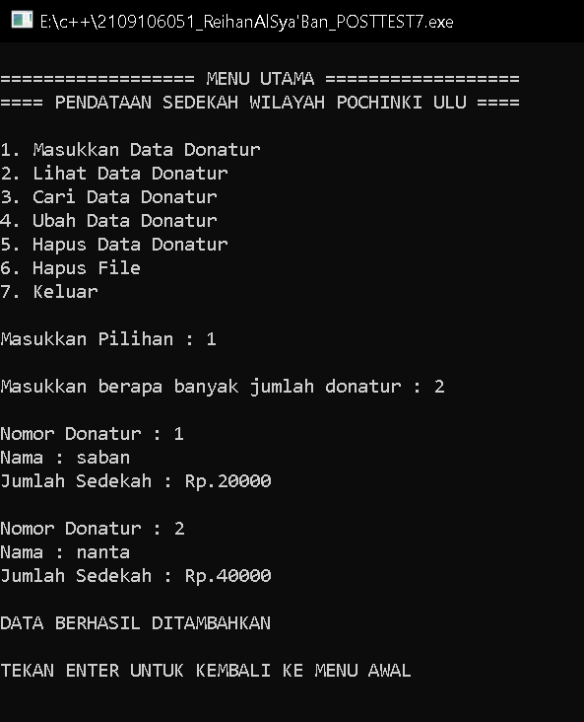

* File eksternal



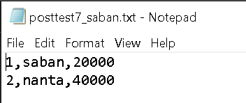

* Fitur hapus file eksternal

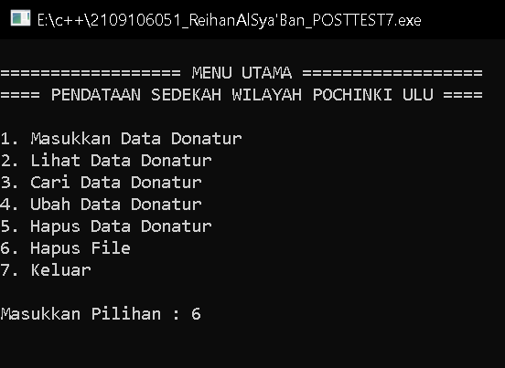

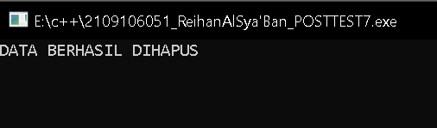

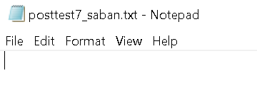

N.B : SS-an fitur lainnya tidak saya masukkan karena sama saja seperti posttest sebelumnya, masih dapat digunakan, yang berbeda kali ini hanya penggunaan file eksternal, Terima kasih.