<Project Name>
<Project Name>

Authors
<Project Name>
<Project Name>
<Project Name>
<Project Name>
<Project Name>
<Project Name>

Project Requirements Analysis

Project Partners: Mr John-Ross Torre, Jacobs Engineering Group Inc.

Demonstrator: <Catherine Hatch>

Academic Supervisor:
Sally Male

Group Meeting Day and Time: Friday 12 midday

Word Count: insert word count

Word Limit: 10000

Version 1.5

Revision History
Date | Version | Description | Author
21/03/17 | 1.0 | Format and insert group drafts into template, begin editing | Drafts by all, formatting edits by Mark Mazzoni
22/03/17 | 1.1 | Continue editing, create additional content to improve flow | Mark Mazzoni
23/03/17 | 1.2 | Continue editing, create additional content to improve flow, fix and find references | Mark Mazzoni
23/03/17 | 1.3 | Continue editing, added comments for possible large changes | Jess Armstrong
23/03/17 | 1.4 | Continue editing, finish abstract, create scope section, begin to find sources for appendices. | Mark Mazzoni
23/03/17 | 1.5 | Continue editing, cut unnecessary section and make more concise

0. Abstract
This report presents an analysis of the requirements for successful completion of “Solar Generation for Remote Boreholes” project created by Jacobs Engineering Group Inc.. This project requires that Team Power present the optimum solution for providing power to remote boreholes located in the Pilbara region of Western Australia. This document was created in order to facilitate team focus on the details relevant to this task, thereby aiding in the design of the best solution for the client. This document details a summary of the relevant stakeholders and literature used to ascertain these requirements, a summary of the requirements themselves and prioritization of these requirements.

Table of Contents
1. Introduction 6
1.1 Purpose 6
1.2 Scope 6
1.3 Definitions, Acronyms, and Abbreviations 6
1.4 References 7
2. Stakeholders 9
3. Literature Review 9
3.1 Previous Similar Designs 9
3.2 Standards and Regulations 10
3.3 Stakeholders and Project Context 10
3.4 Data Sheets and Manuals 10
3.4.1 Technical Data: 11
3.4.2 Advantages and Disadvantages: 14
3.5 Theory and Operational Methods 15
3.6 Reporting Conventions 15
4. Requirements 15
4.1 Summary of Requirements 16
4.2 Detailed Requirements 16
4.2.1 24/7 16
4.2.2 90kW++ 17
4.2.3 Newman 17
4.2.4 Safety 17
4.2.5 Economy 17
4.2.6 Telemetry 17
4.2.7 Maintainable 18
4.2.8 10-year Lifetime 18
4.2.9 Environment 18
4.2.10 Time 18
5. Conclusions 18
5.1 Section 5.1 18
6. Appendices 19
6.1 Appendix A 19
6.2 Appendix B 19
6.3 Appendix C 19

Solar Generation for Remote Boreholes
Requirements Analysis

Introduction
Jacobs Engineering Group Inc., through their representative, Mr John-Ross Torre, have employed Team Power to undertake a project for a mine near the town of Newman, in Western Australia. The main goal of the project is to provide power to three pumps in a bore field located 10 km from the mine site. The proposed power system must operate and supply constant power 24 hours a day seven days a week. The mine has opted Team Power to design a cost-effective method to power the pumps while also maintaining a constant supply. Requirements of the project also include a start-up system, protection, cooling, and telemetry.
The following report is a requirement analysis completed by Team Power. This report outlines the main stakeholders of the project, a literature review of topics relevant to the requirements of the project. The literature review consists of existing examples of similar projects, context of the project, regulatory project drivers, relevant data sheets, operational methods and reporting conventions useful in determining the requirements of the project. The body of this report summarises the requirements of the project, defines what they entail and why they are necessary for successful completion of the project. The requirements are also ranked from most important to least and a justification is outlined for the position of each requirement in this ranking.

Purpose
A requirements analysis is an essential tool when undertaking any new project. It allows everyone who is involved with the project to understand what is needed of them, who the main stakeholders are and how they should tackle the project. When undertaking a project that involves many stakeholders the requirements of the project can vary vastly. After completing this analysis, the team members should have a clear understand of what each requirement is, why it is a requirement for a successful completion of the project, and what priority is this requirement in the timeline of the project. This should allow for the prioritisation of tasks and the creation of a design approach.to arrive at an optimised solution to the challenge of supplying power to the remote bore field.

Scope
The project (Solar Generation for Remote Boreholes) encompasses designing, planning, executing and finalising a power supply for pumps in a remote bore field. Team Power’s reports (this “requirements analysis” and subsequent “design approach” and “final report”) deal with the design phase of this project; specifically, choosing the optimal design approach to realise the client’s objectives.
Turn the dot point list below into a colourful diagram/flowchart
- Design
  - Analysis of project requirements (this report)
    - Literature review
      - Brief investigation of site parameters, available technologies and existing operations with similar objectives
      - In depth review of documents from client
    - Requirements analysis
      - Summary of requirements and their priorities
      - Discussion of requirements and prioritisation
  - Analysis of design options (next report)
    - Literature review
      - Investigation into the designated project site including geographic, climatic, political, socioeconomic and regulatory factors.
      - Review of all extant applicable technologies and their variants
      - Review of cutting-edge and near-edge technologies that may be applicable, or which may be used to partially enhance established solutions
      - Review of existing operations in similar situations or for similar purpose
      - Refine mined data for easy comparison and analysis (e.g. summaries, tables, charts etc.)
    - Choice of appropriate design option
      - Create a list of design paradigms that represent a complete solution (for example “photovoltaic solar with diesel back-up” or “stationary wind turbine with LNG back-up”. Dismiss technologies that cannot be incorporated into a complete solution.
      - Model requirement parameters such as cost, time, quality etc., create estimates of these for the design paradigms.
      - Develop a ranking system based on requirement priority list
      - Use this system to choose the appropriate design paradigm
      - Verify that the chosen solution is sensible and accurately reflects the client’s needs (i.e. “forest for the trees” check and “common sense”)
    - Modification to suit specific needs
      - Re-assess cutting-edge technologies to see if they can contribute to increased value, efficiency and/or durability of chosen solution without significant drawbacks.
      - Refine estimates of efficiency, cost, time, environmental impact etc. and reassess trade-offs (for example, cost-for-time etc.) in light of changing client requirements and priorities.
    - Propose design solution
  - Final design proposal
- Planning (not within our team’s mandate)
- Implementation (not within our team’s mandate)
- Finalisation (not within our team’s mandate)

Definitions, Acronyms, and Abbreviations

References

Stakeholders
The major stakeholders for the project include the mine site where the bore fields operate, the project partner Jacobs, and the design team, with the minor stakeholders in figure 1 below. The information provided in the project brief indicates that the bore fields are in a remote location and there is no local community to be considered as a stakeholder however the mine site employees and native title owners are. There may still be public interest in the project resulting in the public being considered a stakeholder. The land is crown land meaning it is on lease from the state government classifying them as a stakeholder[1].
The hierarchy of communication amongst the three main stakeholders is as follows, the design team has weekly communication with Jacobs, alternating between face to face meetings and emails containing technical queries. While the mine site is a hypothetical in this project, it is assumed that Jacobs communicates with the client frequently with respect to the project deliverables.

 | Low Interest | High Interest
High Power | State Government | Mine site (client)  Jacobs  Design Team
Low Power | Australian public | Employees of mine site  Indigenous peoples
Figure 1: Stakeholder Analysis Matrix
A stakeholder analysis matrix [2] has been completed in the figure above, the three main stakeholders have high interest in the project and high power over the outcome, these stakeholders must be closely monitored following the communication hierarchy strictly. The state government has low interest in the project however they have the power to affect the outcome through legislation. This stakeholder must be satisfied by following government standards and regulations. Finally, the public are considered to have low interest and low power in the project and as such will be monitored to ascertain any changes in stakeholder expectations.

Literature Review
A review of blah blah carried out blah blah in order to blah blah

Previous Similar Designs
Conducting a review of previous similar project allows the team to build an understanding of the advantages and disadvantages of different design ideas. In this case, projects were analysed based on similar requirements such as time and economic restraints. This section outlines projects similar to the remote bore field project undertaken by the design team.
A project completed by Off-Grid Energy Australia in November 2014 involved the design and installation of an off-grid train monitoring and control station [3]. The system consisted of 32 solar modules and battery storage. The average load demand and requirements were 10 kwh/day and 450 W respectively, running 24/7 all year. Located in the northern parts of South Australia the system had to be able to endure extreme weather conditions such as high summer temperatures. Although the power requirements of the monitoring station are lower than that of the remote bore field similarities arise from the location and the operation time. Techniques used in the 24/7 operation of the monitoring station can also be implemented into the operational design of the bore field power system.
During the 2015 Esperance bushfires hundreds of kilometres of power lines and power poles were damaged leaving over 400 residents without power [4]. After the fires, Horizon Power helped rebuild the network and restore power to the majority of residents, however for some select customers an off-grid system was offered as a replacement. These customers were in sections of the network that only supplied power to two or three customers at once, and therefore perfect candidates for an off-grid power supply. Five stand-alone solar powered systems were installed with all the benefits of an on-grid power supply [5]. The successful completion of this project has suggested that off-grid technology (renewables) is now a viable alternative for overhead power lines.
In 2011 Hydro Tasmania commenced the project known as King Island Renewable Energy Integration Project (KIREIP) with the aim to increase use of renewable energy and decrease the use of diesel generators [6]. A project of this size would demand more energy than the remote bore field on an annual basis and therefore is a good indicator of successful a renewable system can become. This relates to the requirement to reduce emissions for the bore field project.
Observing the success and failures of other projects can vastly increase the productivity of new projects with similar requirements or aims. The projects listed above differed in size, load demand, and location however each project contained aspects that relates to the requirements in this analysis.

Standards and Regulations
Standards and guiding documents in play:
- Land Administration Act 1997 [7]
- Land Administration (Land Management) Regulations 2006 [8]
- ISO31000:2009 (Risk Management – Principles and Guidelines) [9]
- Western Australia Electricity Industry (Network Quality and Reliability of Supply) Code 2005 [10]
- Western Australian Electrical Requirements (WAER) [11]
- AS 2067:2016 (Substations and high voltage installations exceeding 1 kV a.c.) [12]
- AS/NZS 3000: The Wiring Rules [13]
- AS/NZ 7000:2016 (Overhead Line Design) [14]
- Native Title Act 1993 [15]
The project requires consideration of multiple design options, and so a range of standards are applicable. Some standards apply specifically to one category of power solution (for example AS/NZ 7000: Overhead Line Design applies only to an on-grid solution which includes overhead lines) while others will apply to all solutions. Consultation of the appropriate standards (the above and possible others) is vital to the success of any project, as private entities must act in accordance with law and in concert with government regulators.

Project Context

Details about user context

What
The project is to design a power system to supply 90kW per day to three bore pumps that supply water to a mine site 10km away (Appendix A). The project deliverables require a detailed design of the power generation system including a single line diagram and cost analysis of three different options for remote power supply. The objective being to design the most cost effective solution compared to the base case of running overhead power transmission lines from the adjacent mine site.
In order to meet the requirement to maximize the economy of the solution, the relevant costs must be considered compared to the base case. There are many costs involved in the construction of overhead transmission lines, with a large portion involved in the construction of the steel lattice towers. There is also the cost associated with the aluminium conductors required to carry high voltages over a large distance[16]. The three bore pumps to be used are the Grundfos mms6000 as they are the client’s preference. The power requirements of such a pump necessitate the use of AC (alternating current) power supply at a frequency of 50Hz[17].
An additional feature the team has considered a requirement is the communications and telemetry system. As provided by the client, this requires an additional 100W of power and a converter to supply 24Volts DC.

Who
The user of the system to be designed is the mine site that owns the bore fields. They have given the team specific technical requirements to work towards, with the objective to supply power to a remote bore field (Appendix A).

Where
The bore field to be powered is located in Newman, a remote mining town in the north west of Australia. Newman is on land originally owned by the Martu people. Aboriginal occupation of the area dates back 26,000 years, however with the spread of European settlers in the North West in the late 19th century they were driven out of their traditional lands. Furthermore, the testing of missiles led the Martu people to settlements and pastoral stations[18]. In 1967 when Newman was established by the Mt. Newman Mining Company, there were no indigenous peoples occupying the land. However, in the 1980’s the Martu people began to move back to their traditional land resulting in the Federal Government granting them land to the east of Newman[18]. There are, therefore, potential native title issues associated with this site.
This region offers harsh weather conditions throughout the year, restricting the teams design. Since it is a requirement that the system operates in Newman, weather conditions are an important aspect of the team’s research. Newman has an average annual rainfall of 317.8mm with the wettest months in summer[19]. The average number of cloudless days is 180.7 every year which could affect the team’s decision to use a photovoltaic power generation method. The average morning wind speed is 9.1km/h and afternoon is 9.4km/h which will be a consideration in the use of wind turbines. Since Newman is located 350km away from the coast it is unaffected by the sea breeze. This means that there is little change in wind direction throughout the day[20]. Newman’s distance from the coast makes it the least affected by tropical cyclones compared to other towns in the Pilbara. However, it is still subject to damaging winds from cyclones turning inland[21].
The topography in Newman consists of rocky outcrops and surrounding hills. This includes Mt. Whaleback where BHP mines iron ore[20] at 610m above sea level and Mt Newman at 1057m [22].
An important consideration due to the location is the ease with which equipment can be delivered to the area. Designs that are not able to be delivered to the site, will not meet the requirements of the project. Considering the mine site is already located in the area, it is assumed that it is already serviceable by rail from the coast and road to site. Following the assumption that the bore field and pumps are already in place, there is also road access adequate to deliver equipment to that size. However, if the team wanted to implement anything larger such as a wind turbine where parts weighing up to one hundred tonnes must be delivered that would require much larger vehicles and wider roads[23].

Data Sheets and Manuals
The Jacobs representative John-Ross Torre has indicated that the client’s preferred equipment is the Grundfos MMS6000. The MMS6000 is a rewindable submersible motor designed to fit pump ends manufactured to NEMA (National Electrical Manufacturers Association) standards. The following information introduces the Grundfos MMS6000.

Technical Data

Exploded Part Diagram for MMS6000
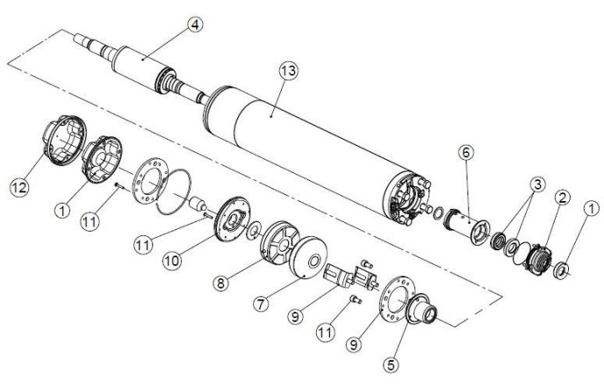
Figure 1

Start Frequency Rating for MMS 6000
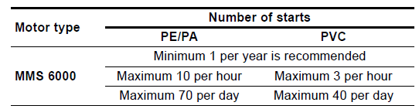
Figure 2

MMS 6000 Connection Diagram
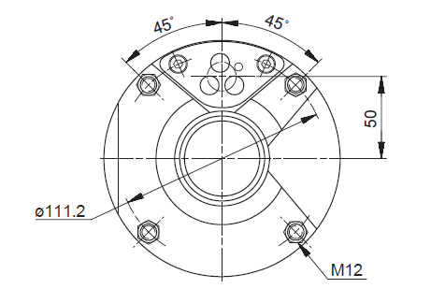
Figure 3

Power-to-Weight and Size Data
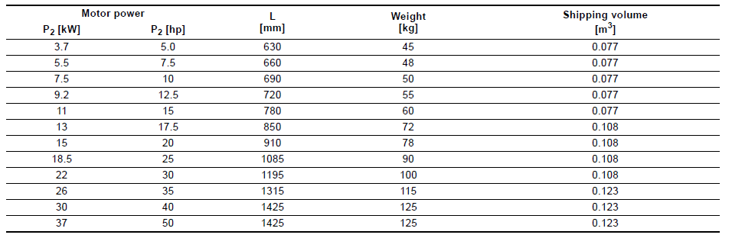
Figure 4

Electrical data of MMS 6000
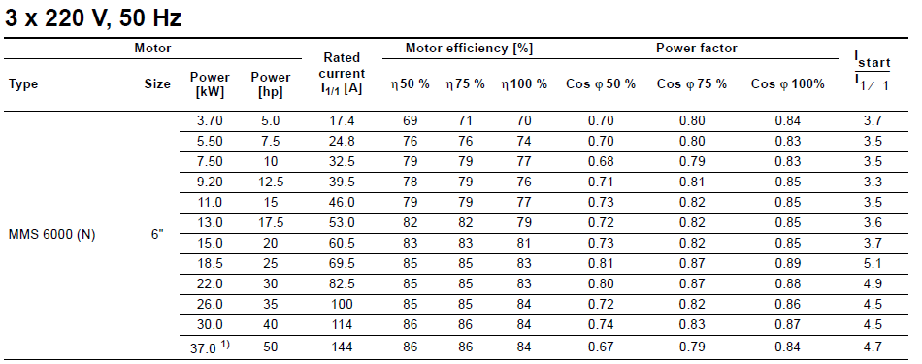
Figure 5

Cable Sizing
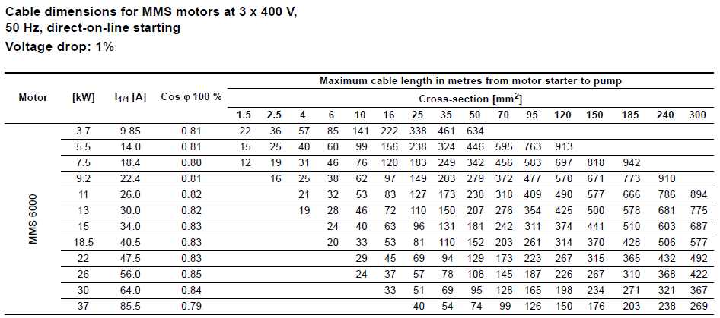
Figure 6

Cooling
The pump chosen for the project is required to be well suited to the harsh weather it could experience in Newman; this will include a requirement for cooling. The cooling of the motor depends on the temperature and the flow velocity of the pumped liquid past the motor. To ensure sufficient cooling, the values for maximum temperature of the pumped liquid and its flow velocity must be kept. It is recommended always to ensure a minimum cooling flow of 0.15 m/s.
The Grundfos literature includes additional information about the MMS 6000 and other devices (Appendix X):

Theory and Operational Methods

Reporting Conventions
Reporting is an important part of the monitoring and evaluation process of a project. Reports also provide an opportunity to highlight the project achievements. Additionally, project reports focus on important details like metrics, issues, open work and resources, giving project managers the tools to keep projects on track and stakeholders informed [24].
Thus, there are three major components to reporting project status [25]:
- Overall
In order to see overall health of the project, these data should be included:
- The project’s name
- The percent complete of this project
- The number of issues in this project
- Milestones
- The milestone name
- The percent compete of the milestone
- Issues
- Issue name
- Time reported
- Issue priority and severity
- Current activity
Contractors always use completion date, bar chart and percentage of completion schedules to track progress, consort subcontractors and monitor delays[26]. Thus, as a subcontractor, one of the most important tasks is reporting project progress to the contractor (Jacobs). In our plan, reports should be sent with e-mails to Jacobs.
The report should identify:
a) Authorized work that was scheduled to be done during the week
b) Progress made against that authorized work presented as:
1. A description of project progress
2. A list of the milestones obtained
3. An assessment of the time remaining to complete the project
c) A list of unplanned work that was conducted, identifying the time spent
d) Authorized work that is scheduled to be done during next week, including any milestones expected to be reached
e) A short description of any troubles met in performing the activities of this project[27].
[25]

This needs to be fixed and relevant content needs adding. It’s currently WAY too general.
How would we as a subcontractor to the main contractor (Jacobs) normally report our progress? What forms and formats? Would we also report directly to the client (the answer is no, I’m pretty sure).
In the mining industry (that’s where the project is) what is the reporting standard? What is the industry expectation?

Requirements
This section contains an itemized summary of requirements listed in priority-order, with an explanation of how priorities were assigned.

Summary of Requirements
Priority | Requirement | Description | Classification
1 | 24/7 | The power generation system is required to operate for 24 hours a day, 7 days a week, 365 days a year.
2 | 90kW++ | The power generation system must produce 90kW of power to supply the main pumps, plus additional power to supply other essential systems.
3 | Newman | The power generation system must operate in Newman. This includes tolerating the harsh conditions.
4 | Safety | The system must run safely. Any safety equipment that requires power must also be supplied.
5 | Economy | Maximise the economy of the proposed solution.
6 | Telemetry | The system requires telemetry and communications equipment, and these will also require power.
7 | Maintainable | The system must be maintainable.
8 | 10-year life | The system must last for at least ten years | EXP, SPO
9 | Environment | The proposed solution should minimise harm to the environment. | EXP, EXC
10 | Time | The proposed solution should take a minimum amount of time to construct. | EXP, EXC
Figure # Table of requirements: blah blah, classified as at least one of the following: expecters (EXP), spokens (SPO), unspoken (UNS) or exciters (EXC).

Detailed Requirements

24/7

Description of requirement
The power generation system is required to operate for 24 hours a day, 7 days a week, 365 days a year. As the client says, 3 pumps have been suggested for use in a duty / duty assist / standby operating mode. Which means maintenance does not require shutdown. Besides, battery storage and backup system are considered to be used in this project. The battery storage and backup system can be used to run the load without starting the engine [28].Thus the pumps can be provided power 24 / 7 / 365.

Requirement origin
This is the basic requirement of this project. Mine site requires 24 / 7 water supply so that reliable power to pumps is essential. In other words, no point having pumps if they are not powered. Besides, runs power 24 / 7 / 365 is the most cost effective way to make profit.

Justification for Assigned Priorities
This requirement is the top priority because it is the demand of stakeholders and the main aim of this project. This requirement is above the 90KW requirement because if it is not met exactly there is still some power supply.

Testability
Monitor and observe the devices condition 24 / 7 / 365 by using telemetry system.

90kW++

Description of requirement
The power generation system must produce 90kW of power to supply the main pumps, plus additional power to supply other essential systems. As the client says, two pumps are sufficient to deliver the required water while the third can be maintained without affecting production. Pumps consume energy to perform mechanical work by moving the fluid and operate by some mechanism like typically reciprocating and rotary [29]. In additional, the pumps require AC power [30]. The client owns and operates the power station in Newman. The energy consumed by pumps can be delivered from the power station. For Comparison purposes the cost of power shall be assumed as 30c/kWh.

Requirement origin
The daily supply is the basic requirement of this project. Without being met water the system will not be pumped at 900ML/year. What is more, monitors and telemetry system can be used to observe the pumps for testing the daily supply and output.

Justification for Assigned Priorities
This is the second top requirement because if it does not meet 90kW it would not be a viable solution and hence not used, therefore safety is below since consider safety of working solution.

Testability
According to monitoring and telemetry of the supply, the daily power can be tested by simulations, ratings / technical specifications and calculations.

Newman

Description of requirement
The power generation system must be suited to operate in the conditions regularly experienced in the Newman area. This means coping with adverse weather conditions such as high temperatures, high wind, rain, lightning strikes and dust. This requirement creates secondary requirements for additional infrastructure such as shelter, cooling systems, dust filters or dust-resistant systems and lightning rods.
This requirement also includes operating in the wider context of Newman, that is, complying with Australian federal and Western Australian state law. See 3.2 (the literature review section concerning relevant legislation) for more information.

Requirement origin
The generation and supply site must be proximal to the bore field to facilitate cost effective transmission of power. Furthermore, the client explicitly stated the power supply would be placed in Newman. Thus, the parameters described in 4.2.3.1 become central to the successful completion of the project.

Justification for Assigned Priorities
Although safety is a paramount requirement for any project, if the project will not function then there in no motivation to construct, and so there can be no concern for safety, as no action will be taken. As previously stated, the power generation system will be non-functional if it is not placed in Newman, and will also be non-functional if it is constantly under repair due to inclement weather. The need to survive in the conditions present in Newman is a lower priority than 24/7 and 90kW++ because if the system does not meet these requirements then there is no reason to build it and so it will not be in Newman in the first place.
The need to comply with legislative demands is paramount for system functionality. Failure to comply could result in compulsory shutdown of the system by court order or similar legal measure, resulting in an inability to meet the systems functional objectives. This then becomes simply a waste of client resources.

Testability
Observe the devices regularly, especially for the appearance and temperature. Make sure the devices can work normally.

Safety

Description of requirement
Regarding safety in this project, it can be best to avoid all preventable harm to human, environment, economic and reputation of companies etc. or at least guarantee the engineering systems to provide acceptable levels of safety and reliability. Additionally, it should comply with the Work Health and Safety (WHS) Act and industry standards and regulations in Australia [31]. Therefore, safety behaviour and management strategies can be critical to ensure the project behaves in a consistently ethical manner, but also has the side effect of often increasing long-term direct benefits for the company.

Requirement origin
From the narrow perspective, safety is to ensure the systems normal operation i.e. satisfying the requirements of 24/7/365 and 90KW power supply even in bad weather. Broadly speaking, safety is a basic moral requirement which is unspoken and expected requirement of employees. The Work Health and Safety (WHS) Act also requires employers to protect all employees from risks to their health and safety arising from their work [32]. Moreover, safer engineering projects can promote sustainable development and an economic growth pattern. The reason is that a company which has gained a good reputation from previous projects which will be given more future opportunities. In other words, it combines safety and economics with the project together which is a win-win model.

Justification for Assigned Priorities
Once a functional system is conceptualised, which means this system can provide a solid power supply and achieve the objective of project. Then the safety is top priority. Considering this priority also meet Engineers Australia Requirements/Code of Ethics [33]. On the contrary, if companies weaken the safety consideration, the effects of not meeting safety requirements could be catastrophic (i.e. Cost outweigh benefits based on the cost and benefit analysis)

Testability
It is essential for the project team to keep team members up to date with risk concerns so they can make significant decisions on an informed basis. Some methods beneficial to the mitigation of risk and tracking of hazards are listed below:
-Risk Register
-Risk Matrix (Based on consequence and likelihood) (Refer to Appendix X)
-ALARP (As low as reasonably practicable [34])
In addition, risk response strategy had better to constantly monitor and control at site work.

Economy

Description of requirement
The economy can be considered as a significant aspect reflecting cost and benefits of the project. Economic considerations also determine the project's desirability and plan how it should be performed. In the companies’ sense, the cost would be cheap as possible or less than the base case. However, the whole engineering system should still function safely and be stable to produce the good value to meet the demanding of 24/7/365 and 90 KW. Additionally, economic sustainability as one of triple bottom line (TBL) still requires the companies to consider the maintenance cost of some broken equipment which is cheaper than replace the whole one [35].

Requirement origin
In company analysis, the project is a reality of business. Developing and performing some certain projects is to gain the profits and satisfy the customer requirement (spoken requirement). In order to achieve more profits, the company is responsible analysing all kinds of economic factors. On the other hand, it is also significant to coordinate well the relationship between internal stakeholders and external stakeholders. By doing these, it will balance the development of interests and benefit all stakeholders.

Justification for Assigned Priorities
The reason is that client said effective and cheap design options are more important than time and environment. As is known to all, business companies are for gaining the profits. Inevitably, the cost is one part of function so the analysation of cost and benefit is vital for all stakeholders. And they could rank high priority for economic consideration (spoken requirement).

Testability
From a financial perspective, net present values (NPV) is the profitability of an undertaking that is calculated by subtracting the present values (PV) of cash outflows (including initial cost) from the present values of cash inflows over a period of time [6]. Meanwhile, it is also an effective measurement for a new project to pick up the best option via the cheapest NPV. What is more, there may be some financial risk (budget, maintenance cost, back to charge etc.) need to pay attention. The recommended solution for the financial risk is risk register and matrix and so forth.

Telemetry

Description of requirement
In large projects with a large number of influence factors, managing these factors effectively are of utmost importance. For example, the technicians need to obtain the effective site data via communication system and telemetry. To be specific, communication not only refers to the communication between the project team members also refers to data transmission. Some technical requirements may include in this project:
-Measurement devices/sensors (power output over time, fluctuation, characteristics (power factor, voltage regulation), heat, state of starter, state of pumps)
-Communication (phone/radio, transmission of measurements/telemetry data)
-Emergency shutdown procedures
-Telemetry: Successfully remote monitoring of the system (bore field power)
Consequently, it can get the best possible results to assist in the transmission of the data for the project.

Requirement origin
First and foremost, communication system or telemetry can guarantee the engineering system normally and efficiently work at site. And the requirement of these technologies and devices were told by client. With the help of these devices, it will enhance the safety and reliability of system. To some extent, it also raises engineers’ awareness of security and avoids the occurrence of unknown accidents. In the meanwhile, it strengthens the insurance on economy.

Justification for Assigned Priorities
The reason is that it enhances the safety of whole engineering project and the system doesn’t need it to work permanently. Compared to the next maintainability, it is higher because it’s a complex system and can’t see inside (As a result of sensors inside). However, with the help of communications or telemetry, the system has easy access to get the data and be more maintainable.

Testability
According to the industry standard, design patterns and prior experience, this stuff poses a big advantage to test the obtained data [31]. Besides, constantly monitoring and controlling is more efficient to achieve the function of communication and telemetry, which is real-time data acquisition and comparison.

Maintainable

Description of requirement
The maintainability is defined as the probability of performing a successful repair action within a given time [36]. This is similar to system reliability analysis, in short, if some equipment broke then they can be fixed. Moreover, the maintainability doesn’t require expert to fix just ordinary technical personnel is able to fix it timely. The broken equipment can be accessible, as well. Additionally, the maintainability can ensure the whole system safely operate in the remote location and harsh weather conditions (The mine site is located outside of Newman, WA).

Requirement origin
The requirement of maintainability is to avoid that the engineering project is unfeasible to supply power of 24/7/365 and 90kW. On the other hand, the requirement of maintainability can guarantee system safely and normally operate throughout its lifetime (10 years) which is unspoken but expected requirement.

Justification for Assigned Priorities
Basically, assigning this item this priority is to maintain the function which includes all previous requirements. Besides, the maintainability can ensure the whole engineering system lasts 10 years seeing the next requirement. Additionally, it is easy to allocate and compare the priority with the lifetime. Because the engineering system won’t last lifetime if it is not maintainable.

Testability
With regards to the testing of maintainability, it may according to the prior experience or design choices. Furthermore, physically test of maintainability is based to some technical devices etc.

10-year Lifetime

Description of requirement
The power supply and accompanying infrastructure must last at least 10 years in its location. This requirement interacts to a small degree with the need for maintainability, but at the same time is separate; for example, if all the system’s constituent parts must be replaced over a decade, the system has not truly lasted 10 years [37]. This requirement also interacts with many other requirements, such as economic considerations and the need to operate in the region around Newman.

Requirement origin
This requirement was specified by the representative for Jacobs. It also arises as an expectation of the industry that the equipment should last for a reasonable period of time [38].

Justification for Assigned Priorities
Requirements 1-7 are all required for profitable functioning of the power supply; if the power supply cannot function profitably then there is no point having a theoretical lifetime of ten years because the client will not operate an unprofitable project for a decade. Furthermore, once the system has met requirements 3, 6 and 7 it is likely to already have an extended lifetime, and these requirements serve other functions as well, so the requirement for a 10-year lifetime should be lower priority than these.

Testability
Testing whether the system will last 10 years is a difficult but not impossible task. Simulations based on industry experience and existing devices can allow reasonable estimates of what can be expected. Materials and subcomponent testing is another crucial aspect of lifetime testing [39]. Ultimately, monitoring the system health over time will provide the best estimate of how much longer the system will last.

Environment

Description of requirement
The project must create the minimal amount of environmental damage. This extends from the planning phase through manufacturing, construction, clean-up and day-to-day operation of the power generation system and associated infrastructure. This also helps meet the part of requirement 3 about complying with Australian regulatory requirements.

Requirement origin
This requirement is created by a myriad of stakeholder elements including public perception and company reputation, legal requirements and the personal value system of our team members. It was also a spoken consideration from Jacobs.

Justification for Assigned Priorities
The Jacobs representative specified that minimizing environmental harm was a minor priority, with the emphasis being on delivering a cost-effective and safe proposal.

Testability
The predicted environmental impact of the design comes from simulation built using literature reports and previous experience. Materials data sheets and industry best practice also provide input into how to damaging certain methods and materials will be. Investigating similar project currently operating will grant insight into possible ways to minimize harm without resulting in extra cost.

Time

Description of requirement
The project should take the minimum amount of time to complete. That is, all four stages of the project lifecycle (conception, planning, execution and finalisation) should be as expedient as possible, and this should be balanced against other drivers like cost, quality and safety.

Requirement origin
This requirement evolves from the need to create an economically sound project. The representative from Jacobs also specifically mentioned this requirement.

Justification for Assigned Priorities
This requirement is ranked 10th, the lowest priority, because the representative for Jacobs specified that it was the lowest priority. This is in part because any off-grid solution is expected to take less time to implement than the base case, that is, routing transmission line power to the bore field.

Testability
Once again, the ability to predict whether the proposed solution meets this requirement is based upon existing literature and industry experience. Actually testing in retrospect whether this requirement was met will be simple, as the time taken to create a functional solution can be measured on a calendar.

Conclusions
In conclusion, the five most significant requirements include that the power generation system should deliver power continuously, the system should produce 90kW per day, the system should be operated in Newman, the system should experience hazards at an ALARP rate and the system should be economically beneficial. In order to ensure successful completion, these critical requirements should be keep in mind during all stages of the project’s life cycle. Team members have a duty to reference the requirement list to ensure maximum productivity. Given the likelihood that the project will grow and change, it is also mandatory that team members maintain the requirements list (adding new requirements or re-order the priority of the existing requirements) in keeping with the client’s evolving demands.

Appendices

Appendices may be used as required, or deleted.

Appendix A
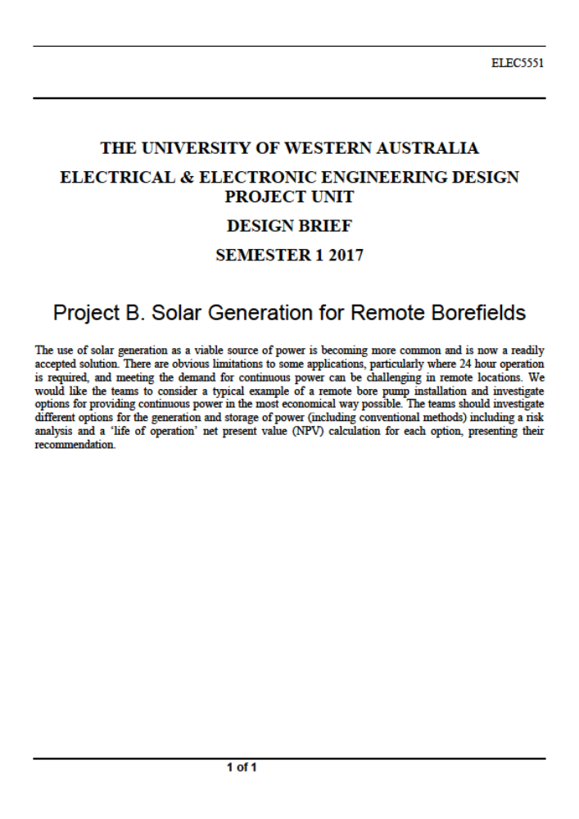

Appendix B

Appendix C

Risk Matrix, Consequence And Likelihood Tables

Risk Matrix
The following risk matrix is used in this document, however there are several variations on this matrix that can be found in the literature. It does not matter which matrix you use as long as you consistently use the same matrix.
 | CONSEQUENCE
LIKELIHOOD | Insignificant (1) | Minor (2) | Moderate (3) | Major (4) | Extreme (5)
Rare (1) | Low | Low | Low | Low | Low
Unlikely (2) | Low | Low | Low | Medium | Medium
Possible (3) | Low | Low | Medium | Medium | Medium
Likely (4) | Low | Medium | Medium | High | High
Almost certain (5) | Low | Medium | Medium | High | Extreme

Likelihood Table
The following can be used as a guide for determining likelihood. However, this tool has limitations as likelihood and frequency of events tend to vary between disciplines and functional areas.
Level | Likelihood | Expected or actual frequency experienced
1 | Rare | May only occur in exceptional circumstances; simple process; no previous incidence of non-compliance
2 | Unlikely | Could occur at some time; less than 25% chance of occurring; non-complex process &/or existence of checks and balances
3 | Possible | Might occur at some time; 25 – 50% chance of occurring; previous audits/reports indicate non-compliance; complex process with extensive checks & balances; impacting factors outside control of organisation
4 | Likely | Will probably occur in most circumstances; 50-75% chance of occurring; complex process with some checks & balances; impacting factors outside control of organisation
5 | Almost certain | Can be expected to occur in most circumstances; more than 75% chance of occurring; complex process with minimal checks & balances; impacting factors outside control of organisation

Consequence Table
The following is a guide to determining consequence. The applicability of the operational definitions of each category of consequence will vary in different Community Health Service and program areas and thus is recommended as a guide only.
Level & descriptor | Health Impacts | Critical services interruption | Organizational outcomes/ objectives | Reputation and image per issue | Non-compliance
Insignificant (1) | First aid or equivalent only | No material disruption | Little impact | Non-headline exposure, not at fault; no impact | Innocent procedural breach; evidence of good faith; little impact
Minor  (2) | Routine medical attention required (up to 2 wks incapacity) | Short term temporary suspension – backlog cleared < 1 day | Inconvenient delays | Non-headline exposure, clear fault settled quickly; negligible impact | Breach; objection/complaint lodged; minor harm with investigation
Moderate (3) | Increased level medical attention (2 wks to 3 mths incapacity) | Medium term temporary suspension – backlog cleared by additional resources | Material delays; marginal under-achievement of target performance | Repeated non-headline exposure; slow resolution; Ministerial enquiry/briefing | Negligent breach; lack of good faith evident; performance review initiated
Major  (4) | Severe health crisis (incapacity beyond 3 mths) | Prolonged suspension of work – additional resources required; performance affected | Significant delays; performance significantly under target | Headline profile; repeated exposure; at fault or unresolved complexities; ministerial involvement | Deliberate breach or gross negligence; formal investigation; disciplinary action; ministerial involvement
Catastrophic (5) | Multiple severe health crises/injury or death | Indeterminate prolonged suspension of work; non performance | Non achievement of objective/ outcome; performance failure | Maximum high level headline exposure; Ministerial censure; loss of credibility | Serious, wilful breach; criminal negligence or act; prosecution; dismissal; ministerial censure

