Project B: Solar Generation of Remote Bore Fields
Team Power (12)

Authors
<Project Name>
<Project Name>
<Project Name>
<Project Name>
<Project Name>
<Project Name>

Design Approach

Project Partners: John-Ross Torre, Jacobs

Demonstrator: Catherine Hatch

Academic Supervisor:
Dr Sally Male

Group Meeting Day and Time: Friday 12pm

Word Count:

Word Limit: 12,500

Version <1.3>
Revision History
Date | Version | Description | Author
<10/04/17> | 1.0 | Addition of Design concepts | Jess
<10/04/17> | 1.1 | Addition of scope, contributions and testing | Steven
11/04/17 | 1.2 | Added more to resources section (for flow), editing and formatting | Jess
11/04/17 | 1.3 | Added table of definitions | Steven

Table of Contents
1. Introduction 6
1.1 Purpose 6
1.2 Scope 6
1.3 Definitions, Acronyms, and Abbreviations 6
1.4 References 7
2. Summary of Design Approach 9
3. Project Scope 10
4. Team Responsibilities 11
4.1 Contributions of team members 11
4.2 SWOT & Competency for Design 11
5. Scheduling 13
6. Resources 14
6.1 Tangible 14
6.2 Intangible 14
6.3 Literature Review 14
6.3.1 Solar 14
6.3.2 Wind 15
6.3.3 Location 15
6.3.4 Battery Storage 16
6.3.5 Inverters 17
6.3.6 Diesel Generators 17
6.3.7 Cooling System 17
6.3.8 Overhead Power 17
6.3.1 Telemetry 18
7. Design Decisions 19
7.1 Base Case 19
7.1.1 Justification 19
7.1.2 What requirements will it meet. 19
7.2 Hybrid 1: Solar, Battery, Diesel 19
7.2.1 Justification 19
7.2.2 What requirements will it meet 19
7.3 Hybrid 2: Solar, Wind, Battery, Diesel 20
7.3.1 Justification 20
7.3.2 What requirements will it meet 20
7.4 Fully Renewable 21
7.4.1 Justification 21
7.4.2 What requirements will it meet 21
7.5 Costing 21
7.6 Testing 21
8. Risk 22
8.1 Risk Register 22
8.2 Tracking Safety Issues 22
9. Project Management 23
9.1 Configuration Management 23
9.2 Communication 23
10. Appendices 24
10.1 Appendix A – Requirements Summary Table 24
10.2 Appendix B – Scope Diagram 25
10.3 Appendix C 25

Introduction
Why read it? Who is it for, and what can you learn?

Purpose
Purpose of the document

Scope
Scope of the document including whats in it and whats not in it

Definitions, Acronyms, and Abbreviations
Abbreviation | Definition
SWOT | Strengths, Weaknesses, Opportunity, Threats
UWA | University of Western Australia
LMS | Learning Management System
NREL | National Renewable Energy Laboratory
NPC | Net Present Cost
LNG | Liquid Natural Gas
O&M | Operation & Maintenance
PV | Photovoltaic
NiCd | Nickel Cadmium
Li-ion | Lithium ion
DC | Direct Current
AC | Alternating Current
IoT | Internet of Things

References

Summary of Design Approach
The purpose of the design approach is to outline proposed designs and detail how the team will be modelling and testing them. This is a necessary step in a design project because without the necessary preparation and research, it is difficult to ensure project goals and requirements are met. The following document is a design approach completed by the members of team power and includes a lit review of the renewable and non-renewable technologies proposed for each design solution, telemetry, cooling and inverters. It also deals with the justification of the design decisions, including how they meet the project requirements. The design approach also contains preliminary costing for each design and the risk analysis of the project.

Project Scope
The project includes the design, execution and finalization of a power supply for pumps in a remote bore field located in Newman, Western Australia. Team Power is responsible for the design phase of this project, choosing the optimal design that best meets all the requirements of the project (Appendix A) and the decommissioning of the project. A flow chart of the project scope has been done and can be seen in Appendix B.

No. This would not be sufficient. The word 'critical' is important. Think critically about the scope, scale of project as a whole and members' responsibilities and competency for the design. What is included and not included in the scope of the project as described in the design brief? Is this feasible or sensible? Is there something that has been or should be added? How large is the design project? Will you need to set some constraints and make some assumptions and if so what? How have you shared the responsibilities? Will this work? What can you do to make sure it works? Do you have the necessary competencies and if not what are you doing about it? There are many other questions you could also address in your critical appraisal.
Team Responsibilities

Contributions of team members
Team Member | Contribution
Jessica Armstrong | - Literature Review of diesel generators and cooling systems  - Design decisions for hybrid system 1  - Team responsibilities section  - Formatting and editing
Steven Bardzovski | - Literature review of battery storage and inverters  - Design decisions for hybrid system 2  - Formatting and editing
Xiaobin Lin | - Literature Review for solar, wind and HOMER software  - Design decisions for fully renewable system
Mark Mazzoni | - Literature review of telemetry  - Cost analysis  - Project management  - Formatting and editing
Shaochen Wang | - Risk analysis
Jie Zhang | - Literature review for base case  - Design decision for base case

In addition to these contributions, team members have contributed to the project by taking on leadership roles such as chairing group meetings, attending partner meetings and taking minute. This has been allocated fairly such that each member will have a turn to do each of these tasks.

- Who will do what, should I talk about chairing and minute taking too??

SWOT & Competency for Design
Team Power completed a strengths, weaknesses, opportunities and threats (SWOT) analysis early in the project to determine the team’s competency for design. This helped the team identify areas where the team was lacking skills. It is also a useful tool when deciding how work will be split amongst members.
Strengths  - Jess – Planning, research and programming  - Steven – Mathematics/Calculations, verbal and interpersonal communication, version control experience  - Xiaobin – Design  - Mark – Planning, Research, Written and Verbal communication  - Shaochen – Design  - Jie – Mathematics/ Calculations | Weaknesses  - Mark – Calculations/Mathematics  - Steven – Written communication  - Jie – Programming  - Xiaobin – Written Communication  - Jess – Calculations
Opportunities  - Steven has taken renewable energy unit  - All members have taken (or are taking) Project Management unit  - Most members have completed Risk unit (5/6) | Threats  - Poor time management  - Group member becomes ill or is unable to attend  - Lack of motivation  - External factors (e.g. project becomes complex, supervisors unable to attend etc.)

Scheduling

Resources

Tangible
Tangible resources include the equipment the team will require for the design, the infrastructure the team uses and the team itself to carry out the work. This includes the use of hardware such as computers for carrying out research and simulations, books and articles and work space (meeting rooms and computer labs).

Intangible
Intangible resources required to complete the design are resources such as time spent carrying out the design, team motivation and organization and software used for simulations. The time spent on project activities is tracked by a schedule that is updated weekly by group members. Team motivation and organization comes from strong leaders within the group, enabling the team to achieve better results when working together. The software that the team requires for this design include Microsoft Office (Word and Excel), HOMER, online tools such as GitHub and LMS for filesharing and (any others??? Maybe project management software). These are available to the team at the University of Western Australia (UWA) in designated computer labs.

The National Renewable Energy Laboratory’s (NREL) hybrid optimization model for electric renewables HOMER simulation software will be considered to perform the optimal design and techno-economic viability of hybrid energy system at project site [1]. Firstly, to achieve the solar-wind-battery model, a specific location (longitude and latitude of project site) can be entered through the “Search Box”, thus it can download observed resources data incudes solar and wind radiation from data bases for this project site. Simulating with HOMER requires some input information regarding resources, economic constraints, and control methods. It also requires inputs of the discount rate, inflation rate, maximum annual capacity shortage, project lifetime, component types, their costs, efficiency, etc. Also, HOMER can present simulation results in a lot of tables and graphs that contribute to analysing system configuration. A system’s technical feasibility and the economic analysis can be estimated by HOMER simulation. Furthermore, Homer can rank the systems based on the total net present cost (NPC), which can be used to compare system design options and choose the cheapest NPC [2].
𝑁𝑃𝐶= 𝐶𝑇𝐴𝐶/𝐶𝑅𝐹 (𝑖,𝐿𝑝𝑟𝑜𝑗) [3]
Where 𝐶𝑇𝐴𝐶 is the total annualized cost, CRF is the capital recovery factor, i is the discount rate used to convert the one-time costs into annualized costs, and Lproj is the project lifetime. The total annualized cost 𝐶𝑇𝐴𝐶 is the sum of the annualized capital cost, the annualized replacement cost and the annualized O&M cost of the hybrid energy system [3].
The operation of a system can be simulated by making energy balance calculations for each of the 8760 hours in a year through HOMER. It also decides for each hour how to operate the generators and whether need to charge or discharge the batteries [2].

Literature Review
Team Power researched various power generation and storage methods including wave and tidal power, biomass, nuclear, pumped hydro, geothermal, liquid natural gas (LNG), and flywheels which have been excluded from this document as they are not used in the teams chosen designs.

Solar
There is variety of renewable energy sources in daily life, with solar energy more economically competitive against other energy. Compared to traditional fossil fuels and other non-renewable source, solar energy can be zero carbon release, neglecting the production of solar panels. For tide and wave energy, because the generating equipment must be placed on or in the ocean, the marine ecosystem could be adversely impacted. Moreover, high O&M cost cannot be suitable for this project [1]. The sun's rays can be absorbed by solar photovoltaic (PV) panels as sources of energy to generate electricity [2]. The advantages and disadvantages of implementing a solar PV system are as follows:
Table 1: Advantages and Disadvantages of Solar [2]
Advantages | - Easy to install and disassemble;  - Long use life;  - No need to service specially;  - High reliability;  - Economically viable, no energy consumption;  - Mechanical wear resistance;  - High compatibility with other technologies.
Disadvantages | - Not suitable for regions of short solar exposure (regions of high latitude);  - Highly weather-dependent;  - Low efficiency;  - Occupy a large area.

Most solar PV panels now are based on variation of silicon, usually different kinds of silicon with variable purity. The panel that made by high purity silicon have high efficiency, which mean the solar energy can be converted to more electricity, while the silicon purifying process is expensive [3]. Specifically, silicon solar PV panels are usually made of either monocrystalline silicon or polycrystalline silicon [2]. Monocrystalline has a higher efficiency than polycrystalline; however, the cost of manufacturing is much higher [2]. The monocrystalline will usually have a longer expected life, which will offset some of those costs [2]. Battery storage is the most compatible with solar PV systems [2].

Wind
Wind energy harvesting employs air flow movement in generating sources of electricity [5]. Currently, wind power is one of the cheapest renewable energy technologies [6]. In order to harness the kinetic energy supplied by an air flow, wind turbines can be implemented [5]. Figure 2 depicts the motion of air flow through an impeller-driven wind turbine design. When an air flow passes through the impeller rotor area, kinetic energy supplied by the air flow translates to a rotational energy experienced by the turbine impeller [5]. The impeller rotation, employing Faraday’s law of electrical induction, causes a connected generator to spin producing an electrical current [5]. 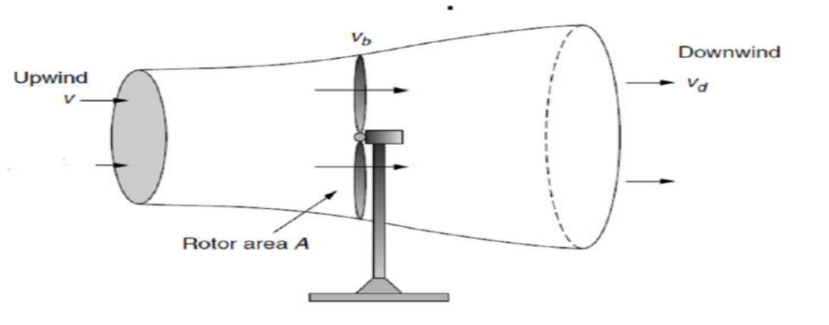
Figure 2: Wind behaviour around a wind turbine

Table 2: Advantages and Disadvantages of Wind [5]
Advantages | - A renewable, clean and sustainable energy source;  - Wind is an abundant energy source;  - Wind power is a relatively cheap source;  - Wind farms/turbines can be constructed on already established farm lands.
Disadvantages | - Wind power must be able to compete financially with conventional electrical generation methods;  - Optimal wind farm sites are generally remotely located;  - Wind farm and resource development may not be feasible on specified land;  - Wind turbines may cause noise pollution and aesthetic obstructions;  - Rotating turbine blades can potentially harm surrounding wildlife.
Depending on the different structure, the wind turbine can be classified to vertical axis wind turbine and horizontal axis wind turbine. Turbine selection is also dependent on local weather conditions and the power capacity demands of the client.

Location
This region offers harsh weather conditions throughout the year, restricting the teams design. Since it is a requirement that the system operates in Newman, weather conditions are an important aspect of the team’s research. Newman has an average annual rainfall of 317.8mm with the wettest months in summer[4]. The average number of cloudless days is 180.7 every year which could affect the team’s decision to use a photovoltaic power generation method. The average morning wind speed is 9.1km/h and afternoon is 9.4km/h which will be a consideration in the use of wind turbines. Since Newman is located 350km away from the coast it is unaffected by the sea breeze. This means that there is little change in wind direction throughout the day[5]. Newman’s distance from the coast makes it the least affected by tropical cyclones compared to other towns in the Pilbara. However, it is still subject to damaging winds from cyclones turning inland[6].The topography in Newman consists of rocky outcrops and surrounding hills. This includes Mt. Whaleback where BHP mines iron ore[5] at 610m above sea level and Mt Newman at 1057m [7].

Battery Storage
Many daily activities and appliances rely heavily on electrical energy and the storage of electrical energy. Although electrical elements such as capacitors are capable of storing electrical energy it is usually of very small magnitude, and hence there was need for other technology capable of storing more electrical energy. One of the oldest inventions for the storage of electrical energy was the battery. The electrochemical cell or battery contained chemicals that, when needed, would undergo a chemical reaction with desired electrical energy as the product [8]. There are two main types of electrochemical cells, those that convert chemical energy into electrical energy (galvanic cells) and cells that convert electrical energy back to chemical energy (electrolytic cells) [9]. Combining these types of electrochemical cells, it is possible to produces batteries that discharge only or discharge and recharge. Electrochemical cells can either be considered as wet or dry depending on the state of the electrolyte [10]. The structure of a typical electrochemical cell is shown in Figure 1. Electrochemical processes have been studied for over 200 years varying the electrodes and electrolyte as technology improved to build better energy storage systems [11].
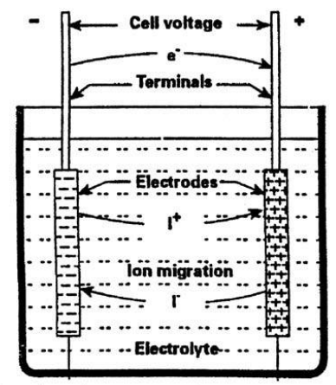
Figure 1: Structure of electrochemical cell
As mentioned previously batteries can be used as a purely discharge system or as a discharge recharge system, with the former most commonly used in small electrical devices (clocks, remotes, and toys) and the latter used for larger applications (cars, trains, planes, and renewable energy systems). Prior to the 1990s the main types of batteries for storage applications consisted of the Lead-acid battery and the Nickel Cadmium (NiCd) battery. However, today’s storage market is predominately made up of Lithium-ion (Li-ion) batteries, with double the storage density of its predecessors [12]. Efficiencies of Lead-acid batteries typically range between 70 – 90 % and lifetimes between 5 – 15 years, Li-ion batteries, however, exhibit higher efficiencies approximately 85 – 98 %, and lifetimes similar to that of Lead-acid batteries [13]. Table 1 lists the advantages and disadvantages of Lead-acid and Li-ion batteries.

Table 1: Advantages and disadvantages of Lead-Acid and Li-ion batteries
 | Advantages | Disadvantages
Lead-acid | - Reliable  - Tolerant to overcharge  - Cheap | - Lead is toxic  - Heavy metal  - Limited life cycle  - No fast-charge [14]
Li-ion | - Higher energy density and therefore occupy less space.  - Ideal for frequency regulation  - Cleaner and safer disposal | - Due to high energy density cells are prone to combustion  - Sensitive to external heat, overcharging and high currents

Inverters
First coined in 1925 by David Prince the word converter is used to describe a power electronic device that converts direct current (DC) power to alternating current (AC) power [15]. Inverters are used widely in industry and especially in renewable energy systems that involve the use of PV cells. Power produced by the sun is in the form of DC power and hence needs to be converted to AC when being used to power other appliances. Average inverter efficiencies range between 50% and 90% depending on the use of the inverter [16]. Average cost of inverters in Australia are approximately 30 c per Watt, however the government offers rebates for the purchase of inverters associated with renewable energy systems [17].

Diesel Generators
Diesel generators are diesel engines coupled to a generator, converting mechanical energy into electrical energy. Generators can generate electricity at the rated power, and any unused power can be used to charge battery storage. The use of diesel generators in hybrid power systems is common place where there is a lack of reliable power supply [18]. The project requires 90 kW of power to supply three 30 kW bore pumps plus some extra power for telemetry. While the generator will be used primarily as a backup system, it will need to be able to supply sufficient power to allow the bore pumps to continue running at full load. To cost the backup system, the price of the generator, the fuel and fuel delivery must be considered.

The cost of a diesel generator that meets the power requirements is approximately $20,000 to $28,000 [19, 20]. Such a generator consumes up to 25 L/hour when running at full load. This incurs a significant cost in using the fuel, in 2016 the average retail price of diesel was 121.6 c/L [21]. Diesel fuel can be transported by pipeline or by vehicle, this project is better suited to the use of a vehicle. Furthermore, the storage of diesel fuel on site must be considered. Any storage tanks must comply with AS 1692 (Tanks for flammable and Combustible liquids) [22].

Cooling System
For the power system to operate in Newman’s harsh weather conditions it will require its own cooling mechanism. Elements such as photovoltaic cells will not require cooling however, elements such as battery banks will. Battery banks are more efficient at an optimal temperature range. There has been investigation to air cooling and liquid cooling in battery packs. It has been found that liquid cooling has a higher heat transfer due to its higher heat capacity than air cooling [23]. Air cooling requires forced air flow, this could be from fans, or a ventilation system, or a combination of both. Water or liquid cooling requires a secondary heat exchanger, cool liquid is streamed around the system and then recycled. Since the liquid is being used to cool electronics, low conductivity water or a glycol solution is used [24]. The simplest method to protect equipment from the environment is to remove it from direct sunlight.

Overhead Power
The most commonly used transmission line types are the following [9]:
- ACSR (aluminum conductor, steel reinforced)
- ACSR/AW (aluminum conductor, aluminum-clad steel reinforced)
- ACSR-SD (aluminum conductor, steel reinforced/self-damping)
- ACAR (aluminum conductor, allow reinforced)
- AAC-1350 (aluminum alloy conductor composed of 1350 aluminum alloy)
- AAAC-201 (all aluminum alloy conductor composed of 6201 alloy)
Different types of conductor can be used in different situations, for instance if the power system has to be operated in corrosive atmospheric conditions then ASCR/AW, ACAR and AAAC-6201 are more suitable compared to other types. Considering high wind conditions, large and heavy conductors shall be chose due to higher inertia compared with small conductors [10], thus the types of ACSR-SD and AAC-1350 would be considered.

Telemetry
Due to the remote nature of the bore field, and the critical role that maintaining adequate process water plays in mine operation[25], it is important to continuously monitor the performance of the power supply and pump system[26]. It is proposed that the telemetry system consume no more than 100W of 24V DC power[27]. Sensing and data logging equipment for the power system, as well as security, safety and site infrastructure, must be able to communicate with the remote operations center located at the client’s mine site. The project does not require design of a sensing system for the pumps themselves, but communication channels and bandwidth will need to be reserved for pump telemetry. Once specific iterations of design option technologies have been identified, application of internet of things (IoT) paradigms and technologies will allow for an efficient and effective telemetry system[26, 28, 29].

Design Decisions

Base Case

Justification

What requirements will it meet.

Hybrid 1: Solar, Battery, Diesel

Justification
The design option to investigate is the use of a photovoltaic (PV) system, with a power storage system and a diesel backup system. The configuration of the proposed system can be seen in Figure 2. This system relies mainly on solar power for generation, while storing unused power in a battery for when sunlight is unavailable at night or on cloudy days. To ensure supply is continuous, there is also a diesel backup generator for use when the battery storage is depleted, or there is a failure in the PV or battery system. This system also demands the use of an inverter since PV only produces DC (direct current) and the load requires AC (alternating current) [30].

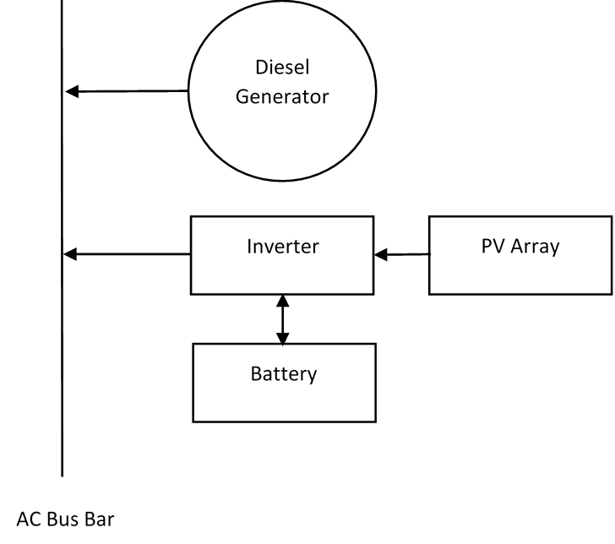
Figure 2: Hybrid System Configuration

PV, battery and diesel systems have had success in similar previous projects where the location meant that the power supply was best suited off grid. This has been used to supply power to homes in Kahramanmaras, Turkey where the temperatures are extreme like those in Newman. It was found that in summer, the system could rely only on the PV and battery but required the generator in the winter months but was always able to meet the power requirements [31]. While this system does not meet the same power requirements as the project, it is relevant due to its success in a harsh climate.

What requirements will it meet
The main requirements (appendix 1) that this option is required to meet are 1, 2, 3, 7, 8, and 9. This means that the system should operate continuously providing sufficient power in Newman. It should also be maintainable, last the required 10 years, and minimise environmental impact. The economy and safety (requirements 4 and 5) of the solution will be compared to other options by means of a risk register and cost benefits analysis carried out by other team members.

The inclusion of a backup generator and battery allows the system the best chance to run without disruption hence meeting the main requirement for the project. This also helps to meet requirement 3 since any poor weather conditions due to the systems location that stop the PV system from generating power is counteracted by including a battery and generator. By sizing the system correctly and selecting appropriate equipment, it will meet the power requirements for all three pumps and telemetry meeting requirement 2. This also helps to meet requirements 7 and 8, equipment that has been used successfully before has the best chance to last the full 10-year lifetime. Equipment used widely in industry is also well documented simplifying maintenance and staff may be familiar with it. The use of a PV array is particularly appropriate in meeting requirements 3 and 9. Due to the remote location (Newman) there is enough land for large PV arrays and the climate has a low number of cloudy days [4]. Solar power is a renewable energy source with no emissions therefore minimising harm to the environment. This system meets some requirements better than others; however, it is important to meet requirements of a higher priority first. For example, the system will be costly, but it will also provide a continuous power supply without disruptions.

Hybrid 2: Solar, Wind, Battery, Diesel

Justification

One of the proposed system to supply power to the remote borefield is a hybrid system consisting of photovoltaics (PV), wind energy, battery storage and diesel generator back-up system. This hybrid system of renewable and non-renewable technologies was chosen based on the efficiency of the technologies, the geographical location of Newman and the cost of implementation. PV was chosen for the system because Newman exhibited high daily solar radiations, however at night this would become a problem and therefore a wind turbine system was chosen to help power the pumps during the night. From the two storage systems, battery was chosen because it was more compact than a PHES system and the geographical location was not ideal for the latter storage system. Although both renewable energy systems may have the ability to supply sufficient power to the pumps the addition of a diesel generator would serve as a contingency, if both renewable energy systems were to fail or provide insufficient power. On top of technologies for power generation, this solution will require a telemetry system to monitor the different renewables and allow for comminution between the borefield and mine site. Many electronic devices including batteries only operate in a finite temperature range, due to the extreme temperatures of Newman, a cooling system will need to be implemented to optimize the performance of the system.

What requirements will it meet

On completion of the simulations using HOMER Energy the sized systems will meet requirements (1), (2), (8), (9). The microgrid simulation program also has the ability to calculate the NPV of the system and hence, the system can be optimised to meet requirement (5). However, further research will need to be conducted to determine the NPV calculation used by HOMER, which could lead to a separate economic analysis of the system with up-to-date cost figures.

Fully Renewable

Justification

What requirements will it meet

Costing

Methodologies
Early indications from Team Power’s extensive literature review are that a hybrid solution is most likely to satisfy the project requirements. As more research is performed, detailed costings can be developed based on the exact iterations of technologies to be used; with resources such as Rawlinson’s Construction Cost Guide and HOMER simulation software providing the basis for these[2, 32].

Further Research and Future Tasks
Jacobs’ representative has promised to deliver detailed pricing information for diesel generators (per kW produced) and local pricing of diesel (per unit volume), as well as pricing per km for overhead lines (including poles, wires etc.). Once these quotes are delivered comparison of price points for finalizing design options can begin.

Testing

Projects with various proposed solutions require testing to determine the extent of their ability to meet each requirement. Using various techniques including software, literature and calculations each of the four solutions proposed in section 7.1 to 7.4 will be tested on how well they meet each requirement in Appendix A.

The microgrid program HOMER Energy will be used to size the fully renewable and hybrid systems. The output of the HOMER simulations will consist of information including proportional energy production of each technology per system, energy usage profile diagrams of each technology, total battery storage, and total carbon emissions. These values will determine how well each system met requirements (1), (2), and (9). It is assumed that the base case system will automatically be sized meet these requirements. Unfortunately, HOMER does not simulate telemetry or cooling systems, hence, requirements (3), and (6) will be tested against previous similar projects and data manuals. By sizing an appropriate telemetry and cooling system along with the use of data sheet for each technology maintenance procedures can be formulated to meet requirement (7). Meeting requirement (8) will also be tested using previous similar projects and data sheets of the technologies used, specifically their average life spans.

The HOMER Energy simulations also have the capability to output the NPV using the calculation stated in section 6.2 and hence test how well each system has met requirement (5). However, other techniques including a cost benefit analysis will also be conducted to further support the extent at which each system has met the requirement. Using Rawlinson’s Cost Guide, the cost of the base case can be determined along with any costs attributed to the construction of each system.

To meet requirement (4), a risk register will be conducted determining possible risk and contingencies associated with each system. Comparing the systems to previous example of similar projects will also help to determine the safety of the system. It was assumed that any other proposed system (hybrid or fully renewable) would have negligible completion time compared to the base case and therefore it can be assumed that all proposed systems will meet requirement (10).

Risk
As stated in Project Management Body of Knowledge (PMBOK), there are seven specific techniques and tools for identifying risk as follows[33]:
- Documentation Reviews
- Information Gathering
- Checklist analysis
- Assumption analysis
- Diagramming Techniques
- SWOT Analysis
- Expert Judgment
In this report, Information Gathering Techniques is the main method to identify risks. The meaning of Information Gathering Techniques is brainstorming, interviewing, finding data from other project and root cause analysis.

Risk Register
Needs to be done

Tracking Safety Issues
Needs to be done

Project Management

Configuration Management
Github and version control

Communication
Minutes, meetings, TQs

You do not need to attach minutes, and certainly do not assume that if you do these would be excluded from the word count. Instead, outline how you are managing communication. e.g. How frequently do you meet? What records are kept, where and how, and who keeps them? How are queries recorded and tracked?

Conclusion
Summarise main design decisions, what is important moving forward, what future work could be done and lessons learned (eg realized we will have to prioritise in the process or timeline)

Appendices

Appendix A – Requirements Summary Table
Priority | Requirement | Description | Classification
1 | 24/7 | The power generation system will be required to operate for 24 hours a day, 7 days a week, 365 days a year | EXP, SPO
2 | 90Kw++ | The power generation system must produce 90Kw of power to supply the main pumps, plus additional power to supply other essential systems. | EXP, SPO
3 | Newman | The power generation system must operate in Newman. This includes tolerating the harsh conditions. | EXP, SPO
4 | Safety | The system must run safely. Any safety equipment that requires power must also be supplied. | EXP, SPO, UNS
5 | Economy | Maximise the economy of the proposed solution. | EXP, SPO
6 | Telemetry | The system requires telemetry and communications equipment, and these will also require power. | EXP, SPO
7 | Maintainable | The system must be maintainable. | EXP, UNS
8 | 10-year life | The system must last for at least ten years. | EXP, SPO
9 | Environment | The proposed solution should minimise harm to the environment. | EXP, EXC
10 | Time | The proposed solution should take a minimum amount of time to construct. | EXP, EXC
EXP – Expected, SPO – Spokens, UNS – Unspokens, EXC – Exciters

Appendix B – Scope Diagram
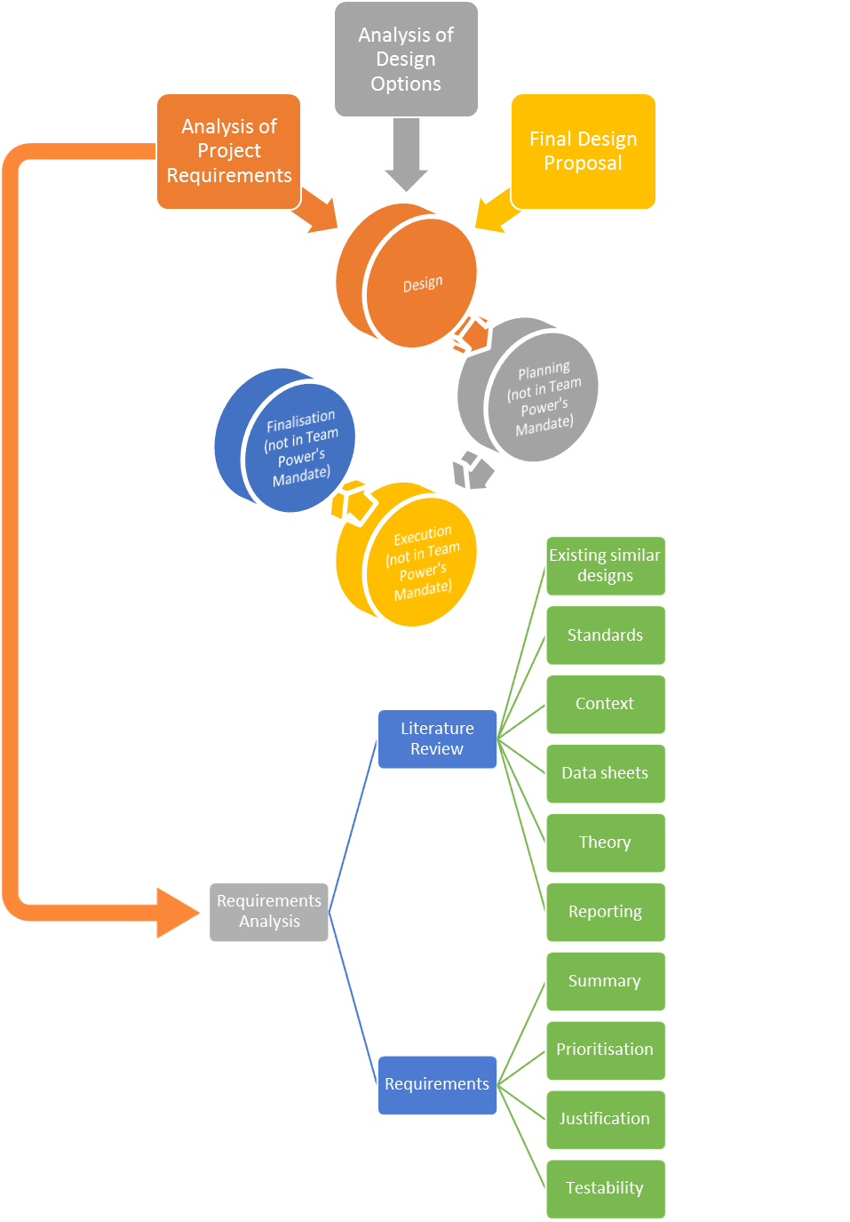

Appendix C

