<Project Name>
<Project Name>

Authors
<Project Name>
<Project Name>
<Project Name>
<Project Name>
<Project Name>
<Project Name>

<Name of Document>

Project Partners: <Name, Organization>

Engineering Consultant (remove if on Project B): <Name, Organization>

Demonstrator: <Name>

Academic Supervisor:
<Name>

Group Meeting Day and Time:

Word Count:

Word Limit:

Version <1.0>

Revision History
Date | Version | Description | Author
<10/04/17> | 1.0 |  | <name>

Table of Contents
1. Introduction 5
1.1 Purpose 5
1.2 Scope 5
1.3 Definitions, Acronyms, and Abbreviations 5
1.4 References 5
2. Summary of Design Approach 5
3. Project Scope 5
4. Team Responsibilities 5
4.1 Contributions of team members 5
4.2 SWOT & Competency for Design 5
5. Scheduling 5
6. Resources 5
6.1 Tangible 5
6.2 Intangible 5
6.3 Literature Review 5
7. Design Decisions 6
7.1 Base Case 6
7.1.1 Justification 6
7.1.2 Requirements 6
7.1.3 Costs 6
7.2 Hybrid 1 6
7.2.1 Justification 6
7.2.2 What requirements will it meet 6
7.2.3 Costs 6
7.3 Hybrid 2 6
7.3.1 Justification 6
7.3.2 What requirements will it meet 6
7.3.3 Costs 6
7.4 Fully Renewable 6
7.4.1 Justification 6
7.4.2 What requirements will it meet 6
7.4.3 Costs 6
7.5 Testing 6
8. Risk 6
8.1 Risk Register 6
8.2 Tracking Safety Issues 6
9. Project Management 6
9.1 Configuration Management 6
9.2 Communication 6
10. Appendices 7
10.1 Appendix A 7
10.2 Appendix B 7
10.3 Appendix C 7

Introduction

Purpose

Scope

Definitions, Acronyms, and Abbreviations

References

Summary of Design Approach

Project Scope

Team Responsibilities

Contributions of team members
- Who did what
- Who will do what

SWOT & Competency for Design

Scheduling

Resources

Tangible
People, equipment, infrastructure

Intangible
Software (HOMER), time, motivation etc.

Literature Review
Solar
Wind
Location

Battery Storage
Many daily activities and appliances rely heavily on electrical energy and the storage of electrical energy. Although electrical elements such as capacitors are capable of storing electrical energy it is usually of very small magnitude, and hence there was need for other technology capable of storing more electrical energy. One of the oldest inventions for the storage of electrical energy was the battery. The electrochemical cell or battery contained chemicals that, when needed, would undergo a chemical reaction with desired electrical energy as the product [1]. There are two main types of electrochemical cells, those that convert chemical energy into electrical energy (galvanic cells) and cells that convert electrical energy back to chemical energy (electrolytic cells) [2]. Combining these types of electrochemical cells, it is possible to produces batteries that discharge only or discharge and recharge. Electrochemical cells can either be considered as wet or dry depending on the state of the electrolyte [3]. The structure of a typical electrochemical cell is shown in Figure 1. Electrochemical processes have been studied for over 200 years varying the electrodes and electrolyte as technology improved to build better energy storage systems [4].
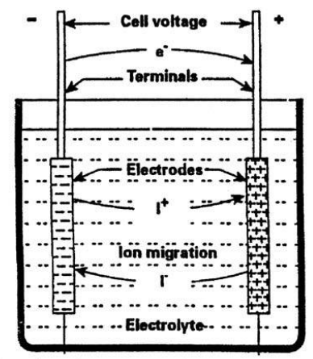
Figure 1: Structure of electrochemical cell
As mentioned previously batteries can be used as a purely discharge system or as a discharge recharge system, with the former most commonly used in small electrical devices (clocks, remotes, and toys) and the latter used for larger applications (cars, trains, planes, and renewable energy systems). Prior to the 1990s the main types of batteries for storage applications consisted of the Lead-acid battery and the Nickel Cadmium (NiCd) battery. However, today’s storage market is predominately made up of Lithium-ion (Li-ion) batteries, with double the storage density of its predecessors [5]. Efficiencies of Lead-acid batteries typically range between 70 – 90 % and lifetimes between 5 – 15 years, Li-ion batteries, however, exhibit higher efficiencies approximately 85 – 98 %, and lifetimes similar to that of Lead-acid batteries [6]. Table 1 lists the advantages and disadvantages of Lead-acid and Li-ion batteries.
Table 1: Advantages and disadvantages of Lead-Acid and Li-ion batteries
 | Advantages | Disadvantages
Lead-acid | - Reliable  - Tolerant to overcharge  - Cheap | - Lead is toxic  - Heavy metal  - Limited life cycle  - No fast-charge [7]
Li-ion | - Higher energy density and therefore occupy less space.  - Ideal for frequency regulation  - Cleaner and safer disposal | - Due to high energy density cells are prone to combustion  - Sensitive to external heat, overcharging and high currents

Inverters
First coined in 1925 by David Prince the word converter is used to describe a power electronic device that converts direct current (DC) power to alternating current (AC) power [8]. Inverters are used widely in industry and especially in renewable energy systems that involve the use of PV cells. Power produced by the sun is in the form of DC power and hence needs to be converted to AC when being used to power other appliances. Average inverter efficiencies range between 50% and 90% depending on the use of the inverter [9]. Average cost of inverters in Australia are approximately 30 c per Watt, however the government offers rebates for the purchase of inverters associated with renewable energy systems [10].

Diesel Generators
Diesel generators are diesel engines coupled to a generator, converting mechanical energy into electrical energy. Generators can generate electricity at the rated power, and any unused power can be used to charge battery storage. The use of diesel generators in hybrid power systems is common place where there is a lack of reliable power supply [11]. The project requires 90 kW of power to supply three 30 kW bore pumps plus some extra power for telemetry. While the generator will be used primarily as a backup system, it will need to be able to supply sufficient power to allow the bore pumps to continue running at full load. To cost the backup system, the price of the generator, the fuel and fuel delivery must be considered.

The cost of a diesel generator that meets the power requirements is approximately $20,000 to $28,000 [12, 13]. Such a generator consumes up to 25 L/hour when running at full load. This incurs a significant cost in using the fuel, in 2016 the average retail price of diesel was 121.6 c/L [14]. Diesel fuel can be transported by pipeline or by vehicle, this project is better suited to the use of a vehicle. Furthermore, the storage of diesel fuel on site must be considered. Any storage tanks must comply with AS 1692 (Tanks for flammable and Combustible liquids) [15].

Cooling System
For the power system to operate in Newman’s harsh weather conditions it will require its own cooling mechanism. Elements such as photovoltaic cells will not require cooling however, elements such as battery banks will. Battery banks are more efficient at an optimal temperature range. There has been investigation to air cooling and liquid cooling in battery packs. It has been found that liquid cooling has a higher heat transfer due to its higher heat capacity than air cooling [16]. Air cooling requires forced air flow, this could be from fans, or a ventilation system, or a combination of both. Water or liquid cooling requires a secondary heat exchanger, cool liquid is streamed around the system and then recycled. Since the liquid is being used to cool electronics, low conductivity water or a glycol solution is used [17]. The simplest method to protect equipment from the environment is to remove it from direct sunlight.

Overhead Power (-2-,-3-,-5-,-10-)
Using overhead power transmission to supply the bore field (the ‘base case’) is ostensibly a viable option. The author has been instructed by Jacobs to assume that there are 22kV lines available from the mine site 10km away[18], which itself will derive power from a client-owned natural-gas-fired power plant in the Newman area[19, 20]. The supplied cost of power from the client’s power plant is 30c/kWh. The project partner’s assumption is that running overhead lines will be the most expensive and time consuming option[21], however Team Power will perform a thorough analysis before coming to any conclusions.

Telemetry
Due to the remote nature of the bore field, and the critical role that maintaining adequate process water plays in mine operation[22], it is important to continuously monitor the performance of the power supply and pump system[23]. It is proposed that the telemetry system consume no more than 100W of 24V DC power[20]. Sensing and data logging equipment for the power system, as well as security, safety and site infrastructure, must be able to communicate with the remote operations center located at the client’s mine site. The project does not require design of a sensing system for the pumps themselves, but communication channels and bandwidth will need to be reserved for pump telemetry. Once specific iterations of design option technologies have been identified, application of internet of things (IoT) paradigms and technologies will allow for an efficient and effective telemetry system[23-25].

Costing

Methodologies
Early indications from Team Power’s extensive literature review are that a hybrid solution is most likely to satisfy the project requirements. As more research is performed, detailed costings can be developed based on the exact iterations of technologies to be used; with resources such as Rawlinsons Construction Cost Guide and HOMER simulation software providing the basis for these[26, 27].

Further Research and Future Tasks
Jacobs’ representative has promised to deliver detailed pricing information for diesel generators (per kW produced) and local pricing of diesel (per unit volume), as well as pricing per km for overhead lines (including poles, wires etc.). Once these quotes are delivered comparison of price points for finalizing design options can begin.

Design Decisions

Base Case
Needs to be split into justification, requirements and Costs

Components of Overhead Transmission Lines
An overhead line consists of conductors and ground wires, towers, insulators, hardware, and foundations [8].

Conductors
The most commonly used transmission types are the following [9]:
- ACSR (aluminum conductor, steel reinforced)
- ACSR/AW (aluminum conductor, aluminum-clad steel reinforced)
- ACSR-SD (aluminum conductor, steel reinforced/self-damping)
- ACAR (aluminum conductor, allow reinforced)
- AAC-1350 (aluminum alloy conductor composed of 1350 aluminum alloy)
- AAAC-201 (all aluminum alloy conductor composed of 6201 alloy)
Different types of conductor can be used in different situations, for instance the power system has to be operated in corrosive atmospheric conditions then ASCR/AW, ACAR and AAAC-6201 are more suitable compared to other types. Considering the high wind condition in Newman, large and heavy conductors shall be chose due to higher inertia compared with small conductors [10], thus the types of ACSR-SD and AAC-1350 would be considered.

Ground wires
Overhead ground wires also called the shield wires. They are the wires that are installed above the phase conductors (or wires). They used to protect the line from lightning and to even out the ground potential and sometimes even used for low-voltage (LV) communication. The overhead ground wires do not conduct the load current, but they very rapidly conduct the very heavy current of a lightning strike to the ground, through their many grounded connections [11]. The sags of the overhead ground wires must be the same as the sags of the phase conductors [12].
During the design stage, protect the power system from lightning strike is one of the requirements of the project. Thus, the use of overhead ground wires in the transmission line construction can effective avoid lighting strike.

Insulators
An insulator is a material that prevents the flow of an electric current and can be used to support electrical conductors. The function of insulation is to provide for the necessary clearance between the line conductors, between conductors and ground, and between conductors and the pole or tower. Insulators are made of porcelain, glass and fiber glass treated with epoxy resins [13].
The basic types of insulators include pin-type insulator, suspension insulators, and strain insulators. The pin-type insulator is supported on a pin. The pin holds the insulators, and the insulator has the conductor tied to it. However, the pin-type insulators are seldom used on transmission lines having voltages above 44 kV [14]. Suspension insulators consist of a string of interlinking separate disks made of porcelain. A string may consist of many disks depending on the line voltage. For example, as an average, for 115 kV lines, usually 7 disks are used and for 345 kV lines, usually 18 disks are used [15]. When there is a dead end of the line, or there is a corner or a sharp curve, or the line crosses a river, then the line will withstand grate strain. The unit assembly of suspension units arranged to dead-end the conductor of a structure is call strain insulator [16].
As discussed above, the selection of insulator could be confirmed when the characteristics of transmission line are identified. The construction design of the transmission towers and foundations might be provided by Jacobs, if not a further investigation on these topics should be performed.

Justification

Requirements
What requirements will it meet, what trade-offs are there between requirements

Costs

Hybrid 1: Solar, Battery, Diesel

Justification
The design option to investigate is the use of a photovoltaic (PV) system, with a power storage system and a diesel backup system. The configuration of the proposed system can be seen in Figure 2. This system relies mainly on solar power for generation, while storing unused power in a battery for when sunlight is unavailable at night or on cloudy days. To ensure supply is continuous, there is also a diesel backup generator for use when the battery storage is depleted, or there is a failure in the PV or battery system. This system also demands the use of an inverter since PV only produces DC (direct current) and the load requires AC (alternating current) [28].

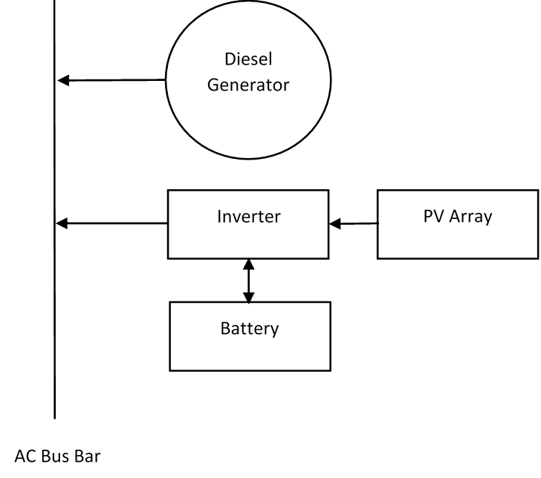
Figure 2: Hybrid System Configuration

PV, battery and diesel systems have had success in similar previous projects where the location meant that the power supply was best suited off grid. This has been used to supply power to homes in Kahramanmaras, Turkey where the temperatures are extreme like those in Newman. It was found that in summer, the system could rely only on the PV and battery but required the generator in the winter months but was always able to meet the power requirements [29]. While this system does not meet the same power requirements as the project, it is relevant due to its success in a harsh climate.

What requirements will it meet
The main requirements (appendix 1) that this option is required to meet are 1, 2, 3, 7, 8, and 9. This means that the system should operate continuously providing sufficient power in Newman. It should also be maintainable, last the required 10 years, and minimise environmental impact. The economy and safety (requirements 4 and 5) of the solution will be compared to other options by means of a risk register and cost benefits analysis carried out by other team members.

The inclusion of a backup generator and battery allows the system the best chance to run without disruption hence meeting the main requirement for the project. This also helps to meet requirement 3 since any poor weather conditions due to the systems location that stop the PV system from generating power is counteracted by including a battery and generator. By sizing the system correctly and selecting appropriate equipment, it will meet the power requirements for all three pumps and telemetry meeting requirement 2. This also helps to meet requirements 7 and 8, equipment that has been used successfully before has the best chance to last the full 10-year lifetime. Equipment used widely in industry is also well documented simplifying maintenance and staff may be familiar with it. The use of a PV array is particularly appropriate in meeting requirements 3 and 9. Due to the remote location (Newman) there is enough land for large PV arrays and the climate has a low number of cloudy days [30]. Solar power is a renewable energy source with no emissions therefore minimising harm to the environment. This system meets some requirements better than others; however, it is important to meet requirements of a higher priority first. For example, the system will be costly, but it will also provide a continuous power supply without disruptions.

Costs

Hybrid 2: Solar, Wind, Battery, Diesel
One of the proposed system to supply power to the remote borefield is a hybrid system consisting of photovoltaics (PV), wind energy, battery storage and diesel generator back-up system. This hybrid system of renewable and non-renewable technologies was chosen based on the efficiency of the technologies, the geographical location of Newman and the cost of implementation. PV was chosen for the system because Newman exhibited high daily solar radiations, however at night this would become a problem and therefore a wind turbine system was chosen to help power the pumps during the night. From the two storage systems, battery was chosen because it was more compact than a PHES system and the geographical location was not ideal for the latter storage system. Although both renewable energy systems may have the ability to supply sufficient power to the pumps the addition of a diesel generator would serve as a contingency, if both renewable energy systems were to fail or provide insufficient power. On top of technologies for power generation, this solution will require a telemetry system to monitor the different renewables and allow for comminution between the borefield and mine site. Many electronic devices including batteries only operate in a finite temperature range, due to the extreme temperatures of Newman, a cooling system will need to be implemented to optimize the performance of the system.

The system will be simulated using a microgrid software known as HOMER Energy. This program will allow the Team to optimise the size of the system that would increase the NPV, increase the use of renewables and hence, decrease the carbon emissions from the use of the diesel generator. The program is also capable of sizing the storage system needed for the particular power system. Unfortunately, HOMER is incapable of sizing telemetry or cooling systems and therefore these will need to be sized based on previous projects and data manuals.

On completion of the simulations using HOMER Energy the sized systems will meet requirements (1), (2), (8), (9). The microgrid simulation program also has the ability to calculate the NPV of the system and hence, the system can be optimised to meet requirement (5). However, further research will need to be conducted to determine the NPV calculation used by HOMER, which could lead to a separate economic analysis of the system with up-to-date cost figures.

Justification

What requirements will it meet

Costs

Fully Renewable

Solar
Now, there is variety of renewable energy sources in daily life, with solar energy more economically competitive against other energy. Compared to traditional fossil fuels and other non-renewable source, solar energy can be zero carbon release, neglecting the production of solar panels. For tide and wave energy, because the generating equipment must be placed on or in the ocean, the marine ecosystem could be adversely impacted. Moreover, high O&M cost cannot be suitable for this project [1]. The sun's rays can be absorbed by solar photovoltaic (PV) panels as sources of energy to generate electricity [2]. The advantages and disadvantages of implementing a solar PV system are as follows:
Table 1: Advantages and Disadvantages of Solar [2]
Advantages | - Easy to install and disassemble;  - Long use life;  - No need to service specially;  - High reliability;  - Economically viable, no energy consumption;  - Mechanical wear resistance;  - High compatibility with other technologies.
Disadvantages | - Not suitable for regions of short solar exposure (regions of high latitude);  - Highly weather-dependent;  - Low efficiency;  - Occupy a large area.

Most solar PV panels now are based on variation of silicon, usually different kinds of silicon with variable purity. The panel that made by high purity silicon have high efficiency, which mean the solar energy can be converted to more electricity, while the silicon purifying process is expensive [3]. Specifically, silicon solar PV panels are usually made of either monocrystalline silicon or polycrystalline silicon [2]. Monocrystalline has a higher efficiency than polycrystalline; however, the cost of manufacturing is much higher [2]. The monocrystalline will usually have a longer expected life, which will offset some of those costs [2]. Battery storage is the most compatible with solar PV systems [2].

Climate information requirements of project site
Each technology has specific requirements to optimize functionality and suitability for the system, for example a solar PV system will work more effectively in areas that have higher solar radiation. The available background climate information can be found in the Figure 1, which is high number of sunshine hours at around Newman (More details refer to Appendix B [4]). Therefore, solar can be considered in this design option.

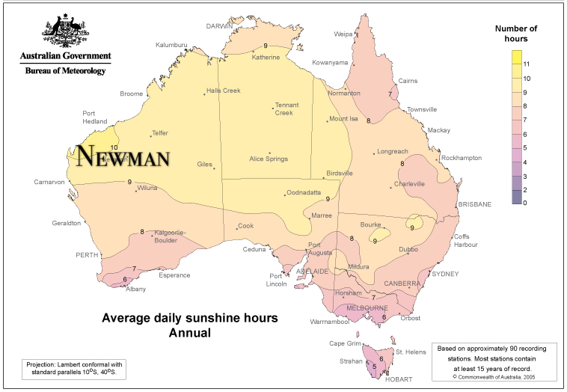
Figure 1: Average daily sunshine hours annual

Wind
Wind energy harvesting employs air flow movement in generating sources of electricity [5]. Currently, wind power is one of the cheapest renewable energy technologies [6]. In order to harness the kinetic energy supplied by an air flow, wind turbines can be implemented [5]. Figure 2 depicts the motion of air flow through an impeller-driven wind turbine design. When an air flow passes through the impeller rotor area, kinetic energy supplied by the air flow translates to a rotational energy experienced by the turbine impeller [5]. The impeller rotation, employing Faraday’s law of electrical induction, causes a connected generator to spin producing an electrical current [5]. 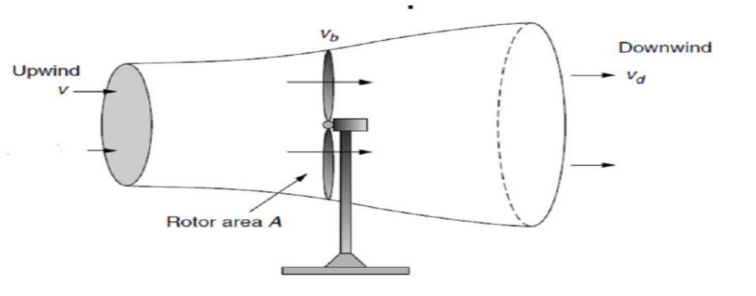
Figure 2: Wind behaviour around a wind turbine
Table 2: Advantages and Disadvantages of Wind [5]
Advantages | - A renewable, clean and sustainable energy source;  - Wind is an abundant energy source;  - Wind power is a relatively cheap source;  - Wind farms/turbines can be constructed on already established farm lands.
Disadvantages | - Wind power must be able to compete financially with conventional electrical generation methods;  - Optimal wind farm sites are generally remotely located;  - Wind farm and resource development may not be feasible on specified land;  - Wind turbines may cause noise pollution and aesthetic obstructions;  - Rotating turbine blades can potentially harm surrounding wildlife.
Depending on the different structure, the wind turbine can be classified to vertical axis wind turbine and horizontal axis wind turbine. Turbine selection is also dependent on local weather conditions and the power capacity demands of the client. The decision to use wind energy for this system was based on the abundance of the energy source. The average morning wind speed is 9.1km/h and afternoon is 9.4km/h [4]. Secondly, wind energy offers a clean and renewable method to energy production when modelling a power system to be independent of diesel electricity generation. Wind energy harvesting additionally offers a cheap energy source and creates job opportunities in areas where wind turbines are installed.

Battery Storage
The battery can be introduced as the energy storage in the system based on renewable sources due to their fluctuation and the insufficient reliability of supply. As a result of the uncertain nature of solar panel and wind turbine, battery can be considered to supply the load via storing energy during periods of high energy production brought on by high solar exposure or strong winds.
The main types of batteries for consideration are sealed lead acid or lithium ion [7]. The advantages and disadvantages of using battery storage are as follows:
Table 3: Advantages and Disadvantages of Battery [7]
Advantages | - Provide longer run time at a higher power rating.
Disadvantages | - Usually cannot be fully discharged;  - Large initial capital investment;  - Take time to recharge; and  - Require electricity source to recharge.

Best storage for solar PV is batteries [8], which can match the design of PV system model. However, when considering the trade-off analysis for a specific application of batteries, there are lots of factors need to consider. Especially for initial cost, lifetime, weight, volume, temperature sensitivity all plays a significant role in battery selection [8]. Based on its common market application, advantages and disadvantages of these two types of batteries are analysed and compared as shown in the following table [8].
Table 4: Lead Acid VS Lithium-ion
Cost ($/kWh) | VRLA lead acid (25℃) | Lithium-ion
Installed capacity | 100 kWh | 50 kWh
Battery cost | $12000 ($120/kWh) | $30000 ($600/kWh)
Installation cost | $20/kWh | $3.6/kWh
Lifetime cost | $0.34/kWh throughput | $0.40/kWh throughput
Transportation cost | $28/kWh | $5/kWh
Lifetime (hours) | 1000 @ 50% DoD1 | 1900 @ 80% DoD
1DoD = Depth of discharge.
Because VRLA lead-acid can be easily affected by the temperature, moreover, for a lead acid system to provide the same amount of energy, it must have a greater nameplate energy capacity than the lithium-ion battery [8]. In terms of cycle life comparison, lithium-ion has higher cycle life than lead acid in deep discharge applications [8]. Therefore, lithium-ion can provide better operation in a lot of situations, specifically in hot climates and that is why they are chosen in this design and future simulation process.

Justification

What requirements will it meet

Costs

Testing

Risk
As stated in Project Management Body of Knowledge (PMBOK), there are seven specific techniques and tools for identifying risk as follows[31]:
- Documentation Reviews
- Information Gathering
- Checklist analysis
- Assumption analysis
- Diagramming Techniques
- SWOT Analysis
- Expert Judgment
In this report, Information Gathering Techniques is the main method to identify risks. The meaning of Information Gathering Techniques is brainstorming, interviewing, finding data from other project and root cause analysis.

Risk Register
Needs to be done

Tracking Safety Issues
Needs to be done

Project Management

Configuration Management
Github and version control

Communication
Minutes, meetings, TQs

Appendices

Appendix A

Appendix B

Appendix C

