Project B: Solar Generation of Remote Bore Fields
Team Power (12)

Authors
<Project Name>
<Project Name>
<Project Name>
<Project Name>
<Project Name>
<Project Name>

Design Approach

Project Partners: John-Ross Torre, Jacobs

Demonstrator: Catherine Hatch

Academic Supervisor:
Dr Sally Male

Group Meeting Day and Time: Friday 12pm

Word Count: 12, 474

Word Limit: 12,500

Version <1.10>
Revision History
Date | Version | Description | Author
10/04/17 | 1.0 | Addition of Design concepts and individual design approaches | All members
10/04/17 | 1.1 | Addition of scope, contributions and testing | Steven
11/04/17 | 1.2 | Added more to resources section (for flow), editing and formatting | Jess
11/04/17 | 1.3 | Added table of definitions | Steven
11/04/17 | 1.4 | Base case and Fully Renewable design decisions added | Steven
12/04/17 | 1.5 | Costing and Project management sections added. | Jess, Steven
12/04/17 | 1.6 | Intro and scheduling added, wind and PV lit reviews edited | Jess, Steven and Mark
12/04/17 | 1.7 | Added risk register, team PPIR and completed tracking safety issues section | Jess, Steven
12/04/17 | 1.8 | Added tracking safety issues, risk paragraph, diesel generator advantages and disadvantages, and fixed table and figure numbers | Jess, Steven
13/04/17 | 1.9 | Format and edit. Completed Intro and Project scope | Steven, Jess, Mark
13/04/17 | 1.10 | Added conclusion, final edit and overall format | Steven, Jess, Mark

Summary of Design Approach
The overall intention of this design approach is to outline four design solutions, methods of testing and costing as well as any project management tools used by Team Power in the completion of the SGRB project. The report is introduced including the scope of the document and the project as a whole. Outlining both what is covered and what is not. A summary of the Team’s contributions to this report is provided, including an analysis of the Team’s competency for the design. This analysis allowed proper allocation of tasks in this report and future submissions.

Before justifying design decisions, an extensive literature review was performed, however only literature relevant to the chosen designs are included in this document. This included solar, wind, location, battery storage, inverters, diesel generators, cooling system, overhead power and telemetry. This section also outlined tangible and intangible resources that the team will require to complete the design, this included room bookings, research tools and simulation software.

Once the research had been covered the team chose three viable solutions that would potentially meet the project requirements. These included two hybrid systems and a fully renewable system which will be compared to the base case which was a grid solution specified by Jacobs. Each of these options were justified based on the chosen technologies specifically factor such as location, availability and power transmission distance. A discussion of how well they would potentially meet the project requirements along with any trade-offs between requirements was conducted for each solution. Following this methods for costing and testing each system is outlined.
As an important practise, Team Power conducted a risk analysis by completing a risk register, brainstorming all risks and separating them into categories; general, business, operability, maintainability and team. Methods of tracking safety issues used by the team and applicable to the operation of the design were outlined. Finally, project management procedures used by the team were discussed, specifically timeline and dependencies in scheduling, configuration management and communication.

Moving forward from this design approach a design review will be conducted analysing the feasibility of the team’s designs decisions. Following this, simulations of each proposed design will commence and exhaustive cost analysis will be carried out.

Table of Contents
Summary of Design Approach 3
1. Introduction 6
1.1 Purpose 6
1.2 Scope 6
1.3 Structure of this Document 6
1.4 Definitions, Acronyms, and Abbreviations 7
1.5 Table of Figures 7
1.6 References 7
2. Project Scope 10
3. Team Responsibilities 11
3.1 Contributions of team members 11
3.2 SWOT Analysis and Competency for Design 11
4. Resources 13
4.1 Tangible 13
4.2 Intangible 13
4.3 Literature Review 13
4.3.1 Solar 13
4.3.2 Wind 14
4.3.3 Location 15
4.3.4 Battery Storage 15
4.3.5 Inverters 16
4.3.6 Diesel Generators 16
4.3.7 Cooling System 17
4.3.8 Overhead Power 17
4.3.9 Telemetry 17
5. Design Decisions 19
5.1 Base Case 19
5.1.1 Justification 19
5.1.2 What requirements will it meet. 19
5.2 Hybrid 1: Solar, Battery, Diesel 19
5.2.1 Justification 19
5.2.2 What requirements will it meet 20
5.3 Hybrid 2: Solar, Wind, Battery, Diesel 20
5.3.1 Justification 20
5.3.2 What requirements will it meet 20
5.4 Fully Renewable 21
5.4.1 Justification 21
5.4.2 What requirements will it meet 21
5.5 Costing 21
5.5.1 Methodologies 22
5.5.2 Further Research and Future Tasks 22
5.6 Testing 23
6. Risk 24
6.1 Risk Register 25
6.2 Tracking Safety Issues 29
7. Project Management 31
7.1 Timeline and Dependencies in Scheduling 31
7.2 Configuration Management 31
7.3 Communication 32
8. Conclusion 33
9. Appendices 34
9.1 Appendix A – Requirements Summary Table 34
9.2 Appendix B – Gantt Chart 35
9.3 Appendix C – Dependencies Diagram 37
9.4 Appendix D – Likelihood Matrix 38

Introduction
Team Power has been tasked by Jacobs Engineering Group Inc. (Jacobs) with designing the power supply for a remote bore field attached to a mine site situated in the area around Newman, in the Pilbara region of Western Australia. These bores will provide process water for a nearby mine site. Team Power’s ultimate objective is to provide a design solution for Jacobs which optimizes (by assigned priority) delivery of their stated and unstated requirements[1]. Jacobs have titled this task “Solar Generation for Remote Boreholes” (SGRB)[2].

Purpose
This document, the design approach (DA), effectively provides a snapshot of a critical planning stage in the project. The DA will be useful as a management tool, as well as for composing the final ‘lessons learned’ report upon project completion. This document presents a summary of progress made by Team Power so far and planned work for the near-future.

Ultimately, the SGRB project requires a solution to a problem. The purpose of this document is to outline proposed designs to satisfy this problem and to detail how the team will be modelling and testing these designs; and so the DA is required in order to undertake design review. The opportunities afforded by design review, as well as the need to prioritise project requirements according to client and stakeholder demands, necessitate the production of a design approach report. Furthermore, without the guidance of updated requirements, and analysis of how these are incorporated into workflow, project focus could potentially be diverted resulting in possible failure to meet requirements.

This report is intended for use by all major stakeholders in the SGRB process (Team Power, Jacobs, Dr Sally Male and others detailed in requirements analysis[1]) to facilitate successful completion of the design process.

Scope
This document provides a summary of Team Power’s work to date and planned future work. Past work includes multi-stage literature review, proposed designs, project management (PM) initiatives and planned project workflow. Literature review includes information on renewable and non-renewable technologies relevant to each proposed design solution, telemetry, cooling and inverters, energy storage, overhead lines and location. It also deals with the justification of design decisions, including which project requirements they address. In addition, preliminary costing information for each design and the risk analysis tools for the project are outlined. Future work will be extensive, including a further review of the existing literature on various iterations of technology options, simulation of these technologies, further cost and risk analyses and continuous consultation with the primary partner and major stakeholders.

This document does not contain a discussion of project stakeholders or an exhaustive review of extant technologies, these can be found in the requirements analysis. Furthermore, this document does not contain explicit recommendations for design nor does it include final costing analyses for broad design options presented; these will be found in the final SGRB report.

Structure of this Document
Post-introduction, this document continues with a definition of SGRB project scope (section 2), an outline of team member contributions (section 3.1) and a justification of the allocation of work through strengths, weaknesses, opportunities and threats (SWOT) analysis of each member (section 3.2). The resources required by Team Power to complete the project are then summarised (section 4), followed by a discussion of the four proposed design solutions (section 5). Concluding statements (section 8) close out the report after a discussion of risk (section 6) and project management (section 7).

Definitions, Acronyms, and Abbreviations
Abbreviation | Definition
AC | Alternating Current
CPA | Critical Path Analysis
DA | Design Approach
DC | Direct Current
HOMER | Hybrid Optimisation Model for Electric Renewables
IoT | Internet of Things
LCOE | Levelised Cost of Energy
Li-ion | Lithium ion
LMS | Learning Management System
LNG | Liquid Natural Gas
NiCd | Nickel Cadmium
NPC | Net Present Cost
NPV | Net Present Value
NREL | National Renewable Energy Laboratory
O&M | Operation & Maintenance
PHES | Pumped Hydroelectric Storage
PM | Project Management
PMBOK | Project Management Body of Knowledge
PPIR | Professional Performance Innovation and Risk
PV | Photovoltaic
RA | Requirements Analysis
SGRB | Solar Generation for Remote Borefields
SWOT | Strengths, Weaknesses, Opportunity, Threats
UWA | University of Western Australia

Table of Figures
Figure 1: Structure of electrochemical cell 15
Figure 2: Hybrid System Configuration 19
Figure 3: Network graph showing changes to branches in GitHub 32
Figure 4: Team Power’s Gantt Chart for the ‘Solar Generation for Remote Borefields’ project. 36
Figure 5: Residual dependencies present in workflow (as identified by CPA and by using Gantt chart) between 04/04/17 and 15/05/17. Critical processes out of team control (“external criticals”) are displayed in yellow. Tasks dependent on external criticals have their input arrows in red. 37

References

Project Scope
The SGRB project calls for the design of a power supply to service a remote bore field located in Newman, Western Australia. Jacobs has requested that three design solutions be presented, including the conventional, on-grid, option (base case) and two others. Designs will have a rated lifetime of ten years and each proposed solution will include net present value (NPV) analysis, factoring in decommissioning costs. Additional requirements were discussed in detail in Team Power’s Requirements Analysis [1]; for the sake of brevity only a summary of these is included in this document Appendix A. Through literature review, simulation and consultation with Jacobs, Team Power will identify the design option that presents the best compromise between the project requirements.

Power generation for the remote bore field will require not only the generation hardware, but also the associated infrastructure. Therefore, the design includes the following elements:

- Primary generation hardware (depending on design solution chosen; for example, photovoltaic panels, turbine, diesel generator, high-voltage transmission lines and poles, etcetera)
- Secondary hardware including:
  - Sensing
  - Telemetry
- Site structures:
  - As specified by the standard [3] in sections 2-7 of the standard. (including pad, perimeter, signage and other elements)
  - Shelter for on-site hardware and telemetry.
- Security
  - On-site lighting
  - Other possible security hardware, based on future cost/benefit analysis, such as a digital video feed, on-site weather station and emergency communications.
- Power transmission infrastructure (cabling etcetera) for powering:
  - Pumps and pump sensors (note that Team Power is responsible for powering these, but not for any aspects of their design)
  - On-site lighting
  - Sensing for power generation hardware
  - Sensing for site security and safety (for example, trespass, smoke or fire)
  - On-site fire suppression systems
- Communication and Telemetry
  - Combined telemetry for sensing data from pumps, primary hardware, secondary hardware and security.
Items that fall outside of Team Power’s mandate include but are not limited to:
- Pump hardware design
- Pump sensor design
- Transformer hardware for high-voltage stepdown
- Transmission line and power pole design for base case hardware
- Bore water transport from pump to reservoir
- Bore hardware
- Maintenance strategies
- Risk management tools and strategies for execution and finalisation of design

Team Responsibilities

Contributions of team members
In team projects, it is vital that all team members contribute fairly to any work undertaken. This improves the overall quality of work as there is a diverse group of people contributing to the decisions made. Table 1 outlines what contributions individual members of Team Power made to this document. However, brainstorming and design making was done as a team.

Table 1: Contributions of Team Members from Team Power
Team Member | Contribution
Jessica Armstrong | - Literature Review of diesel generators and cooling systems  - Design decisions for hybrid system 1  - Team responsibilities section  - Tracking Safety Issues  - Formatting and editing
Steven Bardzovski | - Literature review of battery storage and inverters  - Design decisions for hybrid system 2  - Testing  - Formatting and editing
Xiaobin Lin | - Literature Review for solar, wind and HOMER software  - Design decisions for fully renewable system
Mark Mazzoni | - Literature review of telemetry  - Cost analysis  - Project management  - Formatting and editing
Shaochen Wang | - Risk analysis
Jie Zhang | - Literature review for base case  - Design decision for base case

In addition to these contributions, team members have contributed to the project by taking on leadership roles such as chairing group meetings, attending partner meetings and taking minutes. This has been allocated fairly such that each member will have a turn to do each of these tasks.

SWOT Analysis and Competency for Design
Team Power completed a strengths, weaknesses, opportunities and threats (SWOT) analysis (Table 2) early in the project to determine the team’s competency for design. This helped the team identify areas where the team was lacking skills. It is also a useful tool when deciding how work will be split amongst members. This analysis will be used to divide up the work in future tasks.

Table 2: SWOT Analysis for Team Power
Strengths  - Jess – Planning, research and programming  - Steven – Mathematics/Calculations, verbal and interpersonal communication, version control experience  - Xiaobin – Design  - Mark – Planning, Research, Written and Verbal communication  - Shaochen – Design  - Jie – Mathematics/ Calculations | Weaknesses  - Mark – Calculations/Mathematics  - Steven – Written communication  - Jie – Programming  - Xiaobin – Written Communication  - Jess – Calculations
Opportunities  - Steven has taken renewable energy unit  - All members have taken (or are taking) Project Management unit  - Most members have completed Risk unit (5/6) | Threats  - Poor time management  - Group member becomes ill or is unable to attend  - Lack of motivation  - External factors (e.g. project becomes complex, supervisors unable to attend etc.)

Resources

Tangible
Tangible resources include the equipment the team will require for the design, the infrastructure the team uses and the team itself to carry out the work. This includes the use of hardware such as computers for conducting research and simulations, books, articles and work space (meeting rooms and computer labs). These resources will be managed by the team chair in the form of booking venues for meetings

Intangible
Intangible resources required to complete the design are resources such as time spent carrying out the design, team motivation and organization, and software used for simulations. The time spent on project activities is tracked by a schedule that is updated weekly by group members. Team motivation and organization comes from strong leaders within the group, enabling the team to achieve better results when working together. The software that the team requires for this design include Microsoft Office (Word and Excel), HOMER, online platforms such as GitHub and the learning management system (LMS) for filesharing and Microsoft Project for project management activities such as Gantt charts. These are available to the team at the University of Western Australia (UWA) in designated computer labs.

The National Renewable Energy Laboratory’s (NREL) hybrid optimisation model for electric renewables HOMER simulation software will be used to perform simulations. The optimal design and economic viability of hybrid energy systems can be determined at project site using the software [4]. To size the proposed systems, a specific location (longitude and latitude of project site) can be entered as parameters, the software then downloads data including solar radiation and wind speeds from data bases for the project site. Simulating with HOMER requires some input information regarding resources (e.g. cost of diesel, burn rate of diesel, load size), economic constraints, and control methods. It also requires inputs for the discount rate, inflation rate, project lifetime, component types, their costs, and efficiency. Also, HOMER can present simulation results in tables and graphs that can be used to analyse system configurations. A system’s technical feasibility and the economic analysis can be estimated by HOMER. Furthermore, Homer can rank the systems based on the total net present cost (NPC), which can be used to compare system design options and choose the cheapest option [5].

Literature Review
Team Power researched various power generation and storage methods that are not included in the document since they do not relate to the designs discussed. These include wave and tidal power, biomass, nuclear, pumped hydro, geothermal, liquid natural gas (LNG), pumped hydroelectric storage (PHES) and flywheels. The literature review that follows deals with solar and wind power, location, battery storage, inverters, diesel generators, overhead power and telemetry.

Solar
With the recent growth in renewable energy technology, solar energy is one of the fastest growing technologies. Solar radiation comes from a plentiful source, with 120, 000 TW of solar radiation hitting the Earth’s surface [6]. The market for solar power grew exponentially from 2005 to 2010 and continues to rise. This is aided by the reduced costs associated with producing solar panels and government support in many countries [7]. Solar power is produced using the photoelectric effect and semiconductor materials in the form of photovoltaic (PV) cells. Incident solar radiation on a PV cell made from silicon “excites” electrons (photoelectric effect) giving them energy which is used to produce a direct current [8].

There are many types of PV cells used, with the most popular cells using crystalline silicon. The three main types of solar cells manufactured are monocrystalline silicon cells, polycrystalline silicon cells and thin film cells. Monocrystalline cells are the most efficient and require a smaller array size to produce power compared to polycrystalline and thin film [9]. Monocrystalline cells report an efficiency of 11-16% compared to polycrystalline with 10-14% and thin film cells with 6-8%.

There are two things to consider in the environmental impacts of a PV system the impacts from the production and manufacturing of the system, and the impacts from running the system. Solar PV panels are typically made from purified Silicon. The production of the cells is a chemical process that involves diffusion, oxidation and contacting stages each requiring different chemicals. The manufacturing process of thin film solar panels requires toxic gases. These chemicals together with the power requirement for the manufacturing process have a negative effect on the environment by producing waste and carbon emissions. The operation and production of electricity using PV arrays is a zero carbon emission process which is a significant improvement to burning fossil fuels [10]. Solar generation also requires a large surface area for effective production, this affects the flora and fauna of the area. However when compared to power generation from burning coal, solar generation uses the same or less land per kWh [11]. The advantages and disadvantages of implementing a solar PV system are outlined in Table 3.

Table 3: Advantages and Disadvantages of Solar
Advantages | - Easy to install and disassemble  - Long lifetime  - High reliability  - Renewable energy source  - Mechanical wear resistant  - High compatibility with other technologies
Disadvantages | - Not suitable for regions of low solar exposure (regions of high latitude)  - Highly weather-dependent  - Low efficiency  - Occupy a large area

Wind
For centuries humans have been using the power of the wind in many applications from agriculture to science and recently for the production of electricity. Wind turbines have been used extensively around the world and today are the leading sources of renewable energy [12]. The power in the wind is proportional to the cubed velocity and density of the air flowing, hence any small increases in wind speed will equate to large increases in wind power. Wind turbines are most commonly manufactured with 2 or 3 blades which sweep a circular area, turbines with one blade also exist but are less efficient. The rotation of the blades causes the rotation of a generator which produces electrical energy. Wind turbines can be located both onshore and offshore, with the latter option supplying more power due to fewer wind obstructions and larger space available. As wind passes through the blades of a turbine the air flow changes and becomes distorted therefore copious spacing between wind turbines are needed to reduce the wake caused by rotating blades [13]. Wind energy production also depends heavily on the geographical location including the presence of obstacles such as mountains, buildings, trees, distance to the ocean and altitude from sea level.

Due to improvements in technology over the past 30 years, wind turbine costs have decreased while efficiencies have increased [14]. There are two main types of costs in renewable energy technology, capital costs and variable costs. Capital costs refer to the costs attributed to the initial manufacturing and instalment of the turbines while variable costs consist of operational and maintenance costs, land rent, and employee salaries. Levelised cost of energy (LCOE) is a method used to determine the value of the technology. The LCOE is determined by dividing the yearly cost of generating power by the annual energy production, this value would help distinguish between different turbine brands and designs. Table 4 outlines the advantages and disadvantages of wind energy.

Table 4: Advantages and Disadvantages of Wind Power [15]
Advantages | - A renewable, clean and sustainable energy source  - Wind is an abundant energy source  - Wind power is a relatively cheap source  - Wind farms/turbines can be constructed on already established farm lands
Disadvantages | - Wind power must be able to compete financially with conventional electrical generation methods  - Optimal wind farm sites are generally remotely located  - Wind farm and resource development may not be feasible on specified land  - Wind turbines may cause noise pollution and aesthetic obstructions  - Rotating turbine blades can potentially harm surrounding wildlife

Location
This region offers harsh weather conditions throughout the year, restricting the teams design. Since it is a requirement that the system operates in Newman, weather conditions are an important aspect of the team’s research. Newman has an average annual rainfall of 317.8 mm with the wettest months in summer [16]. The average number of cloudless days is 180.7 every year which could affect the team’s decision to use a photovoltaic power generation method. The average morning wind speed is 9.1km/h and afternoon is 9.4km/h which will be a consideration in the use of wind turbines. Since Newman is located 350km away from the coast it is unaffected by the sea breeze. This means that there is little change in wind direction throughout the day [17]. Newman’s distance from the coast makes it the least affected by tropical cyclones compared to other towns in the Pilbara. However, it is still subject to damaging winds from cyclones turning inland [18].The topography in Newman consists of rocky outcrops and surrounding hills. This includes Mt. Whaleback where BHP mines iron ore [17] at 610m above sea level and Mt Newman at 1057m [19].

Battery Storage
Many daily activities and appliances rely heavily on electrical energy and the storage of electrical energy. Although electrical elements such as capacitors are capable of storing electrical energy it is usually of very small magnitude, and hence there was need for other technology capable of storing more electrical energy. One of the oldest inventions for the storage of electrical energy was the battery. The electrochemical cell or battery contains chemicals that, when needed, undergo a chemical reaction with desired electrical energy as the product [20]. There are two main types of electrochemical cells, those that convert chemical energy into electrical energy (galvanic cells) and cells that convert electrical energy back to chemical energy (electrolytic cells) [21]. Combining these types of electrochemical cells, it is possible to produces batteries that discharge only or discharge and recharge. Electrochemical cells can either be considered as wet or dry depending on the state of the electrolyte [22]. The structure of a typical electrochemical cell is shown in Figure 1. Electrochemical processes have been studied for over 200 years varying the electrodes and electrolyte as technology improved to build better energy storage systems [23].
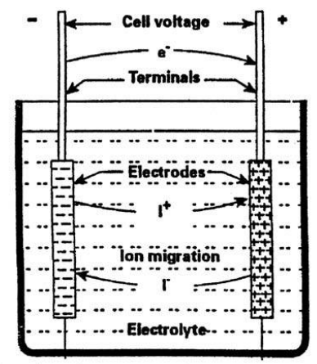
Figure 1: Structure of electrochemical cell
As mentioned previously batteries can be used as a purely discharge system or as a discharge recharge system, with the former most commonly used in small electrical devices (clocks, remotes, and toys) and the latter used for larger applications (cars, trains, planes, and renewable energy systems). Prior to the 1990s the main types of batteries for storage applications consisted of the Lead-acid battery and the Nickel Cadmium (NiCd) battery. However, today’s storage market is predominately made up of Lithium-ion (Li-ion) batteries, with double the storage density of its predecessors [24]. Efficiencies of Lead-acid batteries typically range between 70 – 90 % and lifetimes between 5 – 15 years, Li-ion batteries, however, exhibit higher efficiencies approximately 85 – 98 %, and lifetimes similar to that of Lead-acid batteries [25]. Table 5 lists the advantages and disadvantages of Lead-acid and Li-ion batteries.

Table 5: Advantages and disadvantages of Lead-Acid and Li-ion batteries
 | Advantages | Disadvantages
Lead-acid | - Reliable  - Tolerant to overcharge  - Cheap | - Lead is toxic  - Heavy metal  - Limited life cycle  - No fast-charge [26]
Li-ion | - Higher energy density and therefore occupy less space.  - Ideal for frequency regulation  - Cleaner and safer disposal | - Due to high energy density cells are prone to combustion  - Sensitive to external heat, overcharging and high currents

Inverters
First coined in 1925 by David Prince the word inverter is used to describe a power electronic device that converts direct current (DC) power to alternating current (AC) power [27]. Inverters are used widely in industry especially in renewable energy systems that involve the use of PV cells. Power produced by the sun is in the form of DC power and hence needs to be converted to AC when being used to power other appliances. Average inverter efficiencies range between 50% and 90% depending on the use of the inverter [28]. Average cost of inverters in Australia are approximately 30 c per Watt, however the government offers rebates for the purchase of inverters associated with renewable energy systems [29].

Diesel Generators
Diesel generators are diesel engines coupled to a generator, converting mechanical energy into electrical energy. Generators can generate electricity at the rated power, and any unused power can be used to charge battery storage. The use of diesel generators in hybrid power systems is common place where there is a lack of reliable power supply [30]. The project requires 90 kW of power to supply three 30 kW bore pumps plus some extra power for telemetry. While the generator will be used primarily as a backup system, it will need to be able to supply sufficient power to allow the bore pumps to continue running at full load. To cost the backup system, the price of the generator, the fuel and fuel delivery must be considered.

The cost of a diesel generator that meets the power requirements is approximately $20,000 to $28,000 [31, 32]. Such a generator consumes up to 25 L/hour when running at full load. This incurs a significant cost in using the fuel, in 2016 the average retail price of diesel was 121.6 c/L [33]. Diesel fuel can be transported by pipeline or by vehicle, this project is better suited to the use of a vehicle. Furthermore, the storage of diesel fuel on site must be considered. Any storage tanks must comply with AS 1692 (Tanks for flammable and Combustible liquids) [34]. Table 6 outlines the advantages and disadvantages of diesel generators.

Table 6: Advantage and Disadvantages of diesel generators
Advantages | - Not effected by lack of sun or wind  - Not effected by location and landscape  - Constant and known energy production per volume of diesel  - Generally, take up less room than other energy production technologies
Disadvantages | - High operational carbon emissions  - Cost of diesel can vary  - Frequent visits to fill up with diesel

Cooling System
For the power system to operate in Newman’s harsh weather conditions it will require its own cooling mechanism. Elements such as photovoltaic cells will not require cooling however, elements such as battery system and telemetry system will. Battery banks are more efficient at an optimal temperature range. There has been investigation to air cooling and liquid cooling in battery system. It has been found that liquid cooling has a higher heat transfer due to its higher heat capacity than air cooling [35]. Air cooling requires forced air flow, this could be from fans, or a ventilation system, or a combination of both. Water or liquid cooling requires a secondary heat exchanger, cool liquid is pumped around the system and then recycled. Since the liquid is being used to cool electronics, low conductivity water or a glycol solution should be used [36]. The simplest method to protect equipment from the environment is to remove it from direct sunlight. In general cooling systems can be passive (ventilation) or active (fans, refrigeration) and depending on the chosen method of cooling extra power may needed.

Overhead Power
Overhead power lines are one of the oldest from of transmitting power to a larger population over vast distances. It involves the step down and step up of power from the generator centre to the desired location. Overhead power lines consist of wiring and support structures. These supports structure are in the form of wood or metal depending on the location and weather conditions. One of the main benefits of using overhead power lines are that the delivered power is virtually constant and reliable, unless major spikes in the system occur, hence the need for a back-up system is minimal [37].

The most commonly used transmission line types are the following [38]:
- ACSR (aluminium conductor, steel reinforced)
- ACSR/AW (aluminium conductor, aluminium-clad steel reinforced)
- ACSR-SD (aluminium conductor, steel reinforced/self-damping)
- ACAR (aluminium conductor, allow reinforced)
- AAC-1350 (aluminium alloy conductor composed of 1350 aluminium alloy)
- AAAC-201 (all aluminium alloy conductor composed of 6201 alloy)

Different types of conductors are used in different situations, for instance if the power system has to be operated in corrosive atmospheric conditions then ASCR/AW, ACAR and AAAC-6201 are more suitable compared to other types. Considering high wind conditions, large and heavy conductors are more suitable due to higher inertia compared with small conductors [38], thus the types of ACSR-SD and AAC-1350 would be considered. Therefore, the environmental conditions have an impact on the design decisions involving overhead power.

Telemetry
Due to the remote nature of the bore field, and the critical role that maintaining adequate process water plays in mine operation [39], it is important to continuously monitor the performance of the power supply and pump system [40]. It is proposed that the telemetry system consume no more than 100W of 24V DC power [41]. Sensing and data logging equipment for the power system, as well as security, safety and site infrastructure, must be able to communicate with the remote operations centre located at the client’s mine site. The project does not require design of a sensing system for the pumps themselves, but communication channels and bandwidth will need to be reserved for pump telemetry. Once specific iterations of design option technologies have been identified, application of internet of things (IoT) paradigms and technologies will allow for an efficient and effective telemetry system [40, 42, 43].

Design Decisions

Base Case

Justification
The base case solution will be used as a reference solution which will be used to compare the success of the hybrid and fully renewable systems. For the remote bore fields, the base case will consist of overhead power lines that would run the 10 km distance from the mine site to the location of the pumps. The client has deemed the base case as the ‘worst case’ solution to power the bore fields and therefore any proposed system by Team Power should aim to improve on the base case. It was stated, by the client, that stepped down infrastructure exists at the mine site however a form of step down transformer would need to be implemented at the bore field. Using Rawlinson’s Cost Guide, Team Power will provide a cost analysis of the overhead power line system needed to power the bore field along with an analysis of the types of materials best suited for the geographical location of the bore fields.

What requirements will it meet.
The base case would essential connect the bore pumps to the grid and therefore meet requirements (1) and (2) with possible failure arising from power variations in the grid (not in Team Power’s scope). Research into the types of wires, support structures and manufacturing standards would allow the Team to choose power lines that would meet requirements (3), (4), (7), (8), and (9). Although a cost analysis will be performed on the base case, the client suggested that it would be the most expensive solution and therefore fail to meet requirement (5), also it was inferred by the client that the installation of overhead powerlines would surpass the installation of any other proposed solution, hence, failing to meet requirement (10).

Hybrid 1: Solar, Battery, Diesel

Justification
The design option to investigate is the use of a PV system, with an energy storage (battery) system and a diesel backup system. The configuration of the proposed system can be seen in Figure 2. This system relies mainly on solar power for generation, while storing unused power in batteries for when sunlight is unavailable at night or on cloudy days. To ensure supply is continuous, there is also a diesel backup generator for use when the battery storage is depleted, or there is a failure in the PV or battery system. This system also demands the use of an inverter since PV only produces DC (direct current) and the load requires AC (alternating current) [44].

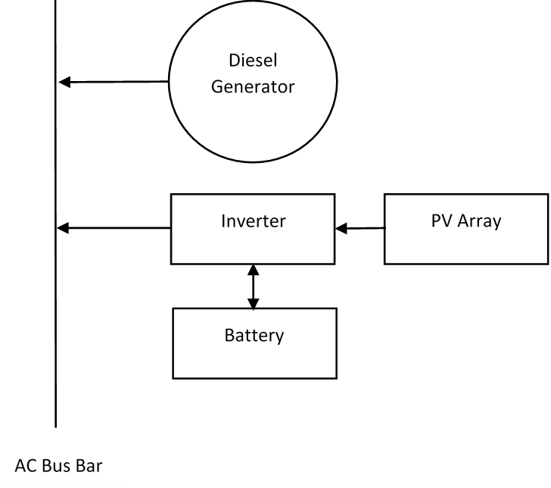
Figure 2: Hybrid System Configuration

PV, battery and diesel systems have had success in similar previous projects where the location meant that the power supply was best suited off grid. This has been used to supply power to homes in Kahramanmaras, Turkey where the temperatures are extreme like those in Newman. It was found that in summer, the system could rely only on the PV and battery but required the generator in the winter months but was always able to meet the power requirements [45]. While this system does not meet the same power requirements as the project, it is relevant due to its success in a harsh climate.

What requirements will it meet
The main requirements (Appendix A) that this option is required to meet are (1), (2), (3), (7), (8), and (9). This means that the system should operate continuously providing sufficient power in Newman. It should also be maintainable, last the required 10 years, and minimise environmental impact. The economy and safety (requirements (4) and (5)) of the solution will be compared to other options by means of a risk register and cost analysis completed by Team Power.

The inclusion of a backup generator and battery allows the system the best chance to run without disruption hence meeting the main requirement for the project. This also helps to meet requirement (3) since any poor weather conditions due to the systems location that stop the PV system from generating power is counteracted by including a battery and generator. By sizing the system correctly and selecting appropriate equipment, it will meet the power requirements for all three pumps and telemetry meeting requirement (2). This also helps to meet requirements (7) and (8), equipment that has been used successfully before has the best chance to last the full 10-year lifetime. Equipment used widely in industry is also well documented simplifying maintenance and staff may be familiar with it. The use of a PV array is particularly appropriate in meeting requirements (3) and (9). Due to the remote location (Newman) there is enough land for large PV arrays and the climate has a low number of cloudy days [16]. Solar power is a renewable energy source with no emissions therefore minimising harm to the environment. This system meets some requirements better than others; however, it is important to meet requirements of a higher priority first. For example, the system may be costly, but it will also provide a continuous power supply without disruptions.

Hybrid 2: Solar, Wind, Battery, Diesel

Justification

One of the proposed systems to supply power to the remote borefield is a hybrid system consisting of PV, wind energy, battery storage and diesel generator back-up system. This hybrid system of renewable and non-renewable technologies was chosen based on the efficiency of the technologies, the geographical location of Newman and the reduction of carbon emissions relative the base case. PV was chosen for the system because Newman exhibited high daily solar radiations, however at night this would become a problem and therefore a wind turbine system was chosen to help power the pumps during the night. From the two storage systems, battery was chosen because it was more compact than a PHES system and the geographical location was not ideal for the latter storage system. Although both renewable energy systems may have the ability to supply sufficient power to the pumps the addition of a diesel generator would serve as a contingency, if both renewable energy systems were to fail or provide insufficient power. On top of technologies for power generation, this solution will require a telemetry system to monitor the different renewables and allow for comminution between the borefield and mine site and an inverter for the PV system. Many electronic devices including batteries only operate in a finite temperature range, due to the extreme temperatures of Newman, a cooling system will need to be implemented to optimise the performance of the system.

What requirements will it meet
After sizing the system, the number of solar panels, wind turbines, and batteries used, along with a diesel generator back-up should be sufficient to meet requirements (1) and (2). Given all technologies to be used for this proposed system are commonly implemented throughout the world, information about the peak operating conditions, maintainability and safety of each technologies is readily available, therefore this system should meet requirements (3), (4), (7) and (8). The client had suggested that the base case option would be the most costly and time consuming to install and therefore compared to the base case, hybrid 2 will meet requirements (5) and (10). Although the hybrid 2 system utilise a diesel generator the carbon emissions should be lower than that produced by the grid hence requirement (9) will be met.

Fully Renewable

Justification
The fully renewable proposed solution will consist of PV, wind and battery storage. The two renewable energy technologies were chosen based on the location of the borefield, the efficiencies and practicality of transmission when compared wave and tidal power which would be generated a great distance from the site. From section 5.3.3 it was noted that Newman exhibits high solar radiation, therefore suggesting that a PV system would be optimal, this would also include the addition of an inverter as power produced by PV is DC while the pumps require AC power. However, during the night no power will be produced by the PV system and hence other technologies must be implemented. Therefore, Team Power has opted to introduce a wind farm to assist in the generation of power during the night, although not exclusive to night-time energy production. A battery storage system has been added to this solution as an additional contingency to reduce any excess produced power going to waste and assisting during the night if wind speeds are too low. This system will also include telemetry to measure and relay information about the system as a whole to the mine site. Due to Newman’s high temperature extremes a cooling system will need to be implemented into the system.

What requirements will it meet
Appropriately sizing this system will allow it to meet requirements (1), and (2), that is the right combination of solar panels, wind turbines and batteries will allow the system to operate continuously and deliver the desired power for both the pumps and the telemetry system. The fully renewable system will utilise technologies familiar in the field of remote power generation, hence, there exists vast knowledge of the operating conditions, safety and maintainability for each technology. This system would therefore meet requirements (3), (4), (7), and (8). Assuming the base case will have the longest installation time out of all proposed systems the fully renewable system automatically meets requirement (10), however how well it meets this requirement will involve comparing with other proposed systems. A fully renewable system will produce no carbon emission in the production of energy hence meeting requirement (9).

Costing
Costing is a method used to compare the economic viability of different proposed solutions and is a necessary task in choosing the final solution that will be implemented. Unfortunately, at this stage of the project the proposed systems have not been sized and therefore an exhaustive costing analysis cannot be completed. Therefore, this section will focus on what costs will be attributed to each system, along with generic cost, and methods of costing each system (Table 7). When costing a project many factors need to be taken into account including; initial capital cost, maintenance cost, present cost, future cost, and replacement costs. Methods exist to calculate these factors and combine them into one normalised value known as the net present value (NPV), which can then be used to compare different systems that may not necessarily contain the same technologies. These methods will be discussed in detail in section 6.5.1.

Table 7: Cost attributed to each system
Base Case  Overhead Power lines | Hybrid 1  PV/Diesel/Battery | Hybrid 2  PV/Wind/Diesel/Battery | Fully Renewable  PV/Wind/Battery
- Wires  - Support Structure  - Transformer  - Fire suppression  - Telemetry | - PV  - Batteries  - Inverter  - Fire suppression  - Cooling  - Telemetry  - Diesel Generator  - Diesel | - PV  - Wind  - Battery  - Inverter  - Fire suppression  - Cooling  - Telemetry  - Diesel Generator  - Diesel | - PV  - Wind  - Battery  - Inverter  - Fire suppression  - Cooling  - Telemetry

Methodologies
Initial capital costs of each proposed system will be calculate based on the options simulated by HOMER. When each solution is simulated, HOMER, outputs a list of different sized technologies. For example, when simulating hybrid 1 the first option may consist of more PV energy production and less diesel generator production while the second option may consist of equal amounts of PV and diesel generator energy productions. Therefore, the initial capital costs of each system will be dependent on the size of technologies used and the average cost of that technology. Maintenance costs will also heavily depend on the size of each technology used per system, however, this cost will not linearly depend on the size of the technologies used and may also depend on the arrangement of the system. Replacement cost will depend on the technologies chosen, for example some solar panels have a longer life span than others and therefore these costs may vary widely although the size of the system will remain constant.

The NPV is used in many finical applications and is calculated by taking the difference between the present inflow of cash and the present outflow of cash [46]. The mathematical formula shown below where C_{t} is the inflow cash at time t, r is the investment rate and C₀ is the initial investment const. The HOMER software is capable of calculating the NPV of the simulated systems using capital costs, replacements cost and O&M that can be manually changed by Team Power to fit today’s average costs. It should be noted that HOMER refers to the NPV as a net present cost (NPC).

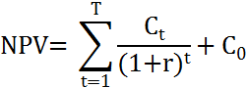

Further Research and Future Tasks
Early indications from Team Power’s extensive literature review are that a hybrid solution is most likely to satisfy the project requirements. As more research is performed, detailed costings can be developed based on the exact iterations of technologies to be used; with resources such as Rawlinson’s Construction Cost Guide and HOMER simulation software providing the basis for these [5, 47].

Jacobs’ representative has promised to deliver detailed pricing information for diesel generators (per kW produced) and local pricing of diesel (per unit volume), as well as pricing per km for overhead lines (including poles, wires etc.). Once these quotes are delivered comparison of price points for finalising design options can begin.

Testing
Projects with various proposed solutions require testing to determine the extent of their ability to meet each requirement. Using various techniques including software, literature and calculations each of the four solutions proposed in section 7.1 to 7.4 will be tested based on how well they meet each requirement in Appendix A.

The microgrid program HOMER Energy will be used to size the fully renewable and hybrid systems. The output of the HOMER simulations will consist of information including proportional energy production of each technology per system, energy usage profile diagrams of each technology, total battery storage, and total carbon emissions [48]. These values will determine how well each system met requirements (1), (2), and (9). It is assumed that the base case system will meet requirements (1) and (2) by default because it is a grid connected solution. Unfortunately, HOMER does not simulate telemetry or cooling systems, hence, requirements (3), and (6) will be tested against previous similar projects and data manuals. By sizing an appropriate telemetry and cooling system along with the use of data sheet for each technology maintenance procedures can be formulated to meet requirement (7). Meeting requirement (8) will also be tested using previous similar projects and data sheets of the technologies used, specifically their average life spans, and the warranty period of equipment chosen.

The HOMER Energy simulations also have the capability to output the NPV using the calculation stated in section 6.5 and hence test how well each system has met requirement (5). However, other techniques including a cost benefit analysis will also be conducted to further support the extent at which each system has met this requirement. Using Rawlinson’s Cost Guide and information provided by Jacobs, the cost of the base case can be determined along with any costs attributed to the construction of each system.

To meet requirement (4), a risk register has been conducted (section 7.1) and will be updated throughout the design process determining possible risks and contingencies associated with each system. Comparing the systems to previous examples of similar projects will also help to determine the safety of the system. It was assumed that any other proposed system (hybrid or fully renewable) would have negligible completion time compared to the base case and therefore it can be assumed that all proposed systems will meet requirement (10).

Risk
There are the four steps to manage risks efficiently in a project [49]:
- Risk Identification
- Risk Quantification
- Risk Response
- Risk Monitoring and Control
Risk identification is the first and most important step in the risk management process [49]. If there is no specific risk identified, other steps of the risk management cannot be implemented. This means in risk analysis, project teams should identify risks before risk quantification, risk response and risk control.

At this stage of the design process, the main task has been to identify possible risks faced in the project. As stated in Project Management Body of Knowledge (PMBOK), there are several techniques and tools for identifying risk [50]:
- Documentation Reviews
- Information Gathering
- Checklist analysis
- Assumption analysis
- Diagramming Techniques
- SWOT Analysis
- Expert Judgment
In this report, information gathering techniques was the main method used to identify risks. Information gathering includes brainstorming, interviewing, finding data from other projects and root cause analysis.

In the following section, a risk register (Table 8Error: Reference source not found) has been completed for the project. This contains all the risks the team has identified and they have been quantified in the form of a priority. The priority was determined by the likelihood of the risk occurring vs. the consequences that occur as a result of the risk. The priority is given a numerical value from 1 to 4, 1 being an extreme risk level and 4 being low. The likelihood consequences table can be found in Appendix D. The risk register also discusses the proposed possible design measure, to mitigate the risk and reduce its priority as much as possible.

The risks have been split into 5 categories, general design issues, business, operability, maintainability and team risks. General design issues deal with potential flaws in the design that did not fit into the other categories. Business risks are associated with the client, particularly economic risks and risks to do with the company reputation. Operability risks that have been identified are to do with the running of the system once it has been implemented, most of these are associated with the extreme weather conditions in Newman. Maintainability similarly considers the system after it has been implemented and concerns risks associated with costs and safety when doing maintenance. Team risks are internal risks that could occur during the design project to do with the successful completion of tasks.

Risk Register

Table 8: Risk Register
SAFETY IN DESIGN CHECKLIST |  | Yes |  | Elimination (E) | Extreme (1)
 |  | No |  | Substitution (S) | High (2)
 |  | NA |  | Isolation (I) | Moderate (3)
 |  |  |  | Engineering (ENG) | Low (4)
 |  |  |  | Administration (A)
 |  |  |  | PPE (P)
 |  | Applicable | Proposed New Design Measures |  | Priority | Further Actions
 |  |  | Description | Treatment Code
SECTION A - GENERAL DESIGN ISSUES
NO. | GENERAL ASPECTS
1 | Product quality does not satisfy requirements | Yes | Test design using software, calculations and comparison to previous similar projects to ensure all requirements are met. | Engineering (ENG) | Extreme (1)
SECTION B – BUSINESS
1 | Project does not meet budget | Yes | Ensure adequate planning, create extensive budget and schedule. Implement reporting measures so that the budget and schedule can be monitored and controlled. | Administration (A) | High (2) | Perform cost analysis to calculate predicted budget
2 | Client Human Resources and task allocation issues (e.g. over or under allocation of staff, re-allocation of staff over time) | No | Planning and scheduling to ensure there is adequate people to complete tasks | Administration (A) | Low (4)
3 | Loss of Reputation | Yes | Maintain stakeholder relationships to ensure their expectations are met. Follow safety procedures to avoid accidents that cause negative media attention. | Administration (A) | High (2) | Control flow of information to ensure no confidential or sensitive information is leaked to the public
SECTION C – OPERABILITY
1 | Risks associated with extreme weather conditions during operation: | Yes | Include temperature and humidity sensors, anemometer and barometer in telemetry so that there is constant reporting of weather conditions.
1.1 | Fire due to extreme temperatures | Yes | Include a suppression system in case a fire breaks out. Design a cooling system to avoid overheating and ensure devices are adequately insulated. | Engineering (ENG) | High (2) | Isolate the fire through design if it does break out, ensure the roads are well maintained so that emergency services have easy access to the site.
1.2 | Lightning damages equipment during storm | Yes | Include lightning arrestor in design so that lightning is unlikely to strike equipment directly. Enclose important equipment in casing. | Engineering (ENG) | Extreme (1)
1.3 | High wind speeds damaging equipment | Yes | Design equipment to withstand high winds, ensure any shelter is stable. | Engineering (ENG) | High (2) | Monitor wind speeds via telemetry, follow weather forecasts.
1.4 | Water damage from heavy rainfall | Yes | Encase sensitive electronics in water proof containers, elevate equipment from the ground so that it is unaffected by flooding and include drainage | Engineering (ENG) | High (2) | Follow weather forecasts to prepare for heavy rainfall
1.5 | Damage from extreme temperatures (high and low) | Yes | Include cooling system for temperature sensitive equipment, encase equipment including ventilation for air flow. | Engineering (ENG) | High (2)
1.6 | Dust | Yes | Shelter sensitive equipment from dust by encasing it, include filters and ventilation. | Engineering (ENG) | High (2)
SECTION D - MAINTAINABILITY
1 | Dust causes maintenance to be more regular | Yes | Change filters regularly, so that dust is unable to damage equipment | Administration (A) | Moderate (3)
2 | Risks associated with maintenance on high voltage equipment | yes | Isolate equipment and turn-off power before maintenance is carried out, ensure staff is able to do this safely. | Engineering (ENG) | High (2)
3 | High cost of maintenance (costs associated with extra infrastructure, manual labour and tools) | Yes | Choose equipment that can be maintained by trained staff, follow schedule and budget to monitor spending. | Administration (A) | Moderate (3)
4 | Equipment unaccessible to fix | yes | Design equipment so that it is easily reached and has enough space to be repaired or replaced | Engineering (ENG) | Moderate (3)
5 | Loss of power due to maintenance | yes | Ensure design is able to isolate equipment so that maintenance does not require complete shutdown of the system | Engineering (ENG) | High (2)
6 | Failure of back up system | Yes | Design extra redundancy in the system, ensure back up system is also maintained even when not used regularly | Engineering (ENG) | High (2)
SECTION E - TEAM
1 | Lack of communication between group members, team members not contributing to discussions | Yes | All team members to attend regular team meetings and participate. Also to read agendas and minutes prepared for all meetings | Administration (A) | Moderate (3)
2 | Loss of documents or lack of version control | yes | Files uploaded to GitHub and LMS to ensure work cannot be lost, follow version control and configuration management and include version number in file names | Administration (A) | Moderate (3)
3 | Conflict between group members | Yes | Resolve conflicts as they arise, ensure members feel they can be honest with each other. Report any conflicts at meetings so they can be resolved. | Administration (A) | Low (4)
4 | Unclear about scope of task | Yes | Create a scoping document before carrying out tasks as a group, and discuss tasks in meetings so all members are clear on their task. Use a lesson's learned document to report further discrepancies and ask questions of other team members and supervisors if still unclear. | Administration (A) | Moderate (3)
5 | Time Management | Yes | Set realistic deadlines for tasks, follow the team Gantt chart and scoping document | Administration (A) | Moderate (3)

Tracking Safety Issues
Tracking safety issues can be split into two categories. Issues within the team, and safety issues associated with the design once it is operational. To track safety issues within the team, risks have been identified in the risk register. The team also created a Profession Performance Innovation and Risk (PPIR) table shown in Table 9. This identifies some issues the team identified and what can be done to monitor them. Actions that have been highlighted in yellow have already been achieved by the team. Another process the team follows to track issues is informally done at team meetings. The first discussion at each meeting is how team members are progressing and resolving any issues that have arisen since the previous meeting. Documents such as the lessons learned also provide tracking of issues within the team. Since the lessons learned document is completed immediately following the completion of tasks, it allows team members to discuss risks that can be avoided in future work.

Tracking safety issues in the design once it is operational will be done using reporting procedures. This includes the constant reporting of the system status. An aspect of this can be included in the telemetry system for continuous feedback. However, not all issues will be measured by the telemetry system, for example wildlife interfering with the system. Issues such as this will need to be a part of regular reporting of the system and include specific information about when the issue was reported, the priority and severity of the issue, and what current actions have been taken [51].

Table 9: PPIR for Team Power
Professional Performance Elements | Assessment | Actions
Relevant Parties and Stakeholders  Do you clearly understand the relationship with the people who depend on you, and those you depend on, and their expectations?” | Mine site  Jacobs  Design Team  State Government  Priority is to deliver uninterrupted power, with a safe installation at minimum cost | Communication at partner meetings with Jacobs and through technical queries.  Follow government legislation
The Engineering Task  Have you discussed and agreed with the person you are working for the objectives and extent of the task you are doing? | Continuous Power (90kW/day)  900ML/annum water pumped  Lifetime of 10 years  Provide cooling/shelter for power system  Allow for weather conditions  Backup system  Start-up method  Maintenance  Power the control and telemetry system | Require clarification on the communication and telemetry system.
Competence to Act  Have you checked that you have the skills, tools and resources required to do the job? | Skills:  Legal knowledge  Electrical Design  Cost Analysis  Risk Assessment  Project Management  Power systems  Fault analysis  Renewable energy  Efficiency calculations  Available software | From SWOT analysis the team lacks legal knowledge and cost analysis skills  Will need to research, learn, review previous learning and ask questions
Statutory Requirements and Public Interest  Have you identified and responded to relevant statutory requirements and public interest? | AS3000 – Aus/NZ wiring rules (insulation etc)  Risk management – ISO31000 and Jacobs risk management template  Environmental protection act  Aboriginal land act | Follow the relevant standards and government land acts
Risk Management  Are you effectively identifying and managing risks which may prevent the proper performance of the job? | Risks that may affect the project:  New laws could disrupt  Risks involved with the project (e.g. underground shelter and confined spaces, electrical faults, fire/electrocution  Cost overflow  Change in scope  Clients change their mind about deliverables  Native titles/reclaiming of land  High temperatures, poor climate and weather conditions | Follow the risk management standard and documents provided by Jacobs  Put controls in place for controllable risks  Mitigate risks outside of the team’s control  Complete a risk register
Engineering Innovation  Are you considering innovative ways of doing your job better? | Renewable energy sources and hybrid power supply  Different construction methods (underground storage)  The way tasks are allocated amongst the group | Research how similar projects have been carried out and consider how they can be improved.
Engineering Task Management  Are you applying the appropriate task management processes? | Tasks will be split based on the type of solution  Solar, wind, diesel, storage, grid etc.  Deliverables: SLD, flow chart, PID, power system design, generic costs, NPV, assumptions, 3 options | Use project management theory  Use time effectively (time management skills)  Use appropriate version control
Contractual Framework  Are you considering implications of the contract under which the work is being done? What are the targeted commercial outcomes? | No specific contract  Cheapest and fastest solution  10 year lifetime | Compare all the solutions for the cheapest and fastest solution  Compare all solutions against base case on an economic scale

Project Management
Successful completion of any project requires a synthesis of in-depth planning, good design decisions, proper execution and rigorous finalization. Project management techniques provide the tools with which to achieve this [52].

The team has already implemented multiple project management (PM) initiatives to promote the success of the team. These include prescribed activities such as chairing team meetings, creating agendas and taking minutes for meetings for an equal share of time, as well as attending meetings with the principle partner. Furthermore, the team developed a “lessons learned” document to complete following the submission of each aspect of the project. This was done immediately following the submission of the requirements analysis, allowing the team make improvements in the submission of the DA and future submissions. Another important aspect of project management is scheduling, this includes scheduling team meetings regularly, planning tasks and decisions that must be made using a Gantt chart and documenting the time spent on tasks. The outcome of these project management initiatives improved team time management, tracking of work hours, ability of all members to be present at group meetings, and the generally positive attitude and culture of Team Power.

Timeline and Dependencies in Scheduling
Team Power has developed multiple scheduling tools in order to effectively manage group resources, including time and human resources. As well as to-do lists and actionable items from meeting minutes, a Gantt chart and subsequent critical path analysis (CPA) were developed (Appendix B). These tools have the capability to improve efficiency and enhance project outcomes when used correctly [52-54]. Interdependence of tasks was analysed and dependencies were noted (Appendix C). Investigation of the Gantt chart established that, for example, the critical path for project completion was dependant on the “research” and “decision deadlines” categories of the final report tasks. To avoid stalling the entire project these critical tasks must be prioritised when scheduling conflicts arise [52, 54]. In the first iteration of Team Power’s Gantt chart (not shown in this report) CPA revealed that a delayed start of research tasks for the final report, such as sizing the system and researching specific technological iterations, was a potential hazard to on-time completion. To remedy this, extra lead time was budgeted to the ‘simulations with respect to requirements analysis’ task. Furthermore, the need for decision deadlines for ‘choosing specific technologies’ and ‘eliminating one hybrid option’, as well as to ‘stop researching and simulating’ (i.e. and focus on writing), was identified during this process. These decision deadlines, or gates, will aid in resource levelling across the final report task [52, 55]. Float was added to the ‘individual submission – writing report’ task to account for the residual time-hazard associated with the preceding decision gates. Lastly, certain tasks were changed from ‘in-series activities’ allocated the entire person-power of the team to ‘in-parallel activities’ assigned specific team members. Examples of these include the script and slides for the final presentation. Working in unison, these controls should enhance team performance and increase the likelihood on-time completion [54, 56].

Configuration Management
Configuration management is the process of tracking all changes to documents, specifications, drawings and processes involved in the project [57]. It includes controlling changes, reporting changes and approving changes. Good configuration management is important to ensure the correctness and completeness of tasks. It is especially important that all members of the project team are active in configuration management and participate in discussions and negotiations about changes [58]. Team Power has employed configuration management in the form of an agreed procedure for naming and uploading documents, this means including a descriptive name for documents, a version number, and a table that includes what changes are made in that version. The use of online platforms such as GitHub allow the team to upload documents to a shared folder that can be accessed easily. GitHub is useful in the organisation of documents as they can be split into branches (equivalent of folders) and for visualizing when documents are uploaded, by who and in which documents. An example of one of the generated graphs showing documents submitted to different branches over the last two weeks can be seen in Figure 3.

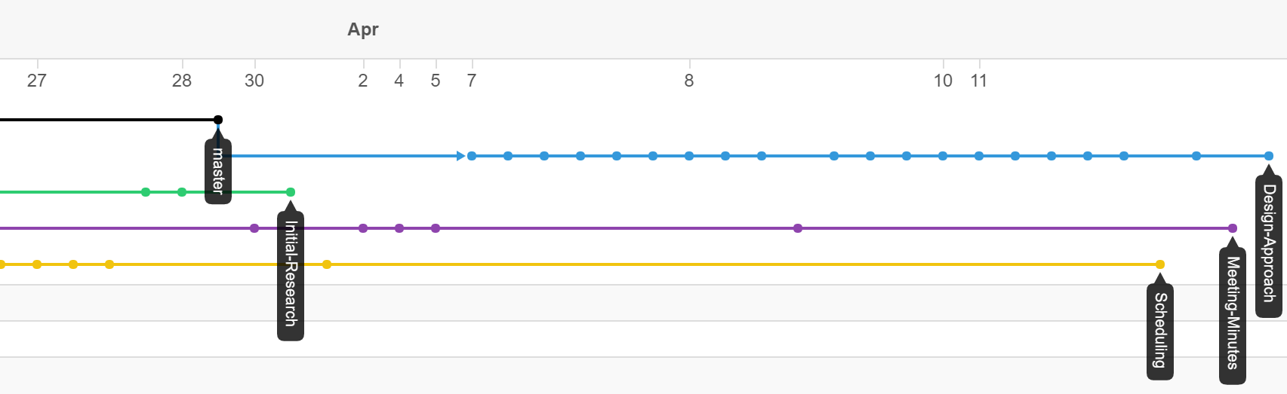
Figure 3: Network graph showing changes to branches in GitHub

The team has also identified a member (Steven) to oversee configuration management, version control and the use of the GitHub. Due to risks involved with configuration management such as losing work and wasting time on old versions of documents, configuration plays a vital role in the team’s success. To mitigate these risks as much as possible, the team has decided to also upload important documents to LMS as a backup.

Communication
Team Power has rostered three meeting times a week, two of these meetings are with the team members and the third includes the team’s academic supervisor and demonstrator. During these meetings, design decisions are made collectively by brainstorming and discussing ideas. Each of these meetings is chaired by a member of the team, this role is rotated through group members. This involves preparing and sharing an agenda for meetings, booking a venue, and facilitating group discussions during the meeting. To record these meetings detailed minutes are kept, this task is also rotated through group members. To keep the minutes and agenda uniform when roles change, templates are used, the meeting minutes template was provided to the team and the agenda template adapted from the provided minutes template and uploaded to the GitHub and LMS. These documents also follow the agreed upon configuration management procedure. At the end of each meeting, the team compiles queries, including technical queries to be sent to the project partner or discussed at project partner meetings.

The main stakeholders that require regular communication with the team are the project partner (Jacobs), the academic supervisor, demonstrator and team members. Technical queries are submitted weekly to the chair of project partner meetings, this ensures regular communication with the main external project stakeholder and allows the team to monitor changes in stakeholder and client expectations. Ongoing communication with internal stakeholders is typically in face-to-face meetings. Once a week the team presents questions about assessments and project processes to the supervisor and demonstrator. Together with task allocation and scheduling, communication helps the team manage stakeholder expectations including the expectations the team has of each member.

Conclusion
As a result of the design approach the three systems that will be investigated further are two hybrids involving renewable and non-renewable technologies with storage systems and a fully renewable system with storage. After preliminary simulations, the team will eliminate one system based on its inability to meet project requirements. An exhaustive cost analysis will be performed on the remaining systems for comparisons purposes.

Due to effective implementation of project management techniques Team Power’s configuration management and version control protocols have been a success. The CPA has revealed that decision deadlines for the elimination of one solution and the selection of specific technologies have the potential to act as barriers to the on-time completion of the design project. As well as the techniques discussed in section 7.1 Team Power intends to monitor the items on the critical path closely to ensure these hazards are avoided. The Team will undergo an internal design review process (Appendix B) followed by a formal review with major stakeholders. This process will ensure that all stakeholders are satisfied that the decisions outlined here will meet the requirements outlined by the client. As well as identifying inconsistencies and weaknesses in the design.

Appendices

Appendix A – Requirements Summary Table
Table 10: Project Requirements
Priority | Requirement | Description | Classification
1 | 24/7 | The power generation system will be required to operate for 24 hours a day, 7 days a week, 365 days a year | EXP, SPO
2 | 90Kw++ | The power generation system must produce 90Kw of power to supply the main pumps, plus additional power to supply other essential systems. | EXP, SPO
3 | Newman | The power generation system must operate in Newman. This includes tolerating the harsh conditions. | EXP, SPO
4 | Safety | The system must run safely. Any safety equipment that requires power must also be supplied. | EXP, SPO, UNS
5 | Economy | Maximise the economy of the proposed solution. | EXP, SPO
6 | Telemetry | The system requires telemetry and communications equipment, and these will also require power. | EXP, SPO
7 | Maintainable | The system must be maintainable. | EXP, UNS
8 | 10-year life | The system must last for at least ten years. | EXP, SPO
9 | Environment | The proposed solution should minimise harm to the environment. | EXP, EXC
10 | Time | The proposed solution should take a minimum amount of time to construct. | EXP, EXC
EXP – Expected, SPO – Spokens, UNS – Unspokens, EXC – Exciters

Appendix B – Gantt Chart
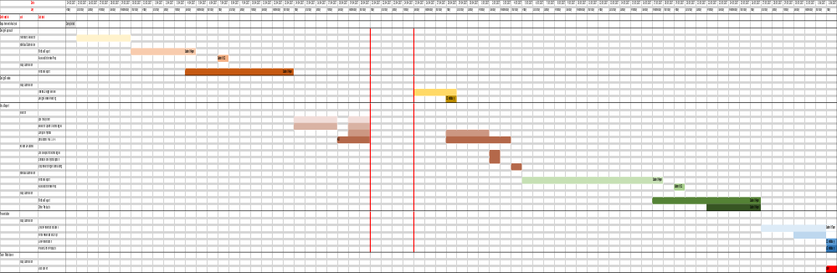
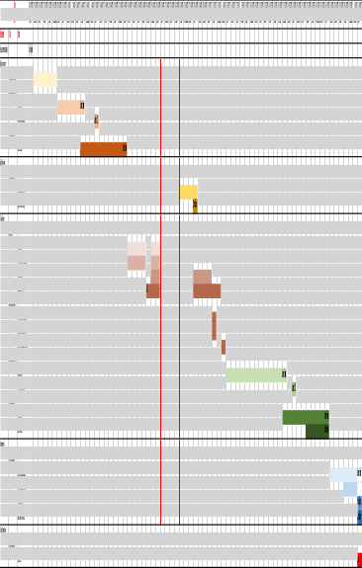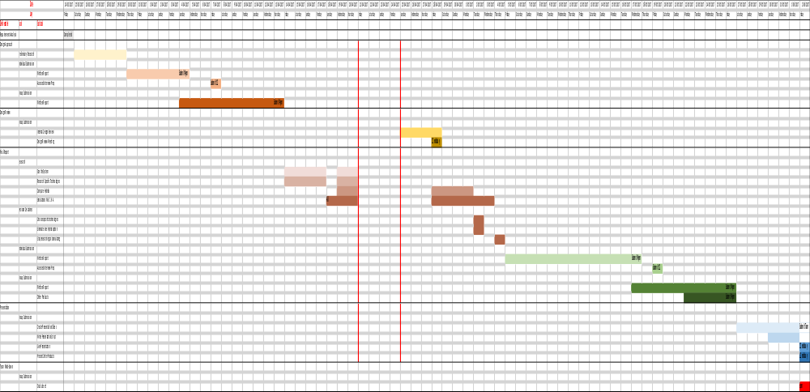
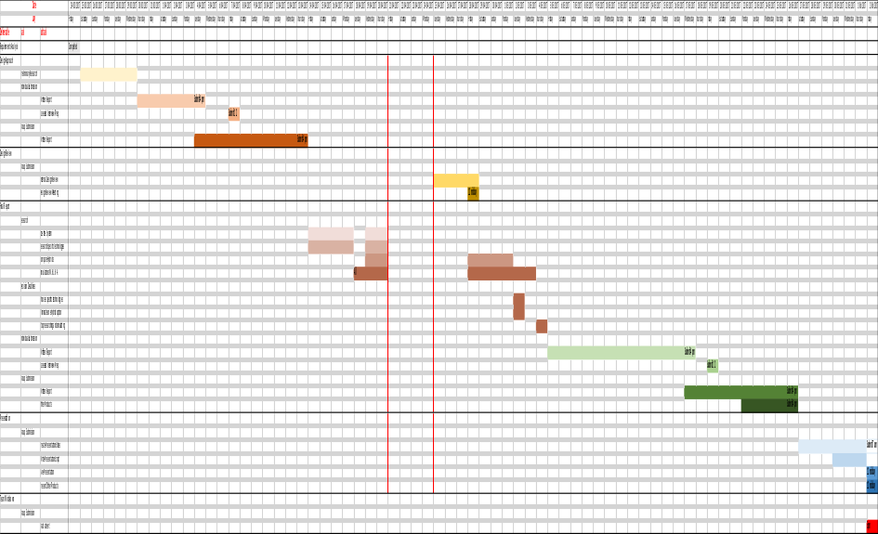
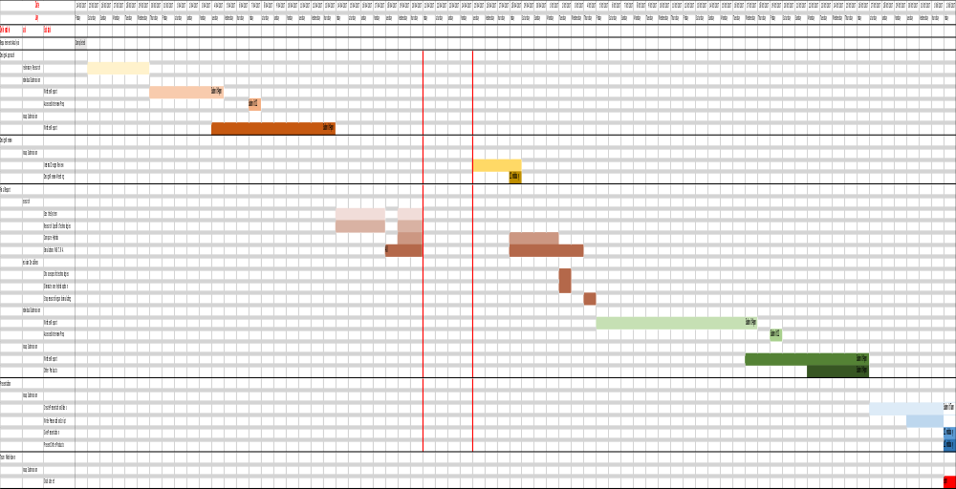
Figure 4: Team Power’s Gantt Chart for the ‘Solar Generation for Remote Borefields’ project.

Appendix C – Dependencies Diagram
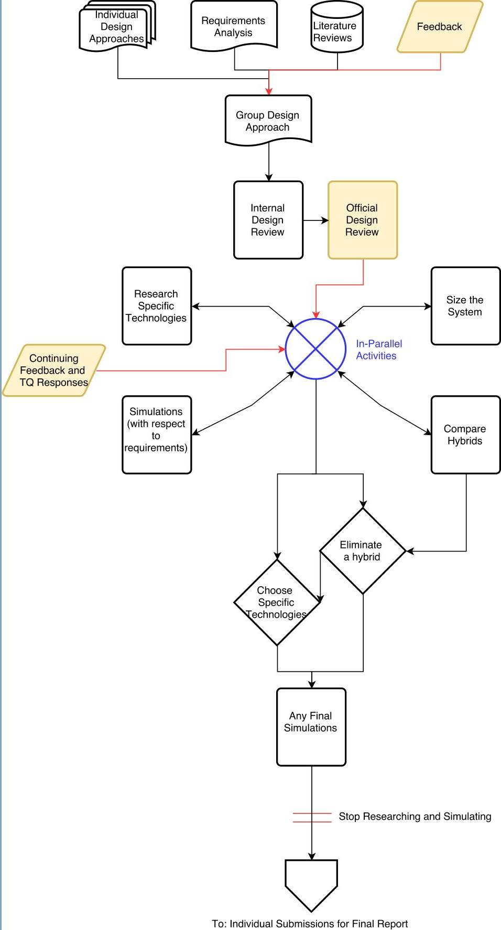
Figure 5: Residual dependencies present in workflow (as identified by CPA and by using Gantt chart) between 04/04/17 and 15/05/17. Critical processes out of team control (“external criticals”) are displayed in yellow. Tasks dependent on external criticals have their input arrows in red.

Appendix D – Likelihood Matrix

Table 11: Risk Likelihood Matrix
 |  |  | Consequence
 | 1 | 2 | 3 | 4 | 5
Likelihood | Insignificant | Minor | Moderate | Major | Catastrophic
Always | H | H | E | E | E
Likely | M | H | H | E | E
Possible | L | M | H | E | E
Unlikely | L | L | M | H | H
Rare | L | L | M | M | H
Risk Level | Priority | Example Action
Extreme | 1 | Cease activity or task; detailed research and planning required.
High | 2 | Senior management attention; immediate corrective and preventative action required
Moderate | 3 | Management responsibility assigned; corrective and preventative action plan developed
Low | 4 | Manage by routine procedures; accept risk

