This topic needs to cover:

* Gantt
  + Actual chart
  + Interpretation of chart
* Critical Path
  + Decision deadlines
  + Dependencies
    - Lag times
    - Lead times
    - Float
  + Hazards evident from critical path

## Timeline and Dependencies in Scheduling

Team Power has developed multiple scheduling tools in order to effectively manage group resources, including time and person-power. As well as to-do lists and lists of actionable items from meeting minutes, a Gantt chart and subsequent critical path analysis (CPA) were developed (Appendix # Gantt). These tools have the capability to improve efficiency and enhance project outcomes when used correctly [1-3]. Interdependence of tasks was analysed and dependencies were noted (Appendix # Dependency Diag). Investigation of the Gantt chart established that, for example, the critical path for project completion was dependant on the “research” and “decision deadlines” categories of the final report tasks. To avoid stalling the entire project these critical tasks must be prioritised when scheduling conflicts arise [1, 3]. In the first iteration of Team Power’s Gantt chart (not shown in this report) CPA revealed that a delayed start of research tasks for the final report, such as sizing the system and researching specific technological iterations, was a potential hazard to on-time completion. To remedy this, extra lead time was budgeted to the ‘simulations with respect to requirements analysis’ task. Furthermore, the need for decision deadlines for ‘choosing specific technologies’ and ‘eliminating one hybrid option’, as well as to ‘stop researching and simulating’ (i.e. and focus on writing), was identified during this process. These decision deadlines, or gates, will aid in resource levelling across the final report task [1, 4]. Float was added to the ‘individual submission – writing report’ task to account for the residual time-hazard associated with the preceding decision gates. Lastly, certain tasks were changed from ‘in-series activities’ allocated the entire person-power of the team to ‘in-parallel activities’ assigned specific team members. Examples of these include the script and slides for the final presentation. Working in unison, these controls should enhance team performance and increase the likelihood on-time completion [3, 5].

[1] S. Hartley, *Professional project management : the integration of strategy, operations and change*. Prahran, VIC: Tilde University Press, 2014.

[2] J. F. Hutchings and J. F. Hutchings, *Project Scheduling Handbook*. Hoboken: Taylor and Francis, 2003.

[3] E. Harrin and E. Harrin, *Project Management in the Real World Shortcuts to Success*. Swindon: British Computer Society, 2006.

[4] Y. Tamura, "Resource levelling," M.Eng, Memorial University of Newfoundland, 1975.

[5] S. Caballé and S. Caballé, *Intelligent Networking, Collaborative Systems and Applications*. Berlin, Heidelberg: Springer Berlin Heidelberg, 2011.

Appendix #:





Figure #: Team Power’s Gantt Chart for the ‘Solar Generation for Remote Boreholes’ project.

Appendix #:

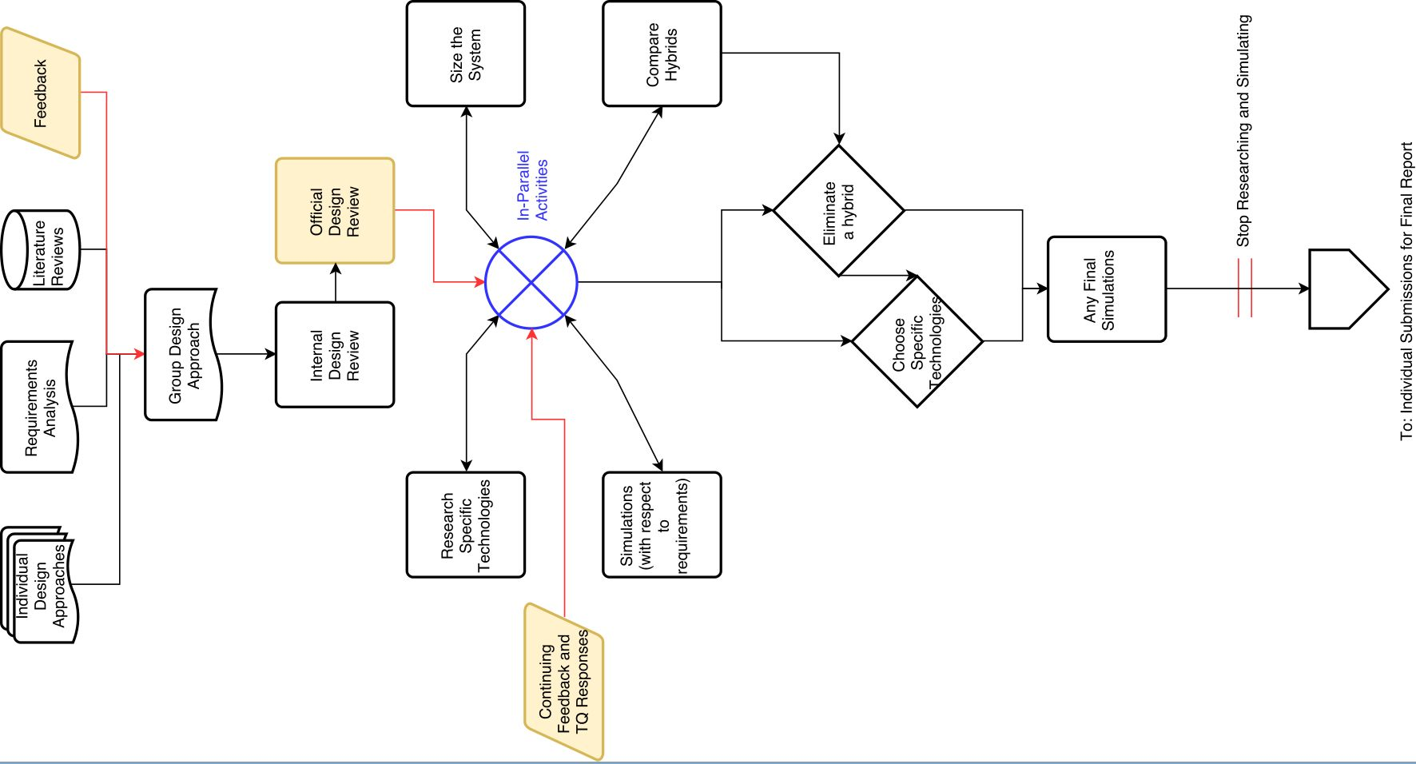

Figure #: Residual dependencies present in workflow (as identified by CPA and by using Gantt chart) between 04/04/17 and 15/05/17. Critical processes out of team control (“external criticals”) are displayed in yellow. Tasks dependent on external criticals have their input arrows in red.