**2F: Resources**

**2. Literature Review**

* 1. **Energy Sources**
     1. **Solar (Xiaobin)**
     2. **Wind(Xiaobin)**
     3. **Tidal(Jess)**
     4. **Wave(Jess)**
     5. **Biomass (Mark)**
     6. **Landfill Gas (Mark)**
     7. **Overhead power (Mark)**
     8. **Diesel Generator (Jess)**
  2. **Energy Storage Technologies**
     1. **Battery Storage (Steven)**
     2. **Pumped-Storage Hydroelectricity (Steven)**
  3. **Other Required Technologies**
     1. **Inverter (Steven)**
     2. **Telemetry (Mark)**
     3. **Cooling system (Jess)**
  4. **Simulation software**
     1. **Homer Tool (Xiaobin)**
     2. **Other software packages/tools (Jie)**
  5. **Design Methodology**

**Table X: HR allocation of Power Team 12**

|  |  |
| --- | --- |
| **Team Members** | **Regular Work Sessions** |
| Jessica Armstrong | On Tuesday at 2:00-5:00pm |
| Steven Bardzovski |
| Xiaobin Lin |
| Mark Mazzoni | On Friday at 1:00-5:00pm |
| Shaochen Wang |
| Jie Zhang |

* 1. **Energy Sources**

**Table 1: Power Generation Solutions**

|  |  |
| --- | --- |
| **Energy Sources** | Solar |
| Wind |
| Tidal |
| Wave |
| Biomass |
| Landfill Gas |
| Overhead Power |
| Diesel Generator |

## 2.1.1 Solar

Now, there is variety of renewable energy sources in daily life, with solar energy more economically competitive against other energy. Compared to traditional fossil fuels and other non-renewable source, solar energy can be zero carbon release, neglecting the production of solar panels. For tide and wave energy, because the generating equipment must be placed on or in the ocean, the marine ecosystem could be adversely impacted. Moreover, high O&M cost cannot be suitable for this project [1]. The sun's rays can be absorbed by solar photovoltaic (PV) panels as sources of energy to generate electricity [2]. The advantages and disadvantages of implementing a solar PV system are as follows:

**Table 1: Advantages and Disadvantages of Solar** [2]

|  |  |
| --- | --- |
| **Advantages** | * Easy to install and disassemble; * Long use life; * No need to service specially; * High reliability; * Economically viable, no energy consumption; * Mechanical wear resistance; * High compatibility with other technologies. |
| **Disadvantages** | * Not suitable for regions of short solar exposure (regions of high latitude); * Highly weather-dependent; * Low efficiency; * Occupy a large area. |

Most solar PV panels now are based on variation of silicon, usually different kinds of silicon with variable purity. The panel that made by high purity silicon have high efficiency, which mean the solar energy can be converted to more electricity, while the silicon purifying process is expensive [3]. Specifically, silicon solar PV panels are usually made of either monocrystalline silicon or polycrystalline silicon [2]. Monocrystalline has a higher efficiency than polycrystalline; however, the cost of manufacturing is much higher [2]. The monocrystalline will usually have a longer expected life, which will offset some of those costs [2]. Battery storage is the most compatible with solar PV systems [2].

**Climate information requirements of project site**

Each technology has specific requirements to optimize functionality and suitability for the system, for example a solar PV system will work more effectively in areas that have higher solar radiation. The available background climate information can be found in the Figure 1, which is high number of sunshine hours at around Newman (More details refer to Appendix B [4]). Therefore, solar can be considered in this design option.

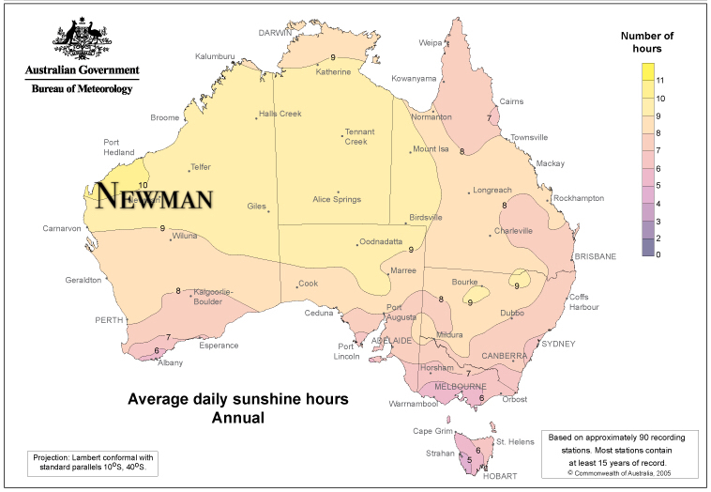

**Figure 1: Average daily sunshine hours annual**

## Wind

Wind energy harvesting employs air flow movement in generating sources of electricity [5]. Currently, wind power is one of the cheapest renewable energy technologies [6]. In order to harness the kinetic energy supplied by an air flow, wind turbines can be implemented [5]. Figure 2 depicts the motion of air flow through an impeller-driven wind turbine design. When an air flow passes through the impeller rotor area, kinetic energy supplied by the air flow translates to a rotational energy experienced by the turbine impeller [5]. The impeller rotation, employing Faraday’s law of electrical induction, causes a connected generator to spin producing an electrical current [5]. 

**Figure 2: Wind behaviour around a wind turbine**

**Table 2: Advantages and Disadvantages of Wind** [5]

|  |  |
| --- | --- |
| **Advantages** | * A renewable, clean and sustainable energy source; * Wind is an abundant energy source; * Wind power is a relatively cheap source; * Wind farms/turbines can be constructed on already established farm lands. |
| **Disadvantages** | * Wind power must be able to compete financially with conventional electrical generation methods; * Optimal wind farm sites are generally remotely located; * Wind farm and resource development may not be feasible on specified land; * Wind turbines may cause noise pollution and aesthetic obstructions; * Rotating turbine blades can potentially harm surrounding wildlife. |

Depending on the different structure, the wind turbine can be classified to vertical axis wind turbine and horizontal axis wind turbine. Turbine selection is also dependent on local weather conditions and the power capacity demands of the client. The decision to use wind energy for this system was based on the abundance of the energy source. The average morning wind speed is 9.1km/h and afternoon is 9.4km/h [4]. Secondly, wind energy offers a clean and renewable method to energy production when modelling a power system to be independent of diesel electricity generation. Wind energy harvesting additionally offers a cheap energy source and creates job opportunities in areas where wind turbines are installed.

### **Wave Power**

Wave Power is generated from the large energy changes in deep sea waves. The amount of energy produced in a deep sea wave is proportional to the amplitude of the wave squared and the period of the wave, for example a wave with a 2 metre amplitude and a period of 10 seconds has energy fluxes between 50 and 70 kW/min [1].

Wave power can be generated with on-shore or off-shore devices. Some on-shore devices include the Tapchan and oscillating water columns and the whale is an off-shore device. The Tapchan uses a tapered channel as seen in Figure 1, where wave energy is converted into potential energy. It is an entirely passive system with no moving parts, and the energy conversion is very similar to that of a hydroelectric power plant[2]. Another on-shore system is the use of an oscillating water column; this uses the rising and falling action of the wave to push air in a piston like action to turn a turbine to convert energy into a usable form. This occurs naturally in the form of blow holes[3]. The whale is a floating device with turbines for converting wave energy efficiently [4].

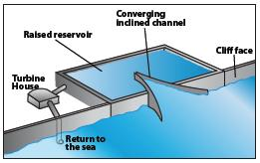

Figure 1: Tapered Channel[5]

### **Tidal Power**

Ocean tides are caused by the gravitational pull of the sun and the moon on the earth. Tidal energy can be captured by tidal stream or tidal current turbines. Barrages could also be used to capture potential energy created by the changing height of tides. This has a low efficiency, of a predicted 3.7TW of available power, 0.8TW is usable due to fluctuations in tide[6].

**Table 1: Advantages and disadvantages of wave and tidal power**

|  |  |  |
| --- | --- | --- |
|  | **Advantages** | **Disadvantages** |
| **Wave Power** | * Large power fluctuations * Predictability of wave conditions from weather and wind * Renewable power source * Some devices can store energy for use during peak time (Tapchan) | * Inefficient, approximately 20% can be successfully converted to electric power[6]. * Best power is available in hard to reach areas (dangerous oceans) making maintenance and power transmission difficult and expensive * Risk of extreme weather that the structure would have to withstand. * Wave frequencies are very low compared to the requirements of electrical generator. |
| **Tidal Power** | * Renewable power source * Predictability of ocean tides | * Inefficient * Disrupt marine life * Expensive |

The use of both wave and tidal power in this project would be inappropriate. Transmitting power from the coast to the required site over 350 km would incur power losses and be very expensive.

* + 1. **Biomass**

Creating energy from biomass, either directly or via conversion to biofuels, has been a staple for thousands of years[8]. New technologies leading to exploitation of new sources of biomass and increased efficiency of energy extraction from existing sources continue to make biomass one of the primary global energy sources [9-11]. Recent advances have allowed the use of biomass processing to create hydrogen for fuel cells [12-15].

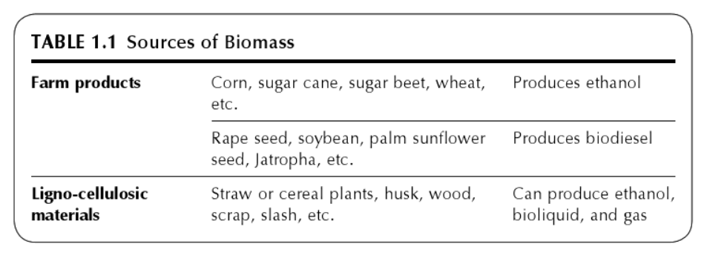

**Figure 1: Table of biomass sources used to produce primary and secondary biofuels[16].**

The usefulness of a source of biomass for energy revolves around its carbon cycle[11]. Key parameters include the speed at which carbon from the atmosphere be locked into a useable source, the energy density of this source and ease of recapturing carbon emissions created[17].

#### **Landfill Gas**

The majority of generated solid waste ends up in landfill[18], largely because landfill provides a one-fits-all solution and therefore is often the cheapest waste disposal method in the short term[19]. Landfills can pollute local environments, including the air, land and water, by emitting greenhouse gasses (GHG) and by contaminating soil and groundwater[18]. Energy production from landfill gas nullifies one of these sources by processing landfill gas (LFG) and extracting useful components for combustion or chemical reaction[17, 20]. One major constituent is methane, which can make up between 40-60% of LFG. Methane’s high potency (as a GHG) and short atmospheric lifetime means that addressing methane emissions is a particularly effective approach for mitigating the near-term impacts of climate change[21].

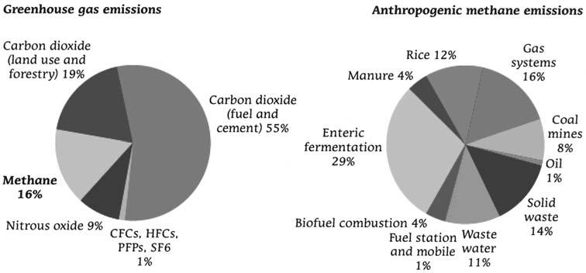

**Figure 2: The proportion of GHG emissions made up by methane, and the proportion of anthropogenic methane produced by waste decomposition, as an indicator of the usefulness of landfill gas capture[21]**

#### **Overhead Power**

Using overhead power transmission to supply the bore field (the ‘base case’) is ostensibly a viable option. The author has been instructed by Jacobs to assume that there are 22kV lines available from the mine site 10km away[23], which itself will derive power from a client-owned natural-gas-fired power plant in the Newman area[24, 25]. The supplied cost of power from the client’s power plant is 30c/kWh. The project partner’s assumption is that running overhead lines will be the most expensive and time consuming option[26], however Team Power will perform a thorough analysis before coming to any conclusions.

* + 1. **Diesel Generator**

Diesel generators are diesel engines coupled to a generator, converting mechanical energy into electrical energy. Generators can generate electricity at the rated power, and any unused power can be used to charge battery storage. The use of diesel generators in hybrid power systems is common place where there is a lack of reliable power supply [7]. The project requires 90 kW of power to supply three 30 kW bore pumps plus some extra power for telemetry. While the generator will be used primarily as a backup system, it will need to be able to supply sufficient power to allow the bore pumps to continue running at full load. To cost the backup system, the price of the generator, the fuel and fuel delivery must be considered.

The cost of a diesel generator that meets the power requirements is approximately $20,000 to $28,000 [8, 9]. Such a generator consumes up to 25 L/hour when running at full load. This incurs a significant cost in using the fuel, in 2016 the average retail price of diesel was 121.6 c/L [10]. Diesel fuel can be transported by pipeline or by vehicle; this project is better suited to the use of a vehicle. Furthermore, the storage of diesel fuel on site must be considered. Any storage tanks must comply with AS 1692 (Tanks for flammable and Combustible liquids) [11].

* 1. **Energy Storage Technologies**

**Table X: Energy Storage Technologies**

|  |  |
| --- | --- |
| **Energy Storage Technologies** | Battery Storage |
| Pumped-Storage Hydroelectricity |

**2.2.1 Battery Storage**

Many daily activities and appliances rely heavily on electrical energy and the storage of electrical energy. Although electrical elements such as capacitors are capable of storing electrical energy it is usually of very small magnitude, and hence there was need for other technology capable of storing more electrical energy. One of the oldest inventions for the storage of electrical energy was the battery. The electrochemical cell or battery contained chemicals that, when needed, would undergo a chemical reaction with desired electrical energy as the product [1]. There are two main types of electrochemical cells, those that convert chemical energy into electrical energy (galvanic cells) and cells that convert electrical energy back to chemical energy (electrolytic cells) [2]. Combining these types of electrochemical cells, it is possible to produces batteries that discharge only or discharge and recharge. Electrochemical cells can either be considered as wet or dry depending on the state of the electrolyte [3]. The structure of a typical electrochemical cell is shown in Figure 1. Electrochemical processes have been studied for over 200 years varying the electrodes and electrolyte as technology improved to build better energy storage systems [4].

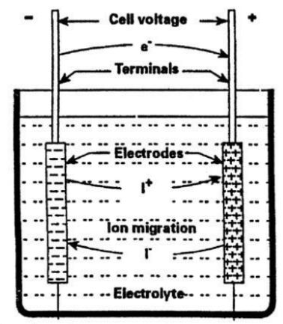

Figure : Structure of electrochemical cell

As mentioned previously batteries can be used as a purely discharge system or as a discharge recharge system, with the former most commonly used in small electrical devices (clocks, remotes, and toys) and the latter used for larger applications (cars, trains, planes, and renewable energy systems). Prior to the 1990s the main types of batteries for storage applications consisted of the Lead-acid battery and the Nickel Cadmium (NiCd) battery. However, today’s storage market is predominately made up of Lithium-ion (Li-ion) batteries, with double the storage density of its predecessors [5]. Efficiencies of Lead-acid batteries typically range between 70 – 90 % and lifetimes between 5 – 15 years, Li-ion batteries, however, exhibit higher efficiencies approximately 85 – 98 %, and lifetimes similar to that of Lead-acid batteries [6]. Table 1 lists the advantages and disadvantages of Lead-acid and Li-ion batteries.

Table : Advantages and disadvantages of Lead-Acid and Li-ion batteries

|  |  |  |
| --- | --- | --- |
|  | Advantages | Disadvantages |
| Lead-acid | * Reliable * Tolerant to overcharge * Cheap | * Lead is toxic * Heavy metal * Limited life cycle * No fast-charge [7] |
| Li-ion | * Higher energy density and therefore occupy less space. * Ideal for frequency regulation * Cleaner and safer disposal | * Due to high energy density cells are prone to combustion * Sensitive to external heat, overcharging and high currents |

## Pumped Hydroelectric Storage

Another form of storing electrical energy is known as pumped hydroelectric storage (PHES). Unlike battery storage, which makes use of chemicals in the storage of electrical energy, PHES uses water reservoirs for the storage of energy. When implementing renewable energy systems such as PV or wind, the biggest impediment is that the majority of energy produced is during times of low demand, and hence PHES allows the storage of excess energy during off peak times and the release of this energy during peak times [8].

Systems that relied on water reservoirs as means of storage have been dated back to 1890 in Italy and Switzerland, however the PHES gained its popularity in the 1960s to 1980s [9]. The basic operation of a PHES system is illustrated in Figure 2. This type of storage system involves raising water from a lower reservoir to a higher reservoir during times when energy production is at an excess. The water is then released through a turbine during peak demand to compensate lower energy productions by the primary system [10]. At first thought PHES energy systems seem to be 100 % energy efficient however due to water loss through evaporation due to open reservoirs the efficiency is approximately 70 – 80 % [11].

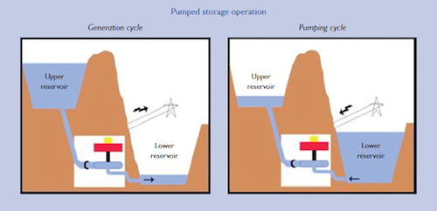

Figure : Basic operation of a pumped hydroelectric storage system

Although PHES systems account for the bulk of global energy storage systems, no large scale PHES systems have implemented in Australia in the last 30 years [12]. Table 2 outlines some advantages and disadvantages of PHES systems.

Table : Advantages and disadvantages of PHES systems

|  |  |
| --- | --- |
| Advantages | Disadvantages |
| * Does not require harmful chemicals * Can be constructed from natural elevations in the area * Largest capacity of energy storage * Flattens load variations | * Involves mechanical parts, hence maintenance may be more frequent * Becomes expensive to implement if landscape has no natural elevations. * Lower energy density, hence large volumes of water required * Evaporation due to open reservoirs * Negative environmental impacts |

The cost of PHES systems can vary greatly depending on the size of the system and the suitability of the location of implementation. World averages suggest that the cost per unit of storage is between US$500/kWh and US$1500/kWh [13], with variation evolving mainly from the location of the system.

* 1. **Other Required Technologies**

**Table X: Other Required Technologies**

|  |  |
| --- | --- |
| **Other Required Technologies** | **Inverter** |
| **Telemetry** |
| **Cooling system** |

## Inverters

First coined in 1925 by David Prince the word converter is used to describe a power electronic device that converts direct current (DC) power to alternating current (AC) power [14]. Inverters are used widely in industry and especially in renewable energy systems that involve the use of PV cells. Power produced by the sun is in the form of DC power and hence needs to be converted to AC when being used to power other appliances. Average inverter efficiencies range between 50% and 90% depending on the use of the inverter [15]. Average cost of inverters in Australia are approximately 30 c per Watt, however the government offers rebates for the purchase of inverters associated with renewable energy systems [16].

### **Telemetry**

Due to the remote nature of the bore field, and the critical role that maintaining adequate process water plays in mine operation[27], it is important to continuously monitor the performance of the power supply and pump system[28]. It is proposed that the telemetry system consume no more than 100W of 24V DC power[25]. Sensing and data logging equipment for the power system, as well as security, safety and site infrastructure, must be able to communicate with the remote operations center located at the client’s mine site. The project does not require design of a sensing system for the pumps themselves, but communication channels and bandwidth will need to be reserved for pump telemetry. Once specific iterations of design option technologies have been identified, application of internet of things (IoT) paradigms and technologies will allow for an efficient and effective telemetry system [28-30].

* + 1. **Cooling System**

For the power system to operate in Newman’s harsh weather conditions it will require its own cooling mechanism. Elements such as photovoltaic cells will not require cooling however, elements such as battery banks will. Battery banks are more efficient at an optimal temperature range. There has been investigation to air cooling and liquid cooling in battery packs. It has been found that liquid cooling has a higher heat transfer due to its higher heat capacity than air cooling [12]. Air cooling requires forced air flow, this could be from fans, or a ventilation system, or a combination of both. Water or liquid cooling requires a secondary heat exchanger, cool liquid is streamed around the system and then recycled. Since the liquid is being used to cool electronics, low conductivity water or a glycol solution is used [13]. The simplest method to protect equipment from the environment is to remove it from direct sunlight.

# Software Tools

**Table X: Software Tools**

|  |  |
| --- | --- |
| **Software Tools** | HOMER |
| RAWLINSONS |
| POWERFACTOR |
| MATHEMATICA/MATLAB |

# 2.4.1 Simulation --- HOMER Tool

The National Renewable Energy Laboratory’s (NREL) hybrid optimization model for electric renewables HOMER simulation software will be considered to perform the optimal design and techno-economic viability of hybrid energy system at project site [9]. Firstly, in order to achieve the solar-wind-battery model, a specific location (longitude and latitude of project site) can be entered through the “Search Box”, thus it can download observed resources data incudes solar and wind radiation from data bases for this project site. Simulating with HOMER requires some input information regarding resources, economic constraints, and control methods. It also requires inputs of the discount rate, inflation rate, maximum annual capacity shortage, project lifetime, component types, their costs, efficiency, etc. Also, HOMER can present simulation results in a lot of tables and graphs that contribute to analysing system configuration. A system’s technical feasibility and the economic analysis can be estimated by HOMER simulation. Furthermore, Homer can rank the systems based on the total net present cost (NPC), which can be used to compare system design options and choose the cheapest NPC [10].

**𝑁𝑃𝐶= 𝐶𝑇𝐴𝐶/𝐶𝑅𝐹 (𝑖,𝑜𝑗)** [11]

Where 𝐶𝑇𝐴𝐶 is the total annualized cost, CRF is the capital recovery factor, i is the discount rate used to convert the one-time costs into annualized costs, and Lproj is the project lifetime. The total annualized cost 𝐶𝑇𝐴𝐶 is the sum of the annualized capital cost, the annualized replacement cost and the annualized O&M cost of the hybrid energy system [11].

This program will allow the Team to optimise the size of the system that would increase the NPV, increase the use of renewables and hence, decrease the carbon emissions from the use of the diesel generator. The program is also capable of sizing the storage system needed for the particular power system. Unfortunately, HOMER is incapable of sizing telemetry or cooling systems and therefore these will need to be sized based on previous projects and data manuals.

On completion of the simulations using HOMER Energy the sized systems will meet requirements (1), (2), (8), (9). The microgrid simulation program also has the ability to calculate the NPV of the system and hence, the system can be optimised to meet requirement (5). However, further research will need to be conducted to determine the NPV calculation used by HOMER, which could lead to a separate economic analysis of the system with up-to-date cost figures.

## Other software packages/tools

PowerFactory: DIGSILENT PowerFactory is the leading electrical network analysis tool for applications in generation, transmission, distribution and industrial systems [2]. PowerFactory is a powerful tool that could be used to design the power transmission solutions for the base case.

Mathematica/MATLAB: These tools could be useful when solving matrices, simplifying equations, and modelling on the characteristics of transmission lines, such as modelling the relationship between the tension of transmission lines and ambient temperature.

RAWLINSONS: This tool could be used when dealing with cost estimation and comparison.

* 1. **Design Methodology**

**Table X: Design Methodology**

|  |  |  |
| --- | --- | --- |
| **Design Methodology** | Base Case: Overhead Power | POWERFACTORY & MATLAB |
| Solar-wind-battery-diesel | HOMER TOOL |
| Solar-battery-diesel | HOMER TOOL |
| Solar-wind-battery | HOMER TOOL |