Project B: Solar Generation of Remote Borefields

Team 12: Team Power

Authors

Jessica Armstrong (21149475)

Steven Bardzovski (21121998)

Xiaobin Lin (21566849)

Mark Mazzoni (10511491)

Shaochen Wang (21663809)

Jie Zhang (21231118)

Final Design Report

Project Partners: John-Ross Torre, Jacobs

Demonstrator: Ms Catherine Hatch

Academic Supervisor: Dr Sally Male

Group Meeting Day and Time: Friday 12pm

Word Count: 11,429

Word Limit: 21,000

Version 1.3

Revision History

|  |  |  |  |
| --- | --- | --- | --- |
| **Date** | **Version** | **Description** | **Author** |
| 19/05/2017 | 1.0 | Initial format and collating all group members work | All team members |
| 21/05/2017 | 1.1 | Added the rest of the groups work, updated to docx | All team members |
| 22/05/2017 | 1.2 | Diesel Generator Sections added | Steven Bardzovski |
| 23/05/2017 | 1.3 | Cable section updated to include base case and diesel generator case. DC cables included. Added table of up-to-date requirements | Jessica Armstrong |
| 23/05/2017 | 1.4 | Updated circuit breaker section to include base case and diesel generator solution, added DC circuit breaker. Edit design philosophy of hybrid and DG | Jessica Armstrong, Steven Bardzovski |

Table of Contents

1. Introduction 5

1.1 Purpose 5

1.2 Scope 5

1.3 Definitions, Acronyms, and Abbreviations 5

1.4 References 5

2. Report Summary 6

3. Final Design 6

3.1 Final Requirements 6

3.2 Base Case 7

3.2.1 Design Philosophy 7

3.2.2 Design Elements 8

3.2.3 Design Architecture 9

3.3 Hybrid System 11

3.3.1 Design Philosophy 11

3.3.2 Design Elements 11

3.3.3 Design Architecture 14

3.4 Diesel Generator 15

3.4.1 Design Philosophy 15

3.4.2 Design Elements 16

3.4.3 Design Architecture 16

3.5 System Integration 16

3.5.1 Cables 16

3.5.2 Circuit Breakers 19

3.5.3 Sensing Reporting Monitoring and Telemetry 20

3.5.1 Component Variables 21

3.5.2 Sensing and reporting technology 21

3.5.3 Subsystem Sensing and Reporting 23

3.5.4 Component Sensing and Reporting 24

3.6 Focus on Safety 24

3.6.1 Controllers 24

3.7 Final Cost Estimates 24

3.8 Stakeholder Engagement 25

3.8.1 Design Review 25

3.9 Safety Issues 27

3.10 Top 5 Risks 31

3.11 List of Design Outputs 31

3.12 Recommended Design Option 31

4. Recommendations for Building the Design 31

4.1 Approvals that must be obtained 31

4.2 Tenders 31

4.3 Recommended tests 31

5. Manual 31

5.1 Operation and maintenance 31

5.2 Start-up procedure? 31

6. Conclusions 32

6.1 Most significant learning 32

6.2 Recommendations for further Improvements 32

7. Appendices 32

7.1 Appendix A 32

7.2 Appendix B 32

7.3 Appendix C 33

# Introduction

## Purpose

## Scope

## Definitions, Acronyms, and Abbreviations

|  |  |
| --- | --- |
|  |  |
|  |  |

## References

[1] X. Wang, P. Adelmann, T. Reindl, X. Wang, P. Adelmann, and T. Reindl, "Use of LiFePO4 Batteries in Stand-Alone Solar System," *Energy Procedia,* vol. 25, pp. 135-140, 2012.

[2] Landcorp, "Part 3 Newman," in *Pilbara Vernacular Handbook*Australia, 2015.

[3] J. F. Manwell and J. F. Q. J. F. Manwell, *Wind Energy Explained Theory, Design and Application*, 2nd ed. ed. Hoboken: Wiley, 2010.

[4] Grundfos, "Grundfos Data Booklet MS 6000 Submersible Motors 50/60Hz," 2015, Available: <http://product-selection.grundfos.com/product-detail.product-detail.html?lang=ENU&productnumber=78635520&productrange=gma>.

[5] SMA Solar Technology AG, "Technical Information Short-Circuit Currents," Available: <https://www.researchgate.net/file.PostFileLoader.html?id=57724de040485405d23d51b0&assetKey=AS%3A377895986974721%401467108832347>.

[6] L. G. Hewitson, M. Brown, and R. Balakrishnan, *Practical Power System Protection* (Practical Professional Books From Elsevier). Oxford: Newnes, 2005.

[7] SolarWorld Real Value, "Sunmodule Plus SW 285-300 MONO," solarworld.com, Available: <https://www.wholesalesolar.com/cms/specs-2801912752.pdf>.

[8] M. S. Y. Ebaid, H. Qandil, and M. Hammad, "A unified approach for designing a photovoltaic solar system for the underground water pumping well-34 at Disi aquifer," *Energy Conversion and Management,* vol. 75, pp. 780-795, 11// 2013.

[9] Alternative Energy Store. (2016). *Wire Sizing Tool for 12, 24 and 48 Volt DC Systems*. Available: <https://www.altestore.com/howto/wire-sizing-tool-for-12-24-and-48-volt-dc-systems-a106/>

[10] A. J. Coker and W. Turner, *Electric Wiring*. Kent, UNKNOWN: Elsevier Science, 1992.

[11] J. L. Blackburn and T. J. Domin, *Protective Relaying*. Baton Rouge, UNITED STATES: CRC Press, 2006.

[12] IEEE Standards Board Corporate IEEE Standards Board, *IEEE recommended practice for applying low-voltage circuit breakers used in industrial and commercial power systems* (Recommended practice for applying low-voltage circuit breakers used in industrial and commercial power systems). Place of publication not identified: Institute of Electrical and Electronics Engineers, 1997.

[13] Schneider Electric, "Schneider Electric Australian Catalogue 2016," ed, 2016.

[14] G. Suciu *et al.*, "Big Data Processing for Renewable Energy Telemetry Using a Decentralized Cloud M2M System," *Wireless Personal Communications,* vol. 87, no. 3, pp. 1113-1128, 2016.

[15] R. Schmitz and R. Schmitz, "Reliable dry run protection for pumps," *Chemie Ingenieur Technik,* vol. 74, no. 9, pp. 1298-1301, 2002.

[16] Anonymous. (2016, 19/03/2017). *Grundfos Product Center MS6000*. Available: <http://product-selection.grundfos.com/product-detail.product-detail.html?custid=GMA&productnumber=78645511>

[17] T. Chapman and T. Q. T. Chapman, *HSPA Evolution : The Fundamentals for Mobile Broadband*. Kent: Elsevier Science, 2015.

[18] G. Prinsloo and R. Dobson, *Sun Tracking and Solar Renewable Energy Harvesting: Solar Energy Harvesting, Trough, Pinpointing and Heliostat Solar Collecting Systems*. Gerro Prinsloo, 2015.

[19] G. Held and G. Q. G. Held, *Ethernet Networks Design, Implementation, Operation, Management*, 4th ed. ed. (Ethernet Networks - Design, Implementation, Operation & Management 4e). Hoboken: Wiley, 2003.

[20] A. F. Zobaa and A. F. Q. A. F. Zobaa, *Handbook of Renewable Energy Technology*. Singapore: World Scientific Publishing Company, 2011.

[21] *ISO 13849-1:2015 : Safety of machinery - Safety-related parts of control systems - Part 1: General principles for design*, 2015.

# Report Summary

# Final Design

## Final Requirements

Table 1: Final Requirements

|  |  |  |  |  |
| --- | --- | --- | --- | --- |
| Priority | Description of Requirement | Description | Classification | Origin |
| 1 | Operate continuously (24/7) | The power generation system is required to operate for 24 hours a day, 7 days a week, 365 days a year. | EXP, SPO | Design brief |
| 2 | At least 90kW of power available | The mine site requires maintenance of a 3ML storage tank with expected usage of 900 ML per year. This will require 90 kW of power to drive three 30kW pumps. The pumps are maintained by the client and so the team requirement is to supply 90 kW of power. | EXP, SPO | Initial meeting with Jacobs |
| 3 | Operate in desired location. | The power generation system must operate in Newman. This includes tolerating the harsh conditions and remote environment. | EXP, SPO | Design Brief |
| 4 | Safety | The system must run safely. Any safety equipment that requires power must also be supplied. | EXP, SPO, UNS | Standards, code of practice, expectations and ethics |
| 5 | Economy | Maximise the economy of the proposed solution. | EXP, SPO | Design brief and the initial meeting with Jacobs |
| 6 | Telemetry | The system requires telemetry and communications equipment, and these will also require power. | EXP, SPO | Initial meeting with Jacobs |
| 7 | Maintainable | The system must be maintainable. | EXP, UNS | Standards and code of practice |
| 8 | 10-year life | The system must last for at least ten years | EXP, SPO | Initial meeting |
| 9 | Environment | The proposed solution should minimise harm to the environment. | EXP, EXC | Team’s personal ethics |
| 10 | Time | The proposed solution should take a minimum amount of time to construct. | EXP, EXC | Arises from requirement 5 (economy) |

## Base Case

### Design Philosophy

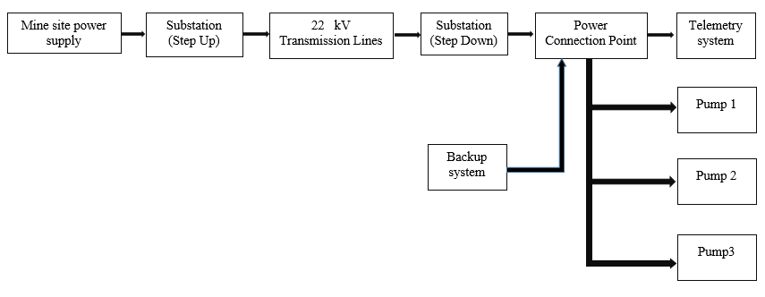

|  |  |
| --- | --- |
| **Element** | **Description** |
| **Mine site power supply** | In the mine site, generating power that needs to be send to the borefield. |
| **Step up Substation** | In the mine site, increasing the voltage to 22 kV by using step up transformers. |
| **Transmission lines** | Transferring electric power from the mine site to the borefield, it is a high voltage (22 kV) short distance (10 km) transmission. |
| **Step down substation** | In the bore field, using step down transformers to decrease the 22 kV to 415 V, which is the value of rated voltage of pumps. |
| **Power connection point** | Using cables connect loads to the power supply. |
| **Telemetry system** | Communicating between the mine site and the bore field. Monitoring the working status of pumps. |
| **Backup system** | Using diesel generators as backup power supply. |
| **Pumps** | Pump 1 and pump 2 are on duty, and pump 3 is on standby. |

Overall, the overhead transmissions lines is a feasible method to provide continuous and stable power to the remote borefield. Different from fully/hybrid renewable methods, the advantages of overhead transmission lines are stable, environmental friendly and easy to maintain. Overhead transmission lines can deliver desire amount of power by changing the input on the sending end (mine site supply in this case), while the power output of solar/wind energy is unstable and the output could be fluctuate with unsatisfactory weather conditions. Also, there are no environmental issues involved with overhead transmission lines method compared to fully/hybrid renewable methods, because the latter has to rely on battery banks to deliver/store power for the system, thus there may exist risks involved with battery chemicals leakage or explosion in the equipment installation, operation and decommission stages. However, as a conventional power supply method, there is a lack of technology innovation of overhead transmission lines method; furthermore, the conventional power supply method involves with relatively high capital cost, thus it may not satisfy the cost-effective primary goal of the project. According to the design brief [Appendix C – design brief], the overhead transmission lines method is treated as a base case, and the role of the base case is to provide references of cost, feasibility and energy transfer efficiency for fully/hybrid renewable methods. Thus, the final design product would be a renewable method other than the overhead transmission lines method.

### Design Elements

Before determining the type of each component of overhead transmission lines, some basic parameters need to be confirmed in advance.

|  |  |  |
| --- | --- | --- |
| **Parameter** | **Description** | **Value** |
|  | Transmission distance | 10 km |
|  | Frequency of the system | 50 Hz [Appendix D] |
|  | Sending end*line to line voltage | 22 kV |
|  | Receiving end** line to line voltage | 415 V [Appendix D] |
|  | Minimum daily power requirement on receiving end | 60.1 kW*** |
|  | Power factor on receiving end | 0.81 [Appendix D] |

*Table -4- Basic parameters of transmission lines used in base case*

*Sending end: mine site.

**Receiving end: borefield.

***

Based on the above parameters, the apparent power and the line current on receiving end can be calculated as follow:

According to the Table 4, the overhead transmission lines can be simulated as a short distance and high voltage transmission model [3].

Overhead Transmission Lines Component---Conductors

Conductor is one of the fundamental elements in overhead transmission lines. There are several types of conductors that can be used in overhead transmission, such as AAC (aluminum alloy conductor), AAAC (all aluminum alloy conductor), ACSR (aluminum conductor, steel reinforced) and ACAR (aluminum conductor, allow reinforced) [4]. Aluminum conductors reinforced with steel are primarily used for medium and high voltage lines and may also be used for overhead services to individual customers [5].

Cost Estimation of Conductors

The cost of conductors used in overhead transmission lines has been provided by Jacobs, which is $ 350,000/km, thus the total estimated expenditure on conductors will be $ 3.5 million.

Corona Effect in Conductors

In high voltage transmission, corona effect can cause significant power loss in transmission lines without any prevention. Thus, bundled conductors can be used to reduce the corona effect. Bundle conductors consist of several conductor cables connected by non-conducting spacers. In this case, two-conductor bundles are usually used in 22 kV transmission lines [6]. The spacers are used usually one per 50 meters which leads to 20 spacers per kilometer [7]. In this case, minimum 200 spacers are required for the overhead transmission lines. The price of one spacer is around $ 45. The total cost on spacers is approximate $ 9,000.

Sag of Conductors

The sag of overhead transmission lines is vertical distance between the highest and lowest point of the curve. A minimum overhead clearance must be maintained for safety [8]. The overhead clearance depends on the type of conductors and the terrain type. In the remote borefield, there is no communities exist in the surrounding area thus according to the the Wiring Rules AS/NZS 3000:2007 [Appendix A], the minimum clearance is 3 meters.

Overhead Transmission Lines Component---Insulators

An insulator is a material that prevents the flow of an electric current and can be used to support electrical conductors. The function of insulation is to provide for the necessary clearance between the line conductors, between conductors and ground, and between conductors and the pole or tower. Insulators are made of porcelain, glass and fiber glass treated with epoxy resins [9]. For high voltage transmission, only suspension-type insulators are common for overhead conductors [10].

Cost Estimation of Insulators

For a high voltage system, the total cost of insulator and hardware is approximate 23% of conductors cost [11]. In this case, the cost of insulator and hardware is around $ 0.817 million.

Overhead Transmission Lines Component---Ground Wires

The role of ground wires is to reduce the probability of direct lighting strikes to the conductors by conducting large lighting strike currents to the ground. In high voltage transmission, two ground wires are required for each tower [12].

Cost Estimation of Ground Wires

For a high voltage system, the total cost of ground wires is approximate 6.7% of conductors cost [13]. In this case, the cost of ground wire is around $ 0.233 million.

Overhead Transmission Lines Component---Towers and Foundations

Transmission towers and foundations are used to support the overhead transmission lines. In high voltage transmission, a lattice-type tower is often used to carry on transmission lines [14].

Cost estimation of Towers and Foundations

For a high voltage system, the total cost of towers and foundations is approximate 1.27 times of conductors cost [15]. In this case, the cost of towers and foundations is around $ 4.433 million.

Step Down Substation

The transmission voltage is 22 kV which is much greater than the limit of pump nominal voltage, thus a step down substation is required in the borefield to reduce the 22 kV transmission voltage to a distribution voltage level. A substation includes transformers, circuit breakers, bus bars, protection equipment and earth grid. In consideration of the large difference between the values of input and out voltage, two step-down transformers are required in the substation. It is difficult to obtain the cost information of a substation with two transformers that exactly the same as the design requirements, thus the estimated cost of substation with two transformers is around $ 9.8 million [16].

Maintenance

The maintenance includes regular and contingency maintenance. The estimated cost rate of maintenance has been given by Jacobs, which is $ 100/hour. Assuming the frequency of regular maintenance is once every three weeks and eight hours each time. Contingency maintenance is assumed once every month and four hours for each time. The estimated cost on maintenance is around $ 18.7K for one year and $ 0.187 million.

### Design Architecture

Base Case Architecture Justification

Overall, the overhead transmissions lines is a feasible method to provide continuous and stable power to the remote borefield. Different from fully/hybrid renewable methods, the advantages of overhead transmission lines are stable, environmental friendly and easy to maintain. Overhead transmission lines can deliver desire amount of power by changing the input on the sending end (mine site supply in this case), while the power output of solar/wind energy is unstable and the output could be fluctuate with unsatisfactory weather conditions. Also, there are no environmental issues involved with overhead transmission lines method compared to fully/hybrid renewable methods, because the latter has to rely on battery banks to deliver/store power for the system, thus there may exist risks involved with battery chemicals leakage or explosion in the equipment installation, operation and decommission stages. However, as a conventional power supply method, there is a lack of technology innovation of overhead transmission lines method; furthermore, the conventional power supply method involves with relatively high capital cost, thus it may not satisfy the cost-effective primary goal of the project. According to the design brief [Appendix C], the overhead transmission lines method is treated as a base case, and the role of the base case is to provide references of cost, feasibility and energy transfer efficiency for fully/hybrid renewable methods. Thus, the final design product would be a renewable method other than the overhead transmission lines method.

Base Case Architecture Specification

The following subsections will introduce the type of each component of overhead transmission lines and an estimated cost of each component, the maintenance of base case and an initial estimation of final cost of base case.

#### Traced to requirements

|  |  |  |  |
| --- | --- | --- | --- |
| 1 | Operate continuously (24/7) | The power generation system is required to operate for 24 hours a day, 7 days a week, 365 days a year. | Pass. Overhead transmission lines can provide continuous and stable electric power under regular maintenance and proper protection. The backup system can be used in contingency. |
| 2 | At least 90kW of power available | The mine site requires maintenance of a 3ML storage tank with expected usage of 900 ML per year. This will require 90 kW of power to drive three 30kW pumps. The pumps are maintained by the client and so the team requirement is to supply 90 kW of power. | Pass. Overhead transmission lines can supply enough amount of electric power under regular maintenance and proper protection. The backup system can be used in contingency. |
| 3 | Operate in desired location. | The power generation system must operate in Newman. This includes tolerating the harsh conditions and remote environment. | Pass. Overhead transmission lines can operate in harsh conditions with appropriate types of its components (conductors, insulators, ground wires and tower structure). |
| 4 | Safety | The system must run safely. Any safety equipment that requires power must also be supplied. | Pass. Overhead transmission lines can supply power safely with proper operations, also the overhead transmission line installation can follow the Wiring Rules AS/NZS 3000:2007 [Appendix A] |
| 5 | Economy | Maximise the economy of the proposed solution. | Fail. Base case will cost substantial amount of money compared with fully/hybrid renewable methods. |
| 6 | Telemetry | The system requires telemetry and communications equipment, and these will also require power. | Pass. Base case includes telemetry system. |
| 7 | Maintainable | The system must be maintainable. | Pass. Conventional maintenance methods can be performed in overhead transmission lines maintenance. |
| 8 | 10-year life | The system must last for at least ten years | Pass. The life expectancy of transmission lines is 40 to 60 years [2]. |
| 9 | Environment | The proposed solution should minimise harm to the environment. | Pass. Overhead transmission lines are environmental friendly, it can operate without the emission of green-house gases. Also, there is no chemical pollution compared with fully/hybrid renewable solutions, which contain battery banks. |
| 10 | Time | The proposed solution should take a minimum amount of time to construct. | Fail. The construction of overhead transmission lines is a time-consuming process compared with fully/hybrid renewable solution. |

According to the above table, the base case meets the majority of design requirements except for the requirements of economy and time. Overhead transmission lines would cost a large amount of money mainly in overhead transmission lines installation, support towers construction, transformers and diesel generators. Also, the construction period of base case is longer than fully/hybrid renewable solutions; however, according to the first Jacobs partner meeting summary [Appendix B], the mine site owner stated that there is no time constraint on construction.

## Hybrid System

### Design Philosophy

The base case system discussed in section 3.2 was used as a reference system to compare new proposed systems to power the three pumps at the borefield. The first proposed system that Team Power has recommended is a hybrid system consisting of photovoltaics (PV), battery storage and diesel generator back up. This system was proposed due to the fact that the borefield were to be connected to an off-grid power supply which the Team inherently thought of renewable energy. Given the borefield requires a constant supply of power with little variability appropriate sizing of a hybrid system should meet energy requirements of the pumps. One of the main reasons why Team Power proposed a hybrid system was due to the implementation of renewable energy. This technology is exciting and innovative and usually a front runner for any off-grid power generation.

As stated above the hybrid system consists of a PV array, battery storage and diesel generator. The PV array will be considered the main source of power generation in the system. The array should be able to both power the pumps and charge the batteries. The battery bank will be implemented to lower the amount of diesel generator use in times when the PV array could not supply sufficient power to run the pumps. Although a battery bank will be implemented to the system there will still be times during the day where neither the PV nor the battery bank will have sufficient power to run the pumps, hence, the diesel generator will act as the secondary power supply. Ideally the diesel generator will operate for a smaller amount of time than the PV and battery bank however Team Power decided that it should still be sized to be able to power the full load of the system for longer periods of time. For example, consecutive cloudy days or days in which the PV system is under maintenance.

### Design Elements

The main elements of the hybrid system include, solar panels, batteries, boost converters, inverters, diesel generator, and regulators. Although not covered in this report the Hybrid system must also include transmission lines capable of caring the various voltages and currents and safety features such as circuit breakers and isolators. A telemetry system must also be included in the Hybrid system to monitor the operation the PV, battery bank and overall system and relay information to the mine site. Fencing and shelter must be implemented to protect the system from external factors such as animals and harsh weather conditions.

The following sections outlines the steps that were involved in sizing the PV, battery storage and diesel generator, including assumptions. This section will be structured to accommodate rapid re-calculation of specific values when changes in the requirements arise during later stages of the project lifetime. Figure 1 is block diagram representation of the electrical flow of the system and not a spatial representation of the components in the system. The Load represents the three bore pumps each of 30 kW alternate current (AC) power rating and the telemetry system of 100 W power rating. The PV array produces direct current (DC) power and hence an inverter was added to convert the DC to AC. The DC/DC boost converter was added to allow for a lower PV array and battery output voltage to power the load.

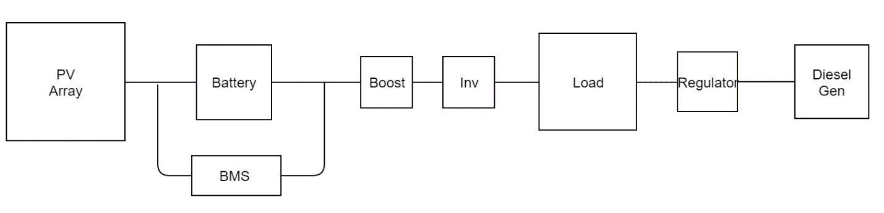

Figure 1: Block diagram of electrical flow of system

The requirements analysis (Appendix A) completed by Team Power in RA report had prioritised cheaper solutions (requirement (5)) over environmentally friendly solutions (requirement (9)) however the Team decided to optimise the solutions green factor as an innovative incentive for the client. From this decision assumptions were made on the operating capability of the system. The first assumption was that the battery bank would be capable of providing power to the load for eight hours without the use of the generator. The second assumption was that the PV array would be sized to supply six hours of power to load along with the ability to completely charge the battery bank during the day. This would mean that the renewable portion of the system would power the pumps for 58 % of the day.

Team Power considered two possible connection for the renewable portion of the hybrid system. The first consisted of one inverter, one boost converter, one battery bank and one PV array to power the entire 90 kW load similar to the block diagram depicted in Figure 1. However, when connecting batteries in parallel variability in the string voltages could cause discharge problems throughout the battery bank and therefore the amount of strings should be kept to a minimum. This connection also left the system with a higher probability of failure, for example, if the inverter were to fail the renewable portion of the system would not be able to supply power to the load. Team Power, therefore, decided on a connection that consisted of an inverter, boost converter, battery bank and PV array per pump as depicted in Figure 2. The layout of this system allows the use of smaller inverters, boost converters and fewer battery strings and therefore an overall more reliable system. Although each pump is connected to its own inverter, booster, battery bank and PV array, spatially these components will be located very close to one another.

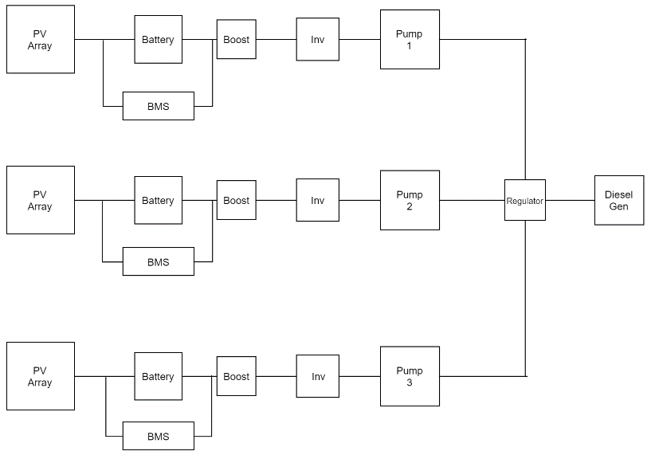

Figure 2: Block diagram of proposed system

The pumps specified by the client were the Grundfos MMS6000 30 kW submersible pumps and therefore the output power from the inverter was required to be 30 kW 3 phase power. Assuming an amplitude modulation ration ma of 0.85 the required input voltage for the inverter can be calculated using the following equation where VLL represents the line to line voltage of the output (415 V for the pumps). The inverter was assumed to have 85% efficiency.

The step-up DC/DC converter would therefore have an output voltage equivalent to the input of the inverter because the converter would be located close to the inverter which would result in legible loss. The input voltage of the boost converter was calculated using the following equation with a duty ratio D of 0.5. The efficacy of the boost converter was assumed to be 100%.

The batteries chosen for the system were 12 V at 100 Ah lithium iron phosphate (LIP) batteries. Other options considered by Team Power included lead acid and lithium ion batteries however the LIP batteries are safer than lead acid and have better temperature tolerance than lithium ion batteries [1]. Assuming 80% depth of discharge of the batteries the number of batteries in series and number of strings can be determined using the equations listed below, where it was assumed the batteries would have the capability to power the pump for 8 hours.

As mentioned previously Team Power had decided to size the PV array to be able to produce enough energy to power the pumps for six hours and charge the battery bank. The solar panels chosen were Sunmodule SW300 with rated voltage at 32.6 V and rated current at 9.31. The average solar insolation of 6.1 kW/m2 for Newman was obtained from the Bureau of Meteorology (BOM) which is equivalent to 6.1 hours at peak sun (1 kW/m2). Using this information and the equations below the number of panels in series and number of strings in the PV array were determined. A derating factor of 0.8 was assumed for the PV array due to dust.

After taking a mathematical approach to sizing the Hybrid system was simulated on using the hybrid optimization model for electric renewables (HOMER) software. The HOMER software calculates all possible combinations of the input variables and ranking the feasible results in order of net present cost (NPC). Solar insolation, wind speeds and temperature ranges were downloaded from the HOMER data base after imputing the location of the borefields. A 95-kW load was added to the simulation, where the extra 5 kW were to be used for telemetry and lighting. Input variables added to the simulation included the diesel generator, PV array, converter, and battery bank. Each input had a variable range of values that HOMER would use to optimise the overall system. Although HOMER is capable of determining the optimum size of each technology in the Hybrid system, it does not output the voltage and current relationships for each technology, hence these would need to calculated manually.

Sizing the hybrid system using either of the methodologies outlined above have allowed the system to meet various requirements outlined in Table 1. During the sizing procedure Team Power was constantly tracing the results back to the requirements

### Design Architecture

Table 1 represents a summary of all the input and output voltages, currents and power of each technology in the renewable connection of the system. These values were determined using the methodology outlined in the section about and can be easily recalculated if changes occur in a later stage of the project lifecycle. Table 2 outlines the amount of batteries and solar panels required in series and number of strings. As mentioned previously the renewable portion of the system was separated into three legs with each pump connected to an inverter, converter, battery bank and PV array and the total number of elements in Table 2 is the sum of all three legs. The diesel generator would be required during periods when the PV array and battery power are insufficient to power the pumps and therefore the size of the generator would be governed by the peak load power. Assuming 85 % efficiency the Hybrid system would require a 110 kW to provide sufficient power to run the pumps.

Table 2: Summary of input and output values of renewable portion of the system

|  |  |  |  |  |  |  |
| --- | --- | --- | --- | --- | --- | --- |
|  | Vin (V) | Vout (V) | Iin (A) | Iout (A) | Pin (kW) | Pout (kW) |
| Inverter | 800 | 415 | 44 | 63 | 35 | 30 |
| Boost | 400 | 800 | 88 | 44 | 35 | 35 |
| Battery | 400 | 400 | 88 | 88 | 35 | 35 |
| PV | - | 400 | - | 88 | - | 35 |

Table 3: Battery and PV size

|  |  |  |  |
| --- | --- | --- | --- |
|  | Number of elements in series | Number of strings | Total number of elements |
| Battery | 34 | 9 | 918 |
| PV | 13 | 27 | 1053 |

Table 3 summerises the size of each technology in the hybrid system as simulated by the HOMER software. These values are lower than the values calculated above because the approach used by the HOMER software involved ranking the systems based on NPC. The HOMER simulation did not take into account the assumptions made for the battery autonomy and therefore the percentage of renewable energy production was much lower than that using the method stated above. Although the final decision will be weighted more on the NPC of the system (not covered in this document), these two methods allow the client to compare the relationship between economic and environmental. If, for example, the NPCs of the two methods were almost equal the client could be excited into implementing the more innovative (renewable) system.

Table 4: Size of technologies using HOMER simulation

|  |  |
| --- | --- |
| PV (kW) | 175 |
| Diesel Generator (kW) | 110 |
| Lithium Ion Batteries | 400 |

The results obtained using the two methods ensured that the proposed hybrid system had met requirements (1) and (2), that is, the system will be capable of providing continuous power to the pumps and the power generation of the system would be over 90 kW. The specific solar panels and batteries were chosen to meet requirement (3) and (4) allowing the system to operate as safely as possible in the desired location. However, overall safety procedure will need to be determined for the system as a whole.

## Diesel Generator

* Justification (traced to requirements)
* Tests, test results
* Comparison with alternatives etc

### Design Philosophy

The DA report, completed by Team Power, outlined three proposed solutions, along with the base case, to power the remote borefields. The base case involved connecting the pumps to the grid view the mine site located 10 km away from the borefield. The three proposed solutions consisted of two hybrid systems and a purely renewable system. Hybrid 1 was a photovoltaic (PV), battery storage, and diesel generator back-up system, Hybrid 2 was a PV, wind, battery storage and diesel generator back-up system and the purely renewable system contained PV, wind and battery storage. Team Power chose these solutions based on preliminary research into the types of technology and the location of the borefield and their extent to meet the requirements. However, after submission of the DA and further extensive research into the technologies and location the proposed solutions were modified.

The diesel generator solution was not an original proposed solution by Team Power. After further research into the weather conditions at the location of the borefields (Newman, Western Australia) it was discovered that the average morning wind speed was 9.1 km/h (2.5 m/s) and the average afternoon wind speed was 9.4 km/h (2.6 m/s) [2]. The cut-in wind speed of a turbine is the minimum wind speed required for the turbine to overcome internal frictions and produce useful power, this is usually around 4-5 m/s but varies based on the wind turbine [3]. The average wind speeds in Newman were lower than the average cut-in speeds of wind turbines and hence the use of wind turbines would be inefficient for the successful completion of the project. It was therefore decided by Team Power to remove Hybrid 2 as a possible solution for the project and the wind turbines from the purely renewable solution be removed from the design. This left the purely renewable system consisting of only PV and battery storage however the Team decided that this system would not be reliable as a standalone system and therefore it was removed as a possible solution. After revisiting the requirements, it was noted that being environmentally friendly was a low requirement (9) for the project and that economics was a higher requirement (5). This lead Team Power to propose a purely diesel generator system as the second solution for powering the remote borefields.

### Design Elements

Unlike the hybrid system discussed in section 3.3 the diesel generator solution contains fewer elements to successfully operate and meet the requirements. Two diesel generators will be implemented in the solution, one acting as the primary generator and the other as a back-up in times when the primary is down for maintenance or down due to technical breakdowns. The system will also require a rectifier to convert the AC power the generator will output to DC power for the telemetry system. Appropriately sized cables, circuit breakers and isolators will also be integrated throughout the system however they will be discussed in detail in section 3.5.

Although the pumps will operate in a duty, duty assist and stand-by configuration the diesel generators were sized to meet the maximum load, that is all three pumps (including telemetry) operating at the same time. Therefore, the generators chosen must be capable of suppling at least 90 kW of power. Two 138 kVA 3 phase 415V Cummins diesel generators were chosen to provide the required power. These generators have output voltages and currents of 415 V and 174 A respectively, sufficient for the voltage and current requirements of the pumps. The generators consist of a 490 L fuel tank and consume 20 L of diesel per hour of operation, therefore, the system will also require a diesel storage tank. This tank should be larger enough to supply the generator with enough fuel to void any unnecessary visits to the site to re-fuel the generators. The Cummins diesel generator consumes approximately 15 L of fuel every hour when operating at 75 % of the full load. Using this assumption, a diesel storage tank of 10,000 L will consist of sufficient fuel to allow approximately 30 days of operation before refilling the tanks. A storage tank of this size would reduce costs associated with site visits for refueling and cost associated with fuel transport as refueling will occur once a month.

A three phase controlled rectifier will be required for the system to power the telemetry. This rectifier will convert the 415 V line-to-line voltage from the generator to 24 V DC to power the telemetry system. No external storage such as batteries are implemented for this system as the failure of the primary generator will cause the secondary generator to turn on. Hence both generators will be sized equally.

While sizing the diesel generator proposed system the Team constantly traced the elements back to the requirements in Table 1. Choosing to install two diesel generators into this system allows it to meet requirement (1), that is, the system will be capable of supplying continuous power to the pumps. Operating the generators as primary and back-up allows a constant supply of power. The Cummin diesel generator specified above is capable of supplying 110 kW of power which is over the required power for the system and hence requirement (2) will be met. The generator is capable of operating in the extreme conditions of Newman which include the vast temperature changes and hence meet requirement (3). Included in the system are various circuit breakers and isolators which add to the safety of the system. The generators themselves would have been built by the manufactures according to strict standards and therefore coupling this with the added circuit breakers and isolators the system will meet requirement (4). Unfortunately, being a diesel generator solution the system emits carbon dioxide and therefore fails to meet requirement (9) as the system is not environmentally friendly.

### Design Architecture

## System Integration

### Cables

Considering the base case, the hybrid and the diesel generator solutions, cables must be selected to satisfy project requirements. The cables that run from the generator to the pump, and the transformer to the pump, must be capable of supplying three pumps in parallel. The cables that run from the inverters to the pumps, only need to supply one pump. As a result, the cables used in the hybrid will be different to the cables required for the base case and the generator only solution. Before calculating the required current carrying capacity of the cables, the required current and voltage must be determined for the pumps.

As specified by the client the Grundfos MS 6000 submersible pumps are to be used in the bore field. It is a requirement of team power to supply sufficient power to three 30 kW pumps as seen in appendix A. These pumps require a specific voltage and current as shown in Table 4 and in the Appendix B [4]. The relevant row has been extracted from the pumps data sheet referring to the 30 kW pumps. The rated current refers to the maximum current for the pump to continue operating in acceptable conditions. From this information, the voltage and current running to the pumps can be calculated and therefore the voltage and current capabilities of the cables.

Table 4: Characteristics of Pump 3 x 415V, 50Hz, T40 (voltage code 18, 39) from Grundfos literature [4]

|  |  |  |  |  |  |  |  |  |  |  |  |  |
| --- | --- | --- | --- | --- | --- | --- | --- | --- | --- | --- | --- | --- |
| **Power (kW)** | **Rated Current (A)** | **Motor efficiency (%)** | | | **Cos (Power Factor)** | | | **N (min-1)** | **Rated torque (Nm)** | **LRC (%)** | **LRT (%)** | **BT (%)** |
| 100 % | 75 % | 50 % | 100 % | 75 % | 50 % |
| 30 | 63.0 | 84.0 | 84.4 | 82.7 | 0.82 | 0.76 | 0.64 | 2880 | 100 | 530 | 170 | 290 |

The 3 x 415V refers to a line-to-line voltage of 415V, this corresponds to a phase voltage of . Using the power factor and motor efficiency given for when the pump is running at 100% capacity, the power factor (PF), , is 0.82 summarised in Table 4. This can be used to calculate the real and reactive components of the apparent power using the power triangle seen in Figure 3.

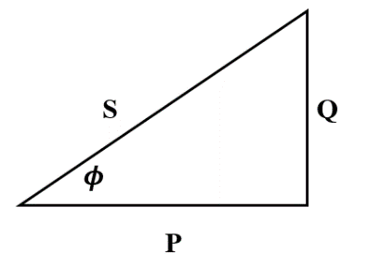

Figure 3: Power Triangle

From this triangle and using simple trigonometry, , . Using this value for apparent power, the required current can be determined as follows:

This current is below the rated current given in the pump data sheet and does not consider the efficiency of the pump. This can be corrected in the equation below for rated current. This yields a current much closer to the rated current given by the pumps datasheet.

As such the cables will be sized to meet the requirements of the pumps, as well as being capable of higher currents in the case of faults or disturbances in the system.

#### V-I characteristics and selection

As given by the pump data sheet [4] and confirmed by the calculations above, the current required for each motor is a maximum of 63A. The hybrid system is connected such that there is one inverter for each pump, meaning that the cables are only required to carry the current necessary for one pump. This is more efficient than one cable for three pumps in parallel since one cable would require a current that is three times higher, incurring more power loss (). Additionally, since the solar panels from the PV system generate direct current (DC), the cables going to the inverter will be one phase DC cables, while the cables going from the inverter to the load will be three phase alternating current (AC) cables. For both the diesel generator solution and the base case, there will be one cable to supply three pumps in parallel. Both these solutions only require three-phase cables and the same cables can be used for both.

The current carrying capacity of the cables is decided from the pump characteristics and possible fault currents. That is the cables should be sized to withstand faults without failing. Should cables fail, there are significant safety issues, if the insulation is not sufficient cables can become exposed increasing the risk of fire and harm to people who may have contact with the cable. Since safety is ranked highly as one of the project requirements, this is a very important aspect of the design. To do this, the short circuit current must be calculated. The short circuit current is calculated using the equivalent impedance diagram for the system, and requires the characteristic impedance of the line. Since the line impedance cannot be determined before choosing the cables, the cable must be chosen based on an estimate, and then calculations must confirm the chosen cable. For the hybrid, using an estimate for short circuit current, the surge short circuit current can be estimated as; and the symmetrical short circuit current as; [5]. Using a table of copper conductors that are PVC insulated 3- and 4- core cables, a 25mm2 copper conductor carries a current of 126A, this is sufficient for the rated current of the load and the circuit breaker (100A) to be used. This cable can withstand a fault current of 2.87kA for a duration of one second, which is more than sufficient for the surge current of 315A and the symmetrical short circuit current of 88.2A. This size conductor also quotes a voltage drop of 1.515 mV/A m and an impedance of 0.8749 Ω/km [6].

For the base case, the short circuit current can be estimated without the line impedance, assuming a fault occurs as close to the low voltage bus as possible, the resistance of the line is not needed.

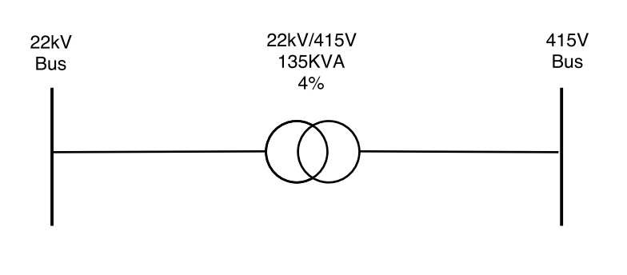

Figure 4: Line Diagram to calculate transformer fault current

Using Figure 4 the power of the transformer is 135kVA and the fault is occurring on the low voltage side of the transformer. The short circuit capacity (SCMVA) and short circuit current is given by the following equations [6].

From this, the short circuit current is approximately 4.7kA, and as such, the cables and protection equipment must withstand this fault level. The diesel generator solution will also use these cables. As a result, a 70mm2 PVC insulated stranded copper conductor is sufficient for this. This cable carries a current of 215A and can withstand a short circuit current of 8.05kA for a duration of one second which is more than sufficient for the calculated short circuit current of 4.695kA. It has a voltage drop of 0.576 mV/A m and an impedance of 0.3325 Ω/km [6].

The hybrid system also requires the use of single phase DC cables as well as three phase AC cables. These are required since the PV array produces DC current, and the batteries output DC current as well. For the design, these cables are to be kept to a minimum distance, that is the batteries and inverter will be located very close to the PV arrays (see diagram from system architecture??). The cable from the PV array, to the batteries, and to the DC/DC boost is required to carry 88A of current, and the cable from the boost to the inverter is required to carry 44A of current. The solar panels used in the design quote a short circuit current of 10.23A [7]. The DC cables connecting them to the batteries must have 125% of this value multiplied by the number of strings shown in the equation below [8].

The Voltage Drop Index (VDI) can also be calculated and the appropriate cable selected based on the result. Assuming an acceptable voltage drop of 3% for the solar panels and a maximum length of 2 meters of cable the VDI can be calculated as shown. Where I is the current calculated above (A), L is the length of the cable in feet (3.28084ft is 1m), Dv­ is the voltage drop (%) and V is the voltage of the system [8].

The VDI is rounded up to the nearest whole number available on the chart, so using VDI=31, the copper conductor will be at least 33.6 mm2 [9].

#### Lengths and losses

For the base case, the load will be 10m away from the transformer resulting in 10m long three phase AC cables. From the cables chosen, this results in a voltage drop of 1.08V corresponding to an approximate power loss of 204.12W. Similarly, for the generator only case, the pumps will only be 5m away from the load resulting in a voltage drop of 0.544V and a power loss of 102.82W. For the hybrid design, the inverter will be located 8 meters away from the load. Across this distance there will be a small loss in voltage. For an underground cable, capable of carrying the required current, there is a loss of 0.27 mV/A resulting in a loss of 0.36V corresponding to approximately 22.68W of power. As a result, more power must be generated to make up for this loss. The cables between the battery, boost and inverter will be kept as short as possible and as such any losses will be negligible.

#### Trace to Requirements

Testing

Last chapter in - [10]

### Circuit Breakers

The protective relaying system of a power system consists of many elements including circuit breakers, current and voltage transformers and relays. The most important aspect that has been considered in the design are circuit breakers. There are four main types of circuit breakers used, oil, air, vacuum and SF6 (Sulphur Hexafluoride). Each of these have their own advantages and disadvantages, oil for example is cheap but prone to fire, air is very loud but is not a fire or health risk, a vacuum is not a health or fire risk, but it is impossible to monitor the medium and SF6 has no fire risk, a low health risk but is a more complex. These circuit breakers are used in power distribution systems and are for high-voltages (HV) [11]. An important consideration in the selection of a circuit breaker is the voltage level of the system and the locations of the circuit breakers within the system. The circuit breakers must be able to isolate equipment in the case of a fault in the system, as such they must be located between each module shown in the block diagram in Figure 1.

The purpose of a circuit breaker is to switch load currents, break fault currents and to carry a fault current without failing. With the important factors being the speed with which the current is broken when the circuit breaker is tripped, and the current capacity that the circuit breaker is capable of interrupting [6]. When a fault occurs in the system, a large current called a fault current is induced. The fault current will trip the circuit breaker, which interrupts the flow of current from the source to the load, so that it does not reach the equipment protecting it from potential damage. This is an important aspect of the design making it safer and more reliable.

The circuit breakers to be used in the system are designed for the low-voltage (LV) of 415V. The two types of circuit breaker considered for LV systems, they are moulded-case circuit breaker (MCCB), and low-voltage power circuit breaker (LVPCB). Insulated-case circuit breakers (ICCB) are a type of MCCB. MCCBs typically use a quick-break mechanism meaning that the speed the contacts are open and closed is independent of how fast the handle is moved. These circuit breakers can be tripped automatically or manually. LVPCBs use a spring charged mechanism that must be manually closed after the trip unit has opened the circuit breaker [12].

The factors to be considered when selecting the circuit breaker are the system voltage, system grounding, system frequency, load current, ambient temperature and altitude, harmonics and short-circuit current [12]. As a result, a MCCB will be used in the system. This is chosen over ICCB and LVPCB for its current limiting ability, the large number of sizes it is available in and its relatively low cost. For the hybrid system, the circuit breaker must have a rated current of at least 63A to match the pump requirements, and the breaking capacity must be at least 315A (short circuit current calculated in section 3.5.1). As such a circuit breaker with a rated current of 100A and breaking capacity of 25 kA is more than sufficient. One such circuit breaker is the NSX100B: (25kA at 415V) which is used for distribution protection available in a few models from Schneider Electric. This circuit breaker uses a thermal magnetic trip unit. For the base case and the generator only system, the rated current is higher at 189A and the short circuit current is much higher at 4.7kA but still requires an operating voltage of 415V. Similarly, a circuit breaker from Schneider Electric is appropriate, the NSX250B: (25kA at 415V) with a rated current of 140-200A [13].

A DC circuit breaker is required for the hybrid system between the solar panel and the batteries.

#### Trace to Requirements

### Sensing Reporting Monitoring and Telemetry

Timely information is crucial to the safe and efficient operation of a remote installation[14]. This is especially true (for example) in installations where pumps are employed, as allowing pumps to run dry can damage pump hardware within a matter of minutes[15]. This need for timely information competes with increased costs associated with more frequent sampling (for example power consumption, increased sampling hardware costs and more frequent transmission costs). It is therefore important to identify the optimum sensing and reporting regimen for the SGRB installation. The need for telemetry comes directly from requirement 6 (see appendix A) as requested by Jacobs. In turn this requirement emerges from requirements 1,4,5 and 7; in that continuous, safe and economically efficient operation of a remote facility will require more information than can feasibly be acquired from on-site inspection.

#### Variables

This section summarises the variables which would be automatically recorded and transmitted by the site telemetry system. Additional in-person checks and inspections are required for proper maintenance and will be in effect. These are not discussed here.

##### System Variables

Given the small size of the site and the remote nature, security video and other site-wide data is not required. System run condition can be ascertained directly from the subsystem states. Cumulative sequential runtime without failure would be tracked centrally at the mine site. For these reasons, no site-wide parameters would be sampled.

##### Subsystem Variables

Depending on which design solution is implemented there are multiple different subsystems involved in the SGRB which require frequent monitoring. “Frequent” meaning anywhere between ‘once a minute’ to ‘once an hour’. For each subsystem, the range of variables to be sampled differs; some simply require reporting of ‘state’ (on/off/shutdown etc.) while others require state monitoring and more. Whenever variables are sampled, assume that subsystem state is also sampled.

|  |  |  |
| --- | --- | --- |
| **Subsystem** | **Variable** | **Monitoring Frequency** |
| **Pump System** | Duty cycle | On change of state |
| **Strings of solar arrays** | Current out of the string | ~Every few minutes |
| **BMS** | State | On state change |
| **Battery banks** | Temperature, charging voltage | ~Every few minutes |
| **Diesel generator/s** | Fuel level and vibration | Multiple times per hour |
| **Overhead lines (at transformers)** | Voltage, current, power | Multiple times per hour |
| **On-site control systems** | State of on-site control ( | On state change |
| **Operability systems** | State of lighting, state of local shutdown | On state change |
| **Safety systems** | State of each system (ready/engaged/offline) | On state change |

*Table 1: Subsystem sampling variables and the frequency of their recording. Available states will vary for each system depending on client’s choice of local hardware implementation (FPGA, PLC, etc.) but basic state library will be essential for function. For example, it is critical that the pump system reports current state so that the duty cycle required to satisfy current and projected demand for process water in the mine reservoir can be implemented.*

### Component Variables

In the battery and PV-array string subsystems, failure of a single component can cripple the whole series system, leading to accelerated deterioration of the serial components. It is thus important to monitor component variables as well as the subsystem variables for these systems. These variables are also already available by necessity, as the MPPT (maximum power point tracking) system, the charge controller and the other BMS (battery management system) subcomponents require these variables in order to function.

Team Power are not responsible for individual component monitoring inside the Grundfos MMS6000 series pumps specified by Jacobs; the pumps possess inbuilt sensory systems and these feed to the variables for the total pump subsystem [16].

|  |  |  |
| --- | --- | --- |
| **Component** | **Variable** | **Monitoring Frequency** |
| **Individual Pumps** | Pressure, level and flow | Multiple times per minute |
| **Solar arrays** | Current out of the array, voltage at terminals | Multiple times per minute |
| **Battery string** | Temperature, charging voltage | Multiple times per minute times per hour |
| **Distributed circuit breakers** | State of breaker (triggered/untriggered/reset) | On state change |
| **DC/DC Boost Converters** | Current in and voltage out for MPPT | Used by BMS |
| **DC/AC Inverters** | Voltage in and voltage out for MPPT | Used by BMS |
| **On-site control systems** | State of on-site control ( | On state change |
| **Operability systems** | State of lighting, state of local shutdown | On state change |
| **Safety systems** | State of each system (ready/engaged/offline) | On state change |

*Table 2: Component sampling variables and the frequency of their recording. Available states will vary for each component depending on client’s choice of local hardware implementation (FPGA, PLC, etc.) but basic state library will be essential for function. For example, circuit breakers must report whether they are closed or open. From this information, central control (at the mine site) can track other statistics such as the last break in the circuit and frequency of interrupts.*

### Sensing and reporting technology

The parameters described in section 6.1 will informing the client’s specification for sensing and reporting technologies on the SGRB project. Examples of general technology archetypes based on these parameters are given here, as well as further considerations informing technology choice.

#### System-wide Sensing and Reporting

Data from all sub-systems is collected at a central PLC (data-hub) with solid-state data storage. Data is relayed via a 3G/4G broadband modem (HSPA/LTE compatible) to a receiver situated in the mine site control centre (10km, see appendix B). A cyclone-rated directional 16dBi Yagi-Uda antenna (vantage point depends on design scenario) will amplify and focus the 850MHz signal to improve transmission. Relatively flat terrain, lack of urban signal interference and generally signal-conducive local weather should contribute to near ideal signal transmission[17]. Furthermore, transmission control protocol (TCP) using scheduled transmission of fixed-size data packets (rather than variable transmission timing and size) will result in increased reception quality.

### Subsystem Sensing and Reporting

The proposed design solutions are comprised of different combinations of subsystems. Each subsystem reports to a local controller ideally implemented using FPGA including PID (proportional integral derivative) control[18]. Local controllers route data to the central data-hub using shielded Cat 6 twisted pair Ethernet, with cable distance not exceeding 90m[19]. Data collection by local controllers from subsystems depends on sensor type.

|  |  |  |
| --- | --- | --- |
| **Subsystem** | **Controller** | **Control/reporting level** |
| **Pumps** | Pump controller | * Sampling pump data * Emergency shutdown of pumps |
| **Strings of solar arrays** | Combined BMS controller | * MPPT control integrated through DC/DC boost converter |
| **BMS** | Combined BMS controller, oversight from mine-site control | * State * BMS Protocol |
| **Battery banks** | Combined BMS controller | * Temperature * Charging voltage |
| **Diesel generator** | Generator controller | * State (on/off) * Fuel level |
| **Overhead lines  (at transformers)** | Power controller | * Sensing and reporting only * Emergency state reporting to safety systems controller |
| **Distributed circuit breakers** | Power controller | * Sensing and reporting only * Emergency state reporting to safety systems controller |
| **On-site control systems** | Manual/by local operator | * Manual site override and emergency shutdown * Lights * Safety systems |
| **Operability systems** | Operability controller, oversight from mine-site control | * Lights * Radio |
| **Safety systems** | Safety systems controller and sub-controllers, partial oversight from mine-site control | * Fire * Weather station and storm controller * Circuit breaker trip * Transformer shutdown * Power re-route * Generator state control * Control over pump, power, BMS and operability controllers |

*Table 3: Subsystem reporting and control hierarchy. Notice that the MPPT, charge controller and BMS functionalities are all integrated into the combined BMS controller. This is because the controller needs to influence multiple subsystems to handle MPPT. This controller will preferably use a perturb/observe protocol for MPPT with a step size ΔD of ~2.5%[20].*

### Component Sensing and Reporting

Some components come from the manufacturer equipped with sensing and reporting capability (for example pumps and battery strings). Others need modification before they can be sampled by local controllers. Sensor design for components is not within the scope of this report. It is unfeasible to sample some individual sub-components, such as individual battery units. In these cases, subsystem parameters are used by the local controller instead (e.g. in the case of a battery string, ideally the system would know the voltage and stored charge for each battery but installing and monitoring this many sensors is impractical so the string is managed as a whole).

## Focus on Safety

### Controllers

Local controllers will be the first to record perturbations in system parameters and are thus likely to be able to respond to safety issues most rapidly. In keeping with requirement 4 and author ethics safety is a priority and so dedicated safety/emergency systems controllers are implemented. As part of a robust safety protocol, local automated controllers (realised as an FPGA for example) have authority to shutdown certain SGRB subsystems upon receiving critical state parameters; after performing automated secondary checks. For example, upon triggering an overcharge or overheat warning the BMS will reroute power away from a battery string, preventing it from damaging the battery bank. In another example, the local pump controller will swap duty pumps to backup/off-duty state in the case of run dry error, and initiate a borehole shutdown if this error spreads to a second pump. This will be monitored locally and reported in the safety systems state (for the pump controller in this case) to the central controller and hence to mine site control. Safety shutdowns can be triggered from mine-site control but cannot be overridden remotely once in place. Once a system has been disabled for a safety critical reason it will require manual restart in accordance with functional safety standards [21].

## Final Cost Estimates

Base Case

|  |  |
| --- | --- |
| **Element** | **Estimated Cost ($ millions)** |
| 1. Transmission Lines |  |
| Conductors | 3.5 |
| Insulators and Hardware | 0.817 |
| Ground Wires | 0.233 |
| Tower and Foundation | 4.433 |
| Land Cost* | 0.7 |
| Studies** | 1.05 |
| Miscellaneous*** | 0.933 |
| Total cost for Transmission Lines | 11.666 |
| 2. Step Down Substation |  |
| Total cost for Substation | 9.8 |
| 3. Maintenance |  |
| Total cost for maintenance | 0.187 |
| Total | 21.653 |

*Table -5- Initial cost estimation for base case (without calculating cost of generators in backup system)*

*Land cost, studies cost and miscellaneous cost account for 6%, 9% and 8% of the total cost of transmission lines respectively [17].

The NPV analysis will be performed in the later stage of design. Based on the above estimation, the cost of power in 10-year period is at least. According to the information provided by Jacobs [Appendix E], for comparison purpose the cost of power is assumed as 30 c/kWh. Thus, the cost of base case is much greater than the assumption cost which does not meet the cost-effective requirement of the project.

## Stakeholder Engagement

### Design Review

1. Basically, Table 5: resource table represents all the important design inputs:

Table 6: Resource Table

|  |  |  |  |
| --- | --- | --- | --- |
| **Design Inputs** | **Three types of energy sources** | **Energy Storage Technologies** | **Other Required Technologies** |
| **Power Generation Solutions** | Base Case:  Overhead Power | Battery Storage | Inverter (100W 24Volts DC) |
| Diesel Generator | Telemetry |
| Renewable Energy (Choosing renewable sources are based on the consideration of location) | Cooling system (Due to the harsh weather at the project site: Newman) |

1. Design Methodology

Table 7: Four Design Options

|  |  |  |
| --- | --- | --- |
| **Design Methodology** | Base Case: Overhead Power | POWERFACTORY & MATLAB |
| Solar-wind-battery-diesel | HOMER TOOL |
| Solar-battery-diesel | HOMER TOOL |
| Solar-wind-battery | HOMER TOOL |

Table 8: Maximum Load (By using Grundfos MMS6000 Series)

|  |  |  |  |  |  |  |  |
| --- | --- | --- | --- | --- | --- | --- | --- |
| System Components | Load (KW) | Voltage  (V) | Power Factor | Load Factor | Running Load(KW) | Running Current (A) | Run  (KVA) |
| 3*Pumps | 30 | 415 | 0.81 | 1.00 | 30 | 51.53 | 37.0 |
| Telemetry | 0.1 | 24 | 1.00 | 1.00 | 0.1 | 0.24 | 0.1 |
| Total | 90.1 |  |  |  | 90.1 | 154.59 | 111 |

1. Line Diagrams related each system model

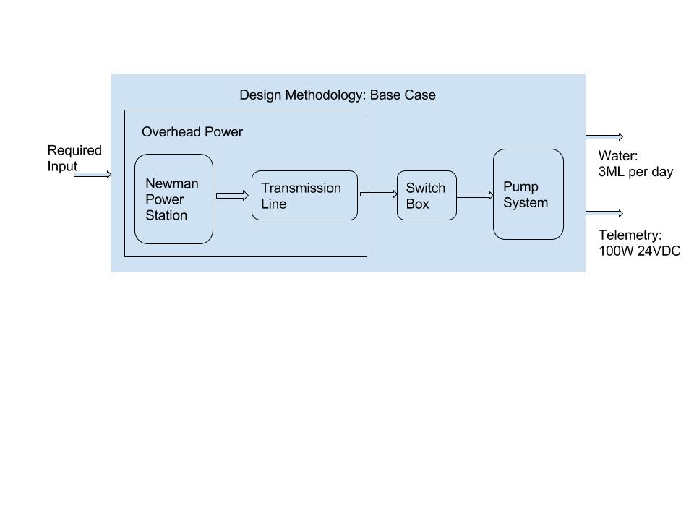

Figure 5: Base Case Line Diagram

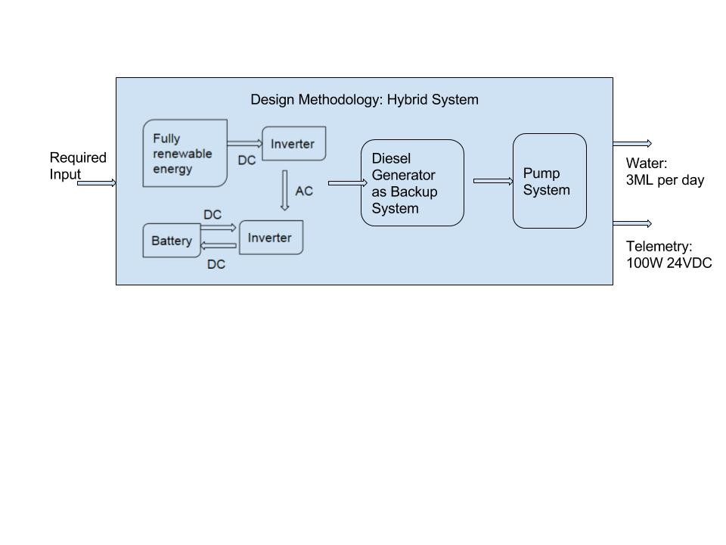

Figure 6: Hybrid System line diagram

## Safety Issues

|  |  |  |  |  |  |  |
| --- | --- | --- | --- | --- | --- | --- |
| **SAFETY IN DESIGN CHECKLIST** | | Yes |  | Elimination (E) | Extreme (1) |  |
| No |  | Substitution (S) | High (2) |  |
| NA |  | Isolation (I) | Moderate (3) |  |
|  |  | Engineering (ENG) | Low (4) |  |
|  |  | Administration (A) |  |  |
|  |  | PPE (P) |  |  |
| **Applicable** | **Proposed New Design Measures** |  | **Priority** | **Further Actions** |
|  | **Description** | **Treatment Code** |  |  |
| **SECTION A - GENERAL DESIGN ISSUES** | |  |  | |  | |
|  |  |  |  |  |  |  |
| **NO.** | **GENERAL ASPECTS** |  |  |  |  |  |
| 1 | Product quality does not satisfy requirements | Yes | Test design using software, calculations and comparison to previous similar projects to ensure all requirements are met. | Engineering (ENG) | Extreme (1) |  |
| **SECTION B – BUSINESS** | | | | | | |
| 1 | Project does not meet budget | Yes | Ensure adequate planning, create extensive budget and schedule. Implement reporting measures so that the budget and schedule can be monitored and controlled. | Administration (A) | High (2) | Perform cost analysis to calculate predicted budget |
| 2 | Client Human Resources and task allocation issues (e.g. over or under allocation of staff, re-allocation of staff over time) | No | Planning and scheduling to ensure there is adequate people to complete tasks | Administration (A) | Low (4) |  |
| 3 | Loss of Reputation | Yes | Maintain stakeholder relationships to ensure their expectations are met. Follow safety procedures to avoid accidents that cause negative media attention. | Administration (A) | High (2) | Control flow of information to ensure no confidential or sensitive information is leaked to the public |
| **SECTION C – OPERABILITY** | |  |  |  |  |  |
| 1 | Risks associated with extreme weather conditions during operation: | Yes | Include temperature and humidity sensors, anemometer and barometer in telemetry so that there is constant reporting of weather conditions. |  |  |  |
| 1.1 | Fire due to extreme temperatures | Yes | Include a suppression system in case a fire breaks out. Design a cooling system to avoid overheating and ensure devices are adequately insulated. | Engineering (ENG) | High (2) | Isolate the fire through design if it does break out, ensure the roads are well maintained so that emergency services have easy access to the site. |
| 1.2 | Lightning damages equipment during storm | Yes | Include lightning arrestor in design so that lightning is unlikely to strike equipment directly. Enclose important equipment in casing. | Engineering (ENG) | Extreme (1) |  |
| 1.3 | High wind speeds damaging equipment | Yes | Design equipment to withstand high winds, ensure any shelter is stable. | Engineering (ENG) | High (2) | Monitor wind speeds via telemetry, follow weather forecasts. |
| 1.4 | Water damage from heavy rainfall | Yes | Encase sensitive electronics in water proof containers, elevate equipment from the ground so that it is unaffected by flooding and include drainage | Engineering (ENG) | High (2) | Follow weather forecasts to prepare for heavy rainfall |
| 1.5 | Damage from extreme temperatures (high and low) | Yes | Include cooling system for temperature sensitive equipment, encase equipment including ventilation for air flow. | Engineering (ENG) | High (2) |  |
| 1.6 | Dust | Yes | Shelter sensitive equipment from dust by encasing it, include filters and ventilation. | Engineering (ENG) | High (2) |  |
| **SECTION D - MAINTAINABILITY** | |  |  |  |  |  |
| 1 | Dust causes maintenance to be more regular | Yes | Change filters regularly, so that dust is unable to damage equipment | Administration (A) | Moderate (3) |  |
| 2 | Risks associated with maintenance on high voltage equipment | yes | Isolate equipment and turn-off power before maintenance is carried out, ensure staff is able to do this safely. | Engineering (ENG) | High (2) |  |
| 3 | High cost of maintenance (costs associated with extra infrastructure, manual labour and tools) | Yes | Choose equipment that can be maintained by trained staff, follow schedule and budget to monitor spending. | Administration (A) | Moderate (3) |  |
| 4 | Equipment unaccessible to fix | yes | Design equipment so that it is easily reached and has enough space to be repaired or replaced | Engineering (ENG) | Moderate (3) |  |
| 5 | Loss of power due to maintenance | yes | Ensure design is able to isolate equipment so that maintenance does not require complete shutdown of the system | Engineering (ENG) | High (2) |  |
| 6 | Failure of back up system | Yes | Design extra redundancy in the system, ensure back up system is also maintained even when not used regularly | Engineering (ENG) | High (2) |  |
| **SECTION E - TEAM** | | | | | | |
| 1 | Lack of communication between group members, team members not contributing to discussions | Yes | All team members to attend regular team meetings and participate. Also to read agendas and minutes prepared for all meetings | Administration (A) | Moderate (3) |  |
| 2 | Loss of documents or lack of version control | yes | Files uploaded to GitHub and LMS to ensure work cannot be lost, follow version control and configuration management and include version number in file names | Administration (A) | Moderate (3) |  |
| 3 | Conflict between group members | Yes | Resolve conflicts as they arise, ensure members feel they can be honest with each other. Report any conflicts at meetings so they can be resolved. | Administration (A) | Low (4) |  |
| 4 | Unclear about scope of task | Yes | Create a scoping document before carrying out tasks as a group, and discuss tasks in meetings so all members are clear on their task. Use a lesson's learned document to report further discrepancies and ask questions of other team members and supervisors if still unclear. | Administration (A) | Moderate (3) |  |
| 5 | Time Management | Yes | Set realistic deadlines for tasks, follow the team Gantt chart and scoping document | Administration (A) | Moderate (3) |  |

## Top 5 Risks

There are top 5 risks identified as below:

1. Product quality does not satisfy requirements

2. Risks associated with maintenance on high voltage equipment

3. Risks associated with extreme weather conditions during operation

4. Incorrect operation of staff

5. Accidental injure

The actual result of this project can not satisfy requirements is the first priority risk. This means the project is a failed project; it cannot meet the stakeholder’s demand.

Except the first one, the remaining four risks are all about safety issues. The safety means the ability of protecting against external harm events. Only the mature and successful project put safe in the first place. Meanwhile, the project safety is the inspection standard to tell whether a project is qualified.

Top 5 risks mitigations

1. For the risk- product quality does not satisfy requirements, the design team should test the project design several times before construction. Test design is planned to use software, calculations and comparison to previous similar projects to ensure all requirements are met. Besides, after project design complete, the design team should go back to the requirements and check if some requirements have not been satisfied.

2. When employees maintain the high voltage equipments, they should follow standard workflow and wear safety tools. Moreover, maintenance equipments should be isolated and turned-off power before maintenance is carried out, and operator must be monitored by other employees to ensure the operator is able to do this safely.

3. From the analysis of 5.2.1, staff should minimize work outdoors as far as possible. However, when staff has to work outside in particular situations, he must wear safety equipments and put himself safety at first place.

4. From the analysis of 5.2.2, when staff needs to operates equipments, the staff must wear safety tools and follow standard workflow. Any violation of the operating process will cause safety issues.

5. From the analysis of 5.2.3, let staff know safety tools can protect their safe at work is essential. Besides, train staff about using safety tools can improve their safety consciousness.

## List of Design Outputs

## Recommended Design Option

# Recommendations for Building the Design

## Approvals that must be obtained

## Tenders

## Recommended tests

# Manual

## Operation and maintenance

## Start-up procedure?

# Conclusions

## Most significant learning

## Recommendations for further Improvements

* Future Tech (when will it be built?) – battery, PV
* More in depth future analysis (FMEA, risk etc.) inc. complexity of PV is it worth the risk?

# Appendices

## Appendix A

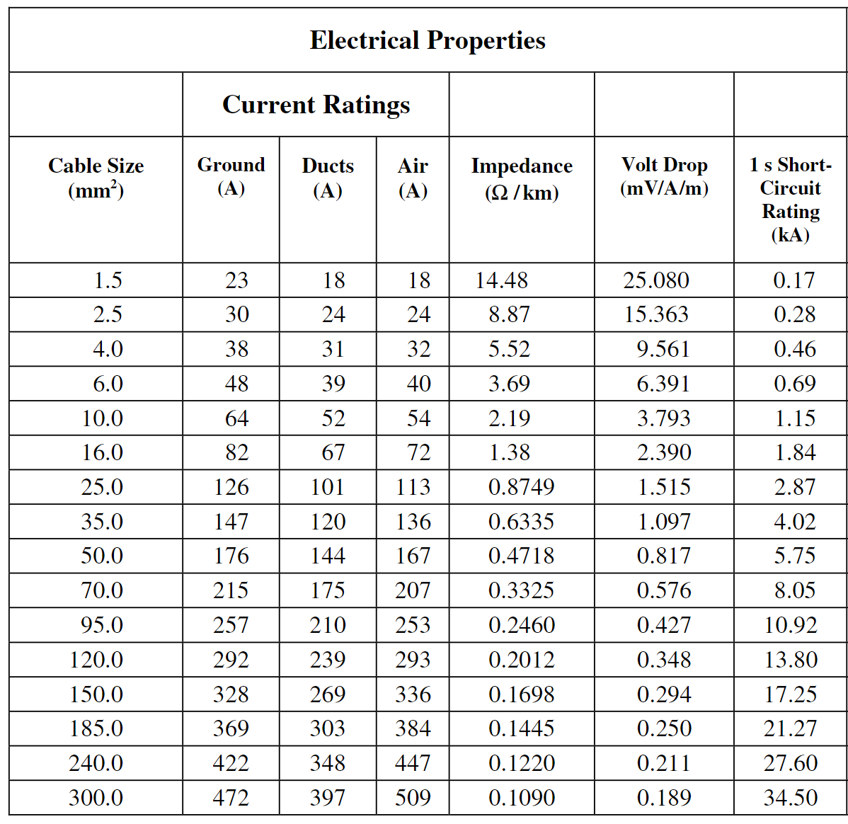

Figure 7: Electrical propertes of PVC insultated PVC bedded SWA PVC-sheathed 600/1000V copper conductor cables [6]

## Appendix B

Information from the grundfos MS 6000 submersible pump literature [4]:

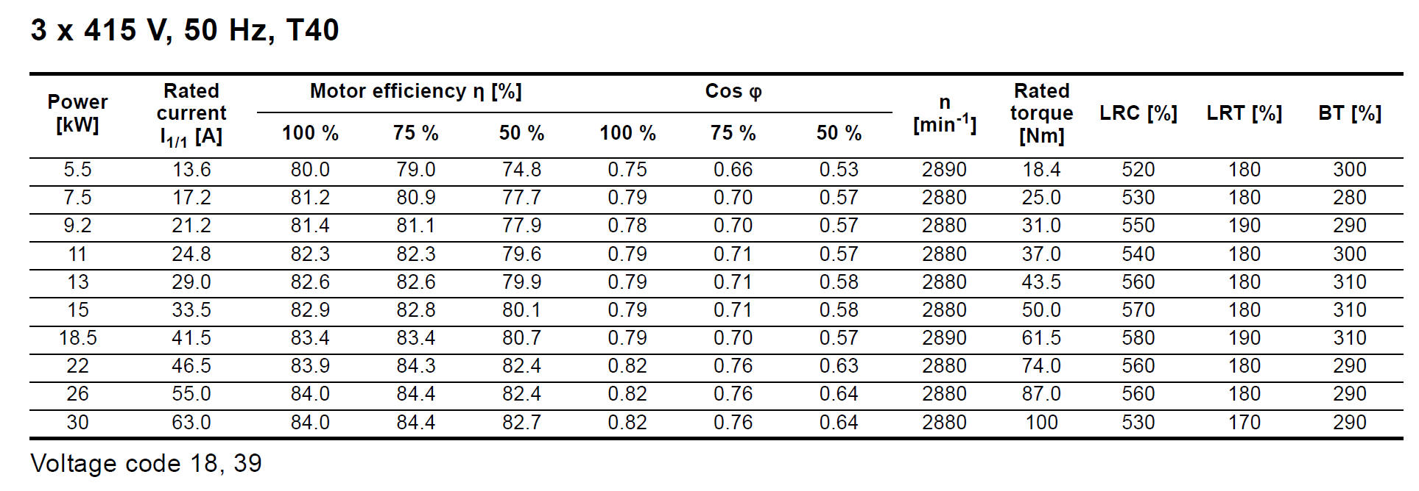

Figure 8: Electrical characteristics of 3 x 415V 50Hz Grundfos MS 6000 submersible pumps

## Appendix C