Solar Generation for Remote Boreholes

Group 12: Team Power

Authors:

Mark Mazzoni (10511491)

Final Submission: Individual

Project Partners: Mr. John-Ross Torre, Jacobs Engineering Group Inc.

Demonstrator: Catherine Hatch

Academic Supervisor:

Dr. Sally Male

Group Meeting Day and Time: Friday 12 Midday

Word Count (excluding updated requirements): 3311

Word Count (including updated requirements): 3569

Word Limit: 3500

Version <1.2>

Revision History

|  |  |  |  |
| --- | --- | --- | --- |
| **Date** | **Version** | **Description** | **Author** |
| 06/05/17 | 0.1 | Draft formatting | Mark Mazzoni |
| 07/05/17 | 0.2 | First text draft begins | Mark Mazzoni |
| 12/05/17 | 0.3 | Expansion on first text draft | Mark Mazzoni |
| 13/05/17 | 0.4 | Initial edits of early draft | Mark Mazzoni |
| 15/05/17 | 0.5 | Additional writing and refocus of topic | Mark Mazzoni |
| 16/05/17 | 1.0 | Restructuring and editing | Mark Mazzoni |
| 17/05/17 | 1.1 | Editing and expanding | Mark Mazzoni |
| 18/05/17 | 1.2 | Editing, proofing and finalising | Mark Mazzoni |

**Table of Abbreviations and Acronyms**

|  |  |  |  |
| --- | --- | --- | --- |
| SGRB | Solar Generation for Remote Boreholes | MPPT | Maximum power point tracking |
| RA | Requirements Analysis | P/O | Perturb and observe |
| DA | Design Approach | TCP | Transmission control protocol |
| Jacobs | Jacobs Engineering Group Inc. | PID | Proportional integral derivative |
| PV | Photovoltaic |  |  |
| FPGA | Field programmable gate array |  |  |
| PLC | Programmable logic controller |  |  |

Table of Contents

1. Introduction 4

1.1 Purpose 4

1.2 Scope 4

1.3 References 5

2. Executive Summary 6

3. Responsibility and Contribution 6

3.1 Project Management 6

3.2 Previous Research and Reports 6

3.3 Final Report 6

3.4 Most significant individual learning 6

4. Updated requirements 6

5. Design Options 7

5.1 Summary of Design Options 7

6. Sensing, Reporting, Monitoring and Telemetry 7

6.1 Variables 7

6.1.1 System Variables 7

6.1.2 Subsystem Variables 7

6.1.3 Component Variables 8

6.2 Sensing and reporting technology 8

6.2.1 System-wide Sensing and Reporting 8

6.2.2 Subsystem Sensing and Reporting 9

6.2.3 Component Sensing and Reporting 10

6.3 Focus on Safety 10

6.3.1 Controllers 10

7. Conclusion 10

8. Appendices 11

8.1 Appendix A: Project Requirements 11

8.2 Appendix B: Newman and Surrounds - 3G Coverage 12

Solar Generation for Remote Boreholes: Final Submission (Individual)

# Introduction

Team Power (group 12) has been tasked by Jacobs Engineering Group Inc. (from here on: Jacobs) to design the power supply for a remote bore field attached to a mine site situated in the area around Newman, in the Pilbara region of Western Australia. These bores will provide process water for the mine site. Team Power’s ultimate objective is to provide a design solution for Jacobs which optimizes delivery (by priority) of their stated and unstated requirements[1]. Jacobs have titled this task “Solar Generation for Remote Boreholes” (SGRB)[2].

## Purpose

This document (in collaboration with other individual submissions) presents the final three design options for the SGRB project. These include the “base case” (grid power), a local, direct-power-generation option (diesel generator) and a hybrid solution (photovoltaic (PV) solar and diesel). These recommendations should allow Jacobs to supply the client with the best possible solution while allowing freedom for client preference and resizing of solutions. The purpose of this document specifically is to address the telemetry aspect of the final design options.

## Scope

Firstly, this document provides a brief summary of the author’s contributions to-date, including research, project management (PM) initiatives and the author’s understanding of project workflow. The author’s key learning is discussed. This report then outlines, in technical detail, the telemetry systems necessary to successfully monitor and run the plant and infrastructure required for each of the three design options. This includes dealing with which variables are critical to the system and how the telemetry technologies required for each component will be integrated into the SGRB as a whole.

## References

[1] J. Armstrong, S. Bardzovski, X. Lin, M. Mazzoni, S. Wang, and J. Zhang, "Solar Generation for Remote Boreholes: Requirements Analysis," University of Western Australia, Assessment Submission, 2017.

[2] Jacobs Engineering Group Inc., "Electrical & Electronic Engineering Design Project Unit Design Brief Semester 1 2017: Project B. Solar Generation for Remote Borefields," Jacobs Engineering Group Inc., Ed., 1.0 ed, 2017.

[3] M. Mazzoni, "Solar Generation for Remote Boreholes: Individual Design Approach," University of Western Australia, Assessment Submission, 2017.

[4] J. Armstrong, S. Bardzovski, X. Lin, M. Mazzoni, S. Wang, and J. Zhang, "Solar Generation for Remote Boreholes: Design Approach," University of Western Australia, Assessment Submission, 2017.

[5] S. Bardzovski, "Individual Final Design Report," University of Western Australia Unpublished (as of 16/5/2017) 2017.

[6] G. Suciu, A. Vulpe, A. Martian, S. Halunga, D. Vizireanu, G. Suciu*, et al.*, "Big Data Processing for Renewable Energy Telemetry Using a Decentralized Cloud M2M System," *Wireless Personal Communications,* vol. 87, pp. 1113-1128, 2016.

[7] R. Schmitz and R. Schmitz, "Reliable dry run protection for pumps," *Chemie Ingenieur Technik,* vol. 74, pp. 1298-1301, 2002.

[8] Anonymous. (2016, 19/03/2017). *Grundfos Product Center MS6000*. Available: <http://product-selection.grundfos.com/product-detail.product-detail.html?custid=GMA&productnumber=78645511>

[9] T. Chapman and T. Q. T. Chapman, *HSPA Evolution : The Fundamentals for Mobile Broadband*. Kent: Elsevier Science, 2015.

[10] G. Prinsloo and R. Dobson, *Sun Tracking and Solar Renewable Energy Harvesting: Solar Energy Harvesting, Trough, Pinpointing and Heliostat Solar Collecting Systems* vol. 2: Gerro Prinsloo, 2015.

[11] G. Held and G. Q. G. Held, *Ethernet Networks Design, Implementation, Operation, Management*, 4th ed. ed. Hoboken: Wiley, 2003.

[12] A. F. Zobaa and A. F. Q. A. F. Zobaa, *Handbook of Renewable Energy Technology*. Singapore: World Scientific Publishing Company, 2011.

[13] International Standards Organisation, "ISO 13849-1:2015 : Safety of machinery - Safety-related parts of control systems - Part 1: General principles for design," in *4.2.2 Contribution to the risk reduction by the control system*, ed. Switzerland: ISO, 2015, p. 97.

[14] Anonymous, Jared, and Telstra. (1/05/17). *Our Coverage*. Available: <https://www.telstra.com.au/coverage-networks/our-coverage>

# Executive Summary

This document contains a summary of the telemetry design recommendations made by Team Power to Jacobs for the SGRB project. These recommendations concern the critical variables and technologies vital to implementing a telemetry system which will successfully satisfy many of the requirements set out in Team Power’s requirements analysis. This includes requirement 6, as well as requirements 1,4,5 and 7 (see appendix A).

# Responsibility and Contribution

## Project Management

The author has played a key role in managing both Team Power and their progress on the project. This has included chairing and taking minutes at triweekly team meetings, attending and chairing meetings with the principle partner, creating scheduling documents, creating quality assurance documents, booking meeting venues and much more. A summary of the authors research and proactive commitment to team and project management (pre-design approach submission) can be found in the individual design approach[3].

## Previous Research and Reports

The author was tasked with the initial research into the existing Newman power infrastructure; furthermore, the author was subsequently tasked with researching the legislative and legal limitations likely to be placed on the project. During RA, the author was tasked with investigating the requirement for the power generation infrastructure to last 10 years, for minimising environmental harm and for minimising construction time. For the design approach (DA)[4] the author was additionally tasked with researching telemetry systems, as well as methods of costing and valuing design solutions proposed by other team members. The author was also tasked with researching the viability of energy generation using biofuels, landfill gas or nuclear, as well as further research into the existing power grid.

## Final Report

For the final group submission, the author has been tasked with describing the design and integration of telemetry systems required for the SGRB project. Additionally, the author has written on the methods and results of cost estimates, as well as the tendering contracts and processes required, for each design option. The author has also completed an analysis of on-site shelter (cabinetting) to contain sensitive SGRB infrastructure. Further research and writings by the author included those for testing techniques during SGRB construction and implementation, as well as other tasks including proofing, formatting and the introduction. Only a summary of telemetry and testing is included in this report, as described in the scope.

## Most significant individual learning

The most significant individual learning the author has garnered from the design project has been that the usefulness of project management techniques can only be realised with full team engagement. In keeping with the official learning objectives for ELEC5551 this would tie in with objectives 4 and 5. Examples of this learning can be found both in what worked successfully for Team Power and what did not; properly implemented lessons-learned documentation after RA submission with full team involvement revealed key issues that needed to be fixed in order for Team Power to move forwards. Neglect of timetabling tools, and failure of certain group members to properly log their work hours, contributed to a sizeable discrepancy between team members in work performed. In future, the author will be even more committed to employing proper project management stratagems, but will apply the key learning that simply making PM tools available to group members is not enough, use must be enforced in some way.

# Updated requirements

For the sake of the brevity of this document the requirements summary list and description, as submitted with the requirements analysis (RA) [1] on the 24/03/17 (and last modified on the 9/05/17), is included in Appendix A. Additionally, each section of this report has been linked to a requirement using the priority rankings as reference numbers. For a full description of each requirement please see RA[1].

# Design Options

## Summary of Design Options

Team Power has isolated three design scenarios for the SGRB project which promise to be successful in achieving the requirements outlined in Appendix A, in accordance with Jacob’s specifications. One of these is the base case, which requires connecting the bore hole infrastructure to the existing power grid. The other two are ‘islanded’ solutions, operating separate from the Newman power grid: a solely diesel-powered system and a diesel-PV solar hybrid. Greater detail on each of these can be found in an upcoming publication by Steven Bardzovski and in previous documentation [4, 5].

# Sensing, Reporting, Monitoring and Telemetry

Timely information is crucial to the safe and efficient operation of a remote installation[6]. This is especially true (for example) in installations where pumps are employed, as allowing pumps to run dry can damage pump hardware within a matter of minutes[7]. This need for timely information competes with increased costs associated with more frequent sampling (for example power consumption, increased sampling hardware costs and more frequent transmission costs). It is therefore important to identify the optimum sensing and reporting regimen for the SGRB installation. The need for telemetry comes directly from requirement 6 (see appendix A) as requested by Jacobs. In turn this requirement emerges from requirements 1,4,5 and 7; in that continuous, safe and economically efficient operation of a remote facility will require more information than can feasibly be acquired from on-site inspection.

## Variables

This section summarises the variables which would be automatically recorded and transmitted by the site telemetry system. Additional in-person checks and inspections are required for proper maintenance and will be in effect. These are not discussed here.

### System Variables

Given the small size of the site and the remote nature, security video and other site-wide data is not required. System run condition can be ascertained directly from the subsystem states. Cumulative sequential runtime without failure would be tracked centrally at the mine site. For these reasons, no site-wide parameters would be sampled.

### Subsystem Variables

Depending on which design solution is implemented there are multiple different subsystems involved in the SGRB which require frequent monitoring. “Frequent” meaning anywhere between ‘once a minute’ to ‘once an hour’. For each subsystem, the range of variables to be sampled differs; some simply require reporting of ‘state’ (on/off/shutdown etc.) while others require state monitoring and more. Whenever variables are sampled, assume that subsystem state is also sampled.

|  |  |  |
| --- | --- | --- |
| Subsystem | Variable | Monitoring Frequency |
| Pump System | Duty cycle | On change of state |
| Strings of solar arrays | Current out of the string | ~Every few minutes |
| BMS | State | On state change |
| Battery banks | Temperature, charging voltage | ~Every few minutes |
| Diesel generator/s | Fuel level and vibration | Multiple times per hour |
| Overhead lines (at transformers) | Voltage, current, power | Multiple times per hour |
| On-site control systems | State of on-site control ( | On state change |
| Operability systems | State of lighting, state of local shutdown | On state change |
| Safety systems | State of each system (ready/engaged/offline) | On state change |

*Table 1: Subsystem sampling variables and the frequency of their recording. Available states will vary for each system depending on client’s choice of local hardware implementation (FPGA, PLC, etc.) but basic state library will be essential for function. For example, it is critical that the pump system reports current state so that the duty cycle required to satisfy current and projected demand for process water in the mine reservoir can be implemented.*

### Component Variables

In the battery and PV-array string subsystems, failure of a single component can cripple the whole series system, leading to accelerated deterioration of the serial components. It is thus important to monitor component variables as well as the subsystem variables for these systems. These variables are also already available by necessity, as the MPPT (maximum power point tracking) system, the charge controller and the other BMS (battery management system) subcomponents require these variables in order to function.

Team Power are not responsible for individual component monitoring inside the Grundfos MMS6000 series pumps specified by Jacobs; the pumps possess inbuilt sensory systems and these feed to the variables for the total pump subsystem [8].

|  |  |  |
| --- | --- | --- |
| Component | Variable | Monitoring Frequency |
| Individual Pumps | Pressure, level and flow | Multiple times per minute |
| Solar arrays | Current out of the array, voltage at terminals | Multiple times per minute |
| Battery string | Temperature, charging voltage | Multiple times per minute times per hour |
| Distributed circuit breakers | State of breaker (triggered/untriggered/reset) | On state change |
| DC/DC Boost Converters | Current in and voltage out for MPPT | Used by BMS |
| DC/AC Inverters | Voltage in and voltage out for MPPT | Used by BMS |
| On-site control systems | State of on-site control ( | On state change |
| Operability systems | State of lighting, state of local shutdown | On state change |
| Safety systems | State of each system (ready/engaged/offline) | On state change |

*Table 2: Component sampling variables and the frequency of their recording. Available states will vary for each component depending on client’s choice of local hardware implementation (FPGA, PLC, etc.) but basic state library will be essential for function. For example, circuit breakers must report whether they are closed or open. From this information, central control (at the mine site) can track other statistics such as the last break in the circuit and frequency of interrupts.*

## Sensing and reporting technology

The parameters described in section 6.1 will informing the client’s specification for sensing and reporting technologies on the SGRB project. Examples of general technology archetypes based on these parameters are given here, as well as further considerations informing technology choice.

### System-wide Sensing and Reporting

Data from all sub-systems is collected at a central PLC (data-hub) with solid-state data storage. Data is relayed via a 3G/4G broadband modem (HSPA/LTE compatible) to a receiver situated in the mine site control centre (10km, see appendix B). A cyclone-rated directional 16dBi Yagi-Uda antenna (vantage point depends on design scenario) will amplify and focus the 850MHz signal to improve transmission. Relatively flat terrain, lack of urban signal interference and generally signal-conducive local weather should contribute to near ideal signal transmission[9]. Furthermore, transmission control protocol (TCP) using scheduled transmission of fixed-size data packets (rather than variable transmission timing and size) will result in increased reception quality.

### Subsystem Sensing and Reporting

The proposed design solutions are comprised of different combinations of subsystems. Each subsystem reports to a local controller ideally implemented using FPGA including PID (proportional integral derivative) control[10]. Local controllers route data to the central data-hub using shielded Cat 6 twisted pair Ethernet, with cable distance not exceeding 90m[11]. Data collection by local controllers from subsystems depends on sensor type.

|  |  |  |
| --- | --- | --- |
| Subsystem | Controller | Control/reporting level |
| Pumps | Pump controller | * Sampling pump data * Emergency shutdown of pumps |
| Strings of solar arrays | Combined BMS controller | * MPPT control integrated through DC/DC boost converter |
| BMS | Combined BMS controller, oversight from mine-site control | * State * BMS Protocol |
| Battery banks | Combined BMS controller | * Temperature * Charging voltage |
| Diesel generator | Generator controller | * State (on/off) * Fuel level |
| Overhead lines  (at transformers) | Power controller | * Sensing and reporting only * Emergency state reporting to safety systems controller |
| Distributed circuit breakers | Power controller | * Sensing and reporting only * Emergency state reporting to safety systems controller |
| On-site control systems | Manual/by local operator | * Manual site override and emergency shutdown * Lights * Safety systems |
| Operability systems | Operability controller, oversight from mine-site control | * Lights * Radio |
| Safety systems | Safety systems controller and sub-controllers, partial oversight from mine-site control | * Fire * Weather station and storm controller * Circuit breaker trip * Transformer shutdown * Power re-route * Generator state control * Control over pump, power, BMS and operability controllers |

*Table 3: Subsystem reporting and control hierarchy. Notice that the MPPT, charge controller and BMS functionalities are all integrated into the combined BMS controller. This is because the controller needs to influence multiple subsystems to handle MPPT. This controller will preferably use a perturb/observe protocol for MPPT with a step size ΔD of ~2.5%[12].*

### Component Sensing and Reporting

Some components come from the manufacturer equipped with sensing and reporting capability (for example pumps and battery strings). Others need modification before they can be sampled by local controllers. Sensor design for components is not within the scope of this report. It is unfeasible to sample some individual sub-components, such as individual battery units. In these cases, subsystem parameters are used by the local controller instead (e.g. in the case of a battery string, ideally the system would know the voltage and stored charge for each battery but installing and monitoring this many sensors is impractical so the string is managed as a whole).

## Focus on Safety

### Controllers

Local controllers will be the first to record perturbations in system parameters and are thus likely to be able to respond to safety issues most rapidly. In keeping with requirement 4 and author ethics safety is a priority and so dedicated safety/emergency systems controllers are implemented. As part of a robust safety protocol, local automated controllers (realised as an FPGA for example) have authority to shutdown certain SGRB subsystems upon receiving critical state parameters; after performing automated secondary checks. For example, upon triggering an overcharge or overheat warning the BMS will reroute power away from a battery string, preventing it from damaging the battery bank. In another example, the local pump controller will swap duty pumps to backup/off-duty state in the case of run dry error, and initiate a borehole shutdown if this error spreads to a second pump. This will be monitored locally and reported in the safety systems state (for the pump controller in this case) to the central controller and hence to mine site control. Safety shutdowns can be triggered from mine-site control but cannot be overridden remotely once in place. Once a system has been disabled for a safety critical reason it will require manual restart in accordance with functional safety standards [13].

# Conclusion

This report contains a summary of the telemetry and control systems implemented in the SGRB project. These systems are designed to meet the requirements of the client as expressed by Jacobs. Telemetry systems have been chosen so as to make the project as safe, economical and maintainable as possible in keeping with these requirements. The author has completed a large body of other work which is not included in this individual submission but which will appear in the final submission for Team Power.

# Appendices

## Appendix A: Project Requirements

|  |  |  |  |  |
| --- | --- | --- | --- | --- |
| Priority | Description of Requirement | Description | Classification | Origin |
| 1 | Operate continuously (24/7) | The power generation system is required to operate for 24 hours a day, 7 days a week, 365 days a year. | EXP, SPO | Design brief |
| 2 | At least 90kW of power available | The mine site requires maintenance of a 3ML storage tank with expected usage of 900 ML per year. This will require 90 kW of power to drive three 30kW pumps. The pumps are maintained by the client and so the team requirement is to supply 90 kW of power. | EXP, SPO | Initial meeting with Jacobs |
| 3 | Operate in desired location. | The power generation system must operate in Newman. This includes tolerating the harsh conditions and remote environment. | EXP, SPO | Design Brief |
| 4 | Safety | The system must run safely. Any safety equipment that requires power must also be supplied. | EXP, SPO, UNS | Standards, code of practice, expectations and ethics |
| 5 | Economy | Maximise the economy of the proposed solution. | EXP, SPO | Design brief and the initial meeting with Jacobs |
| 6 | Telemetry | The system requires telemetry and communications equipment, and these will also require power. | EXP, SPO | Initial meeting with Jacobs |
| 7 | Maintainable | The system must be maintainable. | EXP, UNS | Standards and code of practice |
| 8 | 10-year life | The system must last for at least ten years | EXP, SPO | Initial meeting |
| 9 | Environment | The proposed solution should minimise harm to the environment. | EXP, EXC | Team’s personal ethics |
| 10 | Time | The proposed solution should take a minimum amount of time to construct. | EXP, EXC | Arises from requirement 5 (economy) |

*Figure A: Summary of Project Requirements including classifications. EXP - Expecters, SPO - Spokens, UNS - Unspokens, EXC – Exciters and the origins of the requirement.*

## Appendix B: Newman and Surrounds - 3G Coverage

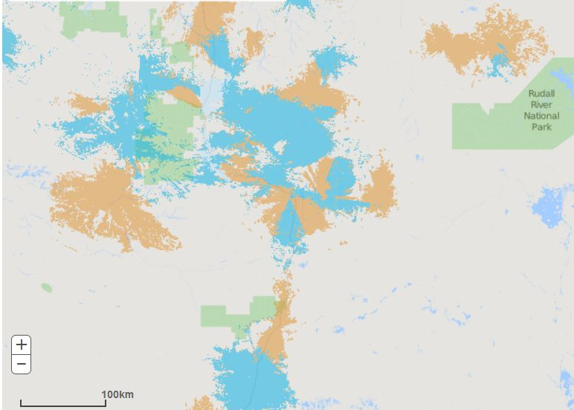

Newman

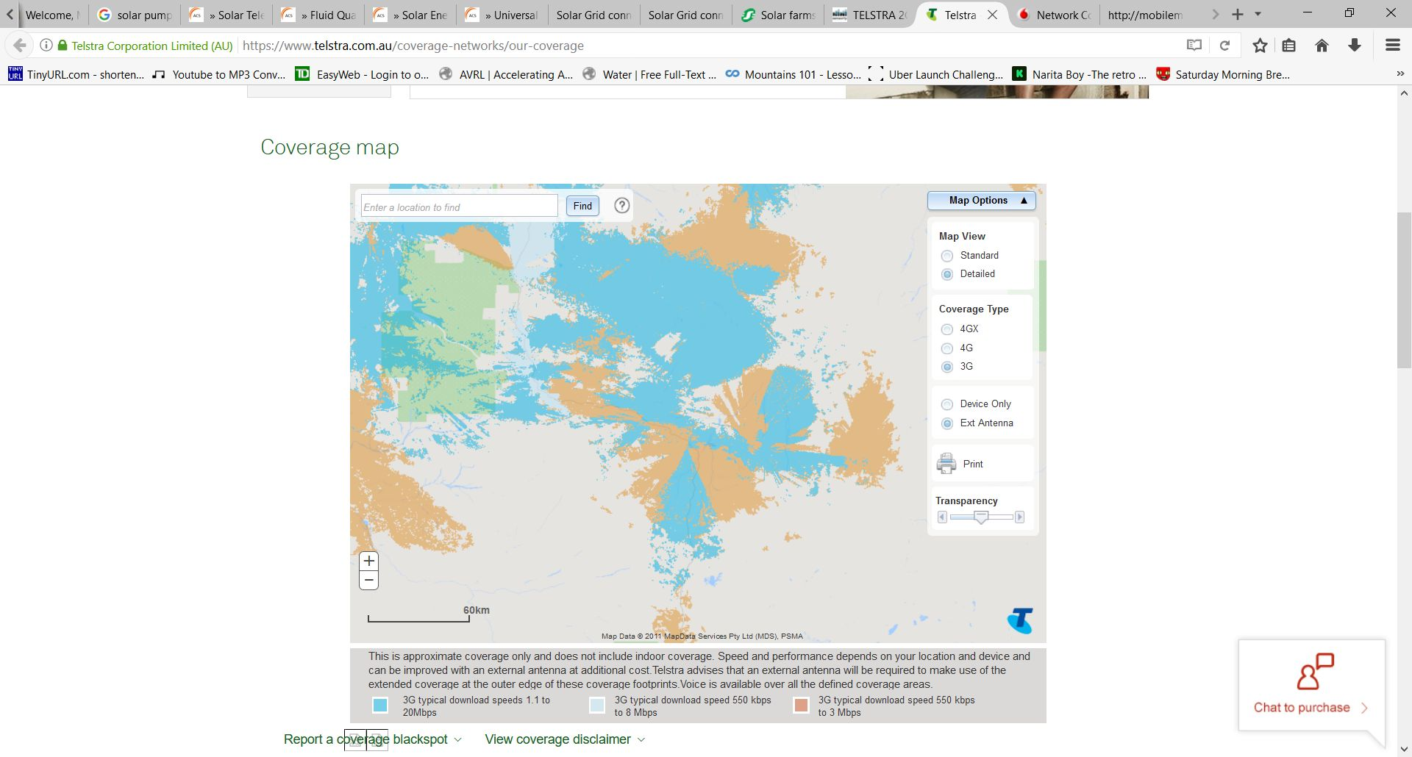

Newman

*Figure B: Maps of 3G network coverage in the area surrounding Newman, at wide and close zoom. It can be seen that using 3G for telemetry from the SGRB field to the mines site is feasible [14].*