Concurrent classification of preschool generalized anxiety disorder from parent-reported symptoms using explainable machine learning
Abstract
Aim: Generalized anxiety disorder (GAD) remains challenging to identify in preschool children, whereas structured diagnostic interviews are time-consuming and require trained interviewers. This study evaluated whether parent-reported symptom items from the Preschool Age Psychiatric Assessment (PAPA) can support the concurrent classification of GAD using explainable machine learning.
Methods: PAPA data from 917 children were analyzed, of whom 226 (24.6%) met the GAD definition. Two variables directly involved in the diagnostic definition were excluded, leaving 54 symptom features for the primary analysis. The L1-regularized logistic regression, decision tree, random forest, and XGBoost classifiers were evaluated using sampling-design-weighted nested stratified cross-validation in a development partition (n = 733). A same-source internal holdout partition (n = 184) was used for the secondary evaluation. Shapley Additive Explanations (SHAP) were applied to characterize the contribution of individual features to model predictions.
Results: The selected random forest classifier yielded the highest point estimates in nested cross-validation, with an area under the receiver operating characteristic curve (AUC-ROC) of 0.77, average precision (AP) of 0.43, sensitivity of 0.56, specificity of 0.82, and Matthews correlation coefficient (MCC) of 0.32. Corresponding bootstrap 95% confidence intervals (CIs) were 0.69–0.85 for AUC-ROC, 0.41–0.72 for sensitivity, and 0.77–0.87 for specificity. In the same-source internal holdout partition, the random forest achieved an AUC-ROC of 0.87, sensitivity of 0.65, specificity of 0.90, accuracy of 0.86, and MCC of 0.52; the Kish effective sample size was 50.52. Frequency of worries, sleep-related symptoms, concentration difficulties, restlessness, and muscle tension were repeatedly identified as influential features, although their relative importance varied across classifiers.
Conclusion: Parent-reported PAPA items supported the moderate concurrent classification of preschool GAD within this cohort. The SHAP findings describe how the fitted models generated their predictions and must not be interpreted as evidence of causal risk factors or as validation of a brief clinical screening instrument. Independent prospective external validation, external calibration assessment or recalibration, and evaluation in clinical settings are required before implementation.

Ebeveyn bildirimli belirtilerden açıklanabilir makine öğrenmesiyle okul öncesi dönem yaygın anksiyete bozukluğunun eşzamanlı sınıflandırılması
Özet
Amaç: Okul öncesi çocuklarda yaygın anksiyete bozukluğunun (YAB) tanısı güç olabilmekte; yapılandırılmış tanısal görüşmeler ise zaman almakta ve eğitimli değerlendiriciler gerektirmektedir. Bu çalışmada, Okul Öncesi Yaş Psikiyatrik Değerlendirmesi’nden (Preschool Age Psychiatric Assessment, PAPA) elde edilen ebeveyn bildirimli belirti maddelerinin açıklanabilir makine öğrenmesi kullanılarak YAB’nin eşzamanlı sınıflandırılmasını destekleyip desteklemediği değerlendirilmiştir.
Yöntem: Çalışmada, 226’sı (%24,6) araştırmada kullanılan YAB tanımını karşılayan toplam 917 çocuğa ait PAPA verileri analiz edilmiştir. Tanısal tanımda doğrudan kullanılan iki değişken analiz dışında bırakılmış ve birincil analiz 54 belirti özelliğiyle gerçekleştirilmiştir. L1 düzenlileştirmeli lojistik regresyon, karar ağacı, rastgele orman ve XGBoost sınıflandırıcıları, geliştirme bölümünde (n = 733) örnekleme tasarımıyla ağırlıklandırılmış iç içe tabakalı çapraz doğrulama kullanılarak değerlendirilmiştir. İkincil değerlendirme için aynı veri kaynağından ayrılan bir iç test bölümü (n = 184) kullanılmıştır. Özelliklerin model tahminlerine katkılarını incelemek amacıyla Shapley Katkı Açıklamaları (SHAP) uygulanmıştır.
Bulgular: Rastgele orman sınıflandırıcısı, önceden belirlenen özgüllük ölçütüne göre seçilmiş ve iç içe çapraz doğrulamada en yüksek nokta tahminlerini üretmiştir. Modelin alıcı işletim karakteristiği eğrisi altında kalan alanı (AUC-ROC) 0,77, ortalama kesinliği 0,43, duyarlılığı 0,56, özgüllüğü 0,82 ve Matthews korelasyon katsayısı 0,32 olarak bulunmuştur. %95 güven aralıkları AUC-ROC için 0,69–0,85, duyarlılık için 0,41–0,72 ve özgüllük için 0,77–0,87’dir. Aynı kaynaktan oluşturulan iç test bölümünde rastgele orman modelinin AUC-ROC değeri 0,87, duyarlılığı 0,65, özgüllüğü 0,90, doğruluğu 0,86 ve Matthews korelasyon katsayısı 0,52’dir; Kish etkin örneklem büyüklüğü 50,52’dir. Endişe sıklığı, uyku ile ilişkili belirtiler, konsantrasyon güçlükleri, huzursuzluk ve kas gerginliği farklı modellerde etkili özellikler arasında tekrarlı olarak belirlenmiş; ancak bu özelliklerin göreli önem sıralamaları sınıflandırıcılar arasında değişmiştir.
Sonuç: Ebeveyn bildirimli PAPA maddeleri, bu kohortta okul öncesi dönem YAB’sinin orta düzeyde eşzamanlı sınıflandırılmasını desteklemiştir. SHAP bulguları, eğitilen modellerin tahminlerini nasıl oluşturduğunu açıklamakta olup nedensel risk faktörlerinin kanıtı veya kısa bir klinik tarama aracının geçerliği olarak yorumlanmamalıdır. Klinik uygulamadan önce bağımsız ve ileriye dönük dış doğrulama, dış kalibrasyon değerlendirmesi veya yeniden kalibrasyon ve klinik ortamlarda değerlendirme gereklidir.
Anahtar kelimeler: açıklanabilir yapay zeka; eşzamanlı sınıflandırma; makine öğrenmesi; okul öncesi çocuklar; yaygın anksiyete bozukluğu

Introduction
Anxiety disorders are among the most common mental health conditions affecting children worldwide (Javaid et al., 2023; Kieling et al., 2024). Community data show that anxiety disorders can be present in preschool and may follow heterogeneous courses into adolescence (Steinsbekk et al., 2022). Despite this burden, fewer than 15% of affected children receive a formal mental health evaluation or treatment (Carpenter et al., 2016). Therefore, an early identification is important, but evidence from preschool-specific tools and prospective outcomes remains limited.
The PAPA is a structured, interviewer-administered parent report for assessing psychiatric disorders, including anxiety disorders, in children aged 2–5 years; its test–retest reliability has been evaluated for preschool populations (Egger et al., 2006). In this age group, parent reports are particularly informative because parents are often the primary observers of children’s behavior and developmental change. Despite its clinical value, the PAPA is difficult to implement in routine pediatric primary care because administration may require approximately 1 h 40 min, extensive interviewer training, and post-interview scoring (Carpenter et al., 2016).
Although machine learning (ML) has been increasingly applied to anxiety classification, preschool-specific studies remain scarce (Taskynbayeva & Gutoreva, 2025; Tayarani-N. & Shahid, 2025). A deep-learning model with SMOTEENN applied to the Healthy Brain Network cohort (aged 5–21 years) achieved a held-out AUC-ROC of 0.94 for anxiety classification using 160 multidomain predictors (De Lacy et al., 2023). That study used SHAP to characterize predictor contributions but relied on neuroimaging and cognitive measures that are not routinely available in pediatric screening. Therefore, the preschool period is both clinically important and comparatively understudied in the ML literature on anxiety (Steinsbekk et al., 2022; Taskynbayeva & Gutoreva, 2025).
One line of work combines neuroimaging with psychometric data. A voting classifier applied to the IMAGEN cohort predicted later GAD onset with an AUC-ROC of 0.69; bilateral caudate and pallidum volumes were among the influential features (Chavanne et al., 2023). A second line of work uses high-dimensional survey data. Gaussian Naive Bayes and random forest models applied to the Young Minds Matter survey achieved AUC values of 0.70 and 0.73, respectively, for separation anxiety disorder classification in children aged 4–17 years (Haque et al., 2023). A third line of work applies ML directly to structured clinical interviews. Carpenter et al. (2016) used an alternating decision tree with PAPA data and showed that a reduced item set could approximate the full interview’s diagnostic classification. The present study extends this framework by excluding two direct diagnostic-definition variables, comparing L1-regularized logistic regression, decision tree, random forest, and XGBoost under sampling-design-weighted nested cross-validation, and using SHAP and feature-set sensitivity analyses to examine model behavior and diagnostic circularity.
Although explainability methods can improve the transparency of clinical ML models, they do not establish clinical validity, trustworthiness, or causal attribution (Lazarjani et al., 2025; Lundberg & Lee, 2017). The SHAP provides a unified additive framework whose values satisfy the local accuracy, missingness, and consistency requirements (Lundberg & Lee, 2017). In pediatric mental health, the SHAP has been used to characterize the contributions of psychometric, behavioral, family-context, and neuroanatomical variables, with attribution patterns that differ across outcomes and models (Chavanne et al., 2023; De Lacy et al., 2023). Practical guidance also supports the use of SHAP to visualize model-specific feature contributions while recognizing its interpretive limits (Ponce‐Bobadilla et al., 2024). Because explainability does not replace performance evaluation, class-imbalanced clinical classification should not be assessed using only accuracy. Therefore, we report the MCC, which incorporates all four cells of the confusion matrix and provides a balanced summary of binary classification performance (Chicco & Jurman, 2020).
In this study, after excluding two direct diagnostic-definition variables, we evaluated whether parent-reported PAPA symptom items support concurrent GAD classification in preschool children without neuroimaging or biomarkers. The specific contributions are fourfold. First, we evaluate L1-regularized logistic regression (LR), decision tree, random forest, and XGBoost in the development partition (n = 733) using sampling-design-weighted nested cross-validation. Second, the selected model is evaluated once in a same-source internal holdout partition comprising the remaining 184 participants. Third, SHAP is applied to describe feature contributions within the 54-variable primary feature set. Fourth, we assess diagnostic circularity in a secondary class-weight sensitivity analysis by comparing the reduced, full, and diagnostic-definition-only feature sets for LR, decision tree, and random forest models.
Methods
Dataset and ethical considerations
The publicly available Duke Preschool Anxiety Study (PAS) training dataset, deposited in the Harvard Dataverse by K. Carpenter (2016), was analyzed. The analyzed file contains parent-reported responses from the interviewer-administered PAPA for 917 preschool-aged children. The binary target variable represents the diagnostic status of GAD. The positive class (GAD-positive) comprises 226 children (24.6%), and the negative class (GAD-negative) comprises 691 children (75.4%), yielding a class imbalance ratio of approximately 3.1:1. The Duke University Medical Center Institutional Review Board approved the original data collection, and written informed consent was obtained from parents or legal guardians (K. L. H. Carpenter et al., 2016). This study involved only a secondary analysis of publicly available, de-identified data and excluded new participant recruitment or data collection. We used only the PAS training data file provided by the repository for all experiments.

Feature engineering and pre-processing
The raw PAPA dataset included symptom and associated onset-timing variables. All onset-related variables were excluded so that temporal-onset information did not enter the concurrent classification models. We also excluded the subject identifier, binary GAD outcome, and SAD variable from the predictors. Sampling weights were retained as metadata for fitting and evaluating the model. Values encoded as periods or blank strings were converted to missing values, and other non-numeric entries were treated as missing values. Median imputation was fitted within each cross-validation training fold. For the internal holdout evaluation, preprocessing was fitted on the development partition and then applied to the holdout. These steps left 56 candidate symptom items for sensitivity analyses. Two direct diagnostic-definition variables were removed from the primary analysis: situational anxious affect and uncontrollable cross-domain worries, resulting in a 54-variable primary feature set. Each model was implemented in a separate pipeline containing median imputation, with standard scaling applied only to L1-regularized logistic regression. The primary analysis used sampling-design weights without SMOTE or class weighting. Separate class-weight and SMOTE analyses were treated as sensitivity analyses and were not used for model selection. We selected median rather than mean imputation because many PAPA items were ordinal and skewed.
Classifiers and hyperparameter justification
Four classifiers were selected to represent different decision boundaries, interpretability profiles, and algorithmic assumptions. L1-regularized logistic regression was included as a sparse and interpretable linear model. The model used an L1 penalty, the liblinear solver, a maximum of 5,000 iterations, and 11 logarithmically spaced values of the inverse regularization parameter C between 0.001 and 100. L1 regularization was selected to reduce model complexity by reducing weak coefficients to zero while retaining an interpretable set of associations (Tibshirani, 1996). A decision tree was included as a directly interpretable nonlinear model. The maximum depths of the candidates were 2, 3, 4, 5, 6, 8, 10, and unrestricted. The minimum number of samples per leaf was 2, 5, 10, 15, 20, or 30. The evaluation criteria for splitting were Gini, entropy, and log loss. Candidate cost-complexity pruning values were 0, 0.0001, 0.001, 0.005, 0.01, and 0.02. To constrain tree complexity and mitigate overfitting, the maximum depth, minimum leaf size, and cost-complexity pruning were optimized. A random forest was included as an ensemble benchmark that can capture nonlinear relationships and interactions while reducing the instability of a single decision tree (Breiman, 2001). The number of candidate trees was 300, 600, and 1,000. The maximum depth was evaluated at 4, 6, 8, 10, 14, and without restriction. The minimum number of samples per leaf was 1, 2, 5, 10, or 20. The number of features considered at each split was set to the square root or base-2 logarithm of the predictor count or to 0.35, 0.50, or 0.75 of all predictors, respectively. Candidate cost-complexity pruning values were 0, 0.0001, 0.001, and 0.005. XGBoost is a gradient-boosting benchmark capable of modeling nonlinear effects and feature interactions (Chen & Guestrin, 2016). The search space included 150, 300, 500, 800, or 1,200 boosting trees, maximum depths from 2 to 6, and learning rates of 0.01, 0.03, 0.05, 0.08, 0.12, or 0.20. Row-sampling proportions were 0.60, 0.75, 0.90, or 1.00, and feature-sampling proportions were 0.50, 0.70, 0.90, or 1.00, respectively. Candidate minimum child weights were 1, 3, 5, and 10, and gamma values were 0, 0.1, 0.5, and 1.0, respectively. The L1 regularization parameter alpha was evaluated at 0, 0.01, 0.1, and 1.0, whereas the L2 regularization parameter lambda was evaluated at 0.5, 1.0, 2.0, 5.0, and 10.0.

For the primary analysis, hyperparameters were selected using sampling-design-weighted average precision in five-fold inner cross-validation. An exhaustive grid search was performed for the L1-regularized logistic regression. Up to 40 randomly sampled hyperparameter combinations were evaluated for the decision tree, RF, and XGBoost models. A base random seed of 42 was used, with deterministic offsets for inner cross-validation, threshold cross-fitting, and bootstrap resampling. Analyses were performed using Python 3.12.12 with scikit-learn, imbalanced-learn, SHAP, and XGBoost.

Evaluation protocol
We estimated the primary performance using sampling-design-weighted nested stratified cross-validation in the 733-sample development partitioning. Ten outer folds generated out-of-fold probability scores, whereas five inner folds selected hyperparameters using the sampling-design-weighted average precision (AP). An additional five-fold cross-fitting procedure generated probabilities for decision-threshold selection within each outer training fold. Within each outer training fold, the decision threshold was selected to maximize sampling-design-weighted sensitivity subject to a specificity of at least 0.80 and was then applied to the corresponding outer validation fold. We reported eight performance metrics: area under the receiver operating characteristic curve (AUC-ROC), average precision (AP), precision (Eq. 1), sensitivity or recall (Eq. 2), specificity (Eq. 3), F1 score (Eq. 4), accuracy (Eq. 5), and Matthews correlation coefficient (MCC; Eq. 6) (Chicco & Jurman, 2020).
$$Precision =\frac{TP}{TP+FP}$$ | (1)
$$\text{Sensitivity }=\frac{TP}{TP+FN}$$ | (2)
$$\text{Specificity}=\frac{TN}{TN+FP}$$ | (3)
$$F1-score =\frac{2* Precision* Precision}{ PRE + Recall }$$ | (4)
$$Accuracy=\frac{TP+TN}{TP+TN+FP+FN}$$ | (5)
$$MCC=\frac{TP×TN-FP×FN}{\sqrt{(TP+FP)(TP+FN)(TN+FP)(TN+FN)}}$$ | (6)
Here, TP, TN, FP, and FN denote the sampling-weighted totals of true positives, true negatives, false positives, and false negatives, respectively. Performance metrics were calculated from pooled outer-fold predictions rather than averaged across folds. Model selection used only development-set out-of-fold results. Eligible models had to satisfy the threshold-selection constraints and achieve a pooled specificity of at least 0.80. Among eligible models, sensitivity was maximized, with ties resolved by AP, MCC, and the prespecified interpretability order of logistic regression, decision tree, random forest, and XGBoost. Final models were tuned and fitted on the full development partition, and their thresholds were determined from five-fold cross-fitted development predictions. All four models were evaluated on the internal holdout, but holdout results were not used for model or threshold selection.
Explainability methods
Feature attribution was assessed using three approaches: absolute coefficients estimated after predictor standardization, tree-based feature-importance scores, and SHAP values. For L1-regularized logistic regression (LR), absolute coefficients were extracted from the final sampling-design-weighted model fitted on the 54-feature development partition without SMOTE. Impurity-based feature-importance scores were extracted from the decision tree and random forest models. We extracted gain-based feature-importance scores for XGBoost. We computed SHAP values for all four models on the 184-sample same-source internal holdout partition. LinearExplainer was used for LR, with the first 300 transformed development observations serving as a fixed background sample. TreeExplainer was used for the decision tree, random forest, and XGBoost without a separately supplied background dataset (Lundberg & Lee, 2017; Ponce‐Bobadilla et al., 2024). All SHAP input matrices were generated using preprocessing steps fitted exclusively on the development partition. Because the explainers produced model-specific attribution scales, SHAP magnitudes were interpreted only within each classifier.

Results
Sampling-design-weighted nested cross-validation performance
The development partition included 733 children, of whom 552 were GAD-negative and 181 (24.7%) were GAD-positive. The sampling design-weighted positivity rate was 14.8%. Table 1 presents the primary sampling design-weighted nested cross-validation results for the four classifiers using the 54-feature set. The RF classifier produced the highest point estimates across all metrics reported in Table 1, including the AUC-ROC (0.77), AP (0.43), sensitivity (0.56), specificity (0.82), and MCC (0.32). Under the prespecified selection hierarchy, the random forest was selected because it achieved the highest sensitivity among the models, satisfying the specificity requirement of 0.80. This requirement was not met by the decision tree, which had a specificity of 0.75. The 95% bootstrap CI for random forest sensitivity was 0.41–0.72, and the corresponding intervals were 0.69–0.85 for AUC-ROC and 0.77–0.87 for specificity.
Internal holdout and calibration
In the same-source internal holdout partition, the selected random forest achieved an AUC-ROC of 0.87, an AP of 0.62, a sensitivity of 0.65, a specificity of 0.90, an accuracy of 0.86, an MCC of 0.52, and a Brier score of 0.105. These estimates were not used to select the model, hyperparameter, feature, or threshold. Because the sampling weights reduced the holdout to a Kish effective sample size of 50.52, the estimates should be interpreted cautiously. In nested CV out-of-fold predictions from the development partition, the random forest had a Brier score of 0.107, an expected calibration error of 0.021, a calibration intercept of 0.093, and a calibration slope of 1.075.
Table 1. Primary sampling-design-weighted nested cross-validation performance for the 54-feature analysis in the development partition
Model | AUC-ROC | AP | F1 | Precision | Sensitivity | Specificity | Accuracy | MCC
L1 Logistic Regression | 0.7 | 0.38 | 0.4 | 0.32 | 0.53 | 0.81 | 0.76 | 0.27
Decision Tree | 0.68 | 0.34 | 0.28 | 0.22 | 0.4 | 0.75 | 0.7 | 0.12
Random Forest | 0.77 | 0.43 | 0.44 | 0.36 | 0.56 | 0.82 | 0.78 | 0.32
XGBoost | 0.74 | 0.41 | 0.39 | 0.31 | 0.51 | 0.81 | 0.76 | 0.26

Confusion matrices
Random forest yielded the lowest sampling design-weighted false-positive (112.5) and false-negative (48.5) totals and the highest weighted true-negative (524.6) and true-positive (62.1) totals among the four classifiers (Figure 1). However, the weighted false-negative rate was 43.8%, indicating that a substantial proportion of the design-weighted GAD-positive group remained undetected.
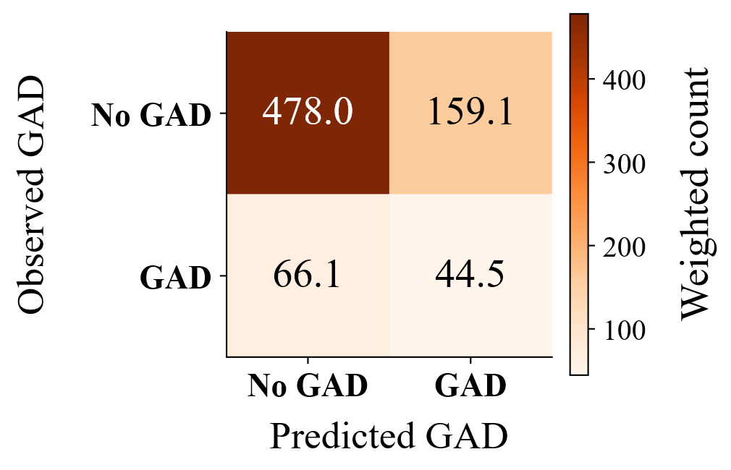 | 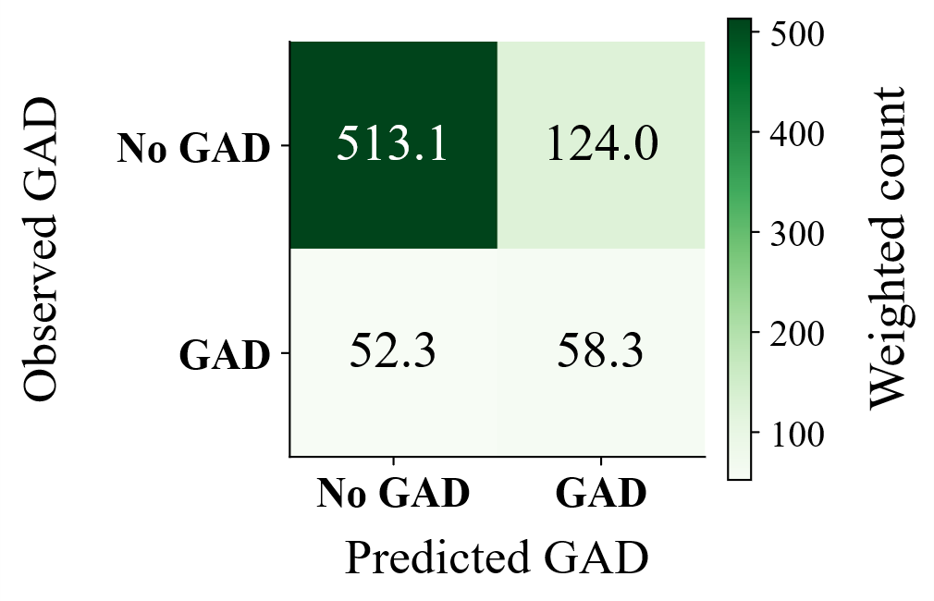 | 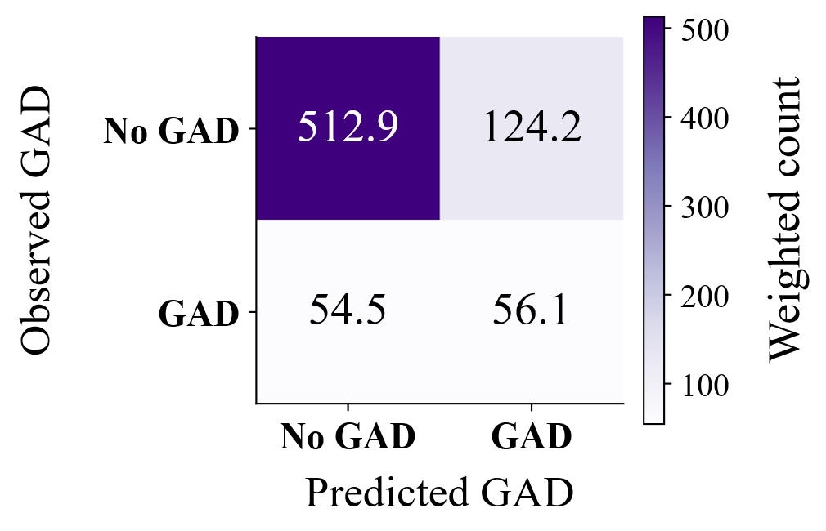 | 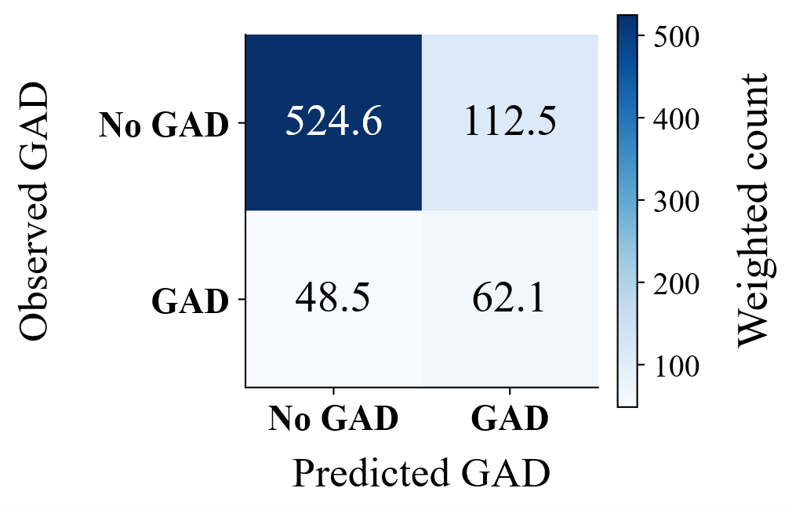
(a) | (b) | (c) | (d)
Figure 1. Sampling-design-weighted confusion matrices for (a) decision tree, (b) L1 logistic regression, (c) XGBoost, and (d) random forest.

SHAP explainability analysis
Figure 2 illustrates the 15 features with the highest mean absolute SHAP values for each classifier. Frequency of worries ranked first for the decision tree, random forest, and XGBoost, whereas reluctance to go to sleep ranked first for L1-regularized logistic regression. Across the four classifiers, worry-related features, sleep-related symptoms, concentration difficulties, restlessness, and muscle tension repeatedly appeared among the 15 highest-ranked features, although their relative rankings varied by model. Higher values of several leading symptoms were concentrated on the positive side of the SHAP axis, corresponding to greater contributions toward the GAD-positive model output.
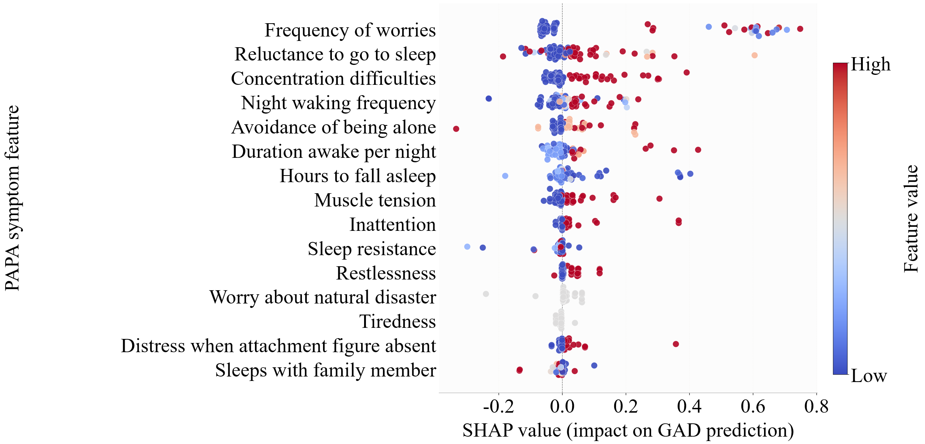 | 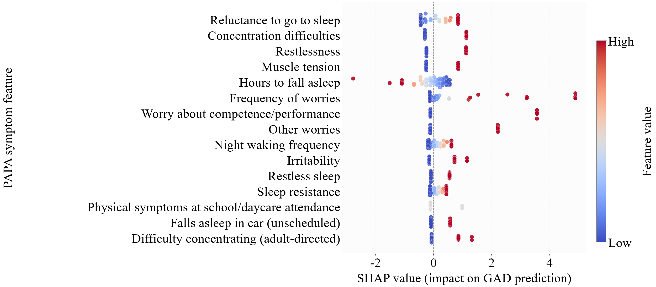
(A) | (B)
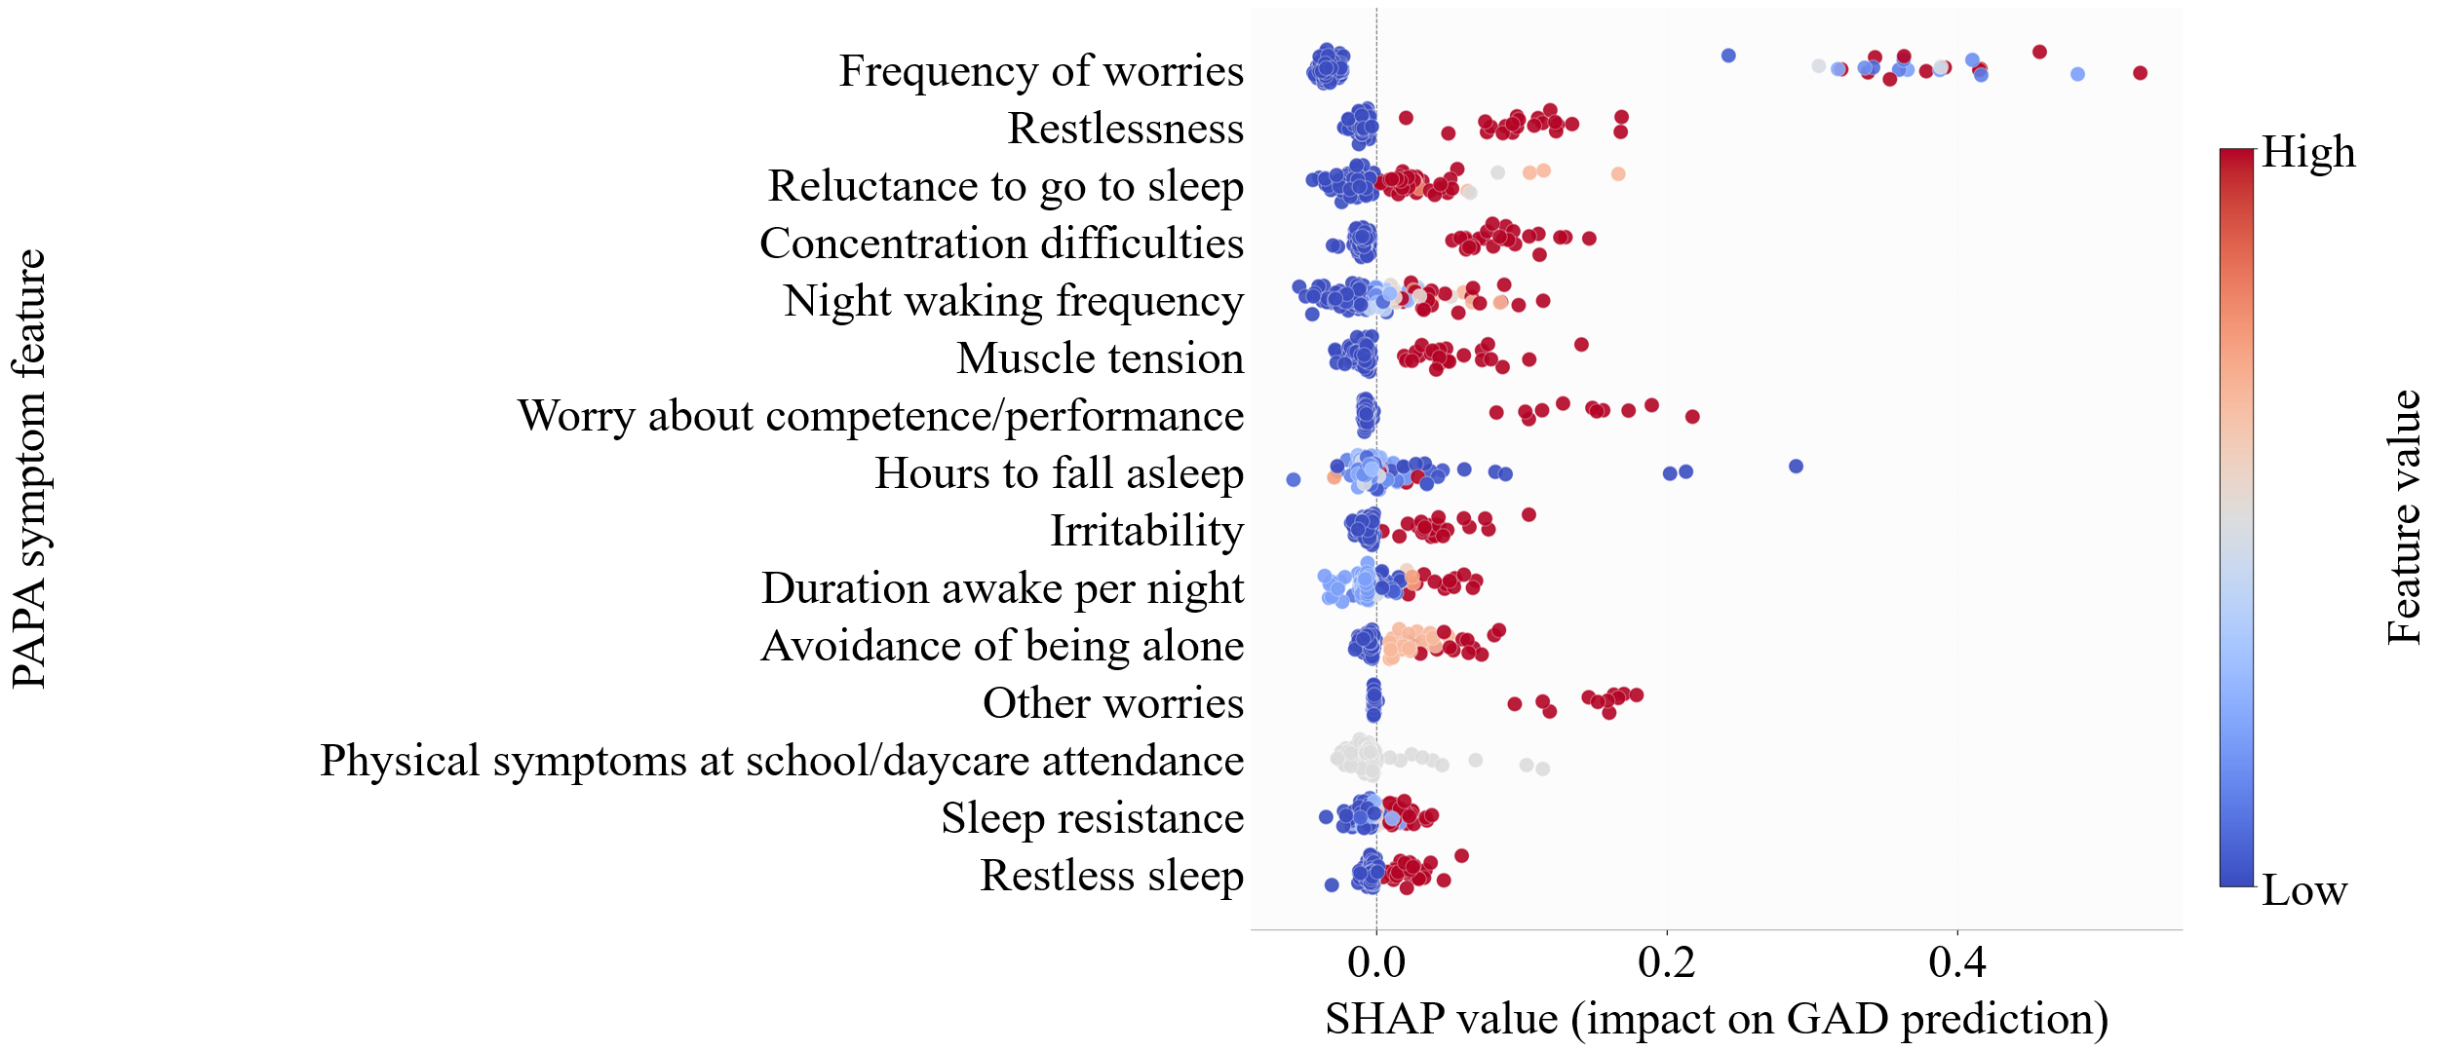 | 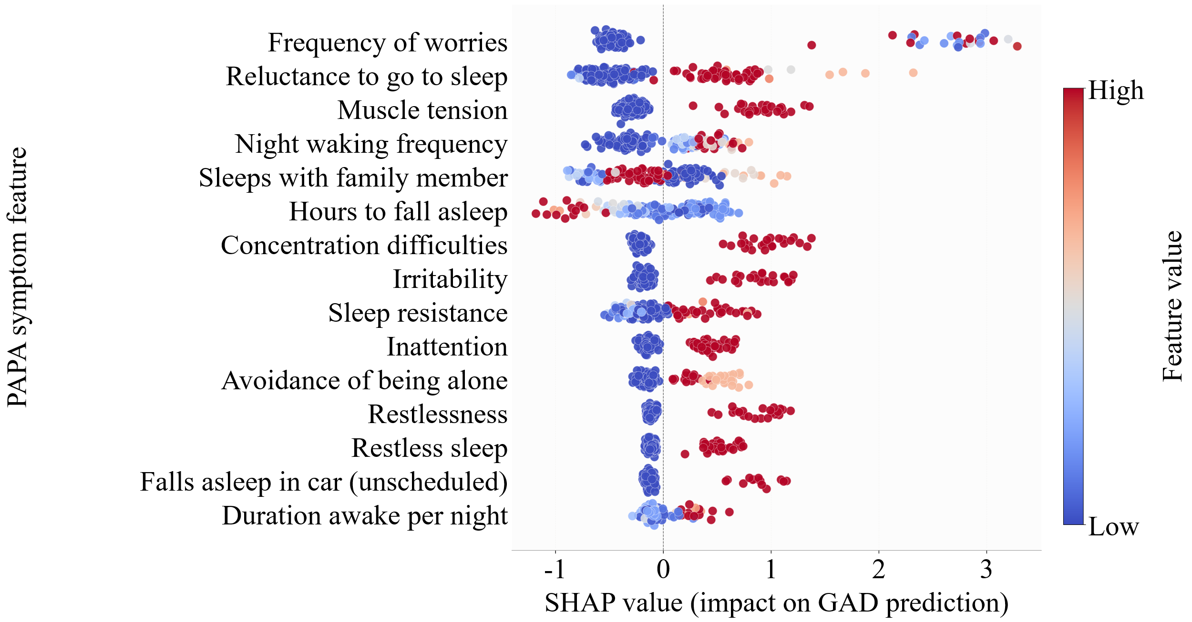
(C) | (D)
Figure 2. SHAP beeswarm plots for the primary 54-feature models evaluated on the 184-observation same-source internal holdout set: (A) decision tree, (B) L1 logistic regression, (C) random forest, and (D) XGBoost.

Diagnostic circularity sensitivity analysis
Retaining the two diagnostic definition variables within the secondary class-weight sensitivity regime increased the nested CV AUC-ROC from 0.775 to 0.969 for L1-regularized logistic regression, from 0.767 to 0.972 for the decision tree, and from 0.763 to 0.970 for random forest. The paired bootstrap AUC-ROC differences were 0.193 (95% CI, 0.115–0.284), 0.206 (95% CI, 0.131–0.288), and 0.206 (95% CI, 0.120–0.296), respectively. The magnitude of these increases is consistent with criterion overlap and supports the exclusion of the two variables from the primary analysis. In the same secondary class-weight sensitivity analysis, models using only the two diagnostic-definition variables achieved nested CV AUC-ROC values of 0.972, 0.965, and 0.967 for L1-regularized logistic regression, decision tree, and random forest, respectively. These sensitivity estimates were not used to select the primary models.

Discussion
The primary analysis showed that parent-reported PAPA symptom items supported the moderate concurrent classification of preschool GAD. The RF classifier provided the most favorable performance profile under the prespecified specificity criterion. However, because the predictors and diagnostic outcomes were derived from the same instrument and model evaluation was confined to the same data source, these findings do not establish prospective screening utility or generalizability to external populations.

Interpretation of model performance and SHAP patterns
SHAP analyses revealed that the highest-ranked features differed across classifiers, with attribution distributed across worry-, sleep-, cognitive-, behavioral-, and somatic-related features rather than a single predictor in every model (Fig. 2). These ranking variations may reflect differences in model structure and fitting, as well as the SHAP explainers used. The higher point estimates produced by RF may reflect its ability to capture the nonlinear relationships and interactions among symptoms. However, statistical superiority was not established, as no paired between-model comparison was conducted. This multifeature interpretation is broadly consistent with previous ML studies on youth anxiety, which reported contributions from psychometric, psychosocial, and neuroanatomical variables (Chavanne et al., 2023; De Lacy et al., 2023). SHAP attributions characterize the model behavior within this dataset and cannot be interpreted as causal risk factors.

Comparison with prior works
Table 2 situates this analysis within selected ML studies of anxiety in children and youth and provides a methodological context rather than a direct-performance ranking. Chavanne et al. (2023) reported an AUC of 0.69 for prospective GAD-onset prediction using neuroimaging and psychometric data collected at age 14, whereas De Lacy et al. (2023) reported a held-out AUC of 0.94 for deep-learning-based anxiety classification in youth aged 5–21 years, after considering 160 multidomain candidate predictors. These estimates are not directly comparable to those of this study because the studies differed in age range, outcome definition, prediction horizon, predictor modality, class distribution, and validation strategy. Therefore, the most informative comparison is among the four classifiers evaluated using the same data under the same sampling-design-weighted nested cross-validation protocol.
Table 2. Methodological context of selected ML studies of pediatric and youth anxiety
Study | Population/data and class balance | Reported model | Validation | Reported result | Main limitation
Present study | Ages 2–5; PAPA; development n = 733; GAD-positive n = 181 (24.7%; design-weighted prevalence = 14.8%) | Random Forest | Sampling-design-weighted nested CV (10 outer and 5 inner folds) | AUC = 0.77; sensitivity = 0.56; specificity = 0.82; MCC = 0.32 | Same-source internal validation; no external cohort
Carpenter et al. (2016) | Ages 2–5; PAPA; training n = 917 and independent test n = 307; GAD-positive n = 226 (24.6%) and n = 46 (15.0%), respectively | Alternating Decision Tree (ADTree) | 50 repeated 10-fold CV runs for model selection; independent-cohort testing | GAD: accuracy = 0.97; sensitivity = 1.00; specificity = 0.97 | Reduced items were evaluated only within the full PAPA interview
Haque et al. (2023) | Ages 4–17; survey data; n = 1,011; SAD-positive n = 235 (23.2%) | Random Forest | 70/30 train–test split; separate 3-, 5-, and 10-fold CV accuracy checks | AUC = 0.73; sensitivity = 0.42; specificity = 0.95 | SAD rather than GAD and a broader age range
de Lacy et al. (2023) | Ages 5–21; multidomain data; n = 1,120; anxiety-positive n = 483 (43.1%) | Deep neural network | 70/30 development–holdout split | AUC = 0.94; accuracy = 0.95; sensitivity = 0.95 | Broad symptom-derived anxiety case definition and multimodal inputs
Chavanne et al. (2023) | Age 14 at baseline and 18–23 at outcome assessment; psychometric/MRI data; n = 466; future GAD n = 42 (9.0%) | Voting ensemble | Leave-three-sites-out CV with nested stratified five-fold tuning | AUC = 0.69; sensitivity = 0.53; specificity = 0.71 | Prospective task in an older population
Jafari et al. (2025) | Mean age = 7.18 years; task-fMRI; n = 45; anxiety-positive n = 22 (48.9%) | Logistic Lasso Regression | Not reported | Angry-face condition: AUC = 0.78 and accuracy = 0.78; fearful-face condition: AUC = 0.77 and accuracy = 0.78 | Small sample and no reported resampling or holdout procedure

Limitations
This study has several important limitations. First, no external validation was performed. Both nested cross-validation and the internal holdout evaluation were derived from the same source cohort; therefore, evaluation in independently recruited clinical cohorts is needed to establish external validity. Second, predictors and outcomes were obtained from the same PAPA interview. The findings represent concurrent classification within this instrument rather than prospective prediction of later GAD, limiting generalizability to brief questionnaires or routine clinical records. Third, sampling weights reduced the Kish effective sample size to 213.65 in the development partition and 50.52 in the internal holdout, contributing to uncertainty around performance estimates, including the random forest sensitivity CI (0.41–0.72) and AUC-ROC CI (0.69–0.85). Fourth, missingness reached 51.1% for duration awake per night and 19.1% for hours taken to fall asleep. No dedicated missing-data sensitivity analysis was completed; therefore, the results may depend on median imputation. One of the 54 retained variables, a child leaving daycare or school because of anxiety, was constant in the analyzed file and therefore provided no discriminative information.

Clinical implications and future directions
The findings provide a basis for further clinical evaluation rather than an immediately deployable screening tool. The SHAP patterns may help researchers understand model behavior; however, they should not be used to prioritize symptoms or guide individual assessments without prospective clinical evaluation. Future studies should (1) externally evaluate the selected random forest classifier in independent preschool cohorts; (2) prospectively assess performance against an independent clinical reference standard and compare it with brief screening instruments in pediatric settings; and (3) assess external calibration or recalibration, threshold stability, missing-data sensitivity, and the reproducibility of SHAP rankings across clinical settings and prespecified demographic subgroups with adequate sample sizes. Clinical implementation should be considered only after external and prospective evaluations establish adequate discrimination, calibration, clinical utility, safety, fairness, and feasibility within the intended care pathway.

Conclusion
Within this cohort, parent-reported PAPA symptom items supported a moderate concurrent classification of preschool GAD, with the random forest classifier providing the most favorable point-estimate balance under the prespecified specificity criterion. Model-specific SHAP explanations indicated that the predictions reflected distributed symptom patterns rather than a single marker. Therefore, the principal contribution is methodological: sampling-design weighting, nested model selection, and model-specific explanations were integrated within a single analytical framework, although these findings do not establish an immediately deployable screening instrument. Independent prospective evaluation in external preschool cohorts using an independent clinical reference standard is required to establish calibration, transportability, and clinical utility before implementation.
Acknowledgment
The authors thank the contributors of the Harvard Dataverse PAPA dataset for making the data publicly available.
Ethics Committee Approval
This secondary analysis used publicly available, de-identified data and involved no new participant contact or data collection. The original studies were approved by the Duke University Medical Center Institutional Review Board, and parents or legal guardians provided written informed consent (K. L. H. Carpenter et al., 2016).
Sources of Funding
This research received no external funding.
Data Availability
The data analyzed in this study are publicly available in the Harvard Dataverse at https://doi.org/10.7910/DVN/N42LWG (K. Carpenter, 2016).
References
Breiman, L. (2001). Random forests. Machine Learning, 45(1), 5–32. https://doi.org/10.1023/A:1010933404324
Carpenter, K. (2016). Quantifying risk for anxiety disorders in preschool children: A machine learning approach [Data set]. Harvard Dataverse. https://doi.org/10.7910/DVN/N42LWG
Carpenter, K. L. H., Sprechmann, P., Calderbank, R., Sapiro, G., & Egger, H. L. (2016). Quantifying risk for anxiety disorders in preschool children: A machine learning approach. PLOS ONE, 11(11), e0165524. https://doi.org/10.1371/journal.pone.0165524
Chavanne, A. V., Paillère Martinot, M. L., Penttilä, J., Grimmer, Y., Conrod, P., Stringaris, A., van Noort, B., Isensee, C., Becker, A., Banaschewski, T., Bokde, A. L. W., Desrivières, S., Flor, H., Grigis, A., Garavan, H., Gowland, P., Heinz, A., Brühl, R., Nees, F., … IMAGEN consortium. (2023). Anxiety onset in adolescents: A machine-learning prediction. Molecular Psychiatry, 28(2), 639–646. https://doi.org/10.1038/s41380-022-01840-z
Chen, T., & Guestrin, C. (2016). XGBoost: A scalable tree boosting system. Proceedings of the 22nd ACM SIGKDD International Conference on Knowledge Discovery and Data Mining, 785–794. https://doi.org/10.1145/2939672.2939785
Chicco, D., & Jurman, G. (2020). The advantages of the Matthews correlation coefficient (MCC) over F1 score and accuracy in binary classification evaluation. BMC Genomics, 21(1), 6. https://doi.org/10.1186/s12864-019-6413-7
De Lacy, N., Ramshaw, M. J., McCauley, E., Kerr, K. F., Kaufman, J., & Kutz, J. N. (2023). Predicting individual cases of major adolescent psychiatric conditions with artificial intelligence. Translational Psychiatry, 13(1), 314. https://doi.org/10.1038/s41398-023-02599-9
Egger, H. L., Erkanli, A., Keeler, G., Potts, E., Walter, B. K., & Angold, A. (2006). Test–retest reliability of the Preschool Age Psychiatric Assessment (PAPA). Journal of the American Academy of Child & Adolescent Psychiatry, 45(5), 538–549. https://doi.org/10.1097/01.chi.0000205705.71194.b8
Haque, U. M., Kabir, E., & Khanam, R. (2023). Early detection of paediatric and adolescent obsessive–compulsive, separation anxiety and attention deficit hyperactivity disorder using machine learning algorithms. Health Information Science and Systems, 11(1), 31. https://doi.org/10.1007/s13755-023-00232-z
Jafari, S., Sharini, H., Foroughi, A., & Almasi, A. (2025). Brain mapping, biomarker identification and using machine learning method for diagnosis of anxiety during emotional face in preschool children. Brain Research Bulletin, 221, 111205. https://doi.org/10.1016/j.brainresbull.2025.111205
Javaid, S. F., Hashim, I. J., Hashim, M. J., Stip, E., Samad, M. A., & Al Ahbabi, A. (2023). Epidemiology of anxiety disorders: Global burden and sociodemographic associations. Middle East Current Psychiatry, 30(1), 44. https://doi.org/10.1186/s43045-023-00315-3
Kieling, C., Buchweitz, C., Caye, A., Silvani, J., Ameis, S. H., Brunoni, A. R., Cost, K. T., Courtney, D. B., Georgiades, K., Merikangas, K. R., Henderson, J. L., Polanczyk, G. V., Rohde, L. A., Salum, G. A., & Szatmari, P. (2024). Worldwide prevalence and disability from mental disorders across childhood and adolescence: Evidence from the Global Burden of Disease Study. JAMA Psychiatry, 81(4), 347–356. https://doi.org/10.1001/jamapsychiatry.2023.5051
Lazarjani, H. G., Zarei, S., Aboutorabi, F., Shalbaf, R., & Shalbaf, A. (2025). Application of explainable artificial intelligence for predicting and diagnosing neurocognitive disorders using tabular data: A systematic review. Archives of Computational Methods in Engineering. https://doi.org/10.1007/s11831-025-10471-w
Lundberg, S. M., & Lee, S.-I. (2017). A unified approach to interpreting model predictions. In I. Guyon et al. (Eds.), Advances in Neural Information Processing Systems 30 (pp. 4765–4774). Curran Associates, Inc. https://proceedings.neurips.cc/paper_files/paper/2017/hash/8a20a8621978632d76c43dfd28b67767-Abstract.html
Ponce‐Bobadilla, A. V., Schmitt, V., Maier, C. S., Mensing, S., & Stodtmann, S. (2024). Practical guide to SHAP analysis: Explaining supervised machine learning model predictions in drug development. Clinical and Translational Science, 17(11), e70056. https://doi.org/10.1111/cts.70056
Steinsbekk, S., Ranum, B., & Wichstrøm, L. (2022). Prevalence and course of anxiety disorders and symptoms from preschool to adolescence: A 6-wave community study. Journal of Child Psychology and Psychiatry, 63(5), 527–534. https://doi.org/10.1111/jcpp.13487
Taskynbayeva, M., & Gutoreva, A. (2025). Machine learning approaches to anxiety detection: Trends, model evaluation, and future directions. Frontiers in Artificial Intelligence, 8, 1630047. https://doi.org/10.3389/frai.2025.1630047
Tayarani-N., M.-H., & Shahid, S. I. (2025). Detecting anxiety via machine learning algorithms: A literature review. IEEE Transactions on Emerging Topics in Computational Intelligence, 9(4), 2634–2657. https://doi.org/10.1109/TETCI.2025.3543307
Tibshirani, R. (1996). Regression shrinkage and selection via the lasso. Journal of the Royal Statistical Society Series B: Statistical Methodology, 58(1), 267–288. https://doi.org/10.1111/j.2517-6161.1996.tb02080.x

