SIGABA

Source: <http://www.cs.sjsu.edu/faculty/stamp/students/Sigaba298report.pdf>

* Cipher and control rotors permute one letter of alphabet to another letter
* Index rotors permute one digit to another digit
* 15 rotors
  + 5 cipher (26 contacts on two faces)
  + 5 control (26 contacts on two faces) - Start of encryption mode
  + 5 index (10 contacts)

Encryption:

1. Plaintext is entered using keyboard
2. Signal is generated that is sent to two banks:
   1. First signal sent to left of cipher rotor bank
      1. Permuted through 5 cipher rotors to produce cipehrtext
   2. Second signal sent to right of control rotor bank
      1. Used to energize the inputs (‘F’, ‘’G’, ‘H, ‘I’)
      2. These inputs are permuted through control rotors right to left
      3. After all get to the left, they go to ORing & determine which inputs for index rotor bank are energized
3. One to three of the control rotors will step

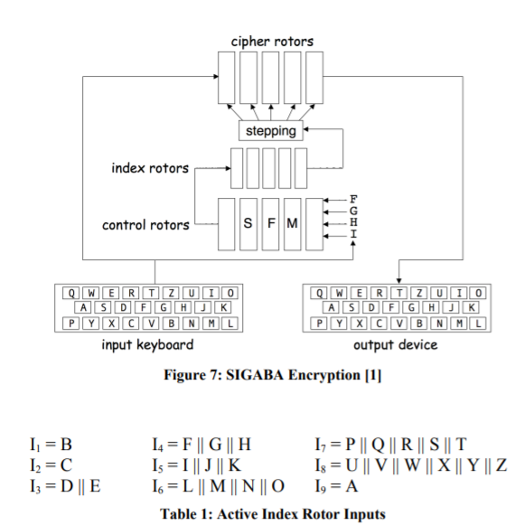

* Has three banks, each consisiting of 5 rotors
  + https://en.wikipedia.org/wiki/SIGABA
  + Bank 1: Cipher Rotots
    - Each have 26 contacts, when a plaintext letter was entered, a signal would enter one side of the bank and exit the other, denoting the ciphertext letter
  + Bank 2: Control Rotors
    - Each have 26 contact rotors. Each received four signals at each step. After passing through the control rotors the outputs were divided into ten groups of various sizes, ranging from 1-6 wires. Each group corresponded to an input wire for the index rotors
  + Bank 3: Index Rotors
    - Each have 10 contacts. Do not step during encryption. After traveling through index rotors. One to four of five output lines would have power. These turn the cypher rotors.
* Rotor Configuration
  + Cipher and Control rotors can be interchanged with each other. Can also be inserted into the cage in a reversed orientation
  + When inserted in normal position, letters are displayed rightside up in a reverse alphabetic order. When a rotor steps, the rotors will rotate UP the alphabet (O would become N).

Psuedo Code, possible help with decryption

<https://pdfs.semanticscholar.org/b401/54ba54acbffe536d577d1861a892278f2d84.pdf>