PackBox Studio — User Manual
Version 0.1.0 · August 2026
A local packaging design application: draw dielines, place artwork, watch the box fold in 3D, and export production files. Nothing is uploaded anywhere — the app runs entirely on your own computer.

How to read this manual
This manual assumes you have never designed packaging before and have never used a terminal. It is arranged so you can read it straight through, or jump to the part you need.
Part | What it covers
Part 1 | Packaging design for beginners — what a dieline is and what every part is called
Part 2 | Installing and running PackBox Studio on macOS and Windows
Part 3 | A map of the application window
Part 4 | Every feature, explained one at a time
Part 5 | A complete worked example: the Card Deck Box (Lock Lid)
Part 6 | Printing, cutting and gluing the box for real
Part 7 | Keyboard and mouse reference
Part 8 | Troubleshooting
Part 9 | Known limitations
Appendix A | The file formats PackBox reads and writes
Appendix B | Glossary

Every illustration in this manual was generated by running PackBox Studio's own geometry code, so what you see here is exactly what the software produces.

Part 1 — Packaging design for beginners

1.1 A box is one flat sheet
Almost every folding carton you have ever opened started life as a single flat piece of board. A machine cut its outline, pressed grooves into it so it would bend in the right places, and someone (or another machine) folded it up and glued one seam.
That flat piece is called a blank or a sheet. The drawing that describes it — where to cut, where to fold — is called a dieline. Producing dielines is the main job PackBox Studio does.
Understanding this one idea makes everything else fall into place: you are not designing a box, you are designing a flat shape that becomes a box.

1.2 The parts of a dieline
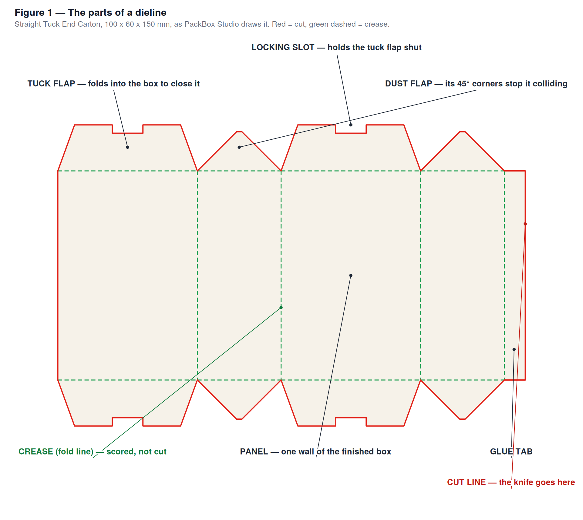
Figure 1 — The parts of a dieline.
Here is the vocabulary. You will meet all of these words in the software.
Panel. One flat area of board that becomes one wall of the finished box. A simple carton has four panels forming a tube: front, one side, back, the other side.
Cut line (drawn in red). Where a knife or die goes all the way through the board. The outer edge of the whole shape is a cut line, and so is every notch and slot inside it.
Crease, also called a fold line or a score (drawn in green, dashed). A groove pressed into the board so it bends cleanly and predictably in one place instead of buckling somewhere random. A crease is not cut. This is the single most important distinction in packaging: red goes through, green does not.
Flap. A panel that folds inward to close the top or the bottom of the box. Flaps come in several kinds.
Dust flap. A small flap on the narrow side walls. It folds in first and closes off the corner gap, keeping dust out — hence the name. Its outer corners are usually cut at 45°, so that when it folds in it doesn't collide with the flap next to it.
Tuck flap. The flap you push down into the box to close it. It is what you open and re-close when you use the box.
Locking slot. A small notch cut into the leading edge of a tuck flap. It catches on the board and stops the flap from popping back open.
Glue tab, also called a glue flap. A narrow strip at one end of the flat strip of panels. Glue goes on it, and it is bonded to the panel at the other end of the strip. That is what turns a flat strip into a closed tube.
Dieline. The whole drawing: outline, creases, slots and all.

1.3 Red and green
PackBox Studio uses one colour convention everywhere — on screen, in the exported SVG, in the exported PDF, and as layer names in the exported DXF:
- Red, solid = cut. The knife goes here.
- Green, dashed = fold / crease. The board is scored here, not cut.
Print shops and die makers expect exactly this separation. When you hand a file to a supplier, this is the language they read it in.

1.4 Length, Width and Height
PackBox Studio asks for three numbers, always in millimetres:
Field | Meaning
Length (L) | How wide the front and back panels are
Width (W) | How deep the box is — the width of the side panels
Height (H) | How tall the box is

So a box of 70 × 24 × 100 has a 70 mm wide face, is 24 mm thick, and stands 100 mm tall. That happens to be about the size of a deck of playing cards, which is the example used in Part 5.
A useful sanity check: the flat strip of panels is always about 2 × L + 2 × W + the glue tab wide, and about H plus the top and bottom flaps tall. If a dieline comes out much bigger than you expected, one of your three numbers is probably wrong.

1.5 Outside and inside
Board has two faces. The outside is what a customer sees on the shelf. The inside is what they see when they open it. PackBox Studio lets you design both separately, and the 3D preview shows both — orbit around to the back of the box and you are looking at inside faces through the opening.
Anything you put on the inside surface is printed on the same physical sheet of paper, on the back. Part 4.12 explains how the PDF export handles this automatically.

1.6 What PackBox does not model
Two honest caveats, so nothing surprises you later.
Board thickness is not modelled. PackBox treats the board as having zero thickness. Real board is typically 0.3–0.5 mm for a folding carton and 3–5 mm for corrugated. For small boxes this rarely matters. For a lid that must slide over a base, it matters a lot — see the Two-Piece Box notes in Part 4.1, where you add the allowance yourself.
Bleed is not added automatically. If your artwork must run right to the edge of the board, extend it a couple of millimetres past the cut line yourself so a slight misalignment during cutting doesn't leave a white sliver.

Part 2 — Installing and running PackBox Studio

2.1 What you need
Operating system | macOS or Windows (Linux also works from the terminal)
Node.js | Required — install once, free, from https://nodejs.org. Take the LTS version. Node.js includes npm, which is what actually does the work.
Disk space | About 500 MB, most of it the dependencies that get downloaded on first run
Internet | Needed only for the first run, while dependencies download. After that PackBox works completely offline.
Graphics | Any reasonably modern computer. The 3D preview uses your graphics card through WebGL.

You do not need to install PackBox Studio itself. It lives entirely in its folder. Delete the folder and it is gone, with nothing left behind on your system.

2.2 What is in the folder
The project folder (packbox) contains, among other things:
Item | What it is
PackBox Studio.app | The macOS launcher — double-click this
PackBox Studio.bat | The Windows launcher — double-click this
README.md | A short technical summary
src/ | The application's source code
electron/ | The desktop-window wrapper
scripts/ | Self-test scripts (see Part 8.6)
launcher.log | A log the launcher writes; useful when something fails
node_modules/ | The downloaded dependencies — created automatically on first run
dist/ | The built application — rebuilt automatically on every launch

2.3 Running it on macOS
- Install Node.js from https://nodejs.org if you have not already. Accept the defaults.
- Open the packbox folder in Finder.
- Double-click `PackBox Studio.app`.
- The first time only, macOS may refuse to open it because it was not downloaded from the App Store. If that happens: right-click (or Control-click) the app, choose Open, and confirm. You only ever have to do this once.
- The first launch takes about a minute while dependencies download — a notification tells you so. Later launches take a few seconds.
- The PackBox Studio window opens, 1440 × 900 pixels.
The macOS launcher looks for Node.js in the usual places, including Homebrew (/opt/homebrew/bin, /usr/local/bin) and nvm. If it still cannot find it, you get a dialog telling you to install Node.js.

2.4 Running it on Windows
- Install Node.js from https://nodejs.org. Accept the defaults.
- Open the packbox folder in File Explorer.
- Double-click `PackBox Studio.bat`.
- A console window appears briefly. On the first run it says "First run: installing dependencies, this takes about a minute…".
- The PackBox Studio window opens.
If Windows SmartScreen warns about running a script, choose More info → Run anyway.

2.5 What the launcher actually does
Worth knowing, because it explains the few seconds of delay on every launch:
- It checks that npm is available, and stops with a clear message if not.
- On the first run only, it runs npm install to download dependencies.
- On every run, it rebuilds the application from the current source (npx vite build).
- It starts the desktop window (npx electron .).
Step 3 is deliberate: it means the version that opens is always the code exactly as it is right now. If the source has been edited since you last used it, the next double-click picks the change up automatically — you never have to reinstall or repackage anything.

2.6 Running it from the terminal
If you are comfortable with a command line, you have more options. Open a terminal in the packbox folder and run:
npm install # once, to download dependencies

Then choose one of:
Command | What it does
npm run electron:dev | Opens the desktop app with hot reload — edit the source and the window updates instantly. Developer tools open alongside.
npm run dev | Runs it as a plain web page instead. Open the http://localhost:5173 address it prints, in any browser.
npm run build | Type-checks and builds into dist/, without opening anything
npm run electron:build | Builds a real installable application into release/ — a .dmg on macOS, an NSIS installer on Windows, an AppImage on Linux
npm run lint | Runs the code linter
npm start | The same as npm run electron:dev

2.7 If a launch fails
Every launch appends to `launcher.log` in the project folder. Open it in any text editor; the last block, headed with a date, tells you what went wrong. Part 8 covers the common cases.

Part 3 — A map of the window
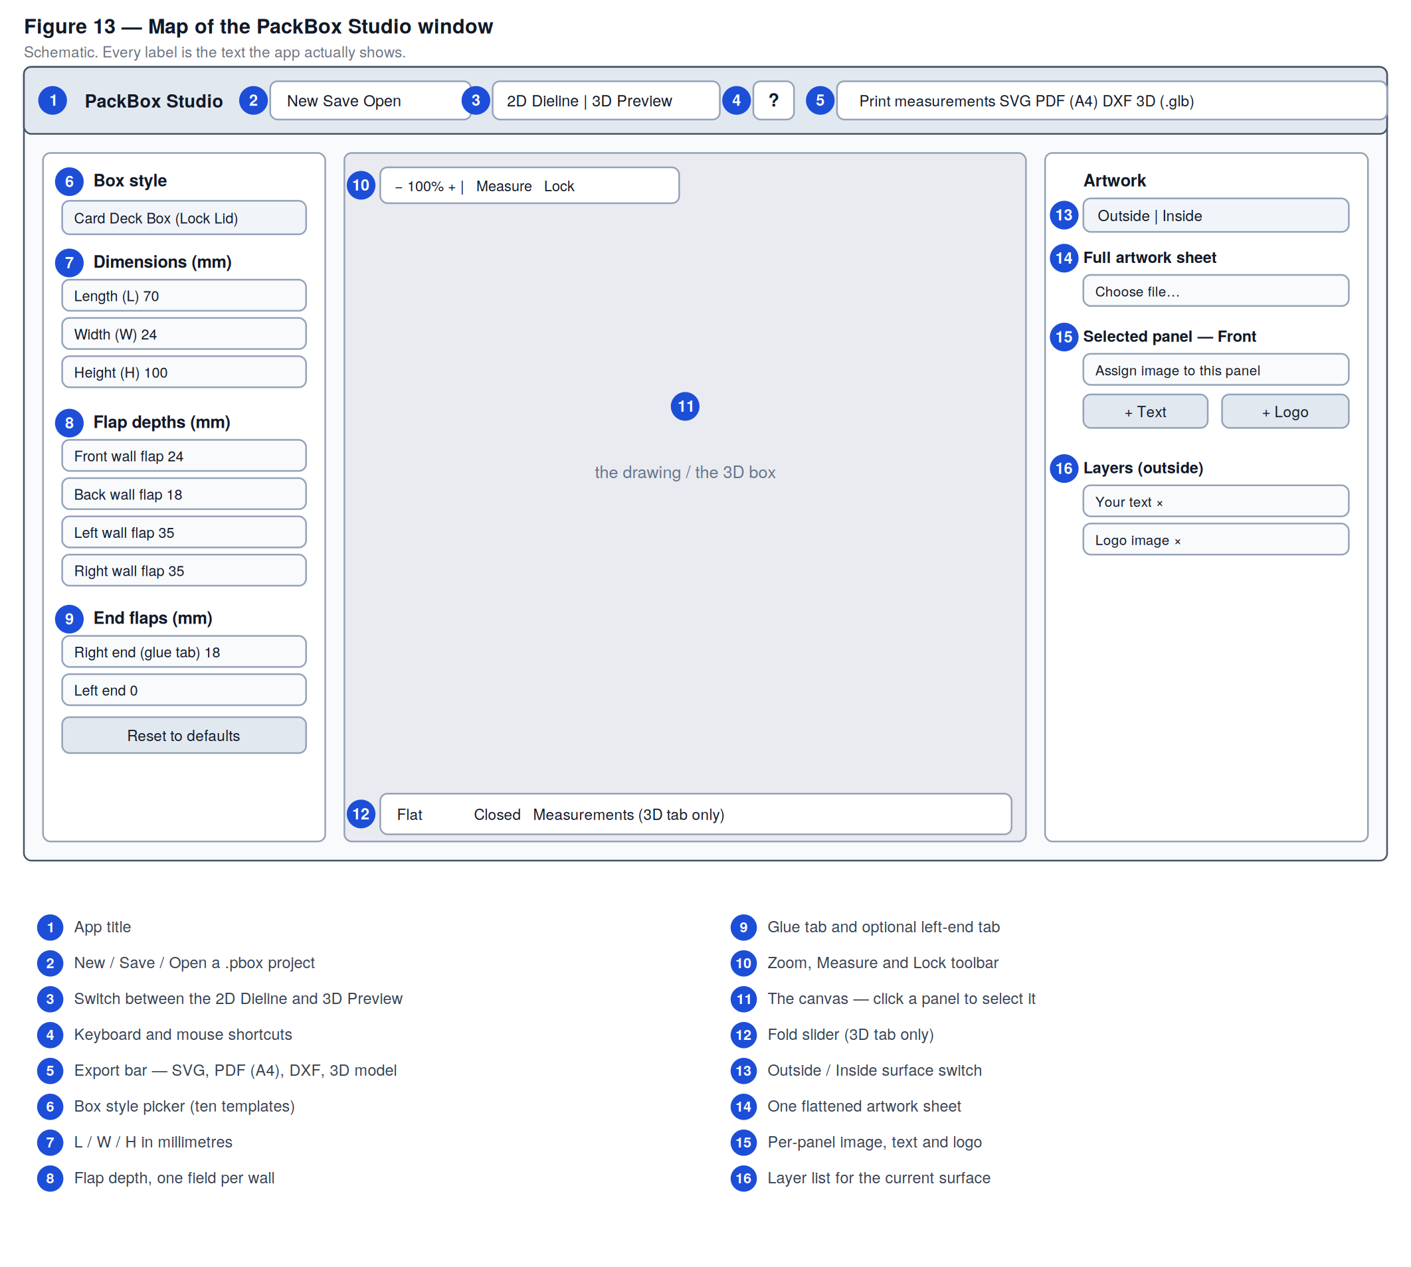
Figure 13 — Map of the PackBox Studio window.
The window has four regions.
The top bar holds project commands (New, Save, Open), the tab switch between the 2D and 3D views, a ? button with the shortcut list, and the export buttons.
The left sidebar is where you define the box: which template, how big, how deep its flaps are.
The centre stage is either the 2D drawing or the 3D preview, depending on the tab.
The right panel is artwork: which surface you are working on, what images and text go where.
The general workflow runs left to right: pick and size the box on the left, look at it in the middle, decorate it on the right, export from the top.

Part 4 — Every feature explained

4.1 Box style
The Box style dropdown at the top of the sidebar picks the template. There are ten. Changing the style resets the dimensions to that style's own sensible defaults, so you never start from a nonsense size.
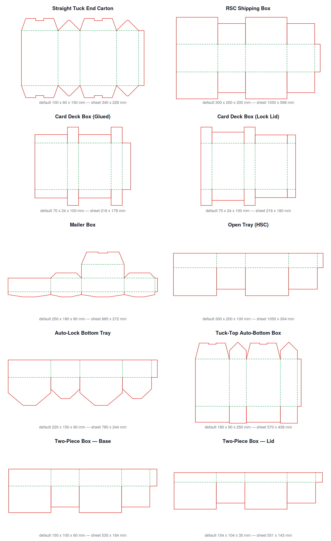
Figure 12 — All ten templates at their default sizes.
Style | What it is | Default L × W × H (mm)
Straight Tuck End Carton | The classic retail folding carton: tuck flaps top and bottom, dust flaps on the sides. Re-openable. | 100 × 60 × 150
RSC Shipping Box | Regular Slotted Container — the ordinary brown corrugated shipping box. Side flaps meet in the middle, front/back flaps fold over them and get taped or glued. | 300 × 200 × 200
Card Deck Box (Glued) | An RSC-style tuck box sized for a deck of cards. The closure is glued shut. | 70 × 24 × 100
Card Deck Box (Lock Lid) | The same size, but with a re-openable lid and a lock flap. This is the worked example in Part 5. | 70 × 24 × 100
Mailer Box | A tuck-lid mailer with auto-lock tabs on the bottom. The lid hinges off the back panel. | 250 × 180 × 80
Open Tray (HSC) | Half Slotted Container — glued bottom, open top. Use it as a tray on its own, or as the base under a separate lid. | 300 × 200 × 100
Auto-Lock Bottom Tray | An open-top tray whose bottom snaps together instead of being glued. | 220 × 150 × 90
Tuck-Top Auto-Bottom Box | Glued bottom, re-openable tuck lid. Common for cosmetics and cereal-style retail boxes. | 180 × 90 × 250
Two-Piece Box — Base | The bottom half of a lid-and-base box. | 150 × 100 × 60
Two-Piece Box — Lid | The shallow cap that slips over the base. | 154 × 104 × 35

Note on the Two-Piece Box. It ships as two separate templates, not one. Design and export the Base, then switch to the Lid and export that too. Make the Lid's L and W a few millimetres larger than the Base's — the default pair (150 × 100 and 154 × 104) allows 2 mm on each side for board thickness and clearance. Adjust that allowance to suit your board.
Underneath the dropdown, a line of grey text describes the selected style. It changes as you change styles.

4.2 Dimensions
Three fields — Length (L), Width (W), Height (H) — all in millimetres, minimum 1.
These fields are designed to be retyped comfortably. You can clear a field completely and type a new number; nothing is clamped or corrected until you press Enter or click away. (An earlier behaviour that snapped the value back to the minimum on every keystroke made deleting digits impossible; that is fixed.) If you leave a field empty or type something that isn't a number, the previous value comes back.
Every change regenerates the drawing immediately.

4.3 Flap depths
Under Flap depths (mm) there is one field per wall that has flaps: Front, Back, Left, Right.
Three things to know:
- *Each field controls that wall's top and bottom flap together.* They always stay symmetrical. This is normal for real dielines and stops you accidentally making a box whose lid fits at one end and not the other.
- Setting a field to 0 removes that flap entirely. The field stays visible so you can bring it back.
- The fields that appear depend on the template. PackBox works out which flaps a template actually has by building it and looking, so the list is always correct — you will never see a control for a flap that doesn't exist.
If a field is showing a value you never typed, that is the template's own computed default for that wall.

4.4 End flaps
Right end (glue tab) is the manufacturer's glue tab — the strip that gets glued to the opposite panel to close the tube. Set it to 0 to remove it.
Left end adds a matching tab at the other end of the strip. Most designs don't need one; the default is 0.

4.5 Lid tuck depth (Mailer Box only)
When the Mailer Box style is selected, an extra Lid section appears with a Lid tuck depth field. It sets how far the lid's tuck flap reaches down inside the front of the box. It defaults to 90 % of the box height.

4.6 Reset to defaults
The button at the bottom of the sidebar puts every dimension back to the current template's defaults. It does not touch your artwork, and it is undoable.

4.7 Click a panel, find its control
Click any panel in the 2D drawing and two things happen:
- The panel gets an orange outline.
- The sidebar field that controls that panel flashes for about a second.
This is the fastest way to answer "which number do I change to make this bit bigger?" Click a side wall and the Width field flashes; click a top flap on the front wall and Front wall flap flashes; click the glue tab and Right end (glue tab) flashes.
Clicking the same panel again replays the flash.
One exception: on the Card Deck Box (Lock Lid), the small lock flaps have no sidebar control of their own. Their depth deliberately follows the back wall's flap depth, so change Back wall flap to change them.

4.8 The 2D editor

Zoom
The toolbar at the top left of the canvas has −, a percentage readout, and +.
- − and + step the zoom by 1.25× each click.
- Clicking the percentage resets to 100 %.
- Scrolling the mouse wheel zooms smoothly, and keeps whatever is under your cursor pinned in place — so you can point at a corner and zoom into it directly.
Zoom ranges from 1 % to 999 %.

Panning
Two ways to move the canvas around:
- Hold Space and drag with the left button.
- Or drag with the middle mouse button.
While Space is held the cursor becomes a hand and the drawing itself stops responding to drags, so you can't accidentally move artwork while panning.

Measure
The Measure checkbox overlays double-headed dimension arrows on the drawing: the overall sheet size, and the width and height of every panel. It is a checking aid — turn it on to confirm that a flap really is the depth you think it is.
The same setting is available in the 3D view (labelled Measurements), where it prints each panel's size onto its face.

Lock
The Lock checkbox changes what your clicks hit.
- Off (the default): the dieline takes priority. Clicking anywhere on the drawing selects a panel. Artwork can only be grabbed where it sticks out beyond the printed lines.
- On: the dieline ignores clicks entirely, so you can grab and drag the artwork from anywhere, including from on top of the panels.
Turn Lock on while you are positioning a large artwork sheet. Turn it off when you go back to selecting panels.

Selecting and transforming artwork
Click a text layer, a logo, or the full artwork sheet to select it. A blue frame with handles appears.
Handle | Effect
Corner handles (four diagonals) | Resize keeping the proportions — an image can't be distorted by a corner drag
Edge handles (four midpoints) | Stretch one axis only, deliberately
Rotation handle (above the selection) | Rotate freely
Rotation handle + Shift | Snap rotation to 45° steps

Dragging anywhere inside the selection moves it.

The image inspector
Whenever a resizable image is selected — the full artwork sheet, or a logo layer — a small floating panel appears at the bottom right of the canvas with:
- a Width slider, in millimetres
- a Height slider, in millimetres
- an Angle slider, −180° to +180°
- a Straighten button, which sets the angle back to 0°
- a Reset image button, which returns the image to its original size and position
Use the sliders when you want an exact number rather than a drag. Text layers have no independent width and height — resizing text scales its font size instead — so the inspector does not appear for them.

4.9 Artwork
The right-hand panel handles everything printed on the box.

Outside and Inside
Two tabs at the top of the panel. Everything below them applies to whichever surface is selected. The two surfaces are completely independent: separate sheet image, separate per-panel images, separate text and logo layers.
The inside surface is shown with a warm beige background on screen to make it read as board — that background is never printed. Exports always render on white.

The full artwork sheet
Full artwork sheet takes one flattened image aligned to the whole dieline. When you upload it, it starts fitted exactly to the dieline's bounds. From there:
- Drag it on the canvas to reposition it (turn Lock on to grab it from anywhere).
- Resize and rotate it with the handles, or with the image inspector sliders.
- Reset to fit sheet puts it back to exactly the dieline's size and position.
- Remove sheet deletes it.
This is the right approach when a designer has handed you finished artwork already laid out to the dieline.

Per-panel images
To put a different image on each face:
- Click the panel in the 2D drawing. The heading in the artwork panel changes to Selected panel — Front (or whichever it is).
- Use Assign image to this panel to choose a file.
The image is clipped to that panel's exact shape, including angled dust-flap corners.
Important: as soon as any per-panel image exists, the full artwork sheet stops being drawn. The two approaches are alternatives, not layers — use one or the other. Remove panel image on every panel brings the sheet back.

Text
With a panel selected, + Text adds a text layer to it. It starts as the words Your text, sized to about 12 % of the panel's height, in near-black, positioned towards the left of the panel.
Edit the words in the Layers list at the bottom of the panel. Move, resize and rotate the text on the canvas.

Logos
With a panel selected, + Logo adds an image layer to it. The logo is scaled to fit inside about half the panel while keeping its own aspect ratio — it is never stretched to a square.

The layer list
Layers at the bottom lists every text and logo layer on the current surface. Text layers show an editable field; logo layers show Logo image. The × button removes a layer.

4.10 Undo and redo
Action | macOS | Windows
Undo | ⌘Z | Ctrl+Z
Redo | ⇧⌘Z | Ctrl+Shift+Z

Undo covers the whole design: box style, dimensions, and all artwork. Up to 50 steps are kept.
Two refinements worth knowing:
- Rapid changes collapse into one step. Dragging a slider fires dozens of changes per second; anything within 400 ms of the previous change joins the same undo step. One undo takes back the whole drag, not one pixel of it.
- Shortcuts are ignored while you are typing in a field. Inside a text or number input, ⌘Z does the normal within-the-field undo you would expect.

4.11 Saving and opening projects
Save writes the entire design — box style, every dimension, and both surfaces' artwork with every image embedded — into a single `.pbox` file. The suggested filename is the style name plus today's date, for example Card_Deck_Box_(Lock_Lid)_2026-08-14.pbox.
Because every image is embedded, the file is completely self-contained. Move it between machines, email it, back it up — it will open exactly as you saved it.
Open loads a .pbox file back. If the file is damaged or is not a PackBox project, you get a plain-language message explaining what is wrong rather than a silent failure.
New starts a fresh project. It asks for confirmation first, and it is undoable even after you confirm.

4.12 The 3D preview
Click the 3D Preview tab.
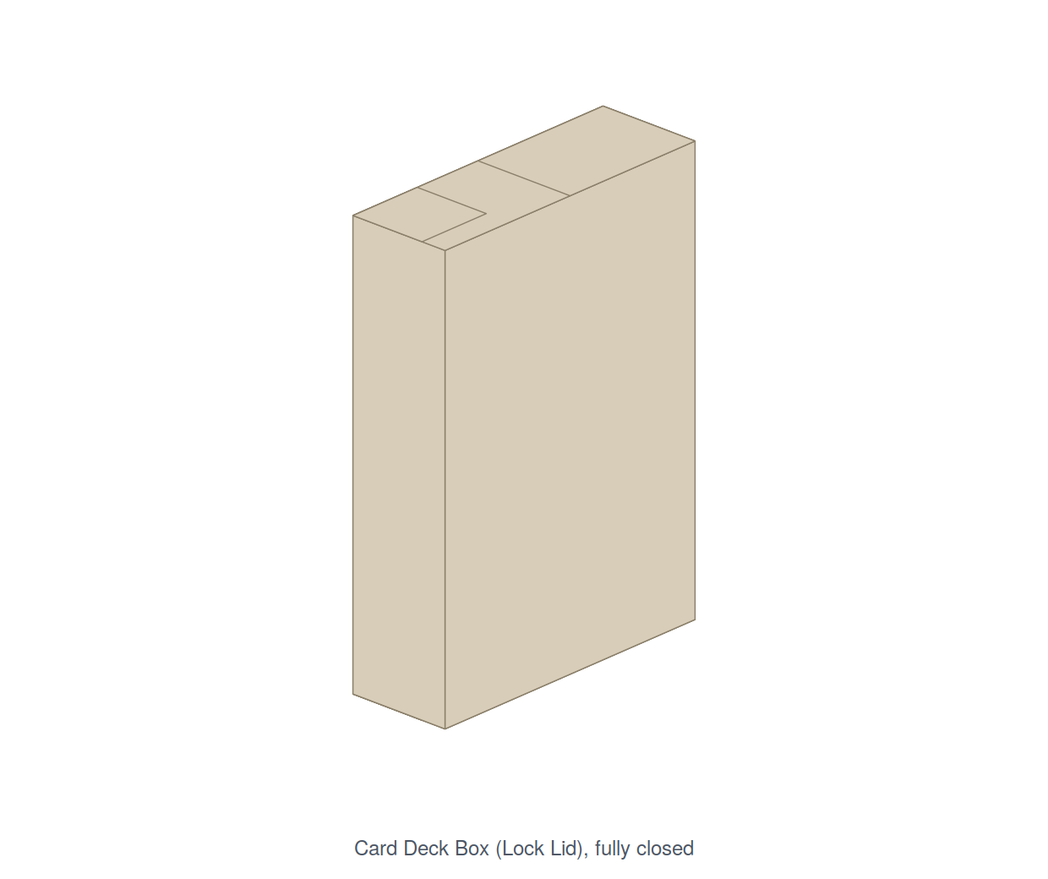
Figure 11 — The Card Deck Box (Lock Lid), fully closed.

The fold slider
The slider under the view runs from Flat on the left to Closed on the right. Drag it and the box assembles.
The assembly is ordered, not simultaneous. Panels fold in the sequence you would actually use to close a real box. For the Card Deck Box (Lock Lid) that order is strictly sequential — each layer finishes completely before the next begins:
Slider | What is moving
0 – 30 % | The four walls fold up into a tube
30 – 55 % | The side dust flaps fold in
55 – 78 % | The inner back flap and the lock flap fold in
78 – 100 % | The lid closes

Most other templates use overlapping phases instead: the tube forms over 0–40 %, inner flaps close over 40–70 %, and outer flaps close over 70–100 %.

Moving the camera
Left-drag | Rotate around the box — unlimited, in every direction, including underneath
Right-drag | Pan the view
Scroll | Zoom in and out

There is deliberately no floor or ground plane, so you can orbit all the way around and under the box without anything getting in the way.

What you see
Your artwork is mapped onto the panels — the outside artwork on outward-facing surfaces, the inside artwork on inward-facing ones. Where a panel has no artwork it renders as plain board colour.
The Measurements checkbox next to the slider prints each panel's width and height directly onto its face — a quick way to confirm the model matches the numbers you typed.

4.13 Exporting
The export buttons live at the right of the top bar. A Print measurements checkbox sits alongside them; when ticked, the dimension arrows are drawn into the exported SVG and PDF. Leave it off for production artwork — it is for checking and for printed mock-ups.

Export SVG
A vector picture of the dieline: cut lines red, fold lines green, artwork embedded behind them.
If the inside surface has any content, you get two files — <name>_outside.svg and <name>_inside.svg. Both are saved the right way round (not mirrored), because these are image files headed for some other program where the eventual page orientation isn't known. If you send them to a duplex printer, mirror the inside one there.

Export PDF (A4)
The most useful export for making a physical prototype. It prints true to size on standard A4 paper.
- A dieline that fits on one A4 sheet gets one page, centred, with a dashed trim guide and corner crop marks so you can square the paper up before cutting.
- A dieline too big for one sheet is automatically tiled across a grid of A4 pages that abut edge to edge, with small + alignment marks at the seams so the printed pages line up when you tape them together. Each page's footer tells you which tile it is.
- Orientation is chosen for you. A single page is portrait if the dieline fits that way, otherwise landscape. Tiled output always uses portrait pages.
Every export contains both faces. For each tile you get an outside page followed by an inside page, each with its own cut and crease lines. The inside page is pre-mirrored so that if you print double-sided with "flip on long edge", the inside artwork lands exactly behind the outside artwork on the same sheet. Print duplex, cut once, and both faces are already registered.
The mirroring axis follows the page orientation automatically — portrait flips left/right, landscape flips top/bottom — because "flip on long edge" means something different for each. Every inside page is labelled in its footer so you can check the setting.

Export DXF
A CAD file for a die maker or a cutting table, with cut lines on a layer named `CUT` and fold lines on a layer named `FOLD`. This is the format most cutting equipment expects.

Export 3D Model (.glb)
Exports the folded 3D model, with your artwork baked in as textures, as a .glb file — the standard format for 3D on the web and in most 3D software.
This button only works while the 3D tab is open, because it exports the live scene. It is greyed out on the 2D tab.

Part 5 — Worked example: the Card Deck Box (Lock Lid)
This part walks through a complete design from scratch. The result is a re-openable box sized for a standard deck of playing cards.

Step 1 — Choose the template
Open PackBox Studio and pick Card Deck Box (Lock Lid) from the Box style dropdown.
The dimensions fill in automatically:
Field | Value
Length (L) | 70 mm
Width (W) | 24 mm
Height (H) | 100 mm
Front wall flap | 24 mm
Back wall flap | 18 mm
Left wall flap | 35 mm
Right wall flap | 35 mm
Right end (glue tab) | 18 mm
Left end | 0 mm

The drawing appears immediately. The whole flat sheet measures 216 × 180 mm — that includes the 5 mm margin PackBox leaves around the drawing — and it comes to 15 panels.

Step 2 — Read the dieline
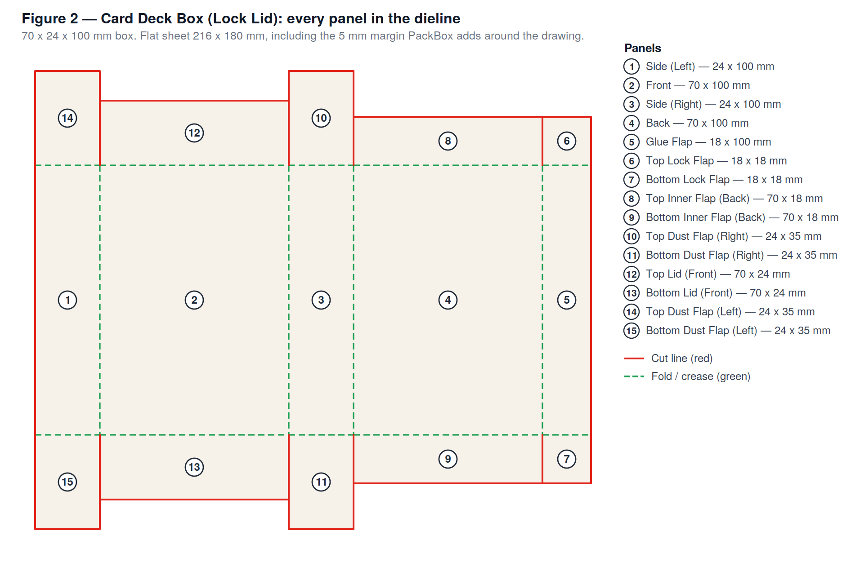
Figure 2 — Every panel in the Card Deck Box (Lock Lid) dieline.
Reading left to right along the middle row, the strip of walls goes: Side (24) → Front (70) → Side (24) → Back (70) → Glue Flap (18). That adds up to 206 mm, plus the margin, giving the 216 mm sheet width.
Above and below that strip sit the flaps, mirrored top and bottom — everything at the top of the box also exists at the bottom.
Click a few panels in the drawing and watch which sidebar field flashes. This is the quickest way to build an intuition for how the dieline is put together.

Step 3 — Understand why this box locks
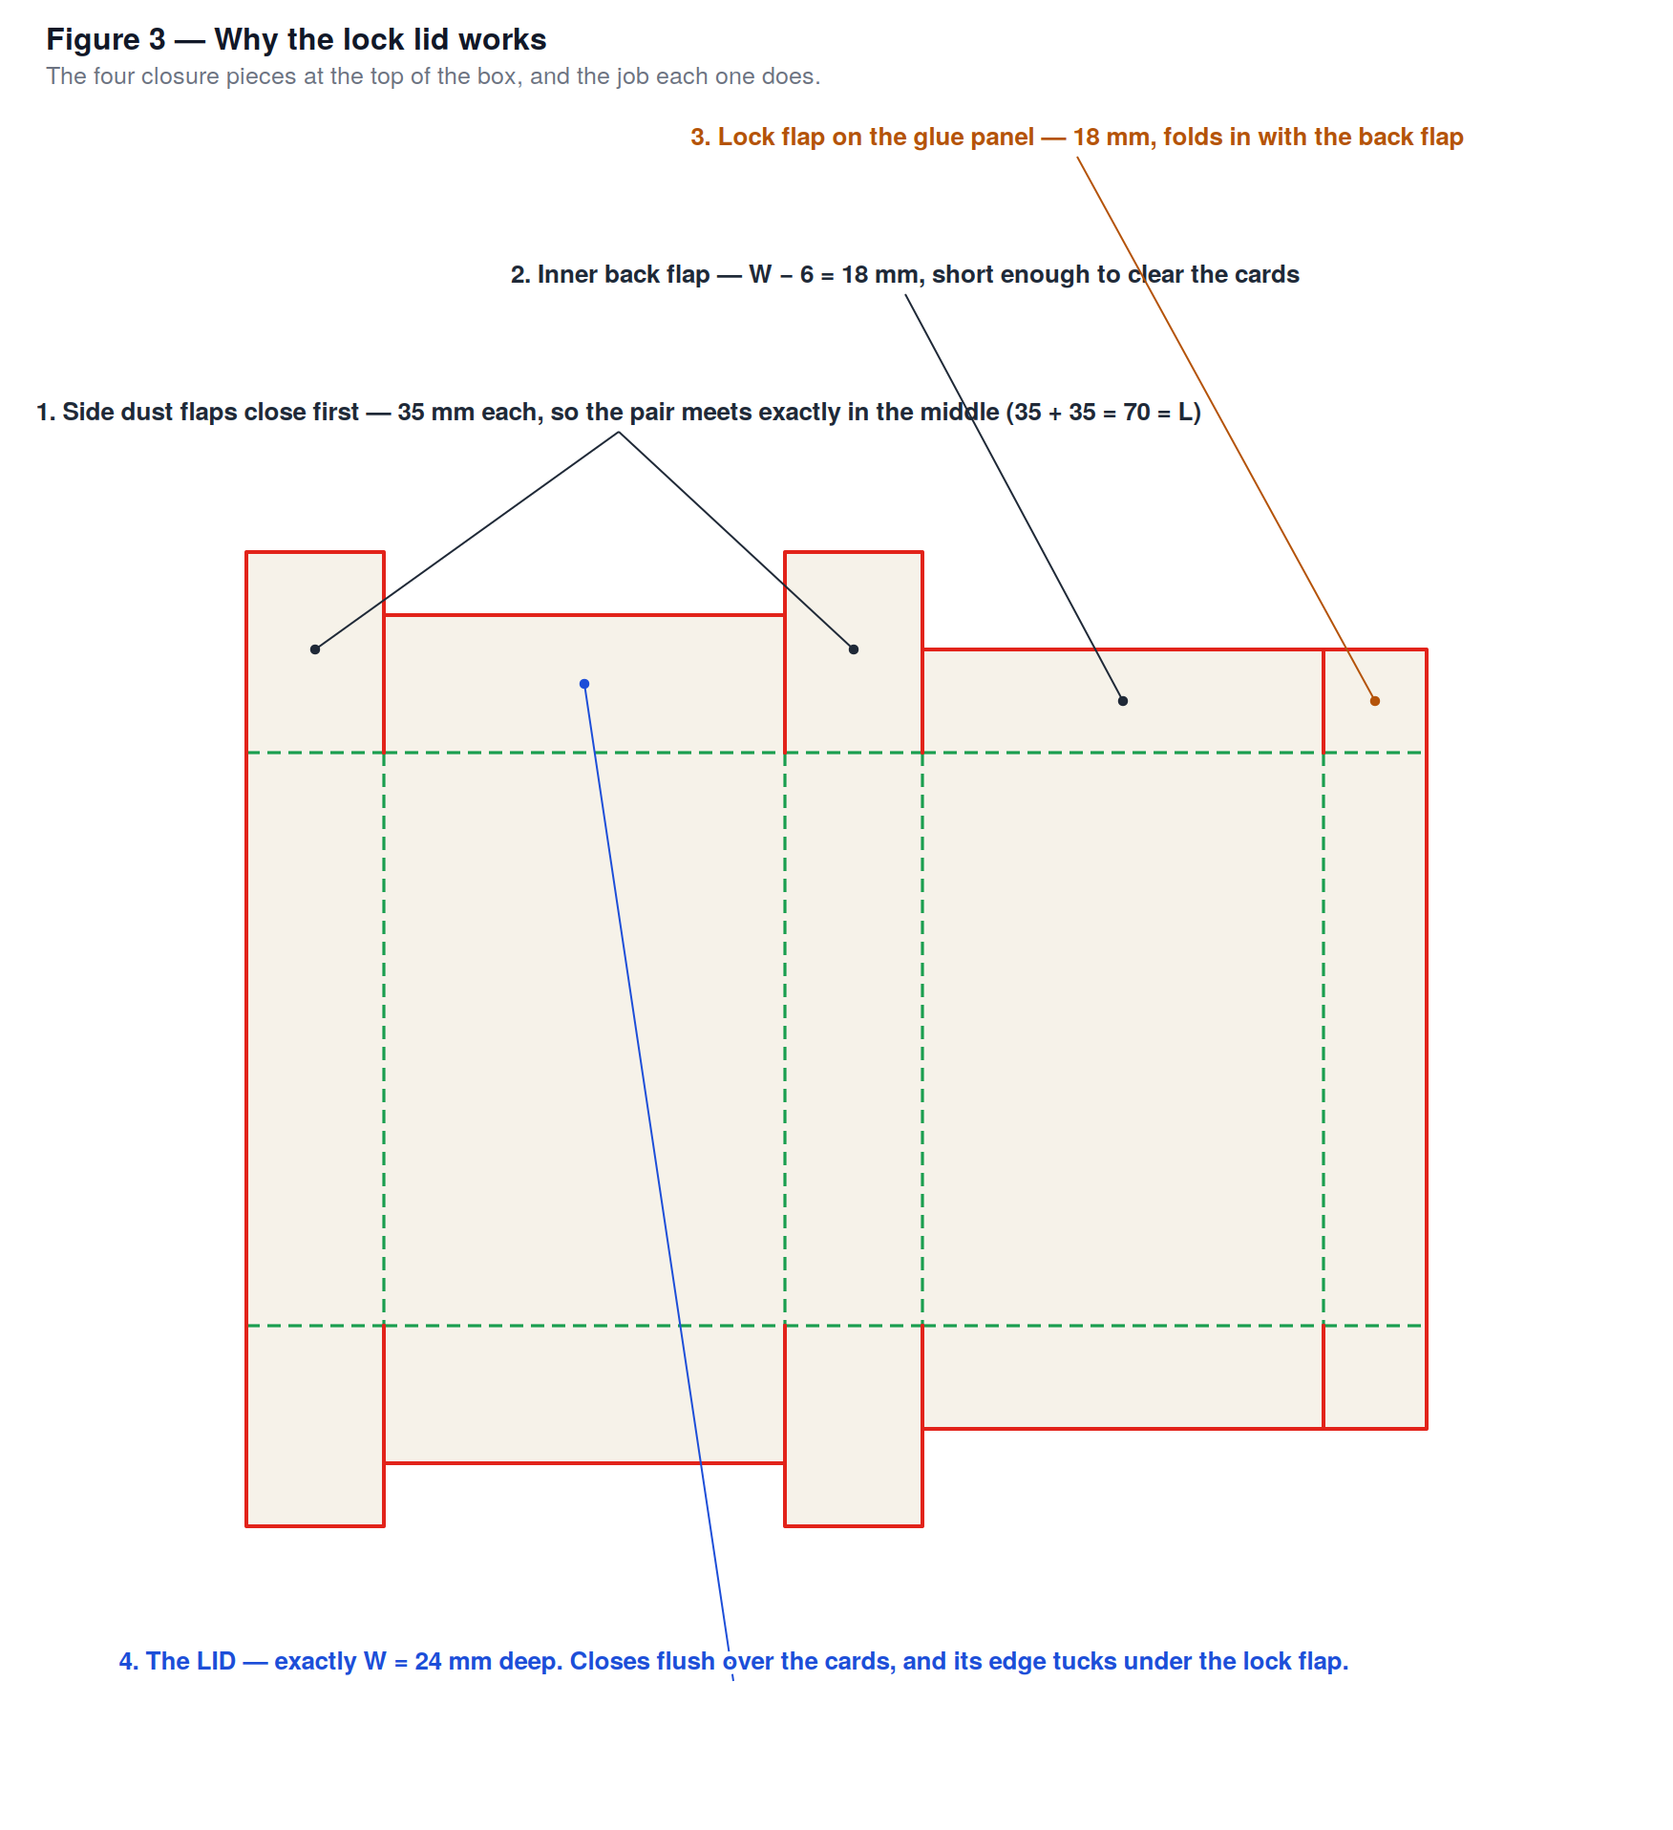
Figure 3 — Why the lock lid works.
The four closure pieces do four different jobs, and their sizes are not arbitrary:
- The side dust flaps are 35 mm each — exactly L ÷ 2. Two of them, folding in from opposite sides, meet precisely in the middle: 35 + 35 = 70 = L. No gap, no overlap.
- The inner back flap is 18 mm — W minus 6. It is deliberately short, so it folds in and stops clear of the cards instead of jamming against them.
- The lock flap on the glue panel is also 18 mm. It follows the back flap's depth, so the two sit at the same level. It folds inward with the back flap.
- The lid is exactly 24 mm — exactly W. It closes flush across the top of the box, and its leading edge tucks under the lock flap. That is the lock. Nothing is glued, so the box opens and closes as many times as you like.
Change Width (W) and watch the lid and the lock flap follow it. Change Length (L) and watch the dust flaps follow. The relationships hold whatever size you make the box.

Step 4 — Adjust the size if you need to
If you are packing something other than cards, change L, W and H, and the whole dieline regenerates with the proportions intact.
Two tips:
- Add 1–2 mm to each internal dimension so the contents slide in rather than wedge.
- If the lid feels too tight to close, that is board thickness — which PackBox does not model. Reduce the Back wall flap by a millimetre or two to give the lid's edge more room to slip under the lock.

Step 5 — Add artwork
Switch to the 2D Dieline tab if you are not already there.
To decorate one face at a time:
- Click the Front panel in the drawing. It gets an orange outline, and the artwork panel heading changes to Selected panel — Front.
- Click + Text. The words Your text appear on the panel.
- Edit them in the Layers list at the bottom of the artwork panel.
- Drag the text where you want it; use the corner handles to resize; use the rotation handle (hold Shift for 45° steps) to angle it.
- Click + Logo to place an image, and size it with the image inspector sliders.
To use finished artwork instead: switch to the Full artwork sheet section, choose your file, and it drops in fitted to the whole dieline. Tick Lock in the canvas toolbar so you can drag it from anywhere, then position it.
For the inside of the box: click the Inside tab at the top of the artwork panel and repeat. The inside of a card box is a good place for rules, a thank-you note, or a plain colour.

Step 6 — Check it in 3D
Click the 3D Preview tab and drag the fold slider slowly from left to right.
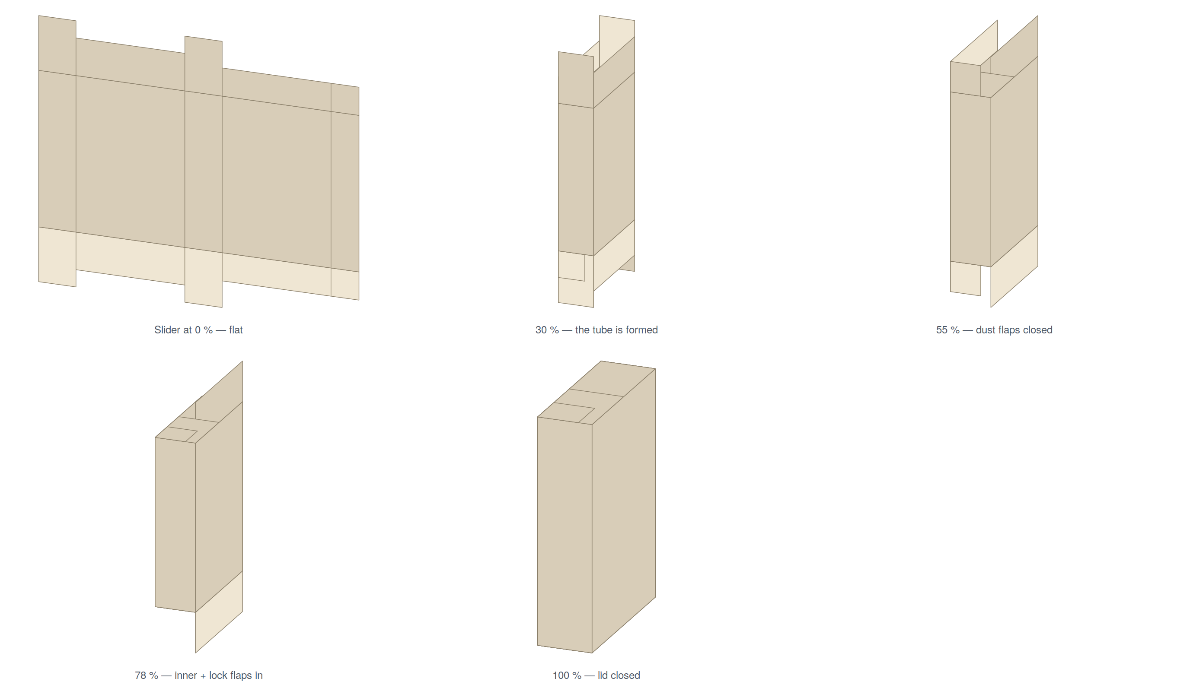
Figures 6–10 — The fold sequence at 0 %, 30 %, 55 %, 78 % and 100 %.
At 0 % you are looking at the flat sheet. By 30 % the four walls have formed a tube. At 55 % the side dust flaps have folded in and met in the middle. At 78 % the inner back flap and the lock flap are in. At 100 % the lid has closed over everything.
Orbit around with a left-drag and check the back and the inside. Tick Measurements to print each panel's size onto its face and confirm the numbers.
This is the moment to catch mistakes. A flap that visibly collides with another one, or a lid that clearly won't reach, is far cheaper to fix here than after printing.

Step 7 — Export
Now produce the files.
For a paper prototype: tick nothing, click Export PDF (A4). This 216 × 180 mm dieline fits comfortably on one A4 sheet, so you get a two-page PDF: page 1 the outside, page 2 the inside.
For a die maker or cutting table: click Export DXF. Your supplier gets cut and fold lines already separated onto CUT and FOLD layers.
For a print vendor or another design program: click Export SVG.
To check the drawing: tick Print measurements first, then export. You get the same file with dimension arrows overlaid on everything.
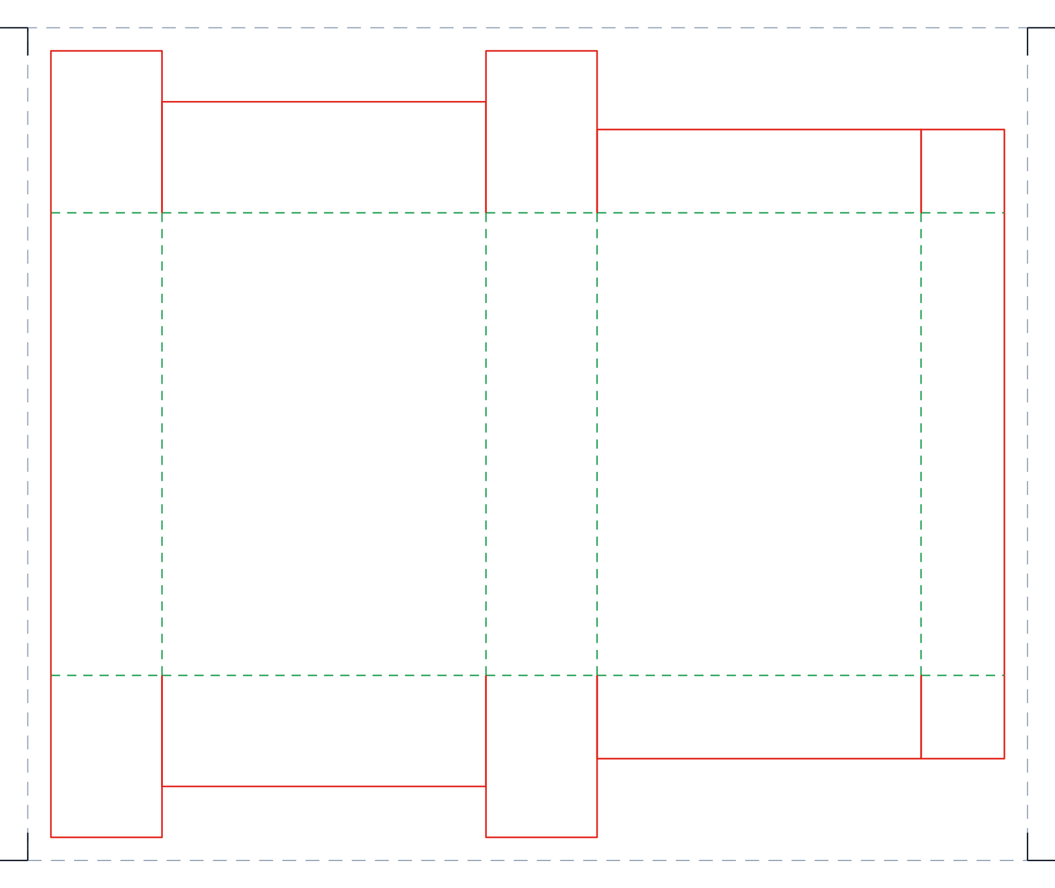
Figure 4 — The exported dieline, exactly as Export SVG writes it. The dashed grey rectangle and the corner ticks are the trim guide and crop marks.
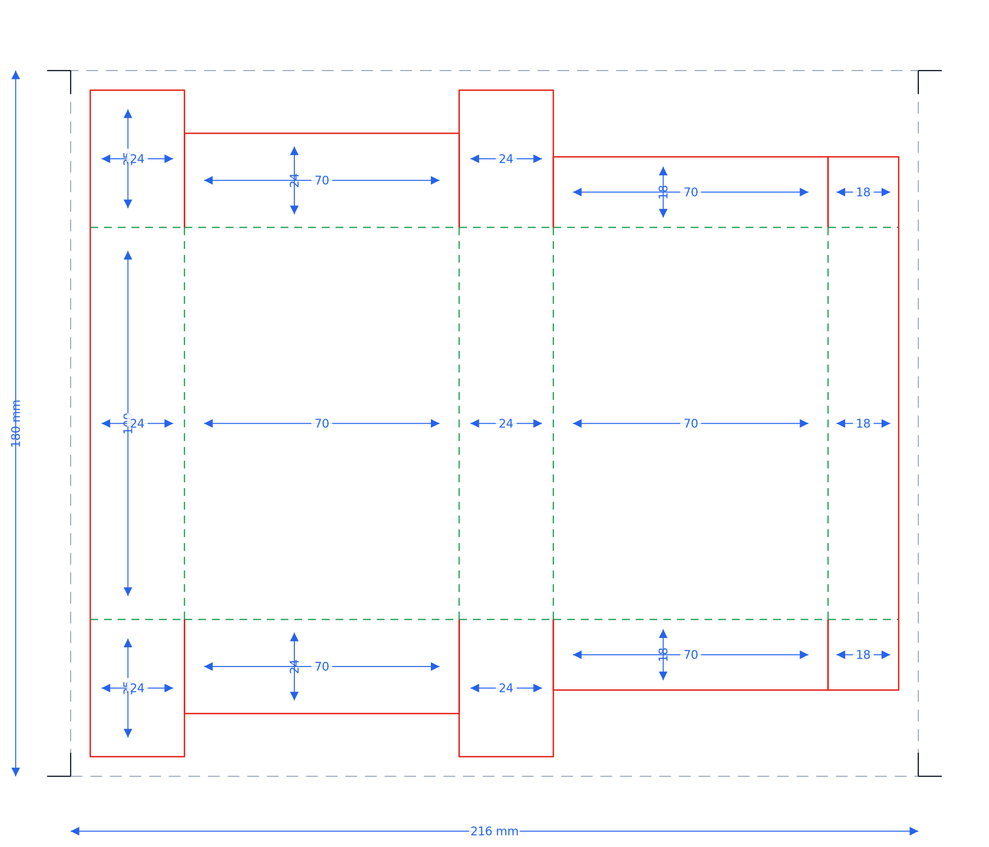
Figure 5 — The same export with Print measurements ticked.

Step 8 — Save your work
Click Save. You get a single .pbox file containing everything — style, dimensions, and all artwork with images embedded. Keep it; Open brings the whole design back exactly as it was.

Part 6 — Printing, cutting and assembling
Turning the PDF into a physical box.

6.1 Printing
- Open the exported PDF.
- In the print dialogue, set scaling to 100 %, Actual size, or None — not "Fit to page". If the printer scales the page, your box comes out the wrong size.
- Choose A4 paper.
- If you want both faces printed: select double-sided / duplex, and set the binding to Flip on long edge. The inside page is already mirrored to suit that setting.
- Print on the heaviest stock your printer will take. 200–300 gsm card behaves much more like real packaging board than ordinary paper.

6.2 Cutting and creasing
- Cut around the red outline with a craft knife against a steel rule, on a cutting mat.
- Cut out any internal notches and slots — they are red too.
- Do not cut the green lines. Instead, score them: run an empty ballpoint pen, a bone folder, or the back of a knife blade along each green line against the ruler, pressing firmly enough to crush the fibres without breaking through.
- Fold every scored line, in the direction it needs to go, and run your thumbnail along it to set the crease.
Scoring before folding is what separates a crisp box from a scruffy one. It takes an extra minute and makes all the difference.

6.3 Gluing and closing
- Form the tube: bring the glue tab round to the panel at the other end of the strip and glue it. A glue stick works; double-sided tape is neater.
- Let it set with the box lying flat and square.
- Close the bottom first, following the fold order from Part 5, Step 6: dust flaps in, then the inner back flap and lock flap, then the lid.
- Fill it, then close the top the same way.
If the lid won't tuck under the lock flap, the culprit is almost always board thickness. Reduce the Back wall flap by 1–2 mm and print again.

Part 7 — Keyboard and mouse reference
The ? button in the top bar shows this list inside the application at any time.

General
Action | macOS | Windows
Undo | ⌘Z | Ctrl+Z
Redo | ⇧⌘Z | Ctrl+Shift+Z

2D editor
Action | Effect
Scroll | Zoom, keeping the point under the cursor in place
Space + drag | Pan the canvas
Middle-mouse drag | Pan the canvas
Click a panel | Select it, and flash its control in the sidebar
Drag a corner handle | Resize keeping proportions
Drag an edge handle | Stretch one side only
Shift + rotate handle | Snap rotation to 45° steps

3D preview
Action | Effect
Left-drag | Rotate around the box (unlimited)
Right-drag | Pan the view
Scroll | Zoom in and out

Part 8 — Troubleshooting

8.1 "PackBox needs Node.js to run"
Node.js is not installed, or the launcher cannot find it. Install it from https://nodejs.org (take the LTS version), then launch again.
If Node.js is installed and you still see this on macOS, the launcher may not be finding it — it checks Homebrew's locations and nvm. Try running npm run electron:dev from a terminal in the folder instead; if that works, the problem is only the launcher's search path.

8.2 macOS refuses to open the app
macOS blocks apps that were not downloaded from the App Store. Right-click (or Control-click) PackBox Studio.app, choose Open, and confirm. You only have to do this once.

8.3 The launch fails with no obvious message
Open `launcher.log` in the project folder. The last block, headed with a date, holds the error. Common causes: no internet during the first npm install, or a partially downloaded node_modules folder. Deleting node_modules and launching again forces a clean re-download.

8.4 "Export failed" when exporting the 3D model
The Export 3D Model (.glb) button needs the 3D scene to exist. Switch to the 3D Preview tab, then export. The button is disabled on the 2D tab for exactly this reason.

8.5 The printed box is the wrong size
Printer scaling. Reprint with scaling set to 100 % / Actual size / None, not "Fit to page".

8.6 The inside artwork doesn't line up on the back
Your printer's duplex setting. It must be flip on long edge. "Flip on short edge" rotates the back of the sheet 180° relative to the front, and nothing will register.

8.7 A flap folds the wrong way in 3D
This would be a bug in that template's fold direction, not something you have done wrong. Note which flap and on which style, so it can be corrected — it is a one-line fix in the code.

8.8 Self-test scripts
If you want to verify the installation, the scripts/ folder holds checks you can run from a terminal in the project folder:
Command | What it checks
npx tsx scripts/smoke-test.ts | Panel counts, no overlapping panels, valid bounds, cut/fold accounting — for every box style
npx tsx scripts/verify-fold.ts card-deck-lock | That walls face outward and every flap closes inward
npx tsx scripts/verify-duplex.ts | That the inside PDF page mirrors correctly
npx tsx scripts/verify-a4.ts | A4 pagination and tiling
npx tsx scripts/verify-project.ts | Saving and reloading .pbox files
npx tsx scripts/render-svg.ts | Writes a dieline SVG for every style to /tmp

Part 9 — Known limitations
Stated plainly, so nothing catches you out.
Curved and compound creases are not supported. The geometry model gives each fold line a single straight crease. That covers everything built from a chain of flat rectangular panels — which is most packaging — but it rules out gable-top (milk carton) shapes and pillow boxes. Those styles are therefore not included.
The Two-Piece Box is two templates, not one. You switch between Base and Lid and export twice, rather than generating both from a single design.
The Auto-Lock Bottom Tray shows the tab shape, not the interlock. The mating slots that make opposing tabs actually lock into each other are not drawn. Treat it as indicative.
Board thickness is not modelled. See Part 1.6.
The 2D editor is deliberately simple. It has text and image layers with move, resize and rotate. It does not have multi-select, alignment guides, or its own separate undo history for layer edits (the global undo covers them).

Appendix A — File formats
Extension | Direction | What it is
`.pbox` | Read and write | A PackBox project. Plain JSON containing the box style, dimensions and both surfaces' artwork, with every image embedded as a data URL. Self-contained and portable. Human-readable if you open it in a text editor.
`.svg` | Write | Vector dieline with the artwork embedded. Cut lines red, fold lines green. Opens in Illustrator, Inkscape, Affinity Designer and any browser.
`.pdf` | Write | True-to-size A4, one or more pages per face, with trim guide, crop marks and (when tiled) seam alignment marks.
`.dxf` | Write | CAD exchange format for die makers and cutting tables. Cut lines on the CUT layer, fold lines on the FOLD layer.
`.glb` | Write | The folded 3D model with textures baked in. Opens in most 3D software and web viewers.
Images | Read | Any format your system can display — PNG, JPEG, SVG, WebP — for artwork sheets, panel images and logos.

Appendix B — Glossary
Blank — the flat piece of board before it is folded. Also called a sheet.
Bleed — artwork extended past the cut line so a slight cutting misalignment doesn't leave a white edge.
Crease — a groove pressed into board so it folds cleanly in one place. Drawn green and dashed. Also called a score or a fold line.
Crop marks — small corner ticks printed outside the design showing where to trim the paper.
Cut line — where the knife goes through the board. Drawn red.
Dieline — the complete drawing of a flat blank: outline, creases, slots.
Duplex — printing on both sides of the sheet.
Dust flap — a small side flap that folds in first and closes the corner gap. Its 45° corners stop it colliding with its neighbour.
Flap — a panel that folds in to close the top or bottom of a box.
Glue tab (glue flap) — the narrow strip glued to the opposite panel to close the tube.
GSM — grams per square metre, the weight of paper or board. Higher means thicker and stiffer.
HSC — Half Slotted Container: an RSC with no top flaps. An open tray.
Lock flap — a flap that holds a lid shut mechanically rather than with glue.
Panel — one flat area of board that becomes one wall of the box.
RSC — Regular Slotted Container: the standard corrugated shipping box.
Score — see Crease.
STE — Straight Tuck End: a carton whose top and bottom tuck flaps both hinge off the same panel.
Tiling — splitting a drawing too large for one sheet across several pages that are taped together.
Trim guide — the dashed rectangle showing the true edge of the dieline, for squaring the paper before cutting.
Tuck flap — the flap you push into the box to close it.

PackBox Studio 0.1.0 — built with React, Three.js and Konva, wrapped in Electron. Your designs stay on your computer.

