Student:__________________________
Midterm exam (Card # 2)
Warm-up (2 points)
- Hiding internal data from the outside world, and accessing it only through publicly exposed methods is known as data _______________________.
- Which type of the field is shared by all objects of the class? _________________________

Problem Solving part (3 points)

1) Create classes according to the following UML diagram:
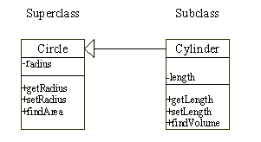

2) Create a class DuplicatesCounter with single method calculateDuplicates which counts how many times you encounter an element in an array and returns an array of pairs with element and its count. Provide 2 constructors – no-arg and the one accepting an array to process. Example:
[1,1,2,3,1,2] -> [[1,3], [2,2], [3,1]]

