P1: **Test a Perceptual Phenomenon**

Soroush Bassam

10/09/2016

In this paper, I will be answering the questions asked in the instructions for project “Test a Perceptual Phenomenon.”

1. What is our independent variable? What is our dependent variable?

2. What is an appropriate set of hypotheses for this task? What kind of statistical

   test do you expect to perform? Justify your choices.

3. Report some descriptive statistics regarding this dataset.

   Include at least one measure of central tendency and at least one measure of variability.

4. Provide one or two visualizations that show the distribution of the sample data.

   Write one or two sentences noting what you observe about the plot or plots.

5. Now, perform the statistical test and report your results. What is your confidence level

   and your critical statistic value? Do you reject the null hypothesis or fail to reject it?

   Come to a conclusion in terms of the experiment task. Did the results match up with your expectations?

6. Optional: What do you think is responsible for the effects observed? Can you think of an alternative or

   similar task that would result in a similar effect? Some research about the problem will be helpful

   for thinking about these two questions!

1. Our dependent variable is the performances of the participants, in other words, the time it takes (in seconds) to complete a task. Our independent variable is the condition in which participant were tested (congruent or incongruent conditions.)

2. Please see answer to question #5.

3. The following table contains median and mean (measures of central tendency) as well as standard deviation (the measure of variability) for each condition.

|  |  |  |
| --- | --- | --- |
|  | Congruent | Incongruent |
| Median | 14.36 | 21.02 |
| Mean | 14.05 | 22.01 |
| Standard Deviation | 3.56 | 4.80 |

4. The following graph is the sample distribution for the congruent condition.

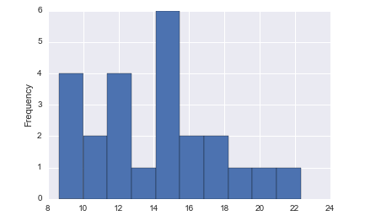

As shown on the above graph, there are three peaks, the highest one being associated with the mean of the sample. It appears that the sample distribution is far from a normal distribution, which could be due to small sample size. I expect this distribution to look more like a normal distribution as the sample size grows.

The below graph shows the incongruent sample’s distribution. It slightly looks like a right skewed distribution in the first look, however I believe the sample distribution would look more like a normal distribution if we increased the sample size.

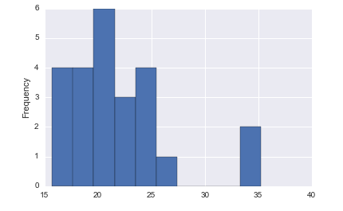

Finally, we compare the two distributions in the following histogram:

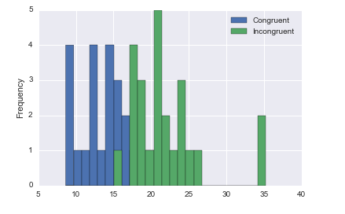

As we expected, incongruent numbers are more concentrated in the area roughly between 17 to 25 whereas congruent numbers largely exist somewhere between 12 to 17. As the sample sizes increase, I would expect to see a bimodal distribution with the lower peak associated with the congruent condition and the higher peak associated with incongruent condition.

2, 5. One interesting aspect of this experiment is to study whether incongruence has an effect on the time it takes someone to complete the task. In that case, the statistical test would be to see how distribution parameters corresponded to the incongruent condition are different from those of congruent condition.

An appropriate set of hypotheses would be the following:

   Ho: (In other words $μ_{i}- μ_{c}= μ_{D}=0$)

   HA:

Where $μ_{i}$ is the Incongruent sample mean, $μ_{c}$ is the Congruent sample mean, and $μ_{D}$ is the difference between these two.

The null hypothesis (Ho) states that there is no statistically significant difference between the means of the samples, whereas the alternative hypothesis (HA) states that the sample means are different.

Based on hypotheses we should conduct a two-tailed test.

Given the fact that same participants have completed two tasks, samples are dependent (within subject design.)

The sample size for each set is 24. Therefore the degree of freedom is 24 - 1 = 23.

From the t-table, for a two-tailed test with $α=0.05$

we have:

tcritical = 2.069

Next, we calculate the point estimate for the mean difference:

$$X_{i}- X_{c}= 22.01-14.05=7.96$$

Standard deviation of difference:

SDdiff = 4.86

Now, we can calculate t-statistic as follows:

$$t= \frac{μ_{i}- μ_{c}}{\frac{{SD}_{diff}}{\sqrt{n}}}=8.02$$

The t-statistic is well past the t-critical value. Therefore, **we reject the null**. In other words, the time it takes to complete an incongruent task is significantly longer than the time it takes to complete a congruent task. If this is an experimental design, we can say that printing words in a different color than what they mean, caused the delay in completing the incongruent task.

Using these values as inputs, we then find the p-value. I used GraphPad website which generated the following output:

“The two-tailed P value is less than 0.0001  
   By conventional criteria, this difference is considered to be extremely statistically significant.”

Now, we calculate the effect size measure, Cohen’s d:

$$d= \frac{μ_{i}- μ_{c}}{{SD}_{diff}}=1.63$$

Next, we calculate the confidence interval for the mean population difference:

$$CI: μ_{D}± tcritical (\frac{{SD}_{diff}}{\sqrt{n}})$$

Which gives us (5.91,10.01) for 95% confidence interval. On average, it takes 5.91 to 10.01 seconds longer to complete the incongruent task.

Finally, we calculate the coefficient of determination, r2:

With the values obtained above, we have:

$$r^{2}= .74$$

This means that 74% of the difference between the mean of the two samples are due to the Stroop effect.