**Deployment Document for MetaData Catalog and XML2MetaData Module**

## Revision History:

|  |  |
| --- | --- |
| Project: | SOD [755166-6192] |
| Date: | 09/25/2011 |
| Version: | 0.1 |
| Prepared by: | Sabin Basyal |

# INTRODUCTION

We have created two modules, listed as:

1. Metadata_Catalog and
2. XML2MetaData

These modules help us import data from xml (in FGDC, Federal Geographic Data Committee standard) into the drupal nodes. Metadata_Catalog module creates the content type required for XML to hold the data and XML2MetaData ultimately creates an interface and backend codes to facilitate importing of the XML into Drupal nodes.

To know more about the FGDC standard, follow through:

<http://www.fgdc.gov/metadata/csdgm>

## Metadata Catalog

### Pre-requisites:

To add the Metadata Catalog Module, we need to make sure that following modules are installed /enabled:

* Cck_select_other (missing),
* Ctools ,i.e. Chaos tools (missing),
* Features (missing),
* Entity API(missing),
* Field_collection (missing),
* Field_group (missing),
* File (enabled),
* Field (enabled),
* Field SQL storage (enabled),
* Link (missing),
* List (enabled),
* Options (enabled),
* Number (enabled),
* Taxonomy (enabled)

When we install the fresh copy of drupal 7, we already have items checked as ENABLED and we do need to install only those MISSING modules.

### Configuration:

You may even encounter a problem while enabling the module. Actually it is not a problem with the module but general settings required for Drupal. It appears like the following:

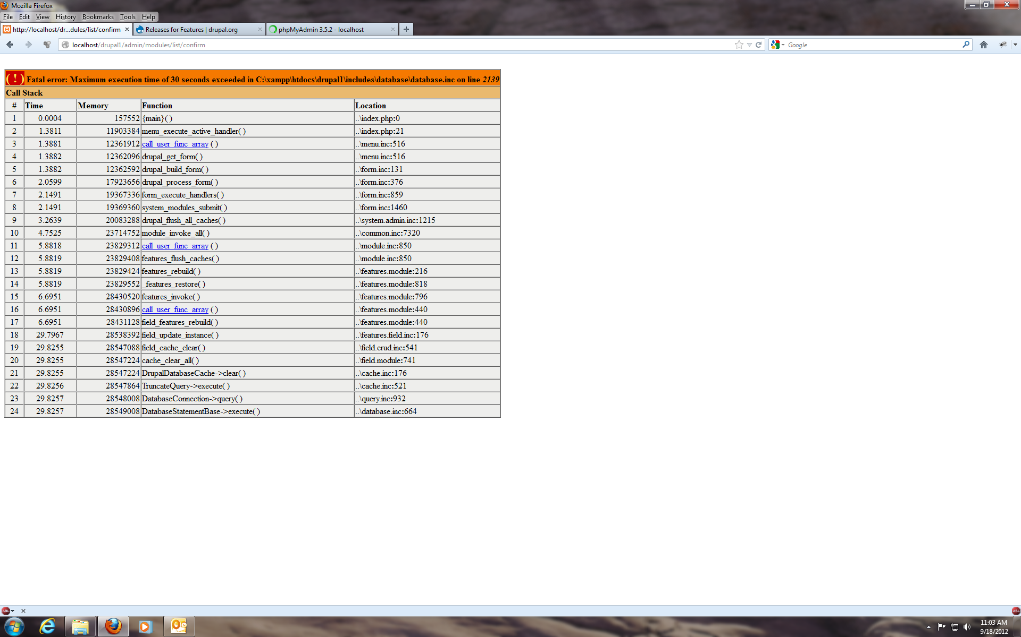

If this happens, we need to change the settings in PHP to allocate more time (generally it is 30 seconds, we may change it to 400 seconds) and memory (it is 128 Mb, we may change it to 1024Mb).

Again, the field collection module needs to be slightly modified; otherwise it gives the following error:

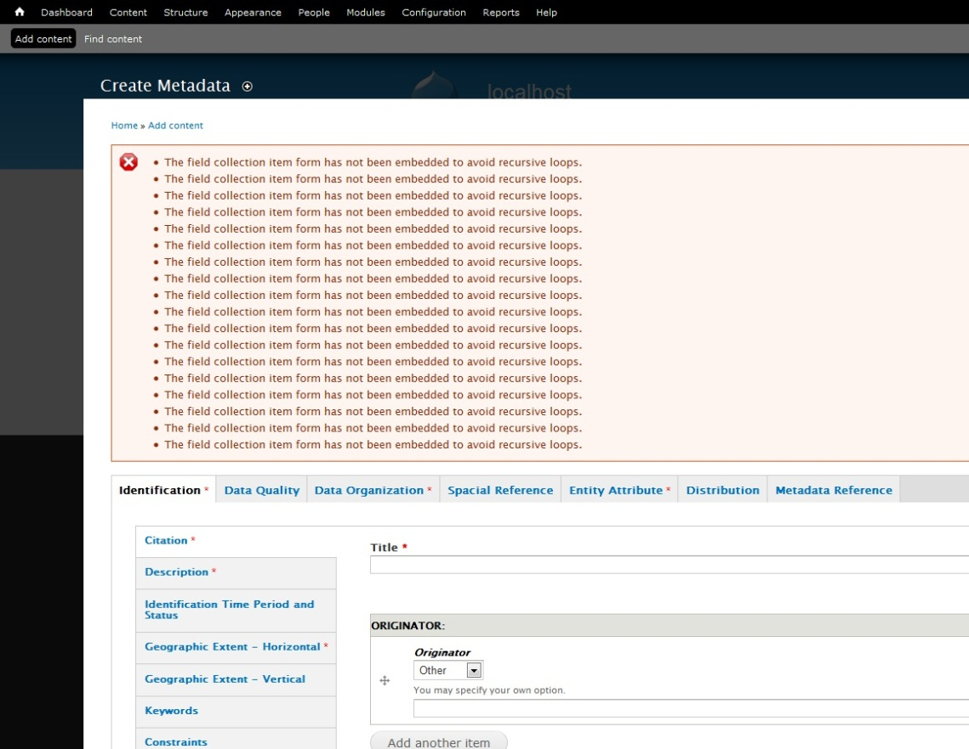

This error can be easily solved using the patch that I have created. Otherwise, we can also change the piece of code to handle it. The patch named “**field_collection.patch**” is provided along with the module. If you want to change the piece of code by yourself, you have to go to field_collection.module file (field_collection module) and edit the following:

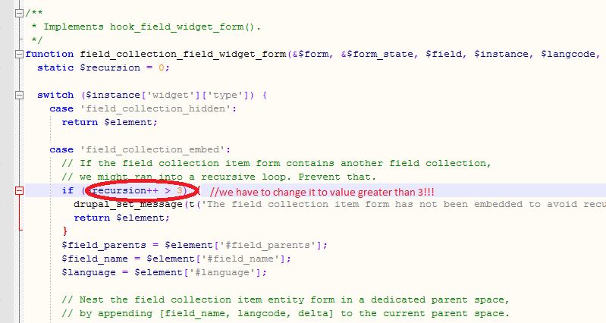

## XML2MetaData

### Pre-requisites:

To add the XML2MetaData Module, we need to make sure that following module is installed /enabled:

* Metadata_catalog (missing)

So, every prerequisite that holds for Metadata Catalog Module also holds for XML2MetaData.

### Default Location:

By default, the location for XML2MetaData is:

<BaseURL>/xml2metadata and it also appears in Navigation Menu.

The interface is quite simple and once you successfully create a node from XML, you will see the success message, as shown below:

