**CMIS 242-Project 2**

|  |  |  |  |
| --- | --- | --- | --- |
| Input | Expected Output | Actual Output | Pass? |
| 1. 500, Withdraw, Savings | Dialog box stating Insufficient Funds. Transaction amount: $500.00  Current Balance:$0.00 | Dialog box stating Insufficient Funds. Transaction amount: $500.00  Current Balance:$0.00 | Yes |
| 1. 500, Withdraw, Checking | Dialog box stating Insufficient Funds. Transaction amount: $500.00  Current Balance:$0.00 | Dialog box stating Insufficient Funds. Transaction amount: $500.00  Current Balance:$0.00 | Yes |
| 1. Hello, withdraw, checking | Dialog box stating “Please enter a valid amount” | Dialog box stating “Please enter a valid amount” | Yes |
| 1. Hello, withdraw, savings | Dialog box stating “Please enter a valid amount” | Dialog box stating “Please enter a valid amount” | Yes |
| 1. 500, deposit, savings | Dialog box stating $500 deposited. New Balance: $500.00 | Dialog box stating $500 deposited. New Balance: $500.00 | Yes |
| 1. 1500, deposit, checking | Dialog box stating $1500 deposited. New Balance: $1500.00 | Dialog box stating $1500 deposited. New Balance: $1500.00 | Yes |
| 1. Balance, checking | Dialog box stating “Your balance is $1500.00” | Dialog box stating “Your balance is $1500.00” | Yes |
| 1. Balance, savings | Dialog box stating “Your balance is $500.00” | Dialog box stating “Your balance is $500.00” | Yes |
| 1. 25, withdraw, savings | Dialog box stating “Withdrawals only permitted in increments of $20” | Dialog box stating “Withdrawals only permitted in increments of $20” | yes |
| 1. 4 $20 withdrawals from savings, then transfer $20 to savings | The transfer will not incur a $1.50 fee even though it is the fifth call to the withdraw method in the Account class. Savings balance will be $440, Checking balance will be $1480. | Dialog box shows “$20.00 transferred to savings. New savings balance: $440.00  New checking balance:$1480.00” | yes |
| 1. 20, withdraw, checking | Checking balance will be $1458.50 after withdrawal, having incurred the $1.50 fee for the 5th withdrawal. Dialog box will say “$20.00 withdrawn. New balance: $1458.50  **After 4 withdrawals you will incur a $1.50 fee per withdrawal” | Dialog box will say “$20.00 withdrawn. New balance: $1458.50  **After 4 withdrawals you will incur a $1.50 fee per withdrawal” | yes |
| 1. 100, transfer, checking | Dialog box will say “$100.00 transferred to checking. New checking balance: “1558.50  New savings balance: $340.00” | Dialog box will say “$100.00 transferred to checking. New checking balance: “1558.50  New savings balance: $340.00” | yes |
| 1. 400, transfer, checking | Dialog box stating “Insufficient Funds. Transaction amount: $400.00. Current Balance: $340.00” | Dialog box stating “Insufficient Funds. Transaction amount: $400.00. Current Balance: $340.00” | yes |
| 1. 340, Withdraw, savings | Dialog box stating “Insufficient Funds. Transaction amount: $341.50. Current Balance: $340.00” | Dialog box stating “Insufficient Funds. Transaction amount: $341.50. Current Balance: $340.00” | yes |

Test Case 1 Screenshot

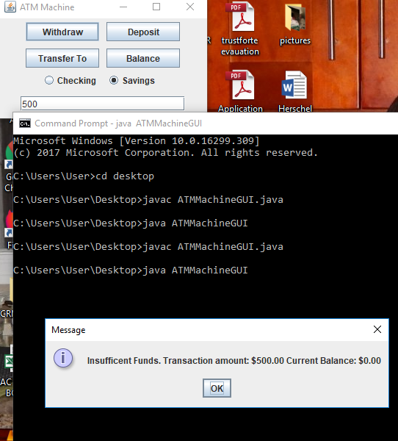

Test Case 2 Screenshot

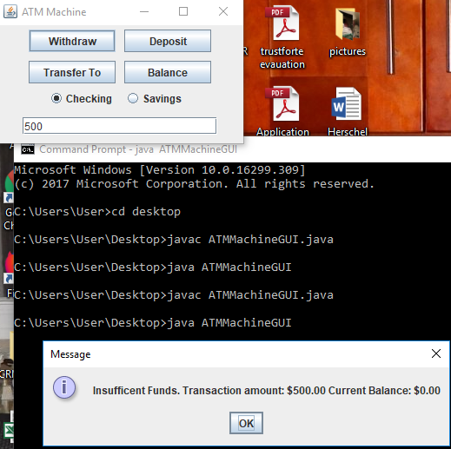

Test Case 3 Screenshot

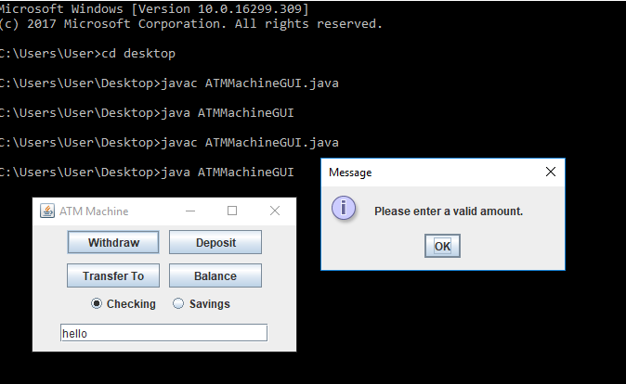

Test Case 4 Screenshot

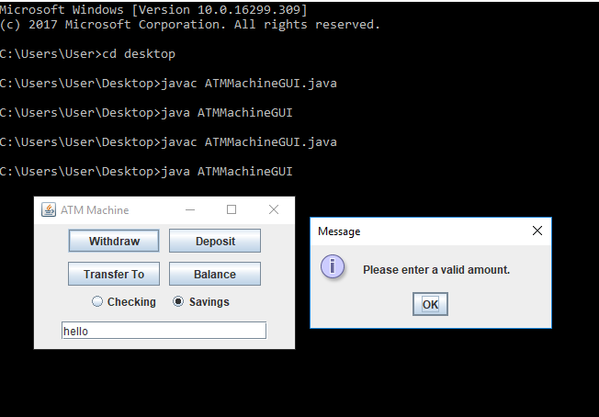

Test Case 5 Screenshot

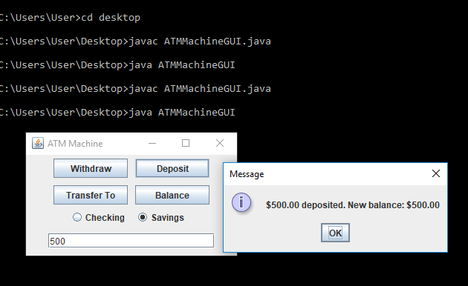

Test Case 6 Screenshot

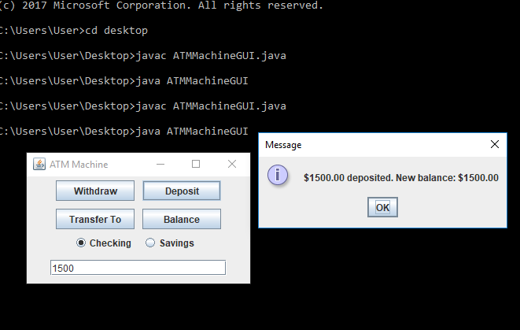

Test Case 7 Screenshot

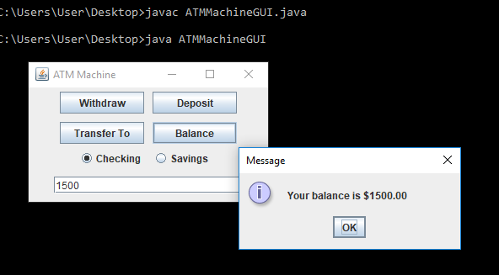

Test Case 8 Screenshot

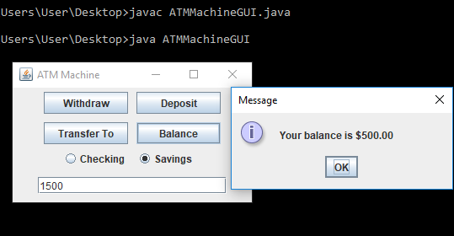

Test Case 9 Screenshot

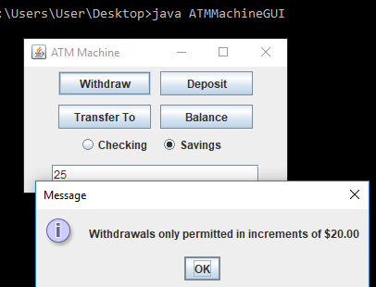

Test Case 10 Screenshot

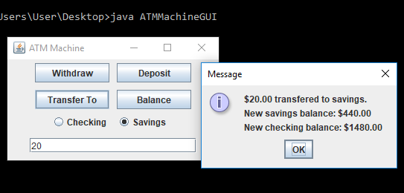

Test Case 11 Screenshot

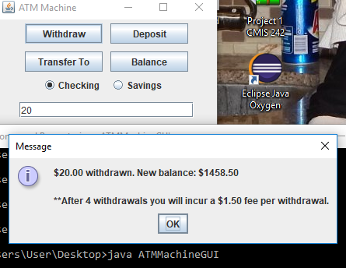

Test Case 12 Screenshot

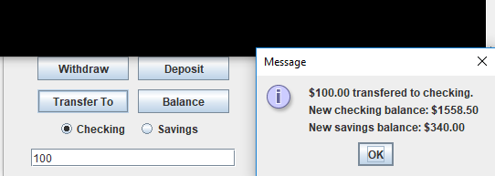

Test Case 13 Screenshot

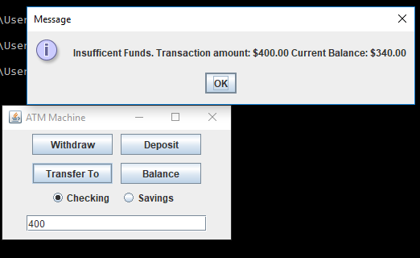

Test Case 14 Screenshot

