Project 4- CMIS 242

|  |  |  |  |
| --- | --- | --- | --- |
| **Input** | **Expected Output** | **Actual Output** | **Pass?** |
| 1.Javac ProjectGui.java  (compiling program) | Initial dialog box pops up | Initial dialog box pops up | Yes |
| 2. hello | “Please enter a positive integer value for ID.” | “Please enter a positive integer value for ID.” | Yes |
| 3. 21235 (incomplete data) | “Both name and major are required.” | “Both name and major are required.” | Yes |
| 4. 21235, Shafro | “Both name and major are required.” | “Both name and major are required.” | Yes |
| 5. 21235, Biology | “Both name and major are required.” | “Both name and major are required.” | Yes |
| 6. 21235, delete  (delete nonexistent ID) | “There is no record with this ID. Please enter a different ID.” | “There is no record with this ID. Please enter a different ID.” | Yes |
| 7. 21235, find  (delete nonexistent ID) | “There is no record with this ID. Please enter a different ID.” | “There is no record with this ID. Please enter a different ID.” | Yes |
| 8. 21235, update  (delete nonexistent ID) | “There is no record with this ID. Please enter a different ID.” | “There is no record with this ID. Please enter a different ID.” | Yes |
| 9. no input, “Process request” | “Please enter a positive integer value for ID.” | “Please enter a positive integer value for ID.” | Yes |
| 10.21235, Shafro Batyrov, Biology, Insert | Student: 21235  Name = SHAFRO BATYROV  Major = BIOLOGY  GPA = 4.00  Successfully added. | Student: 21235  Name = SHAFRO BATYROV  Major = BIOLOGY  GPA = 4.00  Successfully added. | Yes |
| 11. 10119, Lord Farquad, Political Science, Insert | Student: 10119  Name = LORD FARQUAD  Major = POLITICAL SCIENCE  GPA = 4.00  Successfully added. | Student: 10119  Name = LORD FARQUAD  Major = POLITICAL SCIENCE  GPA = 4.00  Successfully added. | Yes |
| 12. 40001, Steve Jobs, Computer Science, Insert | Student: 40001  Name = STEVE JOBS  Major = COMPUTER SCIENCE  GPA = 4.00  Successfully added. | Student: 40001  Name = STEVE JOBS  Major = COMPUTER SCIENCE  GPA = 4.00  Successfully added. | Yes |
| 13. 10119, Update, B, 3 | Student: 10119  Successfully updated.  Name = LORD FARQUAD  Major = POLITICAL SCIENCE  GPA = 3.00 | Student: 10119  Successfully updated.  Name = LORD FARQUAD  Major = POLITICAL SCIENCE  GPA = 3.00 | Yes |
| 14.10119, Update, A, 6 | Student: 10119  Successfully updated.  Name = LORD FARQUAD  Major = POLITICAL SCIENCE  GPA = 3.67 | Student: 10119  Successfully updated.  Name = LORD FARQUAD  Major = POLITICAL SCIENCE  GPA = 3.67 | Yes |
| 15.10119, Fiona, Martial Arts | “This ID value exists. Please enter a different ID.” | “This ID value exists. Please enter a different ID.” | Yes |
| 16. 40001, delete | Student: 40001  Successfully deleted. | Student: 40001  Successfully deleted. | Yes |
| 17.40001, find | “There is no record with this ID. Please enter a different ID.” | “There is no record with this ID. Please enter a different ID.” | Yes |
| 18. 21235, update, C, 3 | Student: 21235  Successfully updated.  Name = SHAFRO BATYROV  Major = BIOLOGY  GPA = 2.00 | Student: 21235  Successfully updated.  Name = SHAFRO BATYROV  Major = BIOLOGY  GPA = 2.00 | Yes |

Test Case 1 Screenshot:

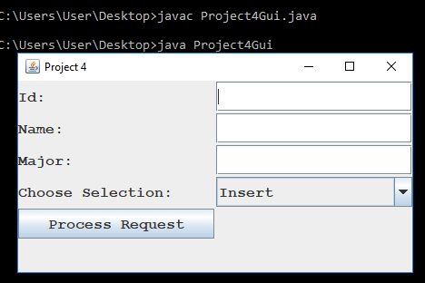

Test Case 2 Screenshot

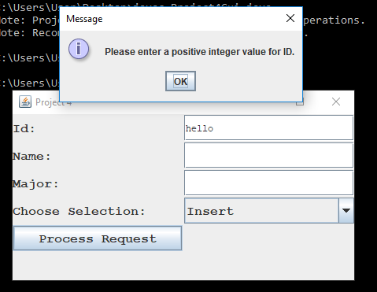

Test Case 3 Screenshot

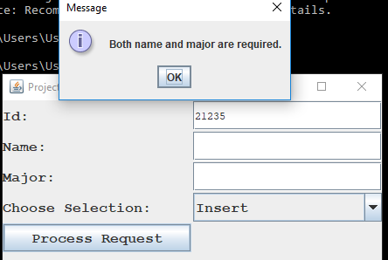

Test Case 4 Screenshot

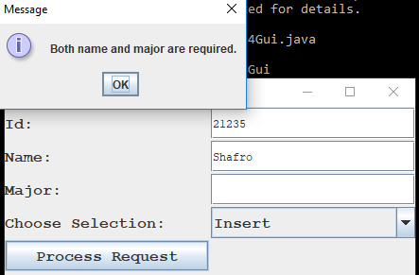

Test Case 5 Screenshot

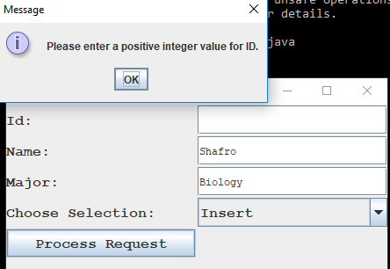

Test Case 6 Screenshot

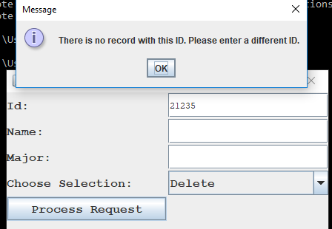

Test Case 7 Screenshot

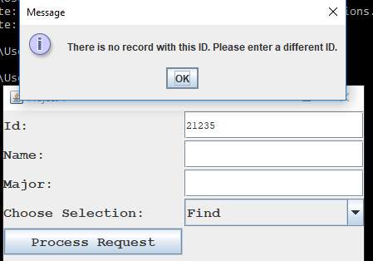

Test Case 8 Screenshot

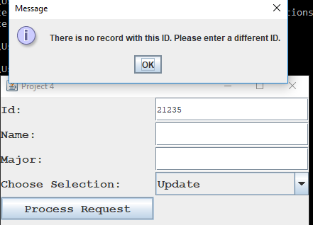

Test Case 9 Screenshot

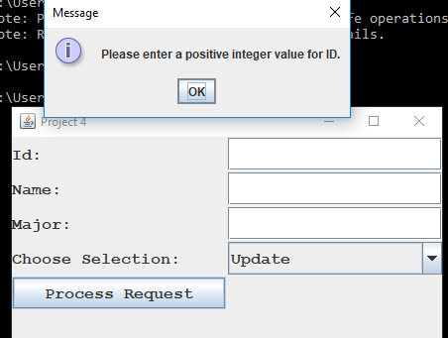

Test Case 10 Screenshot

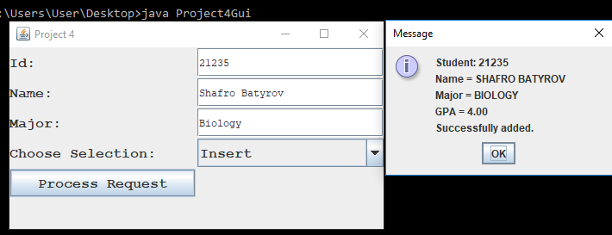

Test Case 11 Screenshot

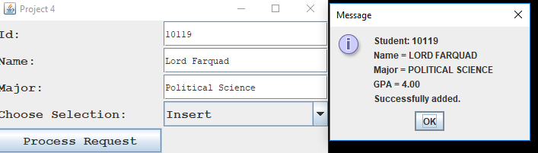

Test Case 12 Screenshot

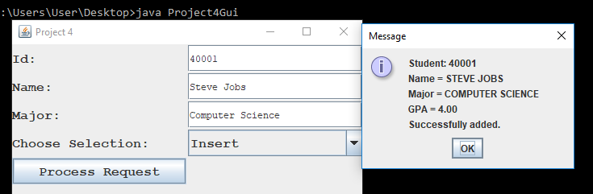

Test Case 13 Screenshot

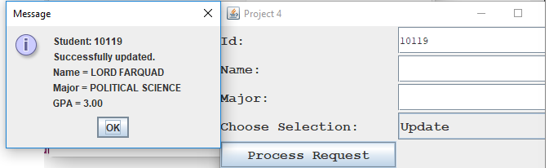

Test Case 14 Screenshot

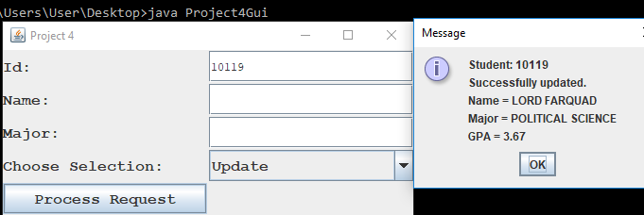

Test Case 15 Screenshot

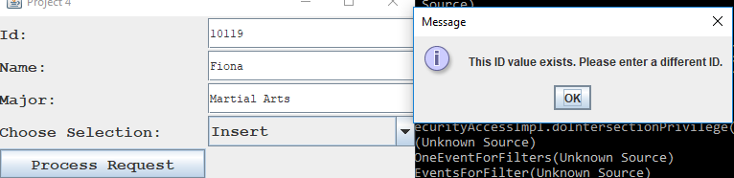

Test Case 16 Screenshot

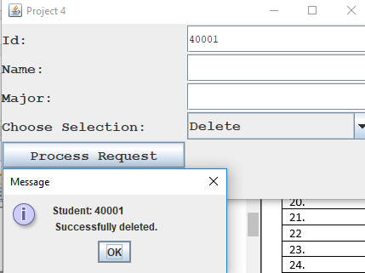

Test Case 17 Screenshot

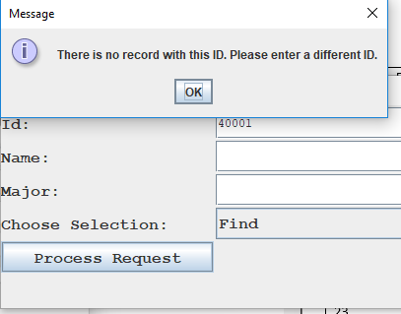

Test Case 18 Screenshot

