Class Problem

Travel Time Based Performance Measures

Overview
The Transportation Secretary of Factiousville has given you the responsibility to create an ordered list of bottlenecks in Factiousville that should be invested in order to mitigate congestion. You will be provided a map of the city with the eligible bottlenecks and more detailed information about each bottleneck including its histogram and volume.

Tasks
- For each bottleneck:
  - Create a cumulative distribution function (CDF) graph with 5% resolution
  - Calculate the:
    - Travel Time Index (TTI)
    - Planning Time Index (PTI)
- Rank the bottlenecks from 1 (bottleneck that justifies immediate investment) to 5 (bottleneck that can wait for improvements) based on the performance measures you calculated and for other reasons (volume not high enough, do not want to cause urban sprawl, etc.)
- Write a narrative at least 1 page (double space) in length justifying your rankings. Feel free to mention other projects around the US as examples.

Map

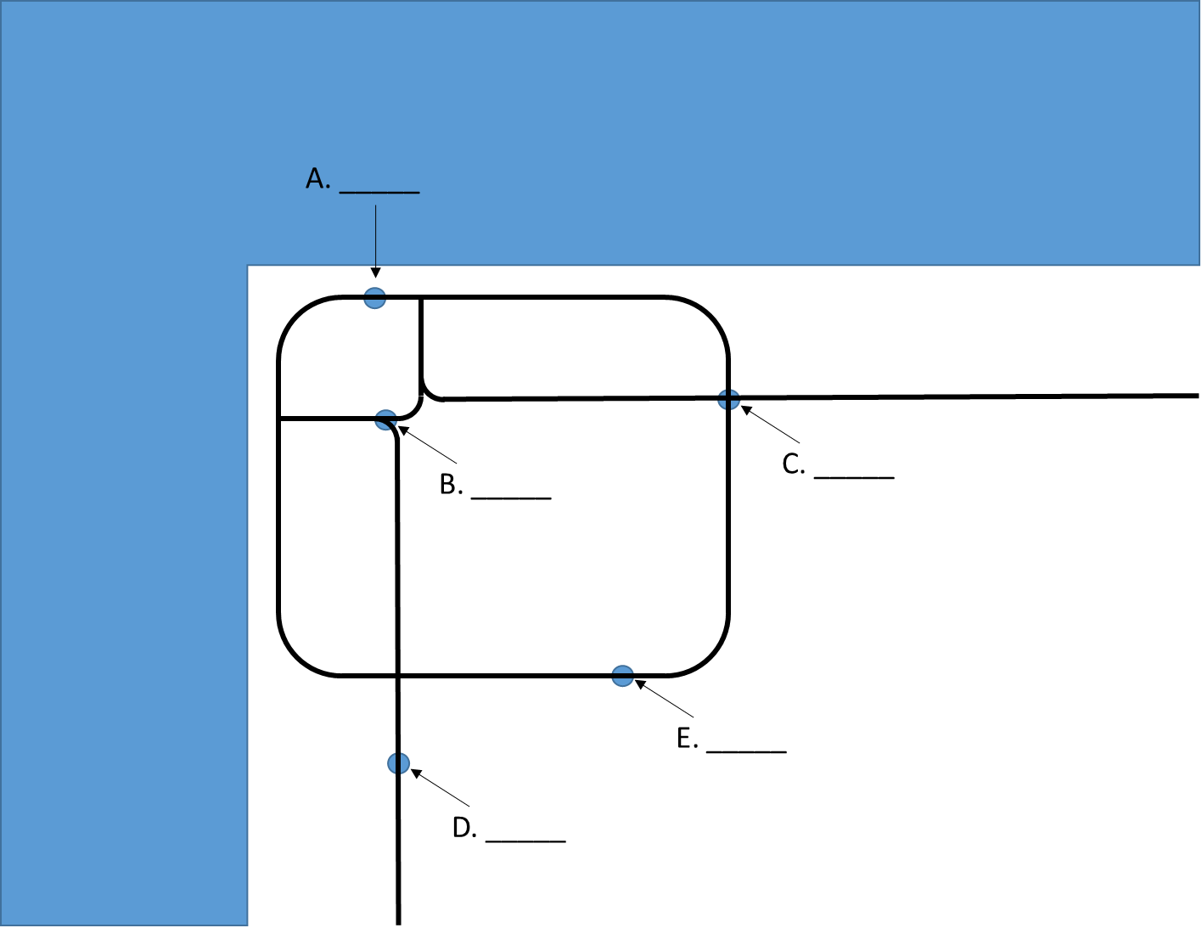

Picture Source: the University of Wisconsin System
Picture Source: Google Maps

Picture Source: dfwfreeways.com
Picture Source: Google Maps

Picture Source: fixoahu.blogspot.com

