RR-TB Updates: September 28, 2023

# Project Aim

* Back out trends in the prevalence of Rifampin resistant TB (RR-TB) over time using Xpert testing data in Sinan
* Develop a relatively simple model that accounts for variation in roll-out of Xpert over time and across geographies (e.g. by state), as well as potential bias in who is getting tested with Xpert

### Trends in Xpert testing overtime

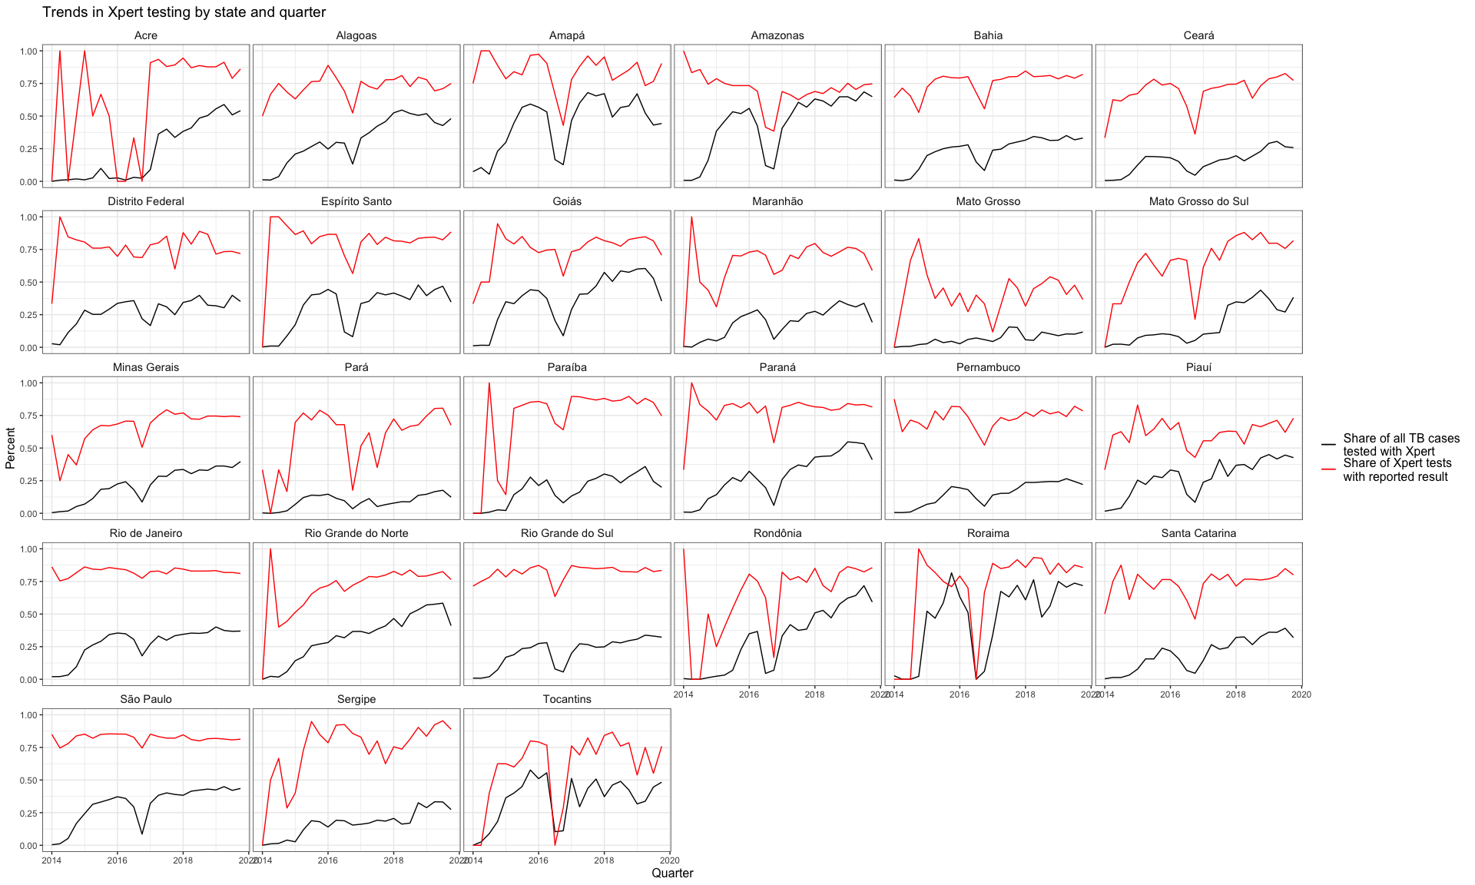

* As of 2019:
  + ~ 40% of cases were being tested with Xpert, compared to ~ 3% in 2014 and 23.5% in 2015, on average
  + Mato Grosso, Pará, and Pernambuco had the lowest average testing coverage
  + Roraima, Amazonas, and Rondônia had the highest average testing coverage

# Model Specification

### Overview

* State-level hierarchical generalized additive model (GAM) that models the prevalence of RR-TB positive cases per quarter among incident TB cases between 2014-2019
* Fit smoothing functions to reduce the noise we were seeing in previous models
* Models risk of positivity by characteristics of patient and municipality where they reside
  + Note: Between 2014-2019, ~3,300 cases diagnosed outside of patient’s state of residence; ~88,000 cases diagnosed outside patient’s municipality of residence
* Separate models for new TB cases, re-entry cases, and relapsed cases

### Set Up

result ~ s(state, bs = "re") + s(time) + s(time, by = state, id = 1) + age_cat +   
 hiv_status + sex + health_unit + bf_cat + urban_cat + has_prison

* Random intercept for each state (patient state of residence)
* A different smooth function for time by state with a shared smoothing parameter
* Each state-level smoothing parameter varies around a grand smooth function for time to allow for pooling across states
* Fixed effects for patient-level characteristics:
  + Age
  + HIV status
  + Sex
  + Level of health unit of diagnosis - Based on CNES merge
* Fixed effects for municipality-level characteristics:
  + Urbanicity (cat) - Percent of the population in urban setting (2010 census)
  + Bolsa Familia coverage (cat) - Percent of the population benefiting from BF (BF: SAGICAD, 2018 - earliest year available; Denominator: 2010 Census)
  + Presence of prison during year (SISPEN)
  + FHS Coverage - Number of health teams per 4,000 people (Forthcoming)

### Specifications:

* Model 1 - Adjusted:
  + Patient-level: HIV status, sex, age, health unit level
  + Municipality: BF coverage, urbanicity, presence of prison
* Model 2 - Adjusted; Restricted > 2015
* Run separately by case type (e.g. new, relapse, re-entry) and for all cases

# Model Output

## New cases

* Model A - Adjusted:
  + Patient-level: HIV status, sex, age (cat), health unit
  + Municipality: Pct average BF coverage (cat), pct pop in urban area, presence of prison
* Model B - Model A + interaction term (HIV, sex, age)
* Model C - Model A, restricted to >2015

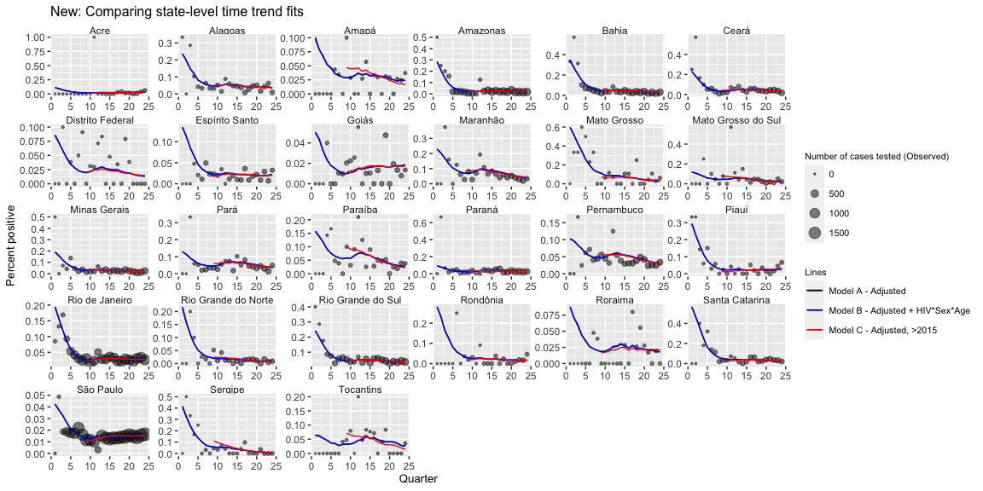

# Re-Entry Cases

## Fixed Axes

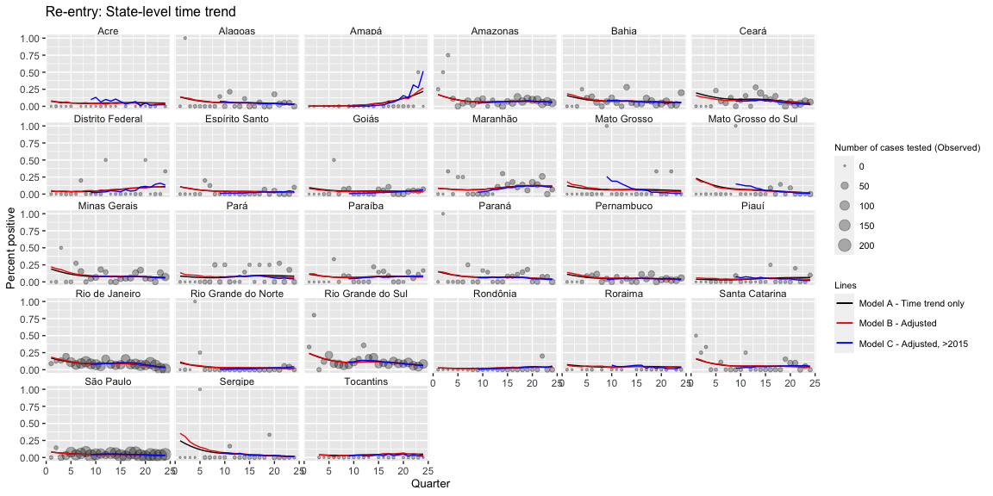

## Varied Axes

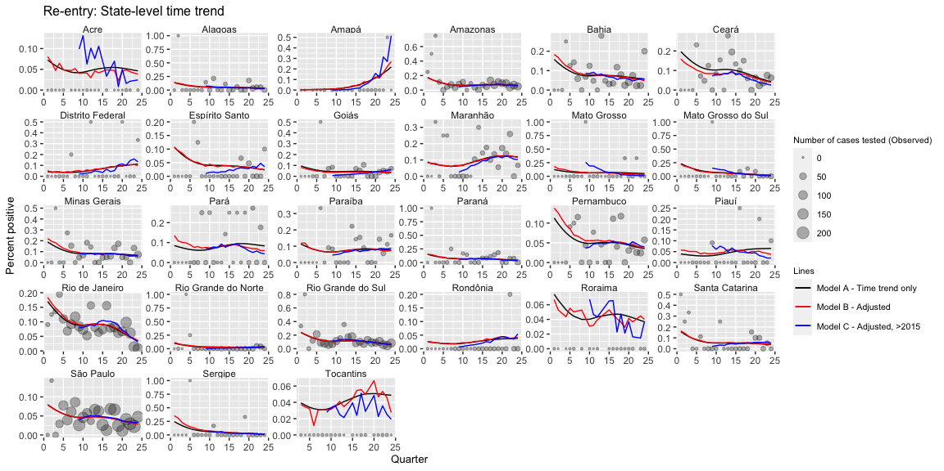

# Relapse Cases

## Fixed Axes

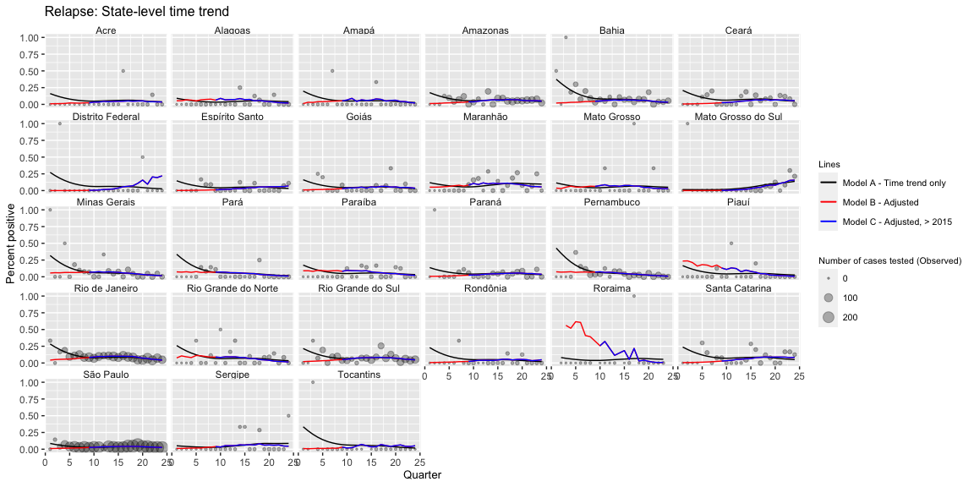

## Varied Axes

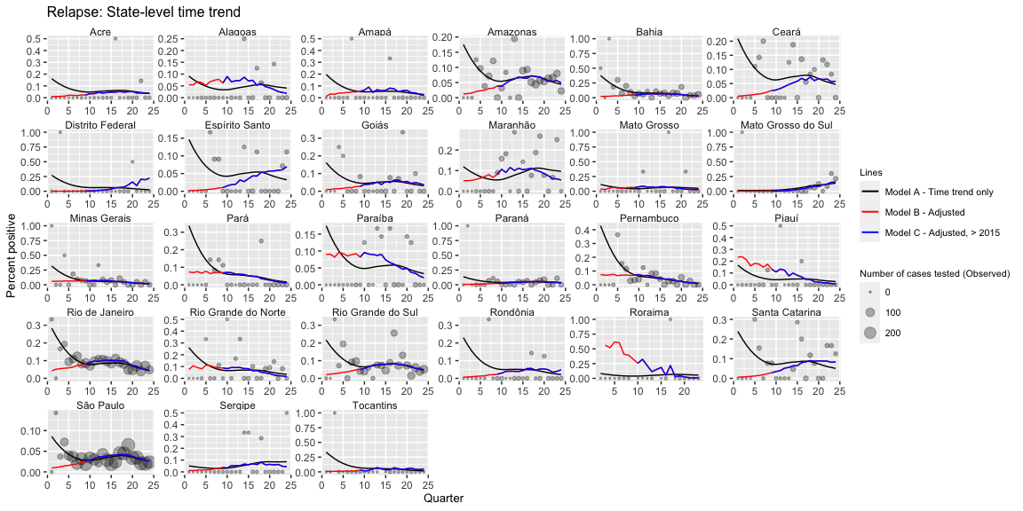

# All cases (e.g. Diagnoses types combined)

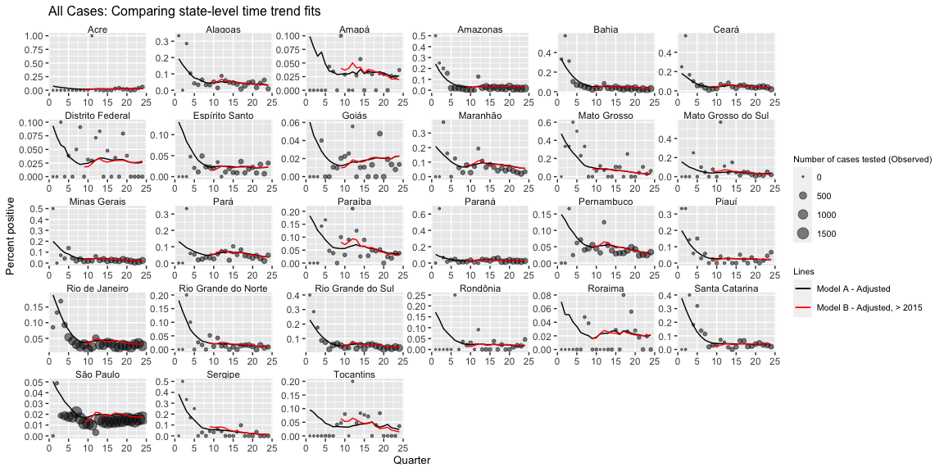

# Going Forward:

* Add in FHS coverage
* Aggregate to health region (to overcome noise when working with small municipalities)