Statistical Learning Project

# Statistical Learning Final Project

Group 2: Sarah, Pavel, Rose, Catherine, Shravya East

#load the necessary packages  
library(plyr)  
library(tidyverse)  
library(reshape2)  
library(readxl)  
library(caret)  
library(rpart)   
library(partykit)   
library(randomForest)  
library(class)  
library (rminer)  
library(e1071)  
library(mlbench)  
library(plyr)  
library(DMwR)

#Read in the data  
dat <- read_excel("Absenteeism_at_work.xls")  
  
#View the data  
glimpse(dat)

## Observations: 740  
## Variables: 21  
## $ ID <dbl> 11, 36, 3, 7, 11, 3, 10, 20,...  
## $ `Reason for absence` <dbl> 26, 0, 23, 7, 23, 23, 22, 23...  
## $ `Month of absence` <dbl> 7, 7, 7, 7, 7, 7, 7, 7, 7, 7...  
## $ `Day of the week` <dbl> 3, 3, 4, 5, 5, 6, 6, 6, 2, 2...  
## $ Seasons <dbl> 1, 1, 1, 1, 1, 1, 1, 1, 1, 1...  
## $ `Transportation expense` <dbl> 289, 118, 179, 279, 289, 179...  
## $ `Distance from Residence to Work` <dbl> 36, 13, 51, 5, 36, 51, 52, 5...  
## $ `Service time` <dbl> 13, 18, 18, 14, 13, 18, 3, 1...  
## $ Age <dbl> 33, 50, 38, 39, 33, 38, 28, ...  
## $ `Work load Average/day` <dbl> 239554, 239554, 239554, 2395...  
## $ `Hit target` <dbl> 97, 97, 97, 97, 97, 97, 97, ...  
## $ `Disciplinary failure` <dbl> 0, 1, 0, 0, 0, 0, 0, 0, 0, 0...  
## $ Education <dbl> 1, 1, 1, 1, 1, 1, 1, 1, 1, 3...  
## $ Son <dbl> 2, 1, 0, 2, 2, 0, 1, 4, 2, 1...  
## $ `Social drinker` <dbl> 1, 1, 1, 1, 1, 1, 1, 1, 1, 0...  
## $ `Social smoker` <dbl> 0, 0, 0, 1, 0, 0, 0, 0, 0, 0...  
## $ Pet <dbl> 1, 0, 0, 0, 1, 0, 4, 0, 0, 1...  
## $ Weight <dbl> 90, 98, 89, 68, 90, 89, 80, ...  
## $ Height <dbl> 172, 178, 170, 168, 172, 170...  
## $ `Body mass index` <dbl> 30, 31, 31, 24, 30, 31, 27, ...  
## $ `Absenteeism time in hours` <dbl> 4, 0, 2, 4, 2, 2, 8, 4, 40, ...

## Pre-Processing Data

#Set factored variables as factors  
col <- c("ID", "Reason for absence", "Month of absence", "Day of the week", "Seasons", "Disciplinary failure", "Education", "Social drinker", "Social smoker")  
#set all categorical variables as ordered factors  
dat[col] <- lapply(dat[col], as.factor)  
dat[col] <- lapply(dat[col], ordered)  
  
#Rename the columns for easier use  
colnames(dat) <- c("ID", "Reason", "Month", "Day", "Seasons", "Transportation_expense", "Distance", "Service_time", "Age", "Work_load", "Hit_target", "Disciplinary_failure", "Education", "Children", "Social_drinker", "Social_smoker", "Pet", "Weight", "Height", "BMI", "Absent_time")  
  
#View the data  
glimpse(dat)

## Observations: 740  
## Variables: 21  
## $ ID <ord> 11, 36, 3, 7, 11, 3, 10, 20, 14, 1, 20,...  
## $ Reason <ord> 26, 0, 23, 7, 23, 23, 22, 23, 19, 22, 1...  
## $ Month <ord> 7, 7, 7, 7, 7, 7, 7, 7, 7, 7, 7, 7, 7, ...  
## $ Day <ord> 3, 3, 4, 5, 5, 6, 6, 6, 2, 2, 2, 3, 4, ...  
## $ Seasons <ord> 1, 1, 1, 1, 1, 1, 1, 1, 1, 1, 1, 1, 1, ...  
## $ Transportation_expense <dbl> 289, 118, 179, 279, 289, 179, 361, 260,...  
## $ Distance <dbl> 36, 13, 51, 5, 36, 51, 52, 50, 12, 11, ...  
## $ Service_time <dbl> 13, 18, 18, 14, 13, 18, 3, 11, 14, 14, ...  
## $ Age <dbl> 33, 50, 38, 39, 33, 38, 28, 36, 34, 37,...  
## $ Work_load <dbl> 239554, 239554, 239554, 239554, 239554,...  
## $ Hit_target <dbl> 97, 97, 97, 97, 97, 97, 97, 97, 97, 97,...  
## $ Disciplinary_failure <ord> 0, 1, 0, 0, 0, 0, 0, 0, 0, 0, 0, 0, 0, ...  
## $ Education <ord> 1, 1, 1, 1, 1, 1, 1, 1, 1, 3, 1, 1, 1, ...  
## $ Children <dbl> 2, 1, 0, 2, 2, 0, 1, 4, 2, 1, 4, 4, 4, ...  
## $ Social_drinker <ord> 1, 1, 1, 1, 1, 1, 1, 1, 1, 0, 1, 1, 1, ...  
## $ Social_smoker <ord> 0, 0, 0, 1, 0, 0, 0, 0, 0, 0, 0, 0, 0, ...  
## $ Pet <dbl> 1, 0, 0, 0, 1, 0, 4, 0, 0, 1, 0, 0, 0, ...  
## $ Weight <dbl> 90, 98, 89, 68, 90, 89, 80, 65, 95, 88,...  
## $ Height <dbl> 172, 178, 170, 168, 172, 170, 172, 168,...  
## $ BMI <dbl> 30, 31, 31, 24, 30, 31, 27, 23, 25, 29,...  
## $ Absent_time <dbl> 4, 0, 2, 4, 2, 2, 8, 4, 40, 8, 8, 8, 8,...

#create a list of the numeric variables in the data set  
nums <- unlist(lapply(dat, is.numeric))   
#create a smaller data set of just numeric variables  
dat.num <- dat[ , nums]

## EDA Response Variable

### Absent_time

summary(dat$Absent_time)

## Min. 1st Qu. Median Mean 3rd Qu. Max.   
## 0.000 2.000 3.000 6.924 8.000 120.000

dat %>%   
 count(Absent_time)

## # A tibble: 19 x 2  
## Absent_time n  
## <dbl> <int>  
## 1 0 44  
## 2 1 88  
## 3 2 157  
## 4 3 112  
## 5 4 60  
## 6 5 7  
## 7 7 1  
## 8 8 208  
## 9 16 19  
## 10 24 16  
## 11 32 6  
## 12 40 7  
## 13 48 1  
## 14 56 2  
## 15 64 3  
## 16 80 3  
## 17 104 1  
## 18 112 2  
## 19 120 3

#plot the Absent_time  
ggplot(data = dat,  
 aes(x = Absent_time)) +  
 geom_histogram() +   
 theme_minimal()

## `stat_bin()` using `bins = 30`. Pick better value with `binwidth`.

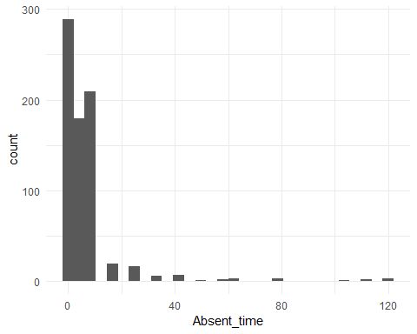

#change variable represent missed time one day or greater  
dat <- dat %>%   
 mutate(Absent_time = ifelse(dat$Absent_time <= 8,0,1))

#save Absent_time as a factor in the data set  
dat$Absent_time <- as.factor(dat$Absent_time)  
#Transforming to Data Frame  
dat <- as.data.frame(dat)

#plot the Absent_time  
ggplot(data = dat,  
 aes(x = Absent_time)) +  
 geom_bar() +   
 theme_minimal()

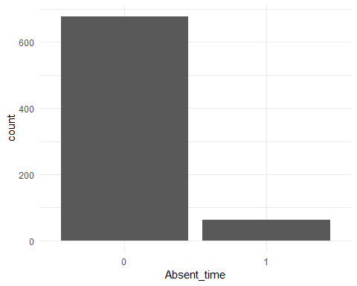

#plot all variables vs. Absent_time  
dat %>%  
 gather(-Absent_time, key = "var_name", value = "value") %>%  
 ggplot(aes(x = value, y = Absent_time)) +  
 geom_point() +  
 facet_wrap(~ var_name, scales = "free") +  
 theme_minimal()

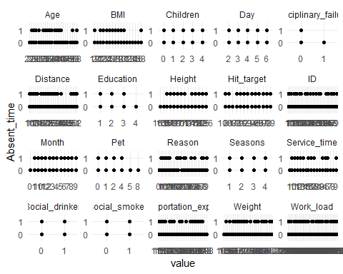

## EDA Predictors

### ID

#frequency table by ID  
dat %>%   
 count(ID)

## # A tibble: 36 x 2  
## ID n  
## <ord> <int>  
## 1 1 23  
## 2 2 6  
## 3 3 113  
## 4 4 1  
## 5 5 19  
## 6 6 8  
## 7 7 6  
## 8 8 2  
## 9 9 8  
## 10 10 24  
## # ... with 26 more rows

#bar chart  
dat %>%   
 ggplot(aes(x = ID)) +  
 geom_bar() +  
 theme_minimal()

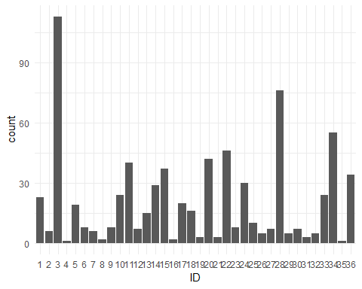

#ID  
dat %>%  
 gather(-ID, key = "var_name", value = "value") %>%  
 ggplot(aes(x = value, y = ID)) +  
 geom_point() +  
 facet_wrap(~ var_name, scales = "free") +   
 theme_minimal()

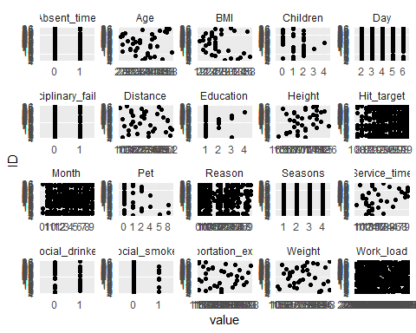

### Reason

#frequency table by Reason for Absence  
dat %>%   
 count(Reason)

## # A tibble: 28 x 2  
## Reason n  
## <ord> <int>  
## 1 0 43  
## 2 1 16  
## 3 2 1  
## 4 3 1  
## 5 4 2  
## 6 5 3  
## 7 6 8  
## 8 7 15  
## 9 8 6  
## 10 9 4  
## # ... with 18 more rows

#bar chart  
dat %>%   
 filter(Absent_time==0) %>%  
 ggplot(aes(x=Reason)) +  
 geom_bar() +  
 theme_minimal()

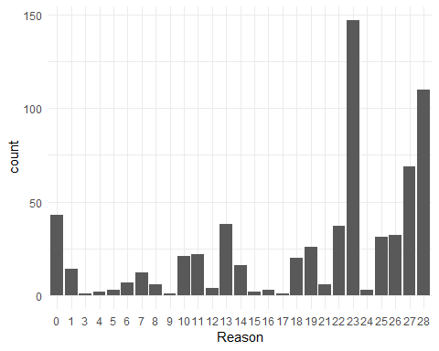

dat %>%   
 filter(Absent_time==1) %>%  
 ggplot(aes(x=Reason)) +  
 geom_bar() +  
 theme_minimal()

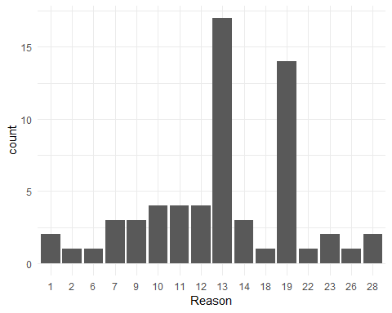

#Reason for absence  
table(dat %>%  
 filter(Reason==0) %>%  
 select(Absent_time))

##   
## 0 1   
## 43 0

dat %>%  
 gather(-Reason, key = "var_name", value = "value") %>%  
 ggplot(aes(x = value, y = Reason)) +  
 geom_point() +  
 facet_wrap(~ var_name, scales = "free") +   
 theme_minimal()

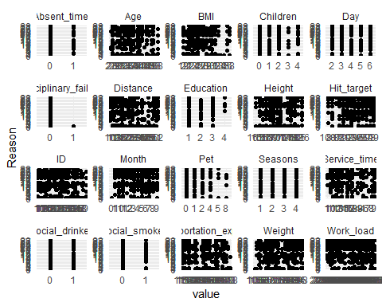

### Month

#frequency table by Month of Absence  
dat %>%   
 count(Month)

## # A tibble: 13 x 2  
## Month n  
## <ord> <int>  
## 1 0 3  
## 2 1 50  
## 3 2 72  
## 4 3 87  
## 5 4 53  
## 6 5 64  
## 7 6 54  
## 8 7 67  
## 9 8 54  
## 10 9 53  
## 11 10 71  
## 12 11 63  
## 13 12 49

#bar chart  
dat %>%   
 ggplot(aes(x=Month)) +  
 geom_bar() +  
 theme_minimal()

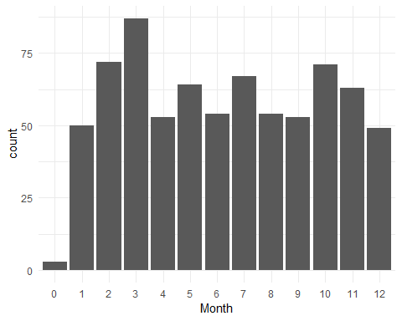

dat %>%  
 gather(-Month, key = "var_name", value = "value") %>%  
 ggplot(aes(x = value, y = Month)) +  
 geom_point() +  
 facet_wrap(~ var_name, scales = "free") +   
 theme_minimal()

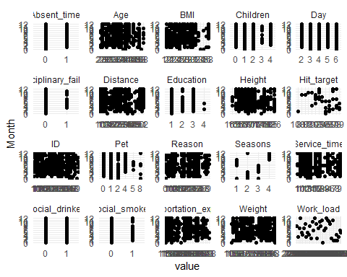

### Day

#frequency table by Day of Absence  
dat %>%   
 count(Day)

## # A tibble: 5 x 2  
## Day n  
## <ord> <int>  
## 1 2 161  
## 2 3 154  
## 3 4 156  
## 4 5 125  
## 5 6 144

#bar chart  
dat %>%   
 ggplot(aes(x=Month)) +  
 geom_bar() +  
 theme_minimal()



dat %>%  
 gather(-Day, key = "var_name", value = "value") %>%  
 ggplot(aes(x = value, y = Day)) +  
 geom_point() +  
 facet_wrap(~ var_name, scales = "free") +  
 theme_minimal()

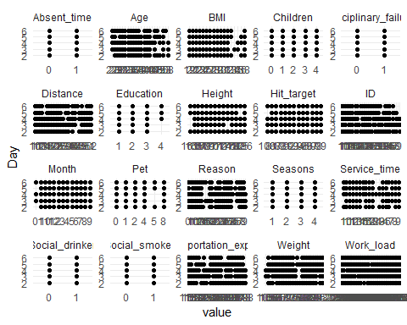

### Seasons

#frequency table by Season of Absence  
dat %>%   
 count(Seasons)

## # A tibble: 4 x 2  
## Seasons n  
## <ord> <int>  
## 1 1 170  
## 2 2 192  
## 3 3 183  
## 4 4 195

#bar chart  
dat %>%   
 ggplot(aes(x=Seasons)) +  
 geom_bar() +  
 theme_minimal()

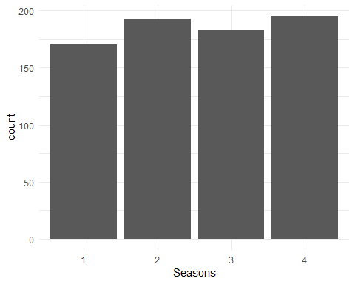

#Scatterplots for variable 'Seasons'  
dat %>%  
 gather(-Seasons, key = "var_name", value = "value") %>%  
 ggplot(aes(x = value, y = Seasons)) +  
 geom_point() +  
 facet_wrap(~ var_name, scales = "free") +  
 theme_minimal()

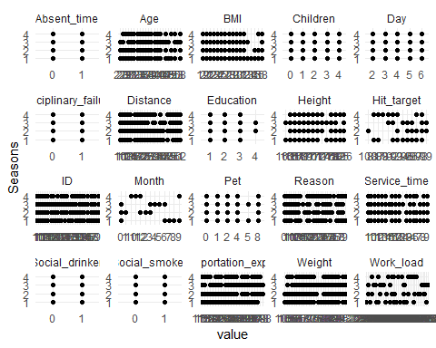

### Transportation Expense

#summary of transportation expenses  
summary(dat$Transportation_expense)

## Min. 1st Qu. Median Mean 3rd Qu. Max.   
## 118.0 179.0 225.0 221.3 260.0 388.0

#histograph  
ggplot(data = dat,  
 aes(x = Transportation_expense)) +  
 geom_histogram(binwidth = 50) +   
 theme_minimal()

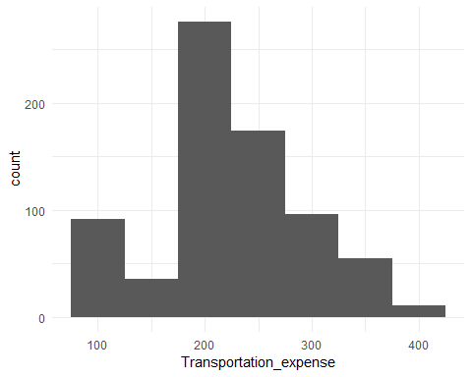

#Scatterplots for variable 'Transportation_expense'  
dat %>%  
 gather(-Transportation_expense, key = "var_name", value = "value") %>%  
 ggplot(aes(x = value, y = Transportation_expense)) +  
 geom_point() +  
 facet_wrap(~ var_name, scales = "free") +  
 theme_minimal()

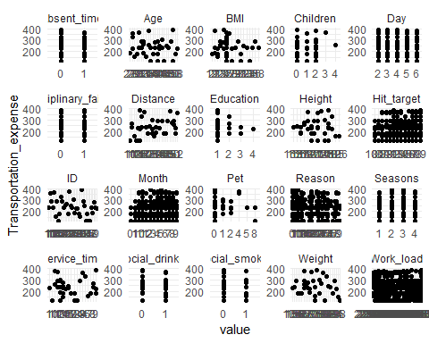

# Possible positive correlation seen between distance and Transportation_expense

### Distance

#summary of distance  
summary(dat$Distance)

## Min. 1st Qu. Median Mean 3rd Qu. Max.   
## 5.00 16.00 26.00 29.63 50.00 52.00

#histogram  
ggplot(data = dat,  
 aes(x = Distance)) +  
 geom_histogram(binwidth = 5) +   
 theme_minimal()

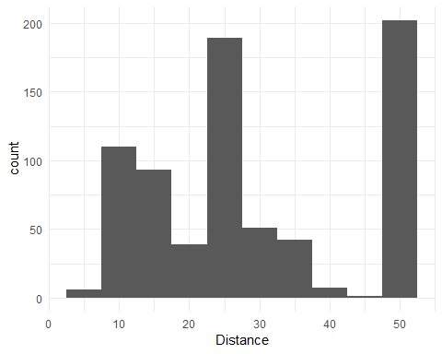

#Scatterplots for variable 'Distance'  
dat %>%  
 gather(-Distance, key = "var_name", value = "value") %>%  
 ggplot(aes(x = value, y = Distance)) +  
 geom_point() +  
 facet_wrap(~ var_name, scales = "free") +  
 theme_minimal()

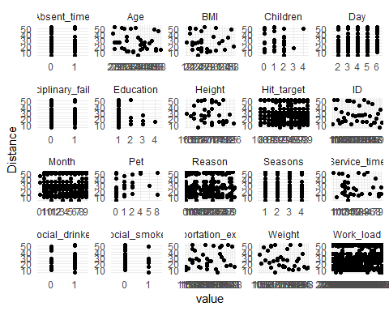

#Possible Positive correlation seen between distance and Transportation_expense

### Service Time

#summary for Service_time  
summary(dat$Service_time)

## Min. 1st Qu. Median Mean 3rd Qu. Max.   
## 1.00 9.00 13.00 12.55 16.00 29.00

#histogram  
ggplot(data = dat,  
 aes(x = Service_time)) +  
 geom_histogram(bins = 20) +  
 theme_minimal()

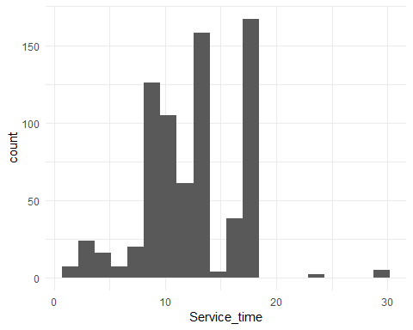

#Scatterplots for variable 'Service_time'  
dat %>%  
 gather(-Service_time, key = "var_name", value = "value") %>%  
 ggplot(aes(x = value, y = Service_time)) +  
 geom_point() +  
 facet_wrap(~ var_name, scales = "free") +  
 theme_minimal()

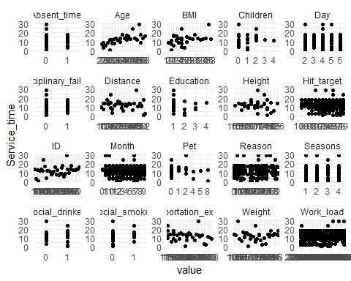

### Age

#summary for Age  
summary(dat$Age)

## Min. 1st Qu. Median Mean 3rd Qu. Max.   
## 27.00 31.00 37.00 36.45 40.00 58.00

#histogram  
ggplot(data = dat,  
 aes(x = Age)) +  
 geom_histogram(bins = 20) +   
 theme_minimal()

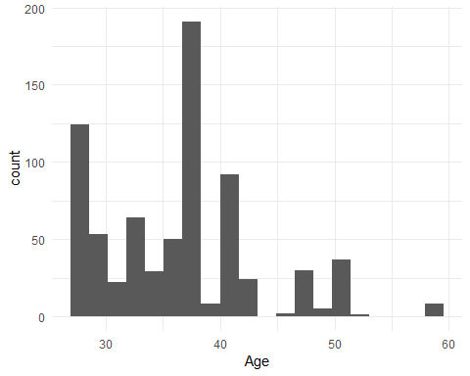

#Scatterplots for variable 'Age'  
dat %>%  
 gather(-Age, key = "var_name", value = "value") %>%  
 ggplot(aes(x = value, y = Age)) +  
 geom_point() +  
 facet_wrap(~ var_name, scales = "free") +  
 theme_minimal()

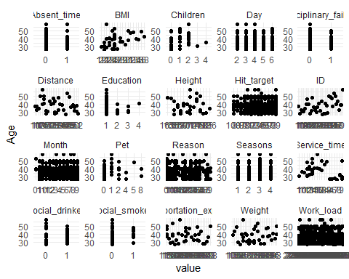

### Workload

#summary for work load  
summary(dat$Work_load)

## Min. 1st Qu. Median Mean 3rd Qu. Max.   
## 205917 244387 264249 271490 294217 378884

#histogram  
ggplot(data = dat,  
 aes(x = Work_load)) +  
 geom_histogram(binwidth = 5000) +   
 theme_minimal()

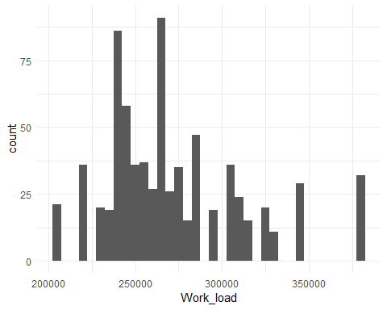

#Scatterplots for variable 'Work_load'  
dat %>%  
 gather(-Work_load, key = "var_name", value = "value") %>%  
 ggplot(aes(x = value, y = Work_load)) +  
 geom_point() +  
 facet_wrap(~ var_name, scales = "free") +  
 theme_minimal()

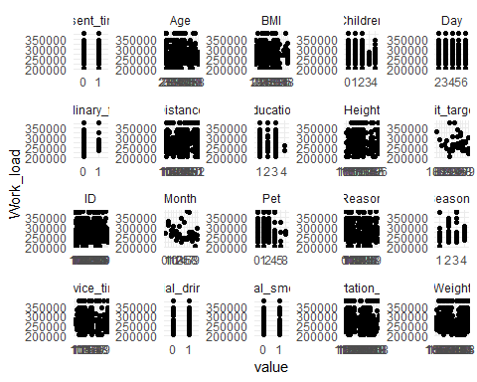

### Hit Target

#summary for hit target  
summary(dat$Hit_target)

## Min. 1st Qu. Median Mean 3rd Qu. Max.   
## 81.00 93.00 95.00 94.59 97.00 100.00

#histogram  
ggplot(data = dat,  
 aes(x = Hit_target)) +   
 geom_histogram(bins = 20) +  
 theme_minimal()

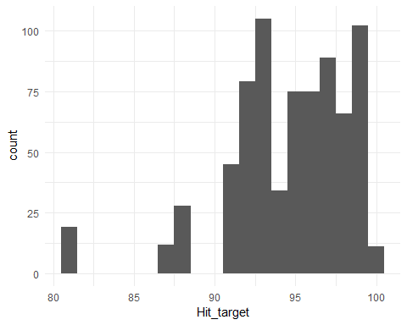

#Scatterplots for variable 'Hit_target'  
dat %>%  
 gather(-Hit_target, key = "var_name", value = "value") %>%  
 ggplot(aes(x = value, y = Hit_target)) +  
 geom_point() +  
 facet_wrap(~ var_name, scales = "free") +  
 theme_minimal()

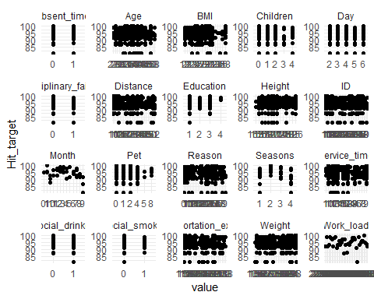

### Disciplinary Failure

#table for disciplinary failure  
dat %>%  
 count(Disciplinary_failure)

## # A tibble: 2 x 2  
## Disciplinary_failure n  
## <ord> <int>  
## 1 0 700  
## 2 1 40

#bar chart  
ggplot(data = dat,  
 aes(x = Disciplinary_failure)) +  
 geom_bar() +  
 theme_minimal()

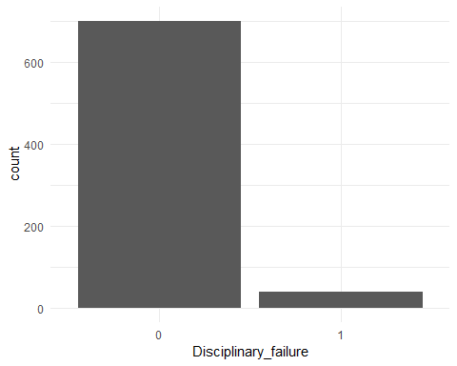

#Scatterplots for variable 'Disciplinary_failure'  
dat %>%  
 gather(-Disciplinary_failure, key = "var_name", value = "value") %>%  
 ggplot(aes(x = value, y = Disciplinary_failure)) +  
 geom_point() +  
 facet_wrap(~ var_name, scales = "free") +  
 theme_minimal()

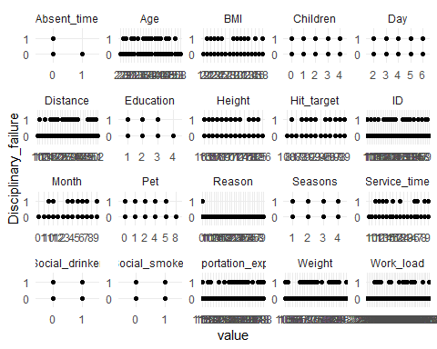

### Education

#table for education  
dat %>%  
 count(Education)

## # A tibble: 4 x 2  
## Education n  
## <ord> <int>  
## 1 1 611  
## 2 2 46  
## 3 3 79  
## 4 4 4

#bar chart  
ggplot(data = dat,  
 aes(x = Education)) +  
 geom_bar() +  
 theme_minimal()

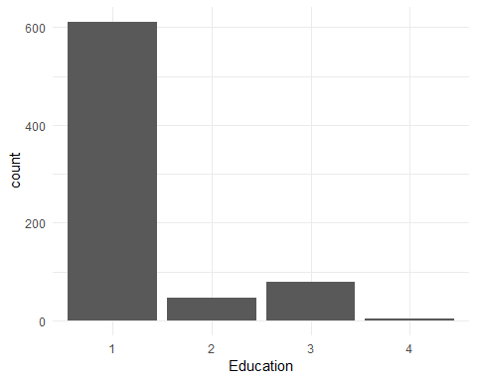

#Scatterplots for variable 'Education'  
dat %>%  
 gather(-Education, key = "var_name", value = "value") %>%  
 ggplot(aes(x = value, y = Education)) +  
 geom_point() +  
 facet_wrap(~ var_name, scales = "free") +   
 theme_minimal()

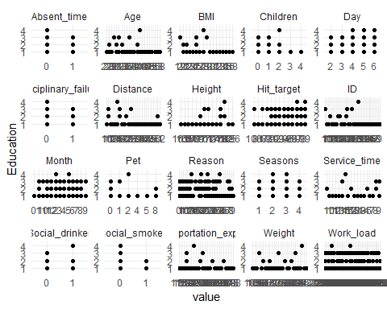

### Children

#table for number of children  
dat %>%  
 count(Children)

## # A tibble: 5 x 2  
## Children n  
## <dbl> <int>  
## 1 0 298  
## 2 1 229  
## 3 2 156  
## 4 3 15  
## 5 4 42

#bar chart  
ggplot(data = dat,  
 aes(x = Children)) +  
 geom_bar() +  
 theme_minimal()

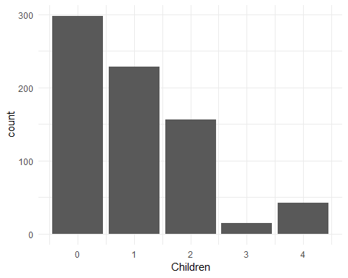

#Scatterplots for variable 'Children'  
dat %>%  
 gather(-Children, key = "var_name", value = "value") %>%  
 ggplot(aes(x = value, y = Children)) +  
 geom_point() +  
 facet_wrap(~ var_name, scales = "free") +  
 theme_minimal()

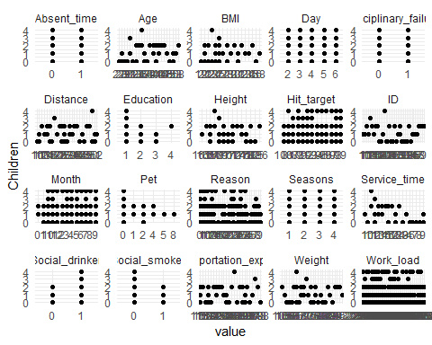

### Social Drinker

#table for social drinking  
dat %>%  
 count(Social_drinker)

## # A tibble: 2 x 2  
## Social_drinker n  
## <ord> <int>  
## 1 0 320  
## 2 1 420

#bar chart  
ggplot(data = dat,  
 aes(x = Social_drinker)) +   
 geom_bar() +  
 theme_minimal()

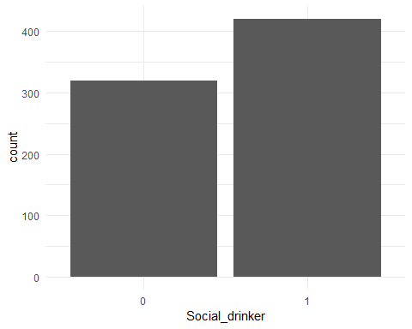

#Scatterplots for variable 'Social_drinker'  
dat %>%  
 gather(-Social_drinker, key = "var_name", value = "value") %>%  
 ggplot(aes(x = value, y = Social_drinker)) +  
 geom_point() +  
 facet_wrap(~ var_name, scales = "free") +  
 theme_minimal()

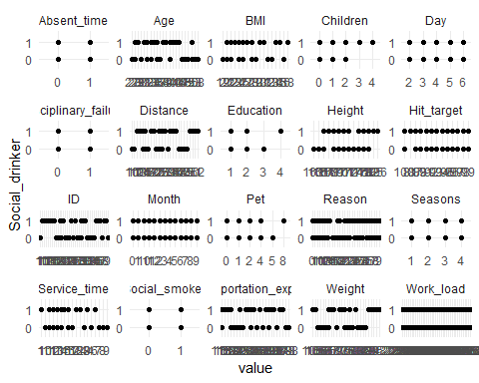

### Social Smoker

#table for social smokers  
dat %>%  
 count(Social_smoker)

## # A tibble: 2 x 2  
## Social_smoker n  
## <ord> <int>  
## 1 0 686  
## 2 1 54

#bar chart  
ggplot(data = dat,  
 aes(x = Social_smoker)) +   
 geom_bar() +  
 theme_minimal()

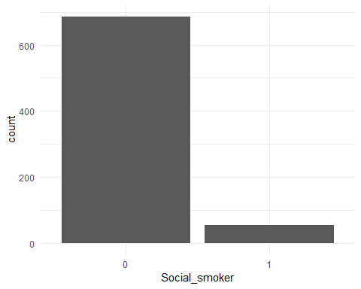

#Scatterplots for variable 'Social_smoker'  
dat %>%  
 gather(-Social_smoker, key = "var_name", value = "value") %>%  
 ggplot(aes(x = value, y = Social_smoker)) +  
 geom_point() +  
 facet_wrap(~ var_name, scales = "free") +   
 theme_minimal()

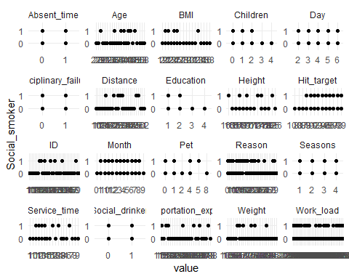

### Pet

#summary for pets  
summary(dat$Pet)

## Min. 1st Qu. Median Mean 3rd Qu. Max.   
## 0.0000 0.0000 0.0000 0.7459 1.0000 8.0000

#histogram  
ggplot(data = dat,  
 aes(x = Pet)) +  
 geom_bar() +  
 theme_minimal()

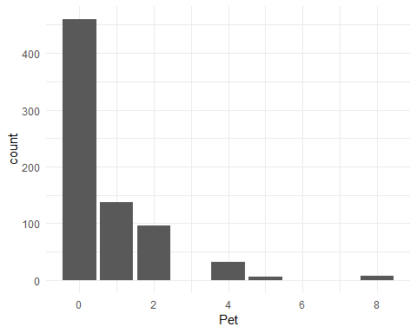

#Scatterplots for variable 'Pet'  
dat %>%  
 gather(-Pet, key = "var_name", value = "value") %>%  
 ggplot(aes(x = value, y = Pet)) +  
 geom_point() +  
 facet_wrap(~ var_name, scales = "free") +   
 theme_minimal()

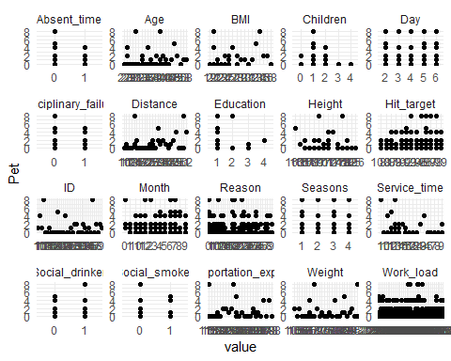

### Weight

#summary of weight  
summary(dat$Weight)

## Min. 1st Qu. Median Mean 3rd Qu. Max.   
## 56.00 69.00 83.00 79.04 89.00 108.00

#histogram  
ggplot(data = dat,  
 aes(x = Weight)) +  
 geom_histogram(bins = 15) +  
 theme_minimal()

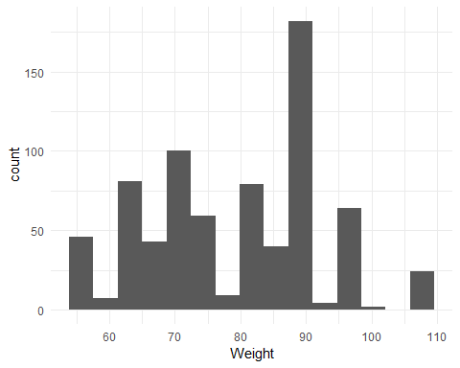

#Scatterplots for variable 'Weight'  
dat %>%  
 gather(-Weight, key = "var_name", value = "value") %>%  
 ggplot(aes(x = value, y = Weight)) +  
 geom_point() +  
 facet_wrap(~ var_name, scales = "free") +  
 theme_minimal()

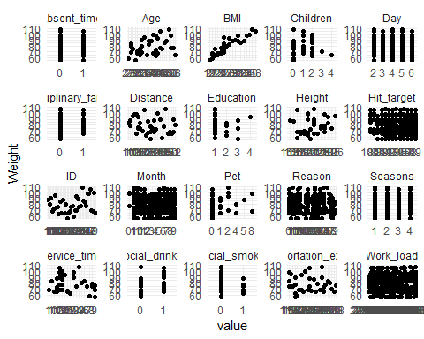

### Height

#summary of height  
summary(dat$Height)

## Min. 1st Qu. Median Mean 3rd Qu. Max.   
## 163.0 169.0 170.0 172.1 172.0 196.0

#histogram  
ggplot(data = dat,  
 aes(x = Height)) +  
 geom_histogram(bins = 10) +  
 theme_minimal()

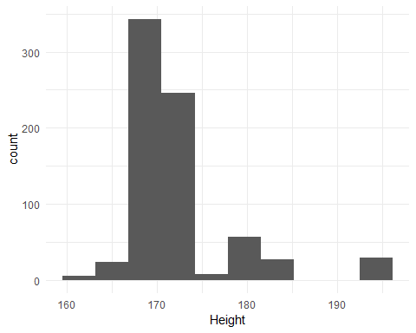

#Scatterplots for variable 'Height'  
dat.num %>%  
 gather(-Height, key = "var_name", value = "value") %>%  
 ggplot(aes(x = value, y = Height)) +  
 geom_point() +  
 facet_wrap(~ var_name, scales = "free") +   
 theme_minimal()

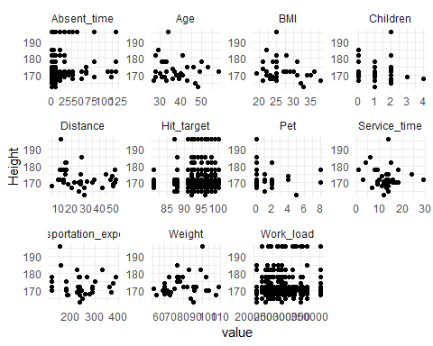

### BMI

#summary for BMI  
summary(dat$BMI)

## Min. 1st Qu. Median Mean 3rd Qu. Max.   
## 19.00 24.00 25.00 26.68 31.00 38.00

#histogram  
ggplot(data = dat,  
 aes(x = BMI)) +  
 geom_histogram(binwidth = 1) +   
 theme_minimal()

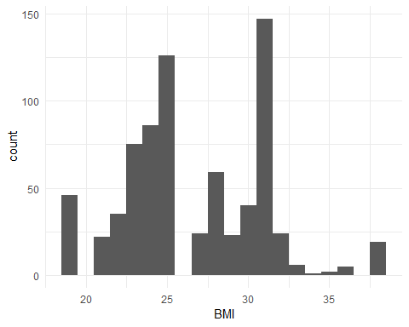

#Scatterplots for variable 'BMI'  
dat %>%  
 gather(-BMI, key = "var_name", value = "value") %>%  
 ggplot(aes(x = value, y = BMI)) +  
 geom_point() +  
 facet_wrap(~ var_name, scales = "free") +   
 theme_minimal()

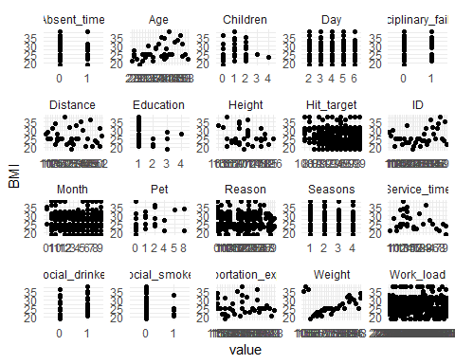

## Additional Preprocessing

dat1 <- dat[-1]  
  
#scale  
scale <- sapply(dat1, is.numeric)  
dat1[scale] <- lapply(dat1[scale],scale)

## Initial Method Testing

R <- 50 # replications  
  
# create the matrix to store values 1 row per model  
err_matrix <- matrix(0, ncol=5, nrow=R)  
  
sensitivity_matrix <- matrix(0, ncol=5, nrow=R)  
  
fmeasure_matrix <- matrix(0, ncol=5, nrow=R)  
  
gmean_matrix <- matrix(0, ncol=5, nrow=R)  
  
# these are optional but I like to see how the model did each run so I can check other output  
KNNcm <- matrix(0, ncol=4, nrow=R)  
glmcm <- matrix(0, ncol=4, nrow=R)  
Treecm <- matrix(0, ncol=4, nrow=R)  
rfcm <- matrix(0, ncol=4, nrow=R)  
SVMcm <- matrix(0, ncol=4, nrow=R)  
  
set.seed(1876)  
  
for (r in 1:R){  
   
# subsetting data to training and testing data  
p <- .6 # proportion of data for training  
w <- sample(1:nrow(dat1), nrow(dat1)*p, replace=F)  
data_train <-dat1[w,]   
data_test <- dat1[-w,]  
   
 ################################################################ knn  
  
#Running the classifier  
  
 knn <- knn(data_train[-20],  
 test = data_test[-20],  
 cl=data_train$Absent_time, k=2)  
   
#predict doesn't work with KNN for factors  
 knntable <- table(knn, data_test$Absent_time)  
   
#generate confusion matrix   
 cm_KNN <- confusionMatrix(data = knntable, reference = data_test[,-20], positive = "1")  
   
 KNNcm [[r,1]] <- cm_KNN$table[1,1]  
 KNNcm [[r,2]] <- cm_KNN$table[1,2]  
 KNNcm [[r,3]] <- cm_KNN$table[2,1]  
 KNNcm [[r,4]] <- cm_KNN$table[2,2]  
   
 err_matrix [[r,1]] <- (cm_KNN$table[1,2]+cm_KNN$table[2,1])/nrow( data_test)  
   
 # store the errors (change the 1 to whichever model you have)   
   
 sensitivity_matrix[[r, 1]] <- cm_KNN$byClass[1]  
   
 fmeasure_matrix [[r, 1]] <- cm_KNN$byClass[7]  
   
 gmean_matrix [[r, 1]] <- sqrt(cm_KNN$byClass[1]* cm_KNN$byClass[2])  
   
 ################################################################### GLM  
   
  
 model_glm_1 = suppressWarnings(  
 train(Absent_time ~ .,  
 data = data_train,  
 method = "glm",   
 family = 'binomial')  
 )  
   
 yhat_glm = predict(model_glm_1, newdata = data_test[,-20])  
   
 cm_glm = confusionMatrix(data = yhat_glm, reference = data_test[,20], positive = "1")  
   
 glmcm [[r,1]] <- cm_glm$table[1,1]  
 glmcm [[r,2]] <- cm_glm$table[1,2]  
 glmcm [[r,3]] <- cm_glm$table[2,1]  
 glmcm [[r,4]] <- cm_glm$table[2,2]  
   
 err_matrix [[r,2]] <- (cm_glm$table[1,2]+cm_glm$table[2,1])/nrow( data_test)  
   
 # store the errors (change the 1 to whichever model you have)   
   
 sensitivity_matrix[[r, 2]] <- cm_glm$byClass[1]  
   
 fmeasure_matrix [[r, 2]] <- cm_glm$byClass[7]  
   
 gmean_matrix [[r, 2]] <- sqrt(cm_glm$byClass[1]* cm_glm$byClass[2])  
   
 #####################################################Decision Tree  
  
 tree_mod = rpart(Absent_time ~ ., data = data_train)  
   
 #prediction  
 yhat_tree = predict(tree_mod, data_test, type = 'class')  
   
 #generate confusion matrix  
 cm_tree <- confusionMatrix(data = table(yhat_tree, data_test$Absent_time), reference = data_test[,-20], positive = "1")  
   
 Treecm[[r,1]] <- cm_tree$table[1,1]  
 Treecm[[r,2]] <- cm_tree$table[1,2]  
 Treecm[[r,3]] <- cm_tree$table[2,1]  
 Treecm[[r,4]] <- cm_tree$table[2,2]  
   
 #store the errors  
 err_matrix[r, 3] = mean(yhat_tree != data_test$Absent_time)  
   
 sensitivity_matrix[[r, 3]] <- cm_tree$byClass[1]  
   
 cm_tree$byClass[1]  
   
 fmeasure_matrix[[r, 3]] <- cm_tree$byClass[7]  
   
 gmean_matrix[[r, 3]] <- sqrt(cm_tree$byClass[1]* cm_tree$byClass[2])  
   
 #################################################### RF  
   
 rf <- randomForest(Absent_time ~.,  
 data=data_train,  
 mtry=6,  
 ntree=50,  
 na.action=na.roughfix)  
   
 yhat_rf = predict(rf, newdata = data_test, type= 'class')  
  
 cm_rf = confusionMatrix(data = yhat_rf, reference = data_test[,20], positive = "1")  
  
  
 rfcm [[r,1]] <- cm_rf$table[1,1]  
 rfcm [[r,2]] <- cm_rf$table[1,2]  
 rfcm [[r,3]] <- cm_rf$table[2,1]  
 rfcm [[r,4]] <- cm_rf$table[2,2]  
   
 err_matrix [[r,4]] <- (cm_glm$table[1,2]+cm_glm$table[2,1])/nrow( data_test)  
   
 sensitivity_matrix[[r, 4]] <- cm_rf$byClass[1]  
   
 fmeasure_matrix[[r, 4]] <- cm_rf$byClass[7]  
   
 gmean_matrix[[r, 4]] <- sqrt(cm_rf$byClass[1]* cm_rf$byClass[2])  
   
 ################################################################ SVM  
   
 csvm_absent = svm(Absent_time~., data=data_train,  
 type='C-classification')  
   
 #prediction  
 y_hat_csvm = predict(csvm_absent, data_test[,-20])  
   
 cm_SVM = confusionMatrix(data = y_hat_csvm, reference = data_test[,20], positive = "1")  
   
 SVMcm [[r,1]] <- cm_SVM$table[1,1]  
 SVMcm [[r,2]] <- cm_SVM$table[1,2]  
 SVMcm [[r,3]] <- cm_SVM$table[2,1]  
 SVMcm [[r,4]] <- cm_SVM$table[2,2]  
   
 err_matrix[r,5] = (cm_SVM$table[1,2]+cm_SVM$table[2,1])/nrow(data_test)  
   
 sensitivity_matrix[[r, 5]] <- cm_SVM$byClass[1]  
   
 fmeasure_matrix [[r, 5]] <- cm_SVM$byClass[7]  
   
 gmean_matrix [[r, 5]] <- sqrt(cm_SVM$byClass[1]* cm_SVM$byClass[2])  
   
#statement indicates where in loop  
 #cat("Finished Rep",r, "\n")  
}

Change the matrix names to make easier to interpret

#rename the columns in the model  
colnames(err_matrix) <- c("KNN","glm", "tree","RF", 'SVM')  
  
colnames(sensitivity_matrix)<- c("KNN","glm", "tree","RF", 'SVM')  
  
colnames(fmeasure_matrix) <- c("KNN","glm", "tree","RF", 'SVM')  
  
colnames(gmean_matrix) <- c("KNN","glm", "tree","RF", 'SVM')  
  
  
#rename the columns  
colnames(KNNcm) <- c("True Negative","False Negative", "False Positive","True Positive")  
  
colnames(glmcm) <- c("True Negative","False Negative", "False Positive","True Positive")  
  
colnames(SVMcm) <- c("True Negative","False Negative", "False Positive","True Positive")

save output

save(err_matrix, file='errmatrix.RData')  
save(sensitivity_matrix, file='sensmatrix.RData')  
save(fmeasure_matrix, file='fmeasmatrix.RData')  
save(gmean_matrix, file='gmeanmatrix.RData')

load output

load( file='errmatrix.RData')  
load( file='sensmatrix.RData')  
load( file='fmeasmatrix.RData')  
load( file='gmeanmatrix.RData')

err_graph <- melt(err_matrix)  
  
ggplot(err_graph,   
 aes(x=Var2, y=value)) +  
 geom_boxplot() +  
 theme_minimal()+ labs(x= "Model", y= "Error", title="Error Comparison")

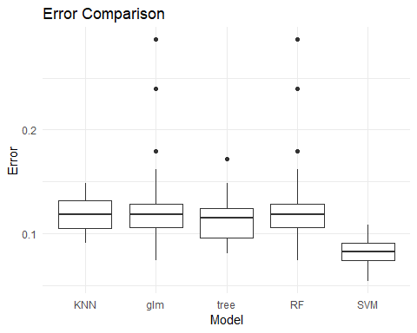

sens_graph <- melt(sensitivity_matrix)  
  
ggplot(sens_graph,   
 aes(x=Var2, y=value)) +  
 geom_boxplot() +  
 theme_minimal() + labs(x= "Model", y= "Sensitivity", title="Sensitivity Comparison")

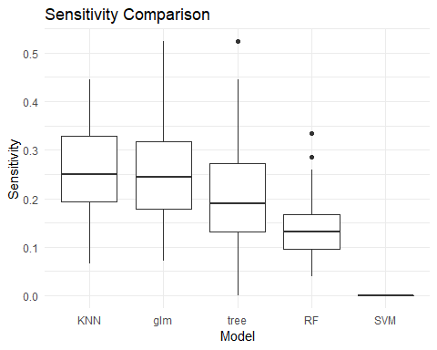

fmeas_graph <- melt(fmeasure_matrix)  
  
ggplot(fmeas_graph,   
 aes(x=Var2, y=value)) +  
 geom_boxplot() +   
 theme_minimal() + labs(x= "Model", y= "F-measure", title="F-measure Comparison")

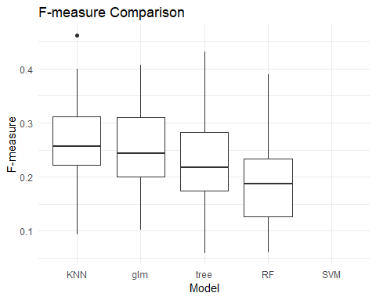

gmean_graph <- melt(gmean_matrix)  
  
ggplot(gmean_graph,   
 aes(x=Var2, y=value)) +  
 geom_boxplot() +  
 theme_minimal() + labs(x= "Model", y= "Gmean", title="Gmean Comparison")

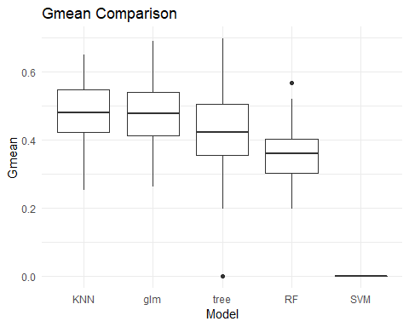 From this we selected the KNN model

# KNN Optimization

## Initial Attempt: Optimize on Error

dat <- read_excel("Absenteeism_at_work.xls")  
col <- c("ID", "Reason for absence", "Month of absence", "Day of the week", "Seasons", "Disciplinary failure", "Education", "Social drinker", "Social smoker")  
dat[col] <- lapply(dat[col], as.factor)  
colnames(dat) <- c("ID", "Reason", "Month", "Day", "Seasons", "Transportation_expense", "Distance", "Service_time", "Age", "Work_load", "Hit_target", "Disciplinary_failure", "Education", "Children", "Social_drinker", "Social_smoker", "Pet", "Weight", "Height", "BMI", "Absent_time")

#change variable represent missed time one day or greater  
dat <- dat %>% mutate(Absent_time= ifelse(dat$Absent_time <=8,0,1))  
dat$Absent_time <- as.factor(dat$Absent_time)  
#Transforming to Data Frame  
dat <- as.data.frame(dat)

###Optimizing the KNN  
  
#For the tunning of the KNN model, we are going to create another traning/test data sets.  
  
#scaling the data:  
dat_v <- dat #we are going to use dat_v for the manipulation  
scale <- sapply(dat_v, is.numeric)  
dat_v[scale] <- lapply(dat_v[scale],scale)

set.seed(1876)  
#predicting class:  
AB_class <- dat_v[, 21]  
names(AB_class) <- c(1:nrow(dat_v))  
dat_v$ID <- c(1:nrow(dat_v))  
  
dat_v <- dat_v[1:737,]  
rand_permute <- sample(x = nrow(dat_v), size = nrow(dat_v))  
  
all_id_random <- dat_v[rand_permute, "ID"]  
dat_v <- dat_v[,-1] #remove ID

set.seed(1876)  
#random samples for training test  
validate_id <- as.character(all_id_random[1:248])  
training_id <- as.character(all_id_random[249:737])  
  
dat_v_train <- dat_v[training_id, ]  
dat_v_val <- dat_v[validate_id, ]  
AB_class_train <- AB_class[training_id]  
AB_class_val <- AB_class[validate_id]  
table(AB_class_train)

## AB_class_train  
## 0 1   
## 448 41

set.seed(1876)  
#Study significance of the variables  
p <- .6 # proportion of data for training  
w <- sample(1:nrow(dat_v), nrow(dat_v)*p, replace=F)  
data_train <-dat_v[w,]   
data_test <- dat_v[-w,]  
  
  
rf <- randomForest(Absent_time ~.,  
 data=data_train,  
 mtry=6,  
 ntree=50,  
 na.action=na.roughfix)  
  
impfact <- importance(rf)  
  
impfact <- as.list(impfact)  
names(impfact) <- colnames(dat_v[,-20])  
impfact2 <- unlist(impfact)  
  
  
most_sig_stats <- names(sort(desc(impfact2)))  
  
  
#Re ordering variables by significance:  
  
dat_v_train_ord <- dat_v_train[ c(most_sig_stats)]  
str(dat_v_train_ord)

## 'data.frame': 489 obs. of 19 variables:  
## $ Reason : Factor w/ 28 levels "0","1","2","3",..: 1 23 25 25 24 18 27 2 28 26 ...  
## $ Month : Factor w/ 13 levels "0","1","2","3",..: 4 8 6 4 9 4 3 11 5 7 ...  
## $ Day : Factor w/ 5 levels "2","3","4","5",..: 3 4 1 3 2 2 2 1 3 5 ...  
## $ Work_load : num [1:489, 1] -0.694 -0.818 -0.651 -1.262 -1.679 ...  
## $ Hit_target : num [1:489, 1] 0.903 0.638 1.167 1.167 -0.685 ...  
## $ Age : num [1:489, 1] -0.841 -0.533 -0.996 3.326 -0.533 ...  
## $ BMI : num [1:489, 1] -0.391 0.775 -1.791 -1.091 0.775 ...  
## $ Weight : num [1:489, 1] -0.701 0.851 -1.788 -1.089 0.851 ...  
## $ Seasons : Factor w/ 4 levels "1","2","3","4": 2 1 3 2 1 2 2 4 3 3 ...  
## $ Height : num [1:489, 1] -0.516 -0.019 -0.185 -0.019 -0.019 ...  
## $ Transportation_expense: num [1:489, 1] 2.2056 1.0107 -0.6322 0.0996 1.0107 ...  
## $ Social_drinker : Factor w/ 2 levels "0","1": 2 2 1 1 2 1 2 1 2 1 ...  
## $ Service_time : num [1:489, 1] -0.126 0.102 -0.811 0.786 0.102 ...  
## $ Children : num [1:489, 1] 1.803 0.893 -0.928 0.893 0.893 ...  
## $ Distance : num [1:489, 1] -0.851 0.429 -0.245 -1.054 0.429 ...  
## $ Pet : num [1:489, 1] -0.566 0.193 -0.566 0.193 0.193 ...  
## $ Education : Factor w/ 4 levels "1","2","3","4": 1 1 3 1 1 2 1 3 1 1 ...  
## $ Disciplinary_failure : Factor w/ 2 levels "0","1": 2 1 1 1 1 1 1 1 1 1 ...  
## $ Social_smoker : Factor w/ 2 levels "0","1": 1 1 1 1 1 2 1 1 1 1 ...

dat_v_val_ord <- dat_v_val[, names(dat_v_train_ord)]

#Monte Carlo Validation:  
set.seed(1876)  
size <- length(training_id)  
red.size <- (2/3) * length(training_id)  
  
training_family_L <- lapply(1:500, function(j) {  
 perm <- sample(1:size, size = size, replace = F)  
 shuffle <- training_id[perm]  
 trn <- shuffle[1:326]  
 trn  
})  
  
validation_family_L <- lapply(training_family_L,   
 function(x) setdiff(training_id, x))

#Finding an optimal set of variables and optimal k  
set.seed(1876)  
N <- seq(from = 2, to = 19, by = 1)  
  
K <- seq(from = 1, to = 7, by = 1)  
times <- 500 * length(N) * length(K)

set.seed(1876)  
paramter_errors_df <- data.frame(mc_index = as.integer(rep(NA, times = times)),   
 var_num = as.integer(rep(NA, times = times)),   
 k = as.integer(rep(NA, times = times)),   
 error = as.numeric(rep(NA, times = times)))

#Core knn_model:  
# j = index, n = length of range of variables, k=k  
core_knn <- function(j, n, k) {  
 knn_predict <- knn(train = dat_v_train_ord[training_family_L[[j]], 1:n],   
 test = dat_v_train_ord[validation_family_L[[j]], 1:n],   
 cl = AB_class_train[training_family_L[[j]]],   
 k = k)  
 tbl <- table(knn_predict, AB_class_train[validation_family_L[[j]]])  
 err <- (tbl[1, 2] + tbl[2, 1])/(tbl[1, 2] + tbl[2, 1]+tbl[1, 1] + tbl[2, 2])  
 err  
}

set.seed(1876)  
param_df1 <- merge(data.frame(mc_index = 1:500), data.frame(var_num = N))  
param_df <- merge(param_df1, data.frame(k = K))  
  
knn_err_est_df <- ddply(param_df[1:times, ], .(mc_index, var_num, k), function(df) {  
 err <- core_knn(df$mc_index[1], df$var_num[1], df$k[1])  
 err  
})

head(knn_err_est_df)  
names(knn_err_est_df)[4] <- "error"  
  
mean_errs_df <- ddply(knn_err_est_df, .(var_num, k), function(df) mean(df$error))  
head(mean_errs_df)  
names(mean_errs_df)[3] <- "mean_error"

save output

save(mean_errs_df, file='mean_errs_df.RData')

load output

load( file='mean_errs_df.RData')

ggplot(data = mean_errs_df, aes(x = var_num, y = k, color = mean_error)) + geom_point(size = 5) +   
 theme_bw()

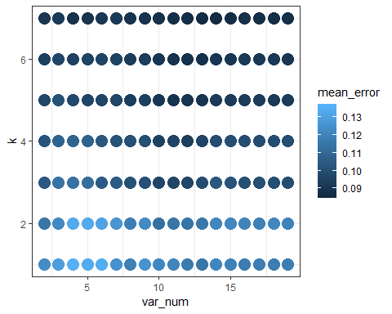

#selects top model  
mean_errs_df[which.min(mean_errs_df$mean_error), ]

## var_num k mean_error  
## 84 13 7 0.08592638

#list in order of models  
mean_errs_df %>% arrange(mean_error)

## var_num k mean_error  
## 1 13 7 0.08592638  
## 2 14 7 0.08638037  
## 3 12 7 0.08699387  
## 4 15 7 0.08699387  
## 5 11 7 0.08731288  
## 6 19 7 0.08755828  
## 7 17 7 0.08775460  
## 8 18 7 0.08779141  
## 9 10 7 0.08788957  
## 10 13 6 0.08796319  
## 11 16 7 0.08822086  
## 12 12 6 0.08869939  
## 13 11 6 0.08885890  
## 14 4 7 0.08903067  
## 15 8 7 0.08922699  
## 16 9 7 0.08941104  
## 17 11 5 0.08944785  
## 18 5 7 0.08977914  
## 19 12 5 0.08980368  
## 20 13 5 0.09011043  
## 21 10 6 0.09026994  
## 22 14 6 0.09034356  
## 23 10 5 0.09040491  
## 24 2 7 0.09063804  
## 25 15 6 0.09068712  
## 26 19 6 0.09094479  
## 27 17 6 0.09125153  
## 28 6 7 0.09152147  
## 29 7 7 0.09176687  
## 30 16 6 0.09177914  
## 31 18 6 0.09181595  
## 32 3 7 0.09223313  
## 33 14 5 0.09230675  
## 34 15 5 0.09247853  
## 35 16 5 0.09279755  
## 36 19 5 0.09294479  
## 37 18 5 0.09295706  
## 38 8 6 0.09301840  
## 39 17 5 0.09303067  
## 40 9 6 0.09342331  
## 41 8 5 0.09371779  
## 42 12 4 0.09438037  
## 43 2 6 0.09451534  
## 44 9 5 0.09465031  
## 45 10 4 0.09538650  
## 46 4 6 0.09548466  
## 47 5 6 0.09588957  
## 48 7 6 0.09591411  
## 49 11 4 0.09614724  
## 50 6 6 0.09625767  
## 51 13 4 0.09633129  
## 52 12 3 0.09663804  
## 53 3 6 0.09665031  
## 54 10 3 0.09668712  
## 55 6 5 0.09690798  
## 56 5 5 0.09693252  
## 57 11 3 0.09699387  
## 58 7 5 0.09710429  
## 59 2 5 0.09763190  
## 60 4 5 0.09803681  
## 61 13 3 0.09948466  
## 62 19 3 0.09975460  
## 63 16 4 0.09991411  
## 64 17 4 0.10002454  
## 65 18 4 0.10006135  
## 66 14 4 0.10012270  
## 67 19 4 0.10022086  
## 68 15 4 0.10051534  
## 69 17 3 0.10067485  
## 70 9 4 0.10068712  
## 71 18 3 0.10069939  
## 72 8 4 0.10073620  
## 73 16 3 0.10101840  
## 74 9 3 0.10120245  
## 75 8 3 0.10153374  
## 76 3 5 0.10174233  
## 77 7 4 0.10222086  
## 78 15 3 0.10285890  
## 79 2 4 0.10293252  
## 80 6 4 0.10379141  
## 81 14 3 0.10411043  
## 82 2 3 0.10424540  
## 83 7 3 0.10541104  
## 84 6 3 0.10547239  
## 85 5 4 0.10835583  
## 86 3 4 0.10856442  
## 87 4 4 0.10865031  
## 88 5 3 0.11258896  
## 89 10 2 0.11334969  
## 90 4 3 0.11409816  
## 91 3 3 0.11435583  
## 92 12 2 0.11512883  
## 93 2 2 0.11559509  
## 94 11 2 0.11564417  
## 95 13 1 0.11592638  
## 96 13 2 0.11631902  
## 97 12 1 0.11754601  
## 98 16 1 0.11775460  
## 99 18 1 0.11835583  
## 100 19 1 0.11838037  
## 101 8 2 0.11883436  
## 102 17 1 0.11893252  
## 103 17 2 0.11934969  
## 104 8 1 0.11949693  
## 105 19 2 0.11990184  
## 106 15 1 0.12003681  
## 107 16 2 0.12025767  
## 108 11 1 0.12107975  
## 109 14 2 0.12130061  
## 110 15 2 0.12138650  
## 111 18 2 0.12155828  
## 112 14 1 0.12175460  
## 113 10 1 0.12195092  
## 114 3 2 0.12245399  
## 115 9 2 0.12316564  
## 116 2 1 0.12338650  
## 117 7 1 0.12569325  
## 118 9 1 0.12624540  
## 119 7 2 0.12644172  
## 120 3 1 0.12961963  
## 121 6 2 0.13150920  
## 122 5 2 0.13343558  
## 123 4 2 0.13374233  
## 124 5 1 0.13412270  
## 125 6 1 0.13449080  
## 126 4 1 0.13629448

The model predicts that error can be reduced by simply predicting a large K-value. This forces the models to chose all major class which explains why the error is ~8% in each model metric.

## Second Attempt: Optimize on Sensitivity

N <- seq(from = 2, to = 19, by = 1)  
sqrt(length(training_family_L[[1]]))

## [1] 18.05547

K <- seq(from = 1, to = 7, by = 2)  
times <- 500 * length(N) * length(K)  
  
core_knn_sen <- function(j, n, k) {  
 knn_predict <- knn(train = dat_v_train_ord[training_family_L[[j]], 1:n],   
 test = dat_v_train_ord[validation_family_L[[j]], 1:n],   
 cl = AB_class_train[training_family_L[[j]]],   
 k = k)  
  
 tbl <- table(knn_predict, AB_class_train[validation_family_L[[j]]])  
   
 #generate confusion matrix   
 cm_KNN <- confusionMatrix(data = tbl, reference =AB_class_train[validation_family_L[[j]]], positive = "1")  
   
 sen <- cm_KNN$byClass[1]  
 sen  
}

param_df1_2 <- merge(data.frame(mc_index = 1:500), data.frame(var_num = N))  
param_df_2 <- merge(param_df1_2, data.frame(k = K))  
  
knn_err_est_df_2 <- ddply(param_df_2[1:times, ], .(mc_index, var_num, k), function(df) {  
 sen <- core_knn_sen(df$mc_index[1], df$var_num[1], df$k[1])  
 sen  
})

names(knn_err_est_df_2)[4] <- "Sensitivity"  
  
mean_sens_df <- ddply(knn_err_est_df_2, .(var_num, k), function(df) mean(df$Sensitivity))  
  
names(mean_sens_df)[3] <- "mean_sensitivity"

save(mean_sens_df, file='mean_sens_df.RData')

load output

load( file='mean_sens_df.RData')

ggplot(data = mean_sens_df, aes(x = var_num, y = k, color = mean_sensitivity)) + geom_point(size = 5) +   
 theme_bw()

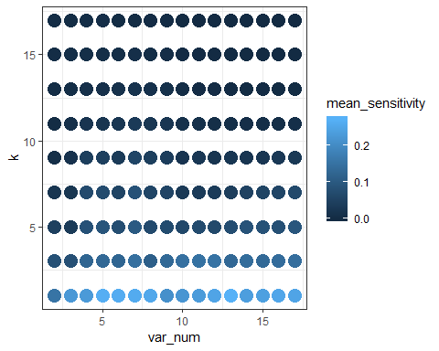

mean_sens_df[which.max(mean_sens_df$mean_sensitivity), ]

## var_num k mean_sensitivity  
## 100 13 1 0.2716719

mean_sens_df %>% arrange(desc(mean_sensitivity))

## var_num k mean_sensitivity  
## 1 13 1 0.2716718922  
## 2 5 1 0.2666981059  
## 3 6 1 0.2628591320  
## 4 7 1 0.2605046872  
## 5 8 1 0.2552407844  
## 6 16 1 0.2517553543  
## 7 12 1 0.2480793032  
## 8 17 1 0.2480296623  
## 9 15 1 0.2397691201  
## 10 14 1 0.2365260921  
## 11 11 1 0.2308062550  
## 12 4 1 0.2286541914  
## 13 3 1 0.2252105500  
## 14 10 1 0.2196269051  
## 15 9 1 0.2096249353  
## 16 2 1 0.1545895840  
## 17 12 3 0.1542561748  
## 18 11 3 0.1507270254  
## 19 10 3 0.1479739460  
## 20 7 3 0.1469051222  
## 21 17 3 0.1439008296  
## 22 14 3 0.1407103771  
## 23 16 3 0.1398890725  
## 24 9 3 0.1333000615  
## 25 15 3 0.1329005332  
## 26 13 3 0.1318616785  
## 27 5 3 0.1314689143  
## 28 6 3 0.1257157165  
## 29 4 3 0.1250362667  
## 30 8 3 0.1135097359  
## 31 7 5 0.1029324995  
## 32 17 5 0.0951682128  
## 33 5 5 0.0921849674  
## 34 14 5 0.0888163290  
## 35 15 5 0.0859068330  
## 36 4 5 0.0850014887  
## 37 7 7 0.0845910357  
## 38 2 3 0.0837267779  
## 39 16 5 0.0828803531  
## 40 3 3 0.0826648706  
## 41 6 5 0.0776177756  
## 42 13 5 0.0760371061  
## 43 9 5 0.0724752027  
## 44 11 5 0.0715366975  
## 45 5 7 0.0710006739  
## 46 8 5 0.0701061563  
## 47 4 7 0.0695262087  
## 48 17 7 0.0670996216  
## 49 12 5 0.0665066364  
## 50 10 5 0.0652124881  
## 51 8 7 0.0590302359  
## 52 7 9 0.0587448537  
## 53 16 7 0.0580783352  
## 54 9 7 0.0571237870  
## 55 6 7 0.0557918592  
## 56 15 7 0.0551483043  
## 57 14 7 0.0517686485  
## 58 2 5 0.0473679592  
## 59 5 9 0.0453139935  
## 60 8 9 0.0443125481  
## 61 4 9 0.0442821882  
## 62 13 7 0.0425773248  
## 63 9 9 0.0414619909  
## 64 11 7 0.0372985831  
## 65 12 7 0.0366790676  
## 66 3 5 0.0361242991  
## 67 6 9 0.0359191392  
## 68 7 11 0.0347852958  
## 69 10 7 0.0317932871  
## 70 17 9 0.0313440351  
## 71 16 9 0.0308590645  
## 72 11 9 0.0280343252  
## 73 8 11 0.0268810348  
## 74 15 9 0.0256688937  
## 75 6 11 0.0250697494  
## 76 9 11 0.0250661199  
## 77 13 9 0.0247272889  
## 78 3 7 0.0242968605  
## 79 14 9 0.0237716903  
## 80 2 7 0.0231146342  
## 81 12 9 0.0223681822  
## 82 5 11 0.0221788938  
## 83 10 9 0.0216155312  
## 84 4 11 0.0215935200  
## 85 7 13 0.0181307948  
## 86 3 9 0.0165409038  
## 87 6 13 0.0160554212  
## 88 8 13 0.0149073185  
## 89 9 13 0.0142500535  
## 90 11 11 0.0132313608  
## 91 10 11 0.0132233833  
## 92 5 13 0.0121080481  
## 93 4 13 0.0118604392  
## 94 3 11 0.0104161169  
## 95 17 11 0.0099627849  
## 96 7 15 0.0098183963  
## 97 5 15 0.0093792438  
## 98 2 9 0.0092919394  
## 99 12 11 0.0091332200  
## 100 6 15 0.0086553094  
## 101 15 11 0.0085188088  
## 102 16 11 0.0083726568  
## 103 4 15 0.0083231166  
## 104 13 11 0.0082022169  
## 105 5 17 0.0079976246  
## 106 14 11 0.0077761245  
## 107 9 15 0.0069795427  
## 108 4 17 0.0067086136  
## 109 3 13 0.0066638406  
## 110 3 15 0.0066516036  
## 111 8 15 0.0063581641  
## 112 2 13 0.0054166823  
## 113 2 17 0.0048990065  
## 114 2 15 0.0045816267  
## 115 10 13 0.0043574426  
## 116 2 11 0.0042295629  
## 117 3 17 0.0040418479  
## 118 6 17 0.0037377511  
## 119 7 17 0.0037298146  
## 120 11 13 0.0034211566  
## 121 8 17 0.0033093018  
## 122 9 17 0.0028870796  
## 123 12 13 0.0026548868  
## 124 17 13 0.0021719122  
## 125 14 13 0.0017992285  
## 126 16 13 0.0015670857  
## 127 15 13 0.0011293151  
## 128 13 13 0.0010770063  
## 129 10 15 0.0010506716  
## 130 11 15 0.0008840049  
## 131 17 15 0.0006172161  
## 132 16 15 0.0005317460  
## 133 17 17 0.0005023310  
## 134 12 15 0.0004444444  
## 135 15 17 0.0003356643  
## 136 16 17 0.0003356643  
## 137 15 15 0.0003095238  
## 138 12 17 0.0002222222  
## 139 13 15 0.0002222222  
## 140 13 17 0.0002222222  
## 141 14 15 0.0001428571  
## 142 10 17 0.0000000000  
## 143 11 17 0.0000000000  
## 144 14 17 0.0000000000

#Best KNN:  
  
KNN_13_1 <- knn(train = dat_v_train_ord[, 1:13],   
 dat_v_val_ord[, 1:13], AB_class_train,   
 k = 1)  
  
tbl_bm_val <- table(KNN_13_1, AB_class_val)  
tbl_bm_val

## AB_class_val  
## KNN_13_1 0 1  
## 0 213 16  
## 1 13 6

cm_KNN_opt <- confusionMatrix(data = tbl_bm_val, reference = dat_v_val_ord[, 1:13], positive = "1")

R <- 50 # replications  
  
# create the matrix to store values 1 row per model  
err_matrix_opt <- matrix(0, ncol=1, nrow=R)  
  
sensitivity_matrix_opt <- matrix(0, ncol=1, nrow=R)  
  
fmeasure_matrix_opt <- matrix(0, ncol=1, nrow=R)  
  
gmean_matrix_opt <- matrix(0, ncol=1, nrow=R)  
  
KNNcm <- matrix(0, ncol=4, nrow=R)  
  
dat_smaller <- dat[, names(dat_v_train_ord)]  
dat_smaller[,20] <- dat$Absent_time  
  
dat_smaller <- dat_smaller[1:737,] # remove lines with non-meaningful data  
  
scale <- sapply(dat_smaller, is.numeric)  
dat_smaller[scale] <- lapply(dat_smaller[scale],scale)  
head(dat_smaller)

## Reason Month Day Work_load Hit_target Age BMI Weight  
## 1 26 7 3 -0.8160263 0.6374158 -0.5292037 0.7818833 0.8561660  
## 2 0 7 3 -0.8160263 0.6374158 2.1019046 1.0158452 1.4779119  
## 3 23 7 4 -0.8160263 0.6374158 0.2446517 1.0158452 0.7784478  
## 4 7 7 5 -0.8160263 0.6374158 0.3994228 -0.6218877 -0.8536352  
## 5 23 7 5 -0.8160263 0.6374158 -0.5292037 0.7818833 0.8561660  
## 6 23 7 6 -0.8160263 0.6374158 0.2446517 1.0158452 0.7784478  
## Seasons Height Transportation_expense Social_drinker Service_time  
## 1 1 -0.01930235 1.0078374 1 0.1025410  
## 2 1 0.97319750 -1.5458897 1 1.2406839  
## 3 1 -0.35013563 -0.6349110 1 1.2406839  
## 4 1 -0.68096891 0.8584966 1 0.3301696  
## 5 1 -0.01930235 1.0078374 1 0.1025410  
## 6 1 -0.35013563 -0.6349110 1 1.2406839  
## Children Distance Pet Education Disciplinary_failure  
## 1 0.89294976 0.4295322 0.2057297 1 0  
## 2 -0.01603363 -1.1199466 -0.5678559 1 1  
## 3 -0.92501702 1.4400619 -0.5678559 1 0  
## 4 0.89294976 -1.6588958 -0.5678559 1 0  
## 5 0.89294976 0.4295322 0.2057297 1 0  
## 6 -0.92501702 1.4400619 -0.5678559 1 0  
## Social_smoker V20  
## 1 0 0  
## 2 0 0  
## 3 0 0  
## 4 1 0  
## 5 0 0  
## 6 0 0

set.seed(1876)  
  
  
for (r in 1:R){  
   
 # subsetting data to training and testing data  
 p <- .6 # proportion of data for training  
 w <- sample(1:nrow(dat_smaller), nrow(dat_smaller)*p, replace=F)  
 data_train <-dat_smaller[w,]   
 data_test <- dat_smaller[-w,]  
   
 ################################################################ knn  
   
 #Running the classifier  
   
 knn <- knn(data_train[,1:13],  
 test = data_test[,1:13],  
 cl=data_train[,20], k=1)  
   
 #predict doesn't work with KNN for factors  
 knntable <- table(knn, data_test[,20])  
   
 #generate confusion matrix   
 cm_KNN <- confusionMatrix(data = knntable, reference = data_test[,1:2], positive = "1")  
   
 KNNcm [[r,1]] <- cm_KNN$table[1,1]  
 KNNcm [[r,2]] <- cm_KNN$table[1,2]  
 KNNcm [[r,3]] <- cm_KNN$table[2,1]  
 KNNcm [[r,4]] <- cm_KNN$table[2,2]  
   
 err_matrix_opt [[r,1]] <- (cm_KNN$table[1,2]+cm_KNN$table[2,1])/nrow( data_test)  
   
 sensitivity_matrix_opt[[r, 1]] <- cm_KNN$byClass[1]  
   
 fmeasure_matrix_opt [[r, 1]] <- cm_KNN$byClass[7]  
   
 gmean_matrix_opt [[r, 1]] <- sqrt(cm_KNN$byClass[1]* cm_KNN$byClass[2])  
   
 #cat("Finished Rep",r, "\n")  
}  
colnames(sensitivity_matrix_opt)<- "KNN"  
graph_sens <- melt(sensitivity_matrix_opt)

graph <- ggplot(graph_sens,aes(x=Var2, y=value) )+ geom_boxplot() + labs(x="2nd Optimization", y="Sensitivity", title ="2nd Optimization")+ theme_minimal()  
graph

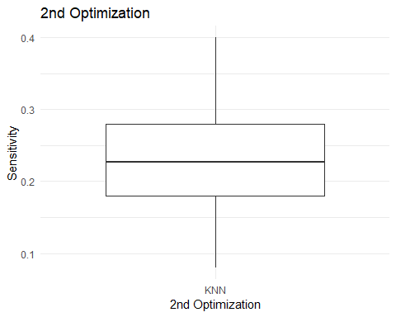

median(sensitivity_matrix_opt)

## [1] 0.2264957

#compare to initial model  
comp_matrix_sens <- cbind(sensitivity_matrix_opt[,1], sensitivity_matrix[,1])  
  
colnames(comp_matrix_sens)<- c("Optimized","Original")  
  
graph_comparison <- melt(comp_matrix_sens)  
  
ggplot(graph_comparison,aes(x=Var2, y=value) )+ geom_boxplot() +labs(x= "Model", y= "Sensitivity") +   
 theme_minimal()

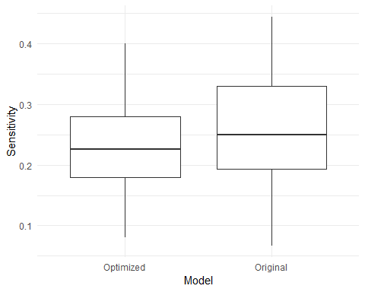

colnames(err_matrix_opt)<- "KNN"  
graph_err <- melt(err_matrix_opt)

graph <- ggplot(graph_err,aes(x=Var2, y=value) )+ geom_boxplot()+ theme_minimal()  
graph

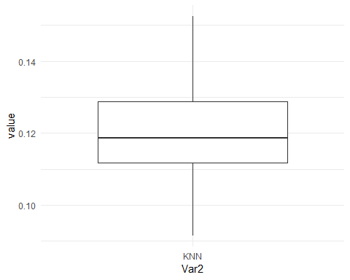 Predicted Model does not do that much better

## Third Attempt: SMOTE

set.seed(1876)  
  
dat <- read_excel("Absenteeism_at_work.xls")  
col <- c("ID", "Reason for absence", "Month of absence", "Day of the week", "Seasons", "Disciplinary failure", "Education", "Social drinker", "Social smoker")  
dat[col] <- lapply(dat[col], as.factor)  
colnames(dat) <- c("ID", "Reason", "Month", "Day", "Seasons", "Transportation_expense", "Distance", "Service_time", "Age", "Work_load", "Hit_target", "Disciplinary_failure", "Education", "Children", "Social_drinker", "Social_smoker", "Pet", "Weight", "Height", "BMI", "Absent_time")  
  
  
nums <- unlist(lapply(dat, is.numeric))   
dat.num <- dat[ , nums]  
  
#change variable represent missed time one day or greater  
dat <- dat %>% mutate(Absent_time= ifelse(dat$Absent_time <=8,0,1))  
str(dat)

## Classes 'tbl_df', 'tbl' and 'data.frame': 740 obs. of 21 variables:  
## $ ID : Factor w/ 36 levels "1","2","3","4",..: 11 36 3 7 11 3 10 20 14 1 ...  
## $ Reason : Factor w/ 28 levels "0","1","2","3",..: 26 1 23 8 23 23 22 23 20 22 ...  
## $ Month : Factor w/ 13 levels "0","1","2","3",..: 8 8 8 8 8 8 8 8 8 8 ...  
## $ Day : Factor w/ 5 levels "2","3","4","5",..: 2 2 3 4 4 5 5 5 1 1 ...  
## $ Seasons : Factor w/ 4 levels "1","2","3","4": 1 1 1 1 1 1 1 1 1 1 ...  
## $ Transportation_expense: num 289 118 179 279 289 179 361 260 155 235 ...  
## $ Distance : num 36 13 51 5 36 51 52 50 12 11 ...  
## $ Service_time : num 13 18 18 14 13 18 3 11 14 14 ...  
## $ Age : num 33 50 38 39 33 38 28 36 34 37 ...  
## $ Work_load : num 239554 239554 239554 239554 239554 ...  
## $ Hit_target : num 97 97 97 97 97 97 97 97 97 97 ...  
## $ Disciplinary_failure : Factor w/ 2 levels "0","1": 1 2 1 1 1 1 1 1 1 1 ...  
## $ Education : Factor w/ 4 levels "1","2","3","4": 1 1 1 1 1 1 1 1 1 3 ...  
## $ Children : num 2 1 0 2 2 0 1 4 2 1 ...  
## $ Social_drinker : Factor w/ 2 levels "0","1": 2 2 2 2 2 2 2 2 2 1 ...  
## $ Social_smoker : Factor w/ 2 levels "0","1": 1 1 1 2 1 1 1 1 1 1 ...  
## $ Pet : num 1 0 0 0 1 0 4 0 0 1 ...  
## $ Weight : num 90 98 89 68 90 89 80 65 95 88 ...  
## $ Height : num 172 178 170 168 172 170 172 168 196 172 ...  
## $ BMI : num 30 31 31 24 30 31 27 23 25 29 ...  
## $ Absent_time : num 0 0 0 0 0 0 0 0 1 0 ...

dat$Absent_time <- as.factor(dat$Absent_time)  
#Transforming to Data Frame  
dat <- as.data.frame(dat)  
  
str(dat)

## 'data.frame': 740 obs. of 21 variables:  
## $ ID : Factor w/ 36 levels "1","2","3","4",..: 11 36 3 7 11 3 10 20 14 1 ...  
## $ Reason : Factor w/ 28 levels "0","1","2","3",..: 26 1 23 8 23 23 22 23 20 22 ...  
## $ Month : Factor w/ 13 levels "0","1","2","3",..: 8 8 8 8 8 8 8 8 8 8 ...  
## $ Day : Factor w/ 5 levels "2","3","4","5",..: 2 2 3 4 4 5 5 5 1 1 ...  
## $ Seasons : Factor w/ 4 levels "1","2","3","4": 1 1 1 1 1 1 1 1 1 1 ...  
## $ Transportation_expense: num 289 118 179 279 289 179 361 260 155 235 ...  
## $ Distance : num 36 13 51 5 36 51 52 50 12 11 ...  
## $ Service_time : num 13 18 18 14 13 18 3 11 14 14 ...  
## $ Age : num 33 50 38 39 33 38 28 36 34 37 ...  
## $ Work_load : num 239554 239554 239554 239554 239554 ...  
## $ Hit_target : num 97 97 97 97 97 97 97 97 97 97 ...  
## $ Disciplinary_failure : Factor w/ 2 levels "0","1": 1 2 1 1 1 1 1 1 1 1 ...  
## $ Education : Factor w/ 4 levels "1","2","3","4": 1 1 1 1 1 1 1 1 1 3 ...  
## $ Children : num 2 1 0 2 2 0 1 4 2 1 ...  
## $ Social_drinker : Factor w/ 2 levels "0","1": 2 2 2 2 2 2 2 2 2 1 ...  
## $ Social_smoker : Factor w/ 2 levels "0","1": 1 1 1 2 1 1 1 1 1 1 ...  
## $ Pet : num 1 0 0 0 1 0 4 0 0 1 ...  
## $ Weight : num 90 98 89 68 90 89 80 65 95 88 ...  
## $ Height : num 172 178 170 168 172 170 172 168 196 172 ...  
## $ BMI : num 30 31 31 24 30 31 27 23 25 29 ...  
## $ Absent_time : Factor w/ 2 levels "0","1": 1 1 1 1 1 1 1 1 2 1 ...

###Optimizing the KNN  
  
#For the tunning of the KNN model, we are going to create another traning/test data sets.  
  
#scaling the data:  
dat_v <- dat #we are going to use dat_v for the manipulation  
scale <- sapply(dat_v, is.numeric)  
dat_v[scale] <- lapply(dat_v[scale],scale)  
head(dat_v)

## ID Reason Month Day Seasons Transportation_expense Distance  
## 1 11 26 7 3 1 1.0107248 0.4292653  
## 2 36 0 7 3 1 -1.5433353 -1.1209354  
## 3 3 23 7 4 1 -0.6322379 1.4402658  
## 4 7 7 7 5 1 0.8613645 -1.6601356  
## 5 11 23 7 5 1 1.0107248 0.4292653  
## 6 3 23 7 6 1 -0.6322379 1.4402658  
## Service_time Age Work_load Hit_target Disciplinary_failure  
## 1 0.1017010 -0.5325083 -0.8176594 0.6382541 0  
## 2 1.2419848 2.0914456 -0.8176594 0.6382541 1  
## 3 1.2419848 0.2392429 -0.8176594 0.6382541 0  
## 4 0.3297577 0.3935931 -0.8176594 0.6382541 0  
## 5 0.1017010 -0.5325083 -0.8176594 0.6382541 0  
## 6 1.2419848 0.2392429 -0.8176594 0.6382541 0  
## Education Children Social_drinker Social_smoker Pet Weight  
## 1 1 0.89311870 1 0 0.1927195 0.8510972  
## 2 1 -0.01722267 1 0 -0.5658572 1.4720605  
## 3 1 -0.92756405 1 0 -0.5658572 0.7734768  
## 4 1 0.89311870 1 1 -0.5658572 -0.8565516  
## 5 1 0.89311870 1 0 0.1927195 0.8510972  
## 6 1 -0.92756405 1 0 -0.5658572 0.7734768  
## Height BMI Absent_time  
## 1 -0.01903313 0.7754078 0  
## 2 0.97516826 1.0087554 0  
## 3 -0.35043360 1.0087554 0  
## 4 -0.68183407 -0.6246778 0  
## 5 -0.01903313 0.7754078 0  
## 6 -0.35043360 1.0087554 0

#predicting class:  
AB_class <- dat_v[, 21]  
names(AB_class) <- c(1:nrow(dat_v))  
dat_v$ID <- c(1:nrow(dat_v))  
  
dat_v <- dat_v[1:737,]  
nrow(dat_v)

## [1] 737

rand_permute <- sample(x = nrow(dat_v), size = nrow(dat_v))  
  
all_id_random <- dat_v[rand_permute, "ID"]  
dat_v <- dat_v[,-1] #remove ID  
  
#######  
  
splitIndex <- createDataPartition(dat_v$Absent_time, p = .50,  
 list = FALSE,  
 times = 1)  
  
trainSplit <- dat_v[ splitIndex,]  
testSplit <- dat_v[-splitIndex,]  
  
trainSplit$Absent_time <- as.factor(trainSplit$Absent_time)  
trainSplit <- SMOTE(Absent_time ~ ., trainSplit, perc.over = 100, perc.under=200)  
  
prop.table(table(trainSplit$Absent_time))

##   
## 0 1   
## 0.5 0.5

#######  
  
#labels to make inserted code work  
validate_id <- c(1:nrow(testSplit))  
training_id <- c(1:nrow(trainSplit))  
  
#rename to work with rest of code  
dat_v_train <- trainSplit  
dat_v_val <- testSplit  
AB_class_train <- trainSplit$Absent_time  
AB_class_val <- testSplit$Absent_time  
#Confirms data comes out as expected  
table(AB_class_train)

## AB_class_train  
## 0 1   
## 64 64

#Study significance of the variables  
  
rf <- randomForest(Absent_time ~.,  
 data=dat_v_train,  
 mtry=6,  
 ntree=50,  
 na.action=na.roughfix)  
  
impfact <- importance(rf)  
  
impfact <- as.list(impfact)  
names(impfact) <- colnames(dat_v[,-20])  
impfact2 <- unlist(impfact)  
  
  
most_sig_stats <- names(sort(desc(impfact2)))  
  
#Re ordering variables by significance:  
  
dat_v_train_ord <- dat_v_train[ c(most_sig_stats)]  
str(dat_v_train_ord)

## 'data.frame': 128 obs. of 19 variables:  
## $ Reason : Factor w/ 28 levels "0","1","2","3",..: 28 23 1 8 23 23 14 8 19 7 ...  
## $ Work_load : num [1:128, 1] -0.0761 -0.1657 -0.1657 -0.8663 -1.6789 ...  
## ..- attr(*, "dimnames")=List of 2  
## .. ..$ : NULL  
## .. ..$ : NULL  
## $ Month : Factor w/ 13 levels "0","1","2","3",..: 12 11 11 6 9 11 7 8 13 8 ...  
## $ Day : Factor w/ 5 levels "2","3","4","5",..: 3 1 5 1 1 5 2 1 1 1 ...  
## $ Hit_target : num [1:128, 1] -0.42 -1.743 -1.743 1.167 -0.685 ...  
## ..- attr(*, "dimnames")=List of 2  
## .. ..$ : NULL  
## .. ..$ : NULL  
## $ Distance : num [1:128, 1] -1.323 -0.649 -0.649 1.508 1.508 ...  
## ..- attr(*, "dimnames")=List of 2  
## .. ..$ : NULL  
## .. ..$ : NULL  
## $ Height : num [1:128, 1] -0.019 -0.848 -0.848 -0.019 -0.019 ...  
## ..- attr(*, "dimnames")=List of 2  
## .. ..$ : NULL  
## .. ..$ : NULL  
## $ Weight : num [1:128, 1] 0.3078 2.093 2.093 0.0749 0.0749 ...  
## ..- attr(*, "dimnames")=List of 2  
## .. ..$ : NULL  
## .. ..$ : NULL  
## $ Age : num [1:128, 1] 0.0849 1.011 1.011 -1.3043 -1.3043 ...  
## ..- attr(*, "dimnames")=List of 2  
## .. ..$ : NULL  
## .. ..$ : NULL  
## $ Transportation_expense: num [1:128, 1] -1.543 0.204 0.204 2.086 2.086 ...  
## ..- attr(*, "dimnames")=List of 2  
## .. ..$ : NULL  
## .. ..$ : NULL  
## $ Service_time : num [1:128, 1] -0.582 0.102 0.102 -2.179 -2.179 ...  
## ..- attr(*, "dimnames")=List of 2  
## .. ..$ : NULL  
## .. ..$ : NULL  
## $ Pet : num [1:128, 1] -0.566 -0.566 -0.566 2.468 2.468 ...  
## ..- attr(*, "dimnames")=List of 2  
## .. ..$ : NULL  
## .. ..$ : NULL  
## $ BMI : num [1:128, 1] 0.3087 2.6422 2.6422 0.0754 0.0754 ...  
## ..- attr(*, "dimnames")=List of 2  
## .. ..$ : NULL  
## .. ..$ : NULL  
## $ Seasons : Factor w/ 4 levels "1","2","3","4": 4 4 4 3 1 4 1 1 4 1 ...  
## $ Children : num [1:128, 1] -0.9276 -0.0172 -0.0172 -0.0172 -0.0172 ...  
## ..- attr(*, "dimnames")=List of 2  
## .. ..$ : NULL  
## .. ..$ : NULL  
## $ Education : Factor w/ 4 levels "1","2","3","4": 1 1 1 1 1 1 3 2 2 1 ...  
## $ Disciplinary_failure : Factor w/ 2 levels "0","1": 1 1 2 1 1 1 1 1 1 1 ...  
## $ Social_drinker : Factor w/ 2 levels "0","1": 1 2 2 2 2 2 1 1 2 1 ...  
## $ Social_smoker : Factor w/ 2 levels "0","1": 1 1 1 1 1 1 1 1 1 1 ...

dat_v_val_ord <- dat_v_val[, names(dat_v_train_ord)]  
str(dat_v_val_ord)

## 'data.frame': 368 obs. of 19 variables:  
## $ Reason : Factor w/ 28 levels "0","1","2","3",..: 26 1 22 23 20 22 2 11 19 28 ...  
## $ Work_load : num [1:368, 1] -0.818 -0.818 -0.818 -0.818 -0.818 ...  
## $ Month : Factor w/ 13 levels "0","1","2","3",..: 8 8 8 8 8 8 8 9 9 9 ...  
## $ Day : Factor w/ 5 levels "2","3","4","5",..: 2 2 5 5 1 1 2 3 1 3 ...  
## $ Hit_target : num [1:368, 1] 0.638 0.638 0.638 0.638 0.638 ...  
## $ Distance : num [1:368, 1] 0.429 -1.121 1.508 1.373 -1.188 ...  
## $ Height : num [1:368, 1] -0.019 0.975 -0.019 -0.682 3.958 ...  
## $ Weight : num [1:368, 1] 0.8511 1.4721 0.0749 -1.0894 1.2392 ...  
## $ Age : num [1:368, 1] -0.5325 2.0914 -1.3043 -0.0695 -0.3782 ...  
## $ Transportation_expense: num [1:368, 1] 1.011 -1.543 2.086 0.578 -0.991 ...  
## $ Service_time : num [1:368, 1] 0.102 1.242 -2.179 -0.354 0.33 ...  
## $ Pet : num [1:368, 1] 0.193 -0.566 2.468 -0.566 -0.566 ...  
## $ BMI : num [1:368, 1] 0.7754 1.0088 0.0754 -0.858 -0.3913 ...  
## $ Seasons : Factor w/ 4 levels "1","2","3","4": 1 1 1 1 1 1 1 1 1 1 ...  
## $ Children : num [1:368, 1] 0.8931 -0.0172 -0.0172 2.7138 0.8931 ...  
## $ Education : Factor w/ 4 levels "1","2","3","4": 1 1 1 1 1 3 1 2 1 1 ...  
## $ Disciplinary_failure : Factor w/ 2 levels "0","1": 1 2 1 1 1 1 1 1 1 1 ...  
## $ Social_drinker : Factor w/ 2 levels "0","1": 2 2 2 2 2 1 2 1 2 2 ...  
## $ Social_smoker : Factor w/ 2 levels "0","1": 1 1 1 1 1 1 1 1 1 2 ...

#######################  
#######################  
  
#Monte Carlo Validation:  
  
size <- nrow(dat_v_train)  
sub <- (2/3) * nrow(dat_v_train)  
  
training_family_L <- lapply(1:500, function(j) {  
 perm <- sample(1:size, size = size, replace = F)  
 shuffle <- training_id[perm]  
 trn <- shuffle[1:sub]  
 trn  
})  
  
validation_family_L <- lapply(training_family_L,   
 function(x) setdiff(training_id, x))  
  
#Finding an optimal set of variables and optimal k  
  
N <- seq(from = 2, to = 19, by = 1)  
sqrt(length(training_family_L[[1]]))

## [1] 9.219544

K <- seq(from = 1, to = 19, by = 2)  
times <- 500 * length(N) * length(K)  
  
#Execution of the test with loops  
  
paramter_errors_df <- data.frame(mc_index = as.integer(rep(NA, times = times)),   
 var_num = as.integer(rep(NA, times = times)),   
 k = as.integer(rep(NA, times = times)),   
 error = as.numeric(rep(NA, times = times)))  
  
  
param_df1 <- merge(data.frame(mc_index = 1:500), data.frame(var_num = N))  
param_df <- merge(param_df1, data.frame(k = K))  
  
N <- seq(from = 2, to = 19, by = 1)  
sqrt(length(training_family_L[[1]]))

## [1] 9.219544

K <- seq(from = 1, to = 19, by = 2)  
times <- 500 * length(N) * length(K)  
  
core_knn_sen <- function(j, n, k) {  
 knn_predict <- knn(train = dat_v_train_ord[training_family_L[[j]], 1:n],   
 test = dat_v_train_ord[validation_family_L[[j]], 1:n],   
 cl = AB_class_train[training_family_L[[j]]],   
 k = k)  
  
 tbl <- table(knn_predict, AB_class_train[validation_family_L[[j]]])  
   
 sen <- (tbl[2, 2] )/(tbl[1, 2] + tbl[2, 2])  
 sen  
}  
  
  
param_df1_2 <- merge(data.frame(mc_index = 1:500), data.frame(var_num = N))  
param_df_2 <- merge(param_df1_2, data.frame(k = K))  
  
knn_err_est_df_2 <- ddply(param_df_2[1:times, ], .(mc_index, var_num, k), function(df) {  
 sen <- core_knn_sen(df$mc_index[1], df$var_num[1], df$k[1])  
 sen  
})  
  
head(knn_err_est_df_2)

## mc_index var_num k V1  
## 1 1 2 1 0.8571429  
## 2 1 2 3 0.8571429  
## 3 1 2 5 0.8571429  
## 4 1 2 7 0.8571429  
## 5 1 2 9 0.9047619  
## 6 1 2 11 0.9047619

names(knn_err_est_df_2)[4] <- "Sensitivity"  
  
mean_sens_df2 <- ddply(knn_err_est_df_2, .(var_num, k), function(df) mean(df$Sensitivity))  
  
names(mean_sens_df2)[3] <- "mean_sensitivity"  
  
ggplot(data = mean_sens_df2, aes(x = var_num, y = k, color = mean_sensitivity)) + geom_point(size = 5) +   
 theme_bw()

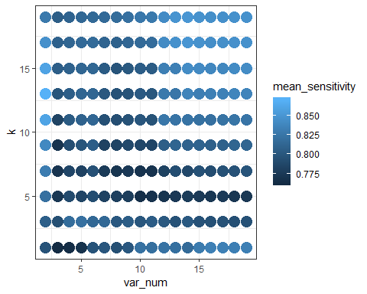

mean_sens_df2[which.max(mean_sens_df2$mean_sensitivity), ]

## var_num k mean_sensitivity  
## 7 2 13 0.8706989

order <- mean_sens_df2 %>% arrange(desc(mean_sensitivity))

save(mean_sens_df2, file='mean_sens_df2.RData')  
save(order, file='order.RData')

load output

load( file='mean_sens_df2.RData')  
load( file='order.RData')

ggplot(data = mean_sens_df2, aes(x = var_num, y = k, color = mean_sensitivity)) + geom_point(size = 5) +   
 theme_bw()



# Repeat test with top 5 choices and resampled training/test data

R <- 100 # replications  
  
  
# create the matrix to store values 1 row per model  
err_matrix_opt <- matrix(0, ncol=5, nrow=R)  
  
sensitivity_matrix_opt <- matrix(0, ncol=5, nrow=R)  
  
fmeasure_matrix_opt <- matrix(0, ncol=5, nrow=R)  
  
gmean_matrix_opt <- matrix(0, ncol=5, nrow=R)  
  
# these are optional but I like to see how the model did each run so I can check other output  
KNNcm <- matrix(0, ncol=4, nrow=R)  
KNNcm2 <- matrix(0, ncol=4, nrow=R)  
KNNcm3 <- matrix(0, ncol=4, nrow=R)  
KNNcm4 <- matrix(0, ncol=4, nrow=R)  
KNNcm5 <- matrix(0, ncol=4, nrow=R)  
  
set.seed(1876)  
  
for (r in 1:R){  
   
 # subsetting data to training and testing data  
 splitIndex <- createDataPartition(dat_v$Absent_time, p = .50,  
 list = FALSE,  
 times = 1)  
   
 trainSplit <- dat_v[ splitIndex,]  
 testSplit <- dat_v[-splitIndex,]  
   
 trainSplit$Absent_time <- as.factor(trainSplit$Absent_time)  
 trainSplit <- SMOTE(Absent_time ~ ., trainSplit, perc.over = 100, perc.under=200)  
   
 ################################################################ knn  
   
 #Running the classifier  
   
 #option 1  
   
 knn <- knn(trainSplit[,1:order[1,1]],  
 test = testSplit[,1:order[1,1]],  
 cl=trainSplit[,20], k=order[1,2])  
   
 #predict doesn't work with KNN for factors  
 knntable <- table(knn, testSplit[,20])  
   
 cm_KNN <- confusionMatrix(data = knntable, reference = testSplit[,20], positive = "1")  
   
 KNNcm [[r,1]] <- cm_KNN$table[1,1]  
 KNNcm [[r,2]] <- cm_KNN$table[1,2]  
 KNNcm [[r,3]] <- cm_KNN$table[2,1]  
 KNNcm [[r,4]] <- cm_KNN$table[2,2]  
   
 err_matrix_opt [[r,1]] <- (cm_KNN$table[1,2]+cm_KNN$table[2,1])/nrow(testSplit)  
   
 # store the errors   
   
 sensitivity_matrix_opt[[r, 1]] <- cm_KNN$byClass[1]  
   
 fmeasure_matrix_opt [[r, 1]] <- cm_KNN$byClass[7]  
   
 gmean_matrix_opt [[r, 1]] <- sqrt(cm_KNN$byClass[1]* cm_KNN$byClass[2])  
   
 ######################  
 #option 2  
   
 knn <- knn(trainSplit[,1:order[2,1]],  
 test = testSplit[,1:order[2,1]],  
 cl=trainSplit[,20], k=order[2,2])  
   
 #predict doesn't work with KNN for factors  
 knntable2 <- table(knn, testSplit[,20])  
   
 cm_KNN2 <- confusionMatrix(data = knntable2, reference = testSplit[,20], positive = "1")  
   
 KNNcm2 [[r,1]] <- cm_KNN2$table[1,1]  
 KNNcm2 [[r,2]] <- cm_KNN2$table[1,2]  
 KNNcm2 [[r,3]] <- cm_KNN2$table[2,1]  
 KNNcm2 [[r,4]] <- cm_KNN2$table[2,2]  
   
 err_matrix_opt [[r,2]] <- (cm_KNN2$table[1,2]+cm_KNN2$table[2,1])/nrow(testSplit)  
   
 sensitivity_matrix_opt[[r, 2]] <- cm_KNN2$byClass[1]  
   
 fmeasure_matrix_opt [[r, 2]] <- cm_KNN2$byClass[7]  
   
 gmean_matrix_opt [[r, 2]] <- sqrt(cm_KNN2$byClass[1]* cm_KNN2$byClass[2])  
   
 ##########  
 #option 3  
   
 knn <- knn(trainSplit[,1:order[3,1]],  
 test = testSplit[,1:order[3,1]],  
 cl=trainSplit[,20], k=order[3,2])  
   
 #predict doesn't work with KNN for factors  
 knntable <- table(knn, testSplit[,20])  
   
 cm_KNN3 <- confusionMatrix(data = knntable, reference = testSplit[,20], positive = "1")  
   
 KNNcm3 [[r,1]] <- cm_KNN3$table[1,1]  
 KNNcm3 [[r,2]] <- cm_KNN3$table[1,2]  
 KNNcm3 [[r,3]] <- cm_KNN3$table[2,1]  
 KNNcm3 [[r,4]] <- cm_KNN3$table[2,2]  
   
 err_matrix_opt [[r,3]] <- (cm_KNN3$table[1,2]+cm_KNN3$table[2,1])/nrow(testSplit)  
   
 sensitivity_matrix_opt[[r, 3]] <- cm_KNN3$byClass[1]  
   
 fmeasure_matrix_opt [[r, 3]] <- cm_KNN3$byClass[7]  
   
 gmean_matrix_opt [[r, 3]] <- sqrt(cm_KNN3$byClass[1]* cm_KNN3$byClass[2])  
   
 ################  
 #option 4  
   
 knn <- knn(trainSplit[,1:order[4,1]],  
 test = testSplit[,1:order[4,1]],  
 cl=trainSplit[,20], k=order[4,2])  
   
 #predict doesn't work with KNN for factors  
 knntable4 <- table(knn, testSplit[,20])  
   
 cm_KNN4 <- confusionMatrix(data = knntable4, reference = testSplit[,20], positive = "1")  
   
 KNNcm4 [[r,1]] <- cm_KNN4$table[1,1]  
 KNNcm4 [[r,2]] <- cm_KNN4$table[1,2]  
 KNNcm4 [[r,3]] <- cm_KNN4$table[2,1]  
 KNNcm4 [[r,4]] <- cm_KNN4$table[2,2]  
   
 err_matrix_opt [[r,4]] <- (cm_KNN4$table[1,2]+cm_KNN4$table[2,1])/nrow(testSplit)  
   
 # store the errors   
   
 sensitivity_matrix_opt[[r, 4]] <- cm_KNN4$byClass[1]  
   
 fmeasure_matrix_opt [[r, 4]] <- cm_KNN4$byClass[7]  
   
 gmean_matrix_opt [[r, 4]] <- sqrt(cm_KNN4$byClass[1]* cm_KNN4$byClass[2])  
   
 #####################  
 #option 5  
   
 knn <- knn(trainSplit[,1:order[5,1]],  
 test = testSplit[,1:order[5,1]],  
 cl=trainSplit[,20], k=order[5,2])  
   
 knntable5 <- table(knn, testSplit[,20])  
   
 cm_KNN5 <- confusionMatrix(data = knntable5, reference = testSplit[,20], positive = "1")  
   
 KNNcm5 [[r,1]] <- cm_KNN5$table[1,1]  
 KNNcm5 [[r,2]] <- cm_KNN5$table[1,2]  
 KNNcm5 [[r,3]] <- cm_KNN5$table[2,1]  
 KNNcm5 [[r,4]] <- cm_KNN5$table[2,2]  
   
 err_matrix_opt [[r,5]] <- (cm_KNN5$table[1,2]+cm_KNN5$table[2,1])/nrow( testSplit)  
   
 # store the errors   
   
 sensitivity_matrix_opt[[r, 5]] <- cm_KNN5$byClass[1]  
   
 fmeasure_matrix_opt [[r, 5]] <- cm_KNN5$byClass[7]  
   
 gmean_matrix_opt [[r, 5]] <- sqrt(cm_KNN5$byClass[1]* cm_KNN5$byClass[2])  
   
 #cat("Finished Rep",r, "\n")  
}  
colnames(sensitivity_matrix_opt)<- c("mod1","mod2","mod3","mod4","mod5")  
graph_sens <- melt(sensitivity_matrix_opt)  
  
ggplot(graph_sens,aes(x=Var2, y=value) )+ geom_boxplot()+ labs(y="Sensitivity", title="Sensitivity Comparison of Optimized Models") + theme_minimal()

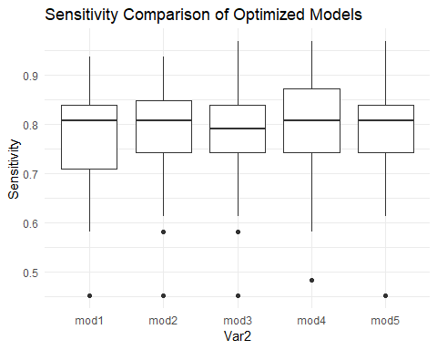

colnames(err_matrix_opt)<- c("mod1","mod2","mod3","mod4","mod5")  
graph_err <- melt(err_matrix_opt)  
  
ggplot(graph_err,aes(x=Var2, y=value) )+ geom_boxplot() + theme_minimal()

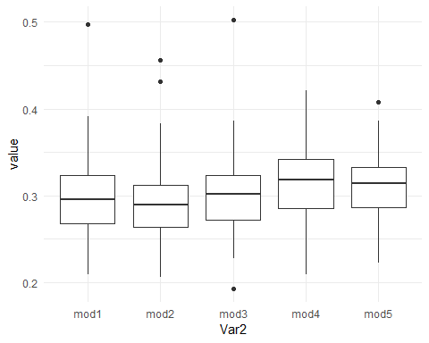

colnames(fmeasure_matrix_opt)<- c("mod1","mod2","mod3","mod4","mod5")  
graph_fmeasure <- melt(fmeasure_matrix_opt)  
  
ggplot(graph_fmeasure,aes(x=Var2, y=value) )+ geom_boxplot() + theme_minimal()

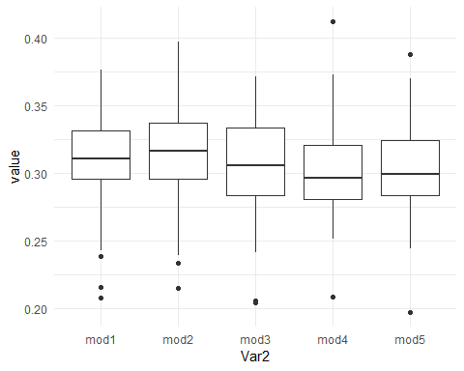

colnames(gmean_matrix_opt)<- c("mod1","mod2","mod3","mod4","mod5")  
graph_gmean <- melt(gmean_matrix_opt)  
  
ggplot(graph_gmean,aes(x=Var2, y=value) )+ geom_boxplot()+ theme_minimal()

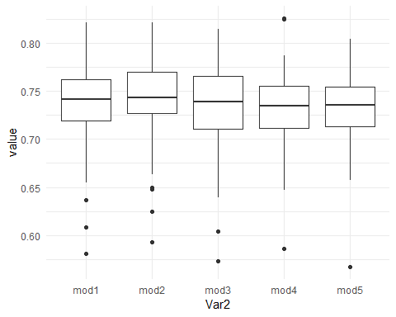

# Comparison to original model

#bind old and new model  
comp_matrix_sens2 <- cbind(sensitivity_matrix_opt[,4], sensitivity_matrix[,1])  
  
colnames(comp_matrix_sens2)<- c("Optimized","Original")  
  
graph_comparison <- melt(comp_matrix_sens2)  
  
ggplot(graph_comparison,aes(x=Var2, y=value) )+ geom_boxplot() +labs(x= "Model", y= "Sensitivity") +   
 theme_minimal()

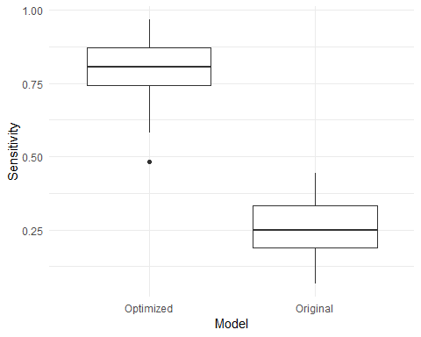

# Confusion Matrix Opminized Model

set.seed(1976)  
 splitIndex <- createDataPartition(dat_v$Absent_time, p = .50,  
 list = FALSE,  
 times = 1)  
   
 trainSplit <- dat_v[ splitIndex,]  
 testSplit <- dat_v[-splitIndex,]  
   
 trainSplit$Absent_time <- as.factor(trainSplit$Absent_time)  
 trainSplit <- SMOTE(Absent_time ~ ., trainSplit, perc.over = 100, perc.under=200)  
   
knn <- knn(trainSplit[,1:order[4,1]],  
 test = testSplit[,1:order[4,1]],  
 cl=trainSplit[,20], k=order[4,2])  
 knntable4 <- table(knn, testSplit[,20])  
   
 cm_KNN4 <- confusionMatrix(data = knntable4, reference = testSplit[,20], positive = "1")  
   
cm_KNN4

## Confusion Matrix and Statistics  
##   
##   
## knn 0 1  
## 0 232 10  
## 1 105 21  
##   
## Accuracy : 0.6875   
## 95% CI : (0.6374, 0.7345)  
## No Information Rate : 0.9158   
## P-Value [Acc > NIR] : 1   
##   
## Kappa : 0.153   
## Mcnemar's Test P-Value : <2e-16   
##   
## Sensitivity : 0.67742   
## Specificity : 0.68843   
## Pos Pred Value : 0.16667   
## Neg Pred Value : 0.95868   
## Prevalence : 0.08424   
## Detection Rate : 0.05707   
## Detection Prevalence : 0.34239   
## Balanced Accuracy : 0.68292   
##   
## 'Positive' Class : 1   
##

# Confusion Matrix Initial Model

set.seed(1976)  
dat1 <- dat[-1]  
  
#scale  
scale <- sapply(dat1, is.numeric)  
dat1[scale] <- lapply(dat1[scale],scale)  
p <- .6 # proportion of data for training  
w <- sample(1:nrow(dat1), nrow(dat1)*p, replace=F)  
data_train <-dat1[w,]   
data_test <- dat1[-w,]  
   
  
#Running the classifier  
  
 knn <- knn(data_train[-20],  
 test = testSplit[-20],  
 cl=data_train$Absent_time, k=2)  
   
 knntable <- table(knn, testSplit$Absent_time)  
   
#generate confusion matrix   
 cm_KNN <- confusionMatrix(data = knntable, reference = testSplit[,-20], positive = "1")  
   
cm_KNN

## Confusion Matrix and Statistics  
##   
##   
## knn 0 1  
## 0 320 20  
## 1 17 11  
##   
## Accuracy : 0.8995   
## 95% CI : (0.8641, 0.9282)  
## No Information Rate : 0.9158   
## P-Value [Acc > NIR] : 0.8868   
##   
## Kappa : 0.3184   
## Mcnemar's Test P-Value : 0.7423   
##   
## Sensitivity : 0.35484   
## Specificity : 0.94955   
## Pos Pred Value : 0.39286   
## Neg Pred Value : 0.94118   
## Prevalence : 0.08424   
## Detection Rate : 0.02989   
## Detection Prevalence : 0.07609   
## Balanced Accuracy : 0.65220   
##   
## 'Positive' Class : 1   
##