Action-Set-Informed Design and System Implementation of a Compact Language Model for Smart-Lighting Control
Seongbok Baik¹ and Yong-Geun Hong^{2,*}
¹ Department of Intelligent IoT, Daejeon University, 62 Daehak-ro, Dong-gu, Daejeon 34520, Republic of Korea; sbbaik@dju.ac.kr; ORCID: https://orcid.org/0009-0009-4420-4084
² School of AI Software, Daejeon University, 62 Daehak-ro, Dong-gu, Daejeon 34520, Republic of Korea; yghong@dju.ac.kr; ORCID: https://orcid.org/0000-0003-2974-3820
* Correspondence: yghong@dju.ac.kr

Abstract
Chat-to-Action systems map variable natural-language requests to a finite set of executable device commands. We examine whether enumerating this set can inform compact-model design in smart-lighting control. Executing the SentiLight policy reduces a nominal space of 1.3 × 10¹¹ actuator combinations to 240 distinct command tuples. We use this effective action count and training exposure per action to structure a multi-seed search over model width, depth, tokenizer and budget. The selected 15.7 M-parameter decoder attains 86.5% exact policy match on the development set and 58.7% on an unseen-frame set. Its advantage over a retrained 23.4 M reference architecture on the latter set is uncertain (+1.2 percentage points; 95% seed interval, −2.1 to +4.6). A mixed-bit export occupies 17.1 MB and has a median inference latency of 95 ms on a four-thread local CPU service. The selected checkpoint is integrated into the catalogue-gated service path of an Android–FastAPI–Tasmota installation with five physical Wi-Fi bulbs. A post hoc machine-paraphrase stress test exposes substantial input-language limitations. These results support effective-action enumeration as an input to capacity and exposure search, while locating the system's demonstrated performance within controlled linguistic conditions.
Keywords: compact language models; smart lighting; edge-assisted inference; effective action set; capacity search; training exposure; reference implementation; input-side generalisation

1. Introduction
Language-based device control requires a mapping from a potentially broad range of utterances to a restricted set of actuator commands. In SentiLight, a Korean request concerning colour and mood must ultimately specify hue, saturation, brightness, dimmer level and colour temperature. The relevant design problem is the relationship between this finite output policy, the model capacity required to implement it and the linguistic variability of requests.
The five actuator fields admit approximately |H|·|S|·|B|·|D|·|CT| ≈ 1.3 × 10¹¹ nominal combinations. However, the executable SentiLight policy maps admissible colour, emotion and intensity combinations to 240 distinct command tuples. We denote this set by A_{eff} and its cardinality by K_{eff}. Enumeration is performed after device normalisation, so this count refers to distinct executable commands rather than to possible user utterances or merely syntactically valid outputs.
This count provides two measurable quantities before training: the number of executable outputs represented by the policy and the average number of training presentations available per output under a specified data budget. We examine whether these task-derived quantities can usefully constrain an empirical search for compact models. Model accuracy, however, remains a function of input representation, data and training conditions and must be determined experimentally.
The tokenizer comparison illustrates that distinction. With K_{eff} fixed at 240, replacing the original 24k tokenizer with a 4k tokenizer changes the widths at which the model performs reliably. Accordingly, our claim concerns an action-set-informed search over capacity and per-action exposure rather than a direct mapping from K_{eff} to hidden width or total parameter count.
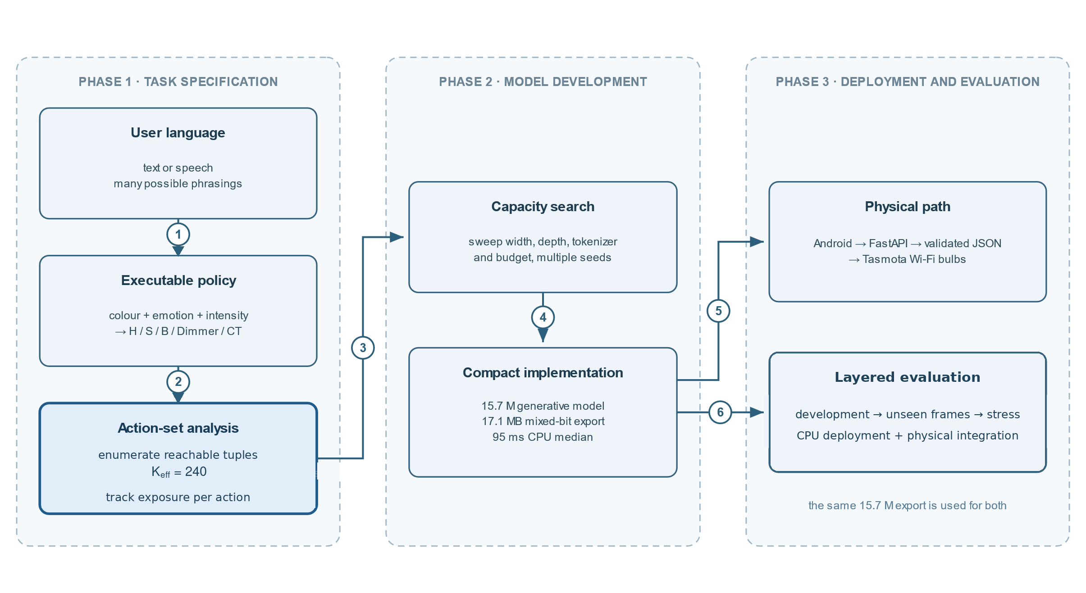
Figure 1. Study design. Executable-action enumeration and per-action exposure define task information for a multi-seed capacity search. The selected configuration is then examined through software integration, deployment measurements, three constructed evaluation distributions and integration with the physical five-bulb platform.
We evaluate width, depth, tokenizer construction and training budget through separate experimental series, extending decision-relevant configurations to five seeds. The resulting 15.7 M-parameter decoder with a 4k tokenizer trained on natural Korean text reaches 86.5% exact match on the development set, compared with 80.8% for the retrained 23.4 M reference architecture. Its mixed 4/6/8-bit export occupies 17.1 MB and has a median service-side inference time of 95 ms with four CPU threads.
The selected checkpoint is integrated into the existing FastAPI model service, which validates its five-field output before the Android client translates admissible tuples into Tasmota commands. The Android application, local service and five-bulb laboratory platform provide the implemented control path documented in this study. The selected checkpoint's software-path compatibility and service-side performance are measured directly; its separate physical-bulb actuation was not logged.
The evaluations address different validity questions. The development set measures policy reproduction under the sentence templates used during model exploration. A post-selection hold-out constructed from 32 new sentence frames probes changes in sentence structure while retaining policy vocabulary. A subsequent machine-paraphrase stress set examines a more distant synthetic input distribution. These language evaluations are reported separately from software-path and deployment measurements.
The contributions of this paper are as follows.
- First, we formulate an empirical capacity-and-exposure search using an enumerable executable-action set. Four nested policies with K_{eff} = 48, 240, 480 and 960 are evaluated under two training schedules. Under fixed steps, accuracy deteriorates even for actions shared among policies; when presentations per action are matched, mean differences among the larger policies decrease at wider model sizes, although seed-level intervals remain inconclusive. A tokenizer comparison shows that the useful width region can change even when K_{eff} is constant (Sections 3.2, 3.3 and 4.1).
- Second, multi-seed experiments across width, depth, vocabulary and budget support selection of a 15.7 M-parameter configuration within the tested grid. Selection accounts for development accuracy and variation among seeds, and its linguistic generalisation is assessed on sentence frames constructed after the architecture was frozen (Sections 4.2–4.4).
- Third, we characterise the selected model as a system component. Its output passes through schema validation and an executable-action catalogue gate in the Android–FastAPI–Tasmota control path; we measure CPU latency, storage after mixed-bit quantization and output behaviour under input shift. The paper documents the physical five-bulb implementation and the software boundary through which admissible commands reach the Tasmota devices (Sections 4.4–4.7).
Section 2 reviews related work. Section 3 specifies the Android-to-bulb implementation, effective-action enumeration and experimental protocol. Section 4 presents the capacity experiments, model comparison, deployment measurements, physical-platform integration and layered language evaluations. Sections 5 and 6 discuss scope and conclusions.

2. Related Work

2.1 Compact Models for Device Control
Language-driven home automation has been studied using cloud models for goal-oriented control and locally deployed models for function calling. Sasha uses a cloud LLM to compose device plans [1], whereas TinyAgent, Octopus v2 and HomeLLaMA examine task-oriented models between approximately 0.5 B and 7 B parameters [2]–[4]. A review describes potential uses of substantially smaller models in automation [5]. Those systems generally adopt a pretrained size as a starting point. Our study instead asks how an enumerable device policy can inform the search for a model trained for a specific action task. The 15.7 M configuration examined here is approximately 32–446 times smaller in parameter count than the cited 0.5–7 B range.
Prior work connects lighting conditions to psychological and affective responses [15], [16], while reviews of affective lighting emphasize the limited evidence from deployed environments [17]. Voice-driven systems that derive lighting commands from inferred sentiment have also been proposed [18]. SentiLight provides an implemented Android-to-lighting path; the present work evaluates compact-model selection, command validation and deployment behaviour using that platform.

2.2 Structured Action Prediction
Mapping utterances to structured actions is closely related to semantic parsing and to intent classification with slot filling [28]–[31]. SentiLight differs mainly in its specific closed output inventory: the policy produces one of 240 executable five-field command tuples. Grammar-guided or constrained decoding may enforce output syntax during generation [32], [33]. We evaluate a decoder that emits JSON alongside a classification head selecting directly among the enumerated tuples, thereby separating the contribution of a learned language representation from the choice of output formulation.

2.3 Capacity, Exposure and Tokenization
Empirical scaling studies relate language-model performance to parameters, data and compute [6]–[8], but do not directly determine the architecture needed to reproduce a finite, device-specific control policy. We use policy enumeration as a task descriptor for a measured candidate search. The observed dependence on K_{eff} is conditional on the input representation and training budget, and is not presented as a general model-size scaling law.
Multiclass learning theory identifies the number of classes and examples per class as relevant to statistical difficulty [34], [35]. Our matched-presentation experiments operationalize a related engineering question for the SentiLight training protocol without applying those theoretical bounds to a pretrained decoder. The architecture search itself is a manually specified, multi-seed grid rather than an automated neural architecture search [36].
Tokenizer construction changes both the number of trainable embedding parameters and the segmentation of Korean requests. Prior work has documented effects of vocabulary size, training corpus and language-dependent tokenization on downstream behaviour [10]–[14]. We compare tokenizer sizes and training corpora within a fixed control task and report diagnostic counts for byte fragmentation and the pretraining frequency of tokens occurring in evaluation inputs.
Seed-level paired differences provide the primary inferential summaries. Row-level McNemar tests, Stouffer aggregation and Holm correction are retained as supporting analyses [19]–[21]; random-effects pooling, hierarchical resampling and equivalence tests address related uncertainty questions [22]–[24]. Series predictions and input hashes were recorded before execution, although the record was not externally registered [25]. For deployment, we evaluate a mixed-bit weight export [26], [27] with load-time dequantization.

3. Materials and Methods

3.1 System Architecture and Software Integration
SentiLight is an Android–FastAPI–Tasmota implementation developed for this smart-lighting project. A Korean-language Android client and five physical Wi-Fi bulbs provide the application context; the local service provides the inference and command-validation path examined here. Figure 2 shows where the schema and policy-membership checks occur before a device command is sent.
The Android application accepts typed input or Korean speech-to-text and sends the utterance to a FastAPI service through POST /predict/{model_id}; /predict_all supports the five-adapter comparison mode. The service normalises each response to {H, S, B, Dimmer, CT}, validates field types and actuator ranges, and checks membership in the frozen 240-tuple executable-action catalogue. The client associates each model identifier with a bulb address in config/frontend.yaml and issues Tasmota HTTP commands for HSBColor, Dimmer and CT. Independent device requests allow other bulbs to continue if one adapter or bulb fails.
The catalogue is enumerated from the policy and stored with a SHA-256 digest and expected entry count. At service start-up, an invalid or missing catalogue causes commands to be withheld. During inference, the default reject mode returns no lighting command for an otherwise well-formed tuple outside the policy and records the reason. An optional snap mode replaces the output with the nearest catalogue tuple using normalised per-field distance and circular hue; the original and substituted tuples are recorded, and substitution is disabled by default. Section 4.4 quantifies the effects of the default gate on recorded evaluation outputs.
The model emits a structured response to the local service; the service validates it and returns an admissible tuple to the Android client for execution. Inference runs on a local CPU workstation rather than on the handset or bulb. Reported latency therefore measures model-service execution and excludes speech acquisition, network transmission and physical bulb response.
The control policy extracts up to three attributes: colour (seven named categories), emotion (five categories) and intensity (five levels including neutral). It combines a colour target with emotion and intensity adjustments and specifies a fallback for requests naming neither colour nor emotion. For the example request, orange, sadness and soft intensity map to {H:21, S:38, B:34, Dimmer:26, CT:358}; the client converts that tuple to HSBColor 21,38,34; Dimmer 26; and CT 358. Exact-tuple evaluation requires all five fields to match the policy output.
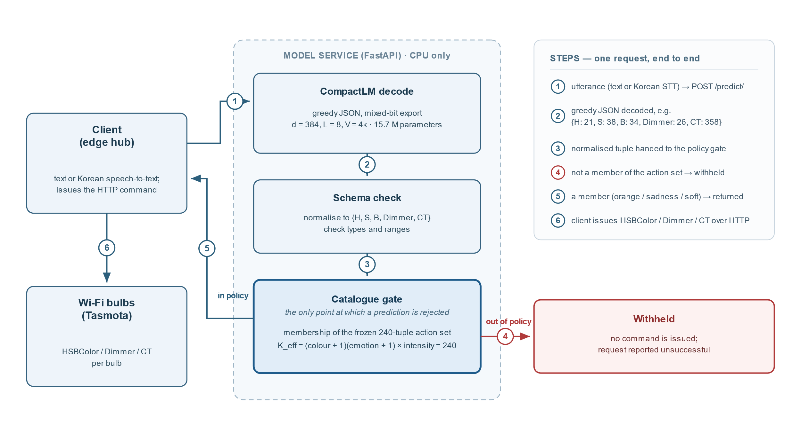
Figure 2. SentiLight software and device control path. The Android application transmits text or transcribed speech to the FastAPI service. After model inference, schema validation and membership testing against the 240-entry action catalogue, an admissible tuple returns to the client for Tasmota execution. Out-of-policy outputs are withheld at the service; capacity experiments and CPU latency are measured on this service path.

3.2 Effective Action Set of the Executable Policy
Let π denote the control policy, A_valid(π) its admissible structured outputs, and f the mapping from a structured output to a command after device normalisation and resolution. The effective action set and its cardinality are defined as follows:
A_{eff}(π, f) = { f(a) : a ∈ A_valid(π) }, K_{eff} = |A_{eff}(π, f)|.
Operationally, A_{eff} is computed by enumerating all admissible attribute combinations, applying π and f, and merging identical commands after device normalisation. K_{eff} counts distinguishable executable tuples; it does not count utterances or determine whether command differences are perceptually discriminable. Because the count depends on both π and f, changing either the policy or the device resolution may change K_{eff} without changing the general application domain.
Algorithm 1 (effective-action enumeration). Given π and f: (1) enumerate the lattice (colour or none) × (emotion or none) × intensity; (2) exclude policy-inadmissible combinations; (3) evaluate each remaining combination through π and f; (4) merge identical normalised commands; and (5) report the number of unique tuples and collisions. The released implementation produces 240 unique SentiLight commands with zero collisions (Table 1).
For the deployed policy, (7 + 1)(5 + 1) × 5 = 240 admissible attribute cells resolve to 240 distinct tuples after normalisation. An 18° hue-snap safeguard is inactive in this enumeration, with maximum hue drift of 7°. Thus K_{eff} = 240, approximately 5 × 10⁸ times smaller than the nominal 1.3 × 10¹¹ actuator combinations.
The capacity series uses collision-free nested policies with a common composition rule: K48 = (3 + 1)(3 + 1) × 3, K480 = (11 + 1)(7 + 1) × 5 and K960 = (15 + 1)(11 + 1) × 5. For the depth control, A2K192 fixes intensity at neutral and varies colour and emotion, yielding (15 + 1)(11 + 1) × 1 = 192. Because only one policy represents each K_{eff} level, cardinality and the semantic composition of newly added categories are partially confounded.
Table 1. Executable policies and effective action counts used in the capacity and depth series.
Policy | Colours (+none) | Emotions (+none) | Intensity levels | K_eff | Role
K48 | 4 | 4 | 3 | 48 | small nested policy
K240 | 8 | 6 | 5 | 240 | production policy
K480 | 12 | 8 | 5 | 480 | expanded policy
K960 | 16 | 12 | 5 | 960 | largest policy
A2K192 | 16 | 12 | 1 | 192 | two-attribute depth control
K_{eff} measures the number of distinct executable outputs, whereas transformer width d specifies the dimension of an internal token representation. There is no mathematical requirement that d equal or exceed K_{eff}: a d-dimensional representation can be mapped to a larger set of output classes. Although the principal 24k-tokenizer width gain lies between d = 224 and 256, around K_{eff} = 240, the 4k-tokenizer experiment yields a substantial additional gain at d = 384. The numerical alignment observed with one tokenizer is therefore a system-specific heuristic rather than a width bound.
K_{eff} does not enter the parameter identity of the generative decoder. A separate K_{eff}-class head would add K_{eff}·d weights (approximately 9 × 10⁴ at K_{eff} = 240 and d = 384, less than 1% of 15.7 M), but the models examined here emit JSON through the token-vocabulary projection. K_{eff} informs the choice of configurations and presentations per action to evaluate empirically.

3.3 Capacity and Exposure Search
We frame capacity selection as a task-conditioned search rather than a direct conversion from the effective action count to model size. For a policy, device mapping, input distribution and training budget, the measured capacity region is the subset of tested architectures that reaches a stated accuracy criterion:
Rτ(π, f, Din, B; H) = { h ∈ H : Accuracy(h; π, f, Din, B) ≥ τ },
where Rτ contains the candidate architectures h ∈ H attaining threshold τ under policy π, device map f, input distribution Din and training budget B. Because this region is conditional on all of these quantities, it can contain several capacity–exposure trade-offs. We estimate a restricted slice by fixing L, V and B and varying width on the tested grid G_d:
d̂τ(π, f, Din, B | L, V) = min { d ∈ G_d : mean Accuracy(d) ≥ τ }, N̂τ = V·d̂τ + 12·L·d̂τ².
The resulting d̂τ is the smallest tested width whose mean accuracy reaches τ, and N̂τ is the approximate parameter count of that tested configuration. Neither quantity is a global minimum or a task-independent prediction. Keff contributes indirectly: it informs the candidate widths and per-action exposure budgets to examine, while measured accuracy under the chosen policy and input distribution determines the retained region.
Before training, policy enumeration and structural considerations defined a deliberately broad candidate grid. For SentiLight, the initial width region was d = 256–384, near the order of Keff = 240, with narrower and wider controls; the three policy attributes motivated an initial depth range of 6–12 layers, tested against shallower alternatives. These were task-specific starting points, not bounds. With the 24k tokenizer, the principal width increase occurred between d = 224 and 256, whereas with the 4k tokenizer d = 256 remained 10.6 percentage points below d = 384.
The experiments therefore swept width from 128 to 512 and depth from 2 to 16, with additional vocabulary, action-set and pretraining-budget series. The 4k tokenizer shifted the useful width region without changing Keff, showing why action count must be combined with input representation and exposure rather than treated as a sizing law. In the resulting procedure, policy enumeration supplies a task descriptor, architecture accounting maps each candidate to parameter count, and multi-seed measurements determine which tested configurations satisfy the engineering objective. Post-selection evaluations then characterise generalisation beyond the development distribution.

3.4 CompactLM Architecture and Parameter Accounting
CompactLM is a decoder-only transformer with rotary position embeddings, a context length of 256 tokens and dropout of 0.1. The experimental series vary hidden width d, block count L and tokenizer vocabulary V as separate architecture levers. At d = 384, the model uses six attention heads and a feed-forward width of 1024; at other widths, the feed-forward dimension scales approximately as 8d/3, rounded to multiples of 32, and the head count approximately as d/64. Generative configurations decode JSON greedily through a vocabulary projection and contain no action-classification head.
For this architecture, parameter count is approximated by N(d, L, V) ≈ V·d + 12·L·d². Weight tying makes the input embedding and output projection share the V·d term. Within each block, the attention projections contribute approximately 4d² and the gated SwiGLU feed-forward matrices another 8d²; normalisation parameters are lower-order terms. The expression therefore maps a specified combination of d, L and V to model size, but it is not itself a performance model. Architectures with untied embeddings or different feed-forward blocks require different accounting.
Substituting d ∈ [256, 512], L ∈ [6, 12] and V ∈ [20k, 50k] into this identity yields an initial candidate band of approximately 9.8–63.4 M parameters, spanning about a factor of six. The band was used to organize the first search and was tested with configurations outside it; inclusion in the band does not imply that a model reaches a performance target. Its practical value is assessed through the controlled series, seed variability and implementation cost, rather than by retrospective inclusion of an existing checkpoint. Exact parameter counts for evaluated configurations are reported in the Supplementary Material.

3.5 Experimental Data and Evaluation Protocol
Standard pretraining uses 2,400 steps at batch size 64 and block length 256, equivalent to approximately 39 M token positions. The cleaned Korean corpus contains 245,258 lines and about 5.1 M tokens under the 24k tokenizer, or approximately 7.6 corpus traversals. It combines the KOTE Korean online-comment emotion dataset [37] with generated lighting-domain sentences; KOTE was retrieved from the authors' default repository branch, which has no tagged release, and is redistributed with its MIT copyright and permission notice. A 120-step warm-up precedes cosine learning-rate decay from 3 × 10⁻⁴ to 3 × 10⁻⁵, and the budget control doubles pretraining to 4,800 steps. Corpus provenance, tokenization files and hashes are included with the research artifacts.
Decontamination preceded construction of the later hold-outs. Against the available validation, development-test and production-rule data, we removed 6,000 exact duplicate lines, six additional normalised matches and 40 near-duplicates above the Jaccard threshold. A later audit of the frozen corpus found no exact or normalised overlap with either post-selection set and no Jaccard similarity of at least 0.8; the observed maxima were 0.56 for unseen frames and 0.67 for machine paraphrases. This audit did not alter the corpus. Build scripts and both audit records are released.
Supervised fine-tuning uses four epochs of policy rows with batch size 64, learning rate 1 × 10⁻⁴, weight decay 0.01 and 5% warm-up; checkpoints are selected by validation loss. The K series contrasts approximately 3,100 fixed updates per policy with four matched epochs. Under fixed steps, mean presentations per action fall from about 4,200 at K48 to 210 at K960. Under matched epochs, presentations remain near 800 per action while total updates range from 596 to 12,768. Exposure per action and total optimisation therefore change together across the two schedules.
Tokenizer variants include the deployed 24k tokenizer, 4k, 8k, 16k and 24k tokenizers trained on 35,977 natural-text lines, and equally sized variants trained on the template-heavy corpus as negative controls. Diagnostics comprise tokens per evaluation line, byte-fragment share, the proportion of evaluation tokens observed fewer than 100 times during pretraining and validation loss in bits per byte. The frequency cutoff is exploratory and was specified after inspection of the results.
The controlled reference uses d = 384, L = 8 and V = 24k and is distinguished from the earlier 23.4 M operational checkpoint with the same architecture. The selected candidate uses d = 384, L = 8 and the natural-text 4k tokenizer, giving 15.7 M parameters. Training and GPU evaluation used two NVIDIA GeForce RTX 5090 GPUs with 32 GB each; deployment measurements used a shared Intel Core Ultra 9 285K workstation with the production runtime limited to four CPU threads.
The inventory contains 112 independent pretraining executions, 243 policy–architecture–seed fine-tuned checkpoints and 309 evaluations: 243 fp32 runs on policy-specific development sets, 56 fp32 runs on the common K48 test set and 10 quantized runs. Separate series vary width (W), effective action set and schedule (K), depth (D), vocabulary (V), pretraining budget (B), width with the revised tokenizer (X), a combined architecture (C) and attribute count in the depth comparison (A). Predictions and input SHA-256 digests were recorded before each series, rejected predictions are retained, and preliminary clean-grid reruns are excluded (Supplementary S1 and S3). No external time-stamped registry was used [25].
Most grid cells use three seeds, while architecture-decision cells were extended to five. In the K series, five-seed reinforcement covers the fixed-step threshold crossings, the K480 and K960 d = 384/512 matched-exposure cells and the K240 column; other cells retain three seeds and are shown as hollow markers. The text and tables identify the seed count whenever a screening result is used.
Policy-only training data contain 9,533 rows for K48, 49,093 for K240, 99,943 for K480, 204,283 for K960 and 39,571 for A2K192, together with validation and 2,000-row development sets. Every reachable tuple appears at least twice in the development set. Training coverage averages 199–213 rows per action, although the least represented action has 17–18 rows. The earlier 1,000-row benchmark contained 105 ambiguous rows because intensity was omitted where the target depended on it; the revised templates explicitly state non-neutral intensity (Supplementary S4).
The 2,000-row policy test set was examined repeatedly during configuration exploration and is therefore treated as a development benchmark. After selection, a separate 2,000-row set was generated for the production policy from 32 previously unused sentence frames in six families. It adds context clauses, particles and altered word order while retaining known policy-category vocabulary, covers every reachable tuple at least twice and has no utterance-level overlap with the K-series files. Because its rows are clustered within frames, uncertainty is resampled across seeds, frames and rows. This unseen-frame set measures transfer to new synthetic frame structures, not performance on spontaneous speech.
A further 2,000-row post hoc stress set was produced after selection from external-LLM paraphrases of the 240 policy cells and screened by a blind back-labelling pass from the same model. Prompts, candidates, decisions, reasons and the final-set hash are retained, and the results did not affect selection. Because generation and screening use one external model and no independent annotation, this set characterises only that synthetic paraphrase distribution. A blinded 57-item author-audit sheet was prepared, but no audit result is reported.
Exact tuple match is the primary policy-reproduction metric: all five output fields must equal those issued by the executable policy. It is not a perceptual measure, since distinct tuples may produce similar illumination. Coarse match discretizes H, S and B into three levels and Dimmer and CT into two. Strict match uses ordinary-field tolerance ±20 and CT tolerance ±80 subject to emotion-specific constraints; because those constraints depend on the policy, strict scores are not compared across policy variants.
The training seed is the unit of inference. Common evaluation rows support paired row-level analyses but do not constitute independent training replications. Headline effects use paired-seed differences, t intervals with n − 1 degrees of freedom and the number of seeds agreeing in direction; the unseen-frame analysis additionally uses hierarchical resampling across rows, frames and frame families. McNemar tests per seed, Stouffer aggregation and Holm correction within each series are supporting analyses [19]–[21]. An adjacent step meets the prospective adoption rule only when corrected row-level p < 0.05 and every seed agrees in sign; hierarchical bootstrap and random-effects pooling are supplementary [22], [24].
Superiority claims report 90% and 95% paired-seed intervals and require both to exclude zero. Equivalence uses two one-sided tests with a ±3 percentage-point margin, whereas non-inferiority requires a separately stated margin; 90% intervals accompany one-sided tests at the 5% level. All mean ± SD values use the sample standard deviation across training seeds, and every table identifies the seed count [23].

3.6 Baseline Models and Engineering Selection
For the fixed 240-action policy, non-generative models provide relevant alternatives to a decoder producing numeric JSON. Each baseline is trained on the same 49,093 policy rows and evaluated by exact tuple match on the corresponding test sets.
- The lexical baseline uses TF–IDF features over character 2–4-grams with multinomial logistic regression. Its purpose is to assess what the training data permit without a learned pretrained sentence representation.
- Frozen-encoder baselines use paraphrase-multilingual-MiniLM-L12-v2 representations either with logistic regression or with nearest-class-centroid prediction. These alternatives separate a frozen representation from an end-to-end tuned language model.
- A larger discriminative baseline fine-tunes the multilingual encoder and a 240-class head end to end for three epochs at learning rate 3 × 10⁻⁵. Its 118 M parameters preclude an equal-capacity comparison with the compact models.
- The size-matched classification baseline attaches a 240-class head to the same CompactLM pretraining checkpoints, fine-tuning rows and five seeds used for the generative configuration. This comparison controls backbone initialization and training rows while varying the output formulation.
Regularization is chosen on validation data without access to the post-selection sets. A class head always outputs a catalogue member, so differences in accuracy must be evaluated together with file size and latency. The previously deployed SBERT adapter was excluded from the controlled baseline table after diagnostic embeddings were found to be highly anisotropic and non-discriminative (Section 4.4 and Supplementary S10).
The empirical design procedure consists of five operations.
- First, execute the policy over all admissible attribute combinations and record the distinct device commands, collisions and K_{eff}.
- Second, count examples per action, including the least represented action, and specify the training presentations available under the chosen budget.
- Third, select a bounded candidate grid of widths, depths and tokenizers conditional on the policy and input corpus. For SentiLight the initial region included d = 256–384, but the tested grid extends beyond it; the depth screen includes L = 2, 3, 4, 6 and 8.
- Fourth, inspect held-out segmentation and token pretraining frequencies, and evaluate candidate configurations across training seeds, using three for the initial screen and five for decision-relevant cells.
- Fifth, choose and freeze an implementation using development performance and seed variation, then measure quantization and CPU operation and assess the frozen selection on newly constructed sentence frames.
The first two operations use the policy and dataset before model training; the subsequent steps require empirical measurements. Section 4 presents the resulting observations for SentiLight.
The two-tier seed protocol was specified before execution, but the choice of particular three-seed cells for reinforcement was informed by initial screening. Additional-run inputs and analysis plans were fixed before those runs. We therefore describe five-seed cells as reinforced decision evidence, not independent confirmations of a fully prespecified hypothesis.
The final configuration reflects a documented engineering selection. Within-series adoption rules, seed protocol and the ±3 percentage-point quantization margin were specified before the corresponding experiments. The descriptive 60% crossing threshold, development accuracy target, variance tolerance, lowest-seed criterion, priority order and hold-out non-inferiority contrast were decided after some development results were available. Supplementary Tables S1 and S2 distinguish these decisions, and post hoc criteria are not presented as confirmatory tests.

4. Results

4.1 Action-Set Size and Training Exposure
Four nested policies with K_{eff} = 48, 240, 480 and 960 were evaluated at widths d = 128, 192, 256, 384 and 512 with L = 8 and the original 24k tokenizer. Figure 3 compares fixed-step and matched-presentation schedules. Decision cells contain five seeds; remaining screening cells contain three. For descriptive comparison, we report the smallest tested width exceeding 60% exact match. The 60% threshold was chosen after inspecting the data and is not a prespecified application requirement; alternative descriptive thresholds appear in Supplementary S5.
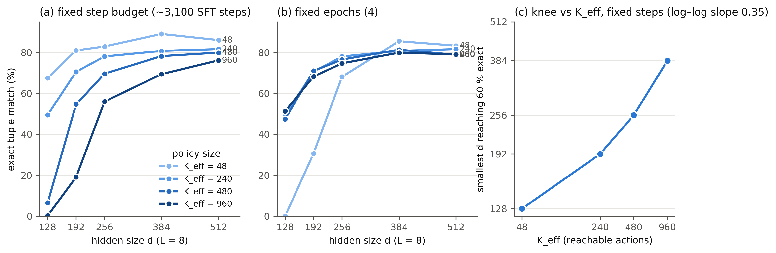
Figure 3. Effective action count, model width and training schedule. Under a fixed number of steps, the smallest tested width above the descriptive 60% line increases across the nested policies. Under matched presentations per action, mean accuracies for the larger policies are closer at wider widths, without seed-level confirmation of the attenuation. Filled and hollow markers denote five and three seeds, respectively.
Under approximately 3,100 steps per policy, the smallest tested widths above the descriptive 60% threshold are d = 128, 192, 256 and 384 for K_{eff} = 48, 240, 480 and 960, respectively. No width below 128 was evaluated for K48. Adjacent five-seed cells are 49.5 ± 4.8% and 70.6 ± 5.4% at d = 128 and 192 for K240; 54.6 ± 6.5% and 69.6 ± 2.9% at d = 192 and 256 for K480; and 56.0 ± 13.3% and 69.4 ± 13.2% at d = 256 and 384 for K960. The screening cells at d = 128 yield 6.5% for K480 and 0.2% for K960. Thus a twentyfold increase in this policy family's action count corresponds to a threefold increase in threshold-crossing tested width. Five-seed reinforcement retains the observed crossing cells, but variation near K960 remains approximately 13 percentage points; the fitted exponent in Supplementary S5 is descriptive for four policies and five widths.
With four training epochs, each action receives approximately 800 presentations. At d = 384, five-seed means for K240, K480 and K960 are 80.8 ± 3.6%, 81.3 ± 4.2% and 79.9 ± 7.8%; at d = 512 they are 81.6 ± 5.3%, 78.8 ± 4.0% and 79.0 ± 9.7%. Means span 1.4–2.8 percentage points, although K960 retains substantial variability. The paired budget difference for K960 is +10.5 points at d = 384 (90% interval [−0.1, +21.1]) and +9.1 at d = 512 over three seeds ([−1.5, +19.6]). K480 differences are +0.6 and +1.0 with intervals encompassing zero. At K48 the four-epoch schedule shortens training to 596 steps, reducing accuracy to 0% at d = 128 and 30.7% at 192 from 67.5% and 81.0% under fixed steps. The schedules alter total optimisation as well as exposure per action; smaller mean gaps are observed, but equivalence and a seed-level attenuation magnitude are not established.
To assess whether declines reflect only the newly added semantic categories, we evaluated actions common to the nested policies at matched widths. We additionally examined outputs on the identical K48 utterance set with verified identical target commands.
Supplementary Table S5 reports accuracy on those shared and added action subsets under both training schedules, together with the number of seeds in each comparison.
At d = 256 under fixed steps, accuracy on K48-catalogue rows is 78.9%, 67.7% and 44.8% for models trained under K240, K480 and K960. At d = 384, the corresponding figures are 80.6%, 81.6% and 63.9%. The decline thus extends to previously shared actions. In a separate common-set evaluation, each of the four policy models received the same 2,000 K48 utterances, and all 2,000 target commands were confirmed identical under all four policies. The matched-presentation schedule reduces the point-estimate gaps, but intervals for the seed-level attenuation include zero. Full ring and common-set analyses appear in Supplementary S6 and S7.
These training schedules jointly change several properties. At fixed optimisation steps, presentations per action decrease as the policy grows; under four epochs, the number of steps increases with the dataset. Larger policies also add semantic categories. The results therefore support a conditional association among action-set size, training exposure and measured capacity, but do not identify exposure dilution independently of interference from newly introduced actions.
The practical implication for this policy family is to examine per-action exposure when selecting width candidates, particularly near performance thresholds. The observed threshold crossings describe five tested widths and one tokenizer at fixed depth; they do not constitute a transferable model-size function.

4.2 Effects of Width Depth and Tokenizer
We next isolate candidate design choices within each series. Figure 4 summarizes width under the original tokenizer, depth at fixed width and natural-corpus vocabulary size; Figure 5 relates measured development accuracy to total parameters for the configurations considered in selection.
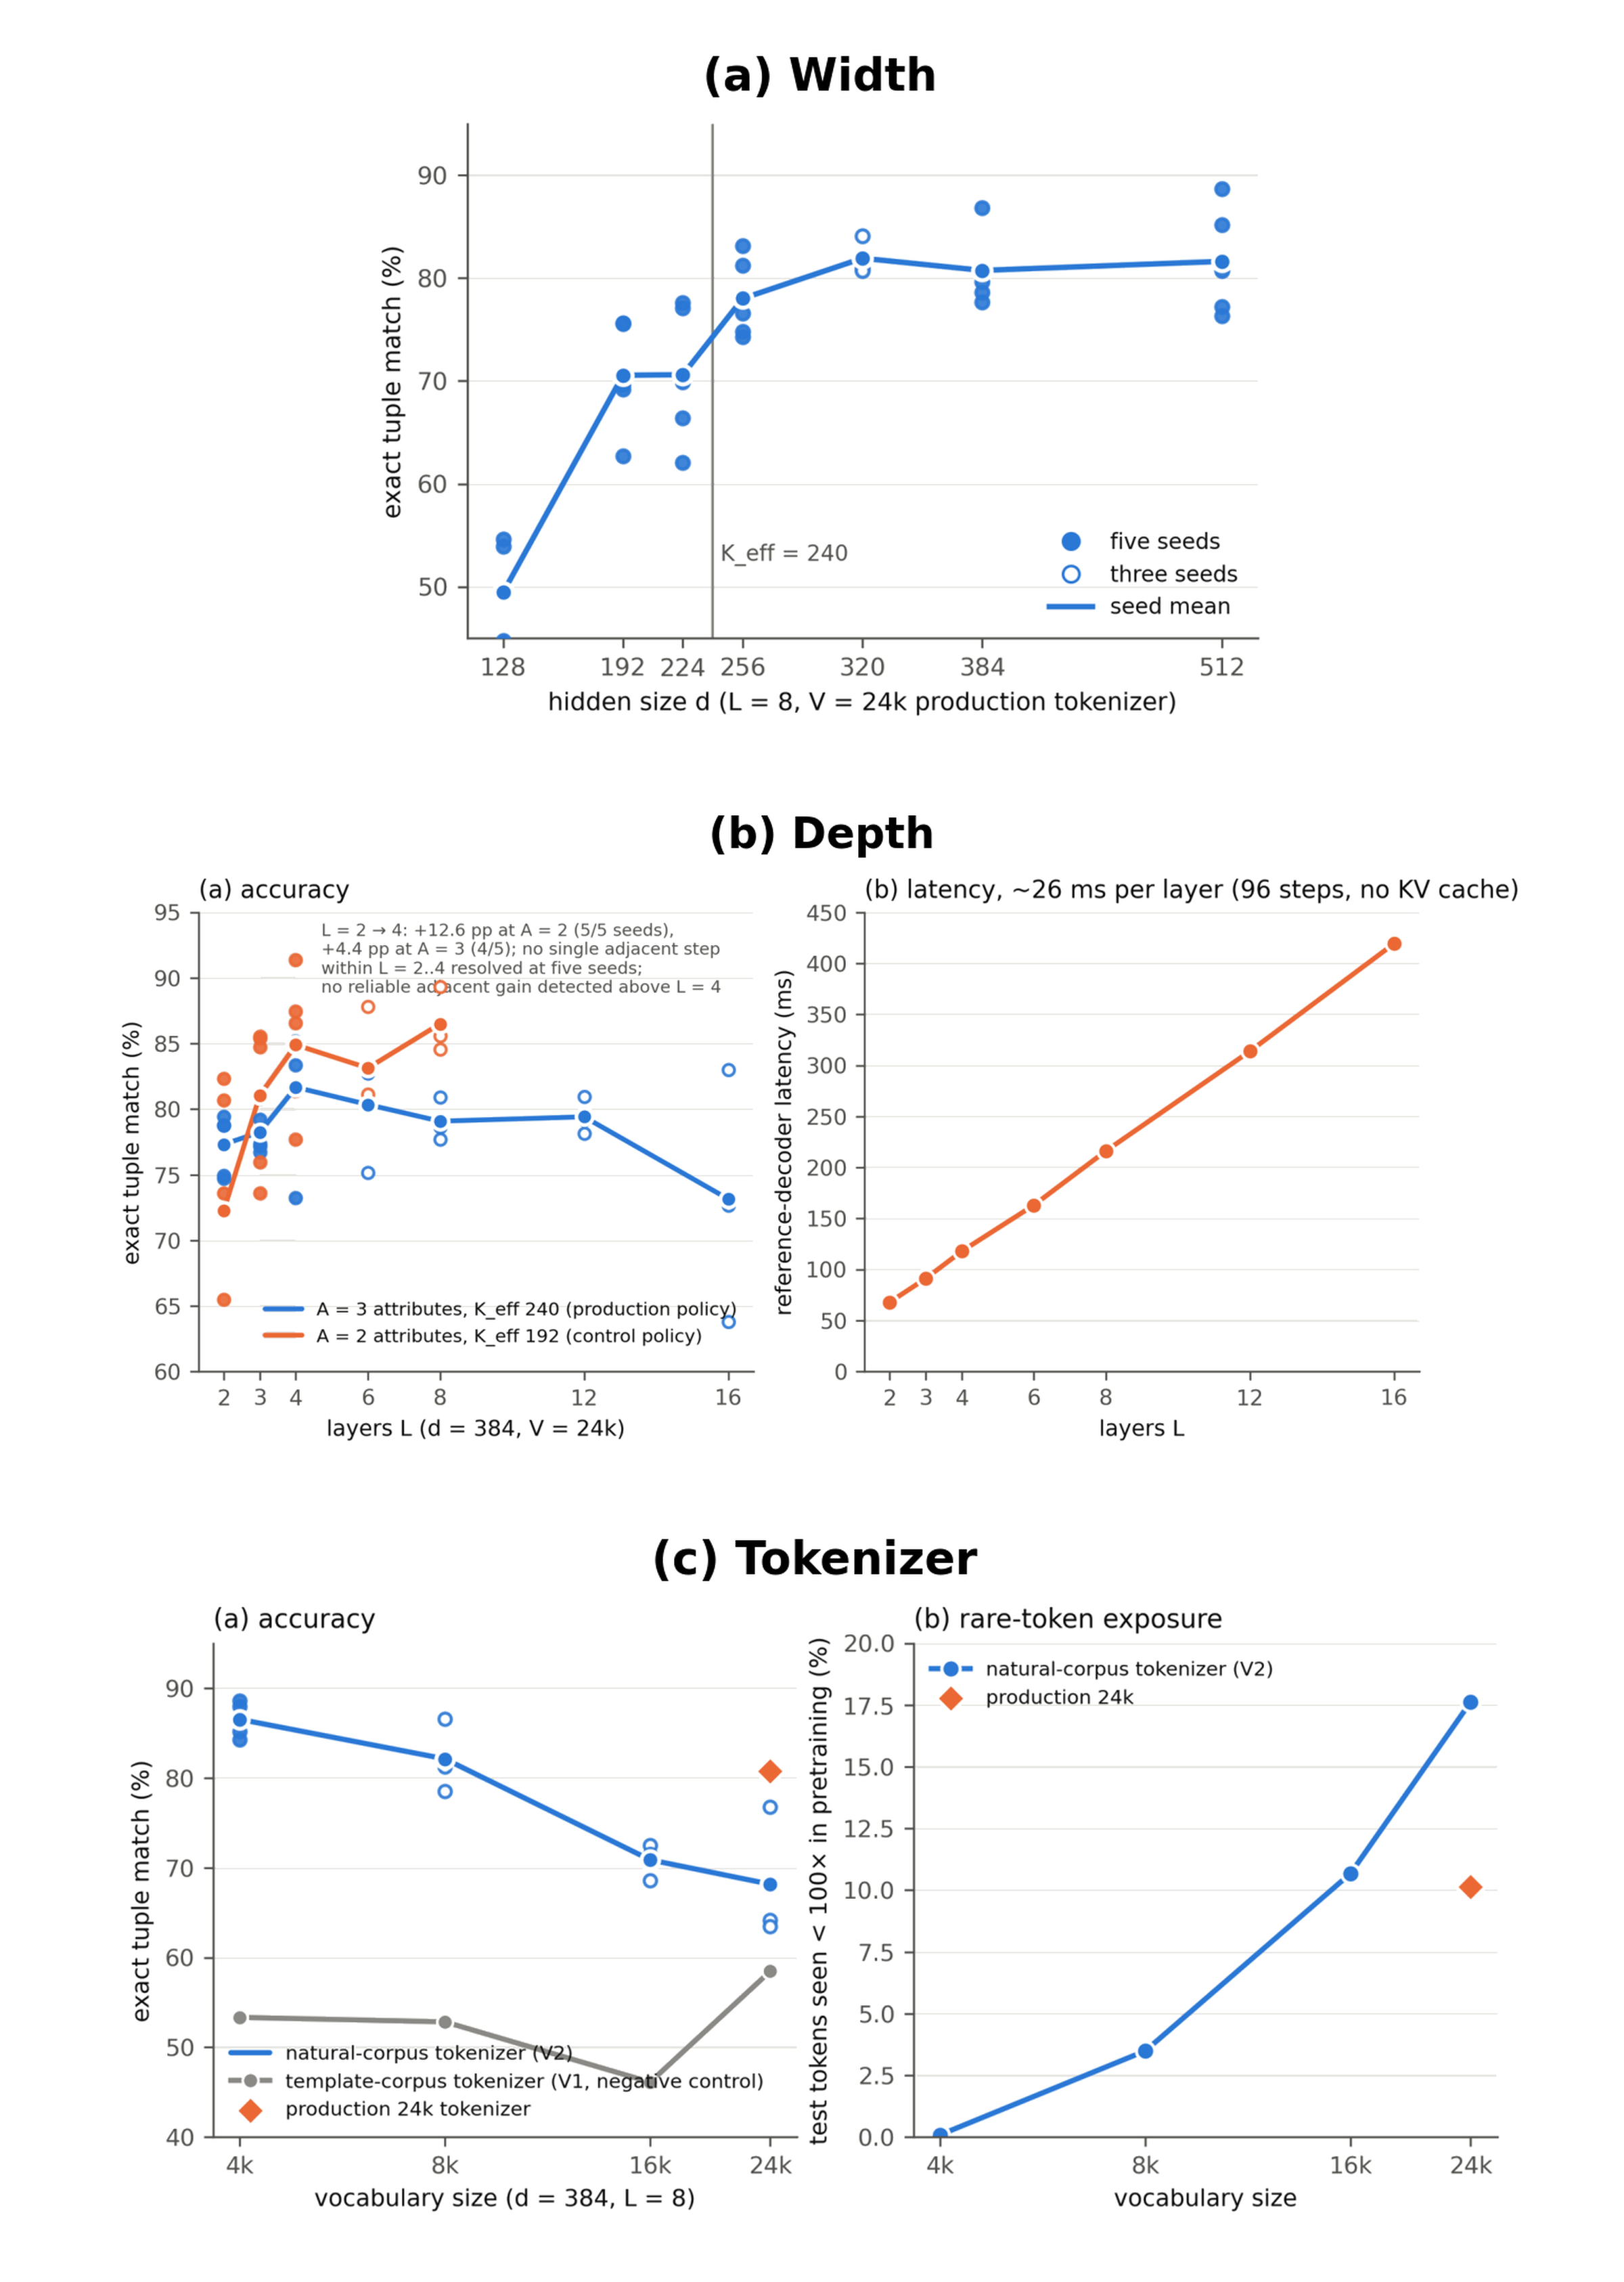
Figure 4. Width, depth and vocabulary experiments. With the original 24k tokenizer, the largest supported neighboring width increase lies between d = 224 and 256. At d = 384 with that tokenizer, no reliable adjacent accuracy gain is detected beyond L = 4, while latency increases with depth. Under the tested pretraining budget, the 4k natural-text tokenizer has the highest development accuracy among the natural-corpus sizes. Connecting lines join measured configurations only.
With L = 8 and the original 24k tokenizer, five-seed development exact match rises from 49.5 ± 4.8% at d = 128 to 78.0 ± 4.0% at d = 256, 80.8 ± 3.6% at d = 384 and 81.6 ± 5.3% at d = 512. The adjacent d = 224→256 gain satisfies the prospective five-seed adoption rule; d = 192 and 224 both average 70.6%, whereas the d = 256→384 point difference of +2.8 percentage points has an interval including zero. This gain brackets K_{eff} = 240 only under the original input representation. At fixed L = 8, reference-decoder latency varies from 209 to 217 ms across the tested widths (Supplementary Table S27).
At d = 384 and L = 8, natural-corpus tokenizers of sizes 4k, 8k, 16k and 24k yield 86.5 ± 1.8%, 82.1 ± 4.1%, 70.9 ± 2.0% and 68.2 ± 7.5% exact match, respectively. The original mixed-corpus 24k tokenizer yields 80.8 ± 3.6%. The 4k and original-24k results use five seeds; other natural-corpus sizes use the seed counts reported in the figures and supplementary tables. Template-corpus tokenizers perform substantially worse, at roughly 46–59%. Vocabulary size, corpus provenance and segmentation jointly affect these comparisons; the tokenizer mechanism is evaluated through auxiliary diagnostics rather than assumed from compression rate.
Rare-token exposure increases with natural-corpus vocabulary size under this budget. The share of evaluation tokens seen fewer than 100 times in pretraining is 0.1%, 3.5%, 10.7% and 17.6% for natural 4k, 8k, 16k and 24k, compared with 10.1% for the original 24k tokenizer. Validation losses expressed in bits per byte remain close (0.926–0.943), showing that this intrinsic measure does not track downstream exact match. The 100-occurrence threshold was selected after inspection. Doubling pretraining from 2,400 to 4,800 steps changes natural 4k accuracy from 86.5% to 85.9% and natural 24k from 68.2% to 70.6%; the 4k–24k difference remains 15.3 points. These results describe the tested corpus and budget rather than a general preference for smaller vocabularies.
At fixed d = 384 and L = 8, changing from the original 24k tokenizer to natural-text 4k increases the five-seed development mean by 5.8 percentage points, reduces seed SD from 3.6 to 1.8 points and reduces parameters from 23.4 M to 15.7 M. Four of five paired seeds favor the 4k version, so the prospective all-seeds direction criterion is not met; the paired 90% interval is [+1.1, +10.5] (Supplementary Table S29).
The width series changes under the natural-text 4k tokenizer. Five-seed exact match is 79.0 ± 3.1%, 76.0 ± 4.9%, 83.8 ± 3.4% and 86.5 ± 1.8% at d = 224, 256, 320 and 384. The paired d = 256→384 gain is +10.6 points (90% interval [+6.1, +15.0]; positive in all five seeds), compared with a +2.8-point estimate under the original 24k tokenizer. The estimated difference between these width effects is +7.8 points, but its 90% interval [−1.9, +17.5] includes zero. A tokenizer–width interaction is therefore suggested, not confirmed; no stable plateau below d = 384 is observed for the 4k condition.
Depth was evaluated under both the three-attribute production policy and a two-attribute control. From L = 2 to 4, the five-seed mean increases by 12.6 percentage points for A = 2, with five positive paired seeds and a 90% interval of [+3.3, +22.0], and by 4.4 points for A = 3, with four positive seeds. Individual L = 2→3 and L = 3→4 contrasts do not consistently locate that gain, so the proposed L = A + 1 sizing heuristic is unsupported. At d = 384 with the original 24k tokenizer, no reliable neighboring gain is observed above L = 4; equivalence of depths has not been established. In the reference decoder, latency rises by approximately 26 ms per additional layer, from 67 ms at L = 2 to 420 ms at L = 16.

4.3 Engineering Selection of a Compact Model
Figure 5 plots development accuracy against parameter count for the tested configurations. Table 2 reports the five-seed candidate cells used in the documented engineering selection.
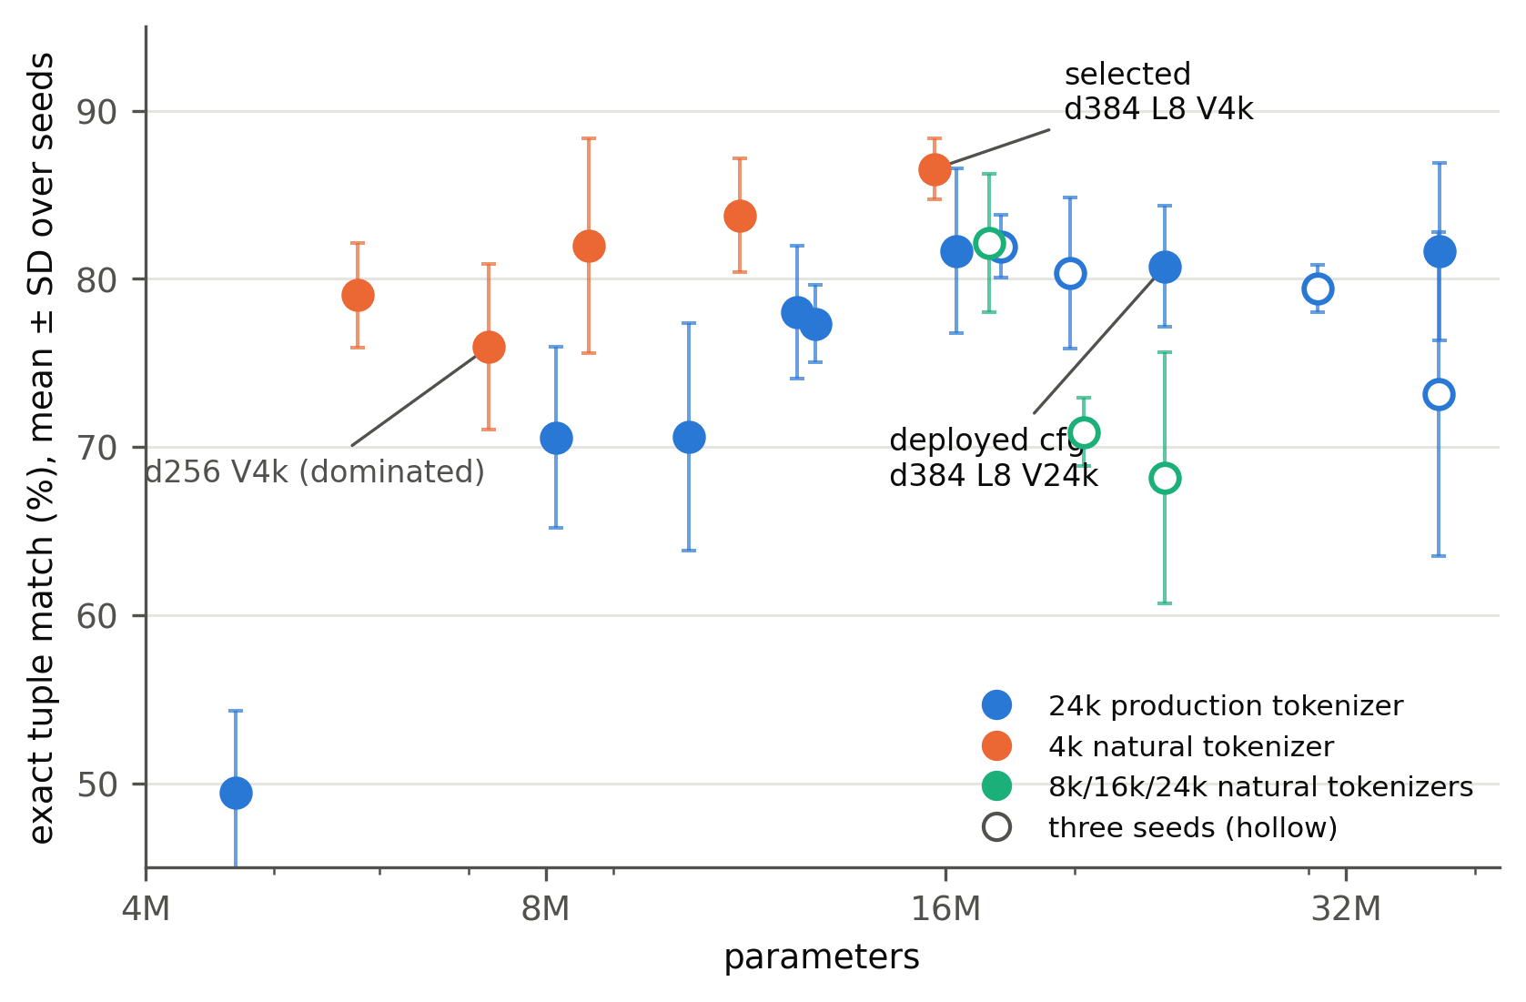
Figure 5. Development-set exact match versus parameter count for the evaluated configurations. The selected d = 384, L = 8, V = 4k model combines the highest development mean among the leading compact candidates with the lowest corresponding seed variation. Selection applies to the tested grid and is not a global architectural optimum.
Table 2. Candidates used for engineering selection, measured on the development test set across five seeds (mean ± sample SD).
Configuration | Parameters | Exact (%) | Interpretation
d384 L8 V24k | 23.4 M | 80.8 ± 3.6 | retrained reference
d384 L4 V24k | 16.3 M | 81.7 ± 4.9 | difference uncertain
d384 L8 V4k | 15.7 M | 86.5 ± 1.8 | selected: highest mean, lowest SD
d384 L4 V4k | 8.6 M | 82.0 ± 6.4 | largest SD; two low seeds
d320 L8 V4k | 11.2 M | 83.8 ± 3.4 | parameter-efficient alternative
Within the tested 4k configurations, d = 384, L = 8 has the strongest development mean and least seed variability. Two of five seeds for the 8.6 M, L = 4 alternative fall below 78%, presenting a downside in policy reproduction. We therefore selected the 15.7 M model using development results and froze the configuration before construction of the unseen-frame set. The 11.2 M, d = 320 alternative has fewer parameters, but its quantized export and CPU operating characteristics were not measured.
The later unseen-frame result for d = 320 appears competitive; it is reported as a post-selection observation and does not change the frozen model choice. Selecting a model after reviewing that evaluation would repurpose the hold-out as development data. The selected configuration is consequently a documented trade-off within the examined grid, not a minimum-size guarantee.
An error decomposition of the development set finds that the selected configuration gains 14.5 percentage points on utterances with colour and emotion but without intensity, and 11.3 points on principal combination templates, relative to the retrained reference. Requests without a named colour remain difficult for all tested configurations (Supplementary Table S2).

4.4 Unseen-Frame Evaluation and Output-Form Baselines
Candidate architectures were fixed before evaluation on 2,000 utterances generated from 32 new sentence frames (Section 3.5). Supplementary Table S12 audits all 30 configuration–seed evaluations by checkpoint identity, parameter count and tokenizer digest, and records the originating fp32 checksum for each quantized export.
Exact match decreases by 23–30 percentage points across configurations. The selected 15.7 M model reaches 58.7 ± 1.7% after attaining 86.5% on development data; the retrained 23.4 M reference reaches 57.4 ± 2.4% after 80.8% (Table 4). All responses remain valid JSON and the coarse score remains near 70%, indicating that failures involve action selection rather than output syntax. The development-set difference between the two architectures is substantially smaller on new frames.
The paired selected-minus-reference differences across five seeds are +4.8, −0.2, +3.5, −1.3 and −0.5 percentage points, yielding a mean of +1.2, a 90% interval of [−1.3, +3.8] and a 95% interval of [−2.1, +4.6]. Only two seeds favor the selected model. Superiority is unsupported (p = 0.181) and equivalence within ±3 points is not established (TOST p = 0.109). A −3-point non-inferiority test yields p = 0.012, but this margin was applied to the comparison after observing the frame results and is exploratory. Resampling seeds and rows within frames gives a 95% difference interval of [−2.1, +4.6]; including the six frame families widens it to [−4.9, +4.9] and crosses the non-inferiority margin. Thus the frame data support neither superiority nor equivalence, with appreciable uncertainty over possible frame families.
Accuracy varies by 67.8 percentage points among the 32 unseen frames, from 24.1% to 91.9% for the selected model (Supplementary Table S13). Hierarchical resampling over seeds, frames and rows gives a 90% interval of [55.9, 61.4] for the aggregate; including frame families gives [56.0, 66.6]. Colour-only requests attain 74.6%, intensity-explicit fallback requests 79.4%, mixed colour-and-emotion requests 55.0% and neutral fallback requests 40.0%. This heterogeneity is obscured by the row-weighted aggregate.
Inverting predicted tuples through the policy shows that, among incorrect unseen-frame outputs from the selected model, 65.0% have an incorrect emotion, 12.7% an incorrect colour and 30.1% an incorrect intensity; categories can overlap. The corresponding emotion-error share of the retrained reference is 73.7%. Approximately 9% of selected-model errors fall outside the executable catalogue and can be withheld by membership testing; wrong outputs that remain within the catalogue cannot be identified by this gate.
The mixed-bit export attains 58.4 ± 1.7% on unseen frames versus 58.7 ± 1.7% for fp32, a paired −0.30-point difference with a 90% interval of [−0.75, +0.15]. This is consistent with the development-set ±3-point quantization equivalence test (Section 4.5).
Supplementary Tables S12 and S13 provide the checkpoint audit and scores for individual frames.
Non-generative baselines were trained on the same 49,093 SFT rows and evaluated with the same exact-tuple criterion. A character n-gram classifier attains 31.8% on unseen frames; frozen multilingual embeddings with logistic regression and nearest-centroid heads attain 17.4% and 18.2%. The frozen-embedding classifier reaches 98.2% on training and 95.4% on template-related validation data but generalises poorly to new frames. The operational SBERT adapter is treated as a separate diagnostic because its embeddings are highly anisotropic and non-discriminative (mean pairwise cosine 0.9991 ± 0.0006; Supplementary S10).
Among the compared systems, learned language representations improve transfer to the unseen frames: the character n-gram model attains 31.8%, the same compact backbone attains 58.3% with a 240-class head and 58.7% with JSON generation, and the larger fine-tuned encoder attains 69.6%. These differences motivate a pretrained language backbone for this control interface, without establishing that autoregressive generation is necessary. Architecture, corpus and pretraining differ for the larger encoder, so no single source of its advantage is identified.
Two output-form comparisons distinguish capacity from inference cost.
End-to-end fine-tuning of a multilingual MiniLM encoder with a 240-class head yields 87.7% on the development set, 69.6% on unseen frames and 22.2% on the post hoc stress set. Its median CPU latency is 5.1 ms. The result comes from one training run and is descriptive. At fp32, its 118 M parameters occupy 471 MB, compared with 15.7 M parameters and 62.8 MB for the selected compact decoder. Size, architecture, tokenizer, pretraining and output formulation vary together, so the accuracy difference cannot be assigned to a single factor.
Using identical pretrained CompactLM checkpoints and training rows over five seeds, the 240-class head attains 58.3 ± 2.3% on unseen frames versus 58.7 ± 1.7% for generation. The paired head-minus-generator difference is −0.41 percentage points (90% interval [−3.68, +2.86]; bootstrap [−3.01, +1.95]; supporting McNemar–Stouffer p = 0.491). This contrast does not resolve an accuracy advantage for either output form. Attribute-level scores differ: emotion is 86.7% for the head versus 69.3% for generation, while intensity is 68.8% versus 83.7%.
Under matched fp32 precision, the class head uses 15.79 M parameters in a 63.2 MB file and requires one forward pass; the decoder uses 15.70 M parameters in 62.8 MB and produces JSON autoregressively. Each was benchmarked in a separate process on the same 300 deterministic development prompts, with four CPU threads and 20 warm-up prompts. Median/p95 latency is 3.4/3.8 ms for the head and 98.0/113.4 ms for the decoder, a median ratio of approximately 28 under this protocol. Loading time is 0.11/0.17 s and peak resident memory 647/788 MB, respectively. CPU comparisons use one seed of each configuration.
The decoder additionally has a mixed 4/6/8-bit export of 17.1 MB. No quantized head was built, so its fp32 63.2 MB file is not a matched-precision comparator for that export. On the same 300-prompt development subset, the fp32 head attains 86.3% and the fp32 decoder 85.3%, alongside full-set five-seed means of 87.2 ± 0.7% and 86.5 ± 1.8%. Because all classes are admitted policy tuples, the head cannot return an out-of-catalogue output. Neither output formulation was evaluated after expanding the policy.
A generative output can satisfy the five-field schema yet lie outside the set of commands the policy permits. We replayed the production catalogue gate on stored predictions from five seeds and 2,000 rows for each evaluation distribution (Table 3). The replay quantifies software withholding decisions rather than physical actuation.
Three forms of system evidence are distinguished: stored-output replay estimates how often a gate decision would be made; service-path tests verify the implemented decision logic; and the earlier physical-bulb study demonstrates the operational platform. There is no recorded end-to-end hardware execution by the newly selected checkpoint.
The gate withholds 1.4 ± 0.7%, 3.9 ± 1.5% and 12.2 ± 3.1% of requests on the development, unseen-frame and synthetic stress sets, respectively. Across 30,000 replayed requests, no policy-correct output is withheld, a property guaranteed by the construction of the admissible catalogue. Membership testing requires neither a learned rejection model nor a calibrated score; the zero false-withholding figure concerns exact policy correctness, not user preference.
The gate detects a minority of errors: approximately 9–13% of wrong outputs are withheld, whereas wrong but admissible tuples remain on 12.1 ± 1.2% of development requests, 37.5 ± 1.2% of unseen-frame requests and 79.9 ± 3.0% of stress requests. Such tuples pass membership testing and may be forwarded by the client. The rise in rejection rate across constructed sets is consistent with input shift, but the sets differ in generation method and were not used for an online drift-monitoring experiment.
A class head always selects an admissible tuple, making catalogue membership redundant for that output form. A reject class or calibrated confidence criterion could provide an alternative withholding mechanism, but neither was implemented or evaluated in this comparison.
Evaluation set | Withheld (% of requests) | Correct answers withheld | Wrong answers withheld (% of all wrong answers) | Wrong answers passed by the gate (% of requests)
Development test | 1.4 ± 0.7 | 0 | 9.9 ± 4.2 | 12.1 ± 1.2
Unseen-frame hold-out | 3.9 ± 1.5 | 0 | 9.2 ± 3.3 | 37.5 ± 1.2
Machine-paraphrase stress set | 12.2 ± 3.1 | 0 | 13.2 ± 3.4 | 79.9 ± 3.0
Table 3. Catalogue decisions obtained by replaying the production service's default reject mode on selected-model predictions (five seeds × 2,000 requests per set; mean ± sample SD). These are software decisions, not new bulb operations. Shares withheld and wrong-but-passed use all requests as denominator; the wrong-answer capture column uses only wrong answers. A withheld tuple cannot exactly match policy gold, while an admitted tuple may still be wrong.
For the fixed 240-action policy, the fp32 class head is the efficiency-oriented implementation under the measured latency protocol. A generative decoder can be selected where a serialized five-field JSON interface is a system requirement, with its latency and catalogue validation costs explicit. The gate mitigates a possible error mode of free-form tuple generation; it does not demonstrate a generative advantage over a head constrained to valid classes. The capacity-and-exposure findings concern the compact backbone rather than superiority of one output form.
Table 4. Exact tuple match on the development set, newly written frames and post hoc machine-paraphrase set. ± denotes five-seed mean ± sample SD; the fine-tuned MiniLM value is one run.
Model | Parameters | Development | Unseen frames | Post hoc stress
Selected generative CompactLM | 15.7 M | 86.5 ± 1.8 | 58.7 ± 1.7 | 7.9 ± 0.6
Retrained deployed architecture | 23.4 M | 80.8 ± 3.6 | 57.4 ± 2.4 | 6.6 ± 0.3
Size-matched 240-class head | 15.8 M | 87.2 ± 0.7 | 58.3 ± 2.3 | 10.3 ± 0.6
Fine-tuned multilingual MiniLM | 118 M | 87.7 (n = 1) | 69.6 (n = 1) | 22.2 (n = 1)
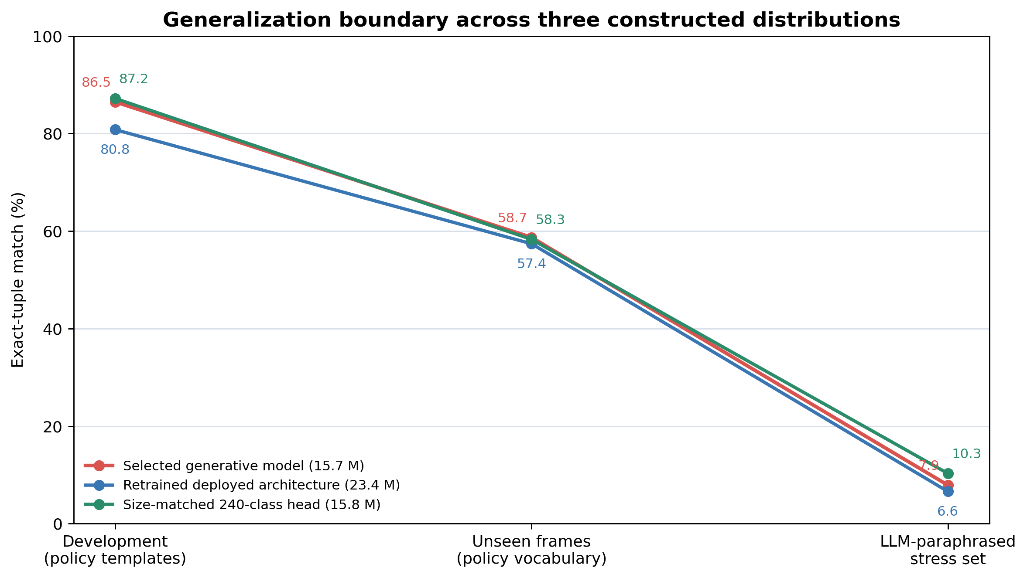
Figure 6. Exact-match results across three constructed input distributions. Development templates support model selection; unseen frames test new sentence structures with known policy vocabulary; post hoc machine paraphrases provide a stronger synthetic wording shift. These estimates do not measure accuracy on spontaneous user utterances.

4.5 Quantization and CPU Deployment Measurements
Figures 7 and 8 summarize paired-seed accuracy after mixed-bit export and the storage and latency properties of the local CPU implementation.
Mixed 4/6/8-bit weight quantization [26], [27] uses groups of 64 and retains embeddings in fp32, with weights dequantised at load time. On development data, the selected model changes by −0.19 percentage points (90% interval [−0.52, +0.14]) and the 8.6 M model by −0.42; both pass the prospectively specified ±3-point TOST equivalence test. The selected export decreases file size from 62.8 MB to 17.1 MB and loading time from 0.17 to 0.10 s, without accelerating the dequantised runtime. On unseen frames its score is 58.4 ± 1.7% versus 58.7 ± 1.7% for fp32 (paired difference −0.30; 90% interval [−0.75, +0.15]). On the machine-paraphrase set it is 7.8 ± 0.5% versus 7.9 ± 0.6% (difference −0.12; 90% interval [−0.34, +0.10]), also passing TOST at ±3 points. Equivalence of the penalty across the three distributions was not separately evaluated.
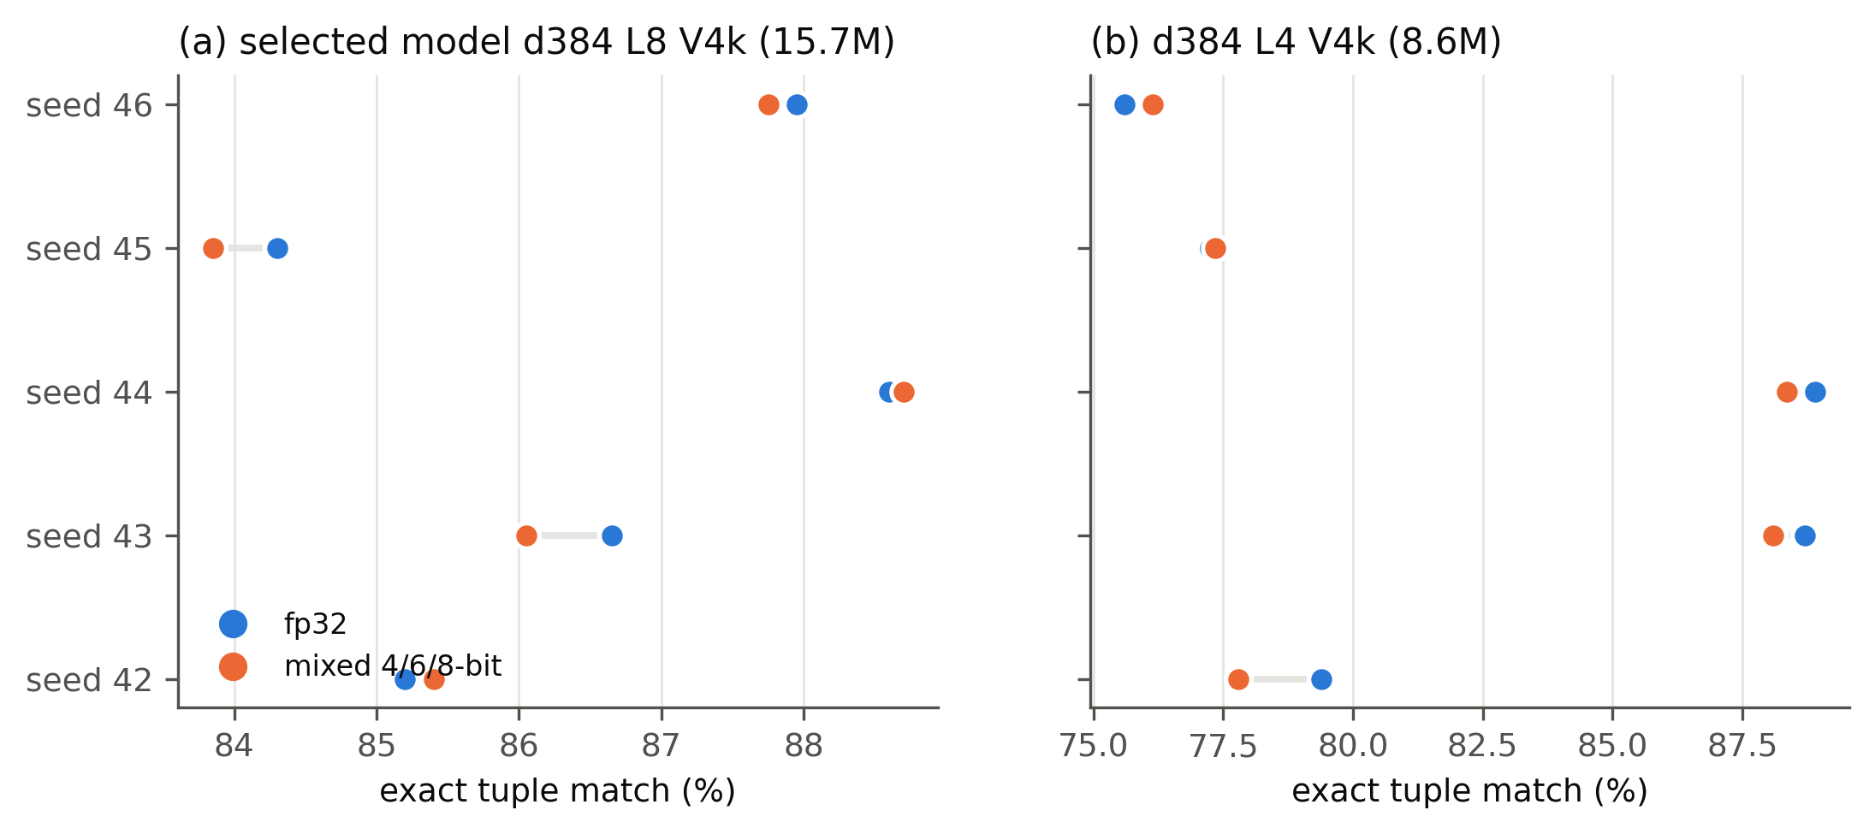
Figure 7. Paired-seed development-set differences after mixed-bit export. Both generative configurations satisfy the prospectively specified ±3 percentage-point equivalence test.
Using the production runtime with a key–value cache, greedy decoding, four CPU threads and 20 warm-up prompts followed by 300 timed prompts, the selected mixed-bit model has median/p95 service latency of 95/105 ms and peak resident memory near 665 MB. The 8.6 M export has 52 ms median latency but greater seed-level accuracy variation. Timings exclude Android capture and speech recognition, network transport and bulb response; no handset inference is claimed. Table 5 includes matched fp32 measurements when comparing the decoder and 240-class head.
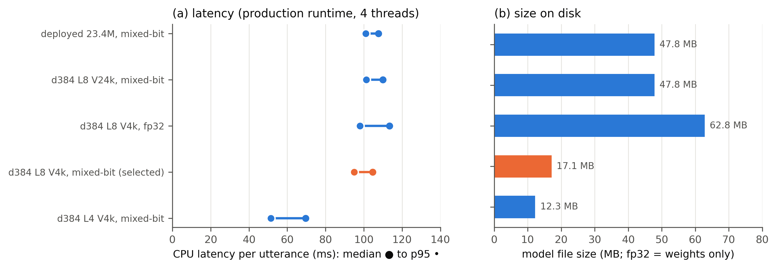
Figure 8. File size, loading and CPU response for tested decoder exports. Mixed-bit storage and loading improve, while inference remains similar because weights are dequantised on load. Four CPU threads were used on the local service.
Table 5. CPU measurements. Each implementation ran in a separate four-thread process on the same deterministic 300 development prompts after 20 warm-up prompts; fp32 head and fp32 decoder can be compared at matched precision.
Implementation | Precision | Params | File | Load | RSS | Median / p95
Selected generative | fp32 | 15.70 M | 62.8 MB | 0.17 s | 788 MB | 98.0 / 113.4 ms
Selected generative | mixed 4/6/8 | 15.70 M | 17.1 MB | 0.10 s | 665 MB | 95.0 / 104.5 ms
240-class head | fp32 | 15.79 M | 63.2 MB | 0.11 s | 647 MB | 3.4 / 3.8 ms
Retrained deployed | mixed 4/6/8 | 23.4 M | 47.8 MB | 0.20 s | 729 MB | 101 / 110 ms
Latency-first generative | mixed 4/6/8 | 8.6 M | 12.3 MB | 0.07 s | 598 MB | 52 / 70 ms

4.6 Physical Platform Integration
The mixed-bit selected model loads through the SentiLight FastAPI adapter and follows the same output normalisation, range checks and catalogue gate as other adapters. All stored evaluation outputs are schema-valid JSON. This establishes software-path compatibility with the implemented Android–Tasmota control interface; separate physical-bulb actuation by the selected checkpoint was not logged.
Figure 2 documents the client-to-service-to-Tasmota control path and its catalogue-gated command boundary. Figure 9 documents the operating platform: (a) the five-bulb laboratory platform and (b) the Android client. Together, they record the implemented device context in which the selected checkpoint is integrated. Model accuracy and CPU characteristics are established by the measurements reported above.
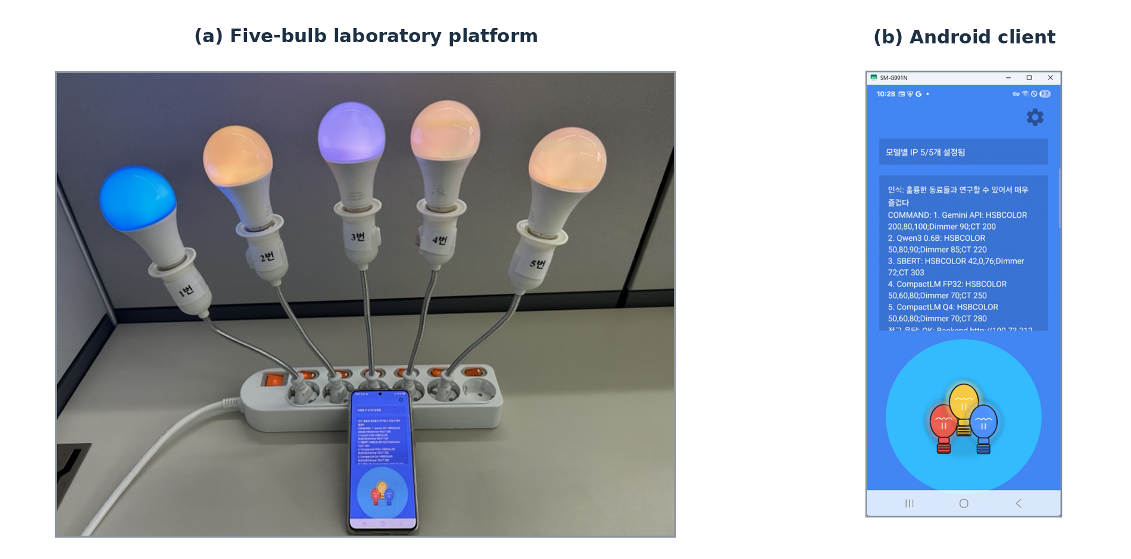
Figure 9. Implemented SentiLight platform. (a) The five-bulb laboratory platform; (b) the Android client with model-to-bulb assignments. The photograph and screen capture document the physical implementation. The software and device control path is shown separately in Figure 2. Capture provenance is supplied with the research artifacts.

4.7 Post Hoc Synthetic Robustness Analysis
The unseen-frame set retains policy vocabulary while varying sentence construction. To examine a more substantial shift in wording, we subsequently evaluated a machine-generated paraphrase set (Section 3.5). The analysis is post hoc; its outcomes were not used to alter the chosen architecture, tokenizer or training dataset.
The selected model obtains 7.9 ± 0.6% exact match over five seeds on the synthetic stress set (90% clustered interval [7.1, 8.6]), versus 58.7% on unseen frames and 86.5% on development data. The retrained 23.4 M reference reaches 6.6 ± 0.3% and the 11.2 M variant 8.4 ± 0.7%. Coarse matching also declines from 70.6% on unseen frames to 22.0%, indicating that the change is not explained solely by strict exact-tuple scoring.
All evaluated configurations still emit valid JSON; the degradation concerns selection of the target action. Among wrong outputs from the selected model, colour is incorrect in 53%, emotion in 62% and intensity in 43%, compared with approximately 13%, 65% and 30% on unseen frames. Attribute errors overlap within rows. Mixed-bit and fp32 scores remain close (Section 4.5).
Within the stress set, rows expressing all named attributes in catalogue terms attain 33.1% exact match, compared with 4.3% when none occur verbatim; uniform guessing over 240 actions corresponds to approximately 0.4%. Shorter utterances are also associated with higher accuracy. Lexical overlap and length covary and were not manipulated independently; their independent causal contributions cannot be inferred from these associations. Item generation and filtering by one external model further restrict interpretation to the accepted synthetic sample (Supplementary S14 and S15).
These distributions correspond to different evaluation questions. Development accuracy (86.5%) measures reproduction of the policy within the explored template family. Unseen-frame accuracy (58.7%) measures transfer to new sentence structures with retained category vocabulary. Stress accuracy (7.9%) measures behaviour on post hoc machine-generated paraphrases that also depart lexically. None of the three is a direct estimate of performance on spontaneous human language.
The 27.8-point reduction from development to unseen frames occurs despite retained category words. Accordingly, vocabulary overlap alone does not define a reliable operating condition. The further stress-set decline demonstrates weak performance on that particular synthetic wording shift. The evidence supports controlled requests near the tested training distribution; it does not establish open-ended natural-language operation. Because the stress set is generated and filtered by a single external model, its observed accuracy is neither an upper nor a lower bound on spontaneous user requests.
On the stress set the size-matched classification head attains 10.3 ± 0.6%, compared with 7.9 ± 0.6% for the generative decoder. The paired head-minus-decoder effect is +2.46 percentage points (90% interval [+1.49, +3.43]; 95% interval [+1.20, +3.72]), with all five seeds in the same direction. Although this contrast is statistically resolved for the constructed items, both configurations are incorrect on the large majority of them.
Figure 6 compares development, unseen-frame and synthetic stress distributions. Their separation identifies the scope of the action-set analysis: executable outputs can be enumerated exactly, but their count does not specify the linguistic coverage of the model receiving the request.

5. Discussion
The effective action set contributes policy-conditioned information to compact-model design rather than a formula for final model size. In SentiLight, executing the policy identifies 240 distinct commands among approximately 1.3 × 10¹¹ nominal actuator combinations. This enumeration establishes the output inventory and supports calculation of presentations per action under a specified training budget. Width, depth, tokenizer and budget experiments subsequently determine which tested configurations reproduce the policy with acceptable measured variability.
At fixed training steps, the smallest tested width above a descriptive accuracy threshold increases across the nested policies, and losses are observed even for identical utterances and actions shared among them. Matching presentations per action yields smaller mean gaps among the larger policies at wider widths, but paired-seed intervals do not establish the magnitude of attenuation. These conditional findings make exposure a material design variable. They cannot isolate its effect from the changing semantic composition of policies or the different total optimisation under the second schedule.
The baseline comparisons locate a distinct challenge at the input interface. Character n-grams attain 31.8% on unseen frames, compared with 58.3–58.7% for the compact language backbone with either a classification head or generation and 69.6% for a larger fine-tuned encoder. This evidence motivates a learned language representation for the tested Korean control inputs; it does not establish a unique need for autoregressive output. For the fixed 240-action policy the class head provides markedly lower measured CPU latency at matched fp32 precision, while a decoder supplies the five-field JSON interface used by the installation.
The selected 15.7 M-parameter decoder uses approximately 33% fewer parameters than the retrained 23.4 M reference and performs better on the development set. On the unseen-frame hold-out, however, its mean difference is +1.2 percentage points with a 95% paired-seed interval of [−2.1, +4.6]; neither superiority nor equivalence is established. The compact classification head and decoder likewise attain 58.3% and 58.7% on these frames without a resolved accuracy difference, although their service-side fp32 latencies differ substantially. The capacity search supports an engineering selection within the evaluated grid; output formulation is an additional system-level decision.
Catalogue replay and software-path tests characterise what the implemented control boundary does. Seven request-path tests verify that admitted tuples reach the send step, while unreadable or out-of-policy tuples produce no Tasmota command; missing or checksum-invalid catalogues fail closed. Eleven additional unit tests verify catalogue logic. Among 30,000 stored predictions replayed through the gate, out-of-policy tuples are withheld, but incorrect tuples that remain within the catalogue pass. These are software-level checks and do not establish that the selected checkpoint physically actuated a bulb.
The application context is an operational Android–FastAPI–Tasmota installation that has controlled five physical Wi-Fi bulbs. The policy, client and physical installation were implemented within the SentiLight project before the capacity search. The selected 15.7 M checkpoint was then integrated as a service adapter and assessed for schema compatibility, catalogue gating, quantized file size and local CPU inference.
Linguistic generalisation constrains application of the selected model. Its 58.7% exact match on synthetic unseen frames is substantially below the 86.5% development score even though policy vocabulary is retained. The later machine-paraphrase set yields 7.9 ± 0.6% exact and 22.0% coarse match while JSON validity remains complete. Both sets are constructed rather than sampled from spontaneous requests; their accuracies are neither estimates nor bounds for performance on such utterances. Action enumeration controls the output inventory but does not confer input-language coverage.
The demonstrated design procedure is specific to a Korean smart-lighting case study. Each action-count level is represented by one nested policy whose category composition also changes, and other applications may have different policies, devices, input languages and training distributions. The transferable object is the measured procedure—enumerating commands, quantifying exposure, testing candidate architectures across seeds and evaluating novel linguistic structures—rather than a numeric width or layer rule.
Several constraints limit interpretation. The study was designed to examine candidate search regions, not to measure how many training runs enumeration saves relative to a counterfactual search. Additional limits concern the policy family, synthetic input distributions and decisions made after screening.
One policy family in one language provides the four K_{eff} levels. Larger catalogues alter category semantics as well as cardinality, so the common-utterance comparison on shared actions cannot separate action-count effects from training interference. Exposure-matched training also changes total updates, and paired-seed attenuation intervals are inconclusive. The A = 2 and A = 3 depth comparisons cover only two policies at one width and the original tokenizer; they do not support a general depth law.
The post-selection paraphrases were generated and back-labelled by the same external LLM. Its 67.7% candidate acceptance rate reflects round-trip consistency, not independent human verification. A 57-item blinded author worksheet was prepared but remains unrated. The unseen-frame set comprises only six frame families; intervals that resample those families are wider than intervals conditional on the observed frames. Neither constructed set provides a sample of spontaneous Korean requests.
The K-series 60% threshold and fitted exponent are post hoc descriptors of four policies and a discrete width grid. Five-seed cells were reinforced after three-seed screening, and some other cells retain three seeds. Pretraining is limited to 2,400 steps on approximately 5 M tokens under the original tokenizer; training schedules change exposure and total work jointly. Worst-seed selection preferences and the hold-out non-inferiority contrast were also specified after inspecting some results. Their status is identified where those comparisons are reported.
Inference latency is measured on a four-thread workstation CPU through the model service, excluding Android capture, speech recognition, network transfer and physical bulb response. The fp32 head and decoder CPU comparison uses one seed per model; a quantized head was not produced. The software-path tests do not measure end-to-end network or bulb-response latency.
Full seed-level results, prospective predictions and verdicts, policy-ring analyses, tokenizer-frequency data and lexical-by-length summaries are provided in the Supplementary Material.

6. Conclusions
We investigated whether the executable action set of a smart-lighting policy can inform compact-model design before training. The SentiLight policy yields K_{eff} = 240 distinct device commands, whereas its nominal actuator fields admit approximately 1.3 × 10¹¹ combinations. Enumeration supplies a precise policy-conditioned output inventory and a basis for calculating training presentations per action; measured model performance is required to choose a width, depth and tokenizer.
Multi-seed comparisons across nested action sets, training schedules and input representations show that the width region associated with adequate policy reproduction depends on exposure and tokenization as well as action-set cardinality. Shared-action degradation under fixed steps and smaller mean gaps under matched presentations are conditional observations, with confounded policy composition and inconclusive seed-level attenuation. The 4k tokenizer moves the useful width region while K_{eff} remains unchanged. These findings support an action-set-informed empirical search, not a general parameter-count prediction.
The resulting selected decoder has 15.7 M parameters, attains 86.5% development exact match and produces a 17.1 MB mixed-bit export with 95 ms median service-side CPU latency. It is integrated through schema and catalogue checks in an established Android–FastAPI–Tasmota platform with five real bulbs. The present checkpoint's directly measured contributions are its model accuracy, software-path compatibility, gate behaviour and local deployment cost.
On a post-selection unseen-frame set, exact match is 58.7% and the selected model's difference from a retrained 23.4 M reference is uncertain (+1.2 percentage points; 95% paired-seed interval [−2.1, +4.6]). The same compact backbone with a classification head yields 58.3% on those frames at substantially lower matched-fp32 inference latency. A subsequent synthetic paraphrase stress set shows severe degradation for all compact configurations. Thus the evaluated implementation demonstrates a compact policy controller for controlled request distributions while identifying input-language generalisation as a separate and unresolved requirement.
For other finite device policies, the applicable procedure is to enumerate executable commands, account for examples per action, screen candidate capacities with repeated seeds, freeze a selection and evaluate it on linguistic structures outside the training templates. The numerical architecture and observed accuracy in this case study should be interpreted under its specific policy, corpus and system conditions.

Author Contributions
Conceptualization, S.B. and Y.-G.H.; methodology, S.B.; software, S.B.; validation, S.B.; formal analysis, S.B.; investigation, S.B. and Y.-G.H.; resources, Y.-G.H.; data curation, S.B.; writing—original draft preparation, S.B.; writing—review and editing, S.B. and Y.-G.H.; visualization, S.B.; supervision, Y.-G.H.; project administration, Y.-G.H. All authors have read and agreed to the published version of the manuscript. Contribution roles: [AUTHORS: supply before submission] confirm.

Funding
This research was funded by the ICT Standardization Program of the Ministry of Science and ICT (MSIT), Republic of Korea, through the Institute of Information & Communications Technology Planning & Evaluation (IITP), grant number RS-2025-02283083.

Institutional Review Board Statement
Not applicable. This study reports no research involving human participants or human-derived data.

Informed Consent Statement
Not applicable.

Data Availability Statement
Series configurations, prospectively specified predictions with input hashes, per-row evaluation outputs (development test, common K48 test and both hold-outs), the unseen-frame hold-out with its frame list and SHA-256 hash, the post hoc LLM-paraphrased synthetic stress set with its generation and back-labelling prompts, its full candidate, accepted and rejected lists with reasons, the raw API responses, the blinded audit sheet and answer key, and a SHA-256 manifest, the provenance audit of all 30 hold-out evaluations, the non-generative baseline code, trained baseline heads and results, the frozen policy catalogue with its SHA-256, the catalogue-gate implementation, its unit and service-path tests and the gate measurement, analysis scripts, tables, figures, the selected model (fp32 and mixed-bit, five seeds) are prepared for release at Zenodo under DOI [AUTHORS: supply before submission]. The deposit must be published and the DOI resolved before submission; until then these artefacts are not publicly available and this statement must not be read as asserting that they are. The pretraining corpus is redistributed with the other artefacts: its upstream source, the KOTE dataset [37], is published by its authors under the MIT licence, which permits redistribution provided the copyright and permission notice accompanies it, and that notice is included in the release. The decontamination record, token counts and hashes are included. The stress set was generated through the Gemini API (model gemini-3.1-flash-lite, called 13 September 2026, temperature 1.0 for generation and 0.0 for back-labelling, 432 calls); the prompts, candidates, acceptances and rejections are released so that the set can be audited, rebuilt or replaced with another generator. No API credentials appear in any released file.

Acknowledgments
The authors used an AI assistant (Claude, Anthropic) to help organise the experimental record, draft and edit portions of the text, and produce analysis scripts, tables and figures from recorded outputs; the authors designed, ran and interpreted all experiments and take full responsibility for the content.

Conflicts of Interest
The authors declare no conflicts of interest.

Abbreviations
The following abbreviations are used in this manuscript: BPE, byte-pair encoding; CI, confidence interval; CPU, central processing unit; GPU, graphics processing unit; IoT, Internet of Things; JSON, JavaScript Object Notation; LLM, large language model; NLP, natural language processing; pp, percentage points; SBERT, Sentence-BERT; SD, standard deviation; SFT, supervised fine-tuning; TOST, two one-sided tests.

References
[1] E. King, H. Yu, S. Lee, and C. Julien, “Sasha: Creative goal-oriented reasoning in smart homes with large language models,” Proc. ACM Interact., Mobile, Wearable Ubiquitous Technol., vol. 8, no. 1, Art. no. 12, Mar. 2024, doi: 10.1145/3643505.
[2] L. E. Erdogan et al., “TinyAgent: Function calling at the edge,” in Proc. Conf. Empirical Methods Natural Lang. Process. (EMNLP): Syst. Demonstrations, Miami, FL, USA, Nov. 2024, pp. 80–88. [Online]. Available: https://aclanthology.org/2024.emnlp-demo.9/
[3] W. Chen and Z. Li, “Octopus v2: On-device language model for super agent,” 2024, arXiv:2404.01744.
[4] X. Huang, L. Shen, Z. Ma, and Y. Zheng, “Towards privacy-preserving and personalized smart homes via tailored small language models,” 2025, arXiv:2507.08878.
[5] I. Lamaakal et al., “Tiny language models for automation and control: Overview, potential applications, and future research directions,” Sensors, vol. 25, no. 5, Art. no. 1318, Feb. 2025, doi: 10.3390/s25051318.
[6] J. Kaplan et al., “Scaling laws for neural language models,” 2020, arXiv:2001.08361.
[7] J. Hoffmann et al., “Training compute-optimal large language models,” in Proc. Adv. Neural Inf. Process. Syst. (NeurIPS), New Orleans, LA, USA, 2022.
[8] B. Isik, N. Ponomareva, H. Hazimeh, D. Paparas, S. Vassilvitskii, and S. Koyejo, “Scaling laws for downstream task performance in machine translation,” in Proc. Int. Conf. Learn. Represent. (ICLR), Singapore, 2025.
[9] R. Eldan and Y. Li, “TinyStories: How small can language models be and still speak coherent English?” 2023, arXiv:2305.07759.
[10] C. Tao et al., “Scaling laws with vocabulary: Larger models deserve larger vocabularies,” in Proc. Adv. Neural Inf. Process. Syst. (NeurIPS), Vancouver, BC, Canada, 2024.
[11] M. Ali et al., “Tokenizer choice for LLM training: Negligible or crucial?” in Findings Assoc. Comput. Linguistics: NAACL, Mexico City, Mexico, Jun. 2024, pp. 3907–3924. [Online]. Available: https://aclanthology.org/2024.findings-naacl.247/
[12] G. Dagan, G. Synnaeve, and B. Rozière, “Getting the most out of your tokenizer for pre-training and domain adaptation,” in Proc. 41st Int. Conf. Mach. Learn. (ICML), Vienna, Austria, 2024, PMLR vol. 235.
[13] A. Petrov, E. La Malfa, P. H. S. Torr, and A. Bibi, “Language model tokenizers introduce unfairness between languages,” in Proc. Adv. Neural Inf. Process. Syst. (NeurIPS), New Orleans, LA, USA, 2023.
[14] K. Park, J. Lee, S. Jang, and D. Jung, “An empirical study of tokenization strategies for various Korean NLP tasks,” in Proc. 1st Conf. Asia-Pacific Chapter Assoc. Comput. Linguistics and 10th Int. Joint Conf. Natural Lang. Process. (AACL-IJCNLP), Suzhou, China, Dec. 2020, pp. 133–142. [Online]. Available: https://aclanthology.org/2020.aacl-main.17/
[15] R. Küller, S. Ballal, T. Laike, B. Mikellides, and G. Tonello, “The impact of light and colour on psychological mood: A cross-cultural study of indoor work environments,” Ergonomics, vol. 49, no. 14, pp. 1496–1507, 2006, doi: 10.1080/00140130600858142.
[16] A. J. Xu and A. A. Labroo, “Incandescent affect: Turning on the hot emotional system with bright light,” J. Consum. Psychol., vol. 24, no. 2, pp. 207–216, Apr. 2014, doi: 10.1016/j.jcps.2013.12.007.
[17] N. Nikookar et al., “Affective lighting in built environments: A scoping review of evidence, technologies, and future directions,” Build. Environ., vol. 295, Art. no. 114446, 2026, doi: 10.1016/j.buildenv.2026.114446.
[18] K. Lu, “Emotion-aware smart lighting via large language models: A conceptual framework for voice-driven sentiment-based control,” in Proc. IEEE Sustain. Smart Lighting World Conf. Expo (LS25), 2025, pp. 1–6, doi: 10.1109/LS2566125.2025.11467705.
[19] Q. McNemar, “Note on the sampling error of the difference between correlated proportions or percentages,” Psychometrika, vol. 12, no. 2, pp. 153–157, Jun. 1947, doi: 10.1007/BF02295996.
[20] S. A. Stouffer, E. A. Suchman, L. C. DeVinney, S. A. Star, and R. M. Williams, Jr., The American Soldier: Adjustment During Army Life (Studies in Social Psychology in World War II), vol. 1. Princeton, NJ, USA: Princeton Univ. Press, 1949.
[21] S. Holm, “A simple sequentially rejective multiple test procedure,” Scand. J. Statist., vol. 6, no. 2, pp. 65–70, 1979.
[22] R. DerSimonian and N. Laird, “Meta-analysis in clinical trials,” Controlled Clin. Trials, vol. 7, no. 3, pp. 177–188, Sep. 1986, doi: 10.1016/0197-2456(86)90046-2.
[23] D. J. Schuirmann, “A comparison of the two one-sided tests procedure and the power approach for assessing the equivalence of average bioavailability,” J. Pharmacokinet. Biopharm., vol. 15, no. 6, pp. 657–680, Dec. 1987, doi: 10.1007/BF01068419.
[24] V. Saravanan, G. J. Berman, and S. J. Sober, “Application of the hierarchical bootstrap to multi-level data in neuroscience,” Neurons, Behav., Data Anal., Theory, vol. 3, no. 5, pp. 1–25, 2020.
[25] B. A. Nosek, C. R. Ebersole, A. C. DeHaven, and D. T. Mellor, “The preregistration revolution,” Proc. Nat. Acad. Sci. USA, vol. 115, no. 11, pp. 2600–2606, Mar. 2018, doi: 10.1073/pnas.1708274114.
[26] E. Frantar, S. Ashkboos, T. Hoefler, and D. Alistarh, “OPTQ: Accurate post-training quantization for generative pre-trained transformers,” in Proc. Int. Conf. Learn. Represent. (ICLR), Kigali, Rwanda, 2023.
[27] J. Lin et al., “AWQ: Activation-aware weight quantization for on-device LLM compression and acceleration,” in Proc. Mach. Learn. Syst. (MLSys), Santa Clara, CA, USA, 2024.
[28] L. Dong and M. Lapata, “Language to logical form with neural attention,” in Proc. 54th Annu. Meeting Assoc. Comput. Linguistics (ACL), Berlin, Germany, Aug. 2016, pp. 33–43, doi: 10.18653/v1/P16-1004.
[29] J. Berant, A. Chou, R. Frostig, and P. Liang, “Semantic parsing on Freebase from question–answer pairs,” in Proc. Conf. Empirical Methods Natural Lang. Process. (EMNLP), Seattle, WA, USA, Oct. 2013, pp. 1533–1544. [Online]. Available: https://aclanthology.org/D13-1160/
[30] C. T. Hemphill, J. J. Godfrey, and G. R. Doddington, “The ATIS spoken language systems pilot corpus,” in Speech and Natural Language: Proc. Workshop, Hidden Valley, PA, USA, Jun. 1990, pp. 96–101. [Online]. Available: https://aclanthology.org/H90-1021/
[31] A. Coucke et al., “Snips voice platform: An embedded spoken language understanding system for private-by-design voice interfaces,” 2018, arXiv:1805.10190, doi: 10.48550/arXiv.1805.10190.
[32] T. Scholak, N. Schucher, and D. Bahdanau, “PICARD: Parsing incrementally for constrained auto-regressive decoding from language models,” in Proc. Conf. Empirical Methods Natural Lang. Process. (EMNLP), Nov. 2021, pp. 9895–9901, doi: 10.18653/v1/2021.emnlp-main.779.
[33] B. T. Willard and R. Louf, “Efficient guided generation for large language models,” 2023, arXiv:2307.09702, doi: 10.48550/arXiv.2307.09702.
[34] B. K. Natarajan, “On learning sets and functions,” Mach. Learn., vol. 4, no. 1, pp. 67–97, Oct. 1989, doi: 10.1023/A:1022605311895.
[35] A. Daniely and S. Shalev-Shwartz, “Optimal learners for multiclass problems,” in Proc. 27th Conf. Learn. Theory (COLT), Proc. Mach. Learn. Res., vol. 35, 2014, pp. 287–316. [Online]. Available: https://proceedings.mlr.press/v35/daniely14b.html
[36] T. Elsken, J. H. Metzen, and F. Hutter, “Neural architecture search: A survey,” J. Mach. Learn. Res., vol. 20, no. 55, pp. 1–21, 2019. [Online]. Available: https://www.jmlr.org/papers/v20/18-598.html
[37] D. Jeon, J. Lee, and C. Kim, “User guide for KOTE: Korean online that-gul emotions dataset,” in Proc. Joint Int. Conf. Comput. Linguistics, Lang. Resources Eval. (LREC-COLING), Torino, Italy, May 2024, pp. 17254–17270. [Online]. Available: https://aclanthology.org/2024.lrec-main.1499/

