Exploratory Data Analysis Report
The dataset consists of 148 rows (observations) and 7 columns (features), 3 of which are numeric.

Overview of Numeric Features
 | count | avg | stddev | min | 25% | 50% | 75% | max
rate | 148 | 3.6331 | 0.4023 | 2.6 | 3.3 | 3.7 | 3.9 | 4.6
votes | 144 | 265.7292 | 662.4903 | 0 | 6 | 39 | 205.5 | 4884
approx_cost(for two people) | 145 | 415.5172 | 221.6978 | 100 | 200 | 400 | 600 | 950

Overview of Categorical Features
 | count | unique | top | freq | relative freq
name | 148 | 145 | San Churro Cafe | 2 | 1.35%
online_order | 148 | 2 | No | 90 | 60.81%
book_table | 148 | 2 | No | 140 | 94.59%
listed_in(type) | 148 | 4 | Dining | 110 | 74.32%

1. Univariate Analysis

1.1 Name
Name is a categorical variable with 145 unique values. None of its values are missing.

Summary Statistics
Mode (Most frequent) | Onesta
Maximum frequency | 2

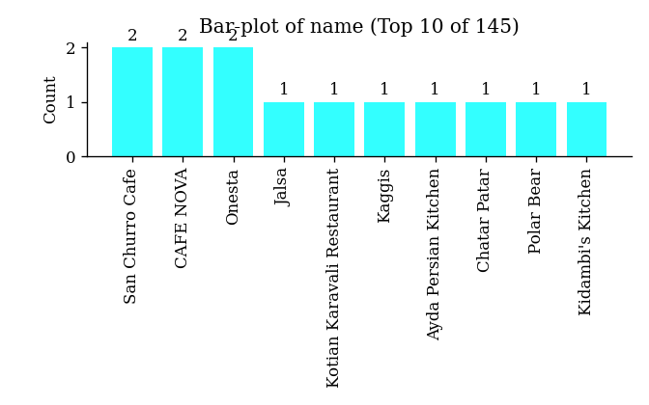

1.2 Online_Order
Online_order is a boolean variable with 2 unique values. None of its values are missing.

Summary Statistics
Mode (Most frequent) | No
Maximum frequency | 90

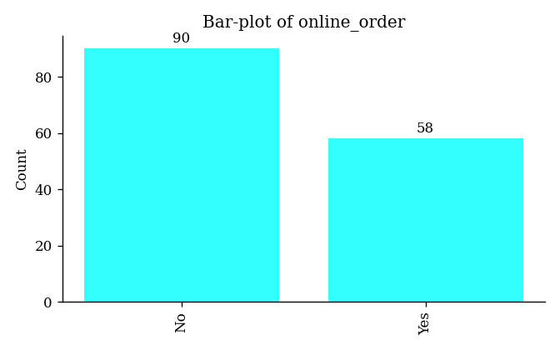

1.3 Book_Table
Book_table is a boolean variable with 2 unique values. None of its values are missing.

Summary Statistics
Mode (Most frequent) | No
Maximum frequency | 140

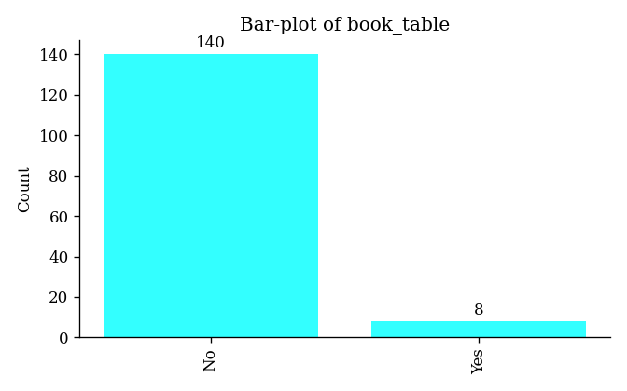

1.4 Rate
Rate is a numeric variable with 19 unique values. None of its values are missing.

Summary Statistics
Average | 3.6331
Standard Deviation | 0.4023
Minimum | 2.6
Lower Quartile | 3.3
Median | 3.7
Upper Quartile | 3.9
Maximum | 4.6
Skewness | -0.156
Kurtosis | -0.4369

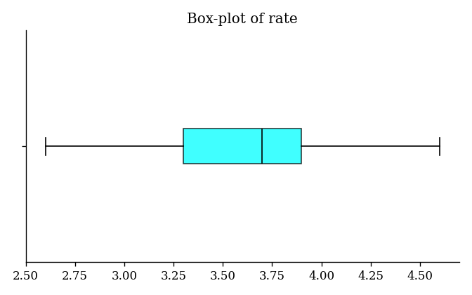
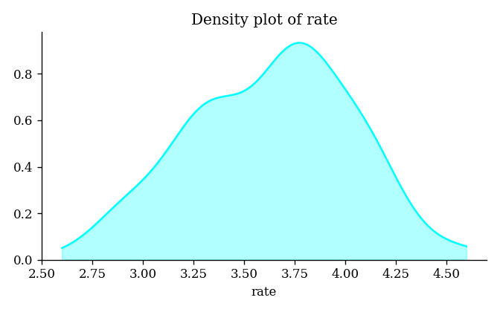
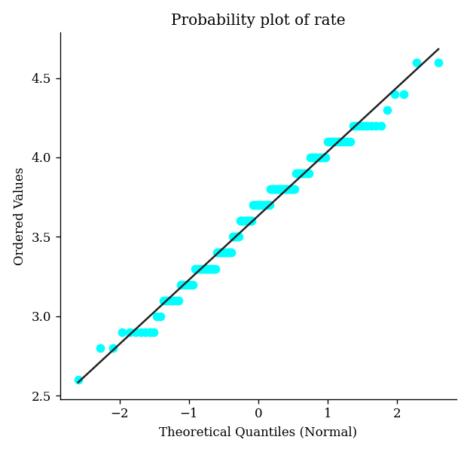

Tests for Normality
 | p-value | Conclusion at α = 0.05
D'Agostino's K-squared test | 0.3272502 | Possibly normal
Kolmogorov-Smirnov test | 0.0000000 | Unlikely to be normal
Shapiro-Wilk test | 0.0706234 | Possibly normal

1.5 Votes
Votes is a numeric variable with 88 unique values. 4 (2.70%) of its values are missing.

Summary Statistics
Average | 265.7292
Standard Deviation | 662.4903
Minimum | 0
Lower Quartile | 6
Median | 39
Upper Quartile | 205.5
Maximum | 4884
Skewness | 4.8722
Kurtosis | 27.6831

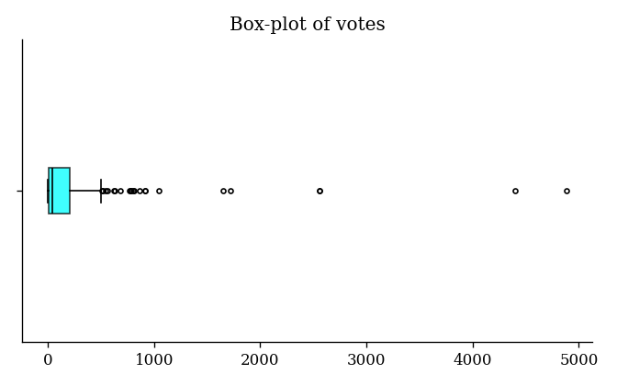
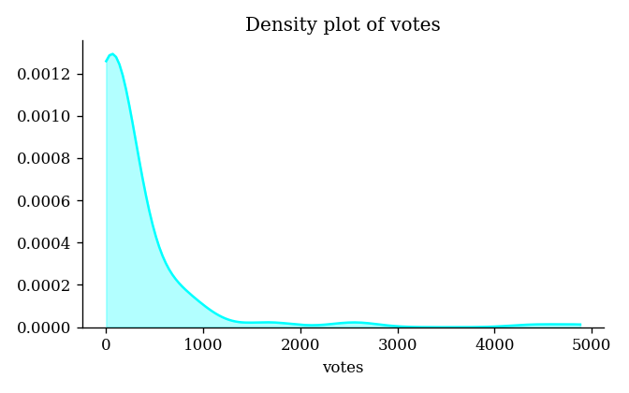
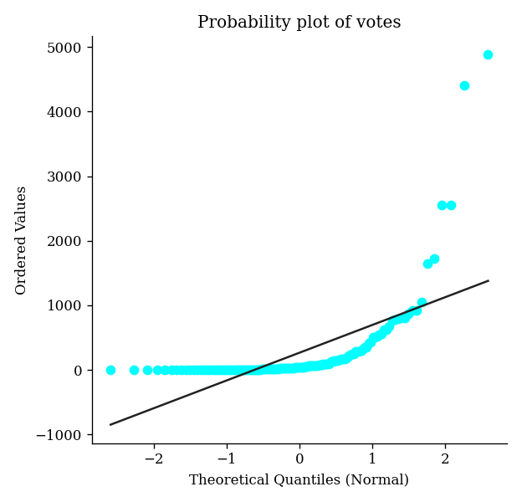

Tests for Normality
 | p-value | Conclusion at α = 0.05
D'Agostino's K-squared test | 0.0000000 | Unlikely to be normal
Kolmogorov-Smirnov test | 0.0000000 | Unlikely to be normal
Shapiro-Wilk test | 0.0000000 | Unlikely to be normal

1.6 Approx_Cost(For Two People)
Approx_cost(for two people) is a numeric variable with 18 unique values. 3 (2.03%) of its values are missing.

Summary Statistics
Average | 415.5172
Standard Deviation | 221.6978
Minimum | 100
Lower Quartile | 200
Median | 400
Upper Quartile | 600
Maximum | 950
Skewness | 0.4859
Kurtosis | -0.8294

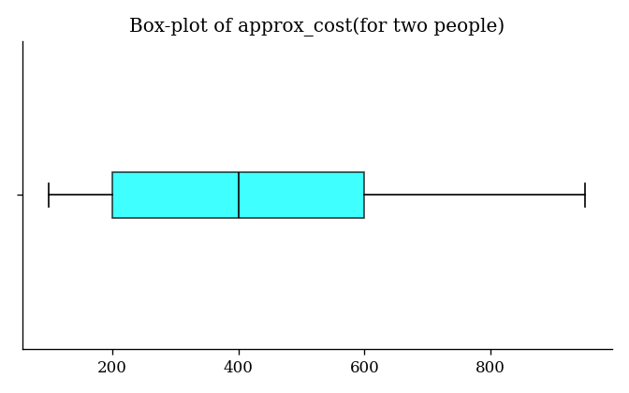
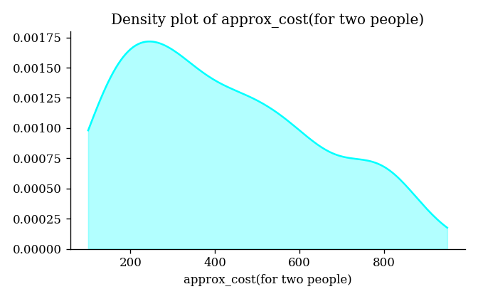
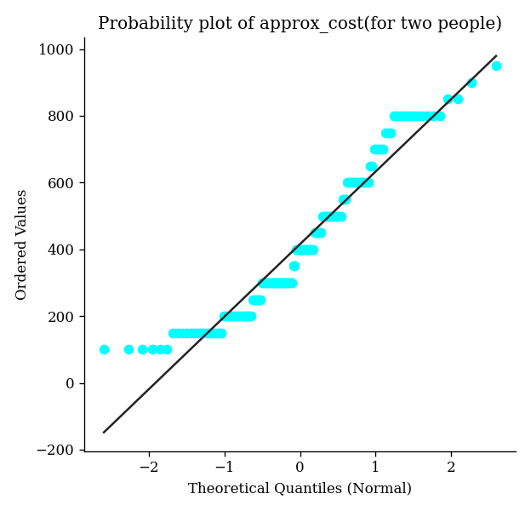

Tests for Normality
 | p-value | Conclusion at α = 0.05
D'Agostino's K-squared test | 0.0002153 | Unlikely to be normal
Kolmogorov-Smirnov test | 0.0000000 | Unlikely to be normal
Shapiro-Wilk test | 0.0000029 | Unlikely to be normal

1.7 Listed_In(Type)
Listed_in(type) is a categorical variable with 4 unique values. None of its values are missing.

Summary Statistics
Mode (Most frequent) | Dining
Maximum frequency | 110

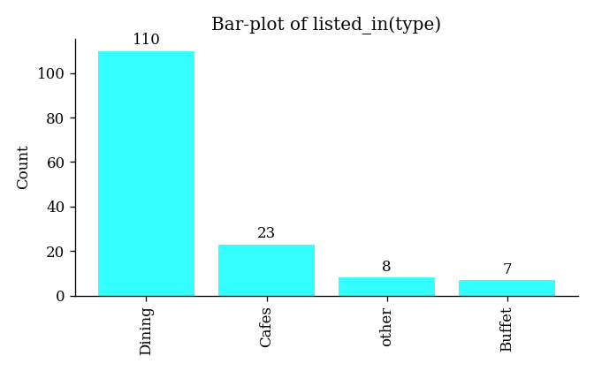

2. Bivariate Analysis

2.1 Overview
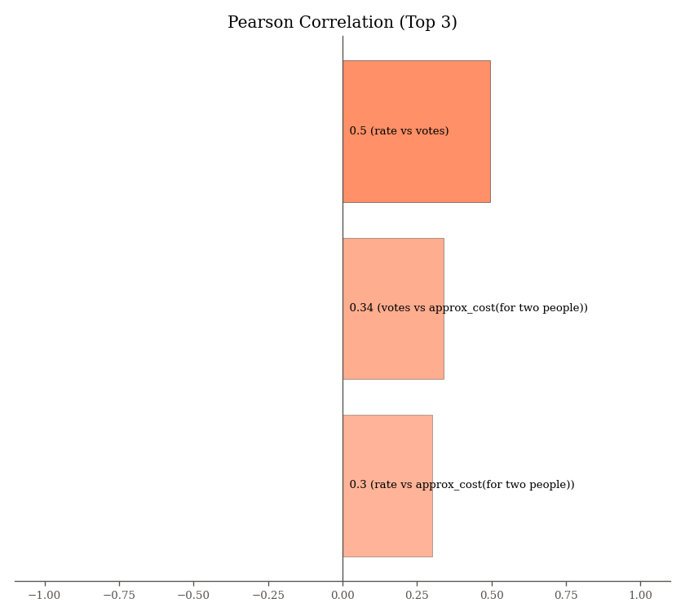

2.2 Regression Plots (Top 20)

2.2.1 Rate Vs Votes
Rate and Votes have moderate positive correlation (0.50).
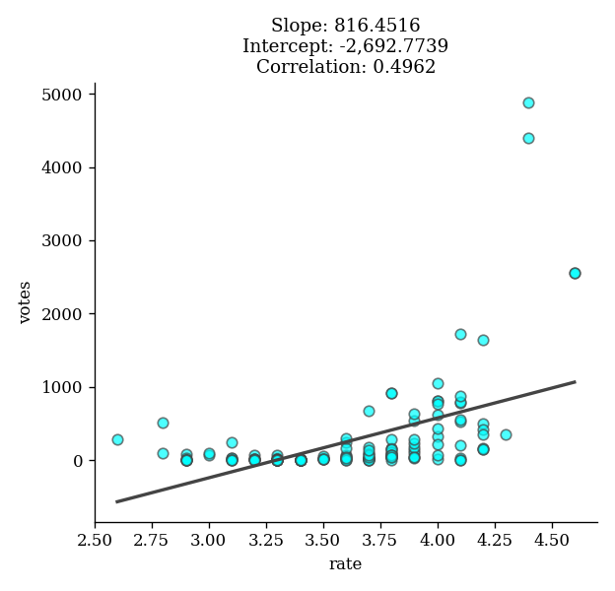

2.2.2 Votes Vs Approx_Cost(For Two People)
Votes and Approx_Cost(For Two People) have weak positive correlation (0.34).
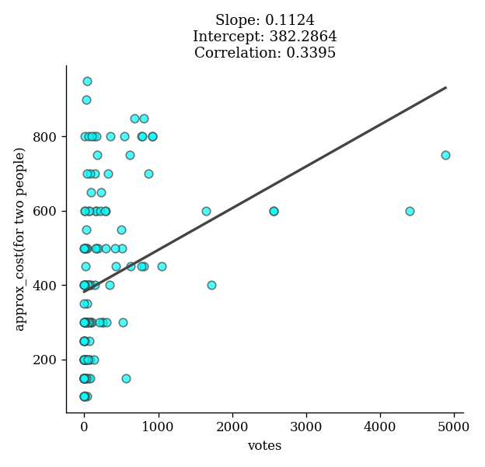

2.2.3 Rate Vs Approx_Cost(For Two People)
Rate and Approx_Cost(For Two People) have weak positive correlation (0.30).
