**CS 140 C++ Programming**

**Dev-Cpp Software**

You can do all of your programming with the CS 145 Lab’s Visual Studio C++ [or Express Visual C++] from Microsoft. Understand that Visual Studio makes a HUGE set of folders/files for even the simplest program.

One alternative is to use Dev-Cpp. This program is FREE. You can run it from your Flash Drive, even on The code is identical [except for one include]. You get very small text files.

Go to this link: <http://bloodshed.net/dev/devcpp.html>

Click on:

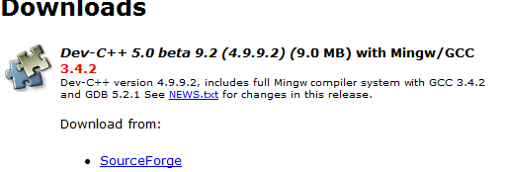



NOTE: You can NOT install this on a CS Lab Computer, but you can install it on your own PC or your Flash Drive.

 When you install it you get:

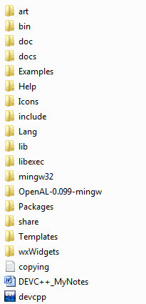

Then DOUBLE CLICK on the ICON 

and take all of the prompts. YOU ARE DONE. Happy Computing!!!