PiTalk

## Instruction Manual

# Getting started

Now that you got your PiTalk, follow these steps to get you phone up and ready to go.

1. Connect the SMA Antenna to the shield as shown
2. Insert the micro SIM card in the SIM slot to the bottom of the shield
3. Mount the shield to the Raspberry Pi via 40 Pin GPIO or through Micro USB.
   1. NOTE: USB mode needs two cables, one for power and the other for communication. Connect both of them to the Raspberry Pi.
4. Connect your Raspberry Pi to the Internet
5. Open the terminal, navigate to the directory inside which you have stored the PiTalk files. Give executable permission setup file by typing:

|  |
| --- |
| sudo chmod +x setup.py |

1. Run setup by typing:

|  |
| --- |
| sudo ./setup.py |

This will download the necessary files needed for running the GUI and also enable your serial port. Your Raspberry Pi will reboot automatically after it is done executing.

1. When the Raspberry Pi is turned on, turn on the power by pressing the power button for 1 second. The red LED will start blinking and will stabilize, blinking once per second indicating that the network is registered.
2. Open the terminal, navigate to the directory inside which you have stored the PiTalk files. Start the GUI on HDMI screen (i.e. Computer Screen not 4”or 5” LCD) in Portrait or Landscape mode by typing:

For Raspberry Pi 3 use ttyS0 -

|  |
| --- |
| ./GUI4_Portrait.py ttyS0 |

Or

|  |
| --- |
| ./GUI4 _Landscape.py /dev/ttyS0 |

For other models use ttyAMA0 -

|  |
| --- |
| ./GUI4 _Portrait.py ttyAMA0 |

Or

|  |
| --- |
| ./GUI4 _Landscape.py /dev/ttyS0 |

**Note:** If PiTalk is connected through USB cable then port number is ttyUSB3 –

|  |
| --- |
| ./GUI4 _Portrait.py ttyUSB3 |

Or

|  |
| --- |
| ./GUI4 _Landscape.py ttyUSB3 |

This will show PiTalk GUI on your computer screen in Portrait or Landscape Mode. (Write ./GUI5 if you have 5” code)

1. If you want to play it on your 4” LCD, mount the LCD via GPIO pins on PiTalk or on Raspberry Pi (if PiTalk is connected to Raspberry Pi through USB).

Or If you want to play it on your 5” LCD, connect the power USB of the LCD to any USB port of Raspberry Pi and connect the HDMI cable to the HDMI output of the Raspberry Pi.

Start GUI on HDMI and navigate to “Menu1”-> “Settings”-> “Screen Orientation”. You will see 4 buttons with different angles. Click on preferred angle and your system will reboot and now boot on 4” or 5” LCD.

Open terminal, go to PiTalk directory and repeat **STEP 8** to start PiTalk UI.

**Note:** Landscape.py works best with 0 and 180 Degree.

Portrait.py works best with 90 and 270 Degree.

# Home Screen and Menu

This section helps you navigate through your home screen and Menu pages

1. 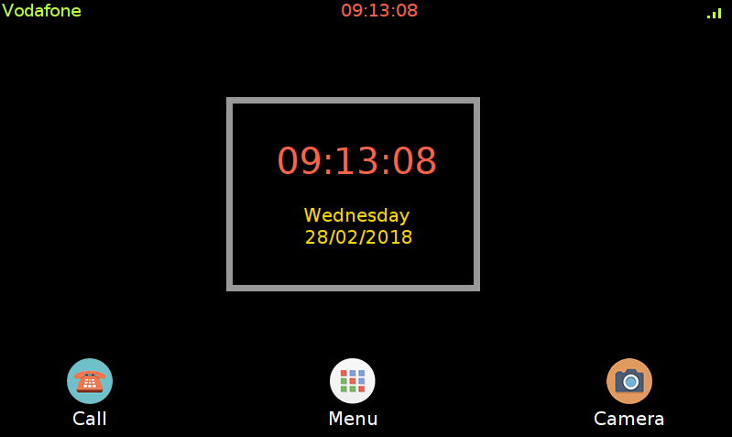Home screen

Signal strength

SIM Carrier

1. Menu Screen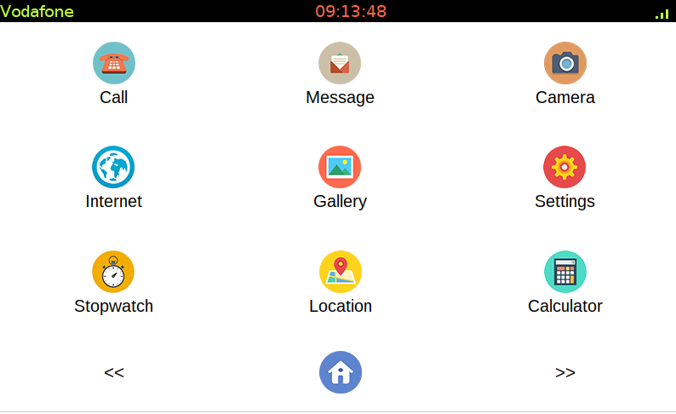

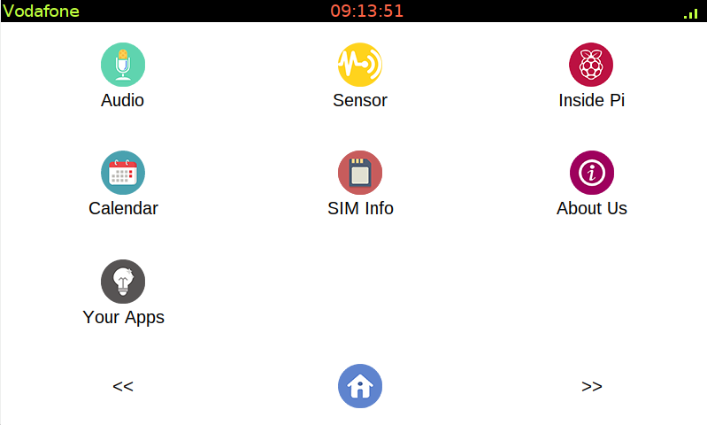

Next button

Back button

Home button

The Back and next button helps in navigating between the different menu screens. The home button takes back to the home screen.

In the following sections we’ll go through the different buttons in the menu screen in the order of their arrangement

# Call Screen

Pressing the call Icon on either home screen on the menu screen takes you to this window.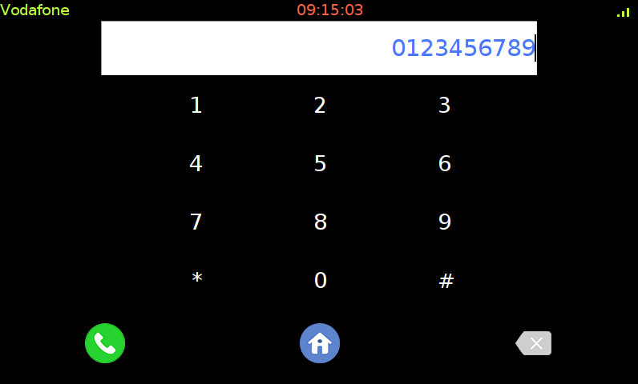

Dialpad

Dial Number

Delete Button

Call Button

**Dial Number**: Dialed Number appears here.

**Call Button**: Pressing the Call button makes a call to the dialed number

**Delete Button**: Delete a single number at a time from Dial Number

: Standard Dialpad used to dial numbers

Pressing the call button takes you to the next screen.

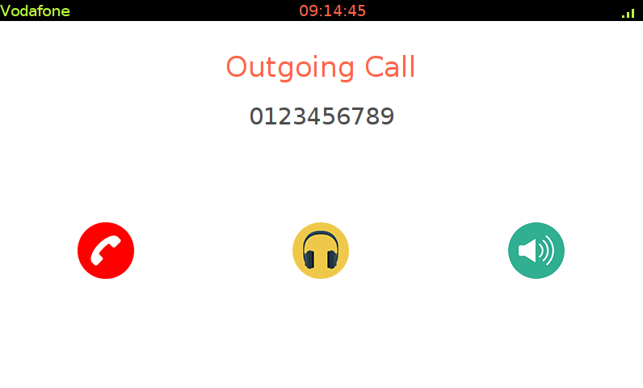

Outgoing Call Indicator

Disconnect

Speaker Mode

Headphone Mode

The dialed number is displayed above, the three buttons accompanying it are as follows.

**Disconnect**: Disconnects the outgoing call and takes you back to the home screen

**Headphone** **Mode**: Routes the audio to the Headphone Jack

**NOTE**: After this selection, the default audio for all functions is routed to the headphone jack

**Speaker** **Mode**: Routes the audio to the connected external speaker

**NOTE**: After this selection, the default audio for all functions is routed to the external speaker. The Label displays the current audio mode.

# Incoming Call Screen

During an incoming call, the screen switches to the following screen: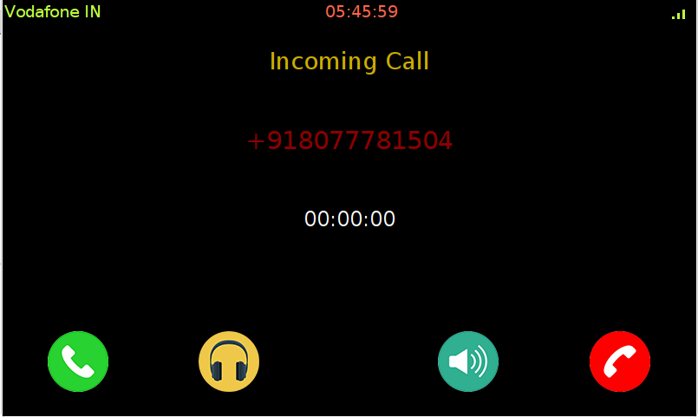

# SMS Screen

Pressing the SMS button in the menu screen brings you to this screen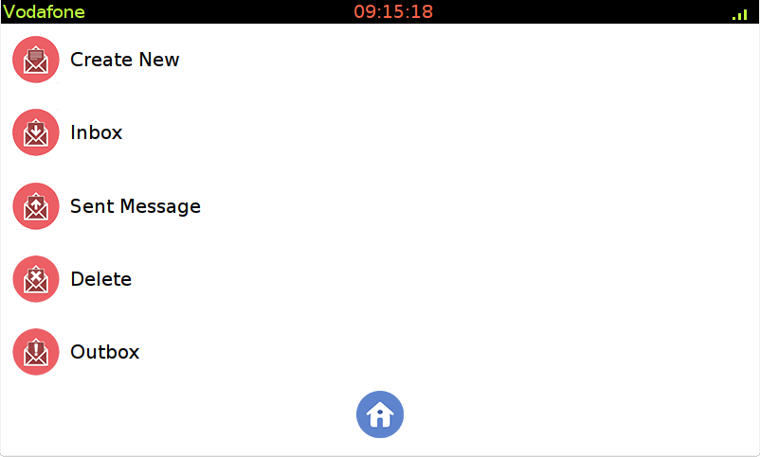

Description of each button in this screen is as follows

1. **Create** **New**: This screen lets you send a regular SMS to the recipient number. Carrier charges apply.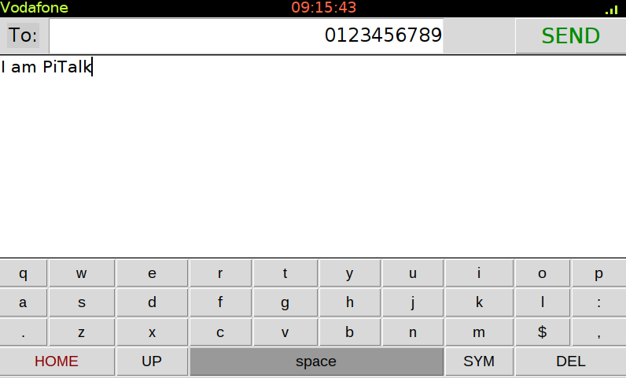

Text Body

Recipient

1. **Inbox**: This screen lets you view incoming SMS sent to your SIM Card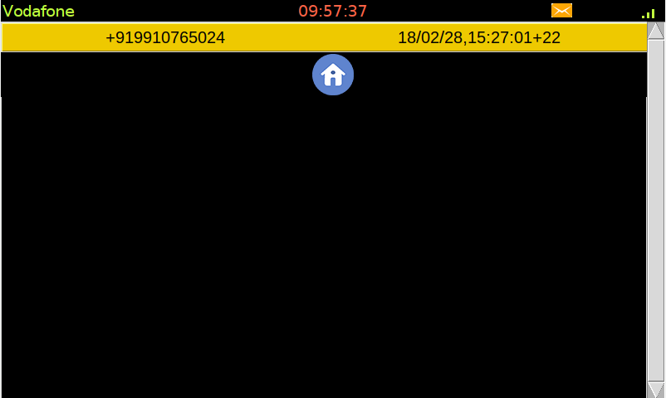

Date/Time of received SMS

Sender’s Number

New SMS indicator

1. Selecting a message from the list above brings you to the following screen, which has the body of the SMS along with the option to reply.

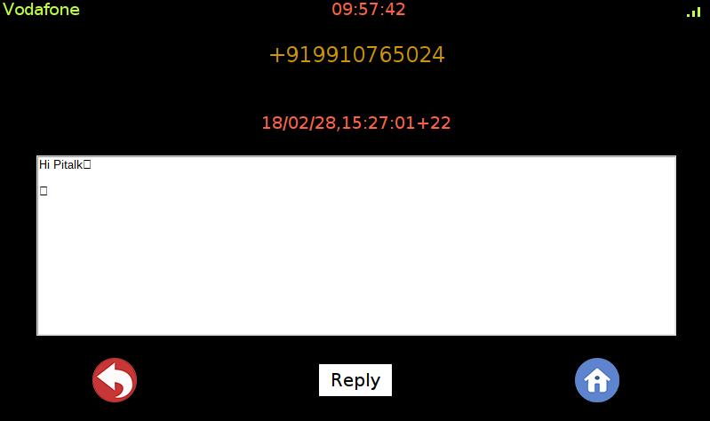

Message Body

Home Button

Reply to sender

Back Button

Sender number

The New SMS indicator is visible across all screens and only goes away if the user has read his unread messages. The unread SMS turns white from yellow in the message list. The scrollbar on the right helps navigate the list of received SMS.

1. 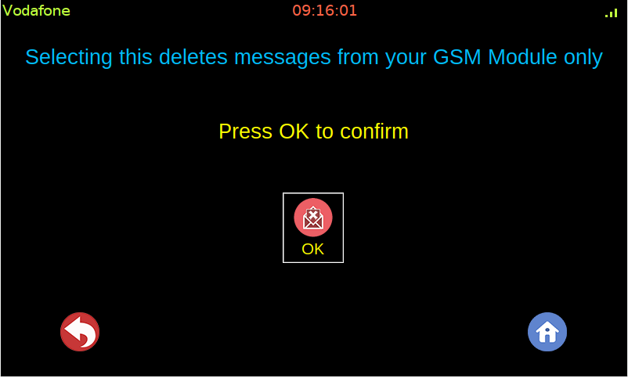**Delete**: Tapping on this button lets you delete all your received SMS from the MODULE or the memory in which the user is storing his SMS while maintaining their copies in Inbox and SMS log. It asks the user for a confirmation before deleting all SMS.

# Camera Screen

Tapping the camera Icon on either the home screen or the menu screen brings you to this screen. 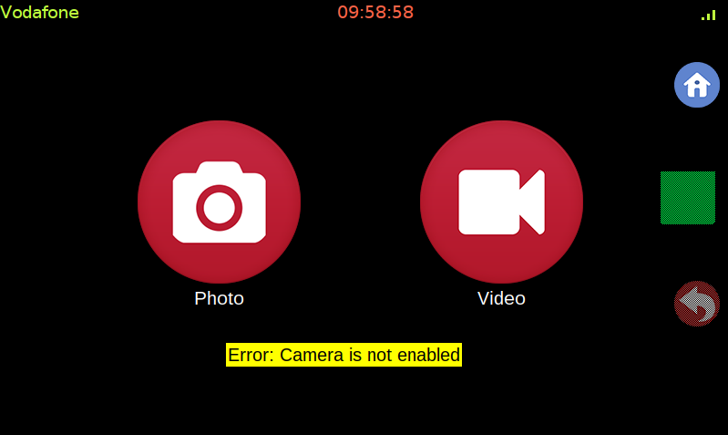

Error Label

Photo Button

Click Button

Back Button

Video Button

Home Button

The different buttons and labels with their functions are described as follows:

1. **Photo** **Button**: This button lets you click photos from your camera attached with the raspberry pi.
2. **Video** **Button**: This button lets you record videos from your camera attached with the raspberry pi.
3. **Click** **Button**: This button remains disabled unless the camera is connected properly and either one of the modes is selected i.e., photo or video. It lets you click photos in photo mode and lets you record videos in video mode
4. **Error** **Label**: This error label pops up on the screen whenever the following scenario happens
   1. Camera is not enabled in the Raspberry Pi
   2. Camera is enabled but not connected to the Raspberry Pi
   3. Camera is connected but the connection is not proper
5. **Back** **Button**: This button lets you go back to the menu screen. It remains disabled unless the camera is connected.
6. **Home** **Button**: This button sends the user back to the home screen.

**NOTE**: To use the camera, you need to connect a Pi compatible camera (sold separately) and attach it to the raspberry pi via SUNNY connector

# Internet Screen

Pressing this icon brings you to the following screen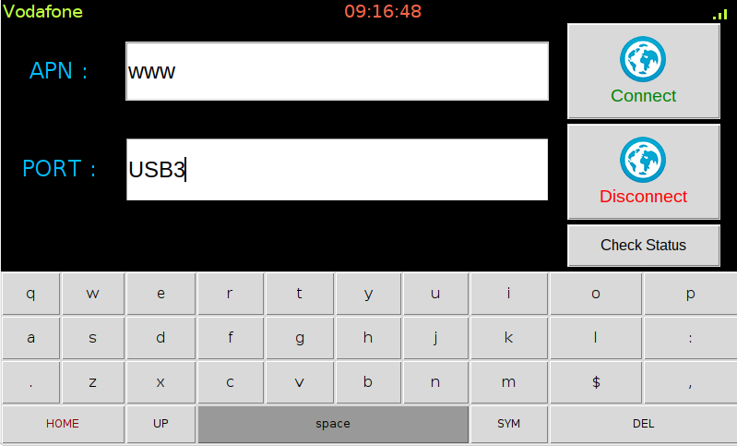

Disconnect Button

Connect Button

Comm PORT

Status Button

APN of carrier

The description of the labeled buttons and entries are as follows:

**APN**: This entry takes in the APN of your Network Carrier

**Port**: This entry takes in the Comm Port assigned to it by the raspberry Pi. The format is ttyxxx where x is the port assigned to it by the Raspberry Pi.

**NOTE**: It is recommended that the user connects the shield to the Pi along with mounting it over via GPIO pins and writing the port as ‘ttyUSBx’ where x is usually 3. This helps in uninterrupted AT communication of the shield with the GSM module via UART1 and internet is routed via UART2

**Connect** **Button**: This button connects the phone to the internet by taking the values from APN and Port. On successful connection it will pop a label with the text ‘Connected’ when the user presses the Status button.

**Disconnect** **Button**: This button allows the user to disconnect from the internet (if connected previously).

**Status** **Button**: This button checks the status of the internet connection. It pops a green ‘connected’ or a red ‘disconnected’ depending on the connection.

# Gallery Screen

Tapping on the gallery icon in the menu brings you to this screen.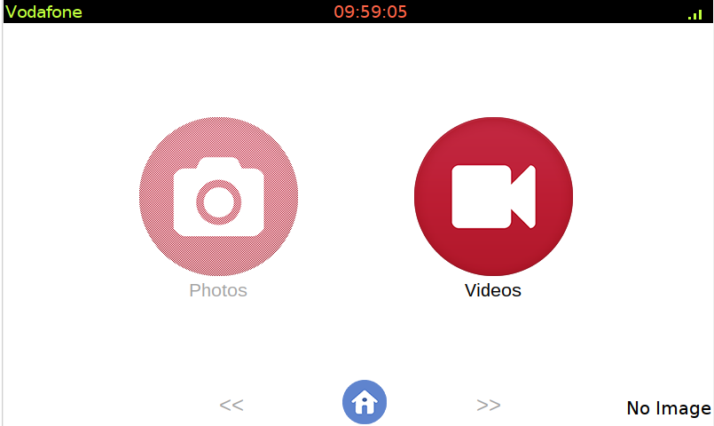

Video Button

Photo Navigation

Photo Button

Photo Navigation

Home Button

The function of the buttons and labels are as follows:

1. **Photo** **Button**: Views the photos stored in the memory. The photos are stored in

“. /Gallery/Images” where “.” Represents the directory in which PiTalk folder is located. It gets disabled when pressed and the error label shows “No Image” if the image folder is empty.

1. **Video** **Button**: Views the video stored in the memory. The videos are stored in

“. /Gallery/Video” where “.” Represents the directory in which PiTalk folder is located. It gets disabled when pressed and the error label shows “No Video” if the Video folder is empty.

1. **Photo** **Navigation** **Buttons**: The navigation buttons help navigating between different photos, and the photos are shown one at a time. They remain disabled until the user press the Photo Button AND there are images to be displayed.
2. **Error** **Label**/ **Image** **counter**: The error label shows the error mentioned above in case of no photo/video and shows the total Images in the photo section when viewing the photos.
3. **Home** **Button**: This button takes the user back to the home screen

# Settings Screen

Tapping this icon in the menu screen lets you access the general settings of the PiTalk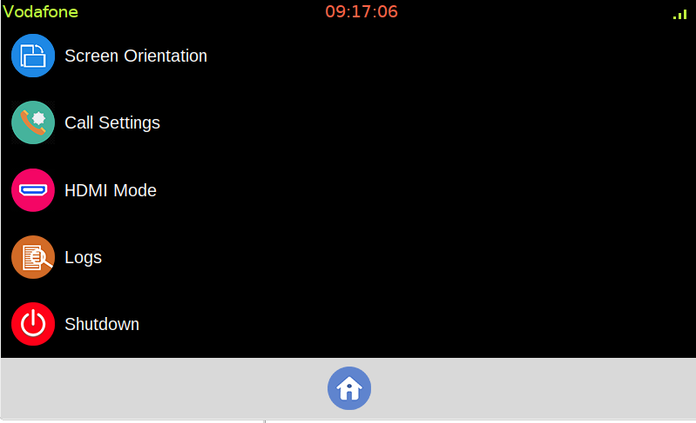

The description of the various settings are as follows:

1. Screen Orientation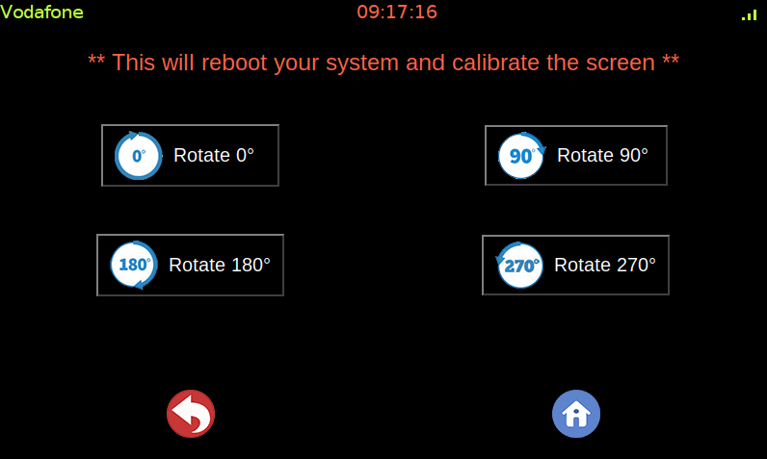

The buttons are as follows:

1. **Rotate** **0°:** Rotates the display output to the default position i.e., landscape mode.
2. **Rotate 90°:** Rotates the display output by 90 degrees. (Portrait Mode)
3. **Rotate 180°:** Rotates the display output by 180 degrees. (Landscape Mode)
4. **Rotate 270°:** Rotates the display output by 270 degrees.

**NOTE**: While the display output will still show on HDMI, it is recommended to view the rotated outputs on the respective LCD as the HDMI output will be zoomed in which might decrease the viewing aesthetics of the GUI

1. Call Settings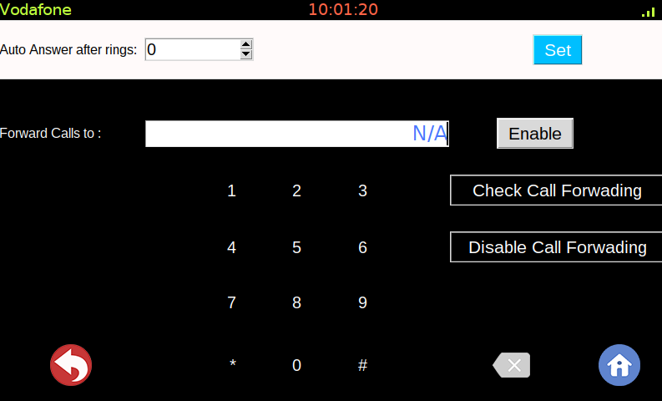

Disable call forwarding

Check Status

Call Forward Number

Set Auto Answer

Enable Call Forwarding

Ring Counter

The description of the various buttons and labels are as follows:

1. **Ring** **Counter**: This counter goes from 0 to 10 and allows the user to set a fixed number of rings before automatically picking up an incoming call
2. **Call** **Forward** **Number**: User can type a number here with the help of the dialpad on which he needs his calls to be forwarded. The call forwarding is unconditional i.e., it will forward all calls until disabled. Carrier charges may apply.
3. **Set** **Button**: This button sets the number of rings displayed on the ring counter as the number of rings after which an incoming call is automatically connected
4. **Enable** **Button**: This button enables call forwarding and sets the number displayed on the entry as the default call forwarding destination. Invalid number or incorrect format (as shown) will result in a warning label popping up saying “Incorrect Format”
5. **Check** **Button**: This button checks the state of call forwarding and it returns the following
   1. The number to which calls are being forwarded, displayed in the entry box
   2. N/A if no number is set or if call forwarding is disabled
6. **Disable** **Button**: This button deletes the stored number for call forwarding and disables call forwarding. To enable call forwarding again, user needs to type in a number and press the enable button.
7. **Back**, **Delete**, **Home** **Buttons**: These buttons work the same as described on various occasions above.
8. HDMI Mode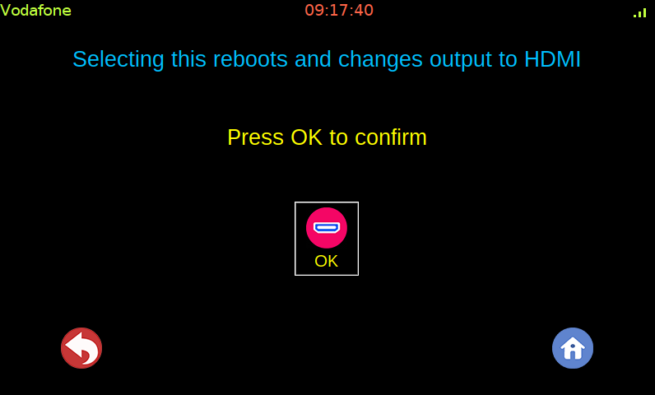

As described in the picture above, pressing OK will reboot the raspberry Pi and PiTalk and changes the default output to HDMI

1. Logs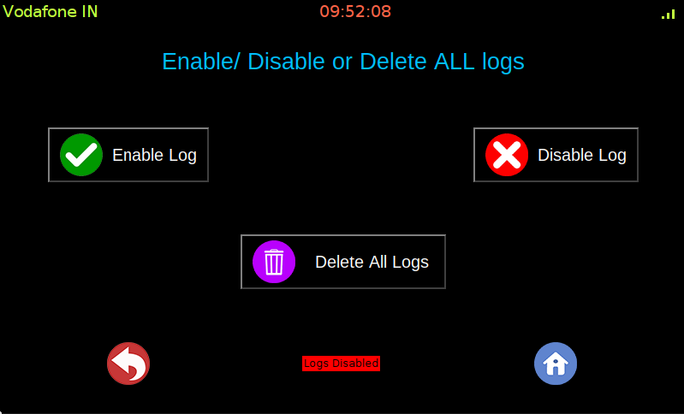

Logs of all the user’s calls and SMS are stored in “./Logs” where “.” Represents the current directory in which PiTalk folders are located. User can enable/disable or delete his logs with the help of the buttons displayed above

1. Shutdown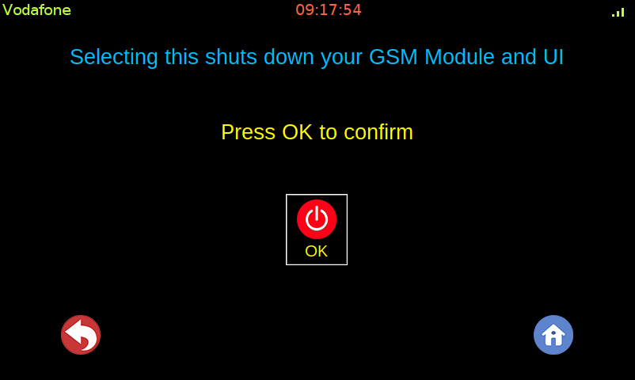

As written in the screenshot, pressing OK will shutdown your GUI and PiTalk, taking the user back to raspberry Pi’s desktop

# Stopwatch Screen

Tapping on this icon in the menu screen will open up this screen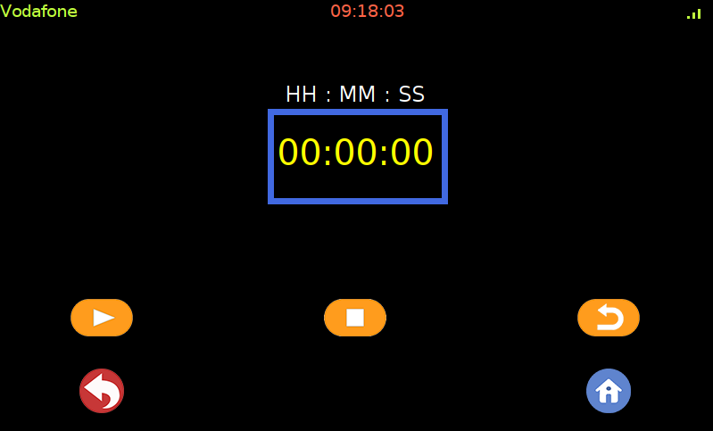

Play button

Reset button

Stop button

The functionality of the various buttons are as follows:

1. **Play** **Button**: This button starts the stopwatch counter
2. **Stop** **Button**: This button pauses the stopwatch counter when pressed.
3. **Reset** **Button**: This button resets the stopwatch counter back to 00:00:00.

Back and Home buttons work the same way as described above

# Location Screen

Tapping on this icon in the menu screen brings this screen forward.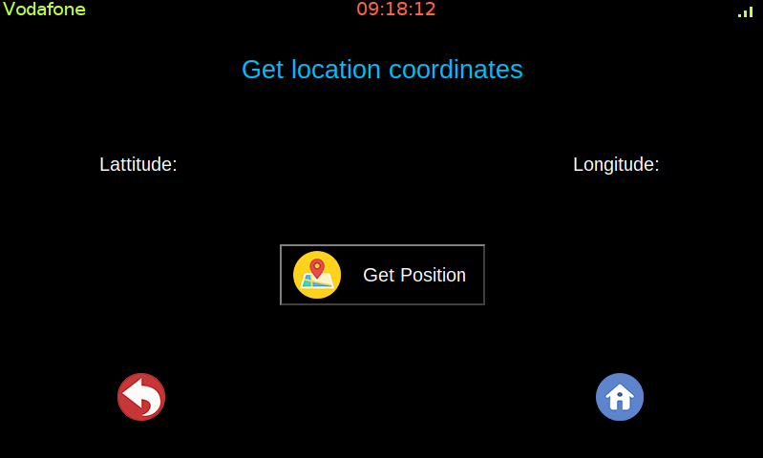

Pressing the “Get Position” button on this screen will display the current latitude and longitude of the shield.

# Calculator Screen

Pressing the calculator Icon brings the user to the following screen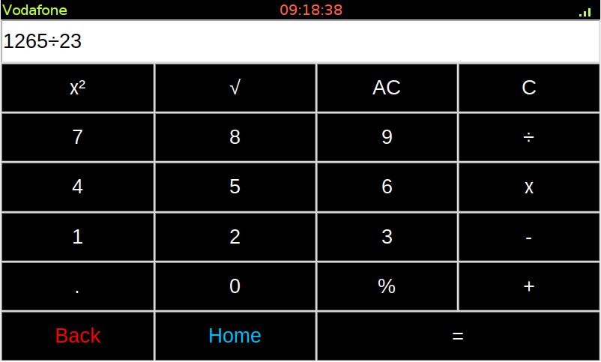

It functions as a regular calculator with symbols representing their usual meaning. The back and home buttons take the user back to menu screen and back to home screen respectively.

# Audio Screen

Pressing this icon on the second page of the menu screen brings up this screen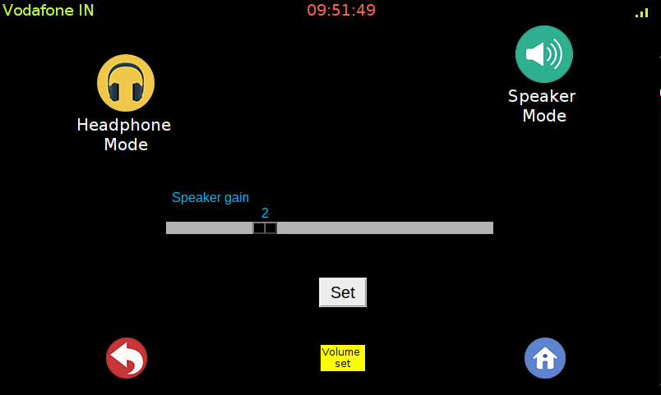

Volume slider

Speaker Mode

Set Volume

Headphone Mode

The description of various buttons with their functionalities are as follows:

1. **Headphone** **Mode**: This Button routes the audio of the phone towards the headphone Jack
2. **Speaker** **Mode**: This Button routes the audio of the phone towards speaker Jack
3. **Volume** **slider**: This slider lets you set the volume of the speaker output, it goes from 0 to a maximum of 7

**NOTE**: The volume slider and the set button work for speaker mode only

1. **Set** **Button**: This button sets the volume shown on the slider to the speaker output.

# Sensor Screen

Pressing this icon on the second page of the menu screen brings up this screen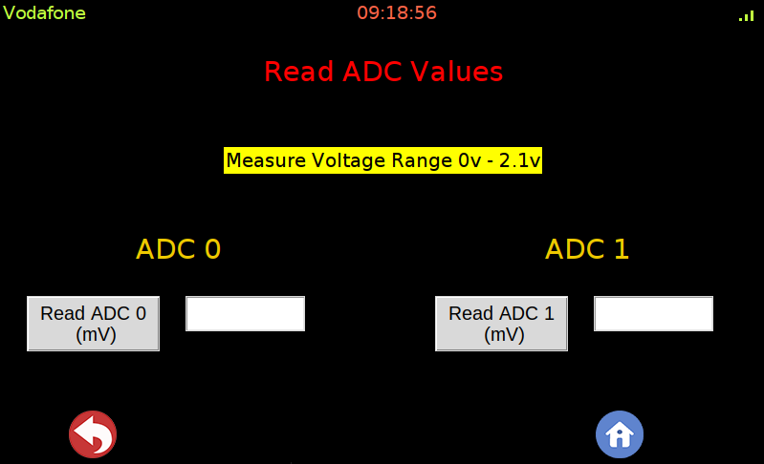

Voltage across ADC1

Voltage across ADC0

The two buttons “Read ADC0” and “READ ADC1” gives the voltage across the two ADC terminals given on the shield. Sensors can be connected to it.

# InsidePi Screen

Pressing this icon on the second page of the menu screen brings up this screen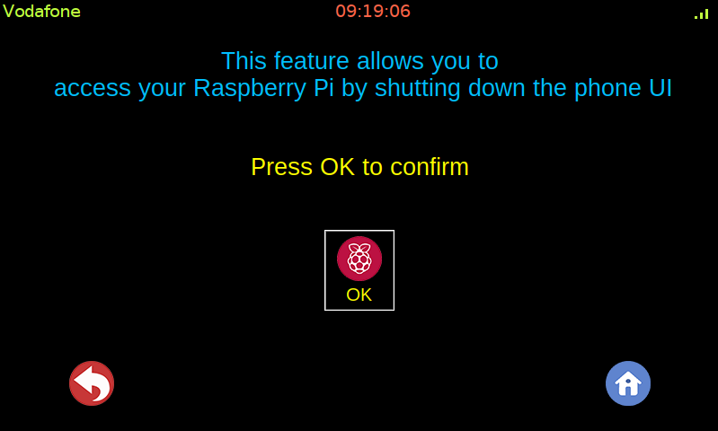

Pressing OK shuts down the GUI.

**NOTE**: This feature doesn’t close Module functionalities such as CALL, SMS or INTERNET

# Calendar screen

Pressing this icon on the second page of the menu screen brings up this screen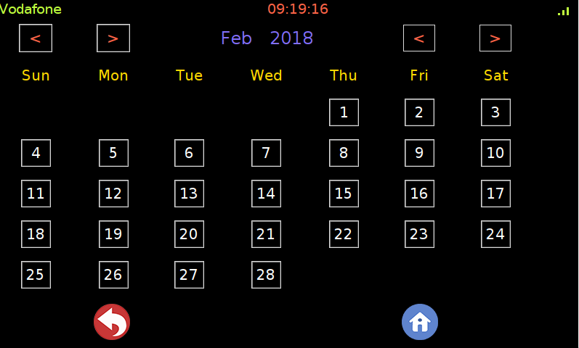

Month Change

Year change

# SIM Info Screen

Pressing this icon on the second page of the menu screen brings up this screen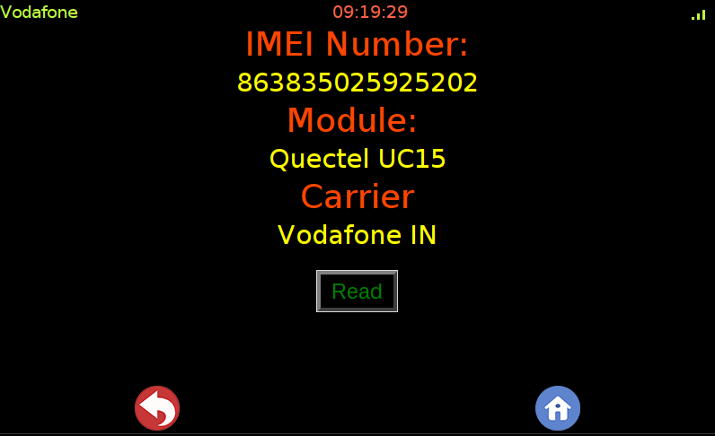

Pressing the Read button brings carrier and IMEI info on screen as follows.

# About Screen

Pressing this icon on the second page of the menu screen brings up this screen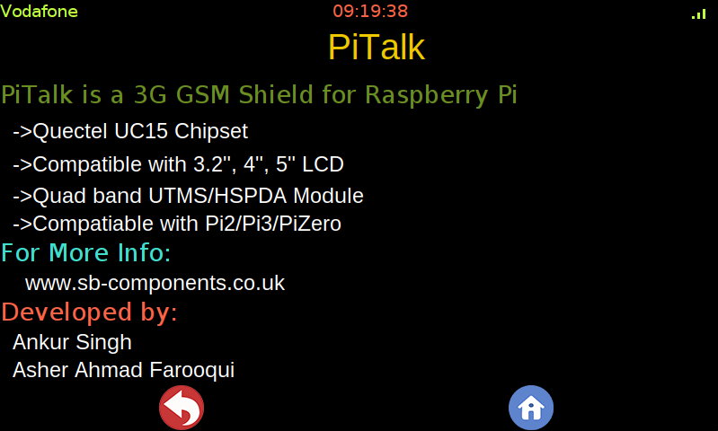

This screen shows the model, company and the developers information.

# Apps screen

Pressing this icon on the second page of the menu screen brings up this screen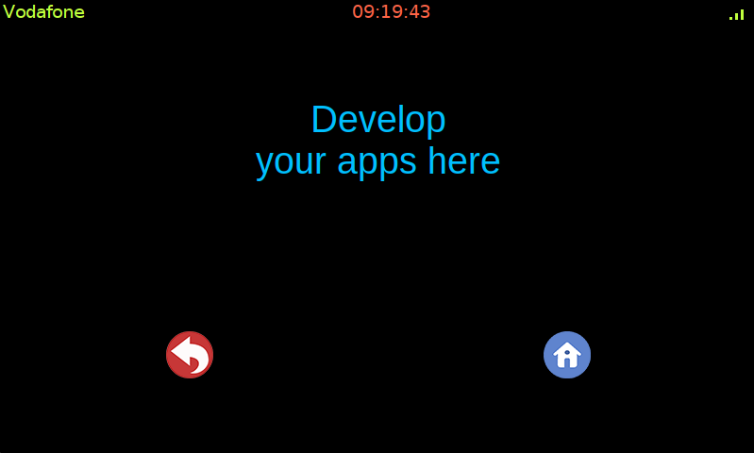

This is a template screen. You can use this screen space to design your app by editing the code. Edit the template code however you want.