**ENR 261 Spring 2023 Chapter 1 Homework**

**General Instructions:**

Save your all your Matlab files for this chapter in the folder named **Ch01** located inside your local repository on your USB Memory Stick. When finished be sure to add, commit, and push your changes to your remote repository on GitHub.

**Getting Started:**

1. Open Matlab and you will see the default desktop as shown below.

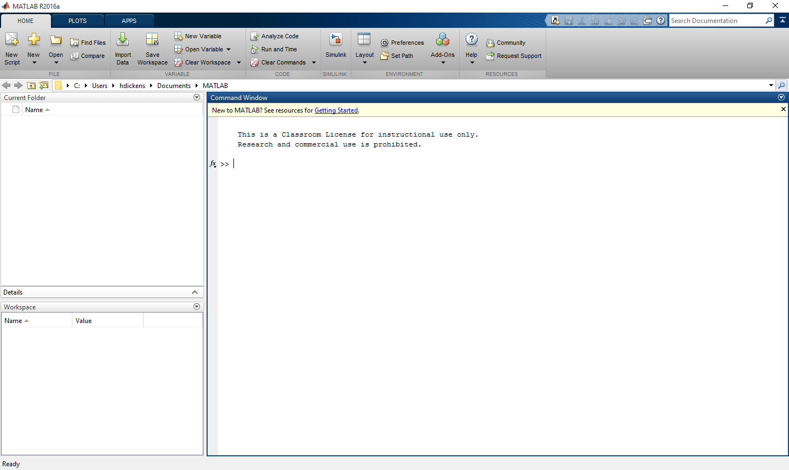

2. Set the Current Directory to your **Ch01** folder from your cloned repository by first clicking on the **Browse** button and then navigating to your folder in the **Browse for Folder** dialog window.

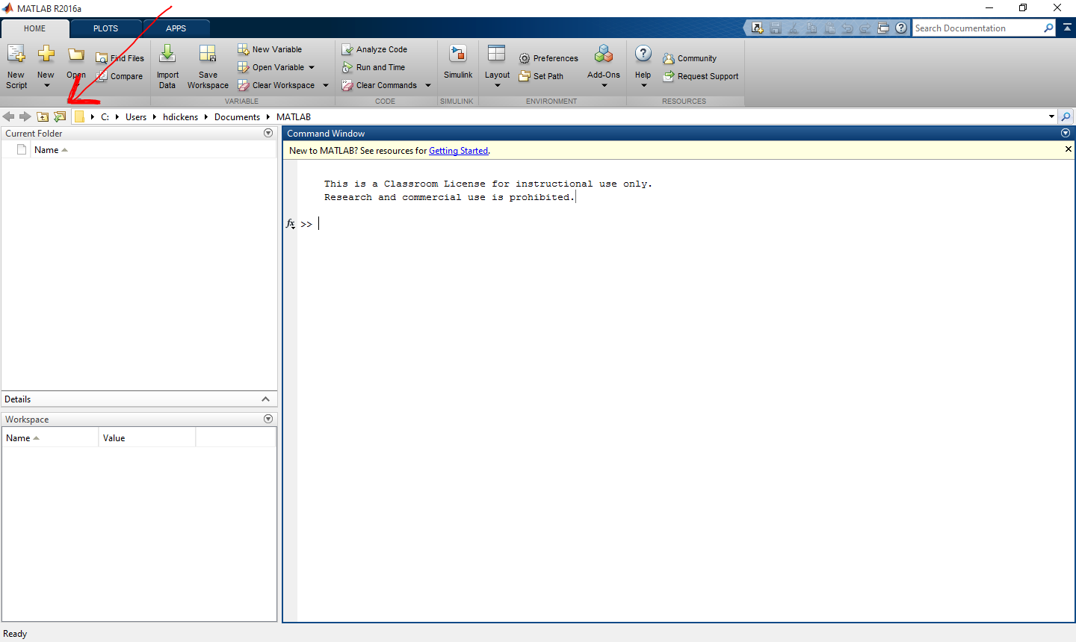

3. Click on the **New Script** menu button shown below to open the **Editor** Window.

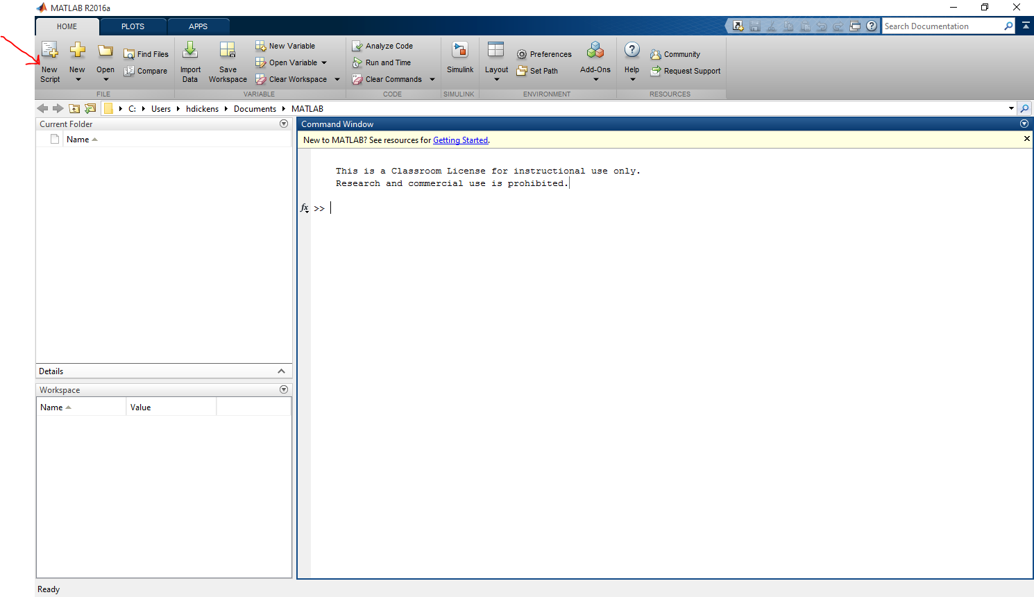

4. Drag and resize the **Editor Window** so that it covers the left half of the command window as shown below.

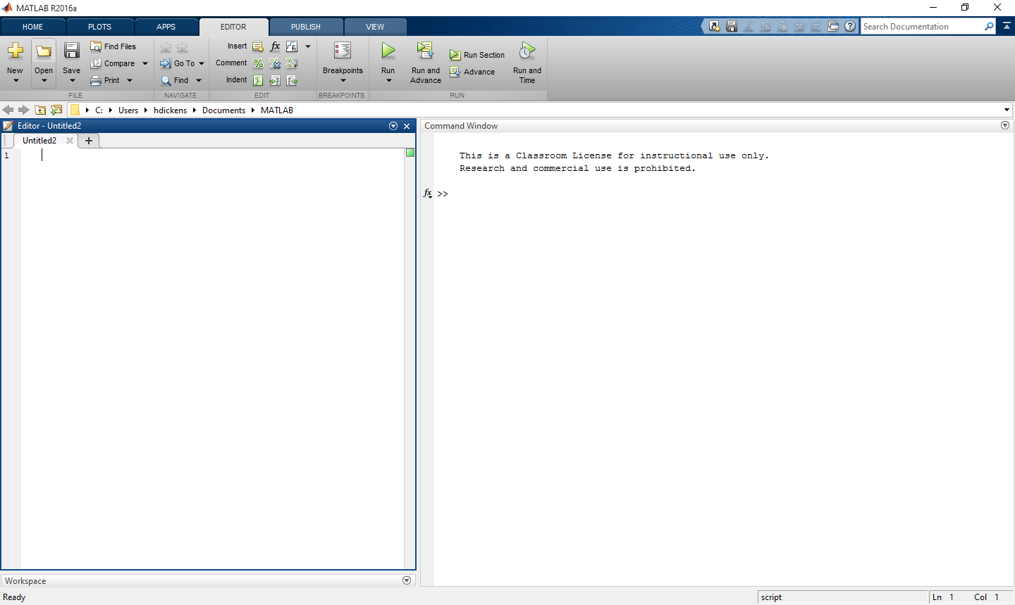

5. Save this layout by clicking on **Layout/Save Layout…** in the **HOME** tab.

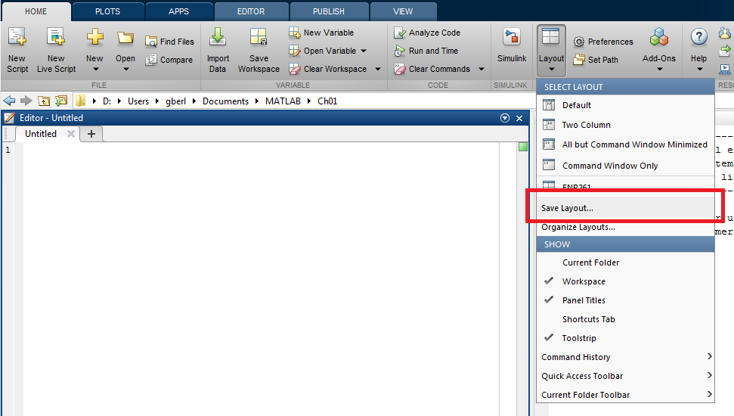

6. Enter ENR 261 as the name of the layout and click **OK**.

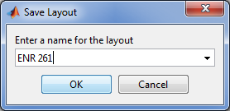

7. Next time you wish to use this layout click on **Layout/ENR 261** in the **HOME** tab.

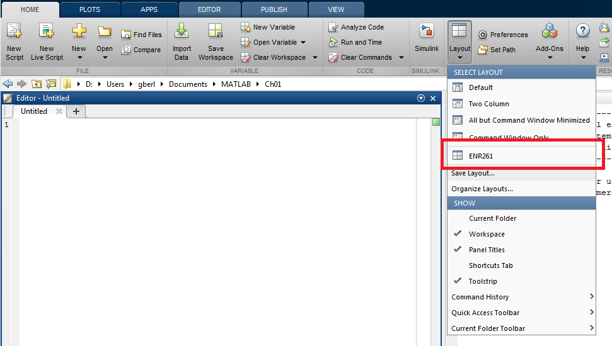

8. Click on **Save/Save As** in the **EDITOR** tab and save the file with the name of the problem given in the current exercise. The file will be saved to the folder defined as the current Matlab directory (Ch01 in this case).

**Assigned Exercises**

**Required File Name: Tutorial_01_1.m**

1. Follow steps 1-12 in the Getting Started section above and save the file with the name **Tutorial_01_1.m** .

It is important that your Matlab file names follow all the rules for naming variables in Matlab. Matlab variable and file names may only contain letters, numbers, and the underscore symbol ( _ ). No blank spaces are allowed.

2. Type the following text into the Editor Window. If you don’t have Matlab at home you may type the program in Notepad or any other unformatted text editor. When you get to MCC you can then copy and paste your program into the Matlab editor.

I suggest that you run your file after each new set of instructions before going on to ensure that the code works as intended.

The Run Command: Each time you run the program it will be saved.

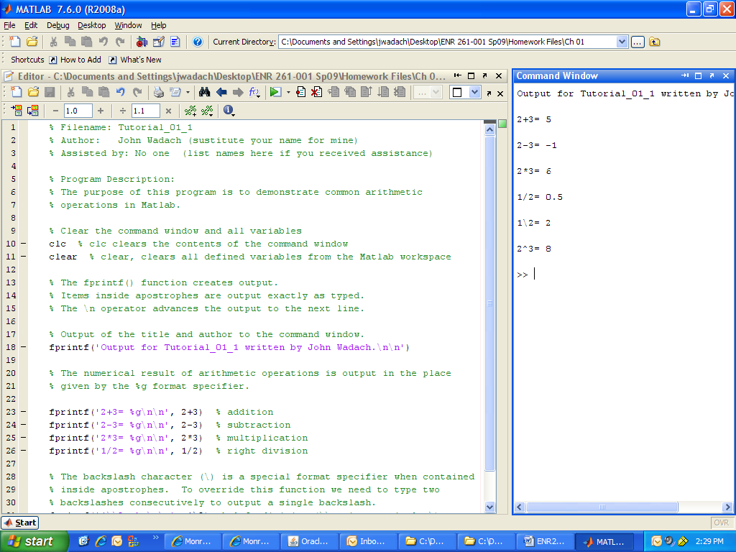

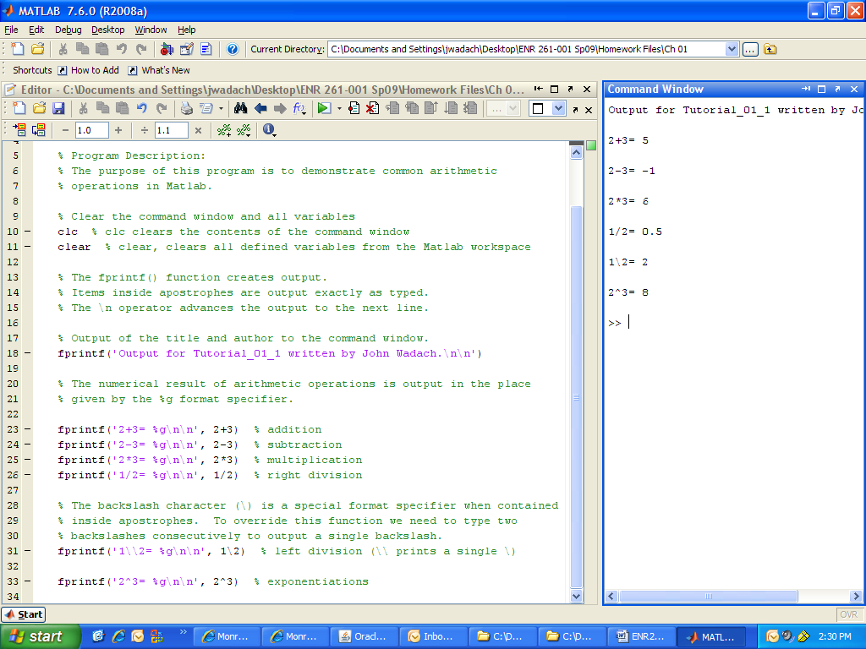

3. You can also run the program by typing the filename of the program after the command prompt in the command window and then hit return. Matlab is case-sensitive so capital and lowercase letters are considered different.

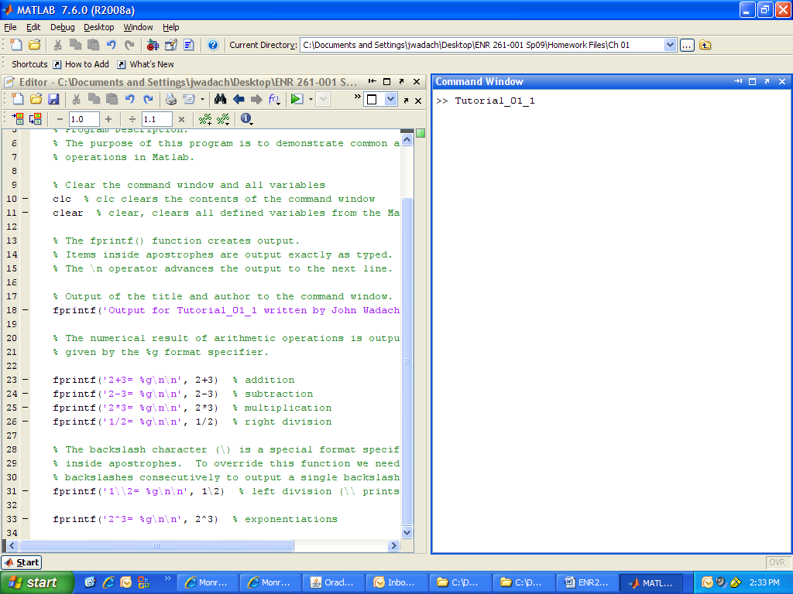

4. Type **tutorial_01_1** after the command prompt and hit enter. Notice that error messages appear because the first “t” was not capitalized. All Matlab variables and file names are case-sensitive.

5. After your program is complete, make sure it’s saved in the correct location in your local repository and **add**, **commit**, and **push** it to your remote repository.

**Additional Tutorials**

1. Recreate all of the following script files and be sure to save them in your ENR261 Ch01 folder on your repository and your USB memory stick.

2. Use the required file names for each script file.

**Required File Name: Tutorial_01_2.m**

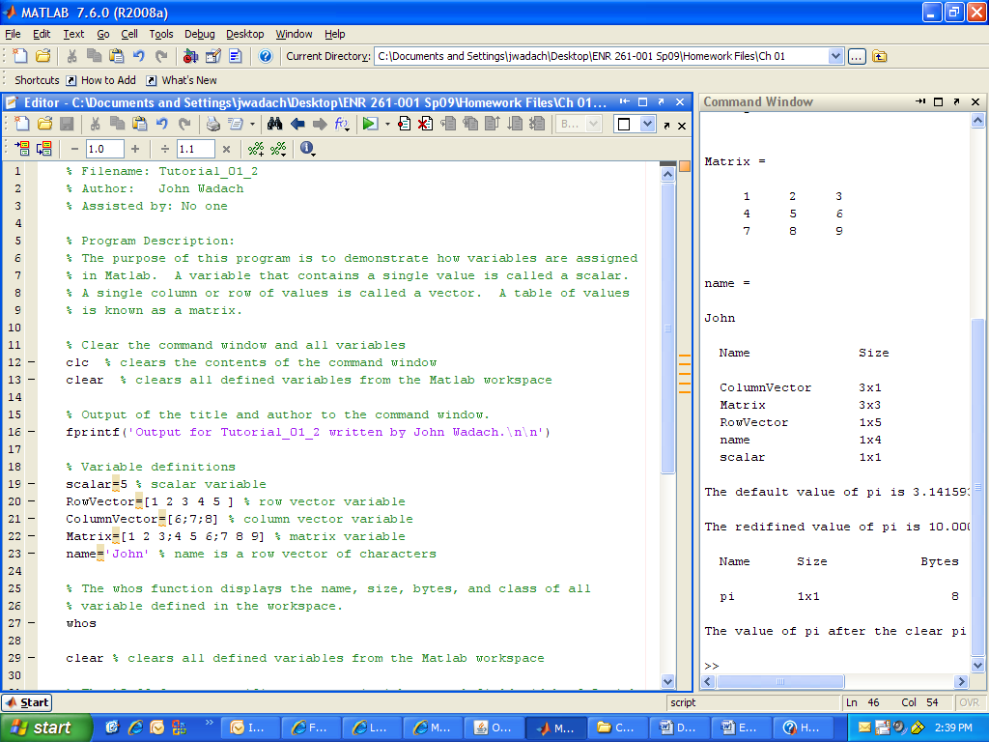

Continued on the Next Page

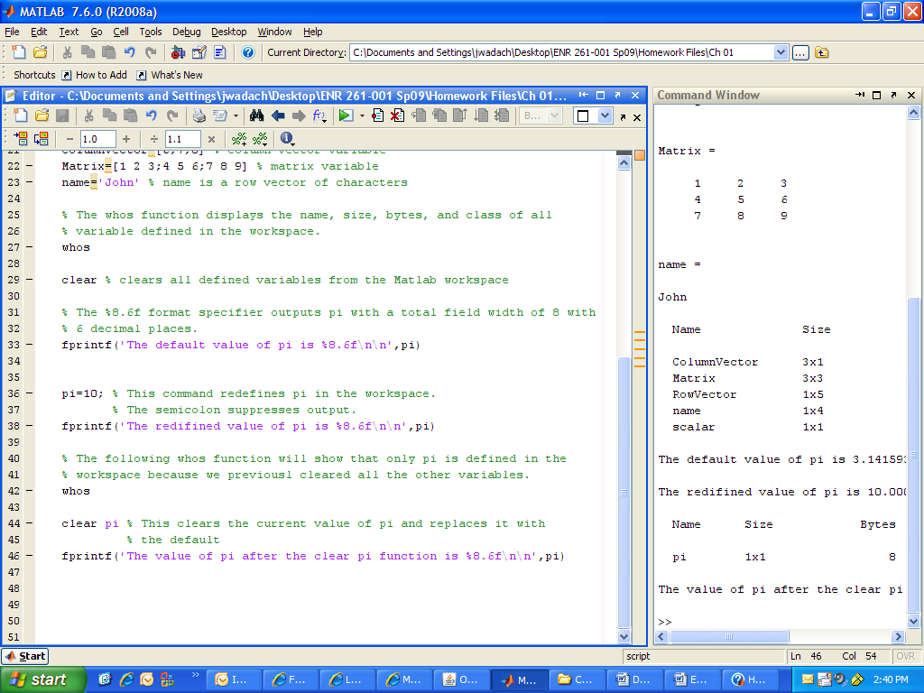

**Required File Name: Tutorial_01_3.m** 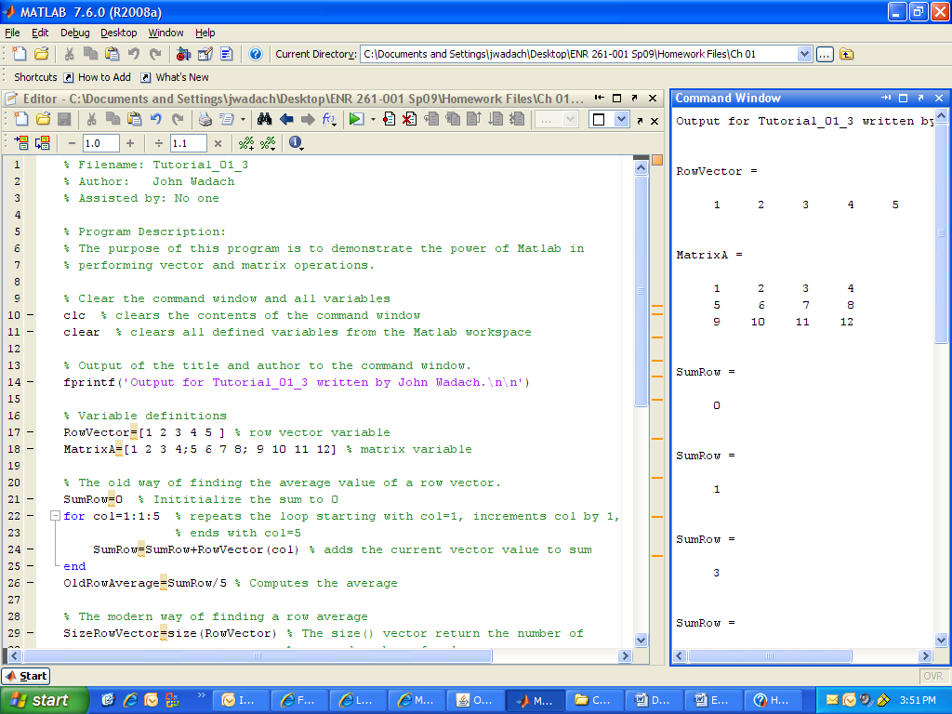

Continued on the Next Page

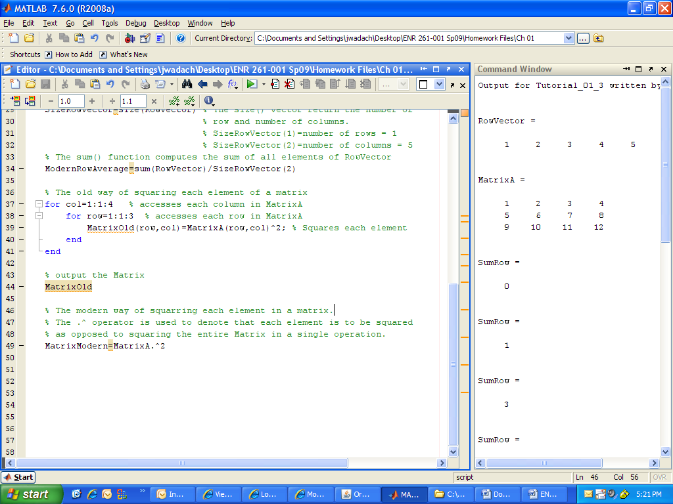

**Required File Name: Tutorial_01_4.m**

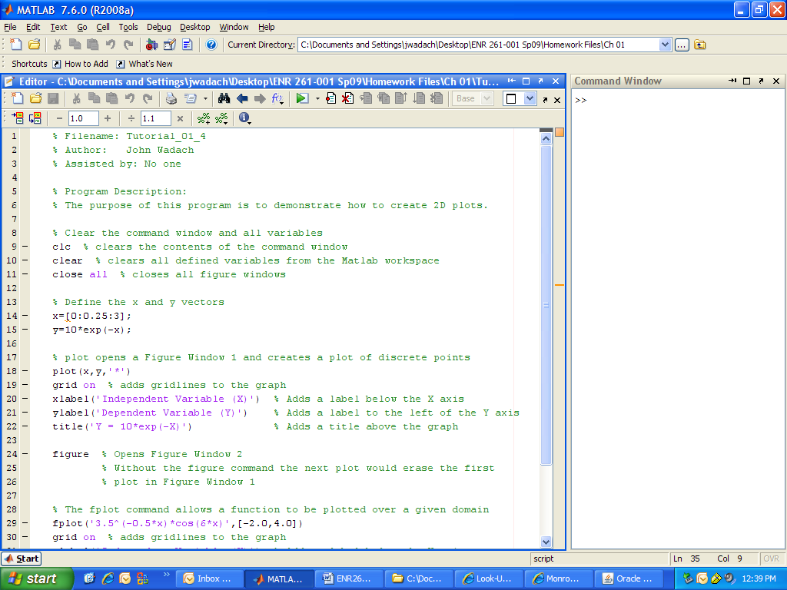

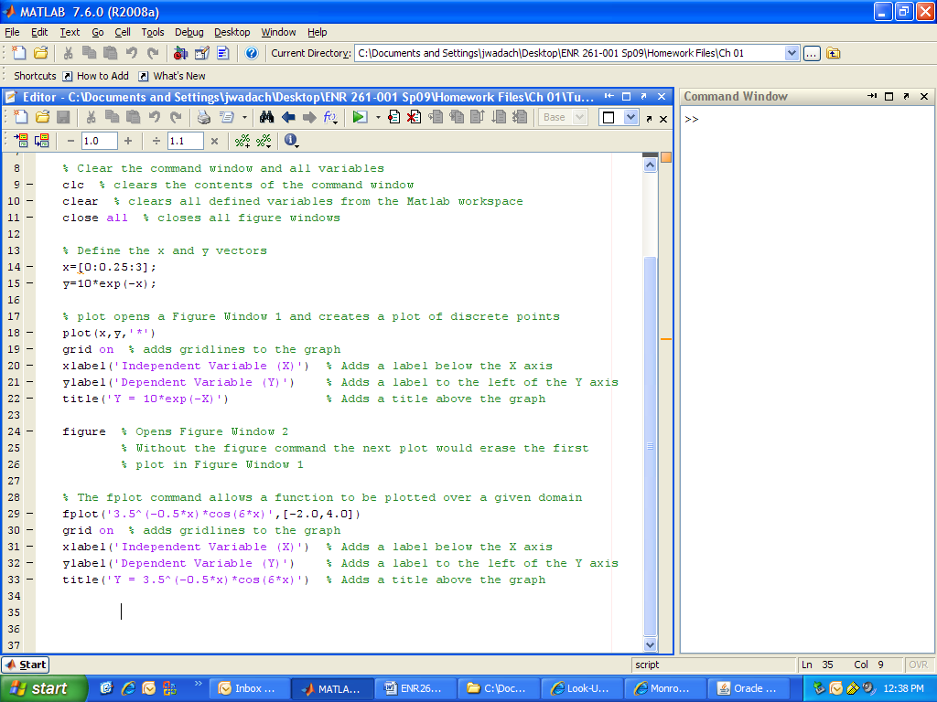 **Required File Name: Tutorial_01_5.m**

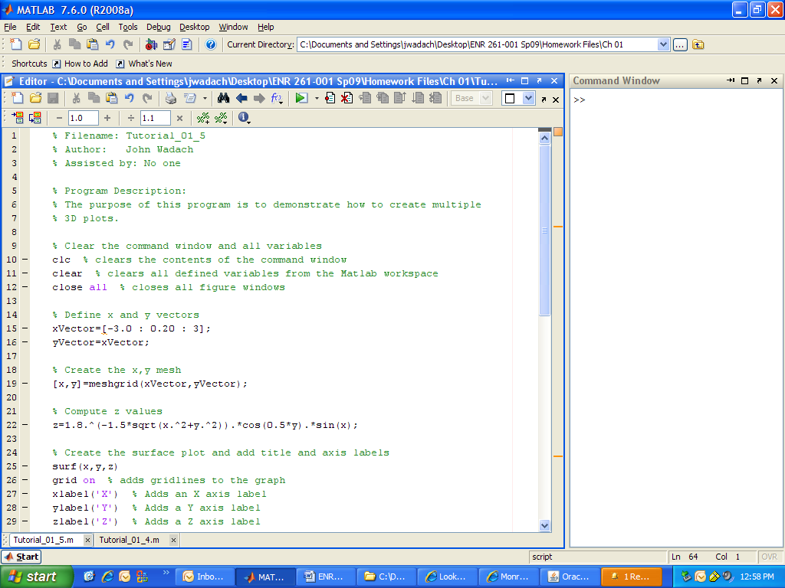

Continued on the Next Page

**Tutorial_01_5.m continued**

