**ENR 261 Spring 2023 Chapter 2 Part 2 Homework**

**General Instructions:**

Save your all your Matlab files for this chapter in the folder named **Ch02_Part2** located inside your local repository on your USB Memory Stick. When finished be sure to add, commit, and push your changes to your remote repository on GitHub.

**Assigned Exercises**

1. Recreate all of the following script files and be sure to save them in your local repository on your USB memory stick, commit the changes and push them to GitHub.

2. Use the required file names for each script file.

Required File Name: **Tutorial_02_5.m (To stop an infinite loop press Ctrl C)**

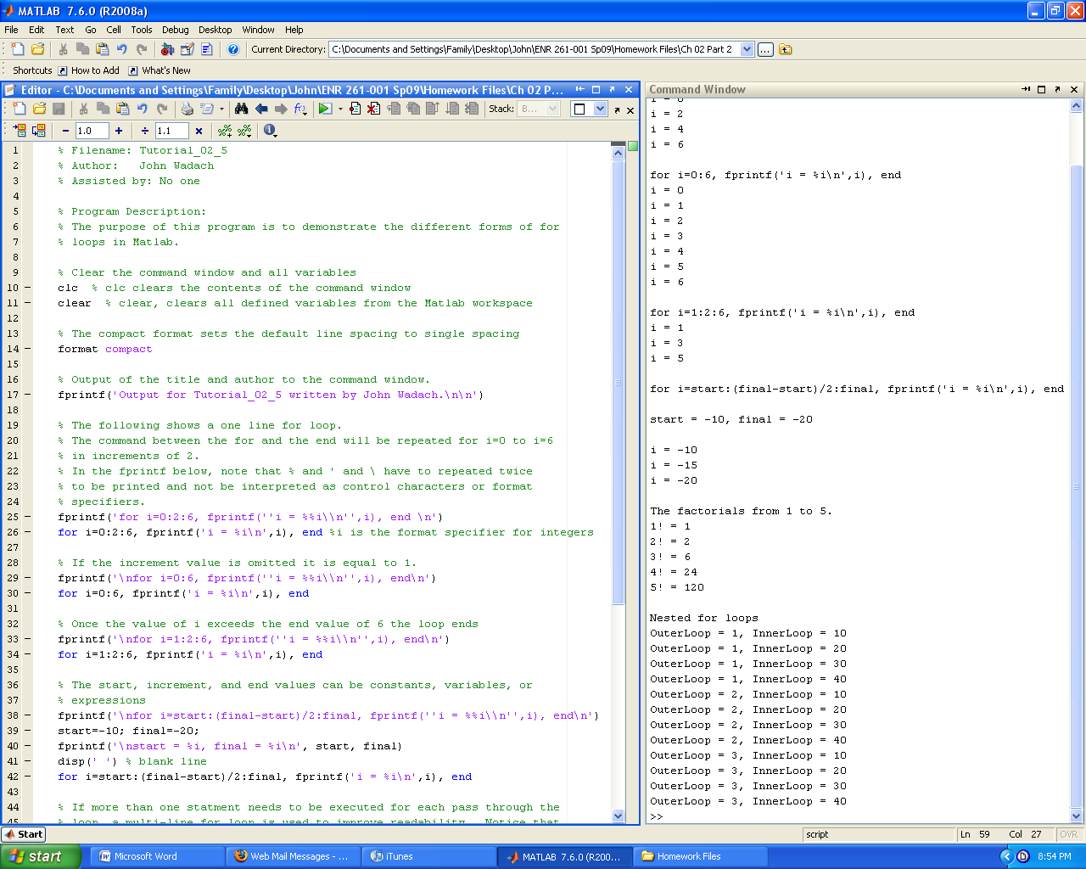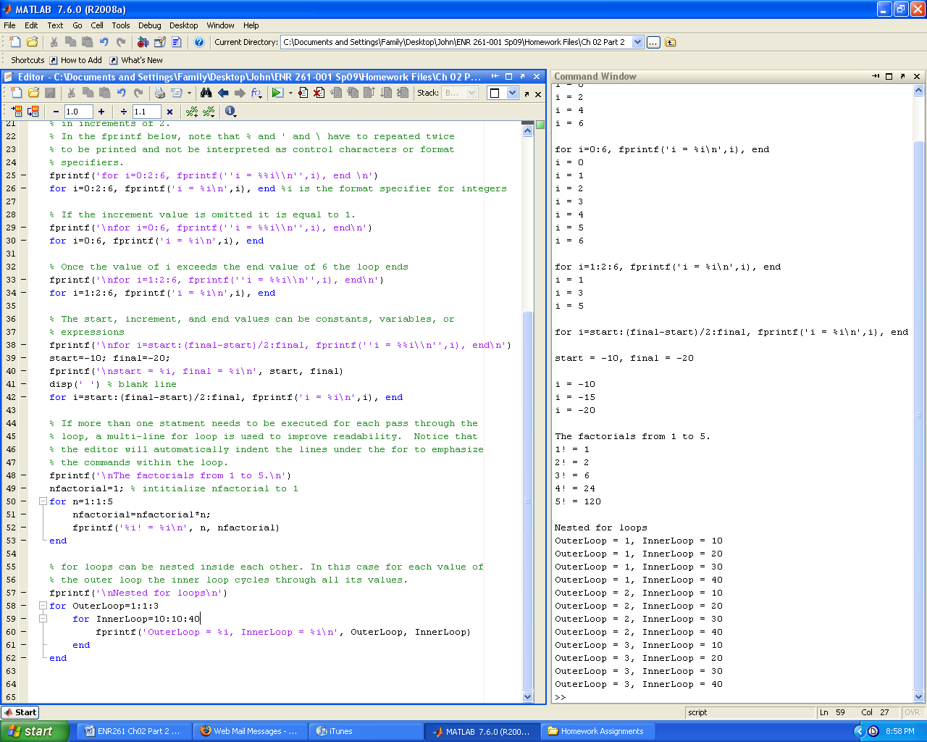

Required File Name: **Tutorial_02_6.m (To stop an infinite loop press Ctrl C)**

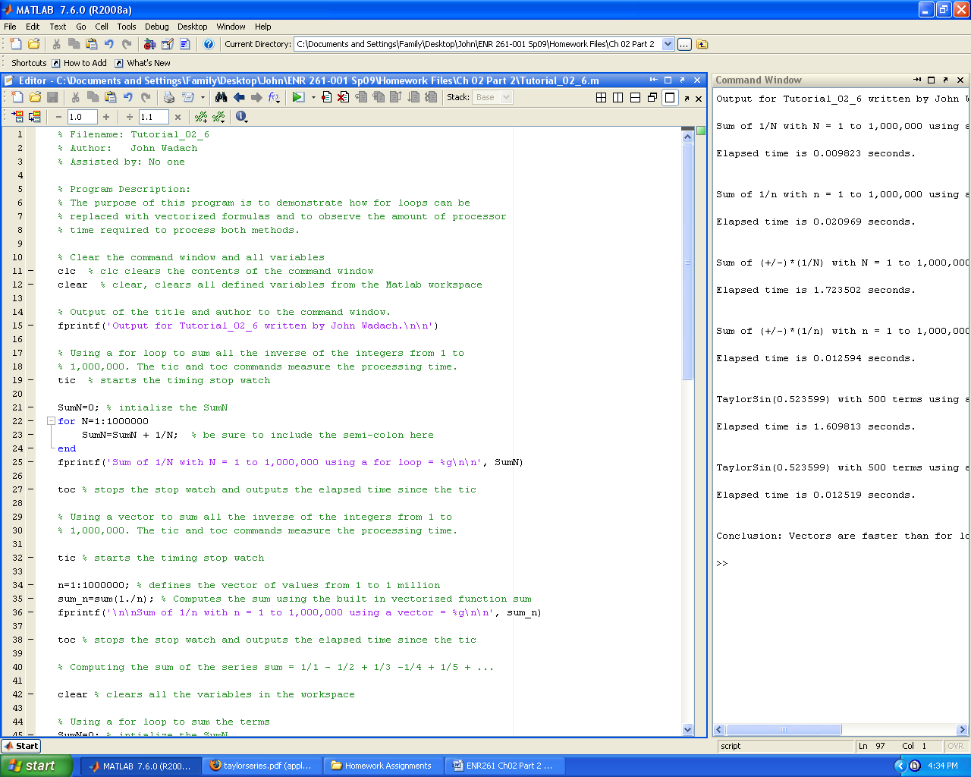

Continued on the Next Page

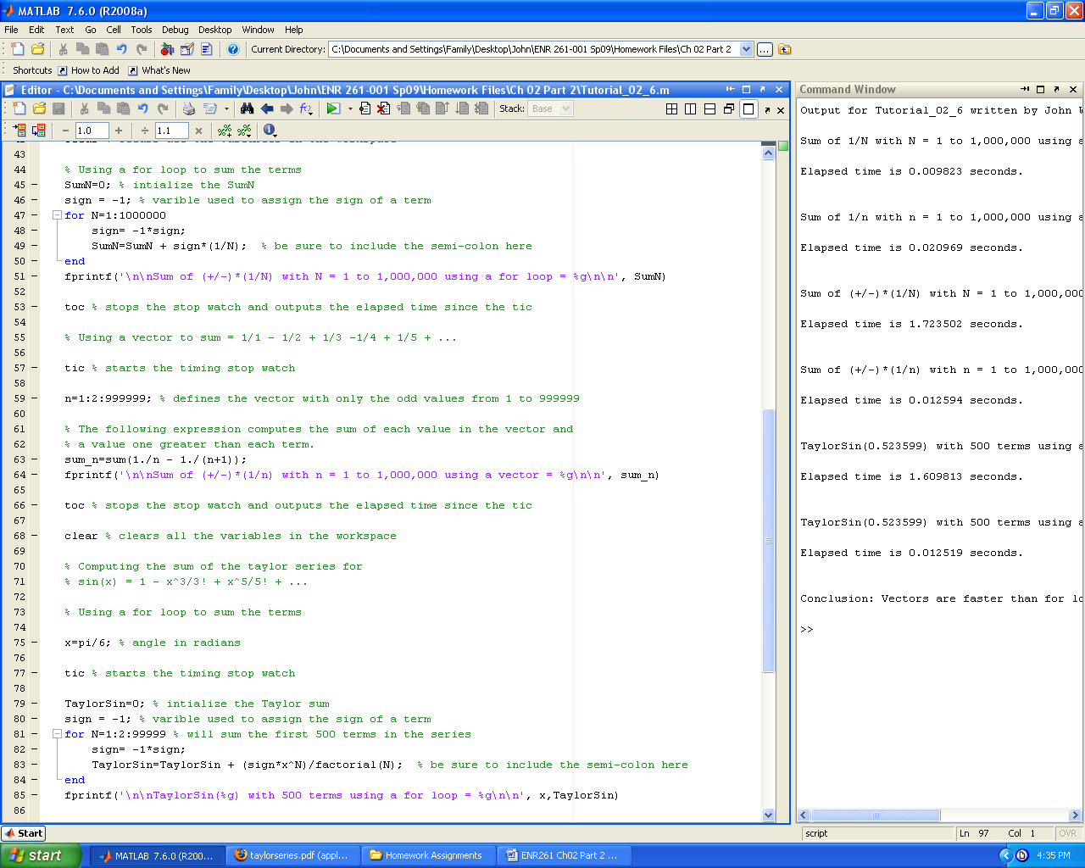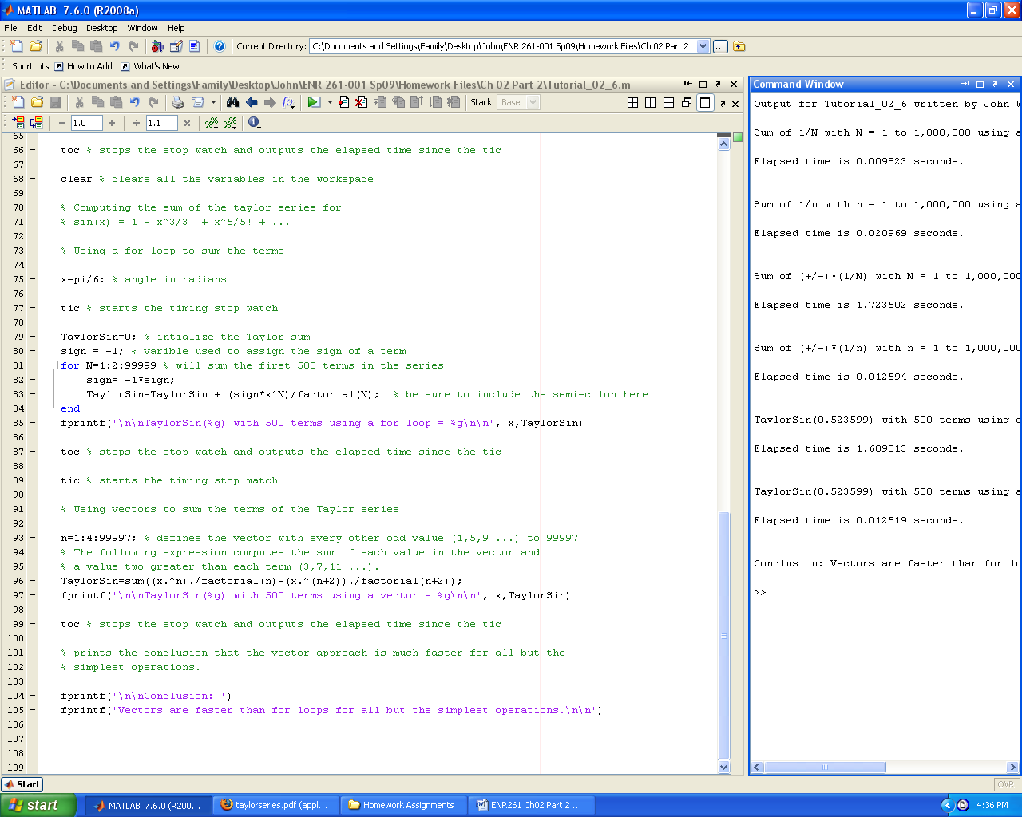

Required File Name: **Tutorial_02_7.m**

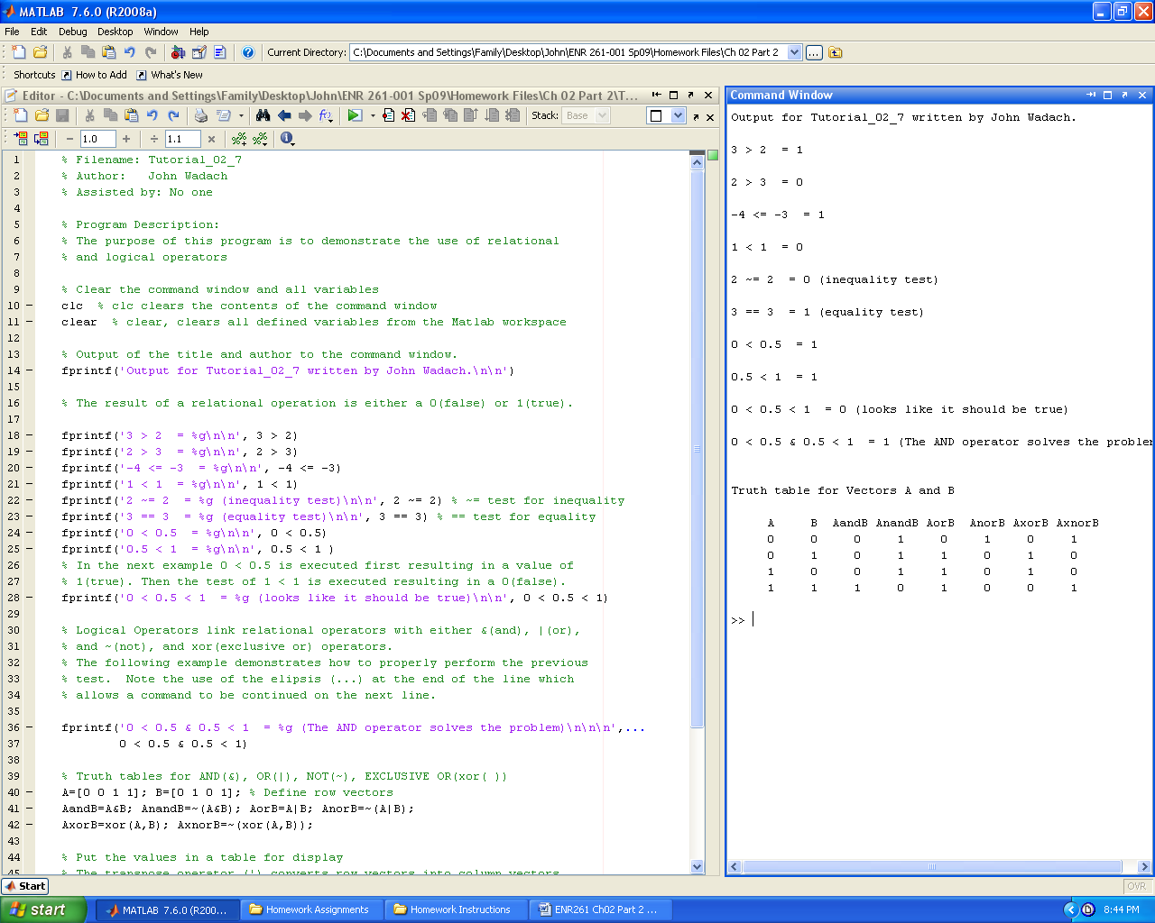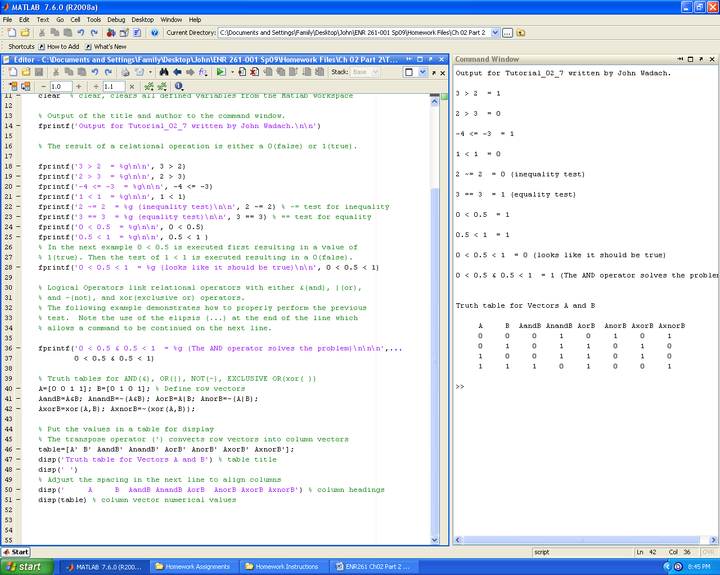

Required File Name: **Tutorial_02_8.m**

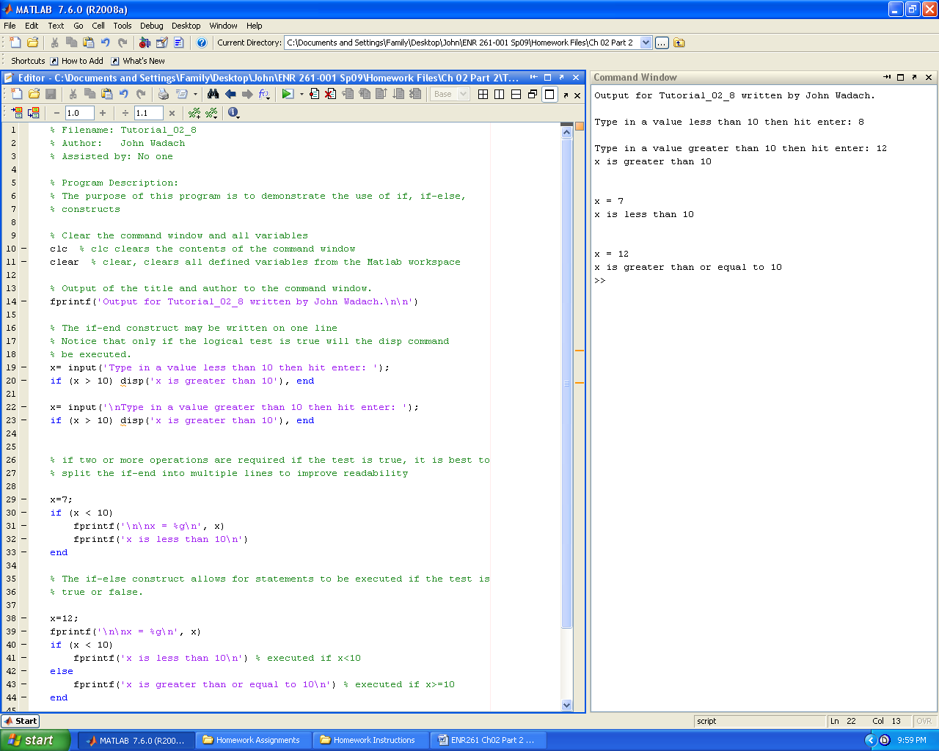

Required File Name: **Tutorial_02_9.m**

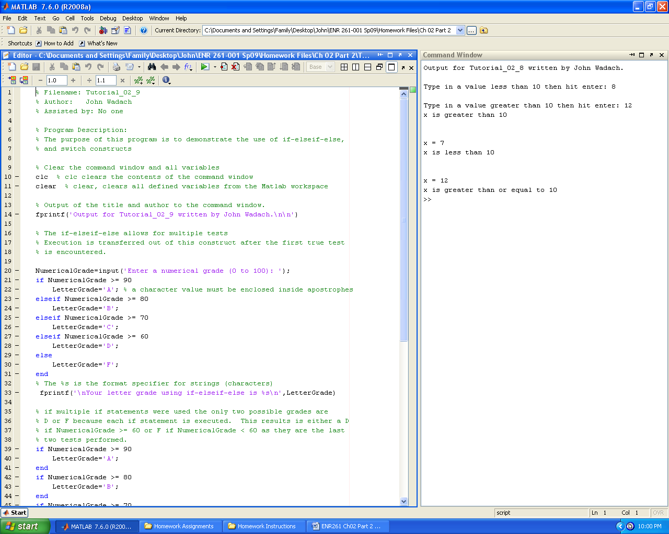

Continued on the Next Page

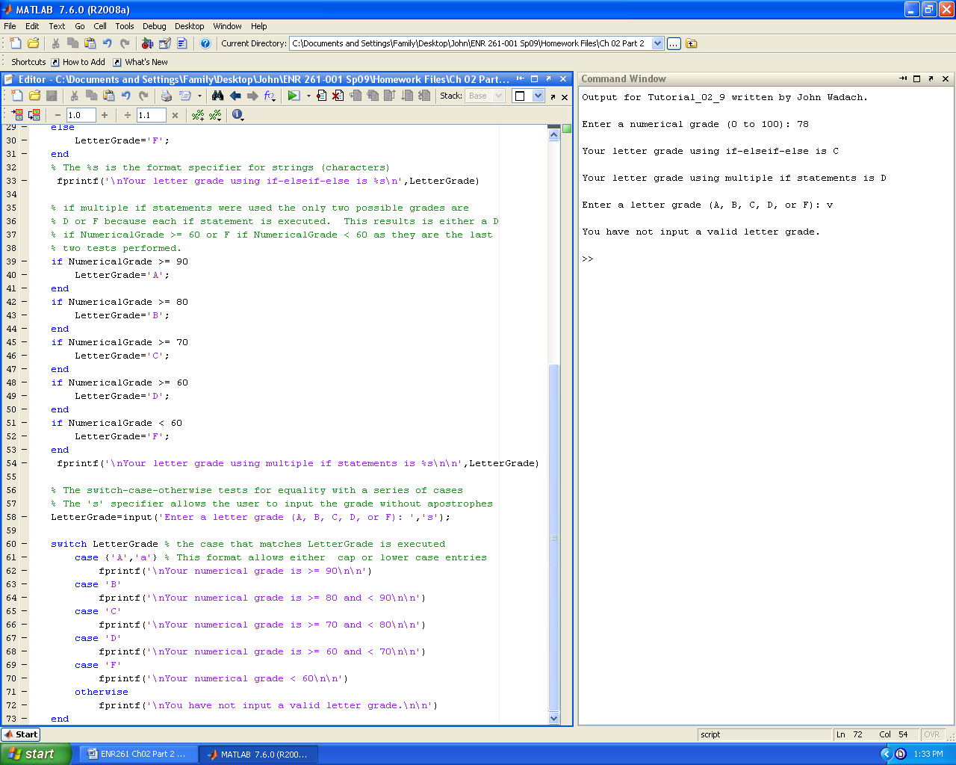

Required File Name: **Program_02_7.m (To stop an infinite loop press Ctrl C)**

1. Complete exercises 1, 2, and 3 on page 63 and use tic-toc to time each operation.

2. Compute the value of ln(x) with x = e using a Taylor series using both a for loop and a vector. Time each operation with tic-toc. Warning: The Taylor series for ln(x) is valid only for 0< x < 2. Use 1/x for values over 2.

3. Create output similar to that shown below.

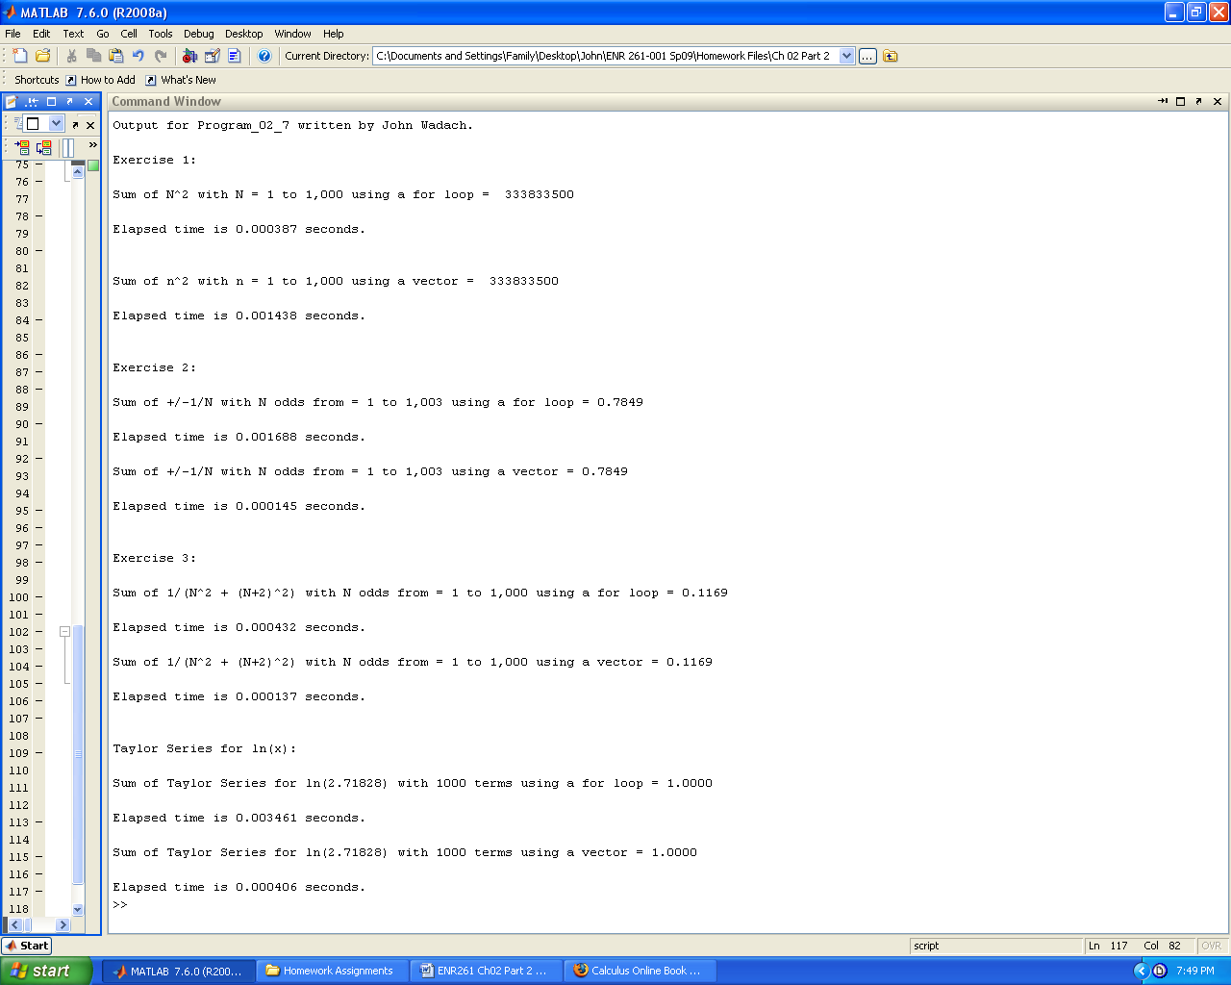

Required File Name: **Program_02_8**

Complete exercise 2.21 on page 78 with the following modifications

* Add the following command at the top of your program

close all % closes all figure windows

* Change the variable definitions in the problem as given  
  E = 10 v, R = 2 ohms, C = 10 µF, L = 4 mH
* Create a vector named ω containing values from 1000 to 10000 1/s in steps of 250 1/s
* Modify the formula for I by removing both 2π terms and vectoring it.
* Create output as shown below (use format **short e** for the table)  
  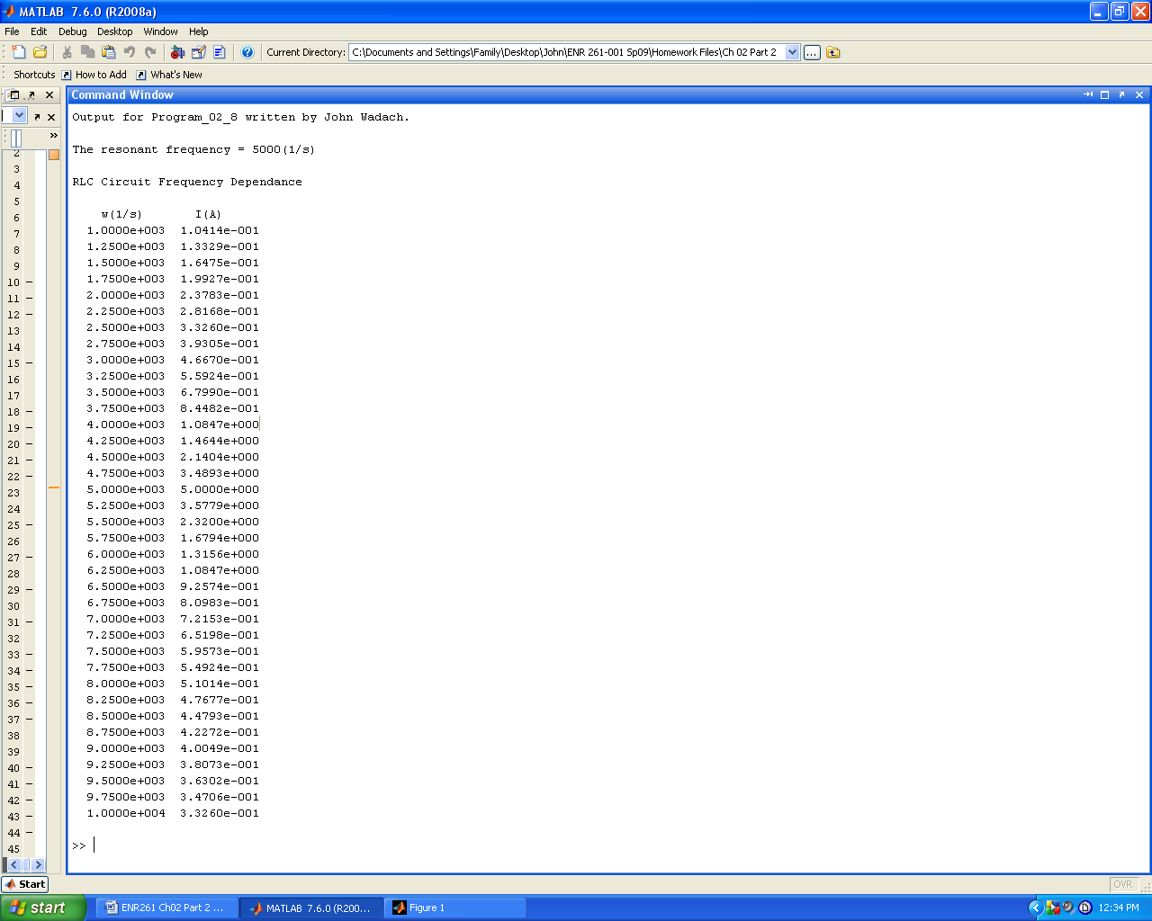
* Create a graph as shown below



Required File Name: **Program_02_9**

Complete exercise 2.25 on page 79 and create the following output.

