**ENR 261 Spring 2023 Chapter 4 Homework**

**General Instructions:**

Save your all your Matlab files for this chapter in the folder named **Ch04** located inside your local repository on your USB Memory Stick. When finished be sure to add, commit, and push your changes to your remote repository on GitHub.

**Assigned Exercises**

1. Recreate all of the following script files and be sure to save them in your local repository on your USB memory stick, commit the changes and push them to GitHub.

2. Use the required file names for each script file.

Required File Name: **Tutorial_04_1.m**

1. For the following, you will use the Excel file: **Tutorial_04_1_Data.xlsx** found in your local repository.

2. Create the following Matlab program.

3. After running the program open the Excel file to check its contents. Also check to see that the file Tutorial_04_1.mat has been created in your CH04 folder.

Continued on the Next Page

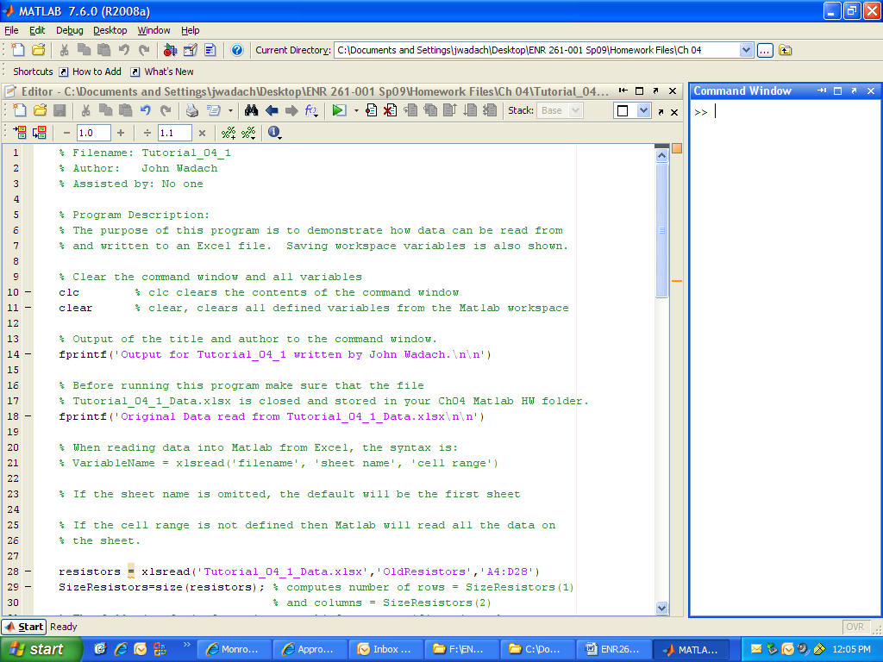

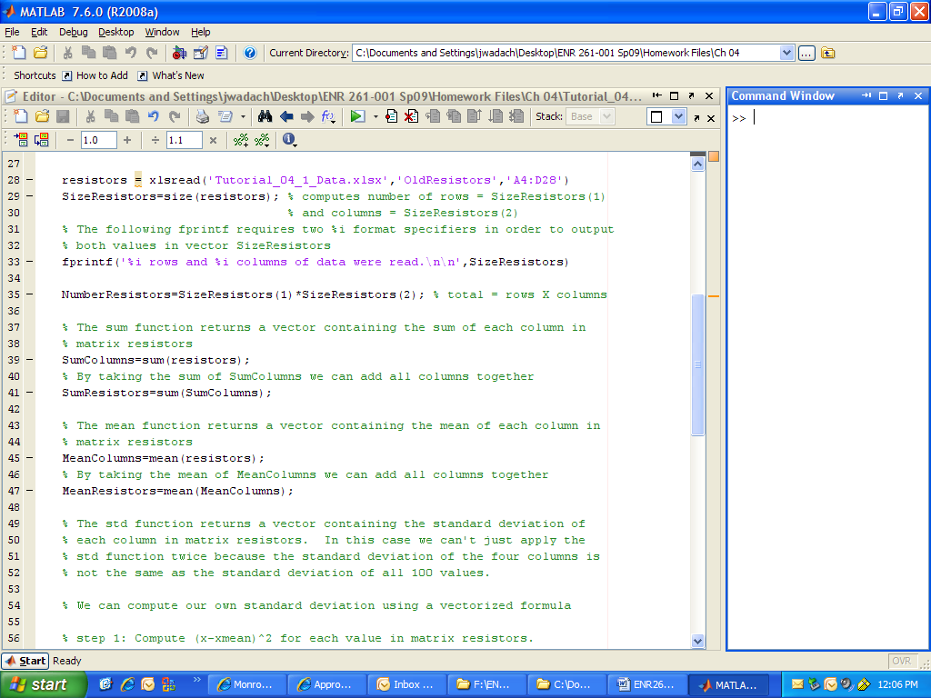

Continued on the Next Page

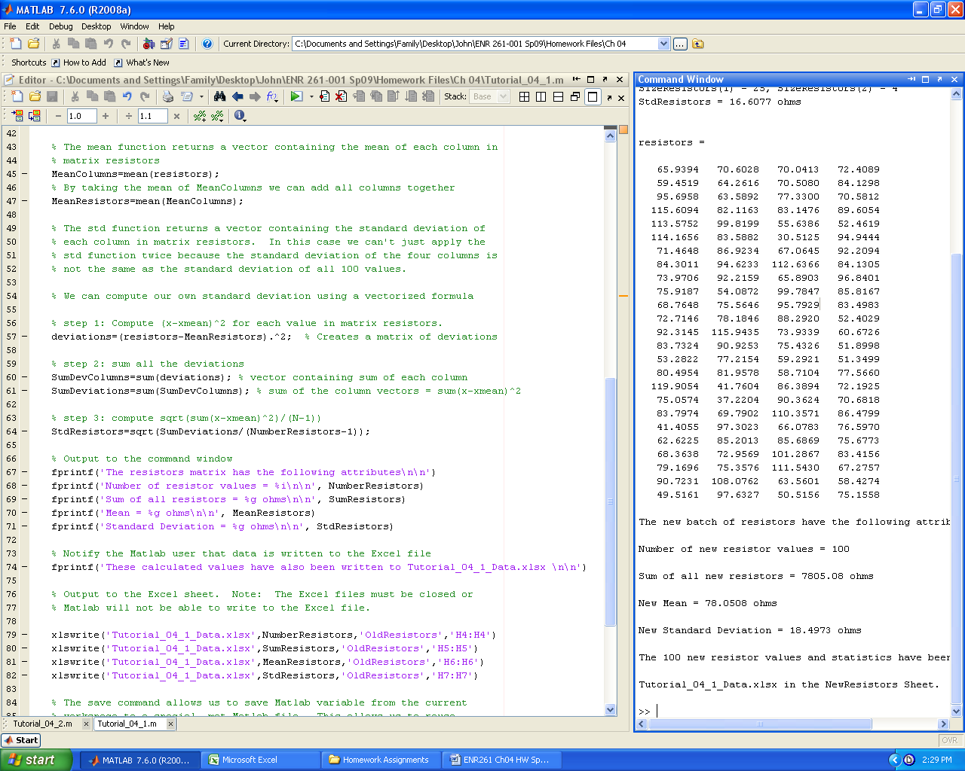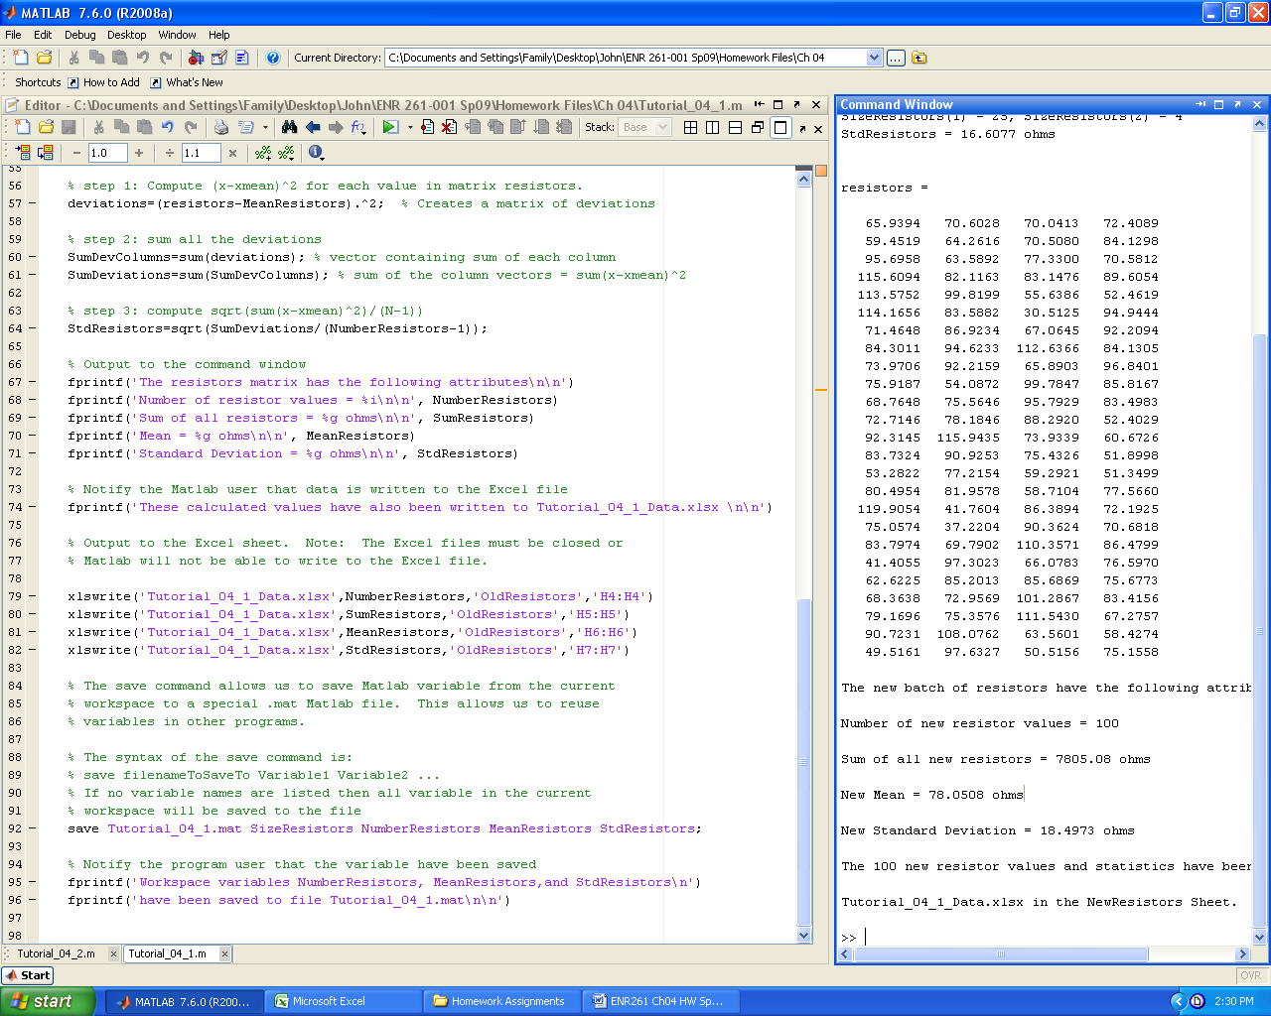

Required File Name: **Tutorial_04_2.m**

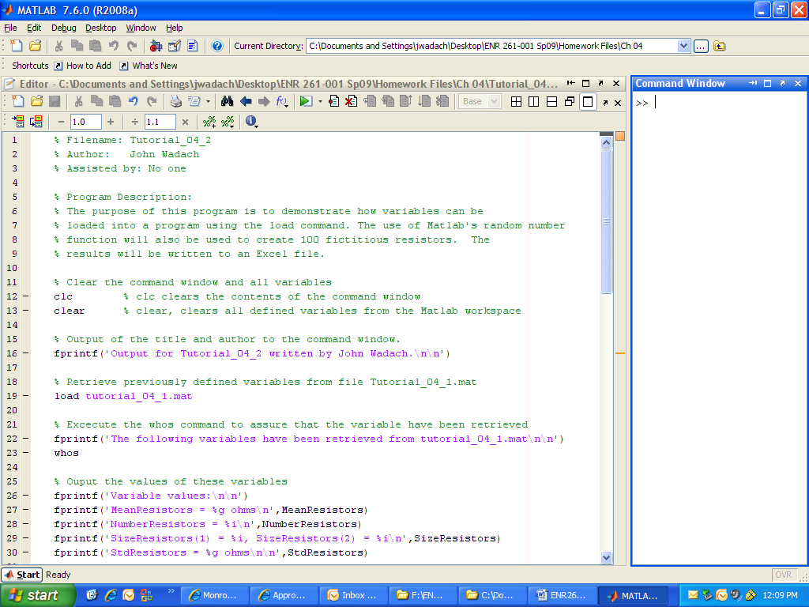

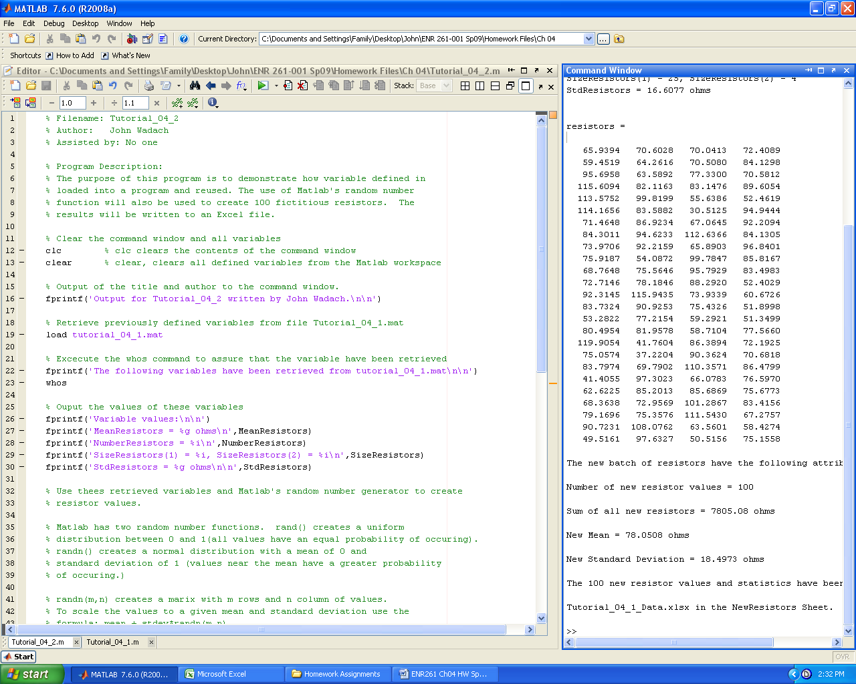

Continued on the Next Page

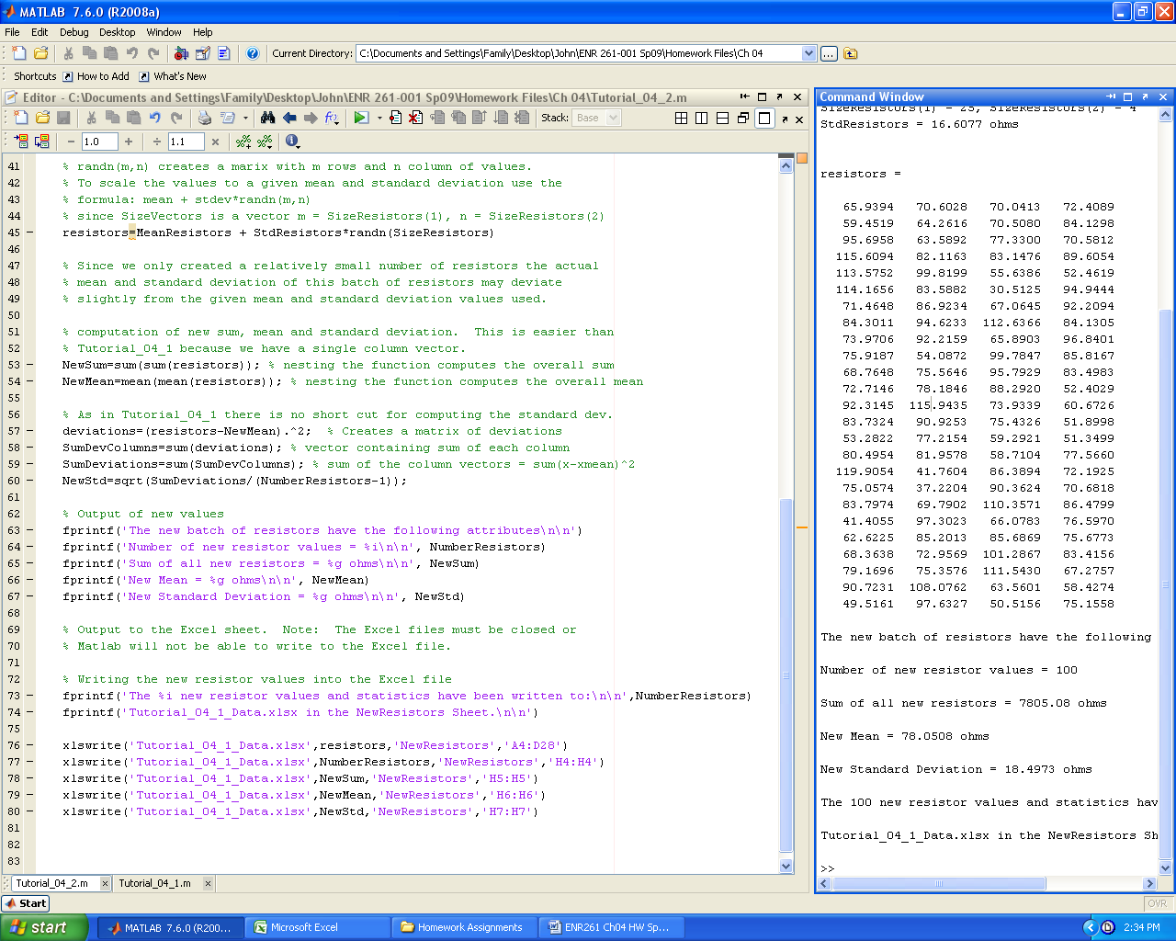

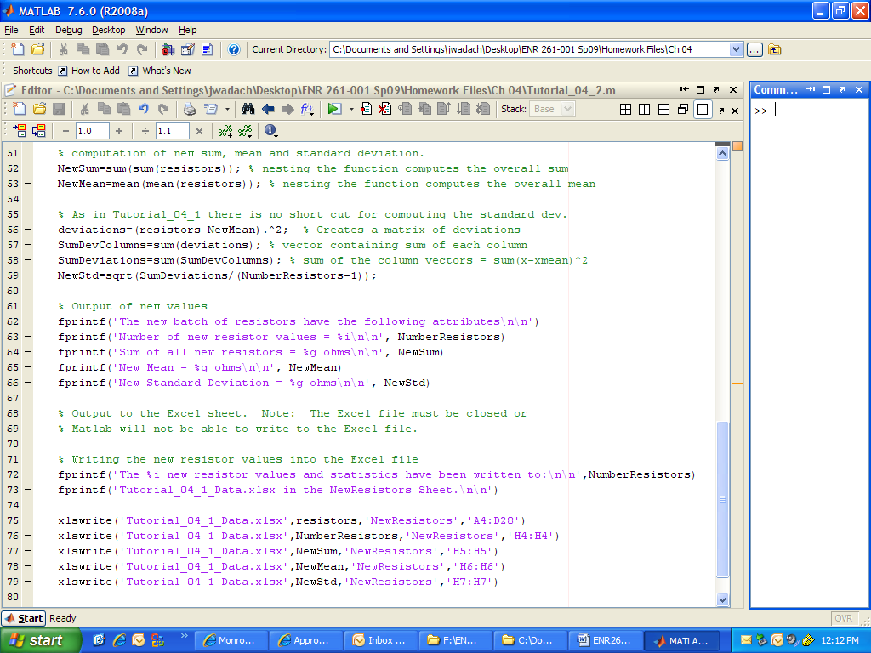

Required File Name: **Tutorial_04_3.m**

1. For the following, you will use the Excel file: **NothernHemTempIndex.txt** found in your local repository.

2. Create the following Matlab program.

3. After running the program, open **TempDataTable.txt** to check its contents.

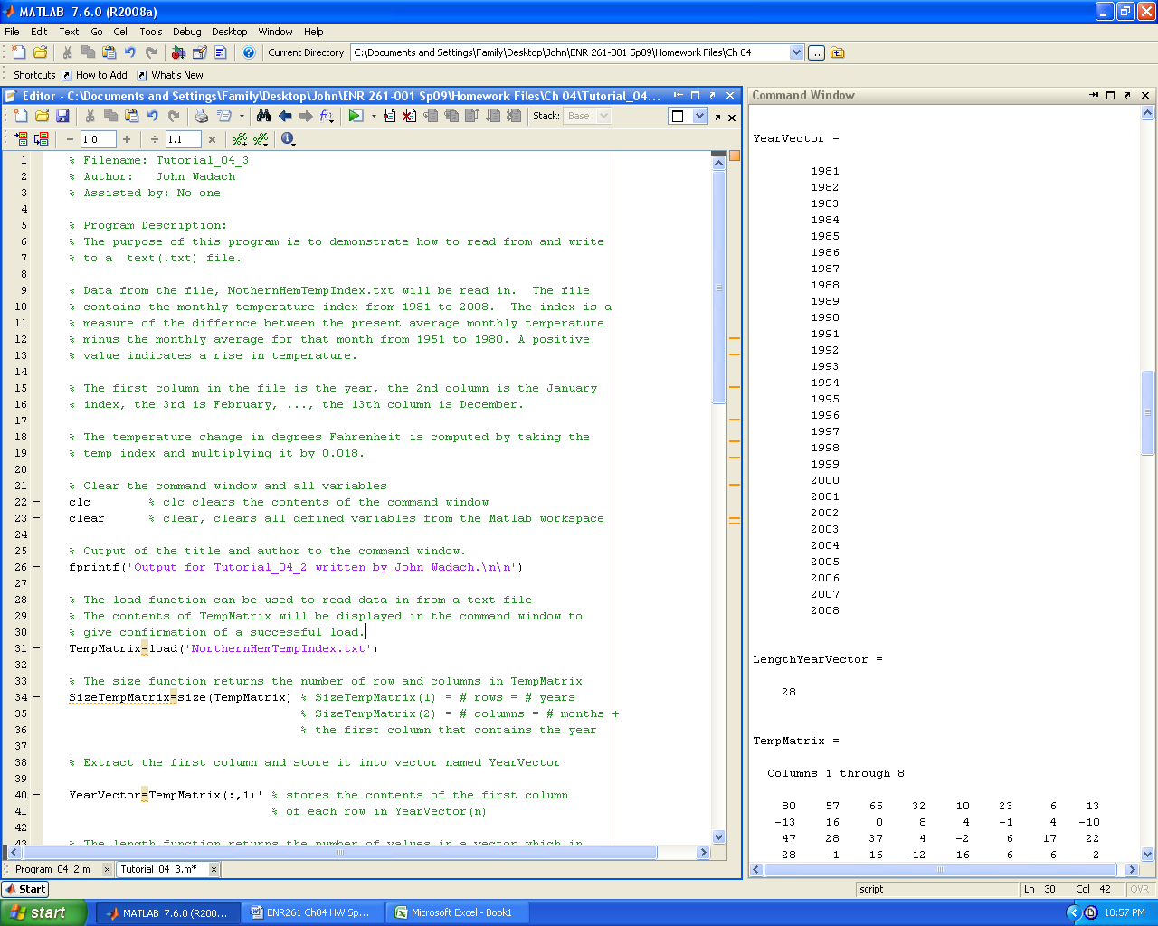

Continued on the Next Page

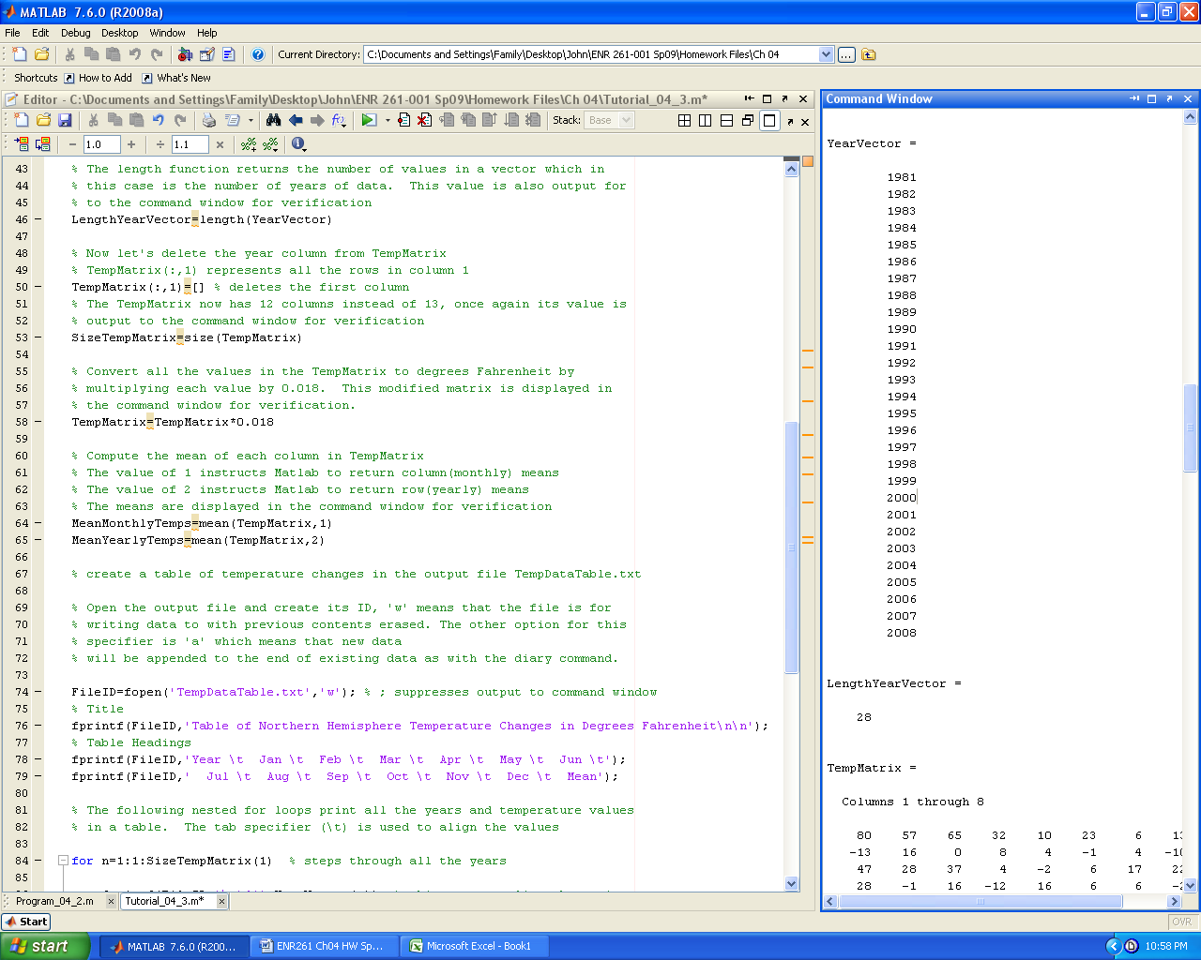

Continued on the Next Page

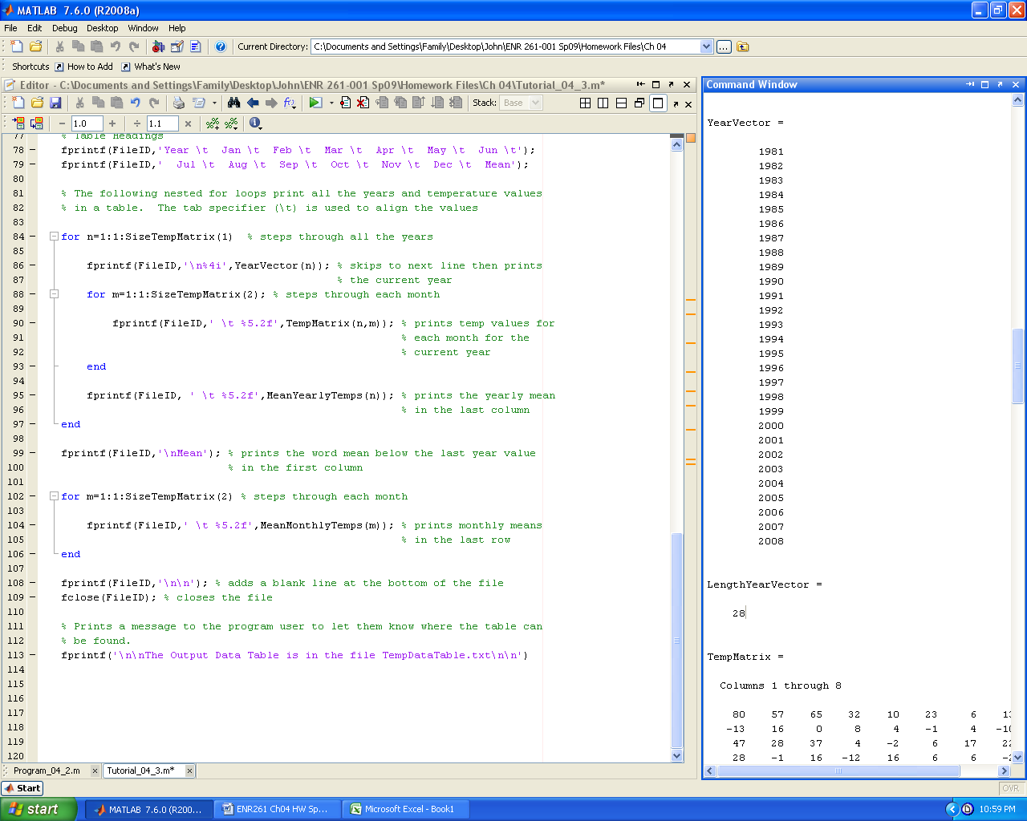

Required File Name: **Program_04_1.m**

1. For the following, you will use the Excel file: **Tutorial_04_1_Data.xlsx** found in your local repository.

2. Create a Matlab program that reads the **Change Due** data from the **Coins** sheet in **Tutorial_04_1_Data.xlsx** and performs the following operations. Hint: See the feet and inches example on page 102 of the text

* Computes the number of quarters, dimes, nickels, and pennies that will equal the value of the change due with the least number of coins.
* Produces the output in the command window of Matab as shown below
* Writes the calculated values to the **Coins** sheet in the **Tutorial_04_1_Data.xlsx** spreadsheet**.**

3. After running the program, open the Excel file to check its contents.

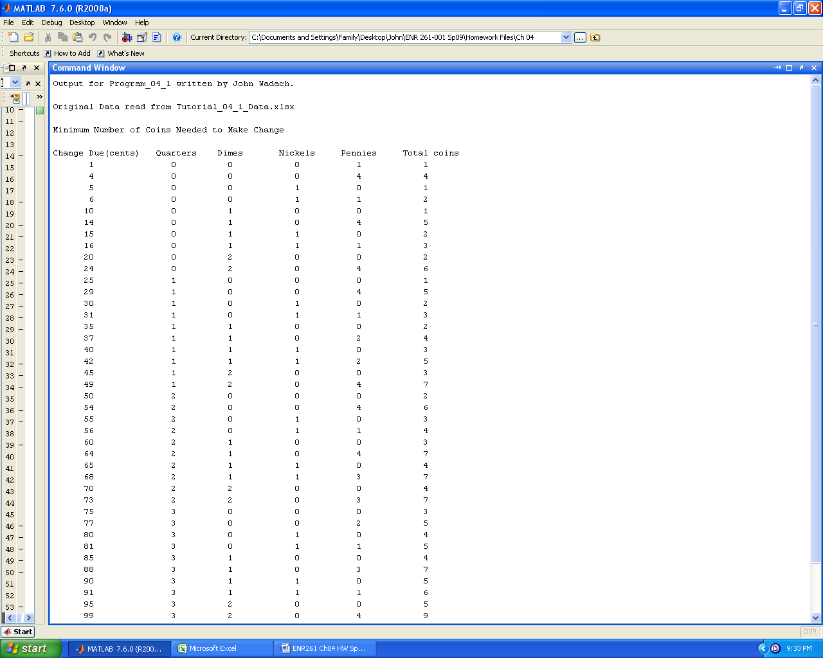

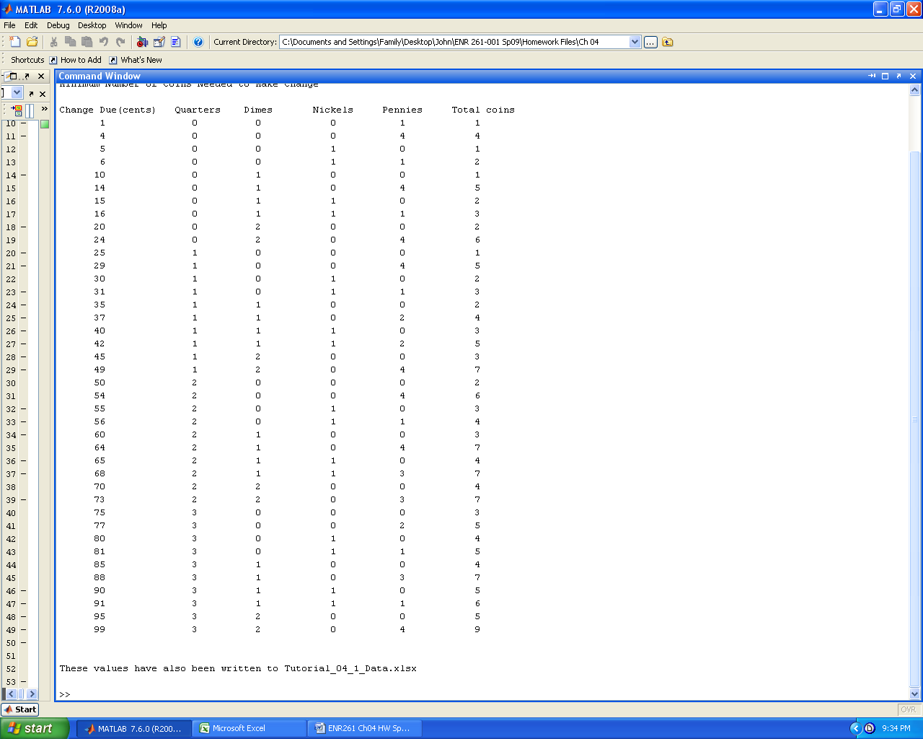

Required File Name: **Program_04_2.m**

1. For the following, you will use the Excel file: **RawGrades.txt** found in your local repository.

2. Create a Matlab program that performs the operations outlined below.

The purpose of this program is to read raw grades from the file **RawGrades.txt**

and to compute the numerical average and the letter grade for each student.

The results will be displayed in the file: **FinalGrades.txt**

The data file contains four columns in the following order from left to

right: Student Number, HW Average, Test Average, Final Exam score.

Numerical Averages are computed according to the formula below.

HW 20%, Tests 35%, Final Exam 45% rounded to the nearest whole number

Letter grades are assigned based on the following curve.

A >= Mean Numerical Average + 1.5* Standard Dev of Numerical Averages

B >= mean + 0.5*Stdev and less than mean + 1.5*Stdev

C >= mean - 0.5*Stdev and less than mean + 0.5*Stdev

D >= mean - 1.5*Stdev and less than mean - 0.5*Stdev

F < mean - 1.5*Stdev

3. After running the program, open **FinalGrades.txt** to check its contents.

