**ENR 261 Spring 2023 Chapter 6 Homework**

**General Instructions:**

Save your all your Matlab files for this chapter in the folder named **Ch06** located inside your local repository on your USB Memory Stick. When finished be sure to add, commit, and push your changes to your remote repository on GitHub.

**Assigned Exercises**

1. Recreate all of the following script files and be sure to save them in your local repository on your USB memory stick, commit the changes and push them to GitHub.

2. Use the required file names for each script file.

Create the following Matlab programs.

Required File Name: **Tutorial_06_1.m**

**Continued on the Next Page**

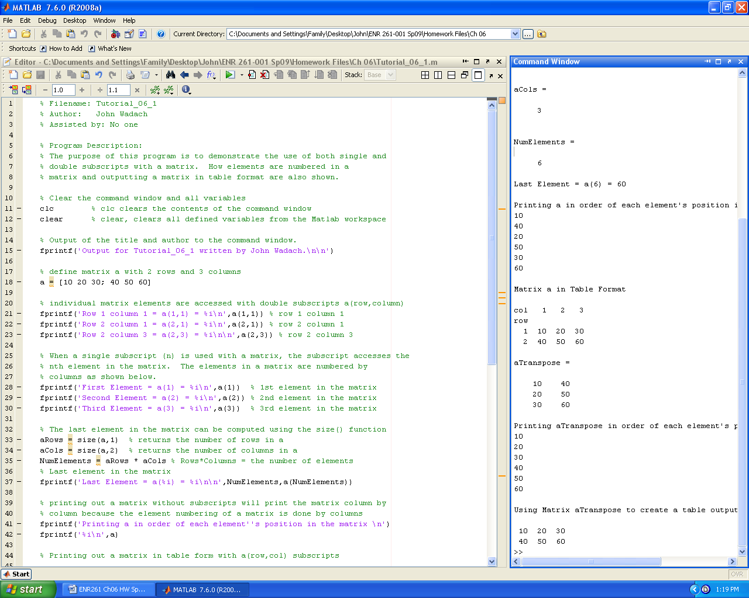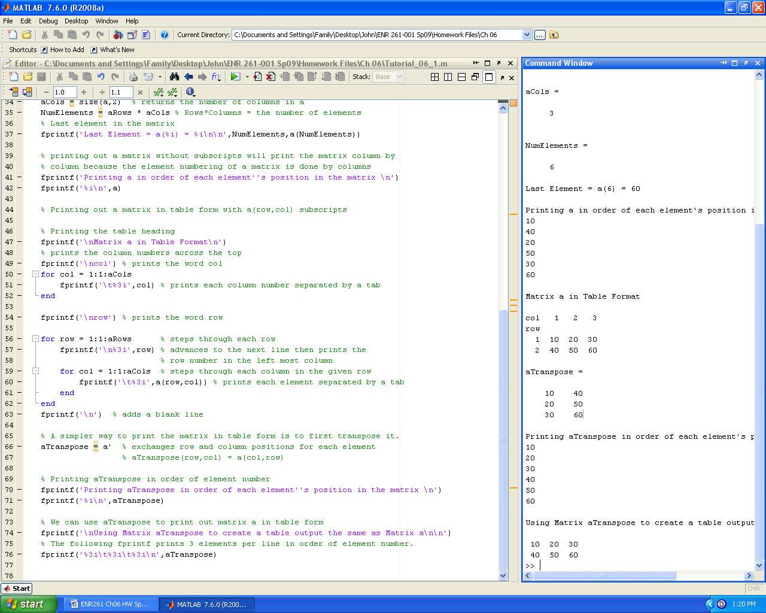

Required File Name: **Tutorial_06_2.m**

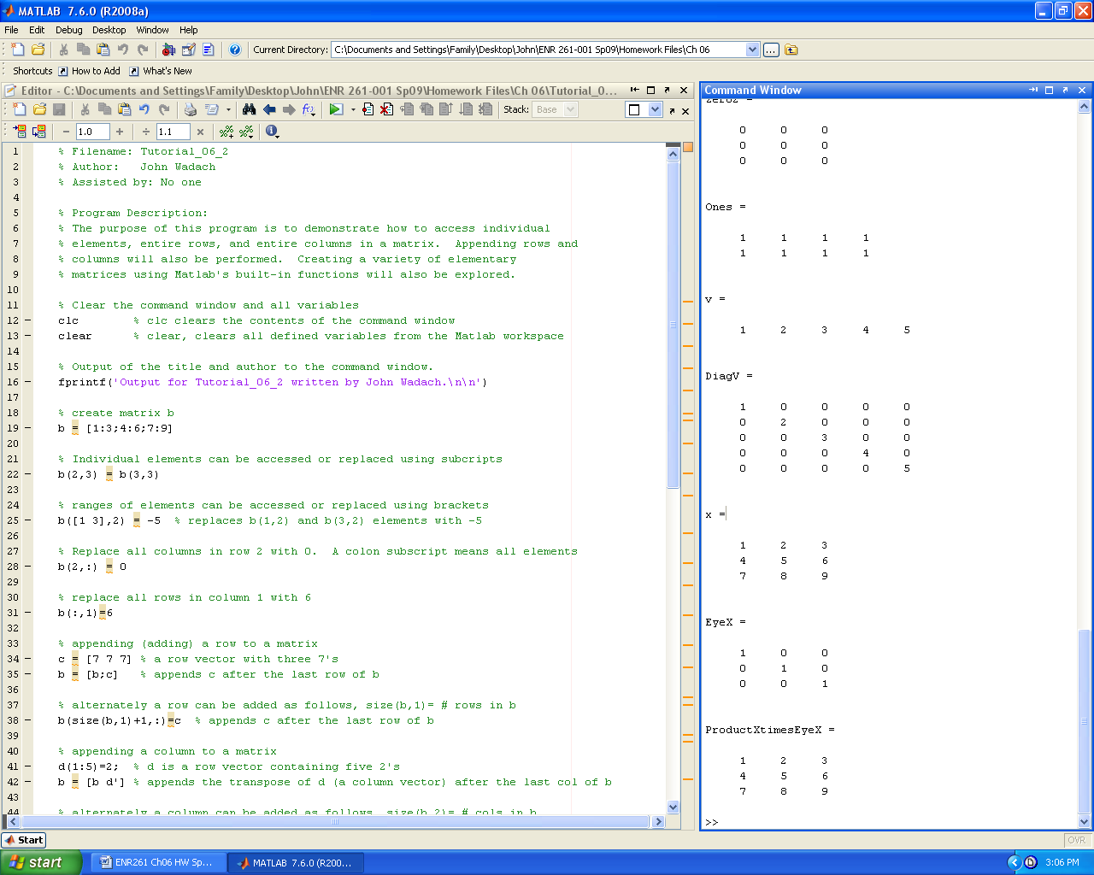 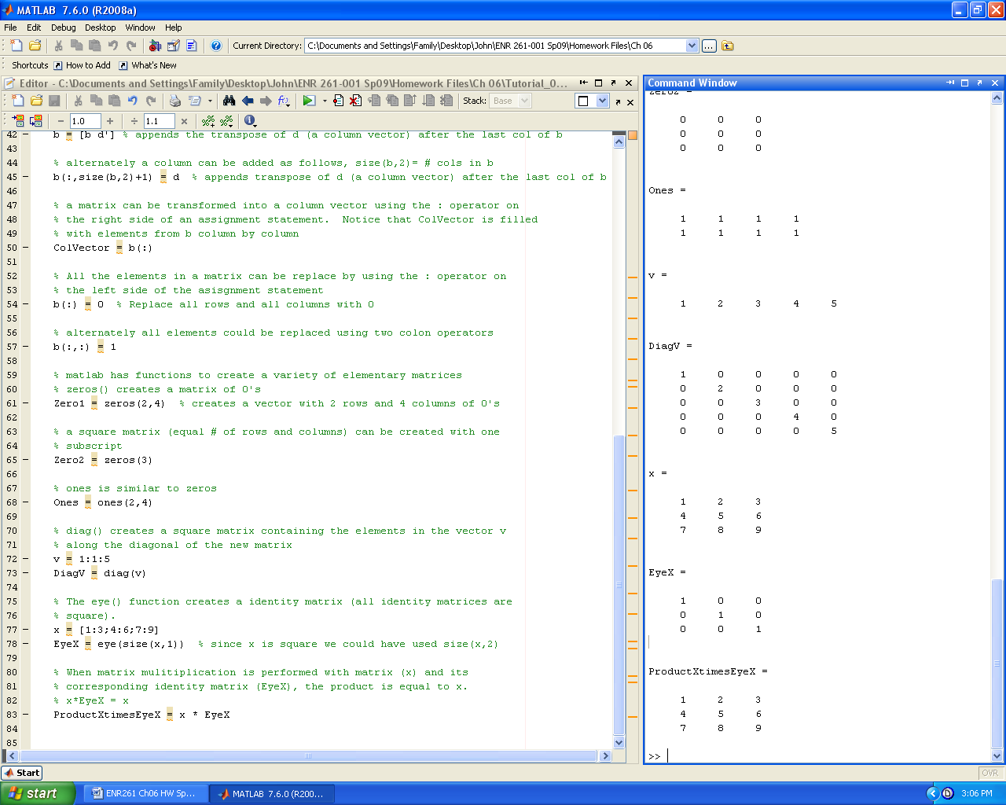

Required File Name: **Tutorial_06_3.m**

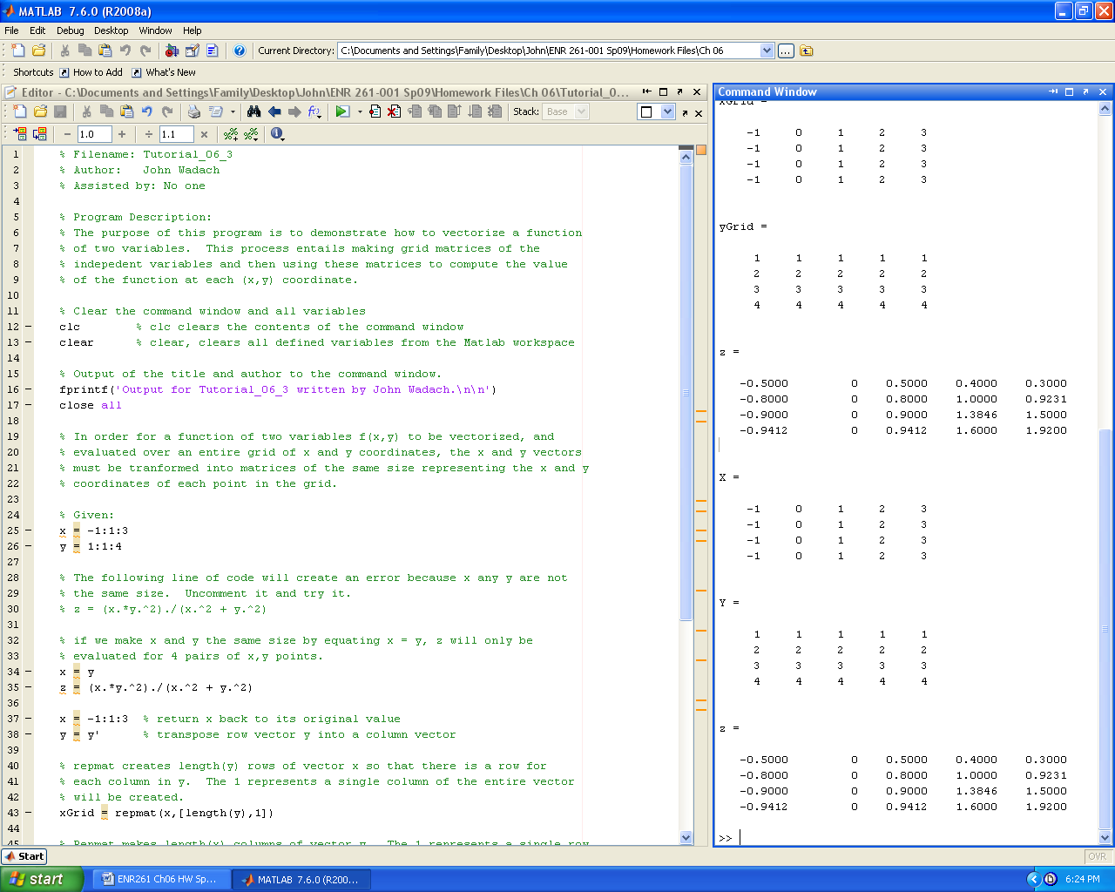 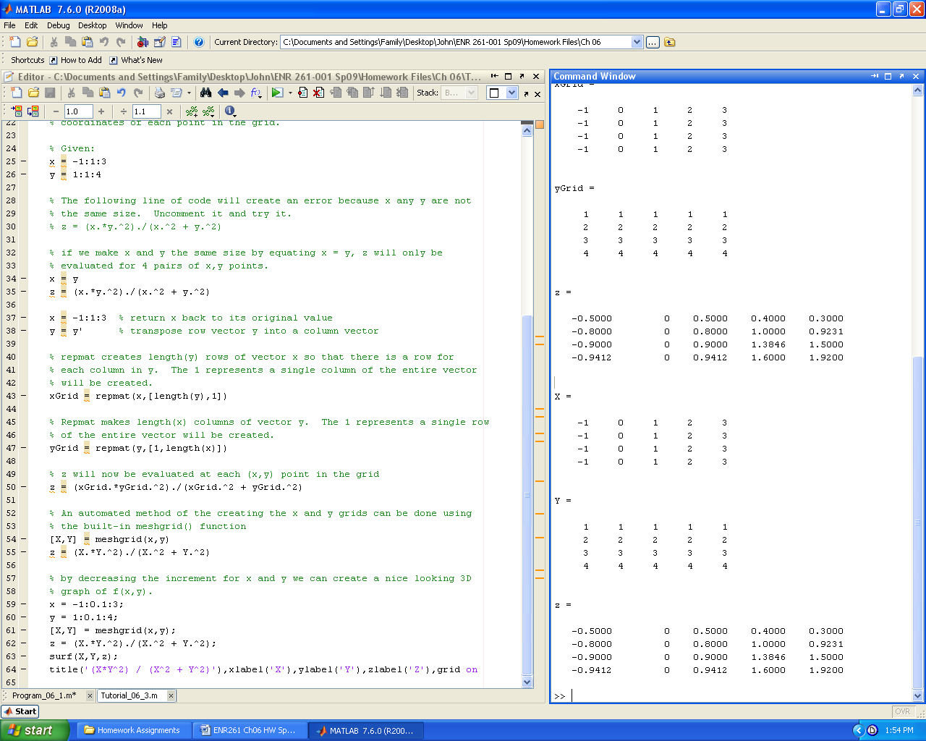

Required File Name: **Tutorial_06_4.m**

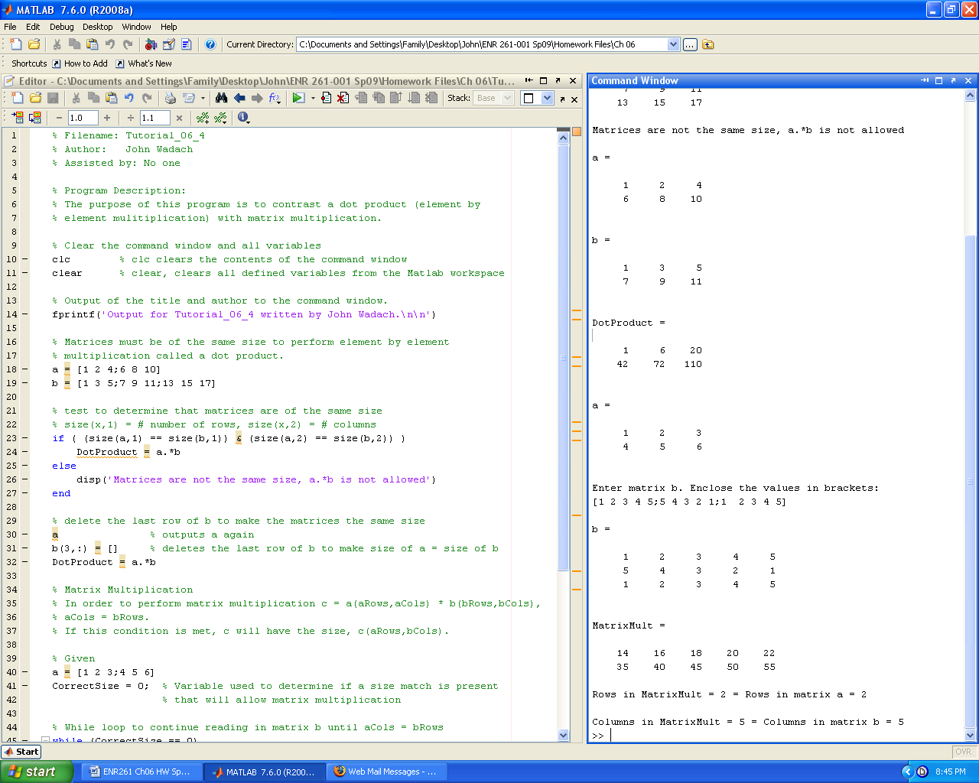 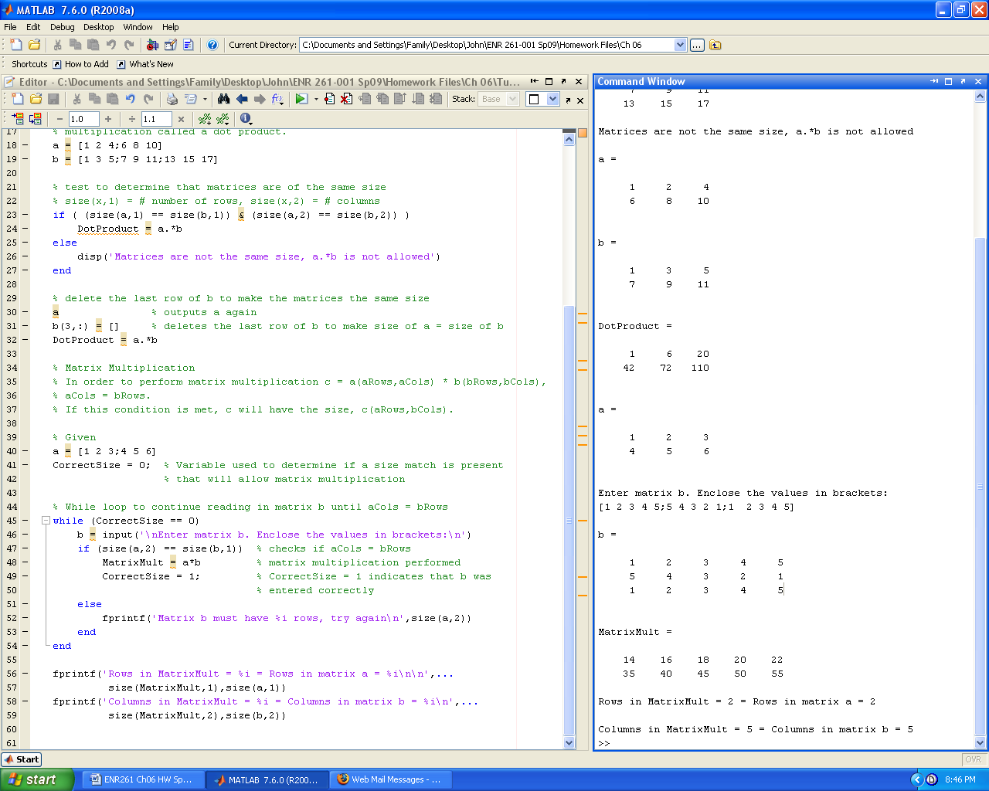

Required File Name: **Tutorial_06_5.m**

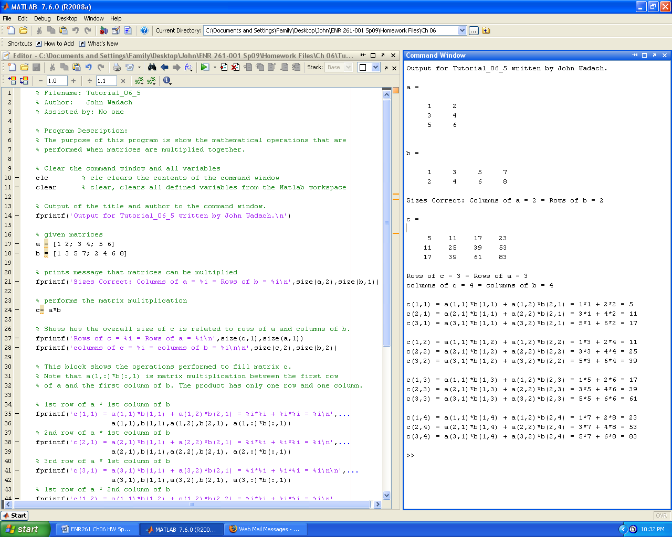 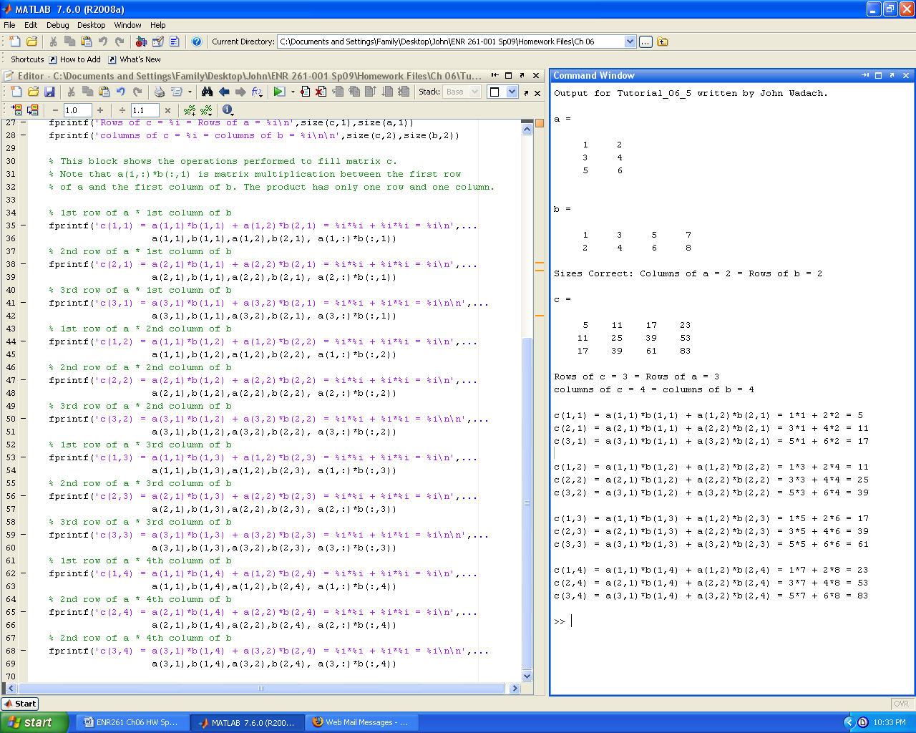

Required File Name: **Program_06_1.m**

Use the ones(), zeros(), eye(), flipud(), fliplr(), and repmat() functions where possible to create matrices a, b, c, d, and e as efficiently as possible.

**Do not** define the matrices using a brute force method such as:

A = [0 0 0 0 0 0 0 0 0 0 0 0; 0 0 0 0 0 0 0 0 0 0 0 0; 0 0 1 1 1 1 1 1 1 1 1 1; …

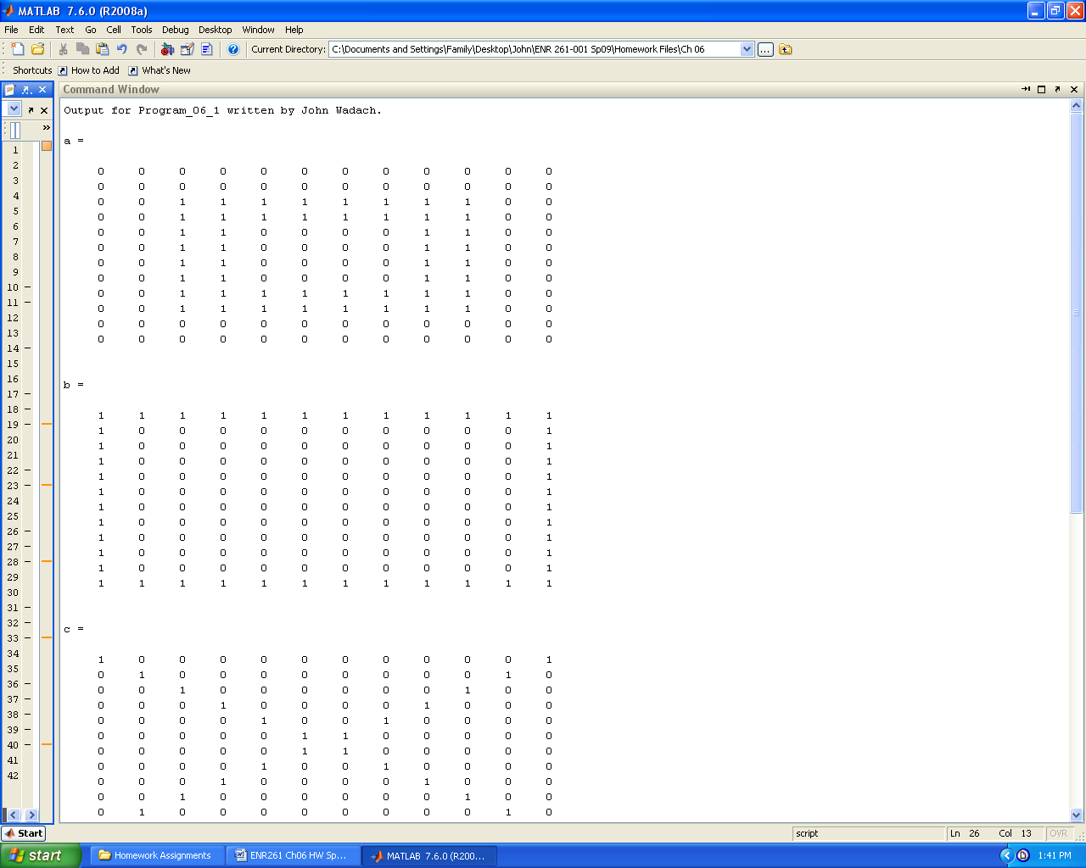

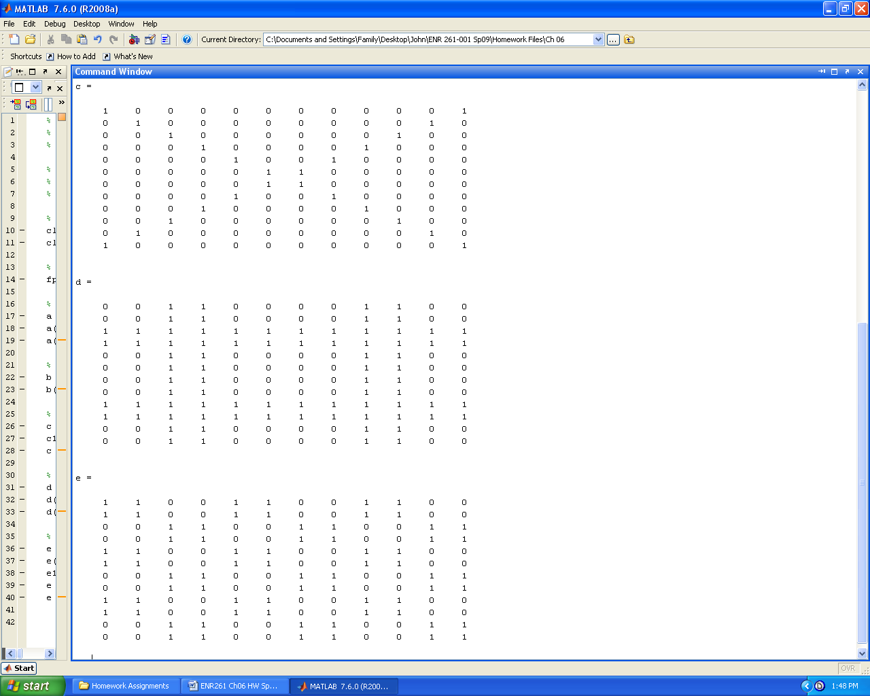

Required File Name: **Program_06_2.m**

1. Create the X and Y meshgrid and use it to evaluate Z to create the table below.

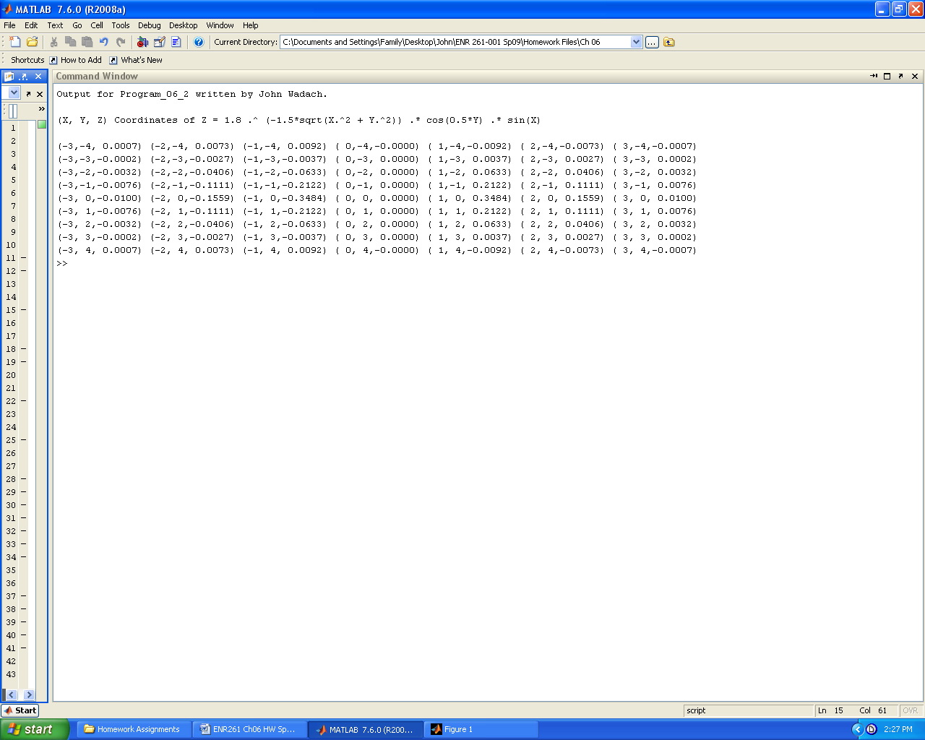

2. Create a new meshgrid with x = y = -3.5: 025: 3.5 and then evaluate Z and create a surf() plot as show below. In the title() function, only the first character after the ^ symbol is superscripted unless you use curly braces { } to enclose the list of characters you would like superscripted.



Required File Name: **Program_06_3.m**

Program Description:

The purpose of this program is to input matrices A and B and then determine

if the matrix multiplication C=A*B can be performed. If not, the user is

instructed to input a new pair of matrices. If C=A*B can be performed the

number of row and columns of C must be output. In computing the value of

C you may not use the matrix multiplication operator A*B. You must

instead create nested for loops to evaluate each element of C manually

using the formulas given in Tutorial_06_5. Matrix C1 will be computed

using C1 = A*B to check our answer. The matrix CminusC1 = C - C1 will be

computed. If all elements of CminusC1 are zero then our method is

correct.

Your output should be similar to that shown below. Notice that I commented out the clc command so that the command window would not be cleared after each run of my program I suggest that you do the same or use a diary file.

Run your program multiple times to test it for many different size matrices. At a minimum, test the cases shown below.

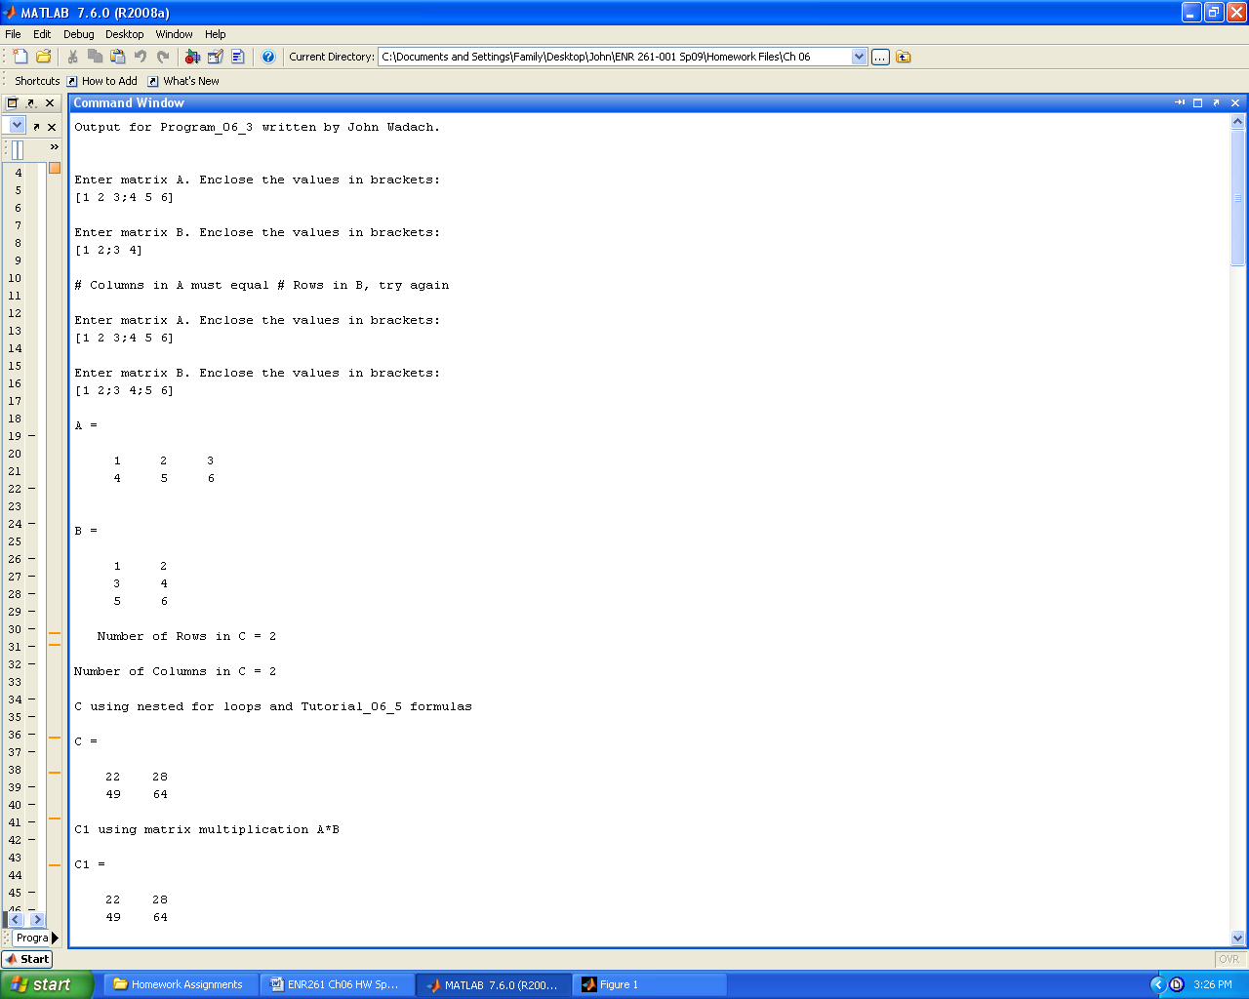

Continued on the next page

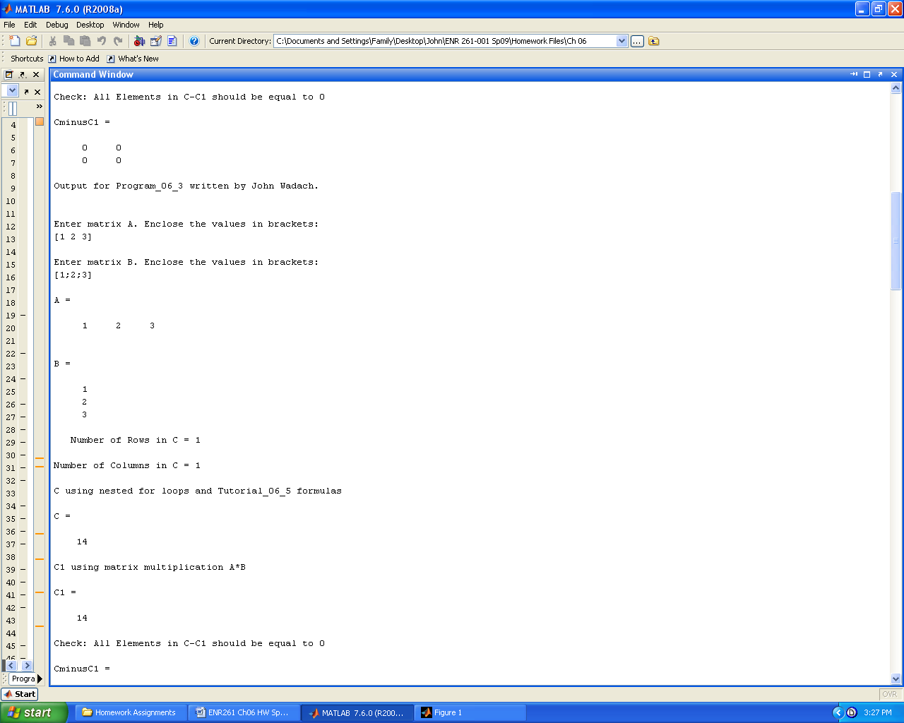

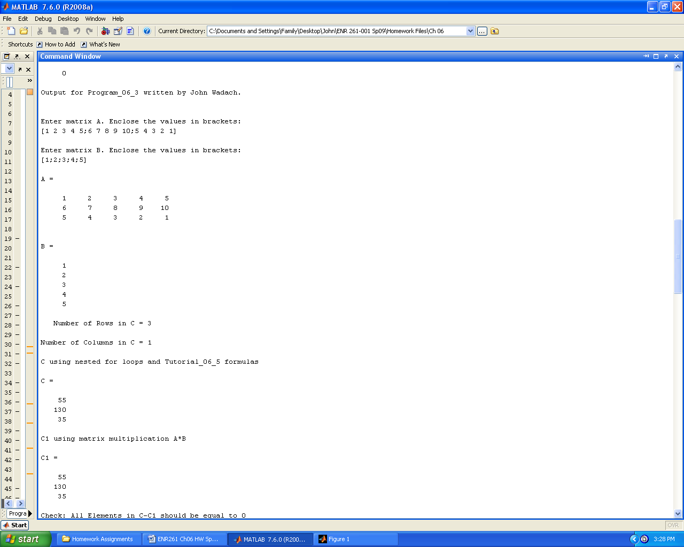

Continued on the next page

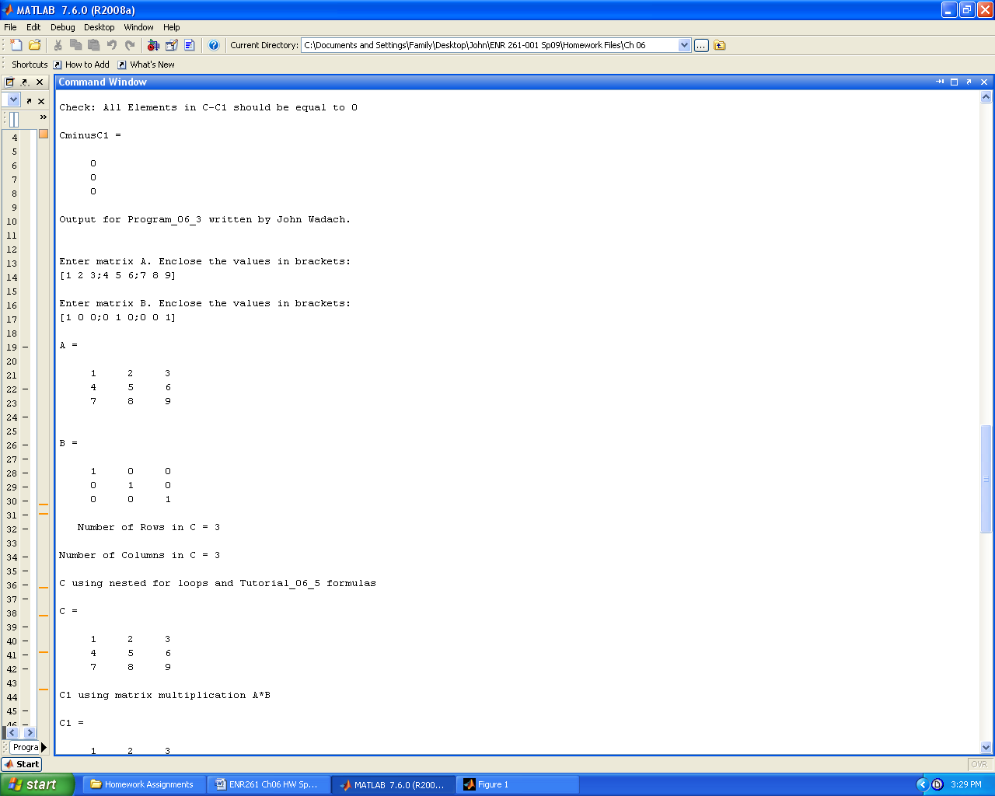

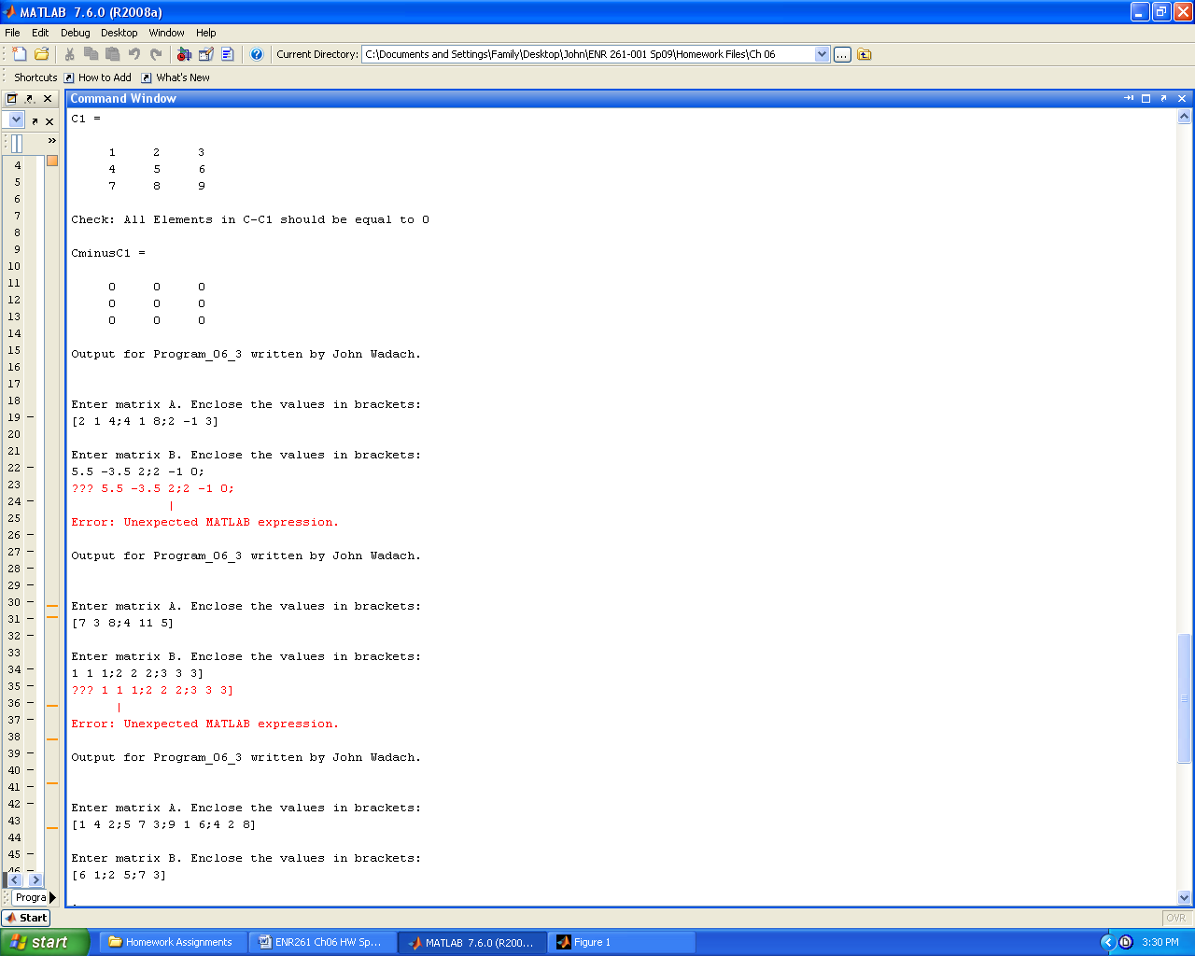

Continued on the next page

