**ENR 261 Spring 2023 Chapter 7 Homework**

**General Instructions:**

Save your all your Matlab files for this chapter in the folder named **Ch07** located inside your local repository on your USB Memory Stick. When finished be sure to add, commit, and push your changes to your remote repository on GitHub.

**Assigned Exercises**

1. Recreate all of the following script files and be sure to save them in your local repository on your USB memory stick, commit the changes and push them to GitHub.

2. Use the required file names for each script file.

Required File Name: **Tutorial_07_1.m**

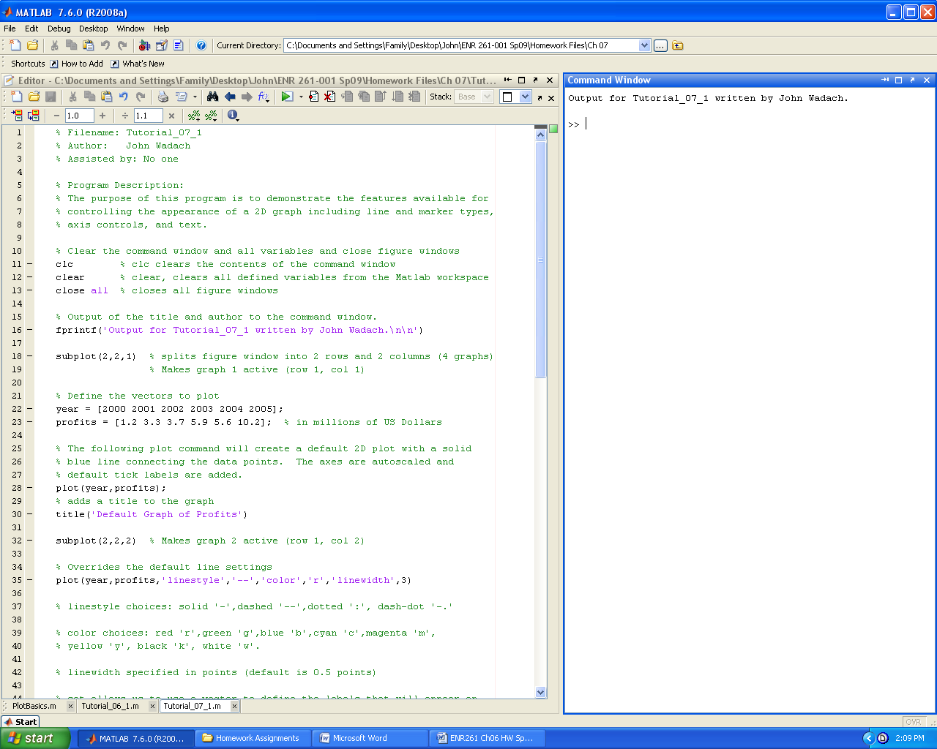

**Continued on the Next Page**

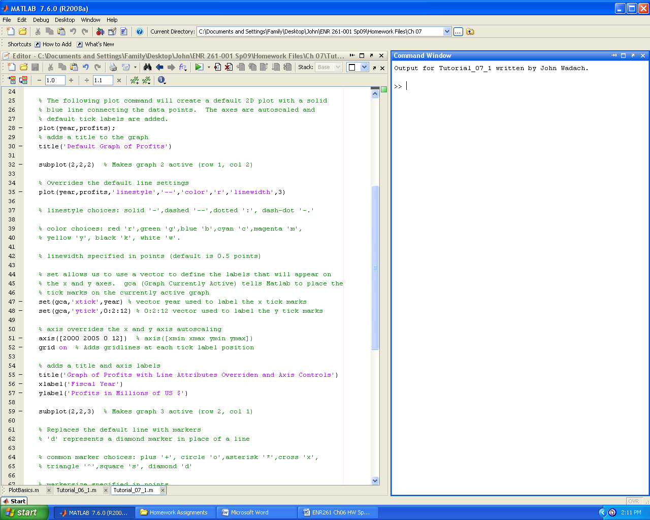 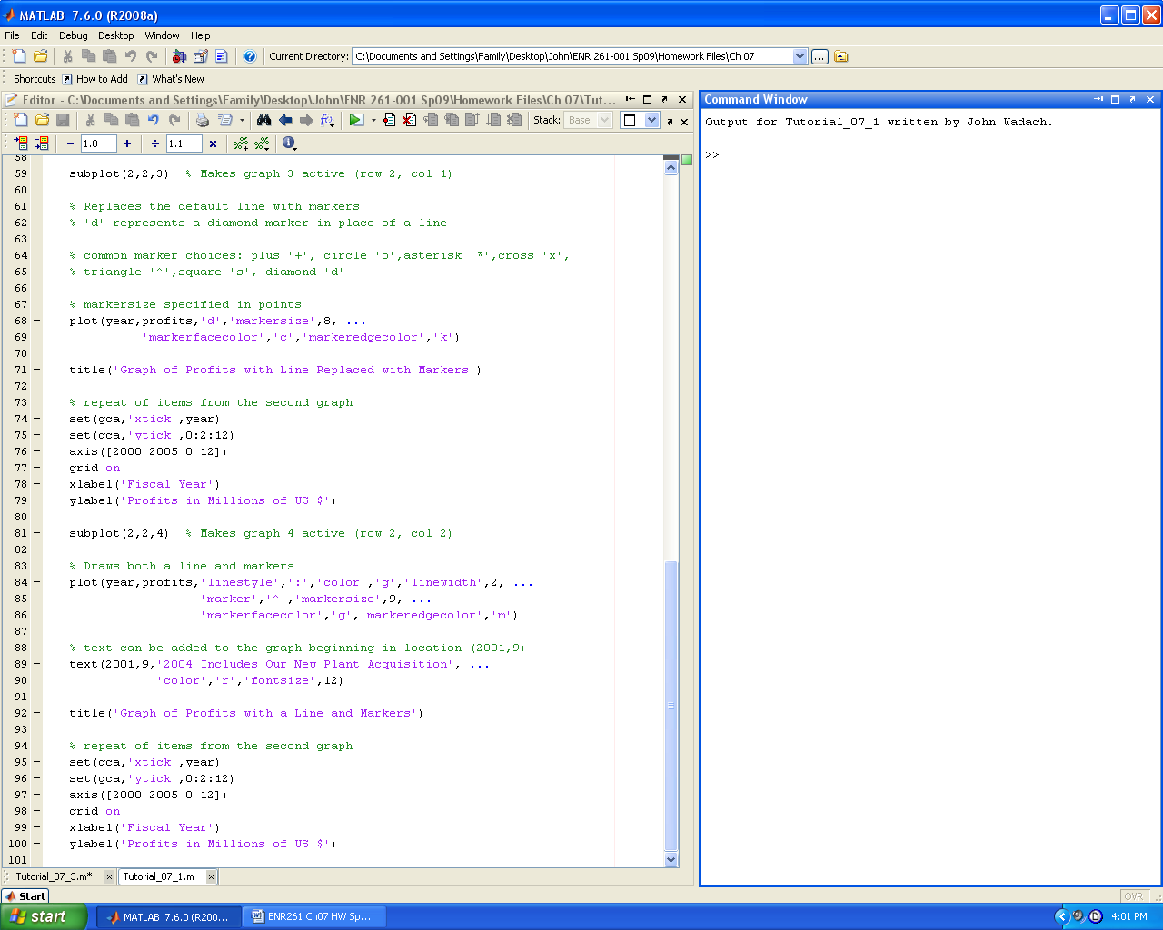

Required File Name: **Tutorial_07_2.m**

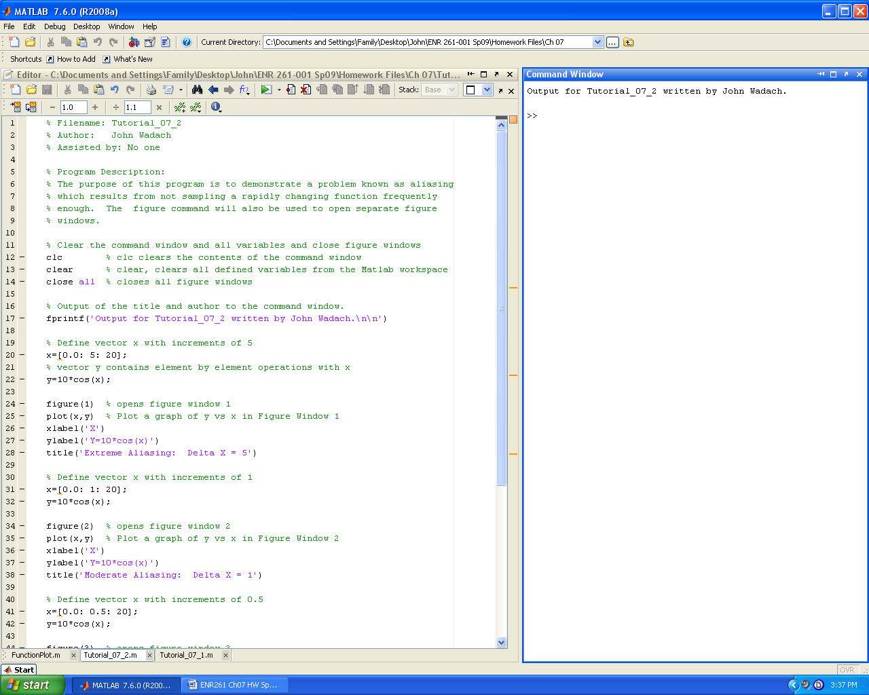 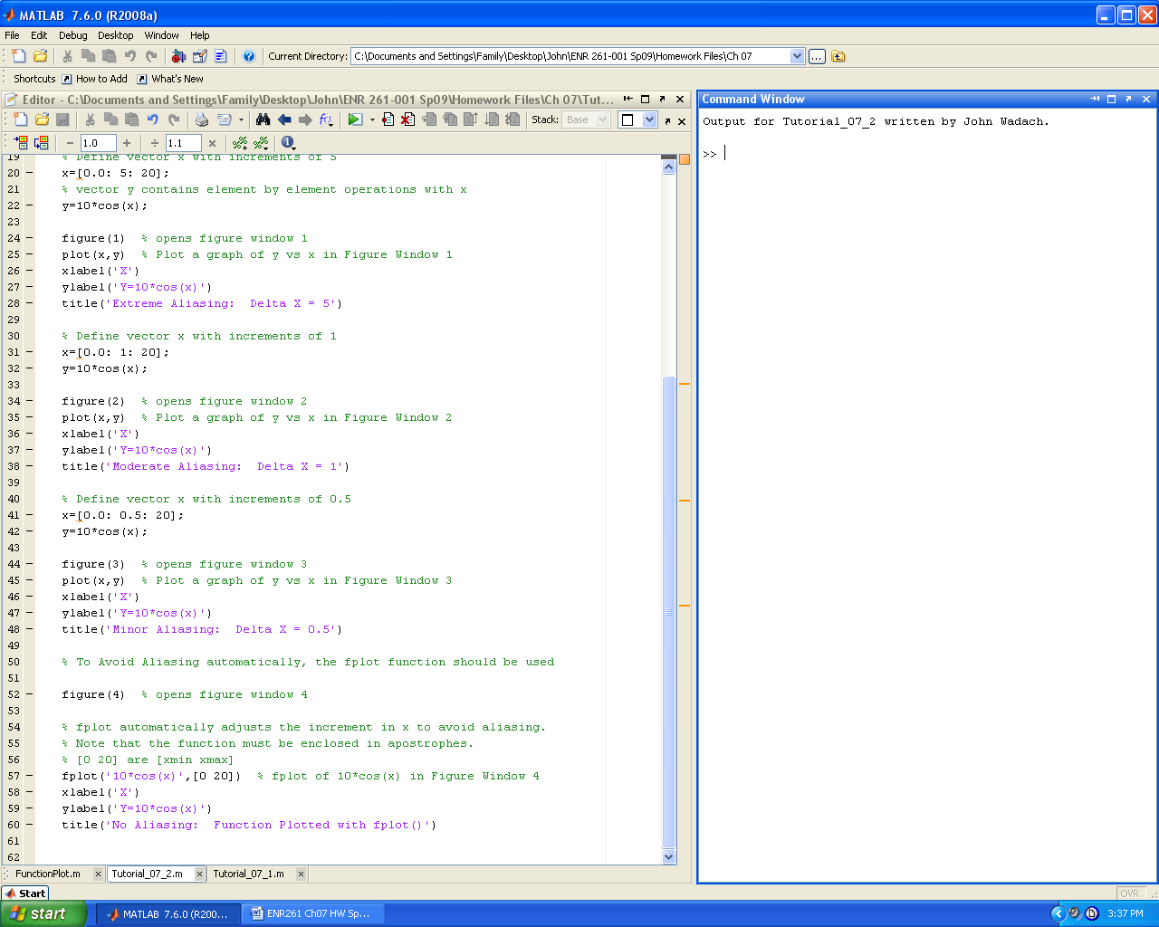

Required File Name: **Tutorial_07_3.m**

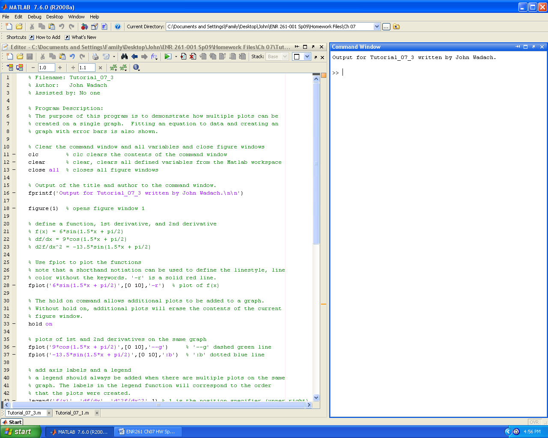 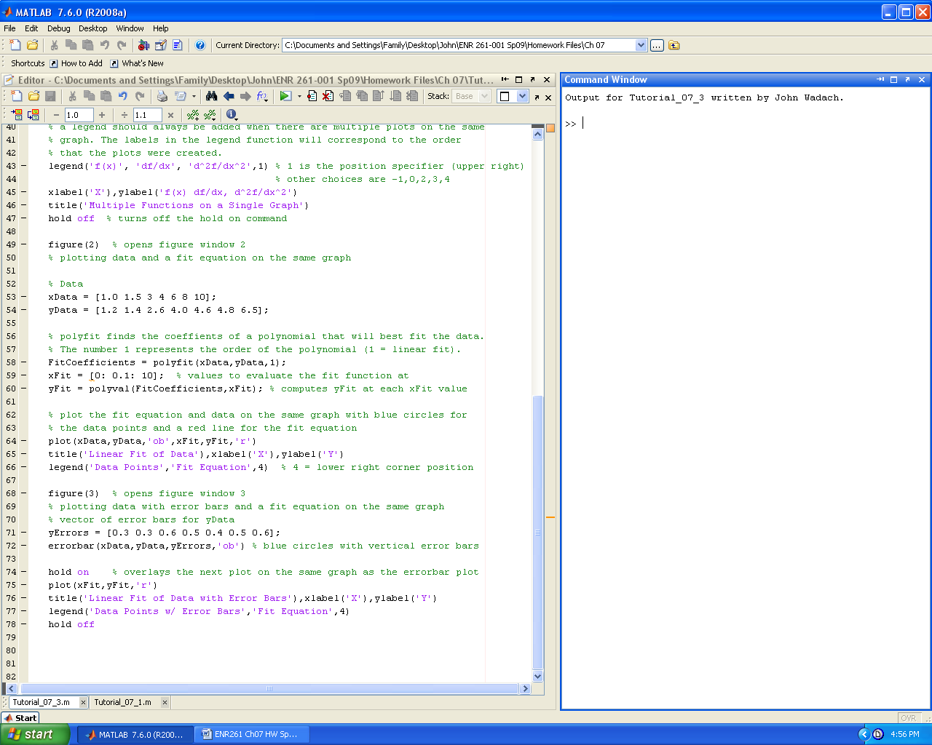

Required File Name: **Tutorial_07_4.m**

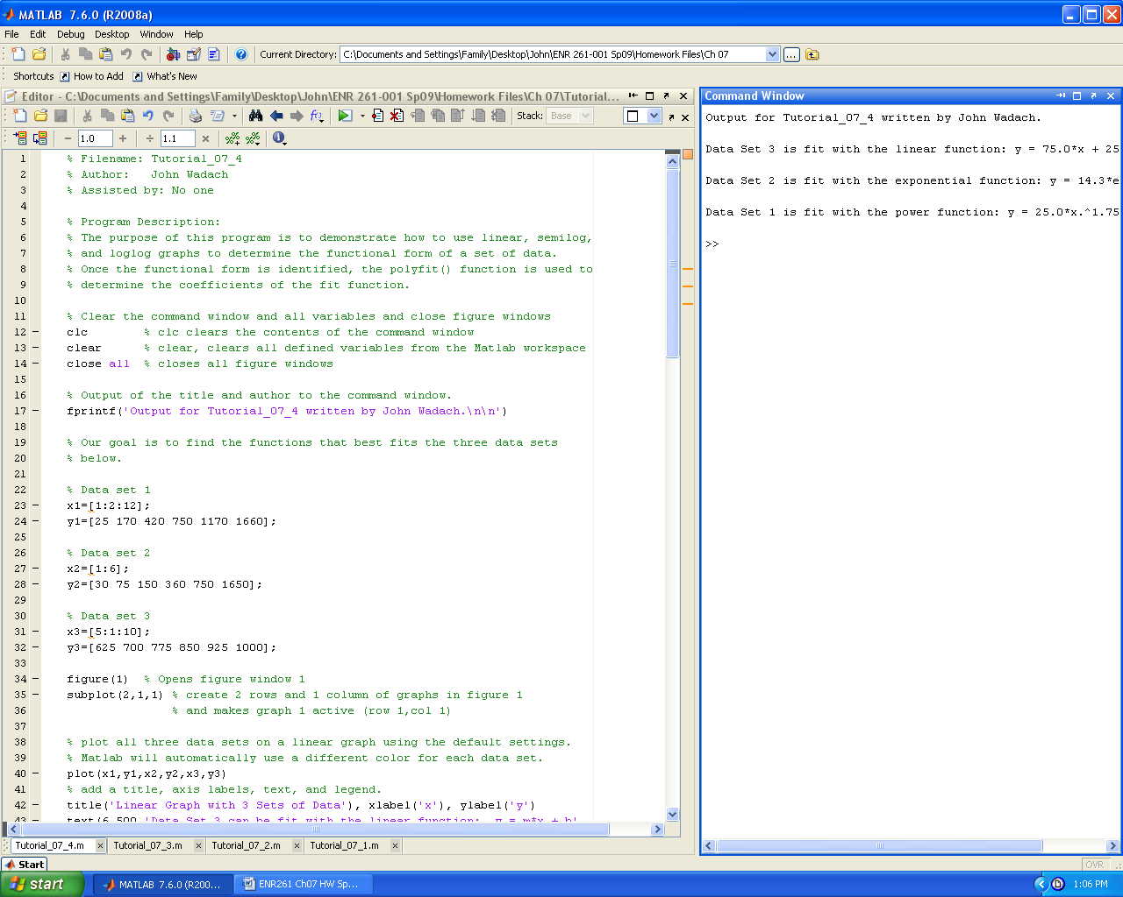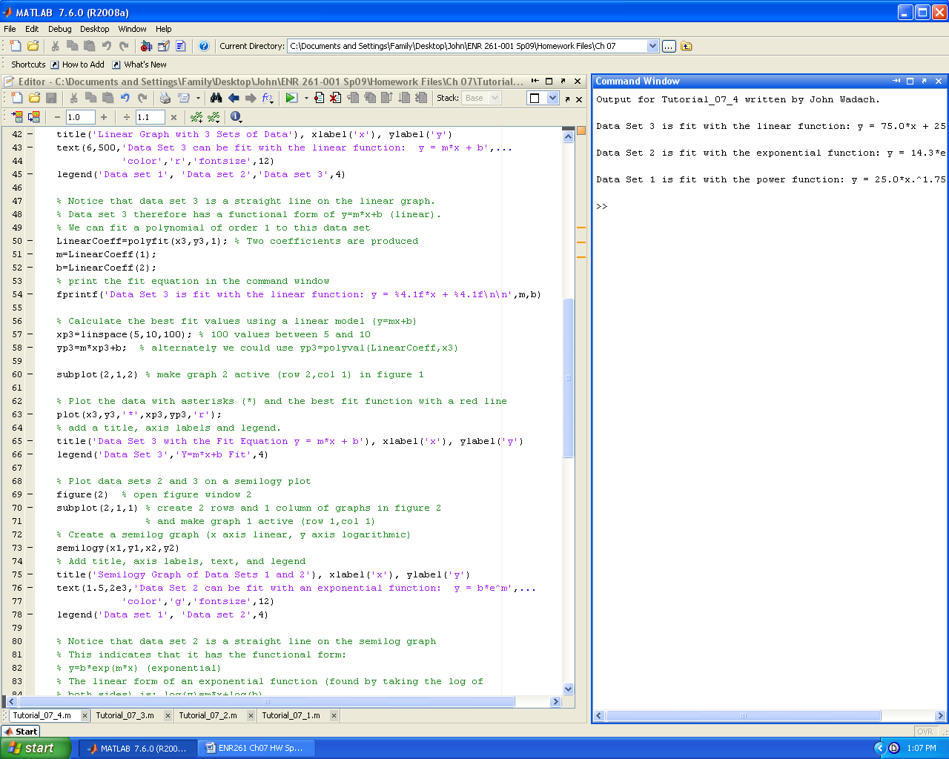

**Continued on the Next Page**

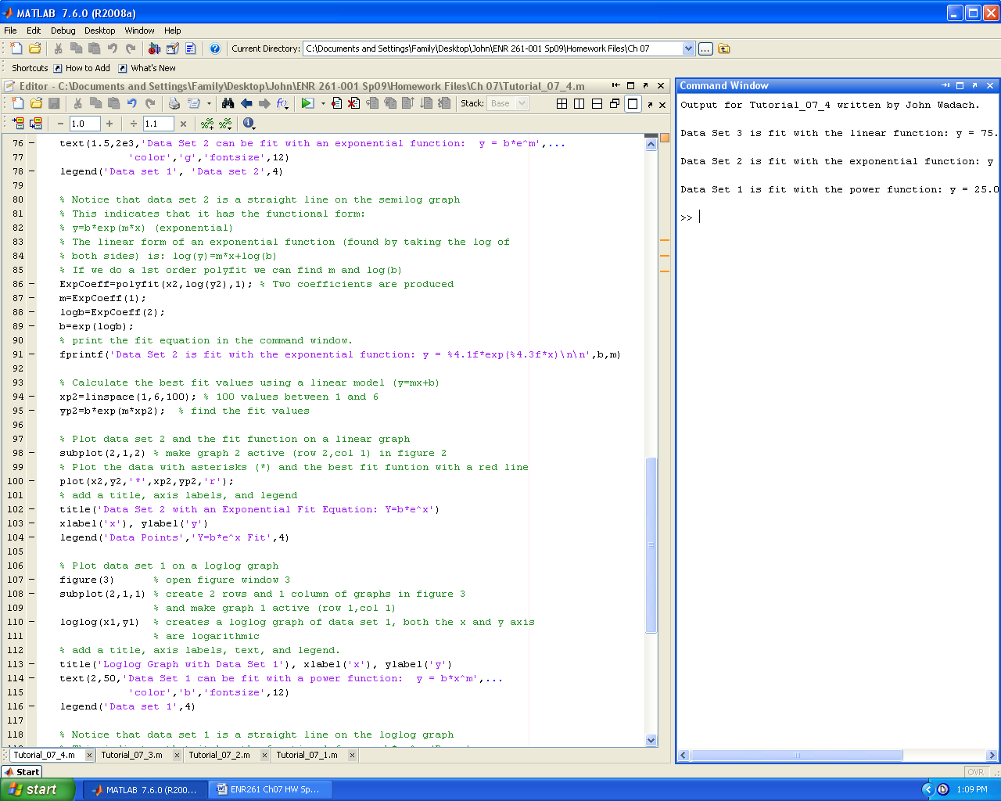 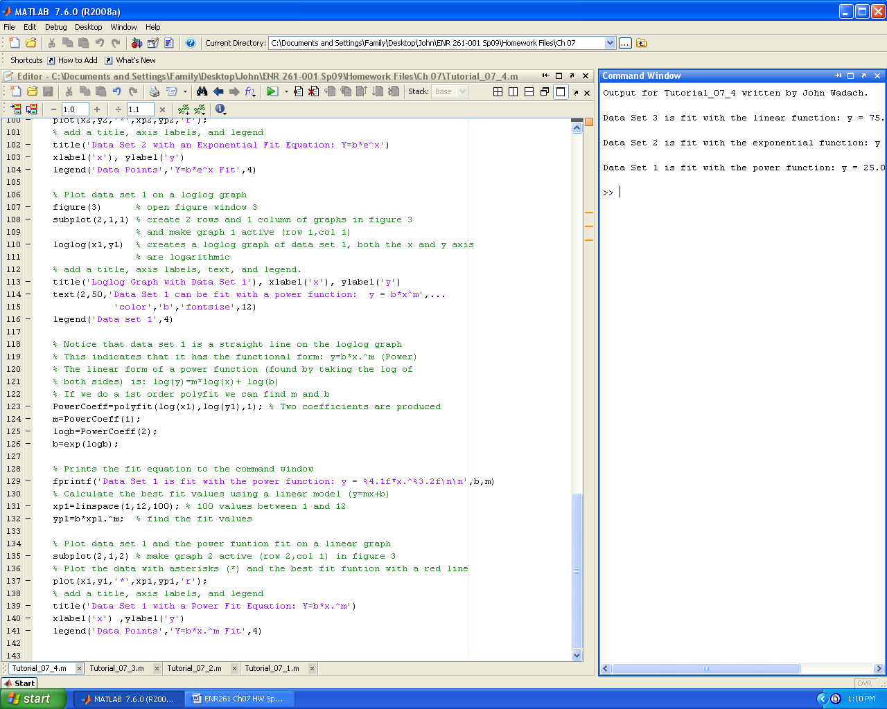

Required File Name: **Tutorial_07_5.m**

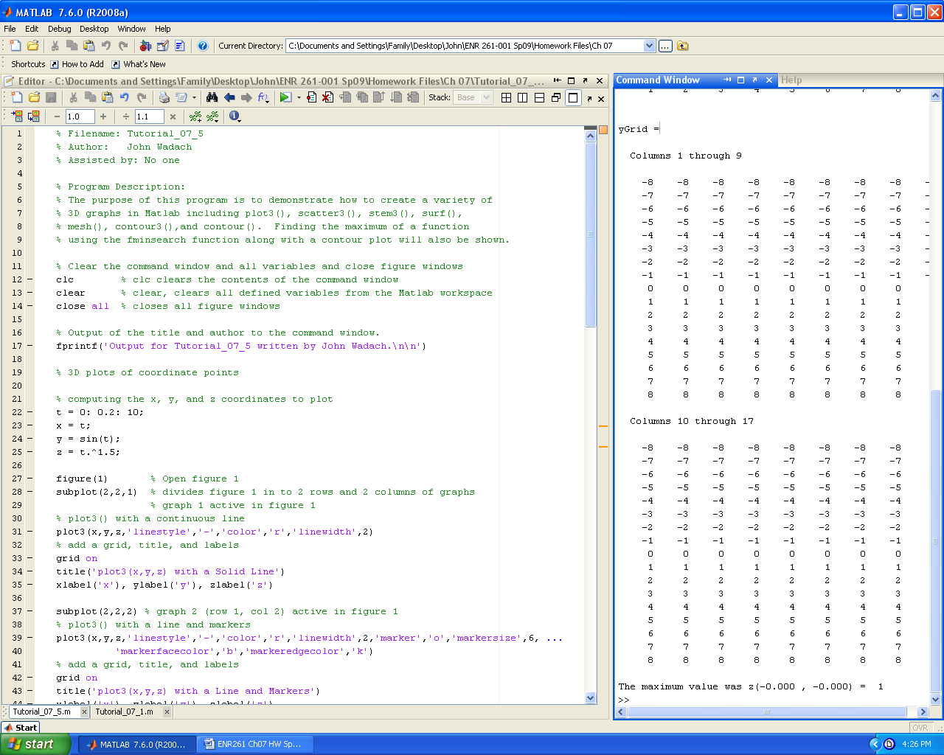 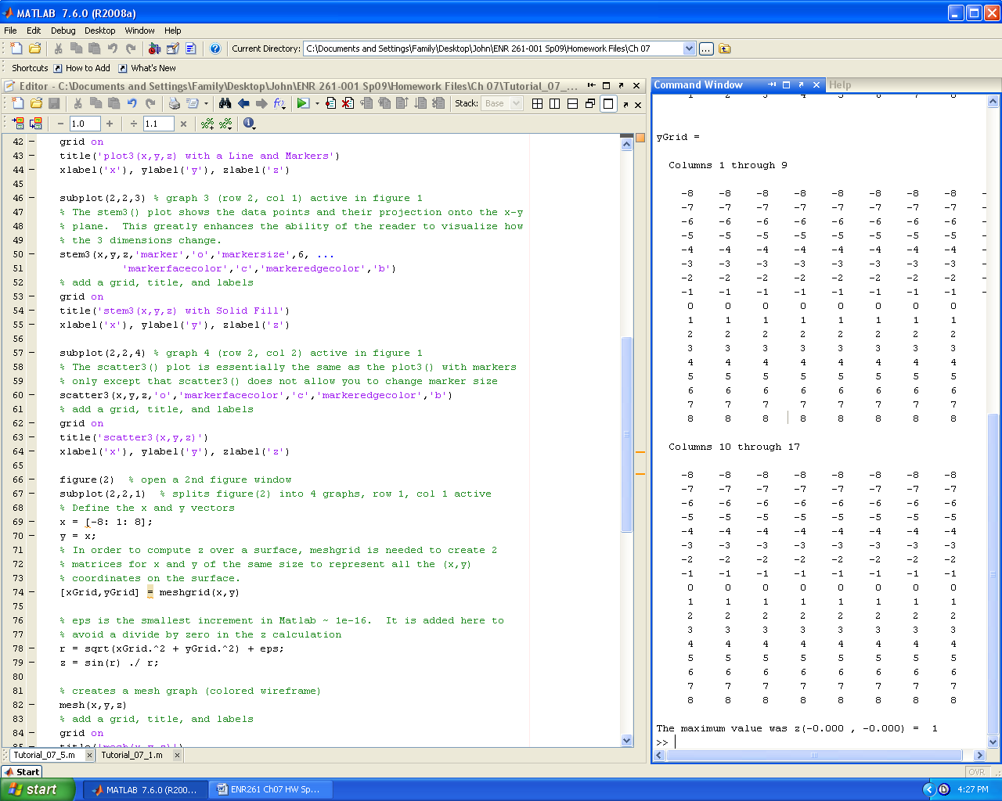

**Continued on the Next Page**

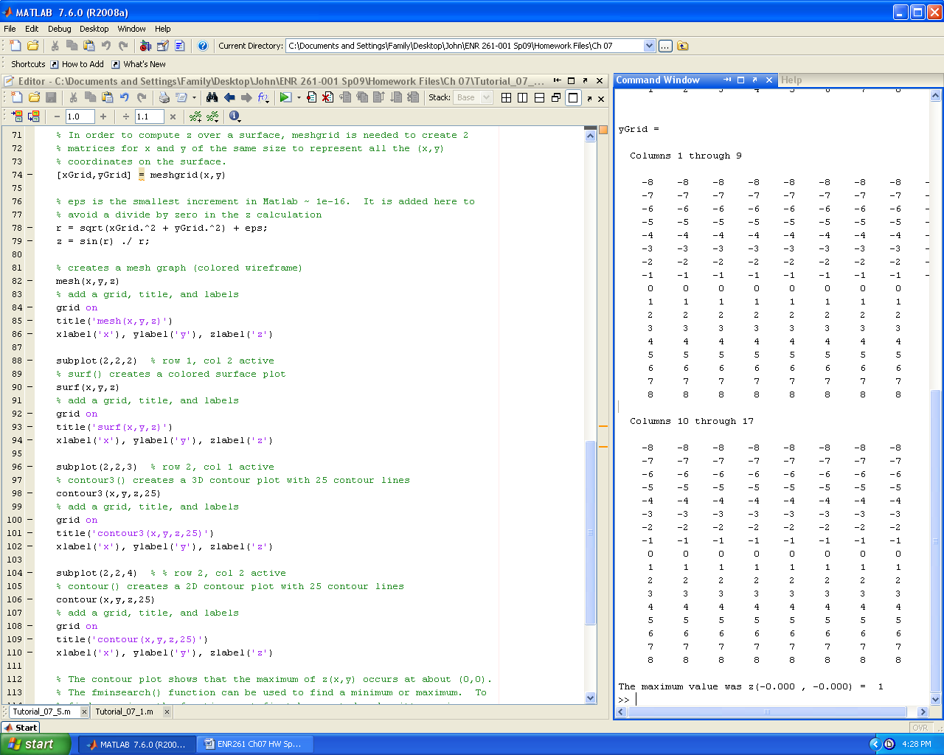 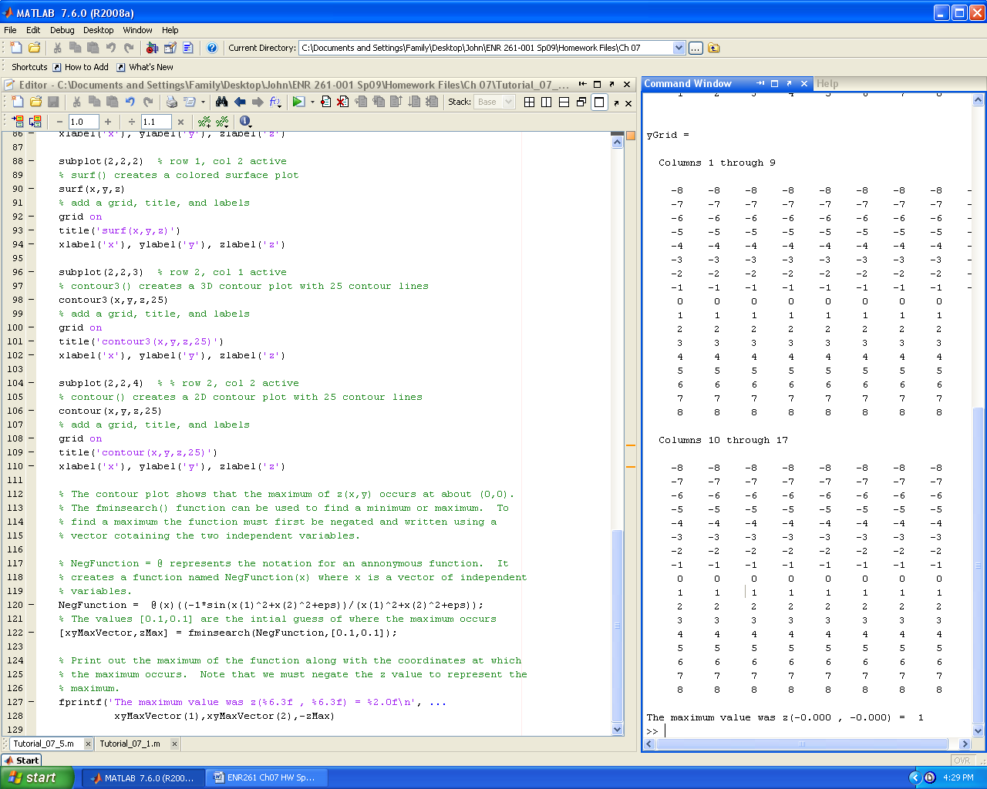

Required File Name: **Tutorial_07_6.m**

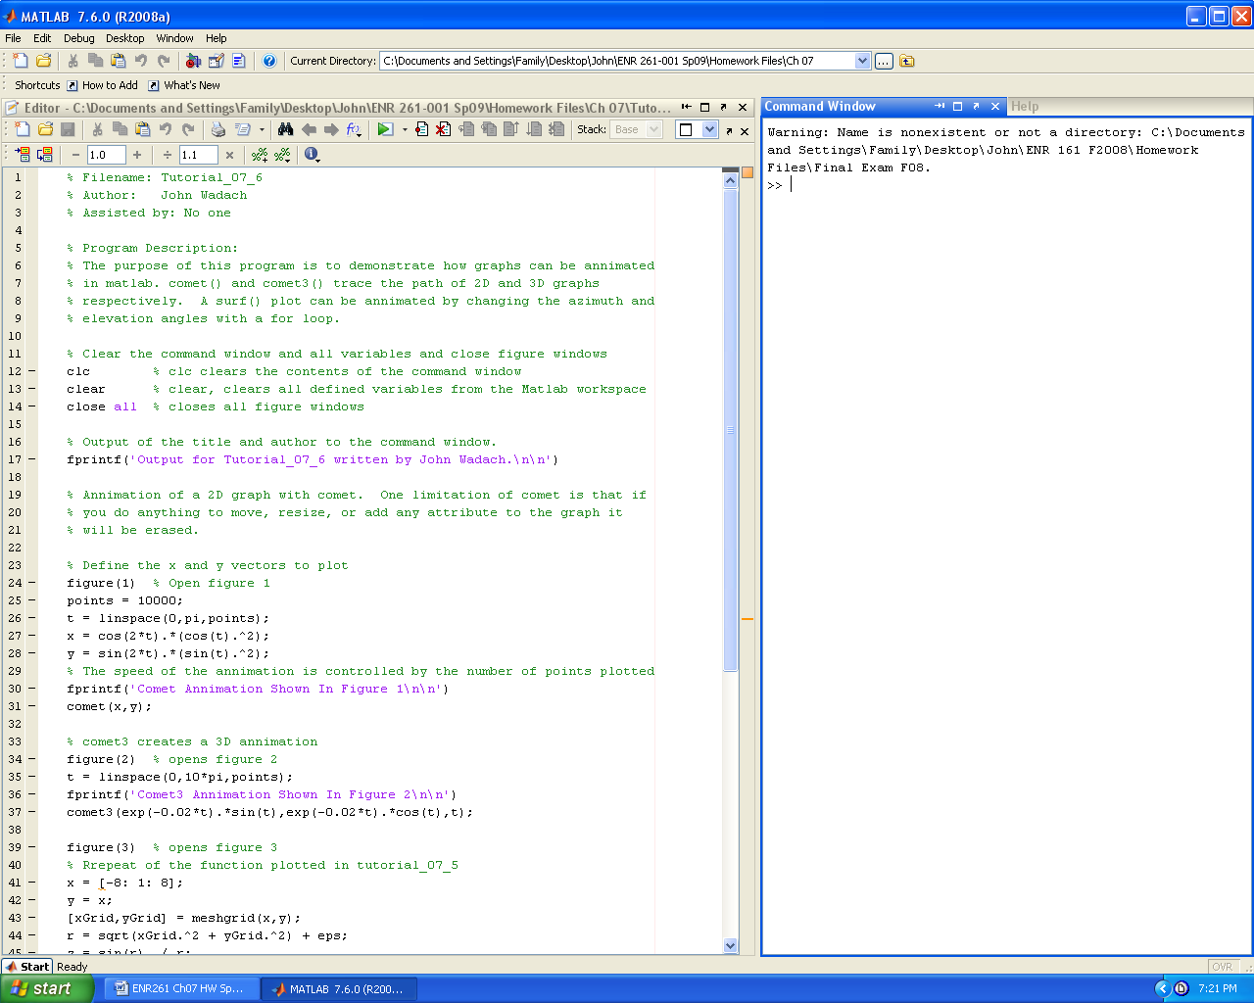 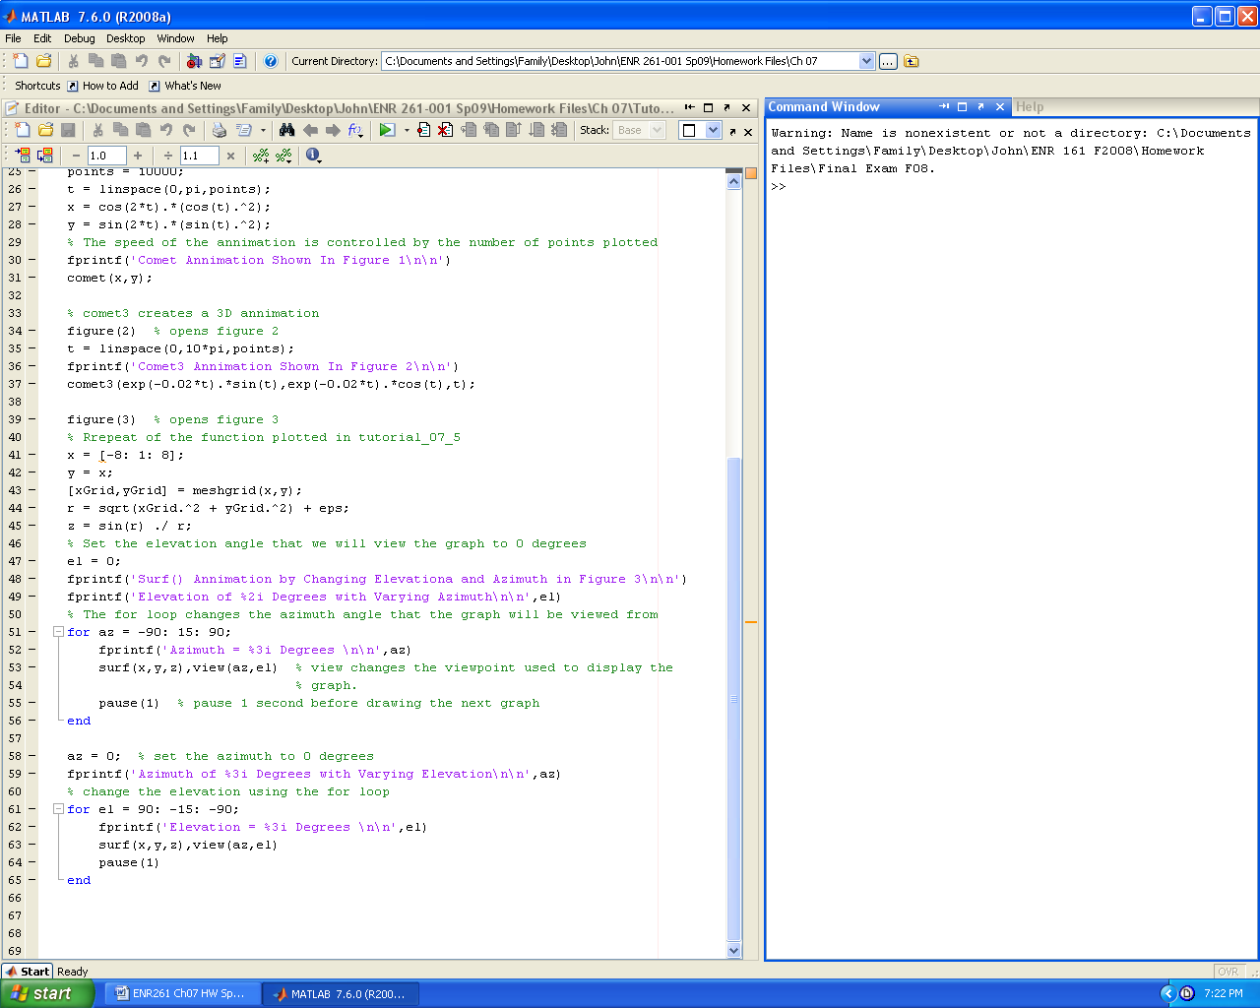

Required File Name: **Program_07_1.m**

Complete problem 9.7 on page 235 of the text following the program description below.

% Program Description:

% The purpose of this program is to create four plots of the fractal function

% given in problem 9.7 on page 235 of the text. To maximize efficiency only

% one for loop should be used. The first graph should plot the first 250

% points of the x and y vectors. The other graphs should include the

% following points: Graph 2: 1st 2500 points, Graph 3: 1st 5000 points,

% Graph 4: All 20000 points.

Use the point ( . ) marker type with a marker size of 0.5 to produce the four graphs in a single figure window as shown below. The resolution of the graphs below is less than that in the Matlab figure window.



Required File Name: **Program_07_2.m**

1. Create the four surf() plots of the function given below in a single figure window.

Z = (1 ./ ((X+3).^2 + (Y-1).^2 + 2)) + ((X-Y) ./ ((X-1).^2 + (Y-2).^2 + 4))



2. Use your graphs along with the fminsearch() function to locate the maximum and minimums of Z and the (X,Y) coordinates where they occurred. Format your output as shown below. Note that xx.xxx is a place holder for a number with a width of 6 and 3 decimal places.

Output for Program_07_2 written by John Wadach.

The minimum value was z( xx.xxx , xx.xxx) = xx.xxx

The maximum value was z( xx.xxx , xx.xxx) = xx.xxx

Required File Name: **Program_07_3.m**

Given the data set below:

% Data set

x = [10 20 30 100 200 300 500 700 1000];

y = [18 38 49 82 102 113 127 137 146];

Complete the tasks described below.

% Program Description:

% The purpose of this program is to determine the functional form of

% an (x,y) data set by creating the following graphs in figure

% window 1: plot(x,y), loglog(x,y), semilogx(x,y), semilogy(x,y). Each

% graph must have a title and axis labels.

% The graph that produces a straight line will indicate the functional form

% of the data set. Use the polyfit() function along with the correct

% linear model to find the m and b fit coefficients. Print the functional

% form along with numerical values of best fit coefficients in the command

% window.

% Use the fit equation to create a linear graph of the data, and

% the fit equation plotted with at least 100 points, in figure window 2.

% The data points should be blue asterisks and the fit line should be solid

% red. The graph must have a title, axis labels, and a legend indicating the % functional form of the fit line.