**ENR 261 Spring 2023 Chapter 8 Homework**

**General Instructions:**

Save your all your Matlab files for this chapter in the folder named **Ch08** located inside your local repository on your USB Memory Stick. When finished be sure to add, commit, and push your changes to your remote repository on GitHub.

**Assigned Exercises**

1. Recreate all of the following script files and be sure to save them in your local repository on your USB memory stick, commit the changes and push them to GitHub.

2. Use the required file names for each script file.

Required File Name: **Tutorial_08_1.m**

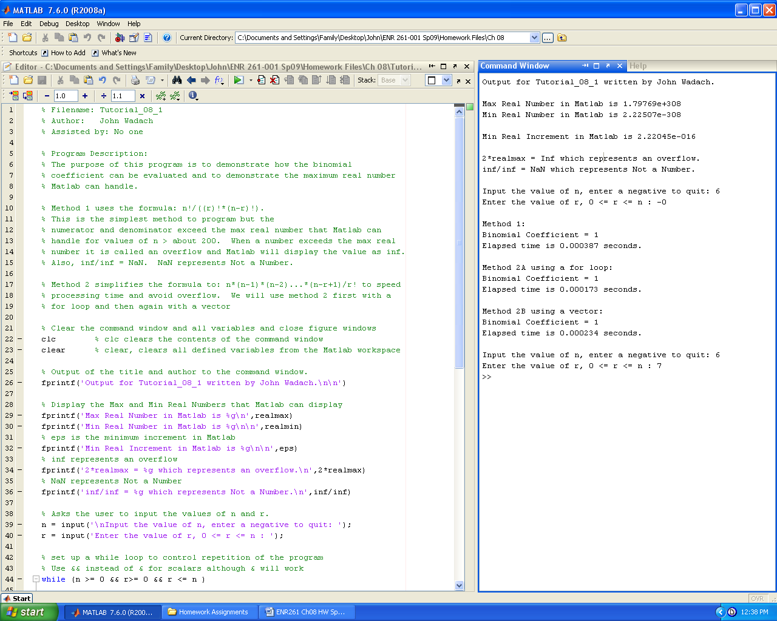

**Continued on the Next Page**

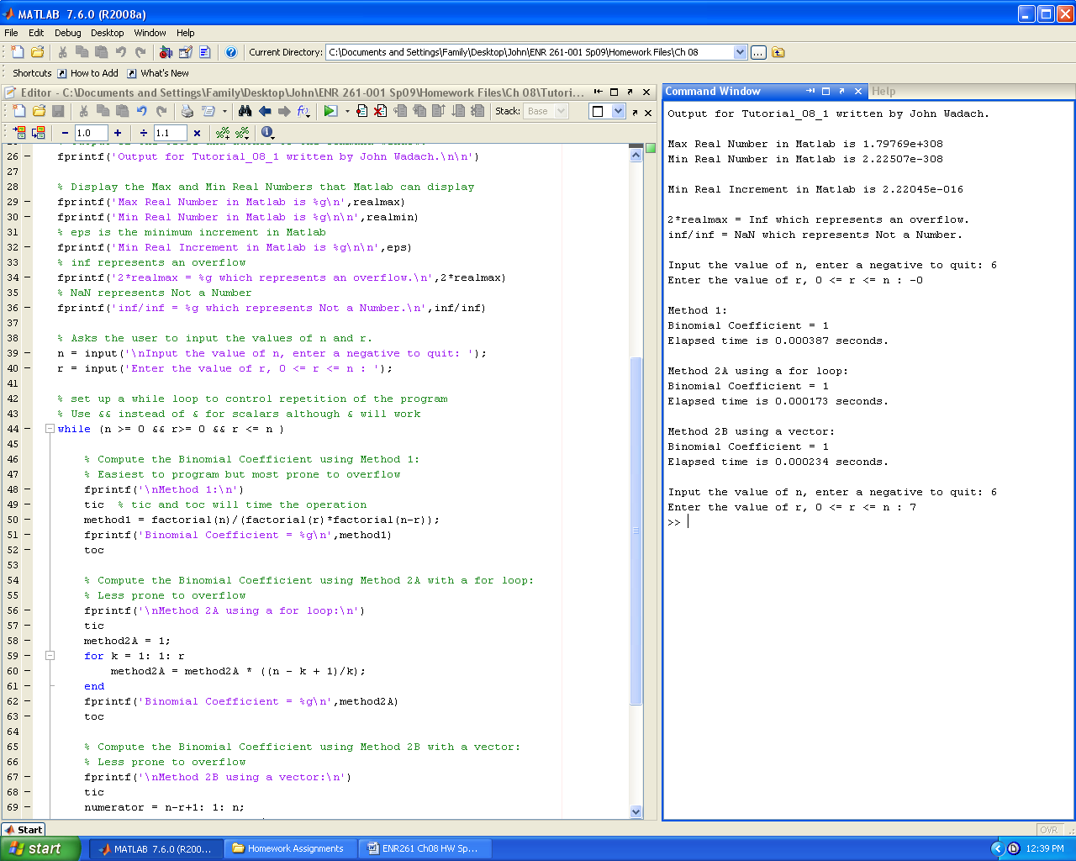 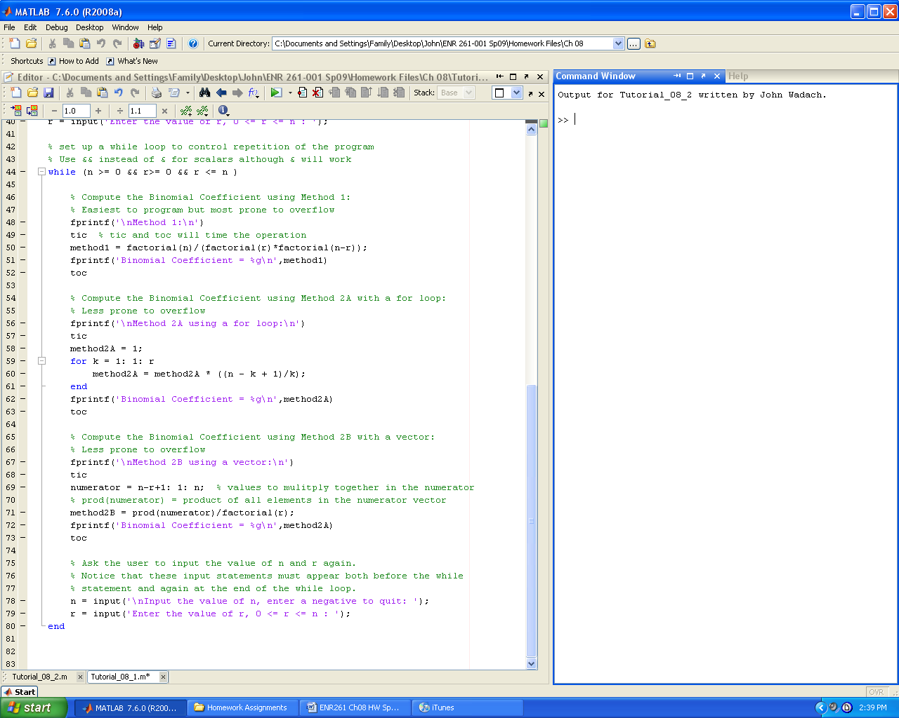

Required File Name: **Tutorial_08_2.m**

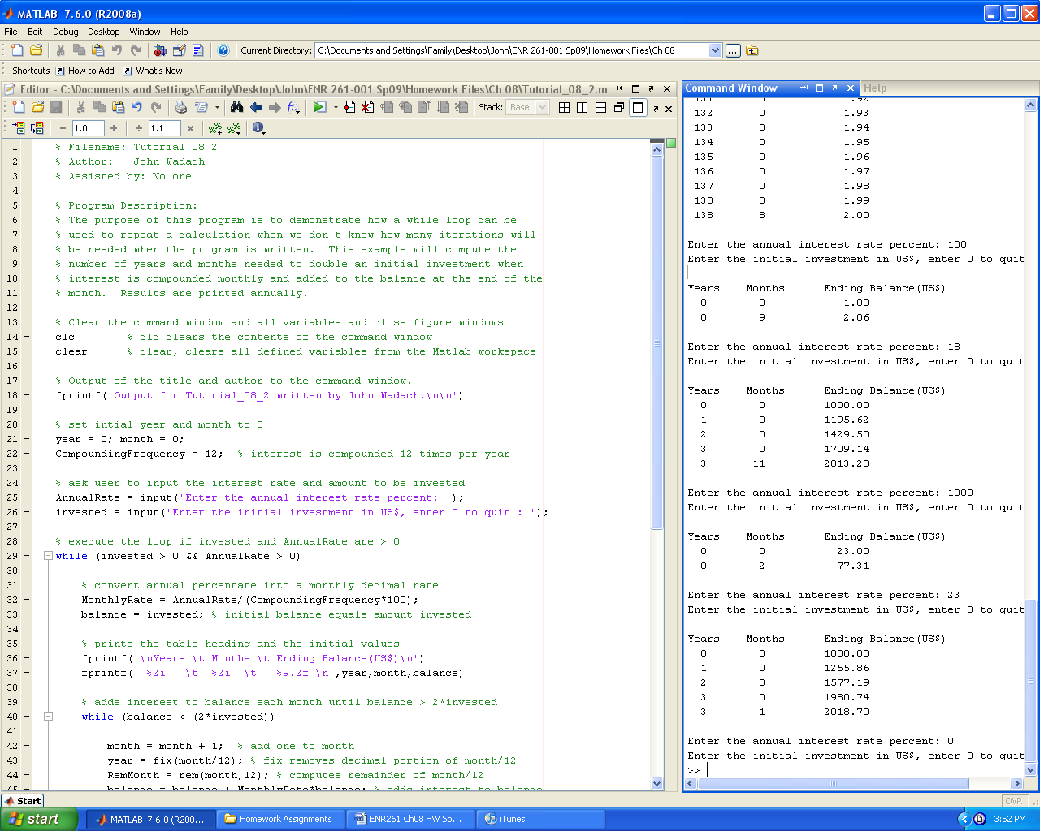 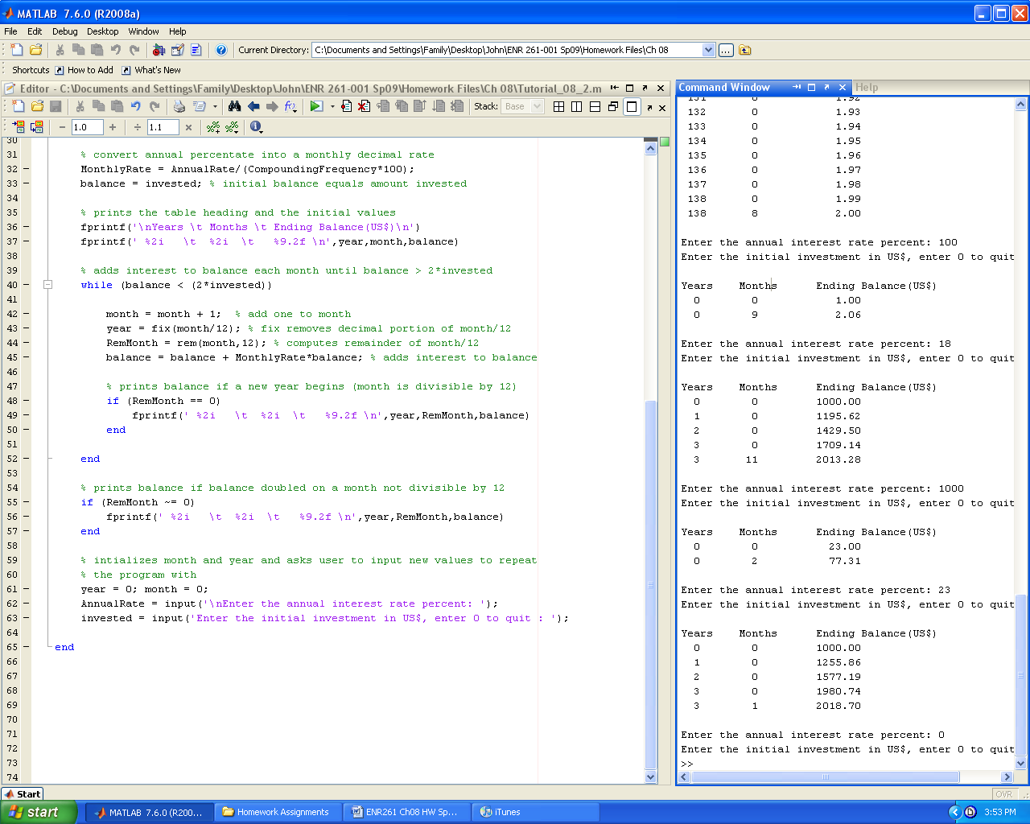

Required File Name: **Tutorial_08_3.m**

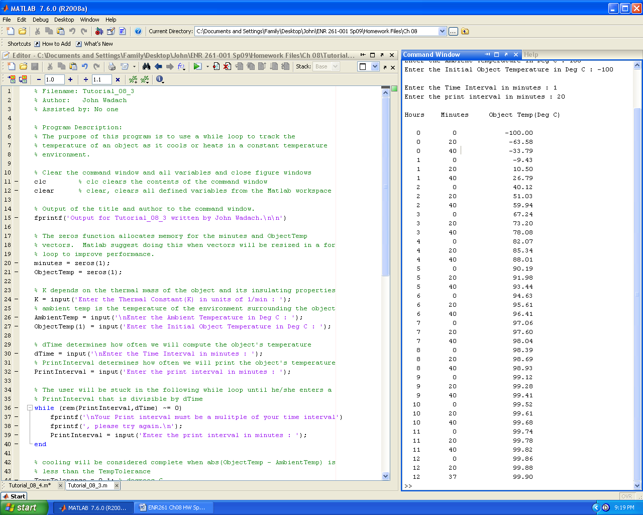

**Continued on the Next Page**

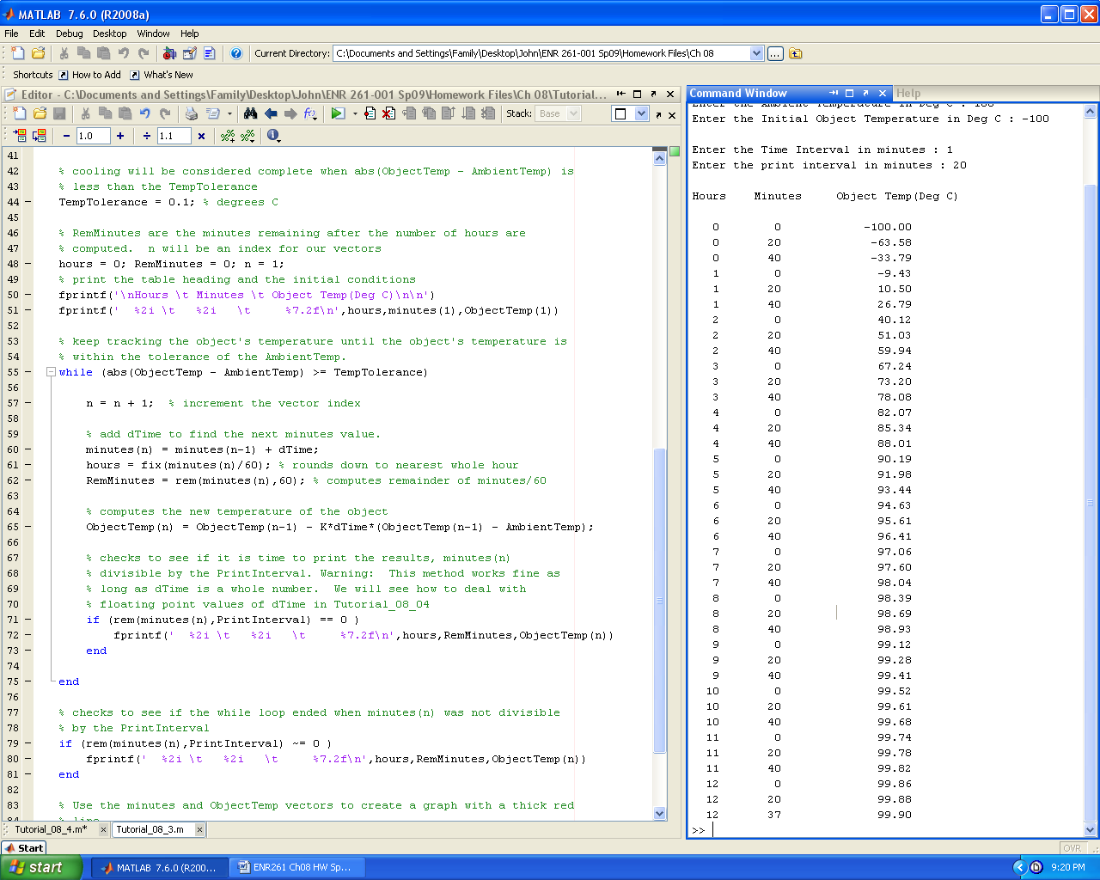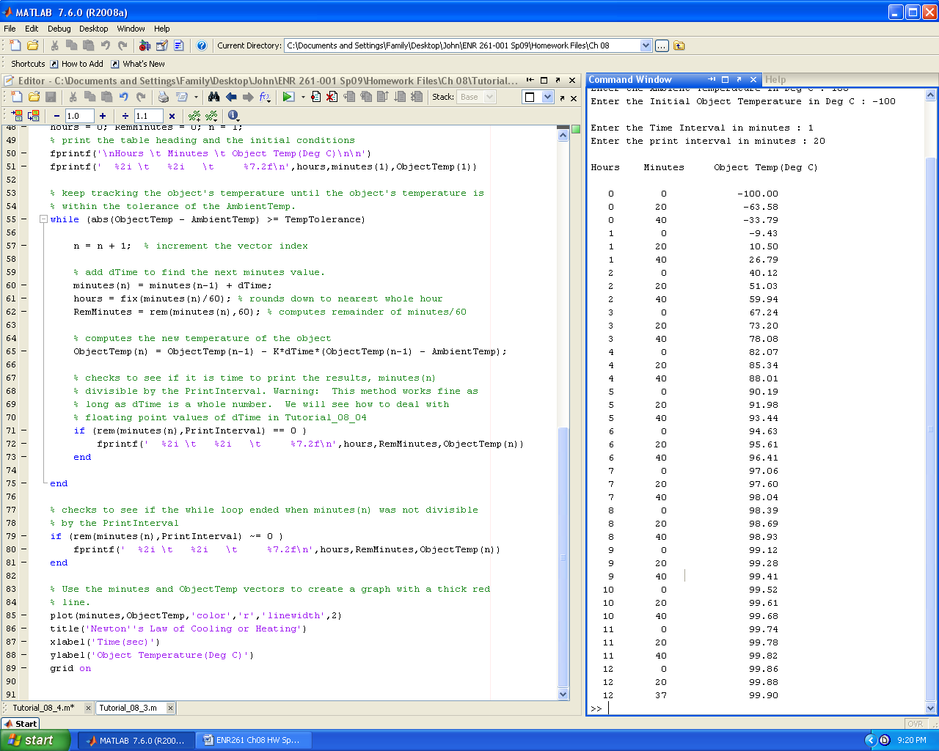

Required File Name: **Tutorial_08_4.m**

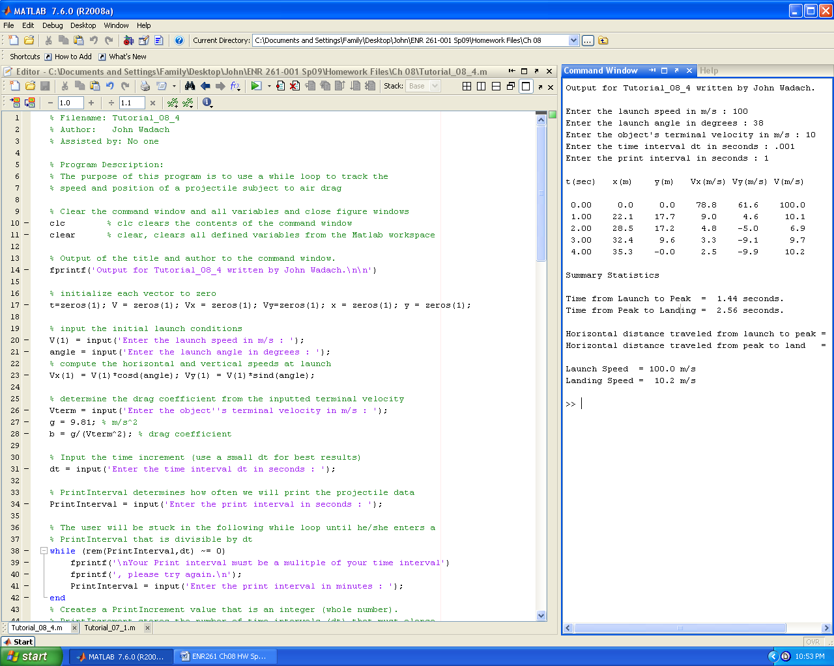

**Continued on the Next Page**

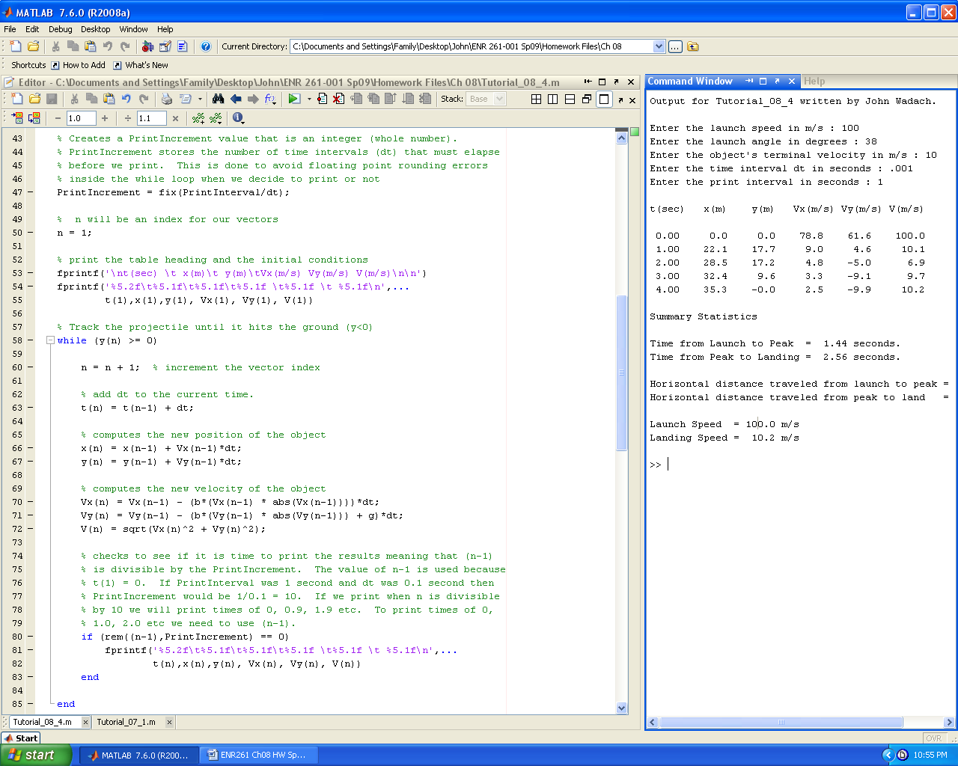 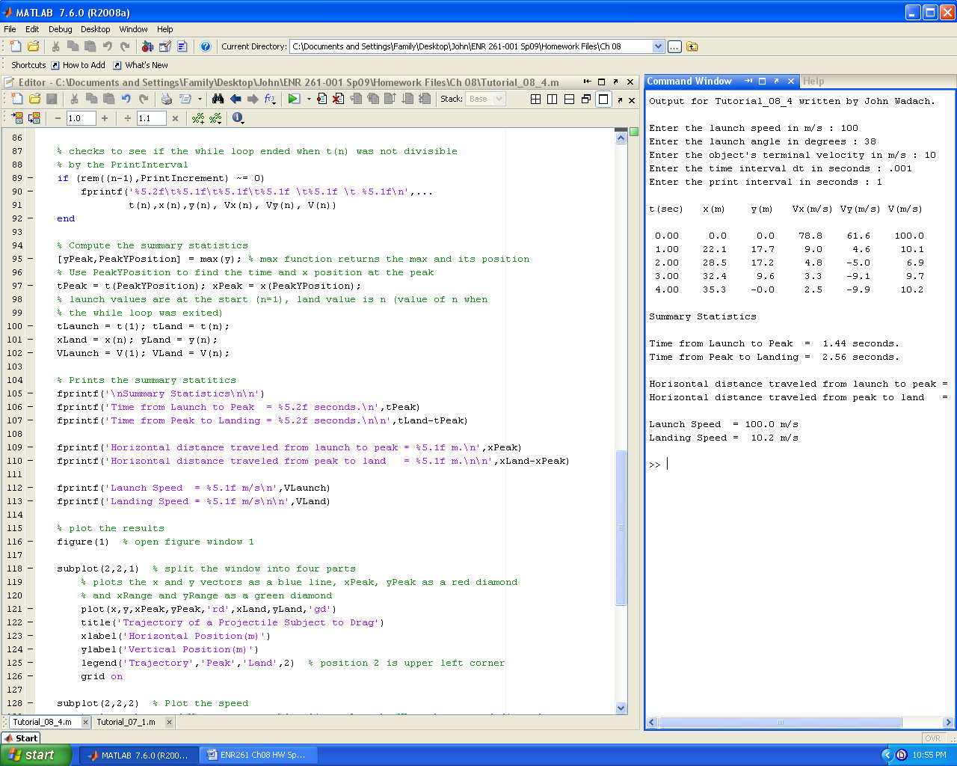

**Continued on the Next Page**

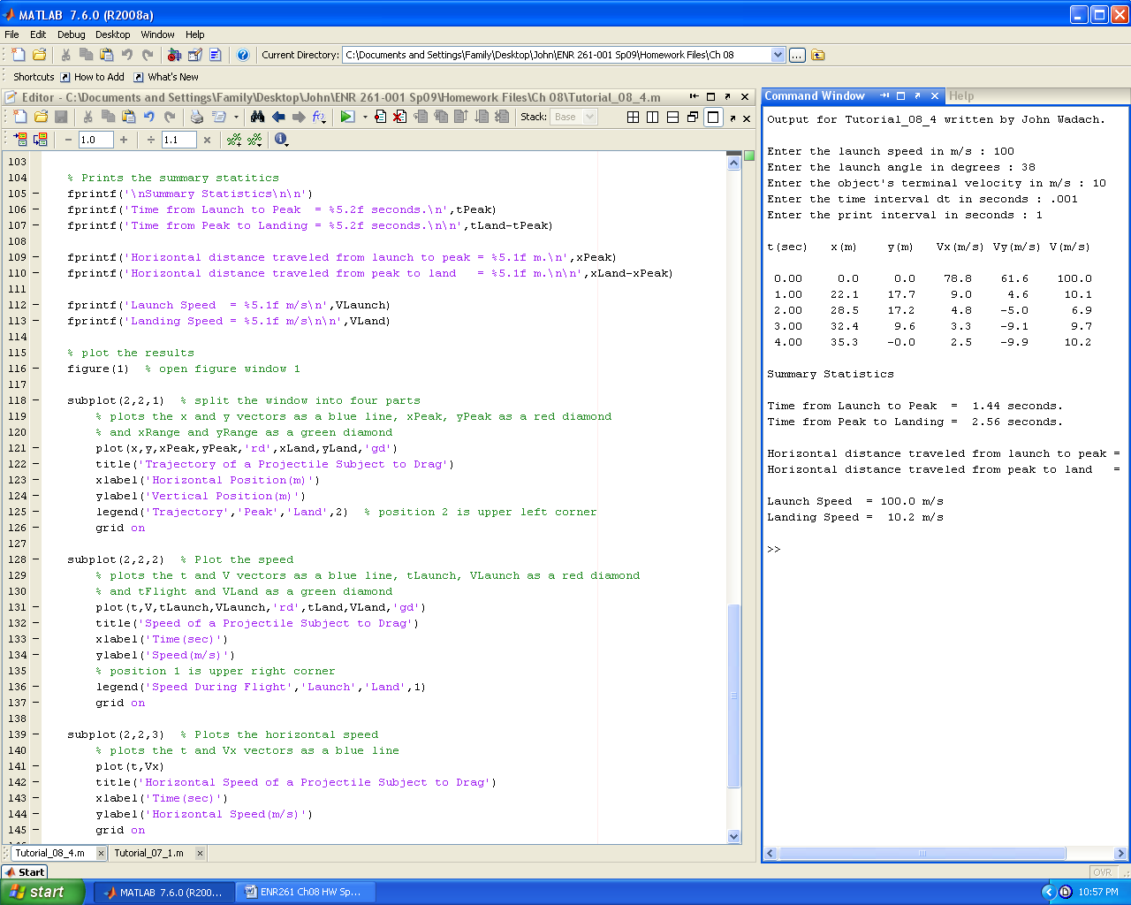 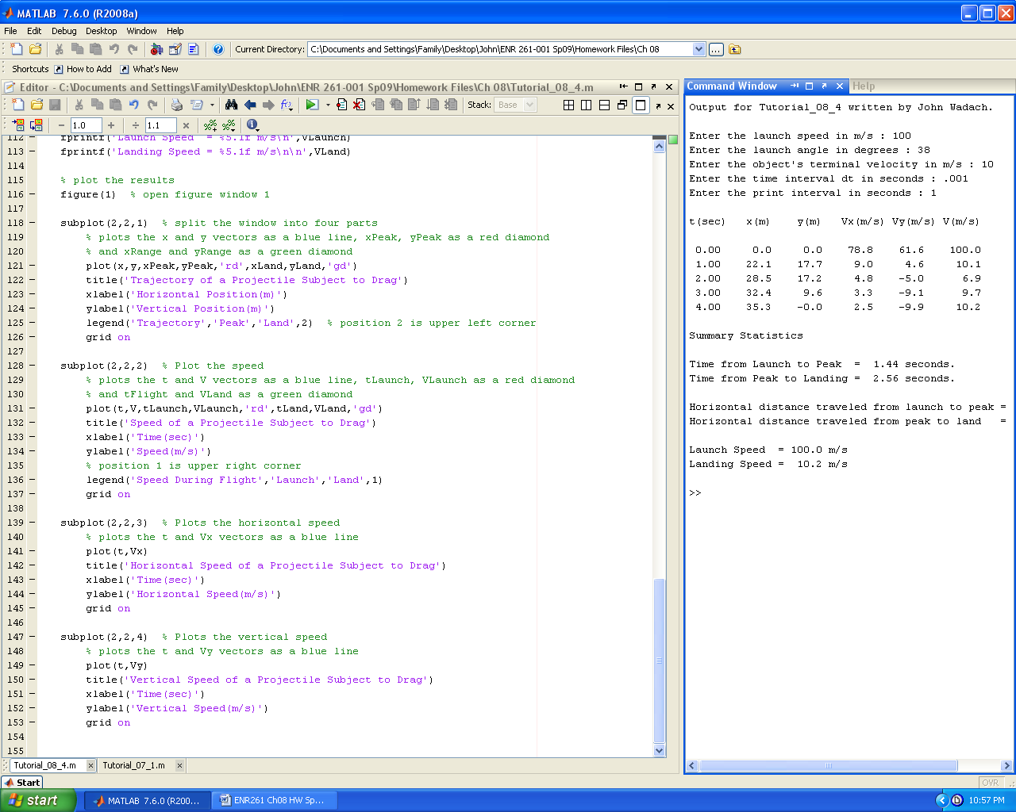

Required File Name: **Program_08_1.m**

Complete Exercise 8.1 on page 192 of the text with the following changes:

1. Make the program more flexible by having the program user input the initial balance and monthly payment amount in the Command Window.

2. Compute the minimum monthly payment needed to pay off the debt by computing the interest in the first month and adding $1 to it.

3. If the payment inputted is below the minimum value computed in step 2, the minimum required payment should be output again and the user should enter a new payment amount.

4. Test your program for the conditions shown below.

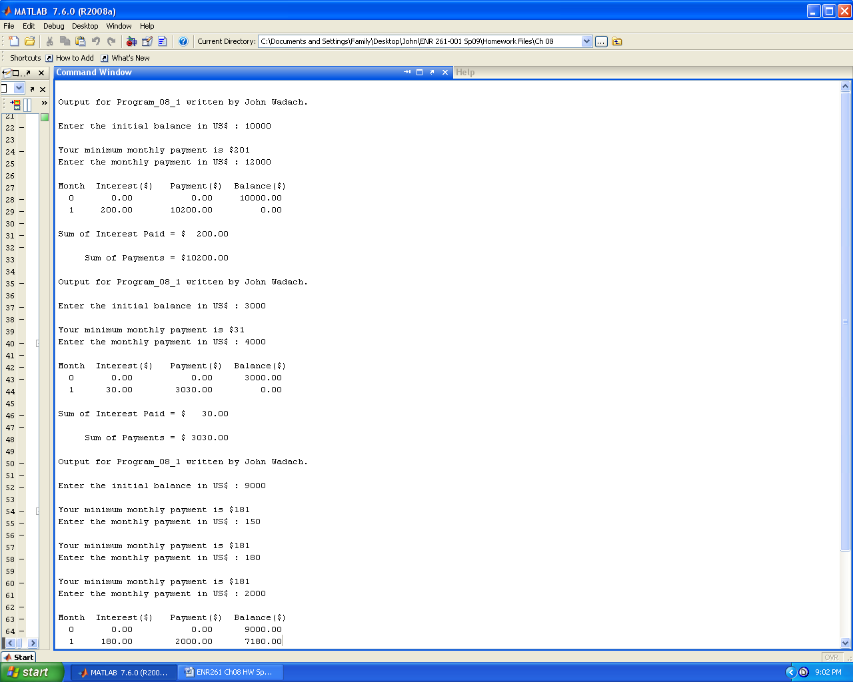

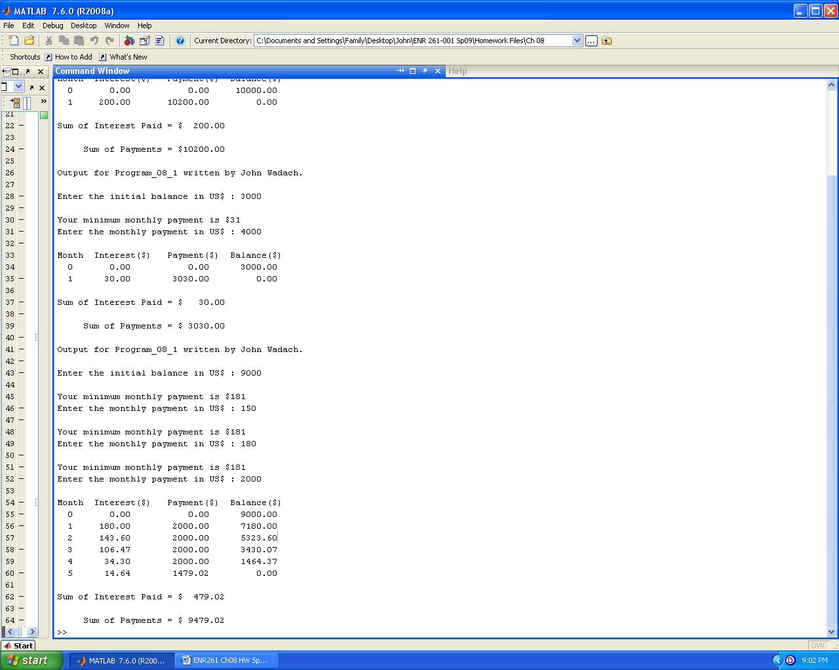

Required File Name: **Program_08_2.m**

Write a Matlab script file that creates a graph of the 555 IC timer output as shown below.



Operation of the 555 Timer:

The output of the 555 timer is controlled by the charge on the external capacitor connected to the 555 timer. The ouput is equal to 5V when the capacitor is charging and 0V when the capacitor is discharging.

The capacitor voltage begins the charging process with a value of (1/3)*Vs where Vs is the source voltage connected to the 555 timer. The charging continues until the capacitor voltage exceeds (2/3)*Vs . While the capacitor is charging, the capacitor voltage (Vc) in volts can be found using the equation below.

Vc = (1/3)*Vs + (2/3)*Vs*( 1 – e-(Tc)/(Rc*C) )

Tc = time elapsed since charging began in sec

Rc = Charging resistor in ohms

C = capacitance in farads

Once the capacitor voltage exceeds (2/3)*Vs it begins to discharge. It continues to discharge until the capacitor voltage falls below (1/3)*Vs . While the capacitor is discharging, the capacitor voltage (Vc) in volts can be found using the equation below.

Vc = (2/3)*Vs*( e-(Td)/(Rd*C) )

Td = time elapsed since discharging began in sec

Rd = discharging resistor in ohms

Have the user input the values shown below in the sample output from the command window.

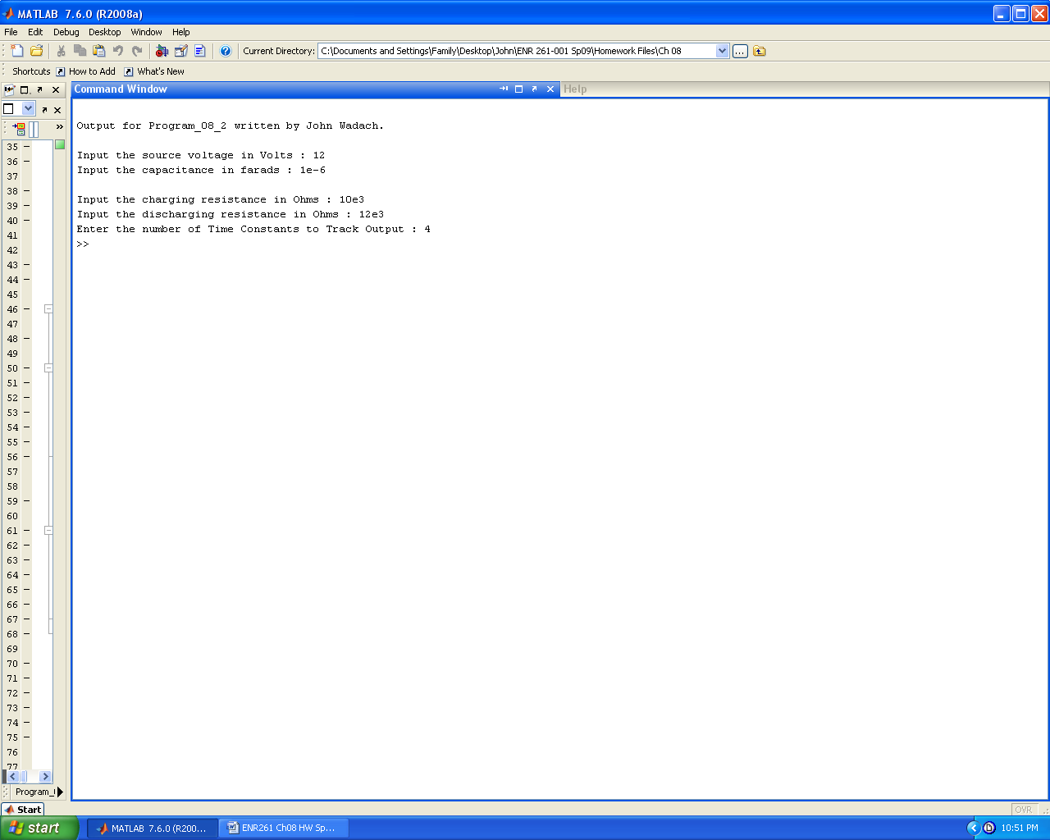

Define the Time Constant as ((Rc + Rd)/2)*C in your program. Use a time increment (dt) such that your vectors for time and voltage will have at least 1000 values stored in them.