**ENR 261 Spring 2023 Chapter 13 Homework**

**General Instructions:**

Save your all your Matlab files for this chapter in the folder named **Ch13** located inside your local repository on your USB Memory Stick. When finished be sure to add, commit, and push your changes to your remote repository on GitHub.

**Assigned Exercises**

1. Recreate all of the following script files and be sure to save them in your local repository on your USB memory stick, commit the changes and push them to GitHub.

2. Use the required file names for each script file.

Required File Name: **Program_13_1.m and Program_13_1.fig**

Watch and follow along with the MATLAB tutorial located here:

<http://blogs.mathworks.com/videos/2013/02/06/introduction-to-gui-building-with-guide-in-matlab/>

I strongly suggest you use the MATLAB tutorials (and MATLAB blogs or other resources) to assist in completing these assignments. This lab is designed for you to explore GUI design, make mistakes, and learn by experimenting. Please leave yourself sufficient time to complete these tasks.

Print a screen capture of your working GUI. If there is time, you may be asked to demo for the instructor for a sign off.

Required File Name: **Program_13_2.m and Program_13_2.fig**

Using what you learned in the previous tutorial create the GUI in the figure below.

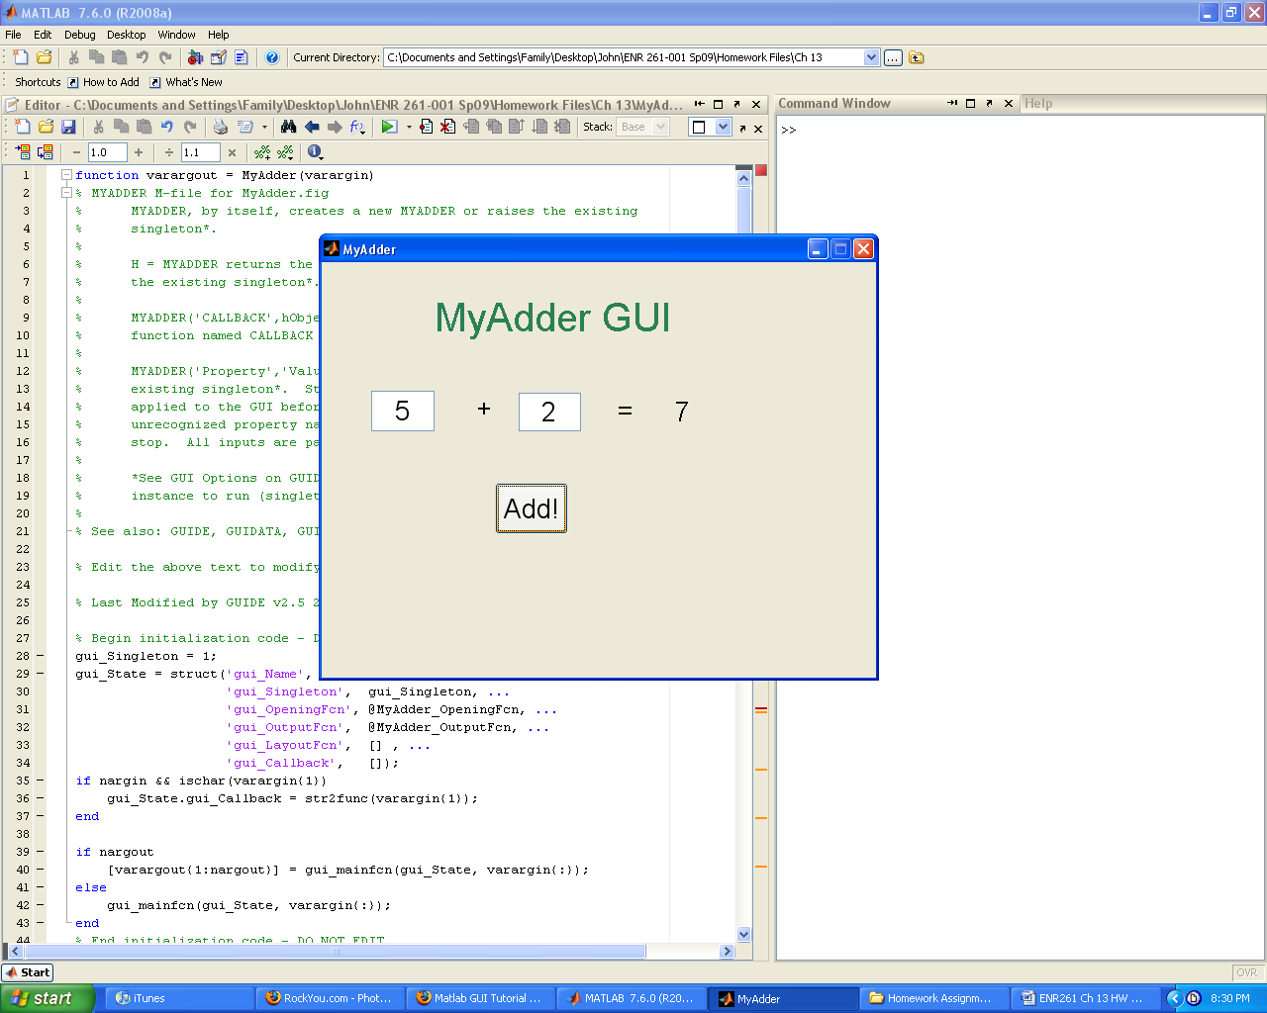

Print a screen capture of you working GUI. If there is time demo for the instructor for a sign off.

Required File Name: **Program_13_3.m and Program_13_3.fig**

Using what you learned in the previous tutorials create the GUI in the figure below.

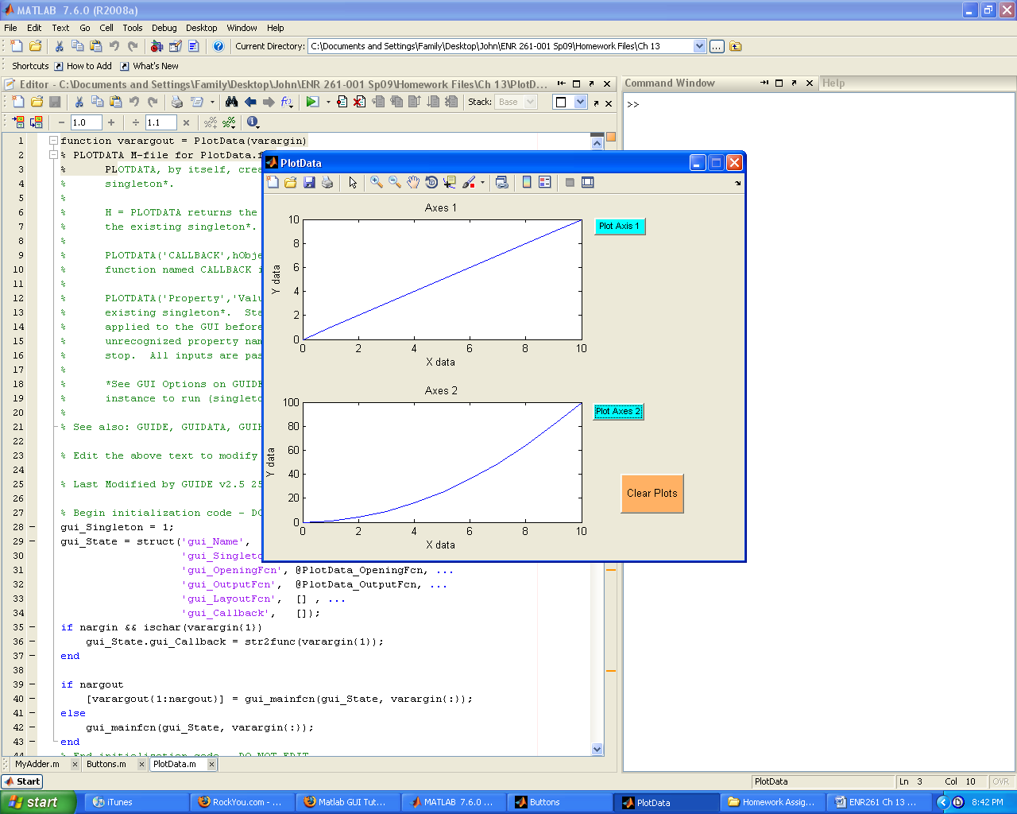

Required File Name: **Program_13_4.m and Program_13_4.fig**

Follow the instructions on the following pages to create the following GUI:

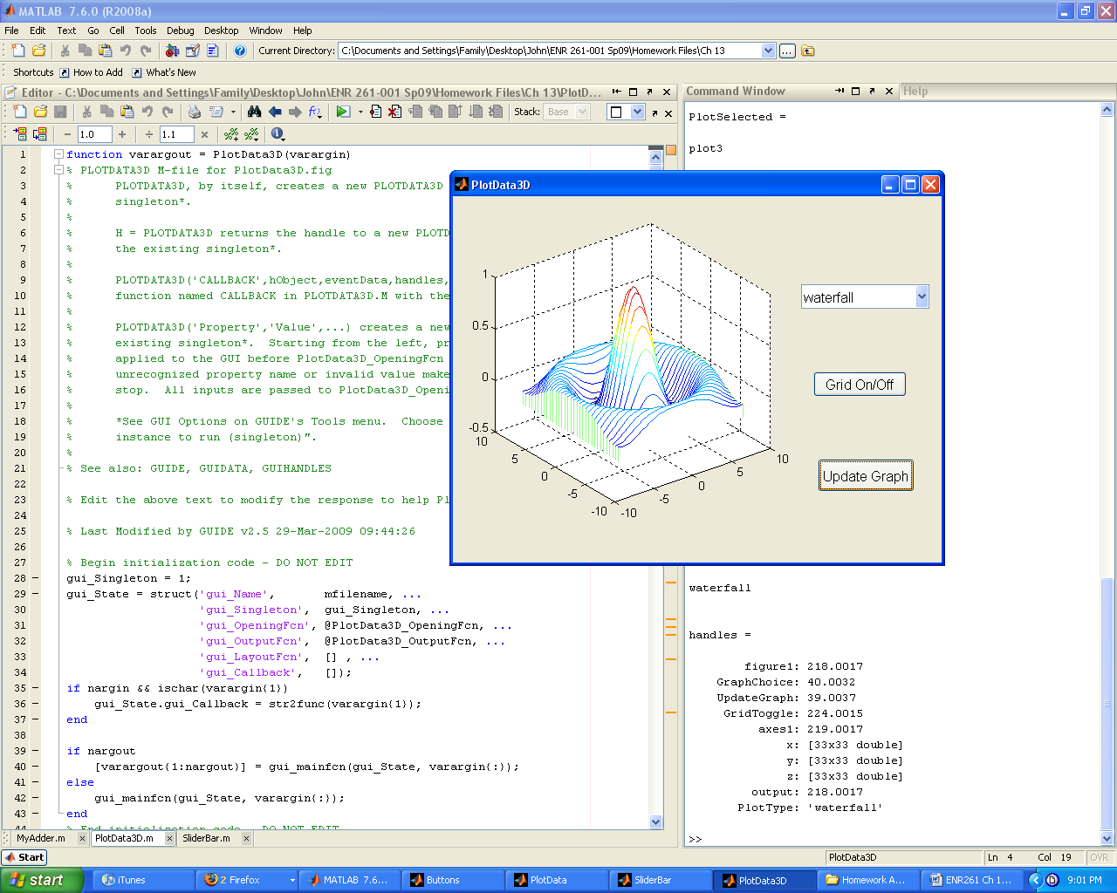

1. Click on the **Guide** icon to open a Blank GUI window where we will build the GUI.

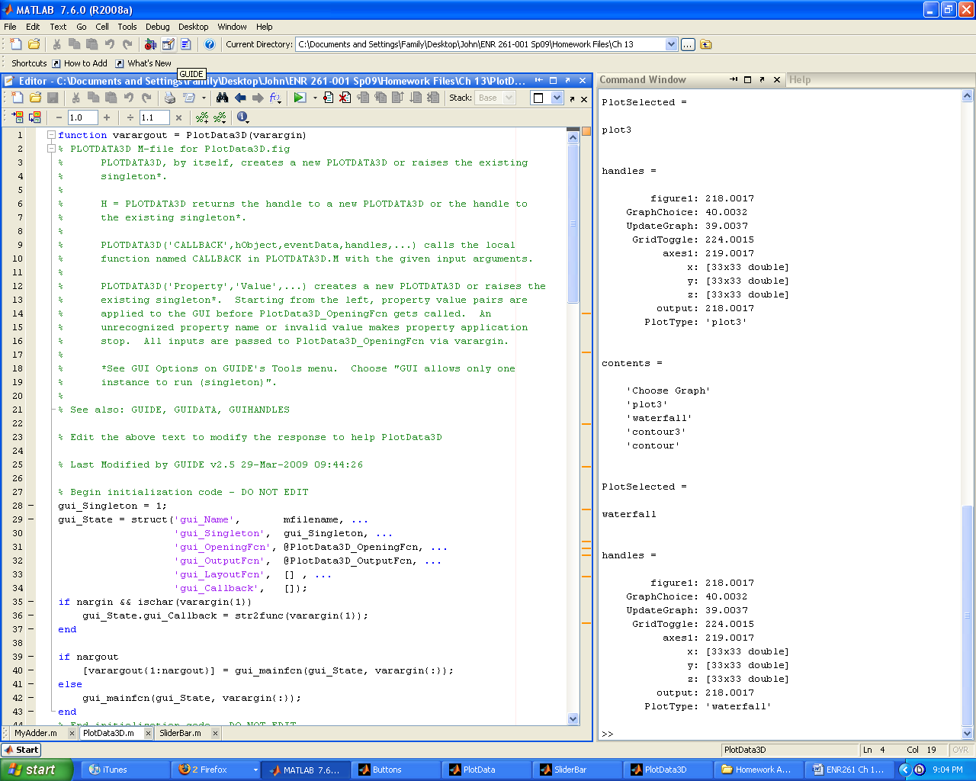

2. Click on **File/Preferences** and click on the **Show names in component palette**.

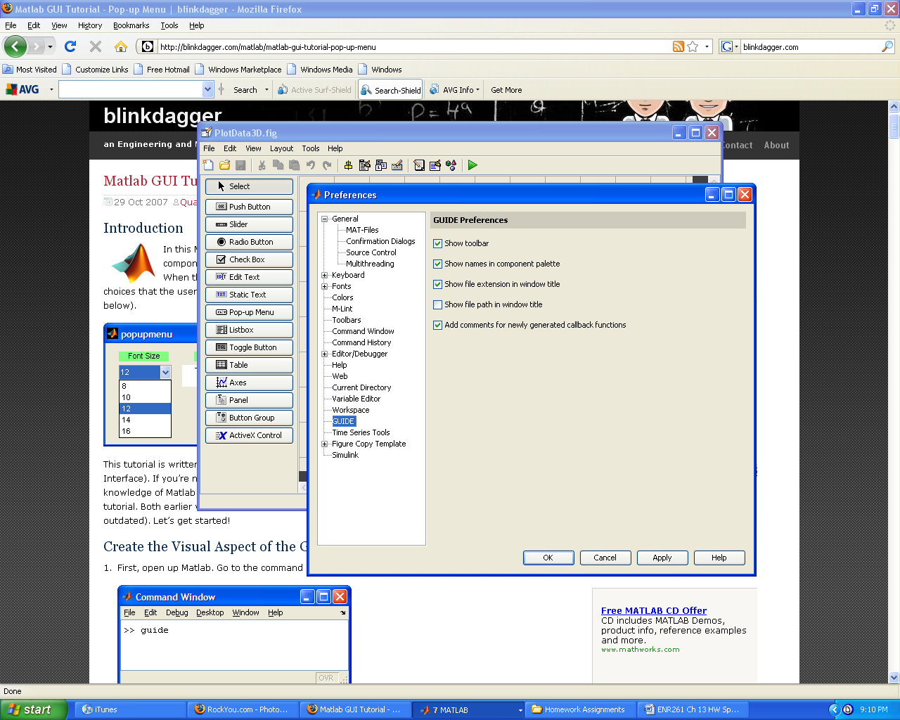

3. Drag an Axes, Pop-up Menu, and two Push Buttons into the figure window.

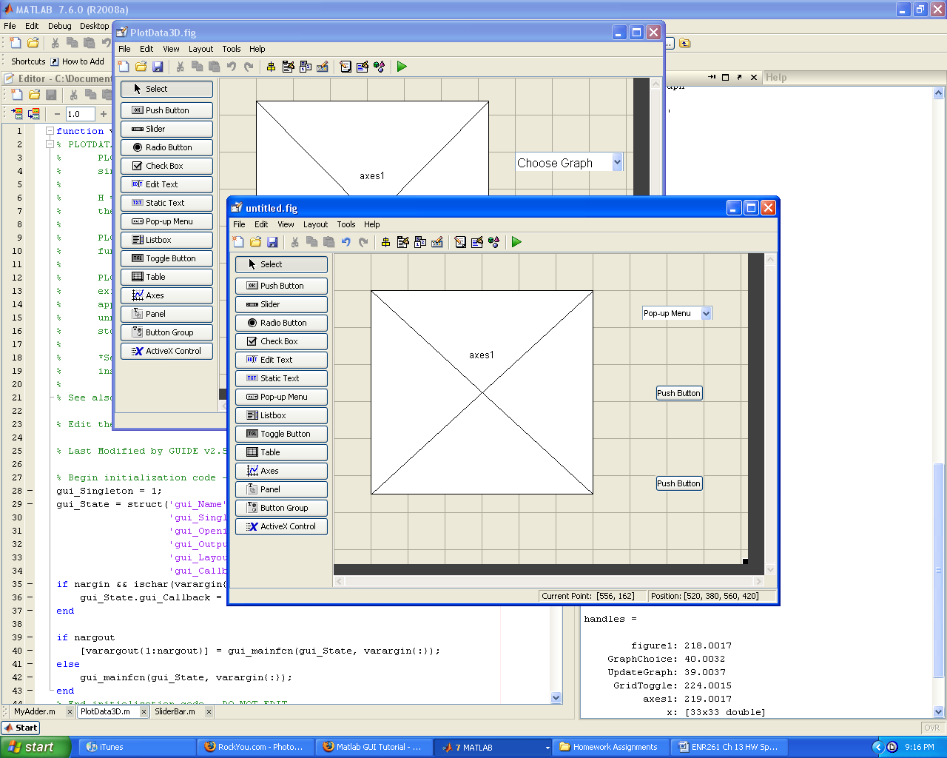

4. Double click on the axes1 object to open its Inspector Window. Make sure that the tag is **axes1**. The tag is used to identify the GUI object.

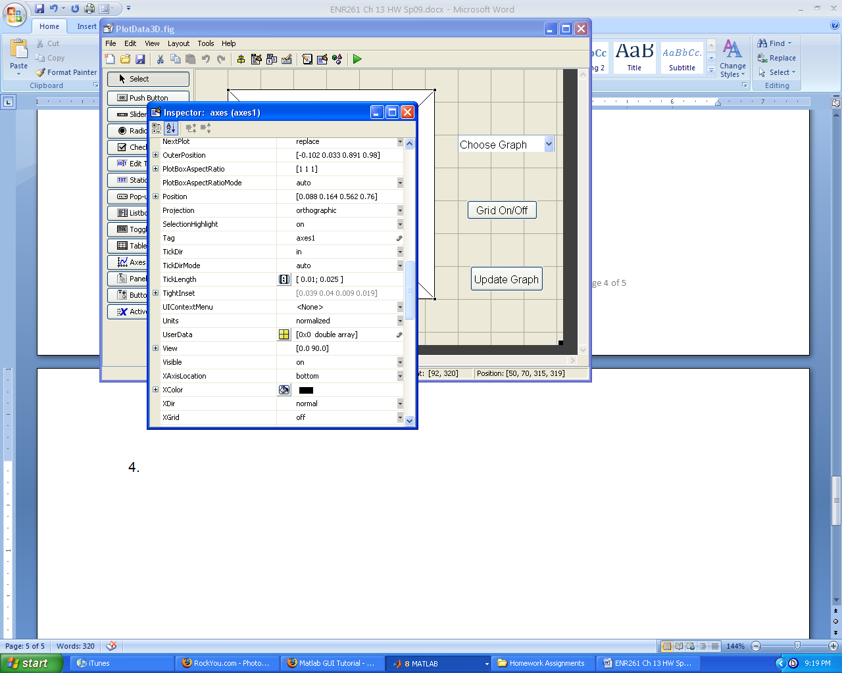

5. Double click on the lower pushbutton object to open its Inspector Window. Enter the values indicated by the arrows.

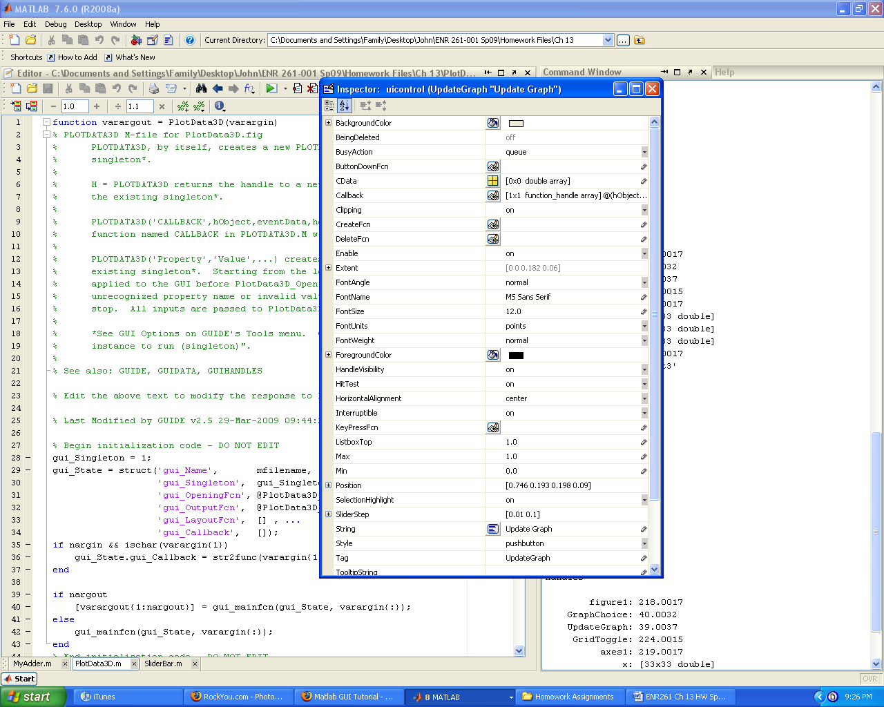

5. Double click on the middle pushbutton object to open its Inspector Window. Enter the values indicated by the arrows.

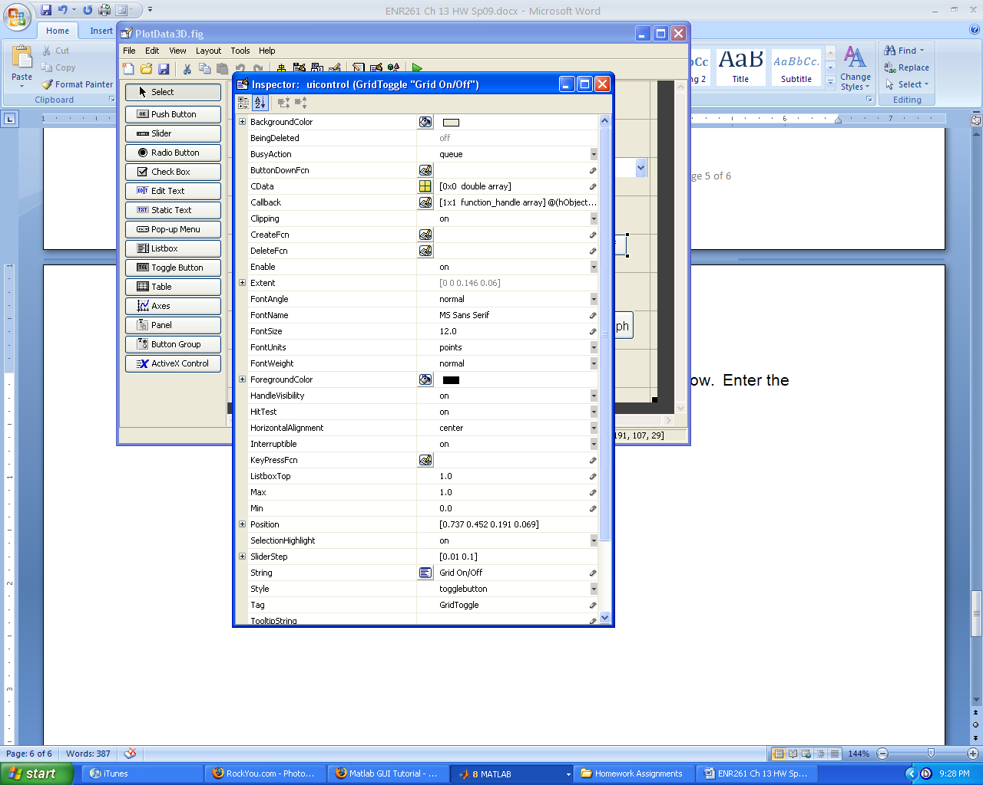

6. Resize the push buttons so the text fits inside the buttons as shown below.

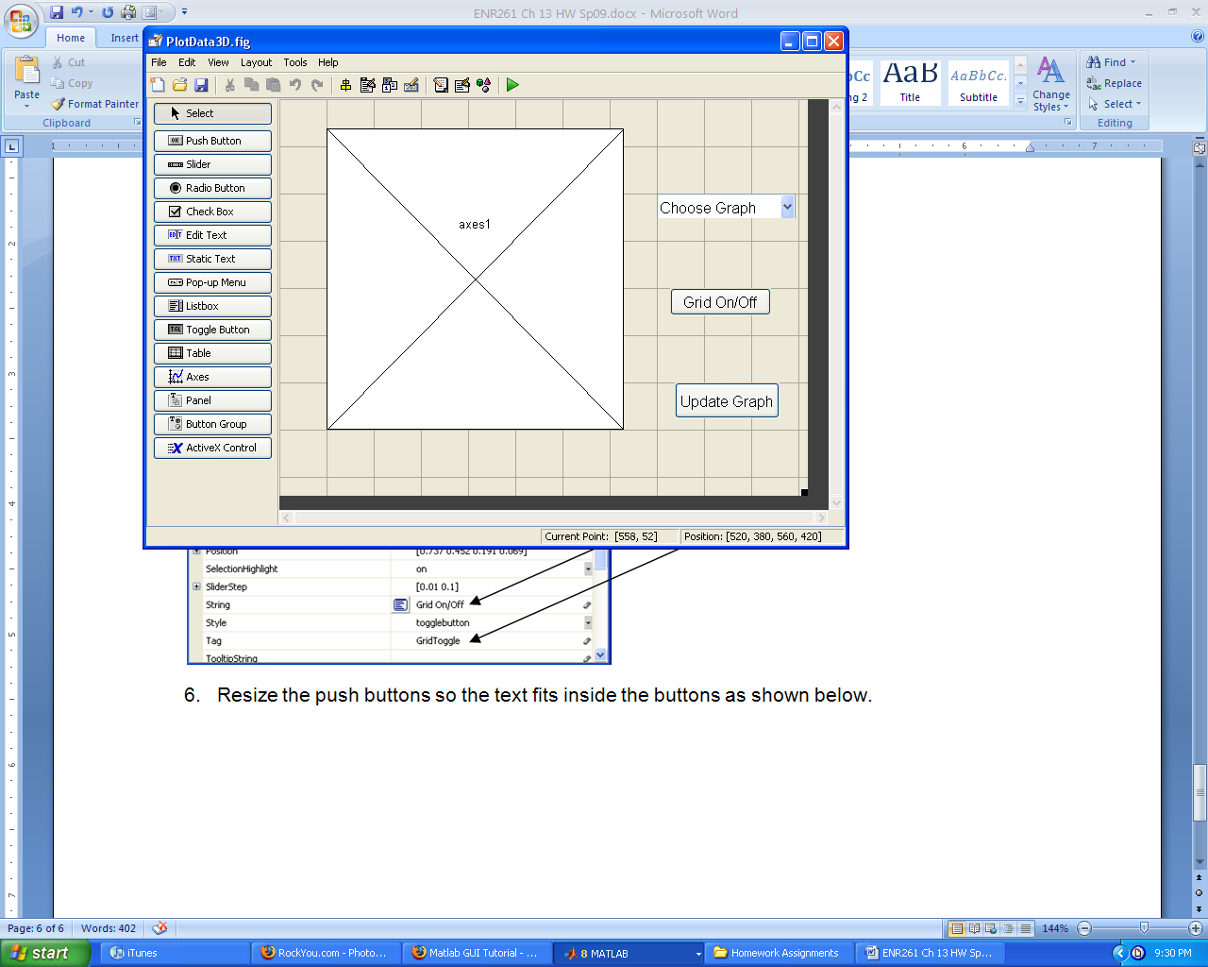

7. Double click on the Pop-up Menu object to open its Inspector Window. Enter the values indicated by the arrows.

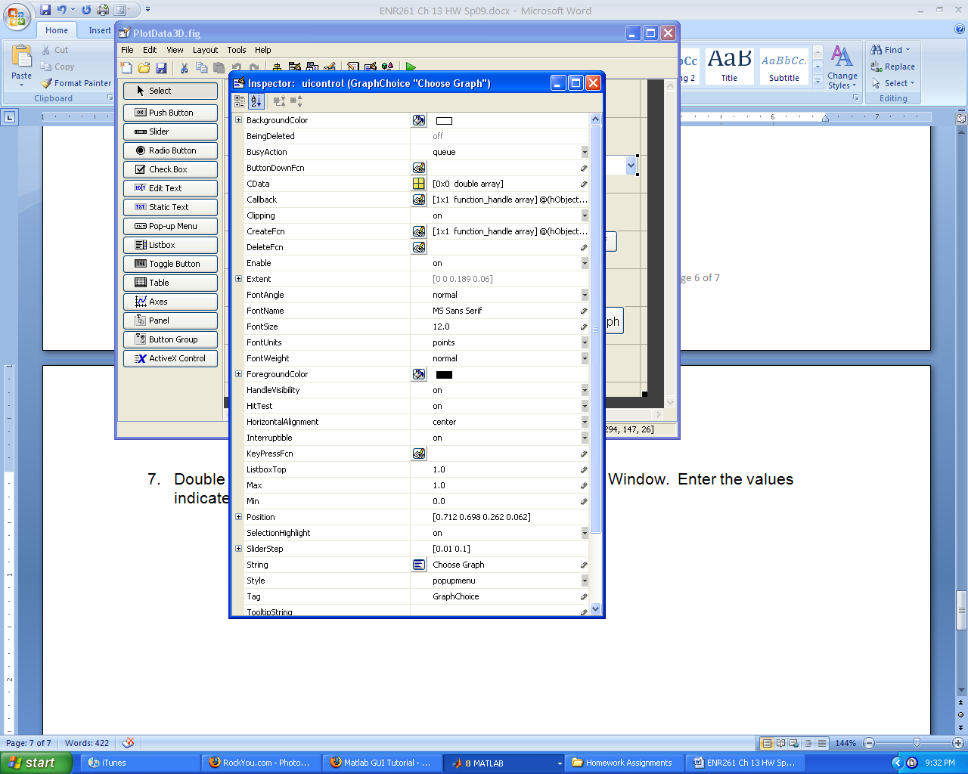

8. Double click on the table icon in the String row. Enter the values shown in the table below then click OK.

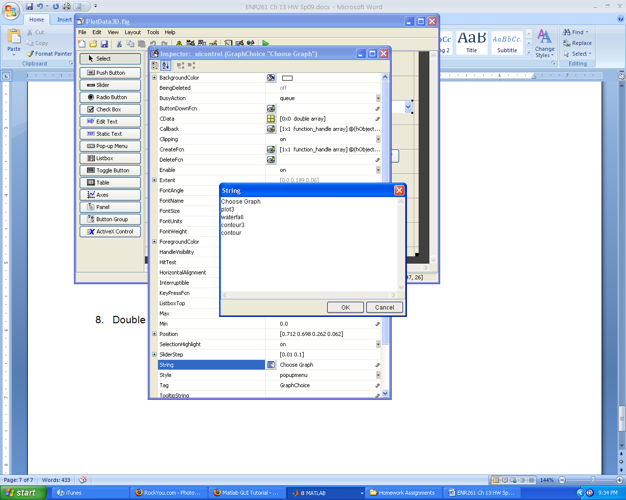

9. Resize the Pop-up menu and axes1 so that the GUI appears as the example below.

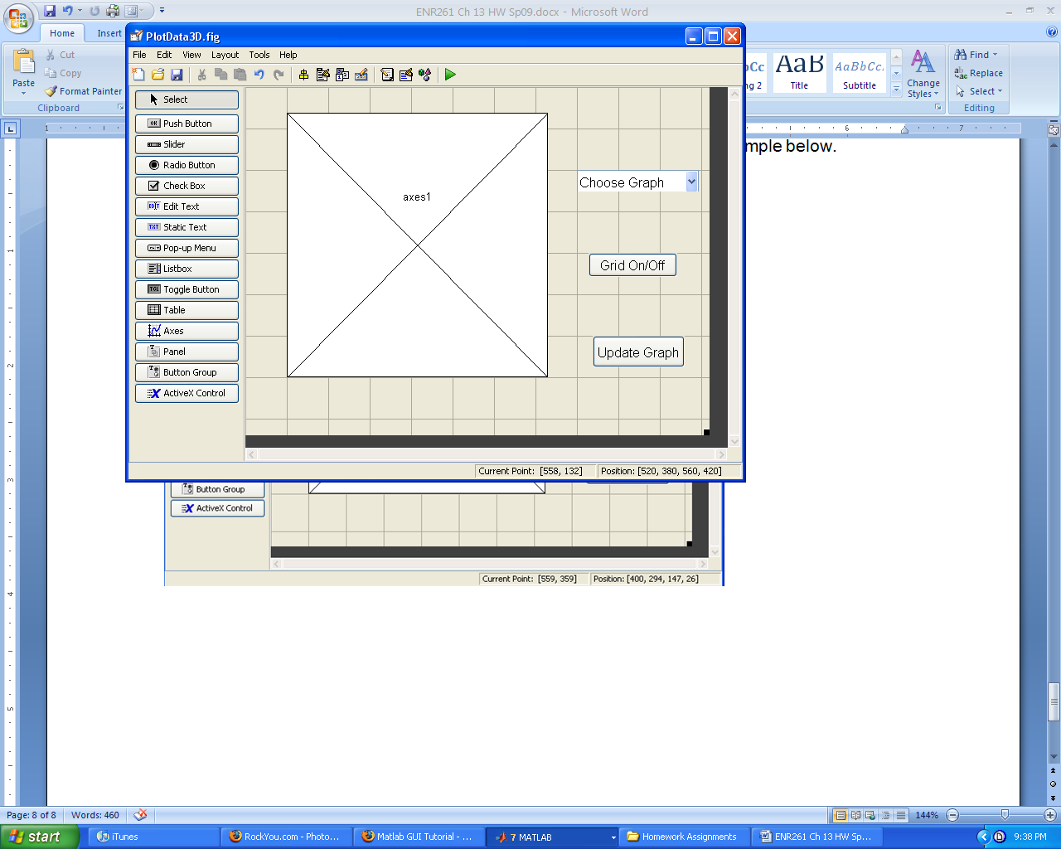

10.Click on the **Run Figure** icon (green triangle) and save the file with the name PlotData3D.

11. Modify the PlotData3D.m file so that it is identical to the code shown below. Most of the code will already be present.

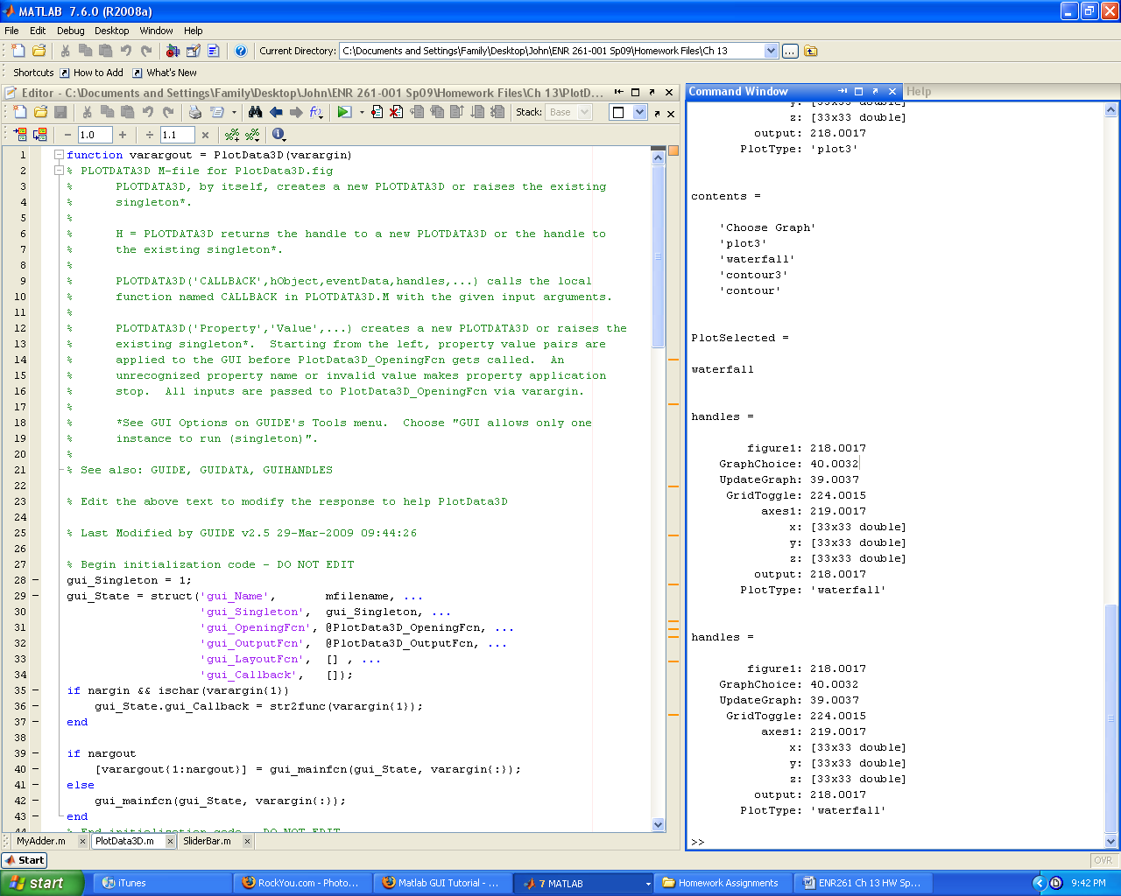

Continued on the next page

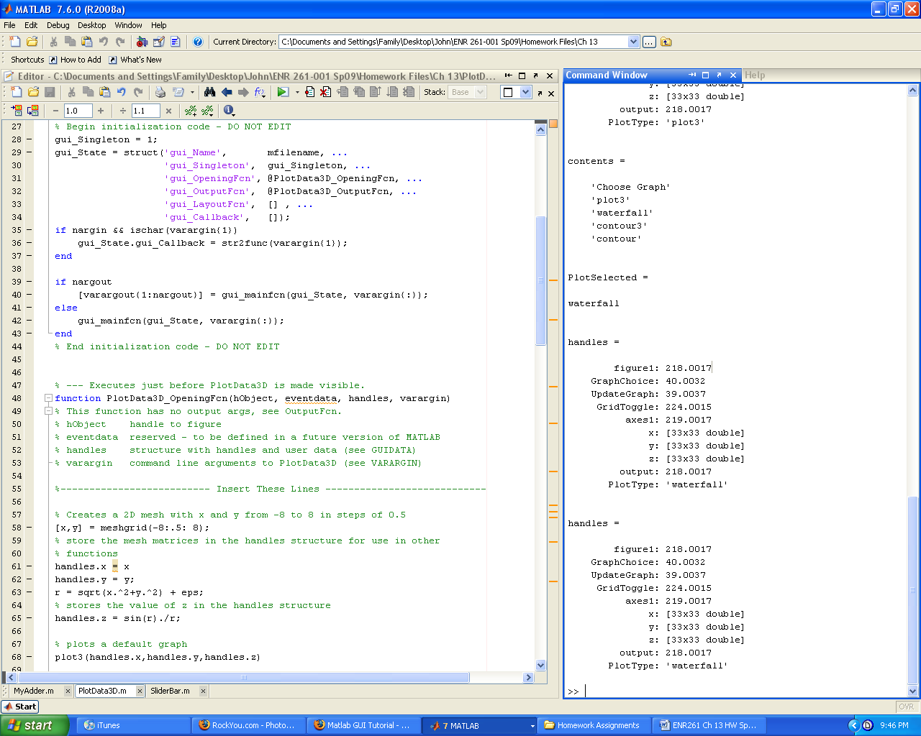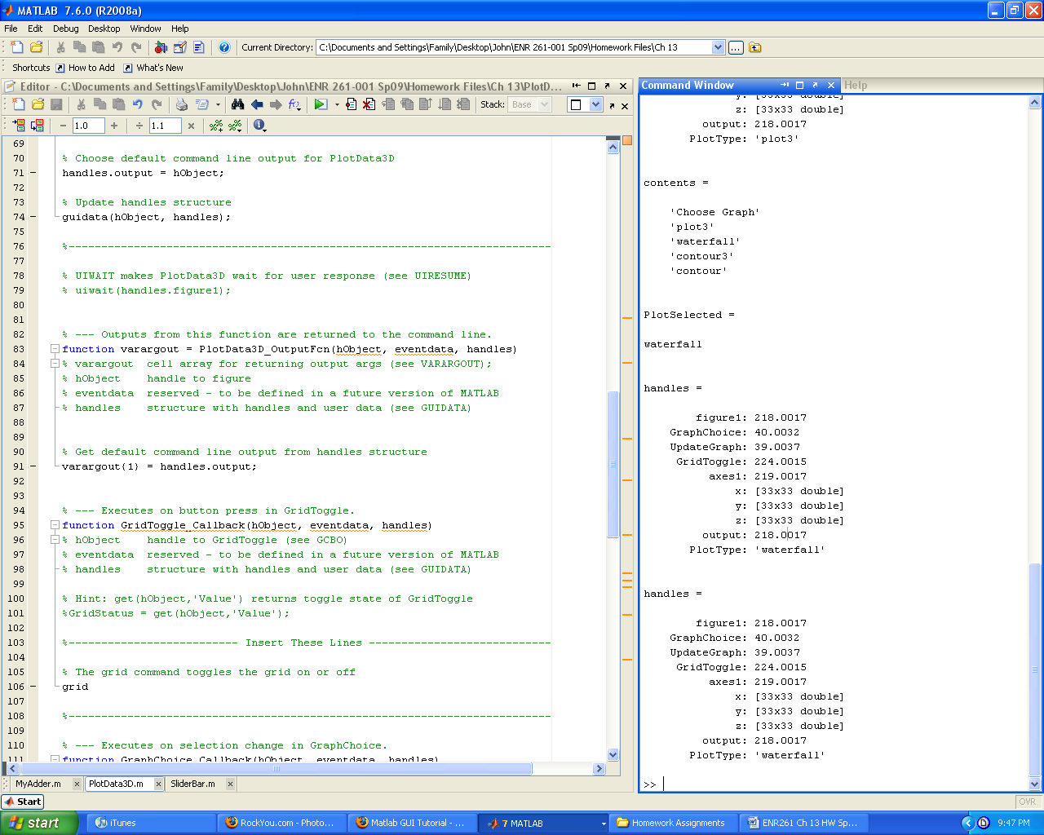

Continued on the next page

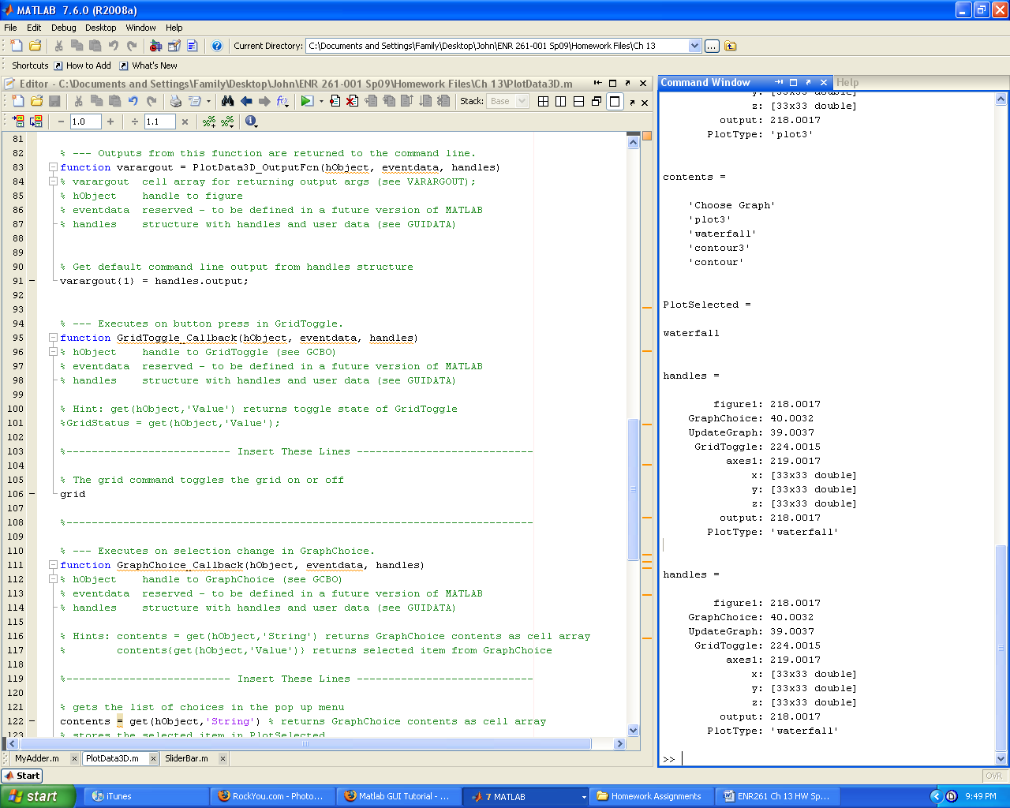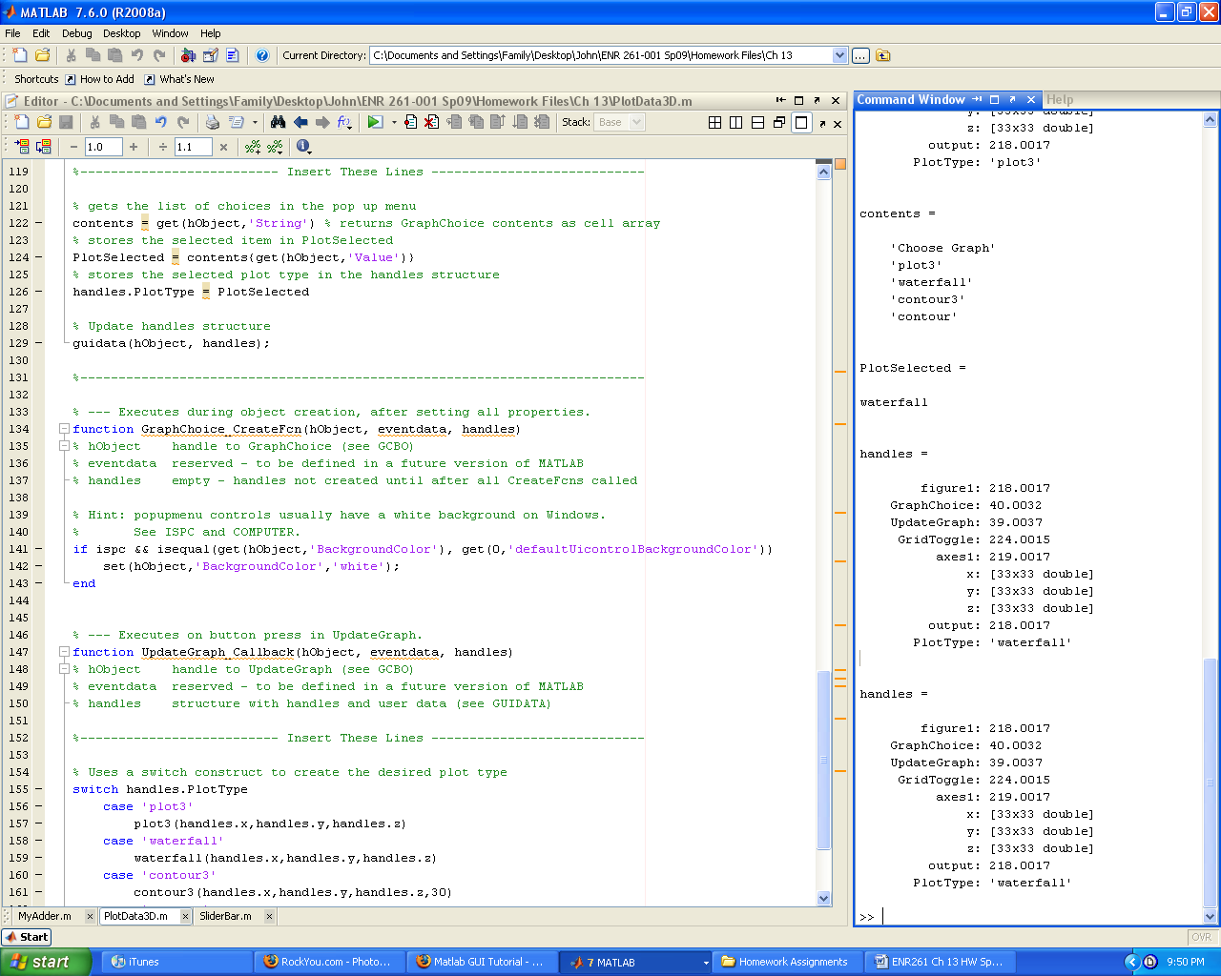

Continued on the next page

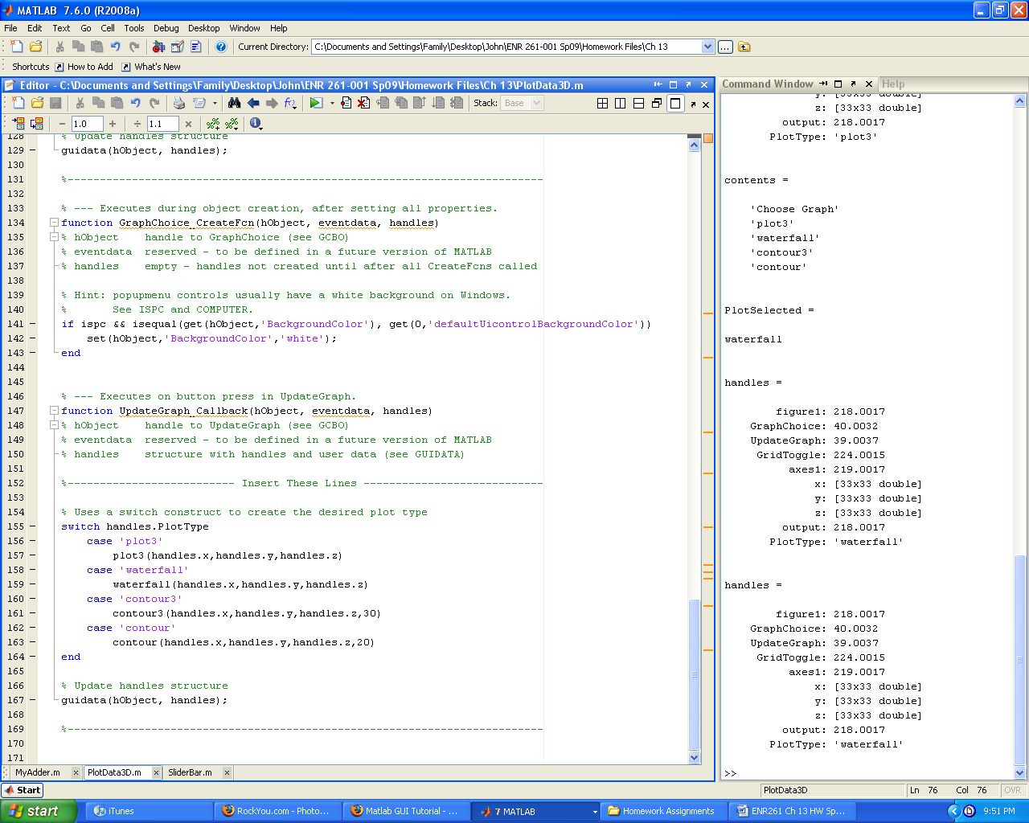

Required File Name: **Program_13_5.m and Program_13_5.fig**

After completing your programs, demonstrate your GUI to your instructor.

**Required Filenames: operator.m and operator.fig**

Create a GUI that uses a Pop-up menu to allow the user to choose from the following operations: a + b, a – b, a*b, a/b.

Your GUI should be laid out as shown below.

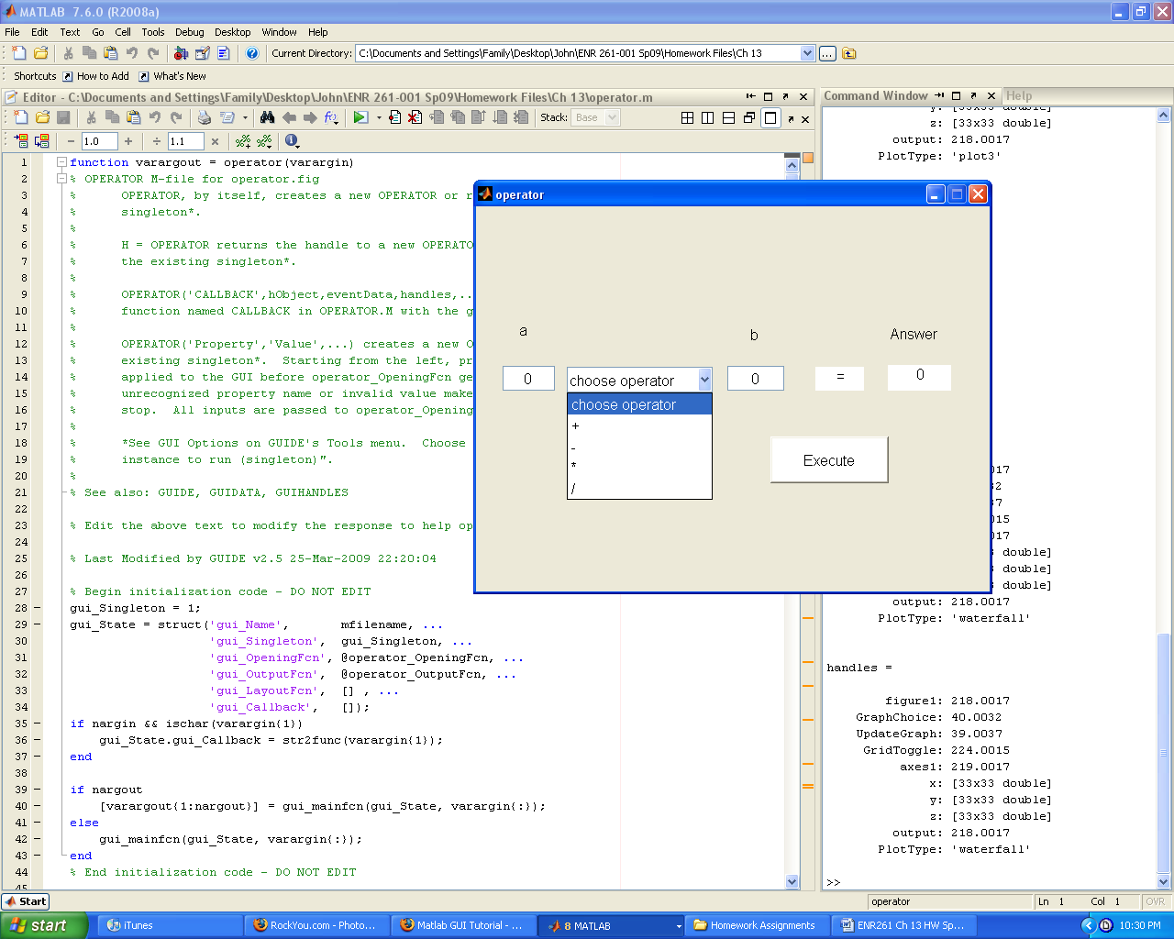

Required File Name: **Program_13_6.m and Program_13_6.fig**

Have your program create 10,000 random numbers with a normal distribution using the formula below along with the mean and standard deviation from the slider bars in the GUI.

normal = mean + StDev.*randn(1,10000);

The GUI should then create a histogram with using the following bin center and boundary values.

% bins are the containers that values will be stored in. The bin center

% is the value at the center of the bin.

BinCenters = 2.5: 5: 298.5;

% bin boundaries are the left and right boundaries of the bins

BinBoundaries = 0: 5: 300;

I suggest that you modify the opening function as shown below

function HistogramGUI_OpeningFcn(hObject, eventdata, handles, varargin)

% This function has no output args, see OutputFcn.

% hObject handle to figure

% eventdata reserved - to be defined in a future version of MATLAB

% handles structure with handles and user data (see GUIDATA)

% varargin unrecognized PropertyName/PropertyValue pairs from the

% command line (see VARARGIN)

%--------------------------Add These Lines -------------------------------

% The initial value of the sliders needs to be defined here unless it is 0

% otherwise the slider will be hidden until the values are defined.

set(handles.MeanSlider,'Value',100);

% set the text in the mean edit box to 100 too

set(handles.mean_editText,'String','100');

% initialize the slide and edit box values for the standard deviation

set(handles.StDevSlider,'Value',10);

set(handles.StDev_edit,'String','10');

% Choose default command line output for HistogramGUI

handles.output = hObject;

% Update handles structure

guidata(hObject, handles);

%----------------------------------------------------------------------------

A sample of the histogram is shown below on the next page.

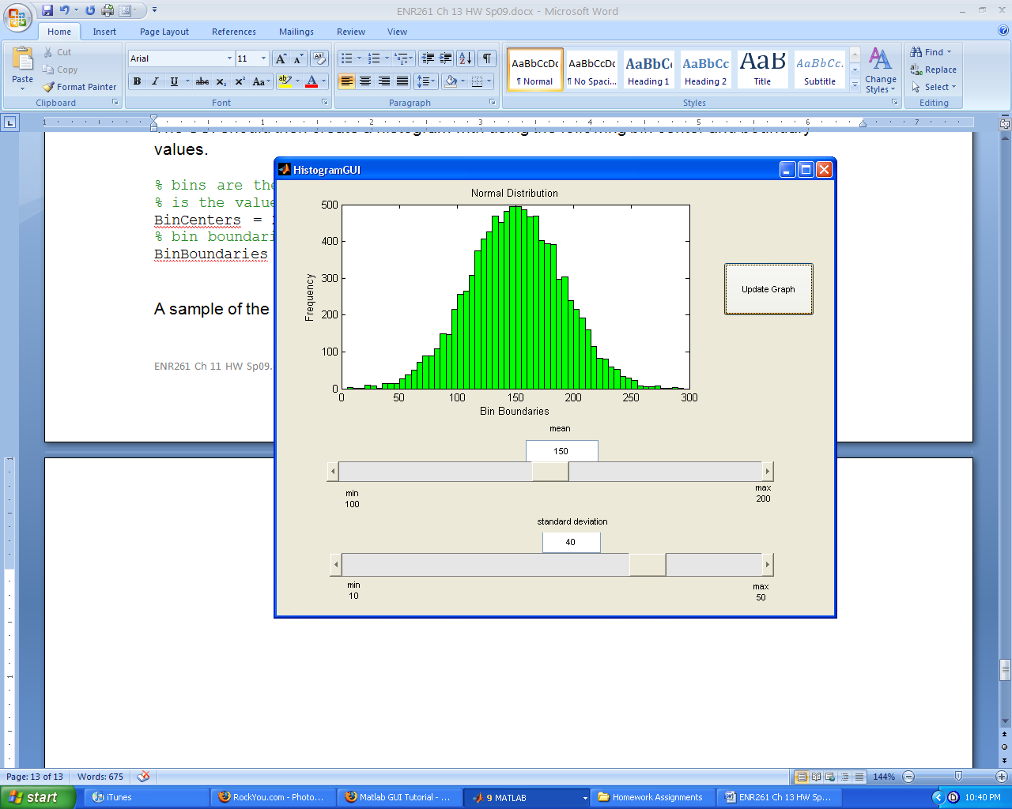

**Extra Credit**

Required File Name: **Program_13_7.m and Program_13_7.fig**

The program uses the plot function along with the user inputs from the **Line Style** radio buttons, **Line Width** Edit Text Box, and **Line Color** Pop-up Menu to create the GUI graph below.

plot(x,y,'color',LineColor,'LineStyle', style, 'LineWidth',width)

